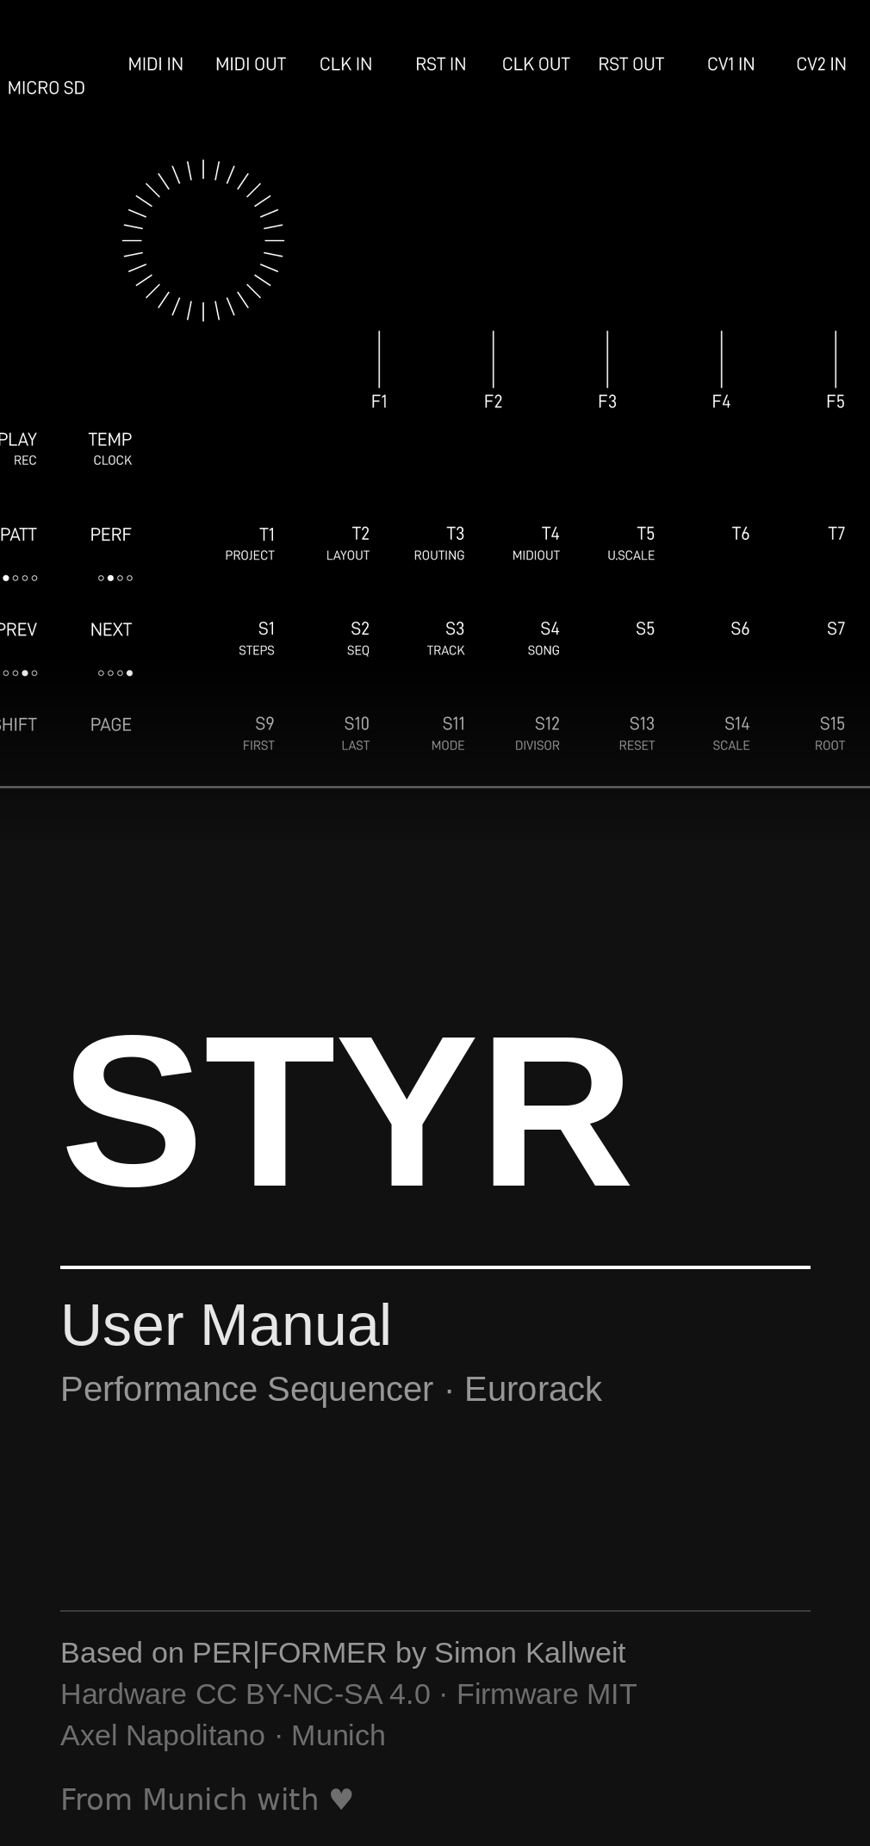
1 Introduction
This manual describes the operation and functions of the module. Replace this paragraph with your introduction. Body text uses the body-text paragraph style; emphasized terms are marked with a character style.
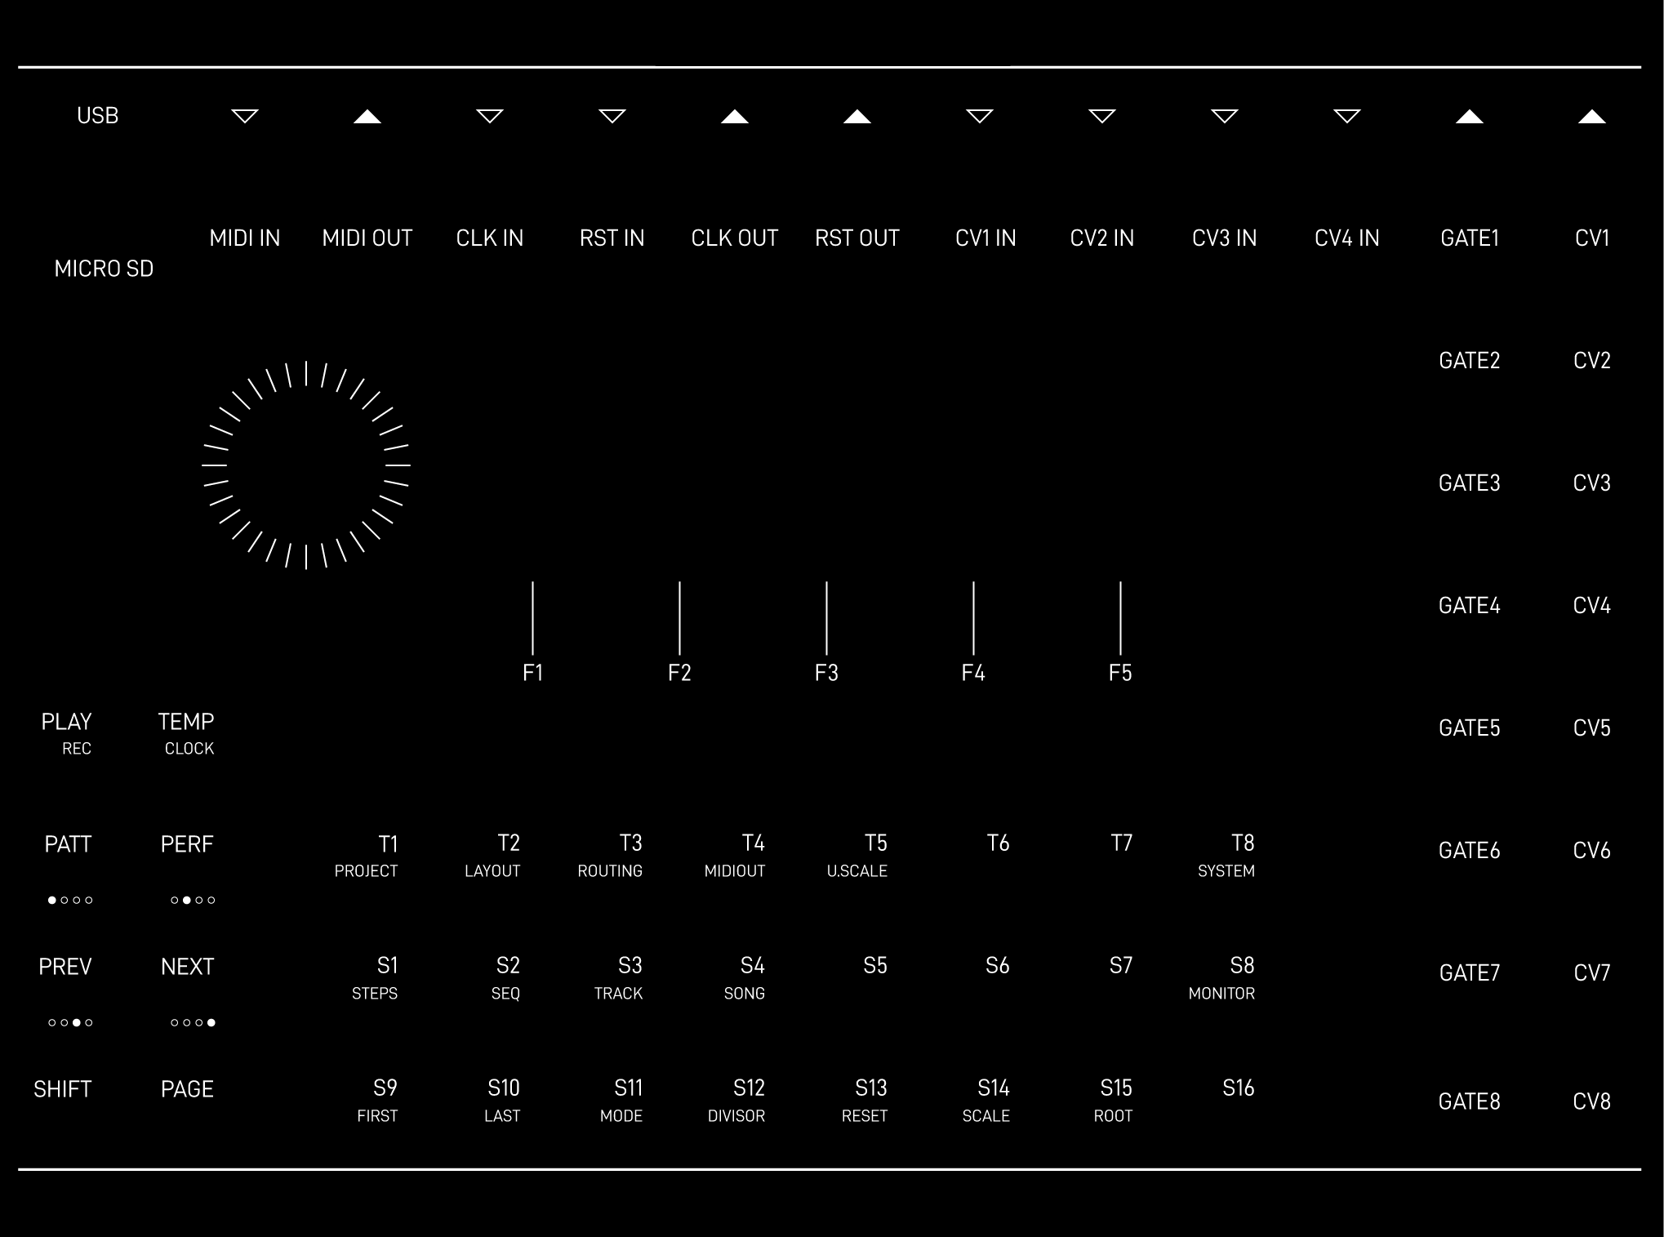
Figure 1 — Front panel (placeholder). Caption uses the “Caption” style.

NOTE
Use this box for notes, warnings or cross-references. References can be color-coded, e.g. section 4.

2 Controls
Short description of the front panel. The table below uses the reference-table format with a black header row and white text.
Ref. | Panel element
1 | Rotary / endless encoder
2 | Transport (PLAY / TEMP)
3 | Function buttons F1–F5

3 Inputs and outputs
Description of the jacks and signal flow. Bulleted lists use the list format:
- Input: one paragraph per item, lead-in in bold.
- Output: replace placeholder text.
- Normalization: replace placeholder text.
Status colors (character styles):
green · red · amber

4 Specifications
Technical data in table format. Measure all values before publishing — invent nothing.
Parameter | Value
Width | [HP]
Depth | [mm]
Current draw | [mA] @ +12 V / −12 V / +5 V

5 Firmware installation
Installation sequence. Replace the placeholders.
- Step 1 — prerequisites and tools.
- Step 2 — put the module into bootloader mode.
- Step 3 — flash the firmware and verify.

6 Version history
Changes per firmware or document version.
Version | Changes
0.1 | Initial template
… | …
Colophon
Document details, attribution and licensing. Replace bracketed placeholders.
Title | STYR — User Manual
Version | [x.y] — [YYYY-MM-DD]
Author | Axel Napolitano · Munich
Based on | PER|FORMER by Simon Kallweit
Hardware license | CC BY-NC-SA 4.0
Firmware license | MIT
Distribution | Non-commercial
Contact / source | [email or repository]

“PER|FORMER” and “westlicht” are trademarks of their respective owners and are not used on this build. Set in Ubuntu. Illustrations and layout produced with AI assistance.

