**SDLC**

This mean Software Development Lifecycle. It is the structured process from A-Z of developing a software from an MVP (minimal viable product) to a user-ready software that delivers all the features required by the product owner. The software is developed in the most efficient way feasible both in terms of budget and time.

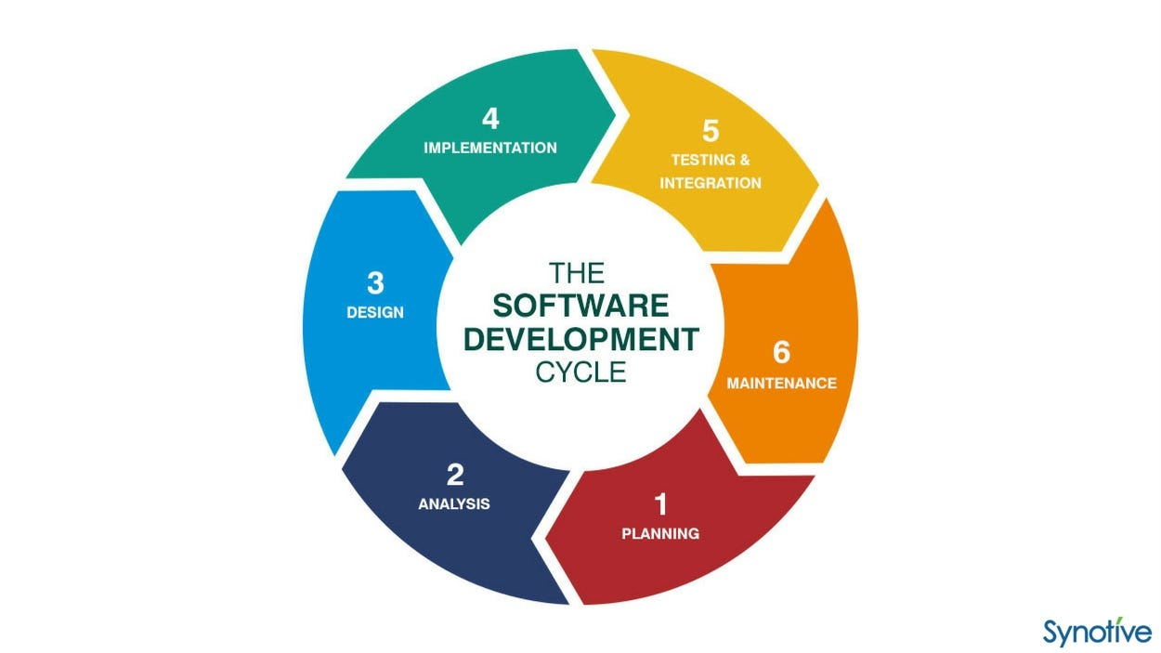

The 5 main aspects of the SDLC are:

Planning

Design

Building

Testing

Deployment

The 6th stage acts as a feedback loop to make enhancements to the product based on user feedback.