**SDLC**

This mean Software Development Lifecycle. It is the structured process from A-Z of developing a software from an MVP (minimal viable product) to a user-ready software that delivers all the features required by the product owner. The software is developed in the most efficient way feasible both in terms of budget and time.

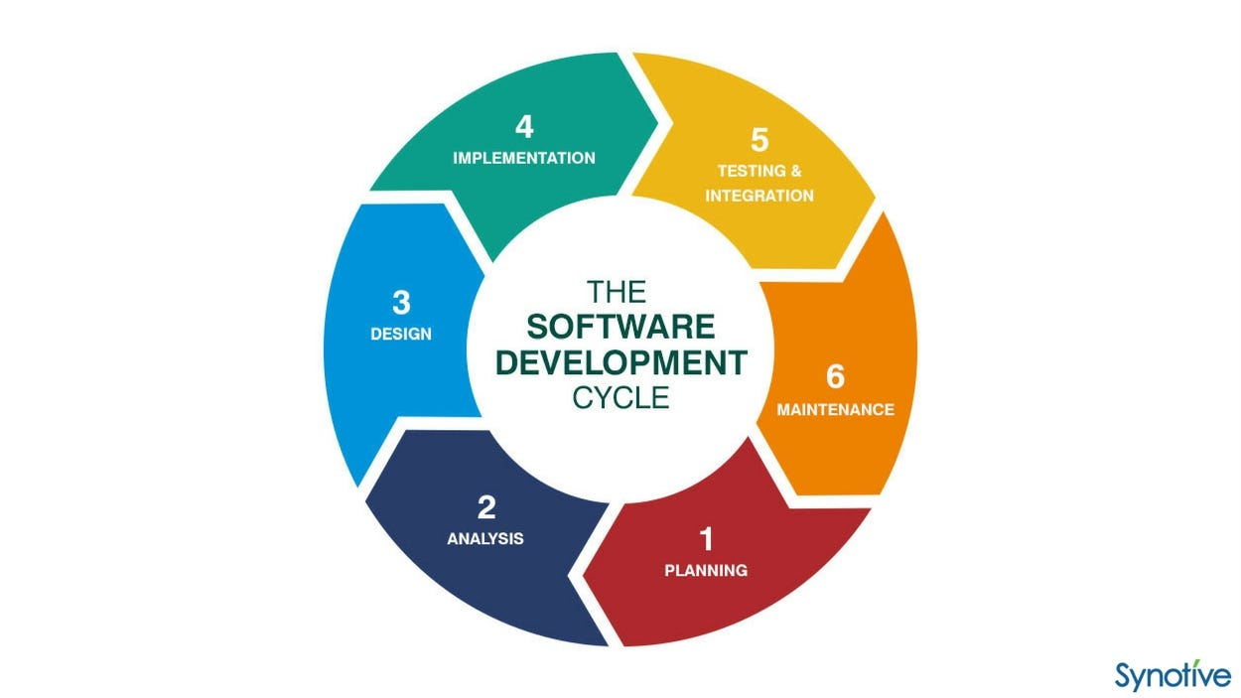

The 5 main aspects of the SDLC are:

Planning

Design

Building

Testing

Deployment

The 6th stage acts as a feedback loop to make enhancements to the product based on user feedback.

**LAMP stack**

There are several technology stacks that can be used to develop a software product. LAMP is an acronym for Linux, Apache, MySQL and a Programming language (e.g. PHP/Python).

LAMP technologies are open source so are easy to access and require no licensing fees. Therefore the overall cost of building the application is lower.

Novel/new web apps require rigorous testing of their frameworks, modules libraries and tools. As LAMP is a tried and tested web development solution, less time is spent on testing and more time on building. The LAMP stack is oft maintained as its open source by numerous experts globally and troubleshooting issues is easier. LAMP also specifies the software components of each layer and so developers can replace them as they see fit.

LAMP is used for back-end (server-side) development which consistes of:

* Data Processing
* Database components
* Business logic in code
* API for communicating with other apps.

**What is the LAMP architecture?**

A software stack is a set of layered tools, libraries, programming languages, and technologies used for building, managing, and running an application. The stack consists of software components that support the application in different ways, such as visual presentation, database, networking, and security.

Similarly, the LAMP architecture consists of four software technologies that work together behind the scenes to create a working web application. It describes how each of these web development technologies interact with each other in a computer server. The LAMP architecture consists of the following layers.

Linux

Linux is an open-source operating system that you can install and configure to meet different application requirements. Linux sits at the first level of the LAMP stack and supports other components on the upper layers.

Apache

Apache is an open-source web server that forms the second layer of the LAMP stack. The Apache module stores website files and exchanges information with a browser using HTTP, an internet protocol for transferring website information in plain text. For example, when a browser requests a webpage, the Apache HTTP server does the following:

1. Receives the request
2. Processes the request and finds the required page file
3. Sends the relevant information back to the browser

MySQL

MySQL is an open-source relational database management system and is the third layer of the LAMP stack. The LAMP model uses MySQL for storing, managing, and querying information in relational databases. For example, developers store application data, such as customer records, sales, and inventories. When a user searches for information, the web server queries the stored data in MySQL. *Query* refers to special instructions for manipulating data in a relational database with the SQL language.

PHP

PHP, which stands for PHP: Hypertext Preprocessor, is the fourth and final layer of the LAMP stack. It is a scripting language that allows websites to run dynamic processes. A dynamic process involves information in software that constantly changes. Web developers embed the PHP programming language in HTML to show real-time or updated information on websites. They use PHP to allow the web server, database, and operating system to cohesively process requests from browsers.

*HTML compared to PHP*

Web developers use HTML for frontend development, such as designing the layout of webpages. Meanwhile, they use PHP to determine the behavior of certain components when users load a webpage. For example, web developers design the graphical layout of an online product catalog with HTML. They then use PHP code to retrieve the latest product price from the backend server.

Chmod and Chown are linux commands that manage permissions and file ownership.