MY DB CONNECTION ON SQL SERVER WITH SOMEE DB FOR LOCAL PRACTICE OF MY PROJECT:

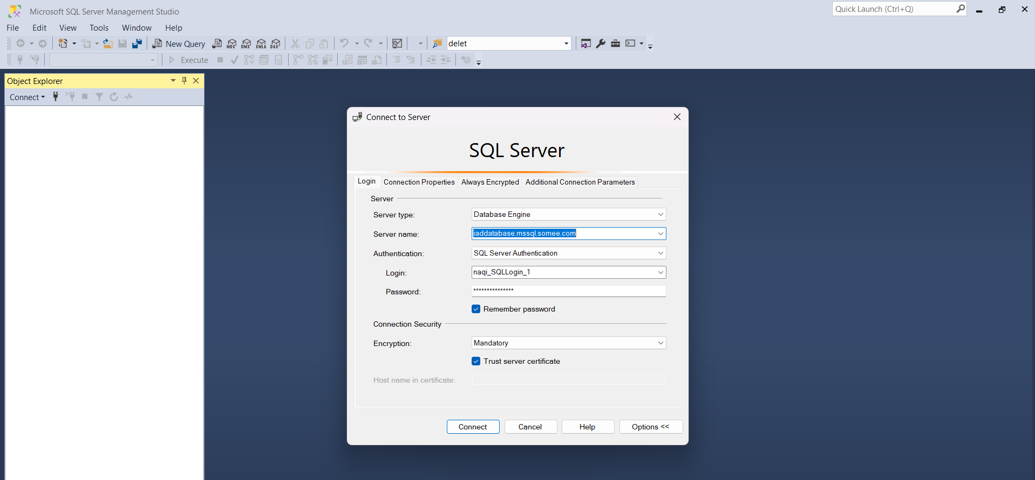

MY DB CONNECTION ON SOMEE SERVER FOR PUBLIC PRACTICE OF MY CODE:

THERE IS SLIGHTLY CHANGE IN MY TABLES NAME COMPARED TO MY ER DIAGRAMS DUE TO DUPLICATION ENTERING OF TABLE NAMES IN MY DB.

