## ES 111 Assignment No # 6 CEP

**2023**

## ES111 Section C

Submitted by: **Syed Muhammad Naqi Raza**

Registration No: **2022574**

Faculty: **Cyber Security**

Class Section: **C**

**“On my honor, as student of Ghulam Ishaq Khan Institute of Engineering Sciences and**

**Technology, I have neither given nor received unauthorized assistance on this academic work.”**

Submitted to:

## Sir Fahad Sikanadar

**TA Ali Haider**

DATE:

**15/05/2023**

**Complex Engineering Problem (CEP) - CLO-5**

Q-1**:** Implementation of central limit theorem on a data set.

**Code:**

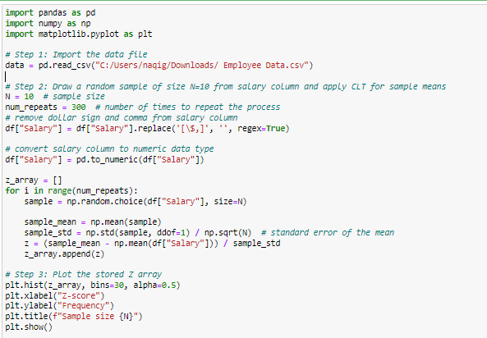

**Output:**



