The detailed solution for integrating RLS with Power BI using Azure Analysis Service is given below,

1. Create a role with the predefined role name as we discussed earlier (Eg : TENANTUSER).
2. In Row filters use CUSTOMDATA() as a variable to apply the filter and convert the data as an Integer (Eg : CONVERT(CUSTOMDATA(),INTEGER)).

1. And in the Members tab, include the Admin email address.

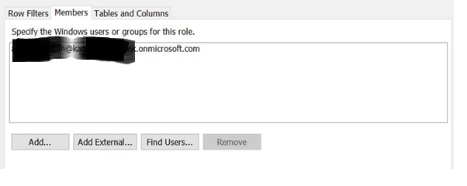

1. For dynamic RLS, add another parameter ‘CustomData’.
2. In Effective Identity, apply the username as Admin email and in the CustomData apply the value in a string format that needs to be filtered.

