1. **sp_who2:** returns the processes connected to SQL Server instance.

**Steps:**

1. Type **sp_who2** in SQL Server query window
2. Copy and paste the result set into an excel file
3. Filter the result set based on DB Name and Login
4. Order the SPIDs based on CPU Time or DISK IO descending
5. Use **Kill** command to terminate the process (eg. Kill 82)
6. To get the status of kill, run the KILL command again (eg. Kill 82)

message like below would be displayed,

*SPID 81: transaction rollback in progress. Estimated rollback completion: 63%*

1. Below query can also be used to get the status of Rollback,

*SELECT SESSION_ID, PERCENT_COMPLETE, LAST_WAIT_TYPE, WAIT_RESOURCE, WAIT_TIME, WAIT_TYPE FROM SYS.DM_EXEC_REQUESTS WHERE STATUS = ‘ROLLBACK’*

1. Run **sp_who2 'active'** to get the active SPIDs

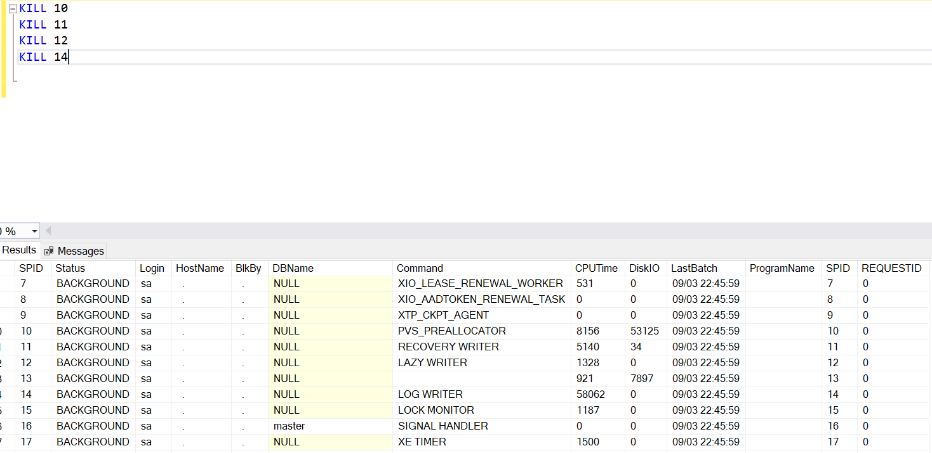

|  |  |
| --- | --- |
| 1. **Debug loads** | |
|  | * Maintain Log tables for load * Insert a fresh record at the start of load and assign the Identity of the table to a variable * Keep updating the status and time at regular steps so the status and duration can be tracked at times of long loads |
|  |  |
|  |  |
| 1. **Debug SPs** | | |
|  | * Include an input param **@DEBUG = 0** in Stored Procedures | |
|  | * Include the statements inside **@DEBUG = 1** block which is required for debugging and pass **@DEBUG = 0** during web call * Use Try-Catch block for error handling | |
|  |  | |
|  |  | |

1. **Query to find out Slow running queries**

SELECT CREATION_TIME

, LAST_EXECUTION_TIME

, TOTAL_PHYSICAL_READS

, TOTAL_LOGICAL_READS

, TOTAL_LOGICAL_WRITES

, EXECUTION_COUNT

, TOTAL_WORKER_TIME

, TOTAL_ELAPSED_TIME

, TOTAL_ELAPSED_TIME / EXECUTION_COUNT AVG_ELAPSED_TIME

, SUBSTRING (ST.TEXT, (QS.STATEMENT_START_OFFSET/2) + 1,

((CASE STATEMENT_END_OFFSET

WHEN -1 THEN DATALENGTH(ST.TEXT)

ELSE QS. STATEMENT_END_OFFSET END

- QS. STATEMENT_START_OFFSET)/2) + 1) AS STATEMENT_TEXT

FROM SYS.DM_EXEC_QUERY_STATS AS QS

CROSS APPLY SYS.DM_EXEC_SQL_TEXT(QS.SQL_HANDLE) ST

ORDER BY TOTAL_ELAPSED_TIME / EXECUTION_COUNT DESC