FAST NUCES
Department of Computer Science

Software Engineering

Silent Voices
An AI-Powered ASL-to-English Web Application

Iteration 2 — Sprint 2 Deliverable

Name | Roll Number
Irtaza Naqvi | 23L-0608
Faizan Ashfaq | 23L-3091
Muhammad Fakhir | 22L-6827

Table of Contents
1. Project Title and Introduction
2. Sprint 2 – Sprint Backlog
2.1 Module Selected for Sprint 2
2.2 User Stories
2.3 Scrum Board (Trello Screenshots)
3. System Design
3.1 Architecture Diagram
3.2 Component Diagram
3.3 Data Flow Diagrams (Level 0, 1, 2)
3.4 Activity Diagrams
3.5 Use Case Diagram
3.6 Sequence Diagrams
3.7 Class Diagram
4. Implementation Screenshots

1. Project Title and Introduction
1.1 Project Title
Silent Voices — An AI-Powered ASL-to-English Web Application
1.2 Introduction
Silent Voices is a browser-based application designed to bridge the communication gap between the Deaf community and hearing individuals. The system allows users to upload a pre-recorded video of American Sign Language (ASL) gestures; a computer-vision pipeline built on Google's MediaPipe extracts 21 hand-landmark coordinates per frame, which are then classified by a trained machine-learning model and converted into readable English text.
Sprint 2 focuses on the core gesture-recognition engine, the complete text and audio output pipeline, and the integration of all components developed in Sprint 1. By the end of this iteration, users will be able to upload a video, see each recognised ASL gesture translated to text in real time, and hear the composed sentence through the browser's Text-to-Speech API.

2. Sprint 2 – Sprint Backlog
2.1 Module Selected for Sprint 2
M3 – Gesture Recognition Engine
Integrates the trained ML classification model with the MediaPipe landmark sequences from Sprint 1. Recognises ASL alphabet letters and common words, accumulates them into words/letters.
M4 – Text & Audio Output
Displays the recognised text live on the screen and converts the composed sentence to audible speech using the browser's Web Speech API.
2.2 User Stories
US-09 – ASL Alphabet Recognition
Role | As a Deaf user,
Goal | I want the system to recognise each letter of the ASL alphabet that I sign in a video,
Benefit | so that I can spell out words that are not in the common-word vocabulary.
Priority | High
Story Points | 8
Sub-User Stories | • The system must detect hand landmarks for all 26 ASL alphabet signs.  • Each detected letter must be displayed immediately after that segment of video is processed.  • If the model confidence is below 50 %, the system displays '?' instead of guessing.  • The recognition engine must process at minimum 10 FPS equivalents of landmark data.
Acceptance Criteria | • Given a clear video of a single ASL letter, the system returns the correct , working on to increase accuracy• Given an ambiguous sign, the system returns '?' and shows a low confidence score.
Status | To Do → In Progress

US-10 – Common-Word Gesture Recognition
Role | As a Deaf user,
Goal | I want the system to recognise frequently used ASL word signs (e.g., HELLO, THANK YOU, HELP),
Benefit | so that I can communicate faster without finger-spelling every word.
Priority | High
Story Points | 8
Sub-User Stories | • The vocabulary must include at least 20 predefined common words/phrases.  • The system must distinguish word-level signs from alphabet signs automatically.  • Each matched word is appended to the sentence builder.
Acceptance Criteria | • Given a video containing a supported word sign, the system appends the correct word to the sentence.  • Given an unsupported sign, the system falls back gracefully (e.g., finger-spells or shows '?').
Status | To Do → In Progress

US-11 – Backspace / Clear Gesture
Role | As a Deaf user,
Goal | I want to be able to remove the last recognised token or clear the entire sentence,
Benefit | so that I can correct mistakes without re-uploading a new video.
Priority | Medium
Story Points | 3
Sub-User Stories | • A 'Backspace' button removes the last appended token (letter or word).  • A 'Clear All' button resets the sentence builder to an empty state.  • Both actions must be accessible via keyboard shortcuts (Backspace / Ctrl+Del).
Acceptance Criteria | • After pressing Backspace the last token is removed from the displayed sentence.  • After pressing Clear All the sentence area is empty.
Status | To Do → In Progress

US-13 – Live Text Output on Screen
Role | As a hearing user reading the screen,
Goal | I want each recognised gesture to appear on screen as soon as it is processed,
Benefit | so that I can read the translation in near-real-time without waiting for the entire video.
Priority | High
Story Points | 5
Sub-User Stories | • The text output area updates incrementally as each gesture is classified.  • A blinking cursor or progress token indicates the system is still processing.  • Font size defaults to 18 pt and is adjustable via a slider.
Acceptance Criteria | • While a video is being processed, new text tokens appear on screen within 2 seconds of that gesture being processed.
Status | To Do → In Progress

US-14 – Text-to-Speech (TTS) Playback
Role | As a hearing user nearby,
Goal | I want the composed sentence to be read aloud when I press the 'Speak' button,
Benefit | so that I can receive the Deaf user's communication audibly without reading the screen.
Priority | High
Story Points | 5
Sub-User Stories | • TTS is triggered by a clearly labelled 'Speak' button.  • The browser's Web Speech API (SpeechSynthesis) is used — no external service required.  • The user can select speech rate (slow / normal / fast) and volume.  • TTS is disabled if the sentence builder is empty; the button is greyed out.
Acceptance Criteria | • Clicking 'Speak' on a non-empty sentence plays the sentence aloud in the browser.  • If the sentence is empty, the 'Speak' button is disabled and shows a tooltip 'No text to speak'.
Status | To Do → In Progress

2.3 Scrum Board – Trello Screenshots
The following screenshots show the Trello board state at the beginning and mid-point of Sprint 2:

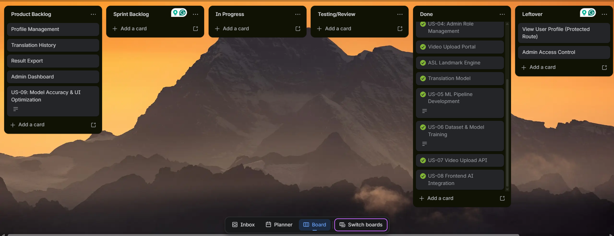

3. System Design
3.1 Architecture Diagram
Silent Voices adopts a three-tier client–server architecture combined with a pipeline/batch-processing architectural style for the ML inference layer.
Tiers:
• Presentation Tier – React.js SPA running in the browser. Handles all user interaction, video upload, live text display, TTS playback, and session history views.
• Application / Business Logic Tier – FastAPI (Python) backend. Exposes REST endpoints for authentication, video ingestion, gesture classification, session management, and admin operations.
• Data Tier – PostgreSQL relational database. Stores user accounts, JWT tokens (blacklist), translation sessions, gesture-feedback records, and admin logs.
Architectural Styles Used:
1. Layered (n-tier) Architecture – enforces separation of concerns; each tier communicates only with the layer directly below it.
2. Pipeline / Batch-Processing Style (ML Engine) – video frames pass through a sequential pipeline: Frame Extraction → MediaPipe Landmark Detection → Feature Normalisation → ML Classification → Sentence Builder. This is ideal for our offline video-processing model.
3. RESTful API Style – React frontend communicates with FastAPI via standard HTTP/JSON REST calls, making the system stateless and scalable.
Rationale: The layered style keeps frontend, backend, and database independently deployable and testable. The pipeline style naturally maps to the sequential computer-vision workflow. REST ensures the frontend and backend remain decoupled, allowing independent iteration.

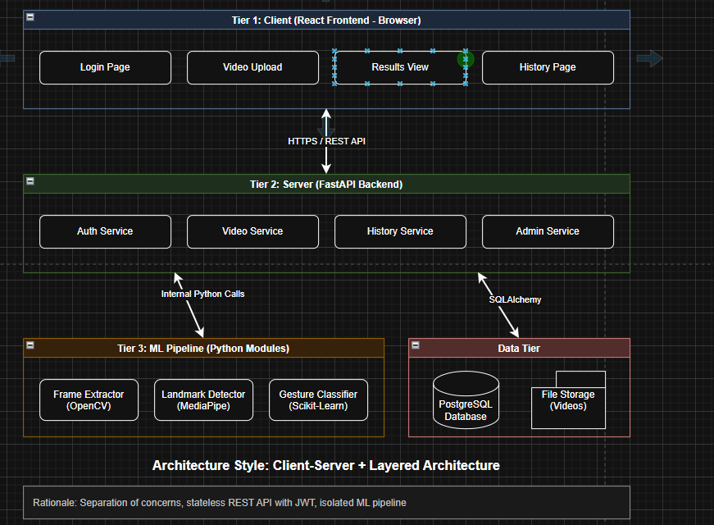
3.2 Component Diagram
The component diagram below illustrates the major software components of Silent Voices and their interfaces.
Key components:
• React Frontend – sub-components: AuthModule, VideoUploadWidget, TextOutputPanel, TTS Controller, SessionHistoryView, VocabGuide, AdminDashboard.
• FastAPI Backend – sub-components: AuthRouter (/api/auth/*), VideoRouter (/api/video/*), SessionRouter (/api/sessions/*), AdminRouter (/api/admin/*), ML Engine Service.
• ML Engine Service – sub-components: FrameExtractor (OpenCV), LandmarkDetector (MediaPipe), Classifier (scikit-learn / TensorFlow Lite), SentenceBuilder.
• PostgreSQL Database – schemas: users, sessions, gestures, feedback, admin_log.
• External Services – Web Speech API (browser-native TTS); no third-party cloud ML APIs.
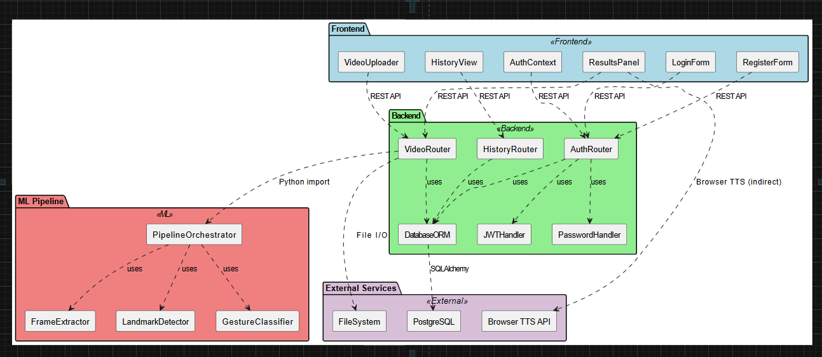
3.3 Data Flow Diagrams
Level 0 – Context Diagram
The Level 0 DFD shows the system as a single process 'Silent Voices' with flows to/from three external entities:
• User (Deaf Individual) – uploads ASL video; receives English text and audio.
• Admin – accesses system analytics and manages user accounts.
• Database – stores and retrieves all persistent data.
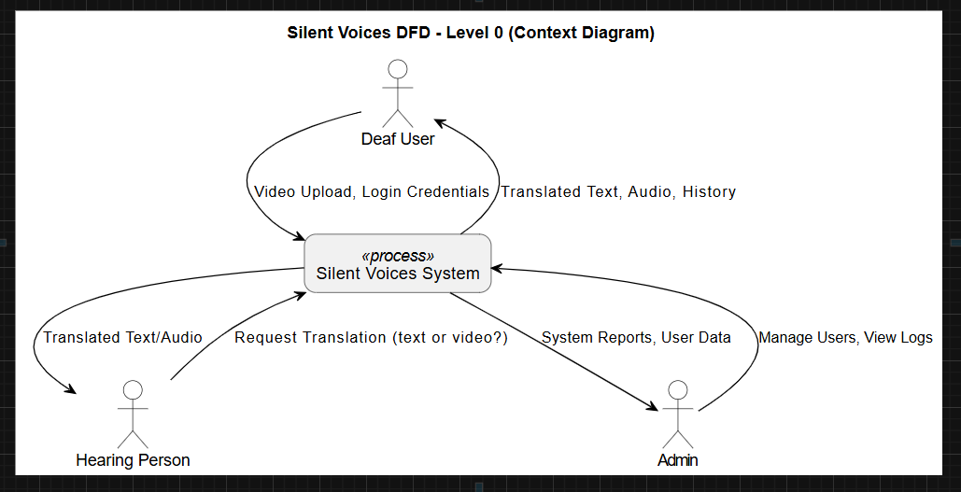
Level 1 – Main Processes
Level 1 expands the system into four main processes:
1. User Authentication – handles registration, login, and JWT token management.
2. Video Processing Pipeline – ingests video, extracts frames, detects landmarks, classifies gestures.
3. Output Generation – assembles sentences, displays text, and triggers TTS.
4. Session & Admin Management – saves session logs, handles feedback, manages admin dashboard.
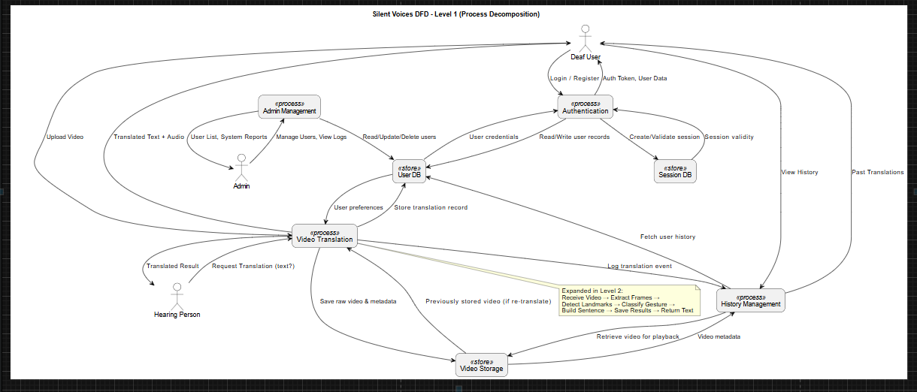
Level 2 – Video Processing Pipeline (Expanded)
Level 2 zooms into Process 2 (Video Processing Pipeline):
2.1 Frame Extraction – OpenCV reads the video and outputs individual frames.
2.2 Landmark Detection – MediaPipe Hands detects 21 key-points per hand per frame.
2.3 Feature Normalisation – coordinates are normalised relative to wrist position.
2.4 Gesture Classification – the ML model maps landmark arrays to gesture labels.
2.5 Confidence Filtering – results below threshold are flagged as uncertain.
2.6 Token Output – confirmed gesture labels are forwarded to the Sentence Builder.
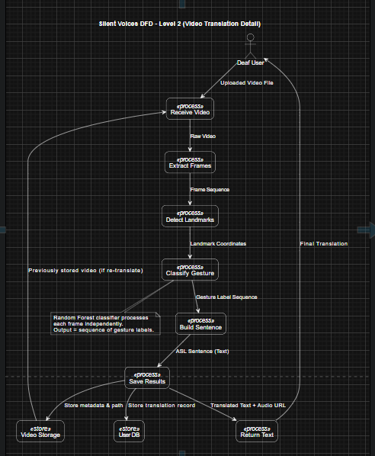
3.4 Activity Diagrams
Activity diagrams are drawn for the three main processes of Sprint 2:
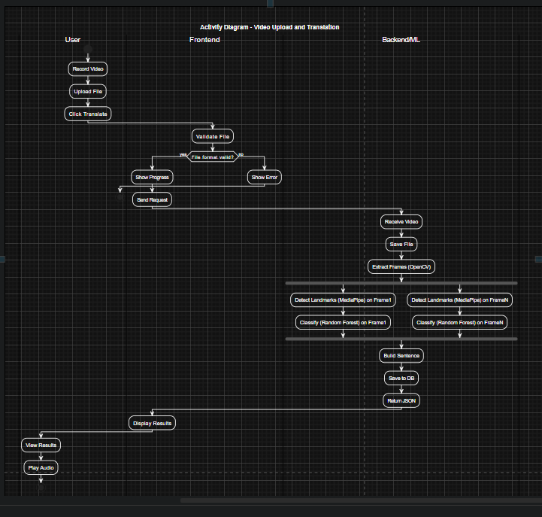

3.5 Use Case Diagram
Actors:
• Deaf User (primary actor) – registers/logs in; uploads ASL video; views translated text; triggers TTS; reviews session history; submits feedback.
• Hearing User (secondary actor) – views on-screen text; receives TTS audio output.
• Administrator – manages user accounts; views session analytics; monitors system health.
• ML Engine (system actor) – processes frames; classifies gestures; returns confidence scores.
Key use cases for Sprint 2:
UC-01: Upload ASL Video
UC-02: View Gesture Recognition Results
UC-03: Build Sentence from Recognised Gestures
UC-04: Trigger Text-to-Speech Playback
UC-05: Clear / Backspace Sentence
UC-06: View Confidence Score
UC-07: Save and View Session History (extends UC-02)
UC-08: Submit Gesture Feedback (extends UC-07)
UC-09: Admin – View Session Analytics
UC-10: Admin – Manage User Accounts
[INSERT USE CASE DIAGRAM IMAGE HERE]

3.6 Sequence Diagrams
Sequence diagrams are provided for the three main activities of Sprint 2:
Sequence 1: ASL Video Upload and Gesture Recognition
Participants: Deaf User, React Frontend, FastAPI Backend, ML Engine, PostgreSQL DB
1. Deaf User → React Frontend : selectFile(video.mp4)
2. React Frontend → FastAPI Backend : POST /api/video/upload {file, JWT token}
3. FastAPI Backend → FastAPI Backend : validateFile(format, size)
4. FastAPI Backend → ML Engine : processVideo(filepath)
5. ML Engine → ML Engine : extractFrames() [loop per frame batch]
6. ML Engine → ML Engine : detectLandmarks() via MediaPipe
7. ML Engine → ML Engine : classifyGesture() via trained model
8. ML Engine → FastAPI Backend : return {gesture_tokens, confidence_scores}
9. FastAPI Backend → PostgreSQL DB : INSERT session record
10. FastAPI Backend → React Frontend : 200 OK {tokens, sentence, confidences}
11. React Frontend → Deaf User : Display translated sentence + confidence scores

Sequence 2: Text-to-Speech Playback
Participants: Deaf User, React Frontend, Web Speech API (Browser)
1. Deaf User → React Frontend : clickSpeakButton()
2. React Frontend → React Frontend : checkSentenceLength()
[alt] sentence is empty:
3a. React Frontend → Deaf User : showTooltip('No text to speak') — end alt
[else] sentence has content:
3b. React Frontend → Web Speech API : speechSynthesis.speak(utterance)
4. Web Speech API → Web Speech API : synthesise audio
5. Web Speech API → React Frontend : onend event
6. React Frontend → Deaf User : audio playback complete — visual indicator resets

Sequence 3: Session History Retrieval and Feedback Submission
Participants: Deaf User, React Frontend, FastAPI Backend, PostgreSQL DB
1. Deaf User → React Frontend : navigateTo('/history')
2. React Frontend → FastAPI Backend : GET /api/sessions {JWT token}
3. FastAPI Backend → PostgreSQL DB : SELECT sessions WHERE user_id = current_user
4. PostgreSQL DB → FastAPI Backend : return session list
5. FastAPI Backend → React Frontend : 200 OK {sessions[]}
6. React Frontend → Deaf User : display session list with timestamps
7. Deaf User → React Frontend : rateFeedback(session_id, rating='thumbsDown', correction='...')
8. React Frontend → FastAPI Backend : POST /api/sessions/{id}/feedback {rating, correction}
9. FastAPI Backend → PostgreSQL DB : INSERT feedback record
10. FastAPI Backend → React Frontend : 201 Created
11. React Frontend → Deaf User : show 'Feedback submitted' toast notification
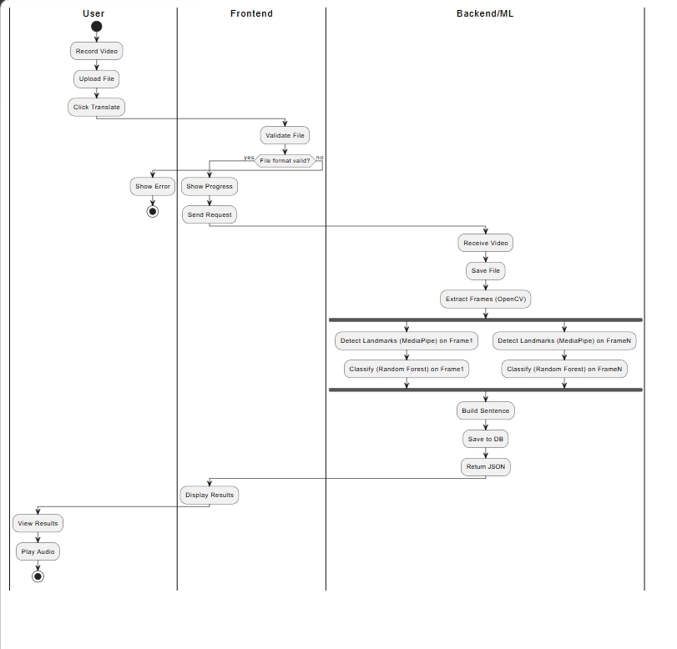
3.7 Class Diagram
The class diagram below illustrates the major entities within the Silent Voices system and their relationships.
Key Classes:
User
- id: int (PK)
- email: str
- hashed_password: str
- full_name: str
- role: Enum (USER, ADMIN)
- created_at: datetime
+ register(), login(), updateProfile(), deactivate()
TranslationSession
- id: int (PK)
- user_id: int (FK → User)
- video_filename: str
- composed_sentence: str
- gesture_tokens: JSON
- confidence_scores: JSON
- created_at: datetime
+ save(), export(format), getHistory()
GestureFeedback
- id: int (PK)
- session_id: int (FK → TranslationSession)
- rating: Enum (THUMBS_UP, THUMBS_DOWN)
- correction: str
- created_at: datetime
+ submit(), getDataset()
MLPipeline
- model_version: str
- confidence_threshold: float
+ extractFrames(video): frames[]
+ detectLandmarks(frame): LandmarkSet
+ classifyGesture(landmarks): (label, confidence)
SentenceBuilder
- tokens: List[str]
- current_sentence: str
+ appendToken(token), backspace(), clear(), compose(): str
Relationships:
• User 1 ——< N TranslationSession (one user has many sessions)
• TranslationSession 1 ——< 1 GestureFeedback (optional feedback per session)
• MLPipeline uses SentenceBuilder (dependency)
• TranslationSession uses MLPipeline (dependency)
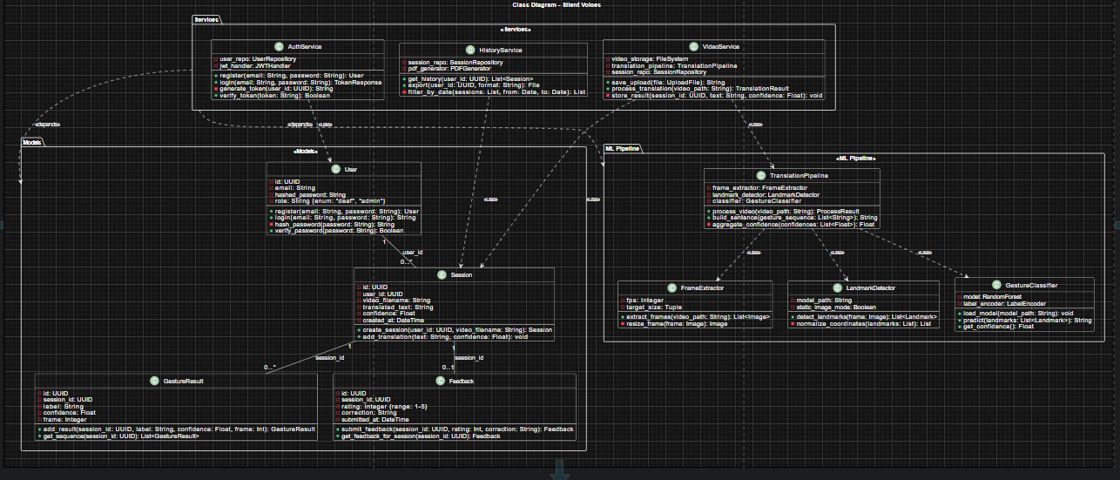

5. Implementation Screenshots
The following screenshots demonstrate the working implementation of Sprint 2 features. Each screenshot is captioned with the feature it illustrates.

Login: 