Silent Voices
AI-Powered ASL to Text Translation System

DELIVERABLE 2 — ITERATION 1 / SPRINT 1
Sprint Backlog · User Stories · Structured Specifications · Scrum Board

Team Member | Roll Number
Irtaza Naqvi | 23l-0608
Faizan Ashfaq | 23L-3091
Muhammad Fakhir | 22L6827
Submission Date: 24-march-2026

Table of Contents
1. Project Introduction 3
2. Sprint Backlog 4
2.1 Module Overview 4
2.2 User Stories 4
3. Structured Specifications 9
4. Scrum Board & Burndown Chart 14
5. NFR Specification 16
6. Implementation Screenshots 18

1. Project Introduction
Silent Voices is a web-based software application designed to bridge the communication gap between the Deaf and hard-of-hearing community and those who do not understand American Sign Language (ASL). The system allows a user to upload a video of themselves performing ASL gestures. The backend then processes that video using a computer vision pipeline — powered by Google's MediaPipe library — to extract hand landmark coordinates frame by frame. These coordinates are passed to a trained machine learning classification model that identifies each gesture and assembles the recognised signs into English text. The final translated text is displayed to the user and can optionally be read aloud using a text-to-speech engine.
The system is being built using Agile Scrum methodology, divided into three two-week sprints. The technology stack consists of Python with FastAPI for the backend REST API, React for the browser-based frontend, PostgreSQL as the relational database, and Scikit-learn with MediaPipe for the machine learning pipeline. Authentication is handled using JWT (JSON Web Tokens), and password security is enforced through bcrypt hashing.

Sprint 1 Overview
Sprint 1 is dedicated entirely to Module M1 — Foundation and Authentication. This sprint delivers the foundational infrastructure that every subsequent sprint will build upon: the database schema, the secure user registration and login system, JWT-based session management, user profile access, and admin role management. At the end of Sprint 1, a user can create an account, log in, receive a JWT token, and access their profile through a protected API endpoint. An admin account can be created with elevated privileges that block access by regular users.

2. Sprint Backlog

2.1 Module Overview
Field | Details
Module Name | M1 — Foundation & Authentication
Sprint Number | Sprint 1 (Iteration 1)
Duration | 2 Weeks
User Stories | US-01, US-02, US-03, US-04
Total Tasks | 16 sub-tasks across 4 user stories
Deliverable | Working authentication system with user and admin roles, database schema, and CI pipeline configured.
Tech Stack (Sprint 1) | FastAPI, SQLAlchemy, PostgreSQL, bcrypt, JWT (python-jose), React, React Router, Axios

2.2 User Stories
The following four user stories have been selected for Sprint 1.

Story ID: US-01 Story Title: User Registration | Priority: High  Estimated Hours: 6
User Story:
As a a new user, I want to create an account by entering my name, email, and password so that I can access the Silent Voices platform and begin using its features.
Description:
This story covers the full user registration flow: a form on the frontend collects the user's details, the backend validates the data, hashes the password securely using bcrypt, and stores the new account in the PostgreSQL database. Duplicate email addresses are rejected with a clear error message.
Sub User Stories:
- As a new user, I want to fill in a registration form with my full name, email address, and password.
- As a new user, I want to receive a clear error message if my email address is already registered.
- As a new user, I want my password to be stored securely so that it cannot be read even if the database is accessed.
- As a new user, I want to be redirected to the login page automatically after successful registration.

Acceptance Criteria:
- The registration form must validate that all fields are filled before submission is allowed.
- The system must reject duplicate email addresses with the message 'An account with this email already exists.'
- Passwords must be hashed using bcrypt before being stored — plain text passwords must never appear in the database.
- Successful registration must return HTTP status code 201 and redirect the user to the login page.
- The registered user must have role='user' assigned by default.

Story ID: US-02 Story Title: Secure Session Handling (JWT Login) | Priority: High  Estimated Hours: 5
User Story:
As a a registered user, I want to log in with my email and password and receive a secure session token so that I can access protected features of the application without logging in again on every page.
Description:
This story implements the JWT-based authentication flow. After the user submits valid credentials, the backend verifies the hashed password, creates a signed JWT token containing the user's ID and role, and returns it to the frontend. The frontend stores this token and attaches it as an Authorization header to every subsequent API request.
Sub User Stories:
- As a registered user, I want to enter my email and password on a login form and receive access to the application.
- As a registered user, I want to receive a JWT token after successful login that proves my identity to the server.
- As a registered user, I want my login session to persist when I refresh the browser page.
- As a registered user, I want my session to expire after 24 hours so that my account remains secure.

Acceptance Criteria:
- Valid credentials must return a JWT token with HTTP status code 200.
- Invalid credentials must return HTTP status code 401 with the message 'Incorrect email or password.'
- The JWT token must include the user's ID, role, and an expiry timestamp.
- The token must be stored in the browser and re-attached to all protected API calls in the Authorization header.
- Expired tokens must be rejected by the backend with a 401 Unauthorized response.

Story ID: US-03 Story Title: User Profile Management ( Left over) | Priority: Medium  Estimated Hours: 4
User Story:
As a a logged-in user, I want to view my profile information through a protected page so that I can confirm my account details and verify that I am correctly authenticated.
Description:
This story covers the protected profile endpoint. Only users who present a valid, non-expired JWT token in their request header can access their profile data. The endpoint returns the user's name, email, and role. This story establishes the pattern used for all future protected routes in Sprint 2 and Sprint 3.
Sub User Stories:
- As a logged-in user, I want to see my full name, email address, and account role displayed on my profile page.
- As a logged-in user, I want to be redirected to the login page if my session has expired.
- As an unauthenticated visitor, I want to be blocked from accessing profile information to protect user privacy.

Acceptance Criteria:
- The GET /auth/profile endpoint must require a valid JWT token in the Authorization header.
- Requests without a token or with an expired token must receive HTTP status code 401.
- The profile response must return the user's full name, email, and role — the password must never be included.
- The React frontend must redirect unauthenticated users to /login when they attempt to access /dashboard.

Story ID: US-04 Story Title: Admin Login & Role Management (Left Over) | Priority: High  Estimated Hours: 5
User Story:
As a an administrator, I want to log in with elevated privileges so that I can manage users and view system statistics so that I can monitor platform usage and maintain the integrity and security of the application.
Description:
This story establishes the admin role within the authentication system. Admin accounts use the same login form as regular users but have role='admin' stored in the database. The backend checks the role claim in the JWT payload on all admin-only endpoints and returns 403 Forbidden for non-admin users. The first admin account is created by manually seeding the database or running a one-time admin creation script.
Sub User Stories:
- As an admin, I want to log in using the same login form as regular users without a separate admin login page.
- As an admin, I want admin-only API endpoints to verify my role before granting access.
- As an admin, I want regular users to receive a 403 Forbidden error when they attempt to access admin endpoints.
- As a developer, I want a seeding mechanism to create the first admin account without going through the registration form.

Acceptance Criteria:
- Admin accounts must have role='admin' stored in the users table in the database.
- The JWT token for an admin must include the role field set to 'admin'.
- Any endpoint decorated with admin protection must return HTTP 403 Forbidden if the token's role is not 'admin'.
- The admin dashboard page in React must not be accessible from the browser navigation by users whose role is 'user'.
- A database seed script or documented manual SQL command must exist to create the first admin account.

3. Structured Specifications
Four structured specifications are provided below — one for each user story selected for Sprint 1.

Structured Specification — UC-01: User Registration
Use Case ID | UC-01
Use Case Name | User Registration
Actor(s) | New User (Unregistered Visitor)
Priority | High
Preconditions | The user has opened the Silent Voices application in a browser and does not already have a registered account.
Trigger | The user navigates to the /register page and clicks the 'Register' button after filling in the form.
Main Flow | 1. The user opens the registration page at /register.  2. The system displays a form with fields: Full Name, Email Address, and Password.  3. The user enters their full name, a valid email address, and a password of at least 6 characters.  4. The user clicks the 'Register' button.  5. The system validates that all fields are non-empty and the email follows a valid format.  6. The system sends a POST request to /auth/register with the form data.  7. The backend checks the database for an existing user with the same email address.  8. No duplicate is found, so the backend hashes the password using bcrypt.  9. The backend creates a new row in the users table with the hashed password and role='user'.  10. The backend returns HTTP 201 with the new user's profile data (excluding password).  11. The frontend redirects the user to the /login page with a success notification.
Alternative Flows | Alt Flow A — Duplicate Email (at Step 7): If a user with the same email already exists, the backend returns HTTP 400 with detail 'An account with this email already exists.' The frontend displays this error below the email field. The user must change their email to proceed.  Alt Flow B — Validation Failure (at Step 5): If any field is empty or the email format is invalid, the frontend displays inline validation messages and does not submit the form to the backend.  Alt Flow C — Server Error (at Step 9): If the database is unavailable, the backend returns HTTP 500. The frontend displays a generic 'Something went wrong, please try again later' message.
Postconditions | A new record exists in the users table. The user's password is stored as a bcrypt hash. The user's role is 'user'. The user is on the /login page.

Structured Specification — UC-02: User Login with JWT Token
Use Case ID | UC-02
Use Case Name | User Login with JWT Token
Actor(s) | Registered User
Priority | High
Preconditions | The user has a registered account in the system. The user is on the /login page and is not currently logged in.
Trigger | The user enters their email and password and clicks the 'Log In' button.
Main Flow | 1. The user opens the login page at /login.  2. The system displays a form with Email and Password fields.  3. The user enters their registered email and password.  4. The user clicks the 'Log In' button.  5. The frontend sends a POST request to /auth/login with the credentials.  6. The backend queries the database for a user matching the submitted email.  7. A matching user is found. The backend runs bcrypt.verify() to compare the submitted password against the stored hash.  8. The password matches. The backend creates a JWT token containing user_id, role, and an expiry time 24 hours from now.  9. The backend returns HTTP 200 with the JWT token: { access_token: '...', token_type: 'bearer' }.  10. The frontend sends a GET request to /auth/profile using the new token to fetch user details.  11. The user profile is received and stored in the React AuthContext global state.  12. The frontend redirects the user to /dashboard.
Alternative Flows | Alt Flow A — Wrong Password (at Step 7): bcrypt.verify() returns False. The backend returns HTTP 401 with detail 'Incorrect email or password.' The frontend displays this error. The form is NOT cleared, allowing the user to correct their entry.  Alt Flow B — Email Not Found (at Step 6): No matching user exists. The backend returns the same HTTP 401 response as Alt Flow A to prevent email enumeration attacks.  Alt Flow C — Expired Token on Revisit: If the user returns after 24 hours, their stored token has expired. The next protected API call returns HTTP 401, and the frontend automatically redirects them to /login.
Postconditions | The user has a valid JWT token stored in localStorage. The AuthContext contains the user's profile data. The user is on the /dashboard page.

Structured Specification — UC-03: View User Profile (Protected Route)
Use Case ID | UC-03
Use Case Name | View User Profile (Protected Route)
Actor(s) | Authenticated User
Priority | Medium
Preconditions | The user is logged in and has a valid, non-expired JWT token stored in the browser.
Trigger | The user navigates to /dashboard or any other page that calls GET /auth/profile.
Main Flow | 1. The user is on the /dashboard page.  2. The React component calls fetchProfile() from authService.js.  3. The service attaches the stored JWT token to the request header: Authorization: Bearer <token>.  4. The frontend sends GET /auth/profile to the backend.  5. The FastAPI backend's get_current_user() dependency extracts the token from the Authorization header.  6. The dependency calls verify_access_token() which decodes the JWT using the server's SECRET_KEY.  7. The token is valid and not expired. The user_id is extracted from the payload.  8. The backend queries the database for the user with that user_id.  9. The user is found. The backend returns HTTP 200 with the user's name, email, and role.  10. The frontend displays the user's name and role on the dashboard.
Alternative Flows | Alt Flow A — Missing Token (at Step 5): The Authorization header is absent. FastAPI's OAuth2PasswordBearer raises HTTP 401 automatically before the endpoint executes.  Alt Flow B — Expired Token (at Step 6): jwt.decode() raises a JWTError due to the exp field being in the past. verify_access_token() returns None. The dependency raises HTTP 401. The frontend detects the 401 and redirects to /login.  Alt Flow C — Tampered Token (at Step 6): The token's signature does not match the server's SECRET_KEY. JWTError is raised, and HTTP 401 is returned.
Postconditions | The user's profile information is displayed on the dashboard. If the token was invalid, the user is on the /login page.

Structured Specification — UC-04: Admin Access Control
Use Case ID | UC-04
Use Case Name | Admin Access Control
Actor(s) | Administrator / Regular User
Priority | High
Preconditions | Both an admin account (role='admin') and a regular user account (role='user') exist in the database.
Trigger | A user attempts to access an admin-only API endpoint (e.g., GET /admin/users).
Main Flow | 1. An admin user is logged in with a valid JWT token whose role claim is 'admin'.  2. The admin navigates to /admin or calls an admin-only endpoint.  3. The frontend attaches the admin's JWT token to the Authorization header.  4. The backend receives the request at an admin-protected endpoint.  5. The get_current_user() dependency decodes the token and retrieves the user object.  6. An additional admin_required() dependency checks if user.role == 'admin'.  7. The role is 'admin', so the check passes.  8. The backend processes the request and returns the requested admin data with HTTP 200.
Alternative Flows | Alt Flow A — Regular User Attempts Admin Access (at Step 6): The user's token has role='user'. The admin_required() dependency raises HTTP 403 Forbidden with detail 'Access denied: admin privileges required.' The endpoint does not execute.  Alt Flow B — Frontend Guard: The React ProtectedAdminRoute component checks the role stored in AuthContext. If role is not 'admin', it redirects to /dashboard without making an API call at all.  Alt Flow C — No Token: The request has no Authorization header. HTTP 401 is returned before the role check is even reached.
Exception Flows | If the admin account is deleted from the database while the admin is still logged in, the get_current_user() dependency will fail to find the user at Step 5 and return HTTP 401.
Postconditions | If the actor is an admin, the requested data is returned. If the actor is a regular user, they receive HTTP 403 and are blocked from the admin interface.

4. Scrum Board & Burndown Chart
The project Scrum Board is maintained on Trello. The board is divided into five columns: Product Backlog, Sprint Backlog, In Progress, Testing/Review, and Done. A sixth column labelled 'Sprint 1 Leftover' is used in Snapshot 3 to record any tasks that were planned but not completed within the sprint duration.

4.1 Snapshot 1 — Sprint Start (All Stories in Sprint Backlog)
.

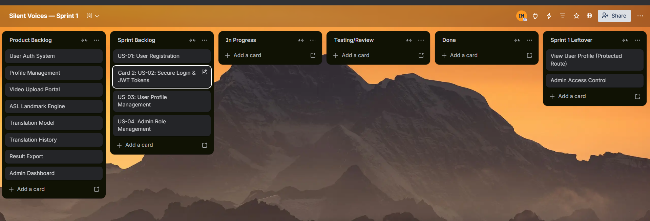

4.2 Snapshot 2 — Mid Sprint (Approximately 50% Complete)

Taken at approximately the halfway point of the sprint
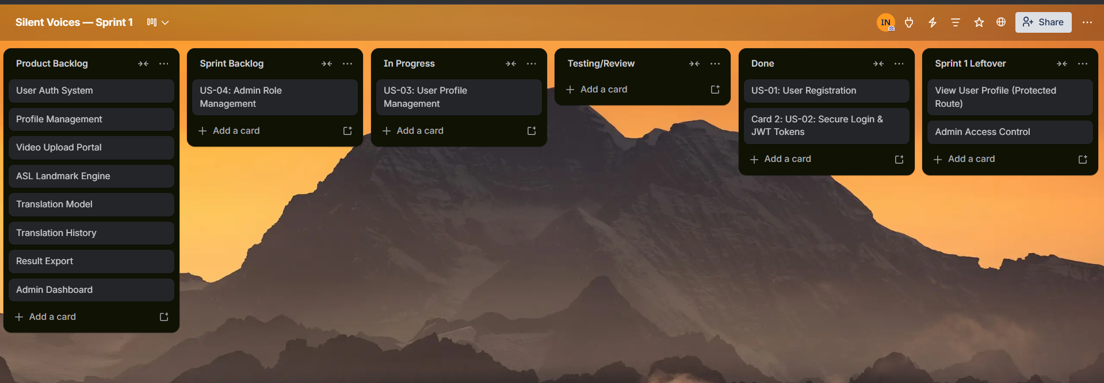

4.3 Snapshot 3 — Sprint End
Taken on the final day of Sprint 1
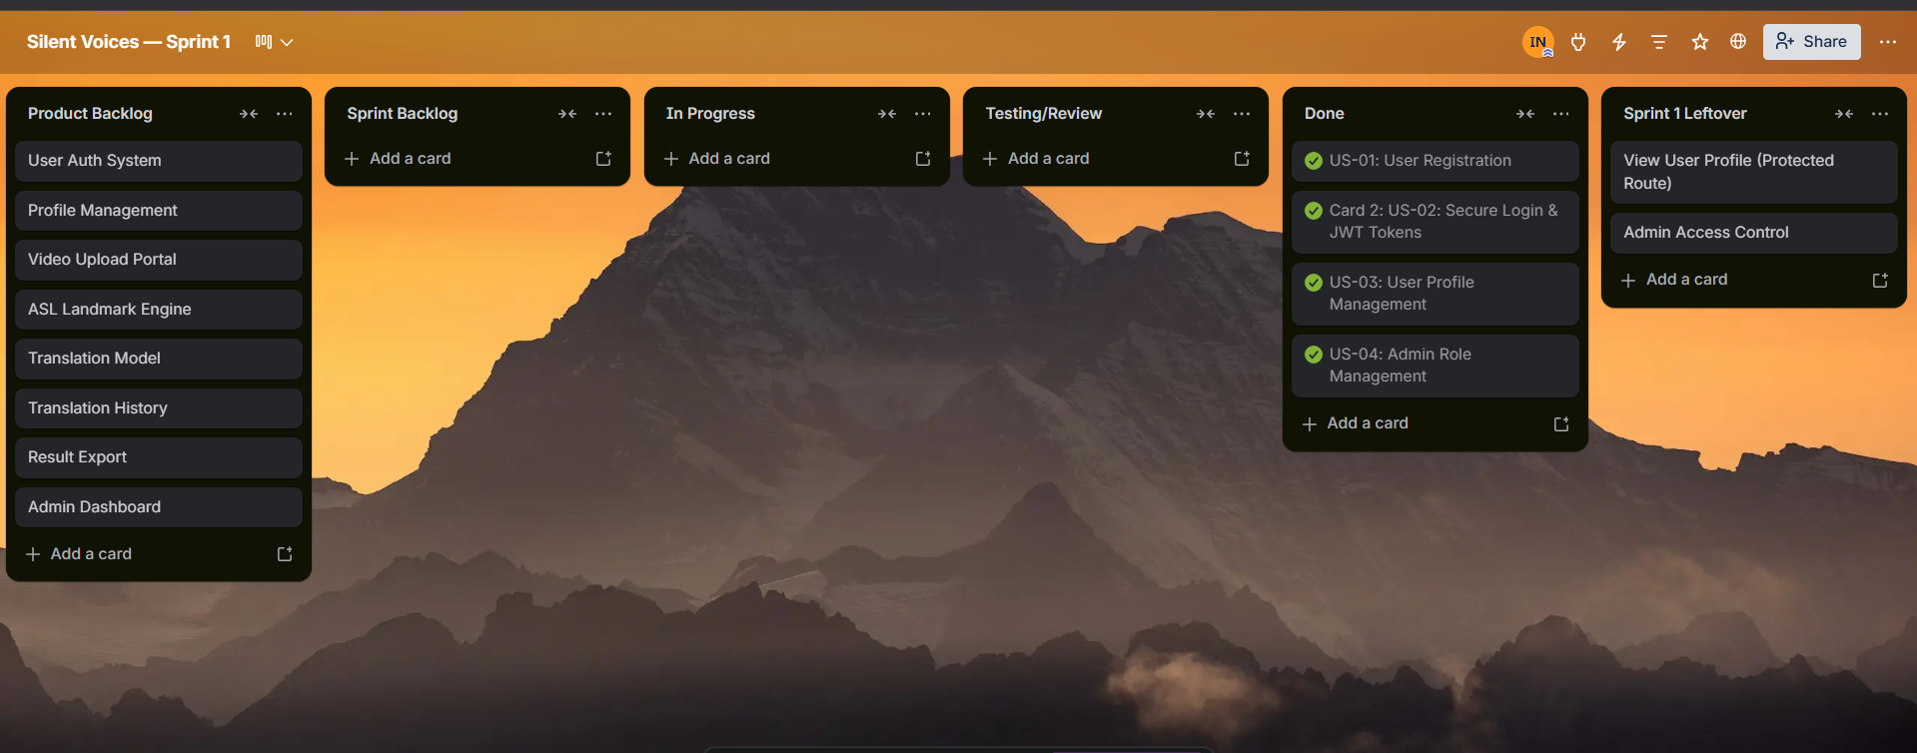

4.4 Sprint 1 Burndown Chart
The burndown chart below tracks the planned versus actual task completion across the 14-day Sprint 1..

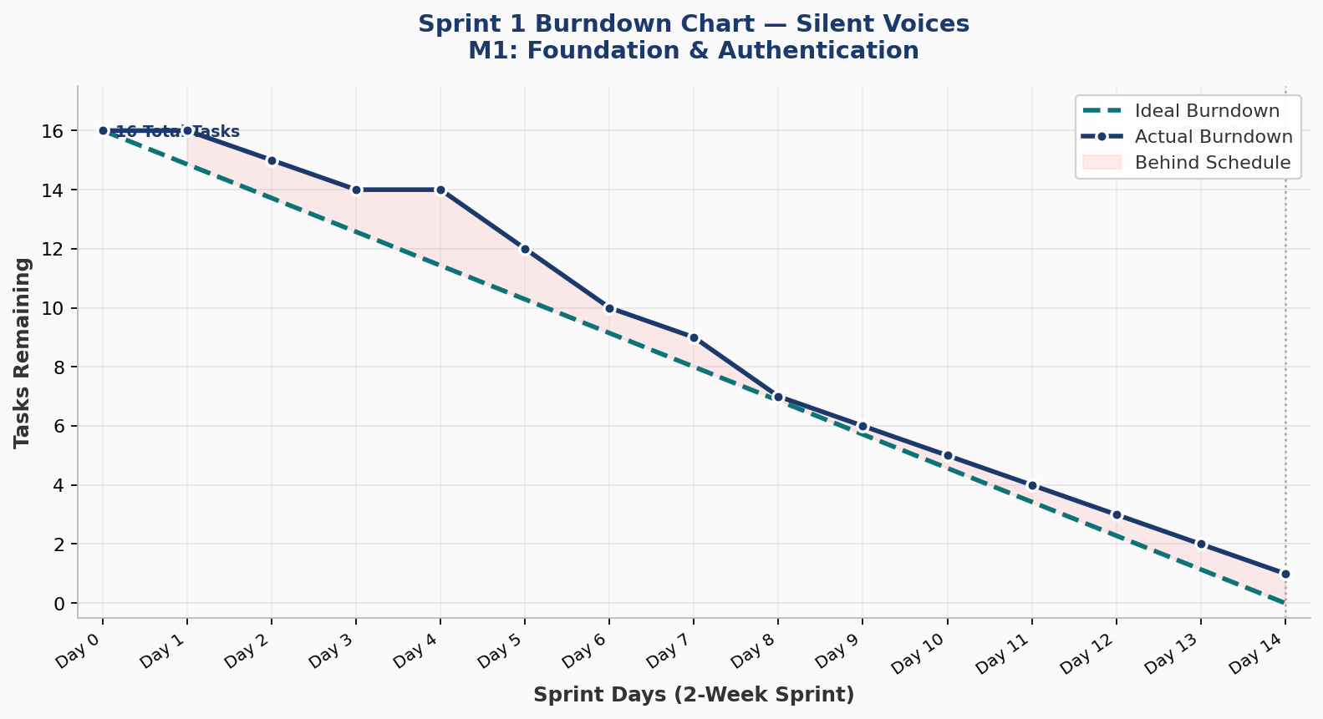

5. NFR Specification — Natural Language
Non-Functional Requirements (NFRs). Each requirement is assigned an identifier for traceability.

ID | Category | NFR Description
NFR-01 | Security — Passwords | All user passwords must be hashed using the bcrypt algorithm with a minimum cost factor of 12 before being stored in the database. Plain-text passwords must never appear in database records, server logs, API responses, or version control history under any circumstances.
NFR-02 | Security — Tokens | JWT tokens must use the HS256 signing algorithm and must expire after 1440 minutes (24 hours). The server's SECRET_KEY used to sign tokens must be a minimum of 32 characters, stored only in the .env file, and never committed to version control.
NFR-03 | Security — Secrets | The .env file containing database credentials and the JWT secret key must be excluded from the Git repository via the .gitignore file. A .env.example file with placeholder values must be committed in its place. No API keys, passwords, or tokens should appear in any committed file.
NFR-04 | Compatibility | The web application must function correctly on the latest stable versions of Google Chrome, Mozilla Firefox, and Microsoft Edge. The minimum supported screen resolution is 1280×720 pixels. The application does not need to support Internet Explorer.
NFR-05 | Usability | All form validation errors (e.g., duplicate email, empty field, incorrect password) must be displayed in human-readable language within 1 second of the submission attempt. Error messages must be specific enough to tell the user what action to take without exposing internal system information.
NFR-06 | Maintainability | The backend codebase must follow a modular structure with separate files for routes (routers/), database models (models/), data schemas (schemas/), and utility functions (utils/). No single Python file should exceed 200 lines of code. All functions must have a docstring explaining their purpose.
NFR-07 | API Standards | All API endpoints must return JSON responses with appropriate HTTP status codes: 200 for success, 201 for resource creation, 400 for bad client requests, 401 for unauthenticated access, 403 for insufficient permissions, and 500 for server errors. Error responses must include a 'detail' field with a descriptive message.

6. Iteration 1 — Implementation Screenshots
The following screenshots demonstrate the working Sprint 1 implementation. Each screenshot is taken from the running application and is accompanied by a caption explaining what is shown. Before submitting, replace each placeholder below with the actual screenshot from your running application.

6.1 Backend Running (Terminal)

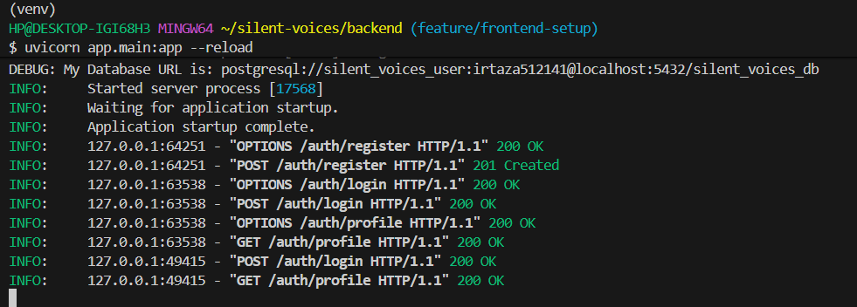

6.2 Frontend Running (Terminal)
Show the /docs page (Swagger UI) at http://localhost:8000/docs displaying the three authentication endpoints: POST /auth/register, POST /auth/login, and GET /auth/profile.

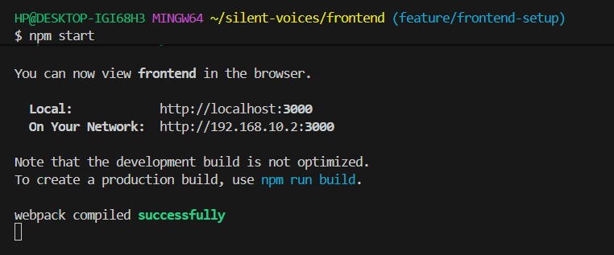

6.3 User Registration Page

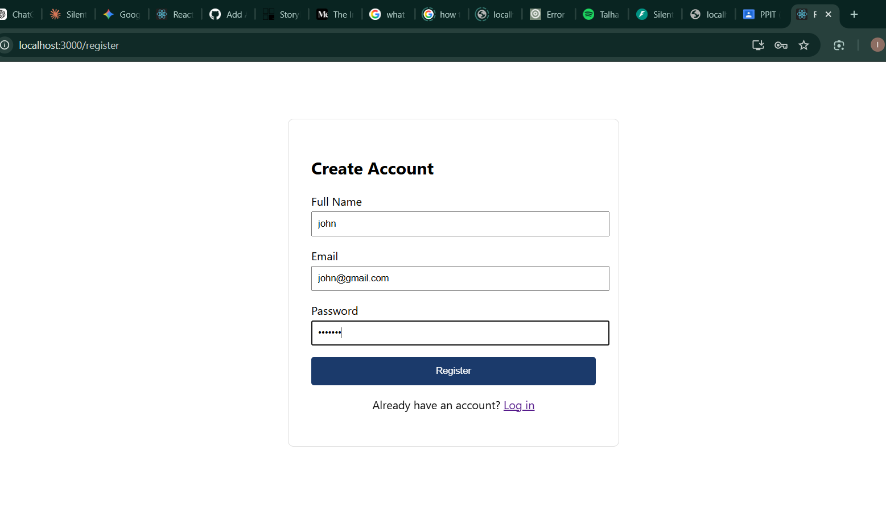

6.4 Login Page
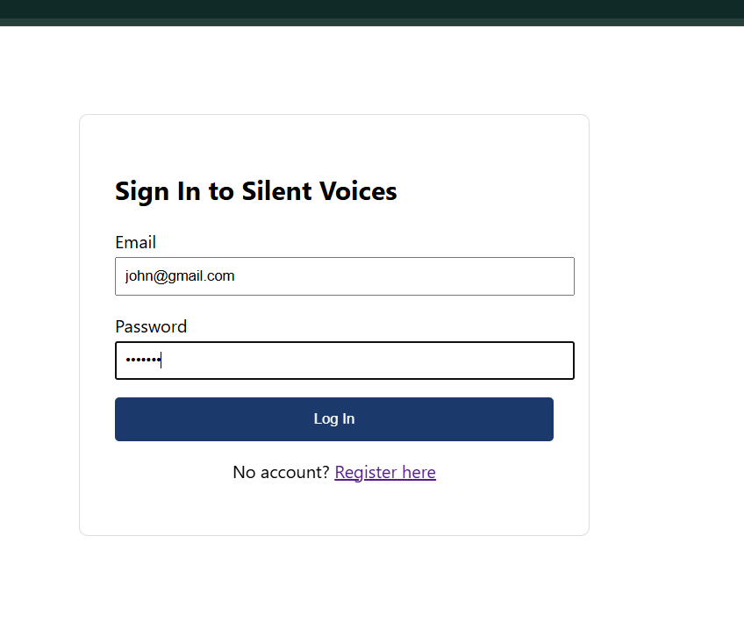

6.5 Dashboard After Login
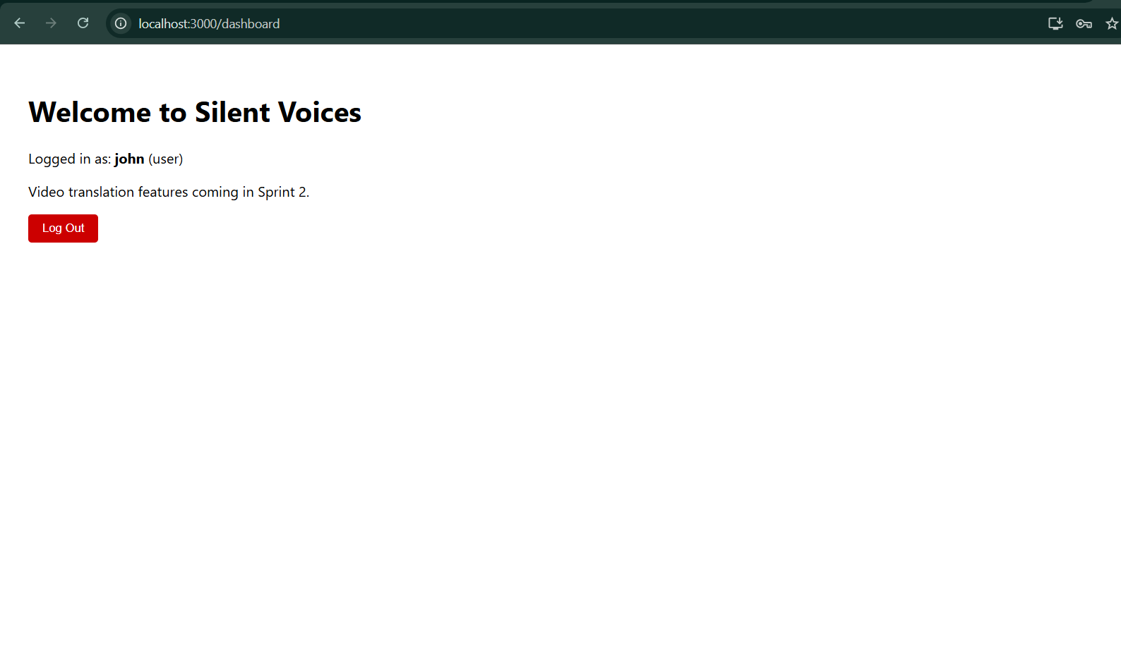

6.9 GitHub Repository
