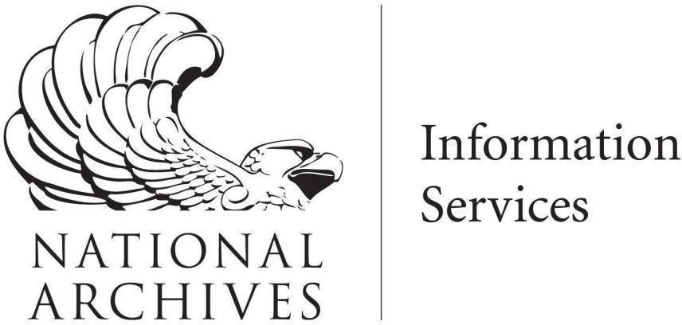

National Archives and Records Administration (NARA)

Information Services (I)

Quality Assurance Division (IQ)

Software Version Control and Promotion of Code to Various Environments

Configuration Management (CM) Standard Operating Procedures (SOP)

|  |  |
| --- | --- |
| **Document Name** | Software Version Control and Promotion of Code to Various Environments Configuration Management (CM) Standard Operating Procedures (SOP) |
| **Version** | 1.1c |
| **Revision Date** | 10/08/24 |
| **Status** | Draft |
| **Contract** | N/A |

Document Control

**Division Name:** Quality Assurance Division (IQ)

**Division Director:** Sherli Nambiar

**Division Sponsor:** Nicole Willis

________________________________________________ ___________

Sherli Nambiar, Director of Quality Assurance Division (IQ) Approval Date

________________________________________________ ___________

Nicole Willis, Deputy Chief Information Officer (DCIO) Approval Date

Document Revision History

|  |  |  |  |
| --- | --- | --- | --- |
| **Version Number** | **Implemented By** | **Revision Date** | **Revision Description** |
| 1.0 | Seema Dheman | 12/04/2023 | Final release |
| 1.1 | CM Team | 7/25/2024 | Final |
| 1.1a | CM Team | 10/07/24 | Update to the process |
| 1.1b | CM Team | 10/07/24 | Incorporate Sherli’s comments |
| 1.1c | CM Team | 10/08/24 | Incorporated Sherli’s comments |

Contents

1. Introduction 5

2. Background 5

3. Scope 5

4. Procedures 5

# 1. Introduction

Software Configuration Management is a formal engineering discipline that provides the methods and tools to identify and control the software throughout its development and use. The Information Services (I) Quality Assurance Division (IQ) within the National Archives and Records Administration (NARA) is responsible for this task.

# 2. Background

To maintain operational integrity and ensure the robustness of our systems, NARA collaborates with various software development contractors for the development of its applications and systems. It is imperative to ensure that the codebase provided by these contractors is comprehensive and that the developed applications, systems, and databases can be fully restored from NARA’s Configuration Management (CM) Repository backups during a Continuity of Operations (COOP) or Disaster Recovery (DR) event. Additionally, the CM Team will ensure that only authorized code is deployed to the production environment, safeguarding the system’s security and stability.

# 3. Scope

The procedures mentioned in this document will be applicable to all NARA application development teams for in-house development and to development contractors upon notification from the Contracting Officer’s Representative (COR) for each development contract.

# 4. Procedures

|  |  |  |
| --- | --- | --- |
| **Steps** | **Activity Description** | **Responsibility** |

Test