

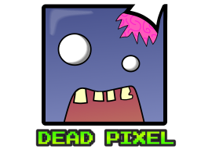

Support : volkov40@hotmail.com

Table of Contents

Level Manager2

Score Type 4

Creating a World6

Unlocking Next Chapter Type A9

Unlocking Next Chapter Type B10

**Level Manager**

*(Look at page 3 for all details on this picture)*

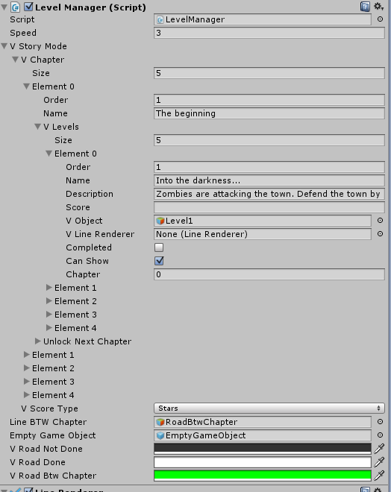

**Speed** : Mouse speed when moving on the map

**VStoryMode :**  In this StoryMode, there are Chapters and each chapter has Levels. You can define as many chapters you want in the Story. We will explain later how the chapters and levels work in-game.

**VChapter** : You define how many chapter you want with the Size. Make sure that the variable Order begin with 1 and increase by 1. So, if you put 5 in the size, it mean you have 5 chapters, then in the Order variable, put 1 to 5.

**VLevels** : Then, you have Level. You have to do the same thing as the chapters.

In a level you got these :

* **Name** : Here you define the name of the level. Can leave blank if you don’t have any.
* **Description** : You can put some storie on the level here.
* **Completed** : If the game start and it is Completed, it will show a score and the next level will be selectable.
* **Score** : Here you can define your score. We will see later how to use this field.
* **Other** : All the other are only used for the score in-game.

We will explain the other variables in the next page.

**Score Type**

In the Level Manager, you have VScoreType which handle all the Score.

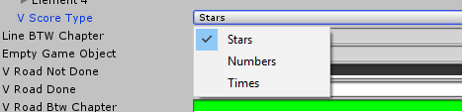

You have Stars, Numbers & Times.

Each of them are handled differently.

**Stars** :

When you click on a level, you see this. How it look in-game.

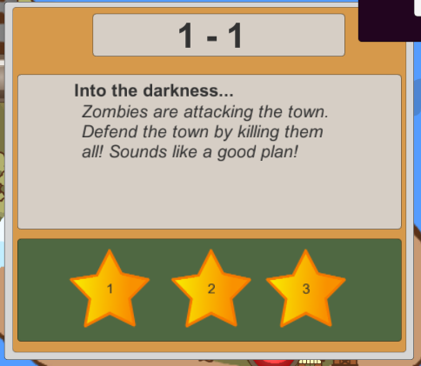

**Numbers** :

When you click on a level, you see this. How it look in-game.

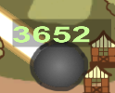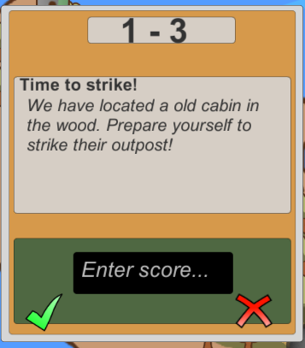

**Time** :

When you click on a level, you see this. How it look in-game.

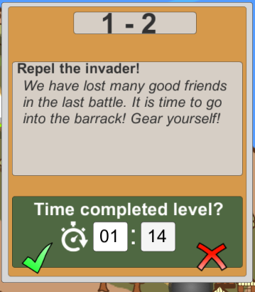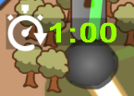

**Creating a World**

Drag & Drop this prefab in your scene from : Assets->2DLevelS->Fabrik->LevelManager.prefab

It should add something like this. 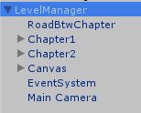

In the LevelManager, you can handle all your chapters and levels.

When you start with the prefab, you have 2 Chapter. You can remove Chapter2 or add Chapter3 as you like.

If you start already the scene, you will have this right now.

As you can see, they are all linked together. Red mean you have to do this level to go forward.

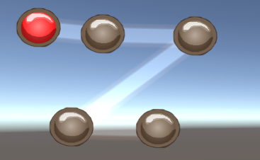

Doing all 5 levels should unlock the Chapter2!

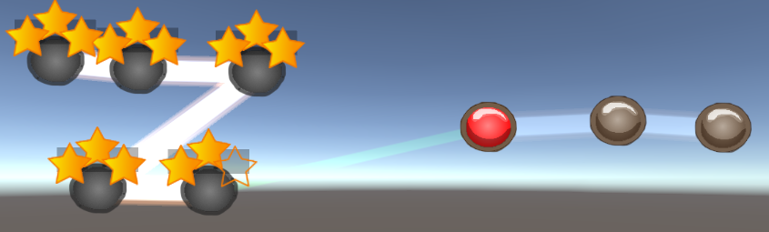

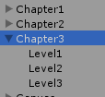Let’s add Chapter 3!

Copy & paste chapter 2 and rename the new one for Chapter3.

You can do the same with the level.

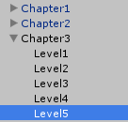

Add 2x more level. Copy & Paste Level 3 2x time.

You should have this right now.

All your Chapter3 objet in your scene are all above the chapter2 right now, because you copied it. Try to move them away like this.

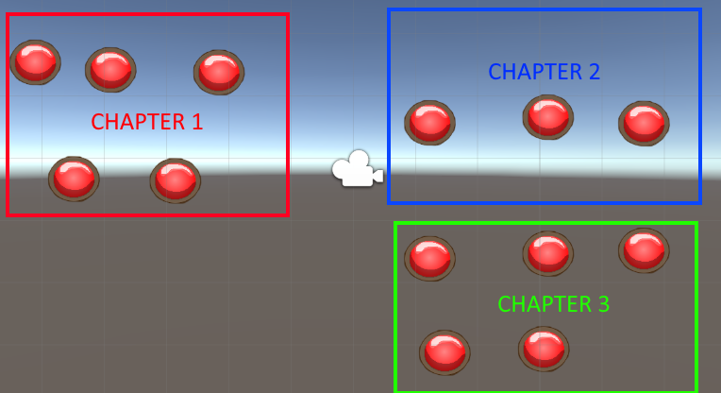

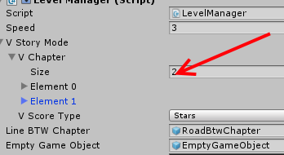We are almost there!

Now, select LevelManager object and in the inspector to the right, we now have to create the Chapter3 here :

Change the 2 for a 3. It will create Element2!

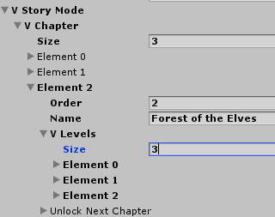

Here, let’s change the Order for 3 because it is your Chapter 3 and change the vLevels Size for 5 for your 5 levels.

You have to link all the new Levels object on each VLevels Element. Now your level are all linked correctly. 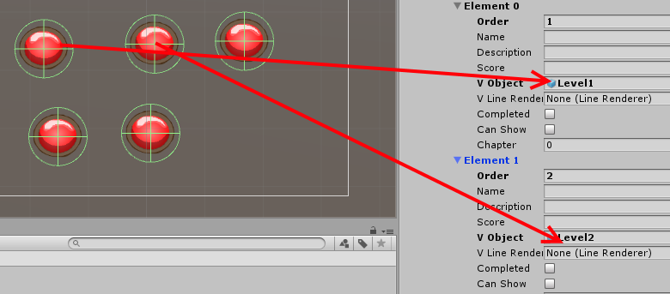

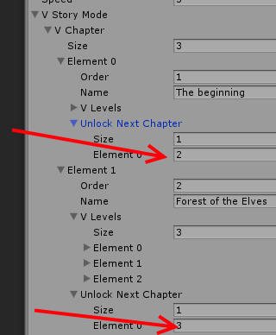**Unlocking next Chapter : Type A**

If you want to make a game where your complete a chapter it unlock always the next one (Chapter1->Chapter2->Chapter3… and so on) Try Option 1.

Go on Chapter 1 and Chapter2 and locate UnlockNextChapter, put 1 on the Size to get a Element. Then, here put the Chapter you want to unlock. Chapter1 Unlock Chapter2 and so on.

You should have something like this.

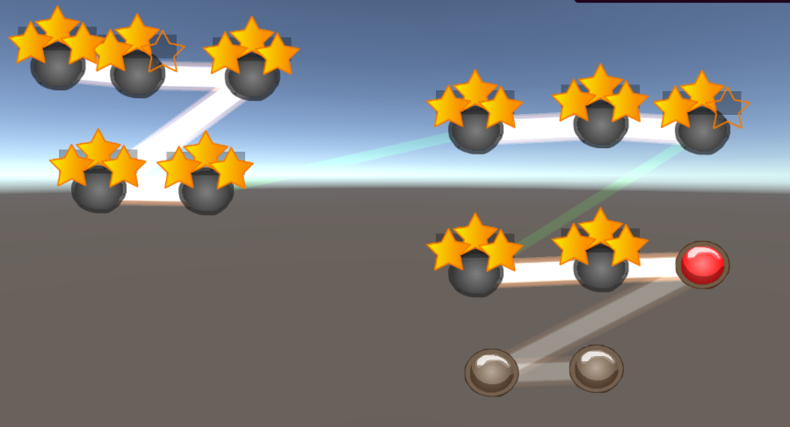

**Unlocking next Chapter : Type B**

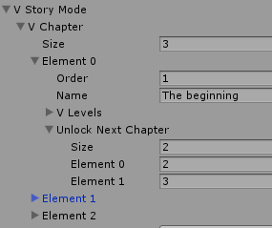If you want to make something complicated like this

(Chapter1->Chapter2 & Chapter3, Chapter2->Chapter4 & Chapter 5 & Chapter6, Chapter3 -> nothing) Try Option 2.

Go on Chapter 1 and locate UnlockNextChapter, put 2 on the Size to get 2x Elements.

Put 2 and 3. So, when you will complete Chapter 1, it will unlock both chapter. The idea behind this is to be able to explore a map without knowing where to go. You can decide to unlock a path until you get in a dead end then you have to go on another way. There is no limit!

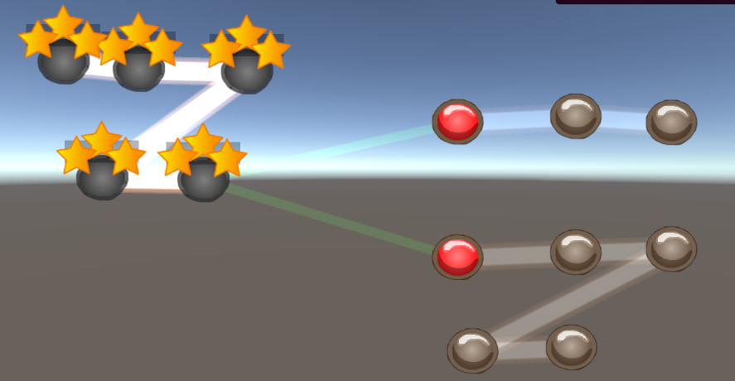It should look like this.