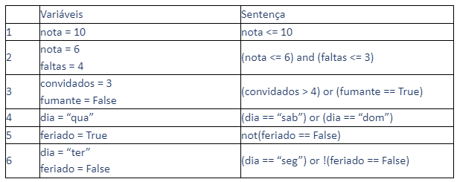

1: V | 2: F | 3: F | 4: F | 5: V | 6: F