TradeSmart India: Trading Platform Features

This Simplifying stock trading with low fees, AI insights, real-time data, secure transactions, and beginner-friendly tools.

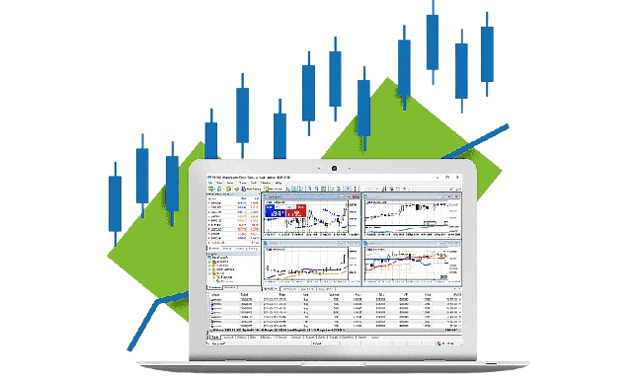

# 1. Secure User Registration and Login

Feature:   
- Registration through an invite code to ensure a trusted user base.  
- Secure login with email/phone and password.  
- Two-Factor Authentication (2FA) for added security.  
Description:  
Provides a safe and seamless onboarding process, protecting user data and maintaining platform integrity.

# 2. Real-Time Market Data

Feature:   
- Live updates on stock prices, indices, and market trends.  
- Comprehensive data for NSE and BSE markets.  
Description:  
Empower users with accurate, up-to-the-second market insights for informed decision-making.

# 3. Advanced Charting Tools

Feature:   
- Customizable charts with technical indicators (e.g., RSI, Bollinger Bands).  
- AI-driven insights and predictive analytics.  
Description:  
Enable professional and retail traders to analyze market movements effectively.

# 4. Portfolio Management

Feature:   
- View, track, and manage investments in one place.  
- Analyze portfolio performance with historical data and insights.  
Description:  
Helps users optimize their investment strategies effortlessly.

# 5. Social Trading Community

Feature:   
- Follow top traders, view their portfolios, and learn from their strategies.  
- Share tips and strategies with the trading community.  
Description:  
Foster a collaborative environment where users can learn and grow together.

# 6. Low Brokerage Fees

Feature:   
- Zero or minimal brokerage plans tailored for different trading needs.  
- Transparent pricing with no hidden charges.  
Description:  
Make trading affordable and accessible to all users.

# 7. UPI and Payment Integration

Feature:   
- Seamless fund deposits and withdrawals via UPI, NEFT, and other Indian payment methods.  
Description:  
Simplify the financial process for users with instant and secure transactions.

Description:  
Accommodates India’s diverse population, making trading more inclusive.

# 8. Advanced Order Types

Feature:   
- Support for market orders, limit orders, stop-loss, and bracket orders.  
- Automated trading options.  
Description:  
Provide flexibility and precision for users to execute their trades effectively.

# 9. Notifications and Alerts

Feature:   
- Customizable price alerts and market notifications.  
Description:  
Keep users updated with critical market movements and personal trade alerts.

# 10. Security Features

Feature:   
- End-to-end encryption for user data and transactions.  
- Regular security audits to protect against vulnerabilities.  
Description:  
Build trust with bank-level security measures.

# 11. Customer Support

Feature:   
- 24/7 support through chat, email, and phone.  
- A comprehensive FAQ and help center.  
Description:  
Ensure users get assistance anytime they need it.

# 12. Analytics Dashboard

Feature:   
- A user-friendly dashboard with trade analytics, profit/loss summaries, and market insights.

# 13. API (3rd party API PLATFORM )

-

Description:  
Empower users to make data-driven decisions.