Ex. No.: 4

**SELECT with various clause – WHERE, pattern matching**

**Output:**

**1.**

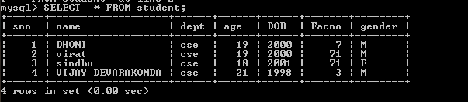

2.

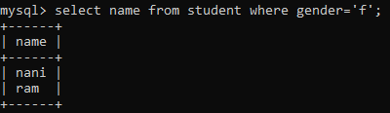

3.

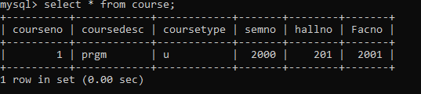

4.



5.

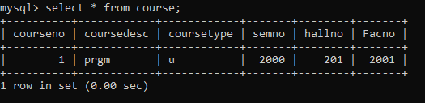

6.



7.

Ex. No.: 4

**SELECT with various clause – WHERE, pattern matching**

**Output:**

**1.**



2.



3.



4.



5.



6.



7.

Ex. No.: 4

**SELECT with various clause – WHERE, pattern matching**

**Output:**

**1.**



2.



3.



4.



5.



6.

1. 