Ex. No.: 5

**SELECT with various clause – BETWEEN, IN, Aggregate function**

Output:

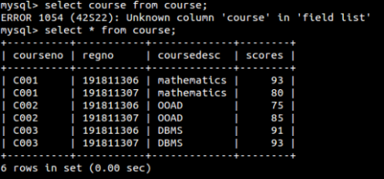

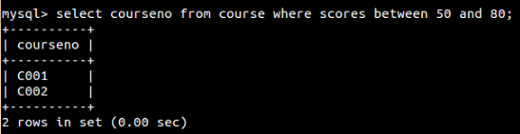

1.

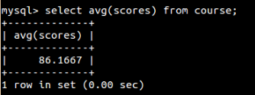

2.

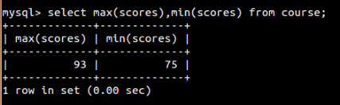

3.

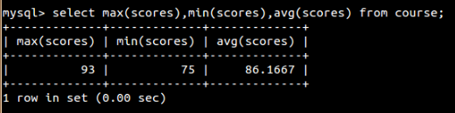

4.

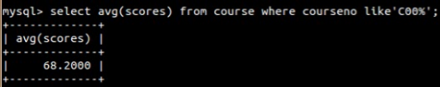

5.

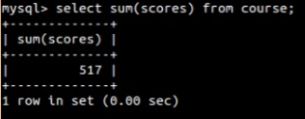

6.



7.

