Ex. No.: 6

**SELECT with various clause – GROUP BY, HAVING,**

**ORDER BY**

Output:

1.



2.



3.

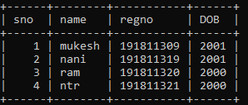

4.

