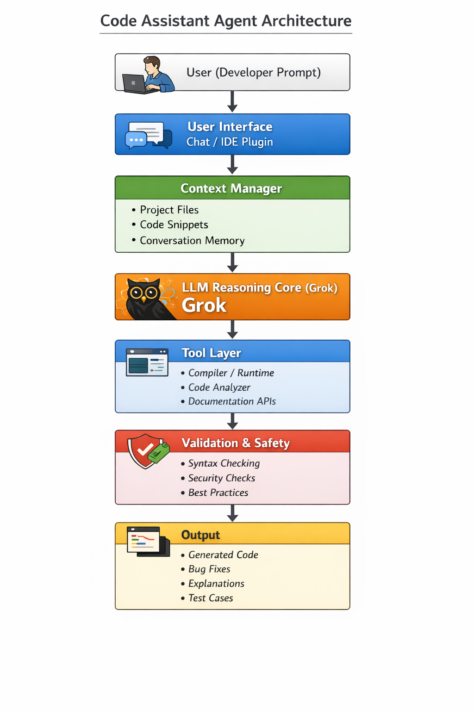
- User Interaction
The developer sends a coding request through a chat interface or IDE plugin.
- Context Manager
Collects project files, code snippets, and conversation history to understand the task.
- LLM Reasoning Core (Grok)
The AI model processes the prompt and context to generate or analyze code.
- Tool Layer
Uses tools like compilers, code analyzers, and documentation APIs to assist the AI.
- Validation & Output
The system checks syntax, security, and best practices, then provides generated code, bug fixes, explanations, or test cases.

