CPE 334 Introduction to Software Engineering in the Age of AI Agents
Lab 2: TokTickIT Requester Ticketing MVP with UI Foundation — Sprint Report
Item | Student & Project Information
Student Name | Nara Kosiyaporn
Student ID | 67070505218
Semester | 1/2026
GitHub Repository | https://github.com/narakosi-dev/toktickit
Final Release PR | https://github.com/narakosi-dev/toktickit/pull/22
Peer Reviewers | Pongrit (Frame) (@FramePongrit), @Leviathan-c137
Primary Requester (A) | Nara Kosiyaporn (nara.kosi@kmutt.ac.th)
Secondary Requester (B) | Sunny farmhouse (nara2012sun@gmail.com)

Answer Part 1: Git Use with Engineering Workflow (10 Points)
The repository strictly follows the course engineering workflow: features are developed on dedicated feature branches, reviewed and approved via Pull Requests, integrated into lab2-staging, and released into main via a final Release Pull Request.

1.1 Git Commit History & Branching Workflow
Commit history graph from the final main branch demonstrating feature branches merging into staging and then into main:
* b793168 Merge pull request #22 from narakosi-dev/lab2-staging
|\
| * 187d516 Merge pull request #21 from narakosi-dev/feature/lab2-e2e-and-docs
| |\
| | * 443c9fd docs(lab2): adjust reviewer list to FramePongrit and Leviathan-c137
| | * 6ea9b92 docs(lab2): update reviewer.md with peer review team members
| | * f30ab16 feat(lab2): implement playwright e2e tests, multi-viewport validation, and documentation (Issue 6)
| |/
| * 1f763af Merge pull request #19 from narakosi-dev/feature/lab2-ticket-detail-and-attachments
| |\
| | * 2cb1352 feat(lab2): implement ticket detail & attachments lifecycle with soft-removal (Issue 5)
| |/
| * 7f846d7 Merge pull request #17 from narakosi-dev/feature/lab2-my-tickets
| |\
| | * 606217e feat: implement my tickets view, ownership isolation, filtering, and tests
| |/
| * 722ff04 Merge pull request #14 from narakosi-dev/feature/lab2-ticket-creation
| |\
| | * 2a5246c feat: implement ticket creation flow, validation, and automated tests
| * | 08b6279 Merge pull request #12 from narakosi-dev/feature/lab2-requester-context
| |\|
| | * 72a7627 feat: implement development requester context, database foundation, and tests
| |/
| * 0bb81ab Merge pull request #10 from narakosi-dev/docs/lab2-specification
|/|
| * 018ac03 docs(lab-02): complete specification, ui-spec, api-spec, and test plan
|/
* 07039ff Merge pull request #9 from narakosi-dev/lab1-staging

1.2 GitHub Projects (Kanban Board) Evidence
All 6 Sprint Issues were systematically tracked across Kanban states (Backlog -> Specified -> Started -> PR Review -> Done):
• Issue 1: Spec-Driven Development & Test Plan (docs/lab-02/) — Done
• Issue 2: Development Requester Context & Seed Foundation — Done
• Issue 3: Ticket Creation Flow & Unique Number Generation — Done
• Issue 4: My Tickets View, Search, Filtering & Ownership Isolation — Done
• Issue 5: Ticket Detail View & Attachments Soft-Removal — Done
• Issue 6: Playwright E2E User Journeys, Multi-Viewport Validation & Documentation — Done

1.3 Rendered Peer Review Record (docs/lab-02/reviewer.md)
Author: Nara Kosiyaporn — Student ID: 67070505218 (@narakosi-dev)
Peer Reviewers: Pongrit (Frame) (@FramePongrit), @Leviathan-c137
PR # | Branch | Target | Scope & Features | Reviewers | Verdict
#10 | feature/lab2-spec-docs | lab2-staging | Issue 1: Spec DD (specification.md, ui-spec, api-spec, tests.md) | @FramePongrit | Approved
#12 | feature/lab2-requester-context | lab2-staging | Issue 2: Dev Requester Context, Prisma Seed, RequesterSelect | @Leviathan-c137 | Approved
#14 | feature/lab2-ticket-creation | lab2-staging | Issue 3: POST /api/tickets, unique TKT number, CreateTicket.tsx | @FramePongrit | Approved
#17 | feature/lab2-my-tickets | lab2-staging | Issue 4: My Tickets, Ownership Isolation, Search, Filters, Sorting | @Leviathan-c137 | Approved
#19 | feature/lab2-ticket-detail | lab2-staging | Issue 5: Ticket Detail, Multer Upload, Soft-Removal, 410 Gone | @FramePongrit | Approved
#21 | feature/lab2-e2e-and-docs | lab2-staging | Issue 6: Playwright E2E suite, Multi-Viewport, reviewer.md, ai_use.md | @Leviathan-c137 | Approved
#22 | lab2-staging | main | Release PR: Merging all 6 sprint increments into main | @FramePongrit | Approved

1.4 Directory Structure of Repository
toktickit/
├── .gitignore
├── docker-compose.yml
├── package.json
├── playwright.config.ts
├── README.md
├── artifacts/
│ └── lab-02/
│ └── screenshots/
│ ├── create-ticket/
│ ├── my-tickets/
│ ├── ticket-detail/
│ └── responsive/
├── client/
│ ├── src/
│ │ ├── components/
│ │ │ ├── AppShell.tsx
│ │ │ ├── CreateTicket.tsx
│ │ │ ├── MyTickets.tsx
│ │ │ ├── RequesterSelect.tsx
│ │ │ └── TicketDetail.tsx
│ │ ├── context/RequesterContext.tsx
│ │ ├── api.ts
│ │ ├── App.tsx
│ │ ├── main.tsx
│ │ └── zen-green.css
│ └── tests/
├── docs/
│ ├── lab-01/
│ └── lab-02/
│ ├── ai_use.md
│ ├── api-spec.md
│ ├── report-answers.md
│ ├── reviewer.md
│ ├── specification.md
│ ├── tests.md
│ └── ui-spec.md
├── e2e/
│ └── lab-02/
│ ├── capture-all-evidence.spec.ts
│ └── requester-ticket-flow.spec.ts
└── server/
├── prisma/
│ ├── migrations/
│ ├── schema.prisma
│ └── seed.ts
├── src/
│ ├── app.ts
│ └── index.ts
├── uploads/
└── tests/

1.5 Repository .gitignore Evidence
# dependencies
node_modules/
# env & secrets
.env
*.env
!.env.example
# build output
dist/
build/
# prisma
server/prisma/*.db
# logs & OS
*.log
# uploads
server/uploads/*
!server/uploads/.gitkeep
# test artifacts
test-results/
playwright-report/

Answer Part 2: Spec DD (5 Points)
Specification Link: https://github.com/narakosi-dev/toktickit/blob/main/docs/lab-02/specification.md
Proof of Prior Creation: Created and merged in PR #10 (Commit 018ac03) before feature implementation branches were created.

2.1 Numbered Functional Requirements (FR)
• FR-01: Development Requester Selection from active database seeded users.
• FR-02 & FR-03: Header identity persistence; dynamic requester switching with instant data isolation.
• FR-04 & FR-05: Create ticket form with Category, System, Priority, Summary, Description, and system-generated unique TKT-YYYY-NNNNNN with initial status New.
• FR-06: Form resilience against backend failures; preserves entered values without data loss.
• FR-07 to FR-09: My Tickets filtered strictly by requesterId, keyword search, filters, sorting, and pagination.
• FR-10: Read-only Ticket Detail view.
• FR-11 to FR-13: Attachment upload (JPG, PNG, WEBP, PDF up to 5MB, max 5 active), active file download, and soft-removal with mandatory reason and 410 Gone download protection.
• FR-14: Cross-requester access rejection (HTTP 404/403) preventing resource enumeration.

2.2 Mandatory Business Rules (BR)
• BR-01: Unique official Ticket Number format TKT-YYYY-XXXXXX generated by backend.
• BR-02: Initial Status begins as New.
• BR-03 & BR-04: Dev Requester Context is a testing harness; inactive requesters (active: false) are excluded from selection.
• BR-05: Strict ownership isolation; queries and endpoints verify requester ownership.
• BR-06 & BR-07: Max 5 active attachments per ticket; soft-removal records active: false, timestamp, and audit reason while preserving file on disk.
• BR-08: Field lengths: Summary (5–120 chars), Description (10–2000 chars), Removal Reason (5–500 chars).

Answer Part 3: Test DD and Traceability (10 Points)
Test Plan Link: https://github.com/narakosi-dev/toktickit/blob/main/docs/lab-02/tests.md

3.1 Test Traceability Matrix
Test ID | Type | AC Target | Scope | Automated Test File Path | Status
API-01 | API | AC-04, BR-01 | Ticket creation & unique number generation | server/tests/lab-02/create-ticket.test.ts | Pass
API-02 | API | AC-04, BR-08 | Validation boundaries (summary & description) | server/tests/lab-02/create-ticket.test.ts | Pass
API-03 | API | AC-03, BR-05 | My Tickets ownership isolation (requesterId) | server/tests/lab-02/my-tickets.test.ts | Pass
API-04 | API | AC-07, BR-08 | My Tickets search, filters, sorting & pagination | server/tests/lab-02/my-tickets.test.ts | Pass
API-05 | API | AC-08, BR-05 | Ticket Detail ownership & 404 on unowned ticket | server/tests/lab-02/ticket-detail.test.ts | Pass
API-06 | API | AC-09, BR-06 | Attachment upload (types, 5MB limit, max 5) | server/tests/lab-02/attachments.test.ts | Pass
API-07 | API | AC-10, BR-07 | Soft-removal audit reason & 410 Gone download | server/tests/lab-02/attachments.test.ts | Pass
UI-01 | UI | AC-02, BR-04 | Requester dropdown & inactive user exclusion | client/tests/lab-02/RequesterSelect.test.tsx | Pass
UI-02 | UI | AC-03 | Header identity display & switch user action | client/tests/lab-02/AppShell.test.tsx | Pass
UI-03 | UI | AC-04 | Create Ticket form rendering & loaded dropdowns | client/tests/lab-02/CreateTicket.test.tsx | Pass
UI-04 | UI | AC-05, BR-08 | Client-side validation messages on invalid submit | client/tests/lab-02/CreateTicket.test.tsx | Pass
UI-05 | UI | AC-06 | Error banner shown & inputs preserved on 500 error | client/tests/lab-02/CreateTicket.test.tsx | Pass
UI-06 | UI | AC-07 | My Tickets table, status badges & empty state | client/tests/lab-02/MyTickets.test.tsx | Pass
UI-07 | UI | AC-09, AC-10 | Ticket Detail view, upload UI & soft-remove modal | client/tests/lab-02/TicketDetail.test.tsx | Pass
E2E-01 | E2E | Full Journey | End-to-end user journey & multi-viewport layout | e2e/lab-02/requester-ticket-flow.spec.ts | Pass

3.2 Passing Test Output from main Branch
=== SERVER VITEST TEST SUITE ===
✓ tests/lab-01/health.test.ts (1 test)
✓ tests/lab-01/categories.test.ts (1 test)
✓ tests/lab-02/related-systems.test.ts (1 test)
✓ tests/lab-02/requesters.test.ts (1 test)
✓ tests/lab-02/create-ticket.test.ts (7 tests)
✓ tests/lab-02/ticket-detail.test.ts (4 tests)
✓ tests/lab-02/my-tickets.test.ts (8 tests)
✓ tests/lab-02/attachments.test.ts (11 tests)
Test Files 8 passed (8)
Tests 34 passed (34)

=== CLIENT VITEST TEST SUITE ===
✓ tests/lab-02/RequesterSelect.test.tsx (2 tests)
✓ tests/lab-01/App.test.tsx (3 tests)
✓ tests/lab-02/CreateTicket.test.tsx (4 tests)
✓ tests/lab-02/AppShell.test.tsx (2 tests)
✓ tests/lab-02/MyTickets.test.tsx (5 tests)
✓ tests/lab-02/TicketDetail.test.tsx (6 tests)
Test Files 6 passed (6)
Tests 22 passed (22)

=== PLAYWRIGHT END-TO-END TEST SUITE ===
ok 1 [chromium] › e2e/lab-02/requester-ticket-flow.spec.ts:9:3 › E2E-01: complete requester journey (1.4s)
1 passed (4.5s)

Answer Part 4: AI Use with Reflection (5 Points)
AI Record Link: https://github.com/narakosi-dev/toktickit/blob/main/docs/lab-02/ai_use.md
AI Tool Used: Google Antigravity AI Agent (DeepMind Advanced Coding Engine).

4.1 Selected Key Prompts Table
# | Prompt Summary | Engineering Outcome
1 | Analyze Lab 2 stakeholder requirements and generate engineering specifications covering Spec DD, UI Spec, API Spec, and Test DD. | Produced complete specification documents adhering to Zen Green and acceptance criteria before writing code.
2 | Design Prisma schema migrations adding Requester, RelatedSystem, Ticket, and Attachment models with relationships, indexes, and seed data. | Established relational foundation with idempotent seed data including active/inactive users.
3 | Implement Development Requester context in React with persistent state, header identity bar, and user-picker modal. | Created RequesterSelect.tsx and AppShell.tsx enabling multi-user testing harness.
4 | Create ticket creation endpoint POST /api/tickets with input validation, transaction-safe unique ticket number generation, and tests. | Implemented concurrent-safe ticket counter with TKT-YYYY-NNNNNN format.
5 | Implement My Tickets screen with ownership isolation, search, category/priority/status filters, pagination, and responsive cards. | Built robust ticket list filtering strictly by requesterId with empty and no-results states.
6 | Build Ticket Detail view and attachment management with Multer disk uploads, 5MB limit, and soft-removal audit reason. | Implemented attachment lifecycle with 410 Gone download protection on removed files.
7 | Write automated Playwright E2E test verifying complete requester flow across Desktop, Tablet, and Mobile viewports. | Created end-to-end automated test suite verifying user flows and responsiveness.
8 | Generate GitHub Pull Request templates, peer-review comments, and Definition of Done checklists for partner collaboration. | Facilitated smooth code reviews with @FramePongrit and @Leviathan-c137.

4.2 My Reflection
Working with an AI coding agent fundamentally shifted development from manual syntax writing to high-level engineering orchestration, specification rigor, and verification. By defining clear business rules, exact error boundary expectations (e.g. 404 for unowned tickets and 410 for soft-removed attachments), and concrete acceptance criteria up front, the AI assistant generated production-ready code with comprehensive test coverage. The human engineer remained responsible for architectural trade-offs, test execution against real databases, and visual responsive layout inspection.

Answer Part 5 & 6: Development Requester & Working Ticket Screen: Create Mode (10 Points)
Demonstrates the Development Requester selection screen, dynamic reference data loading, field-level validations, API failure resilience, and successful ticket creation with unique ticket number generation.

Figure 1: Development Requester Selection Screen
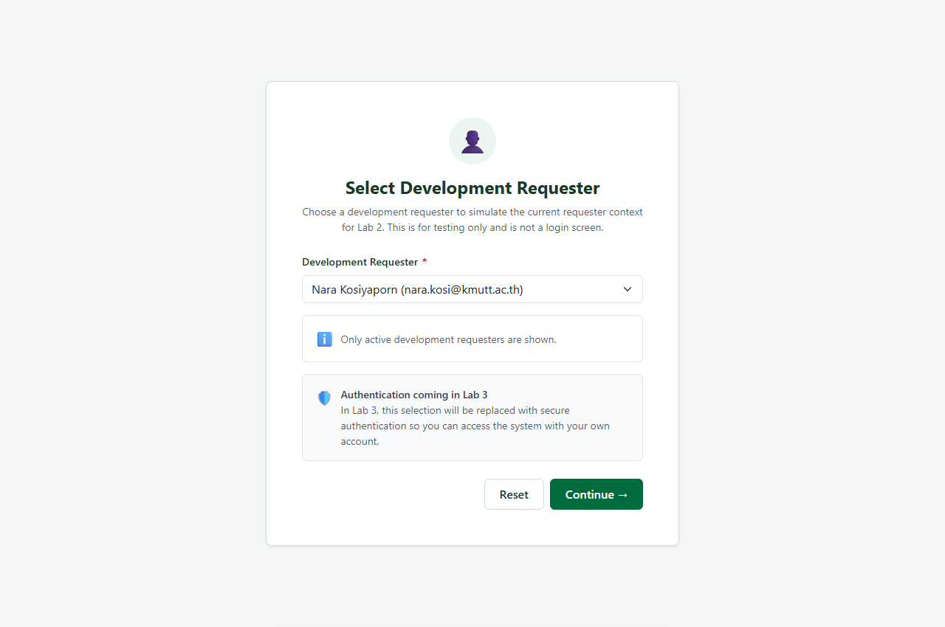
Figure 1: Development Requester selection dropdown displaying active user 'Nara Kosiyaporn (nara.kosi@kmutt.ac.th)'.

Figure 2: Create Ticket Screen (Desktop Viewport)
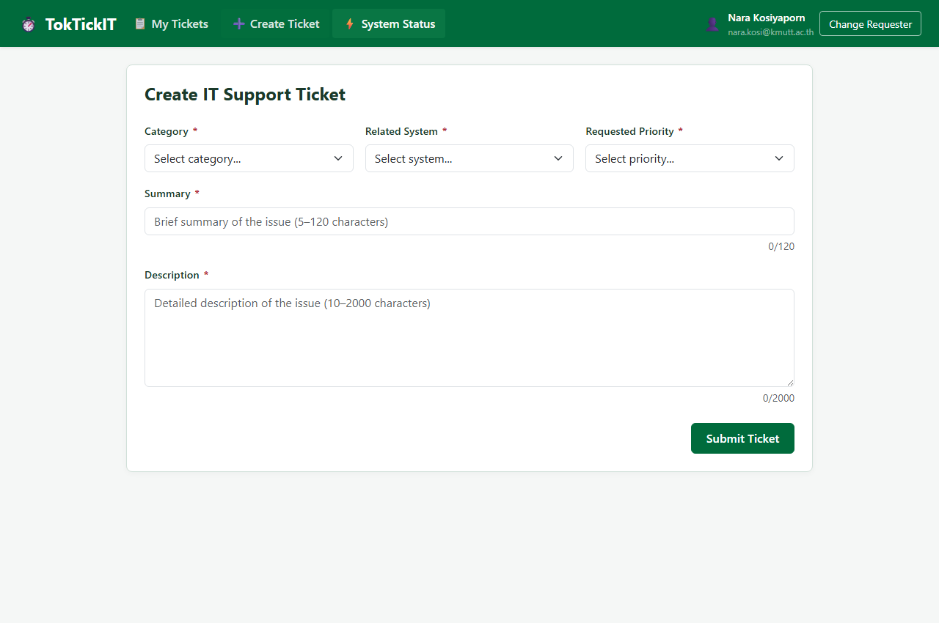
Figure 2: Create Ticket screen on desktop viewport showing category, related system, priority dropdowns, and user identity 'Nara Kosiyaporn' in header.

Figure 3: Client-Side Validation Error States
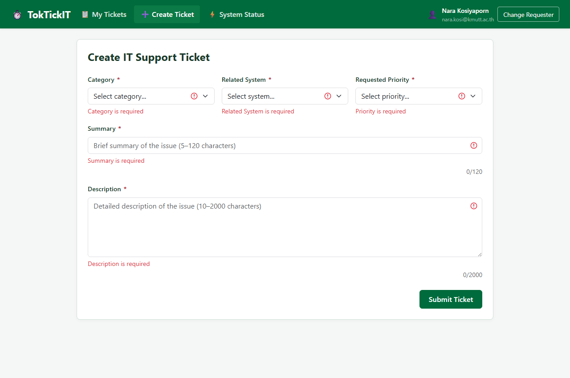
Figure 3: Field-level validation messages shown immediately below required fields upon submitting an empty form.

Figure 4: API Failure Resilience (Form Values Preserved)
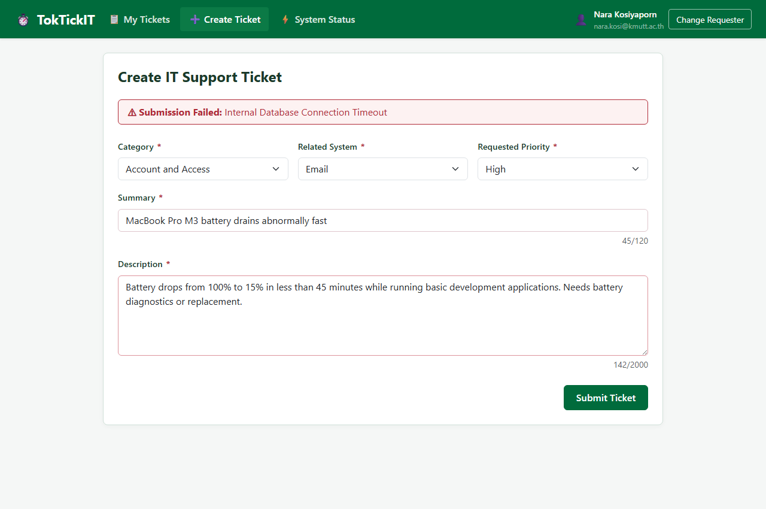
Figure 4: Error banner displayed when backend returns 500; entered Summary and Description are fully preserved without data loss.

Figure 5: Successful Ticket Creation Dialog & Official Ticket Number
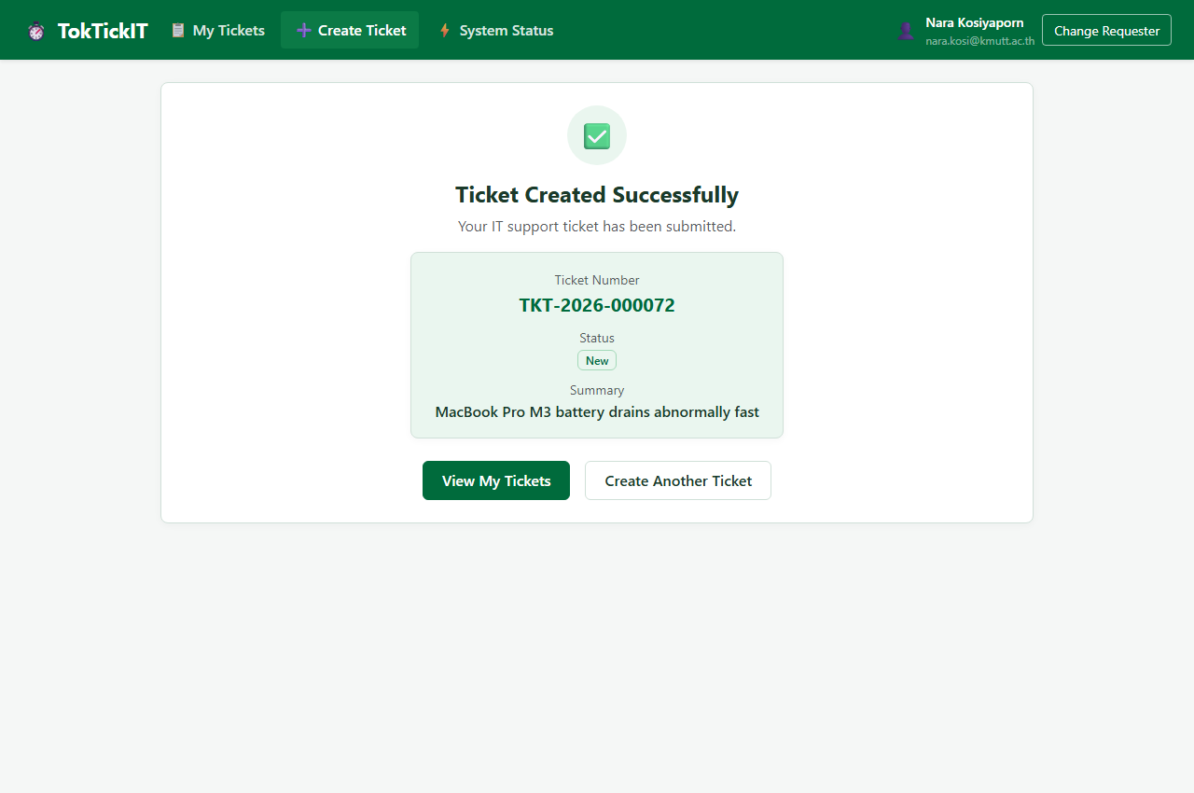
Figure 5: Confirmation view displaying official generated Ticket Number (TKT-2026-000072), initial status 'New', and action buttons.

Answer Part 7: Working My Tickets Screen (10 Points)
Demonstrates ticket list retrieval, real-time keyword search, category filtering, priority filtering, empty states, and strict ownership isolation when switching requesters.

Figure 6: My Tickets List for Primary Requester (Nara Kosiyaporn)
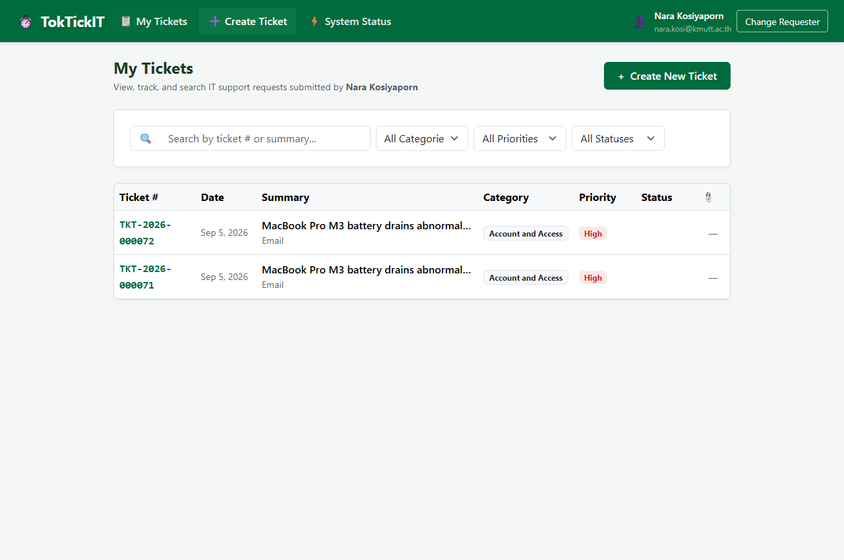
Figure 6: My Tickets table displaying submitted tickets owned strictly by Nara Kosiyaporn.

Figure 7: Filter by Category
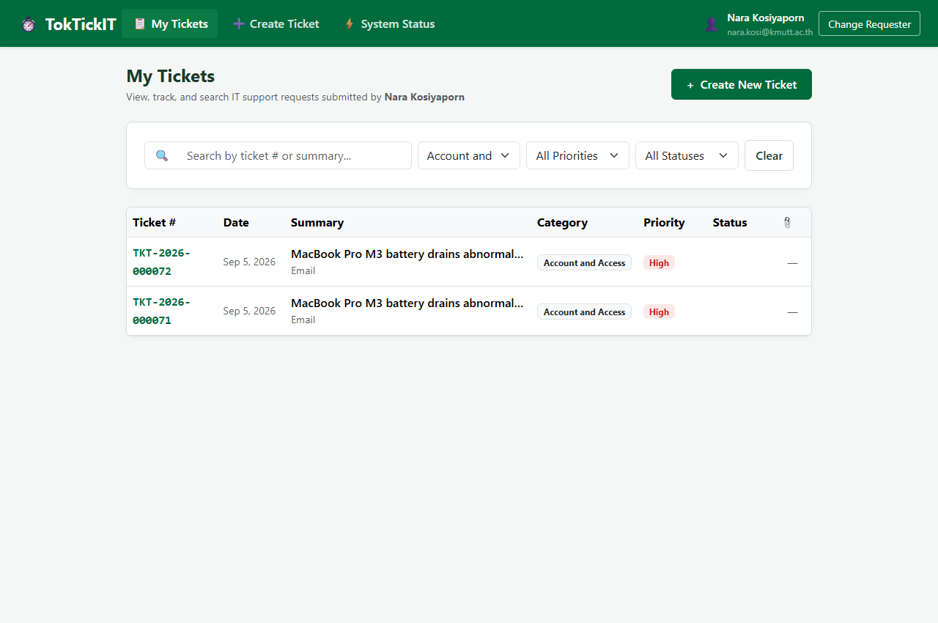
Figure 7: Table dynamically filtered by Category.

Figure 8: Filter by Priority (High)
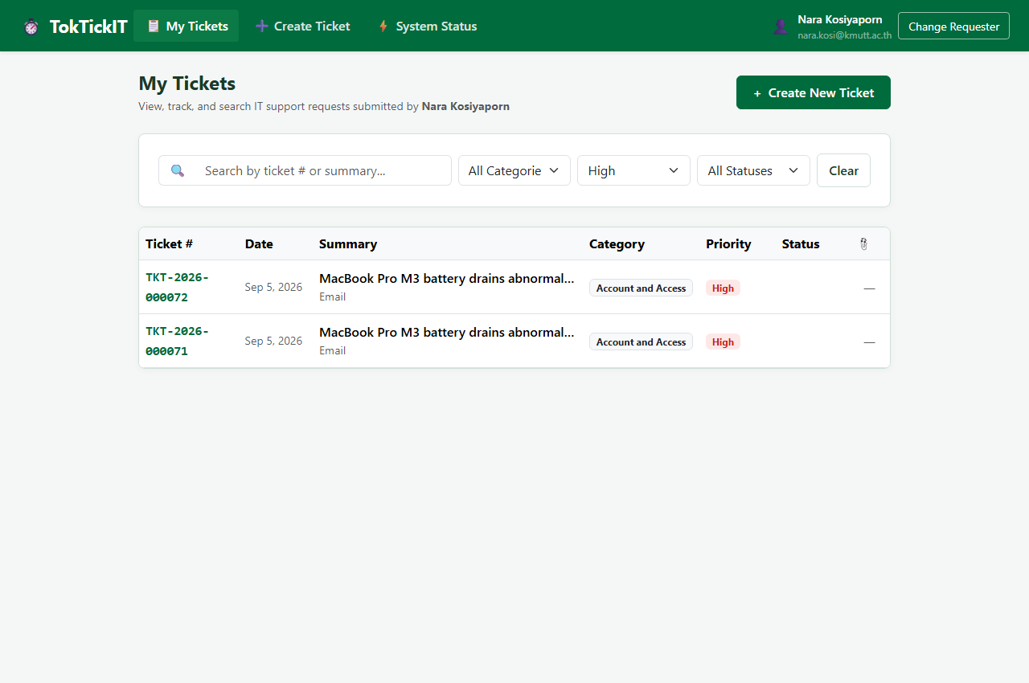
Figure 8: Table dynamically filtered by Priority 'High'.

Figure 9: Real-Time Search by Keyword
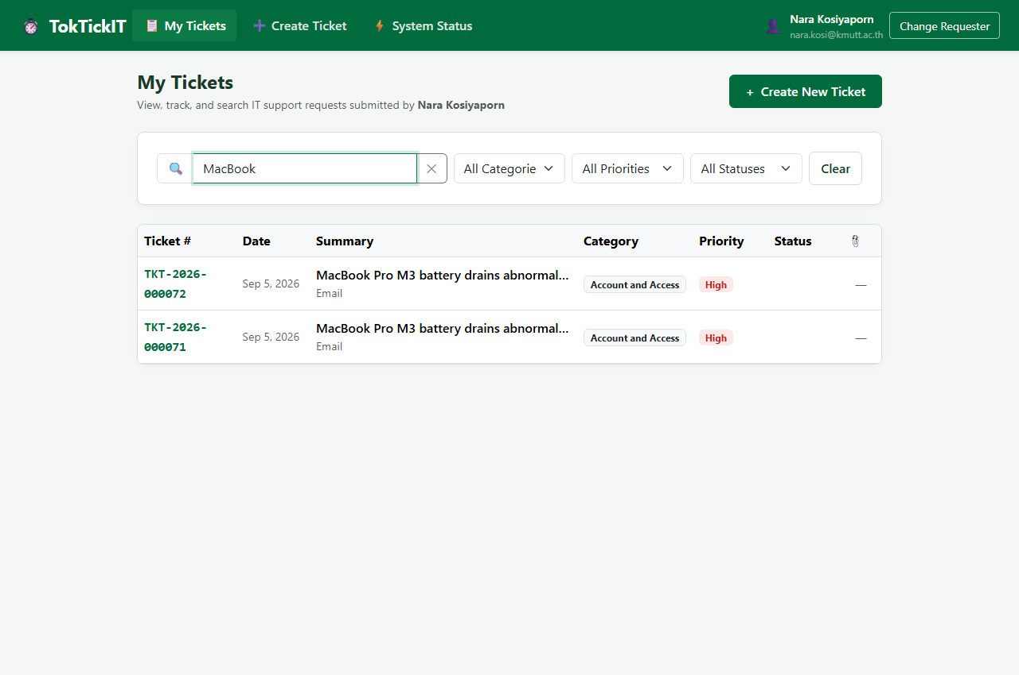
Figure 9: Real-time search matching summary keyword 'MacBook'.

Figure 10: No Matching Results State
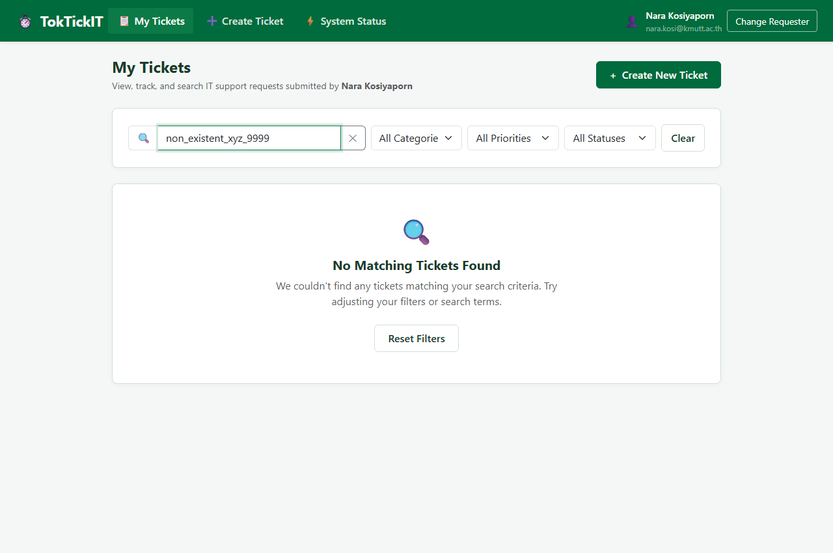
Figure 10: Clear no-results state with 'Clear Filters' button when search keyword has zero matches.

Figure 11: Requester Data Isolation (Switch to Requester B: Sunny farmhouse)
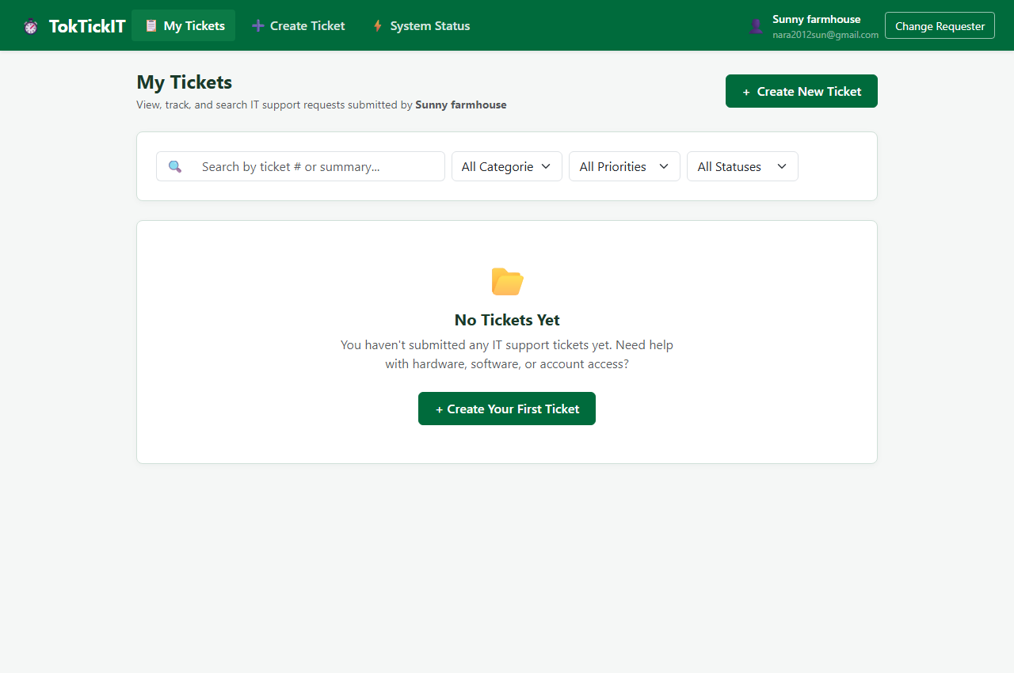
Figure 11: Switched to Sunny farmhouse (nara2012sun@gmail.com); Nara Kosiyaporn's tickets are completely hidden, displaying empty state 'No Tickets Yet'.

Answer Part 8: Working Ticket Screen: View Mode and Attachments (5 Points)
Demonstrates read-only ticket details, attachment format validation, active upload counter, soft-removal modal with mandatory audit reason, and download prevention.

Figure 12: Ticket Detail View
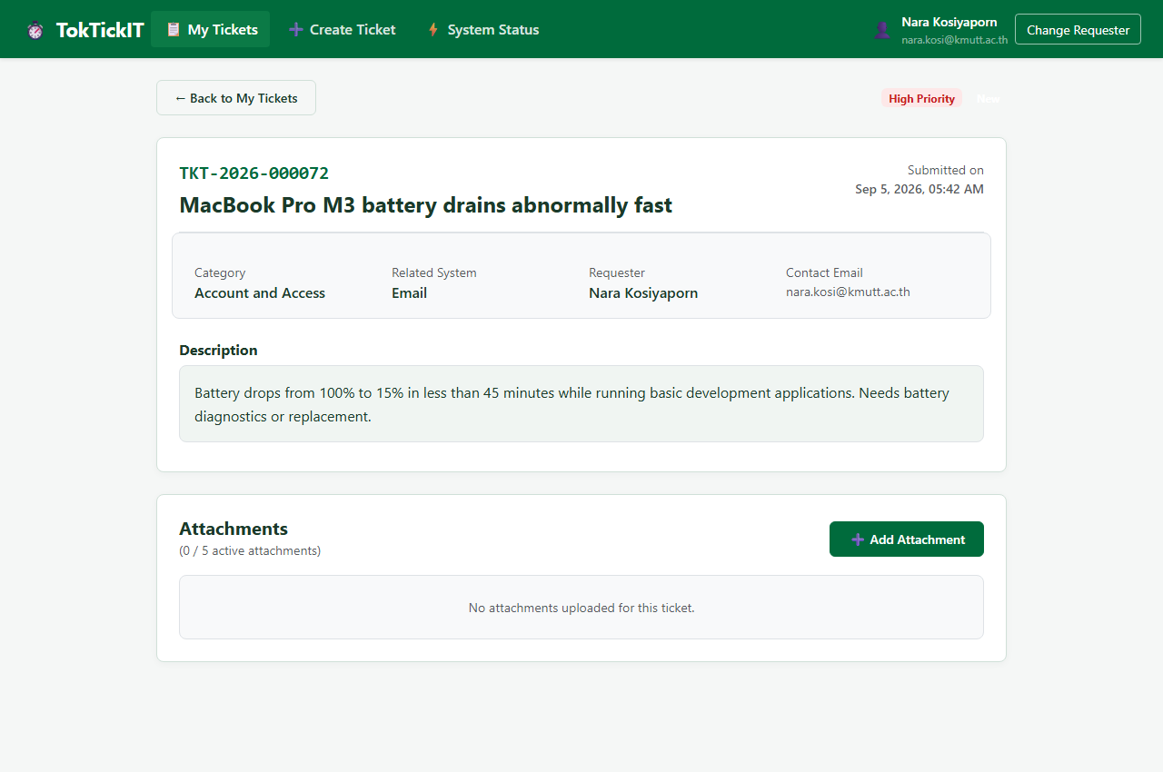
Figure 12: Read-only Ticket Detail view showing Ticket Number, Status, Category, Related System, Requester 'Nara Kosiyaporn', and Contact Email 'nara.kosi@kmutt.ac.th'.

Figure 13: Unsupported Attachment Format Rejection
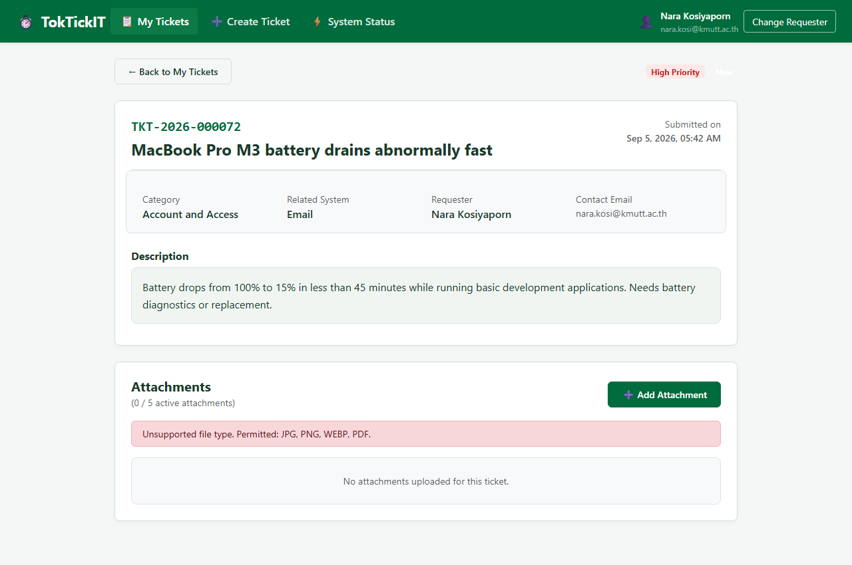
Figure 13: Selecting an unsupported .txt file triggers client-side validation error message.

Figure 14: Valid Attachment Uploaded (Active Count Updated)
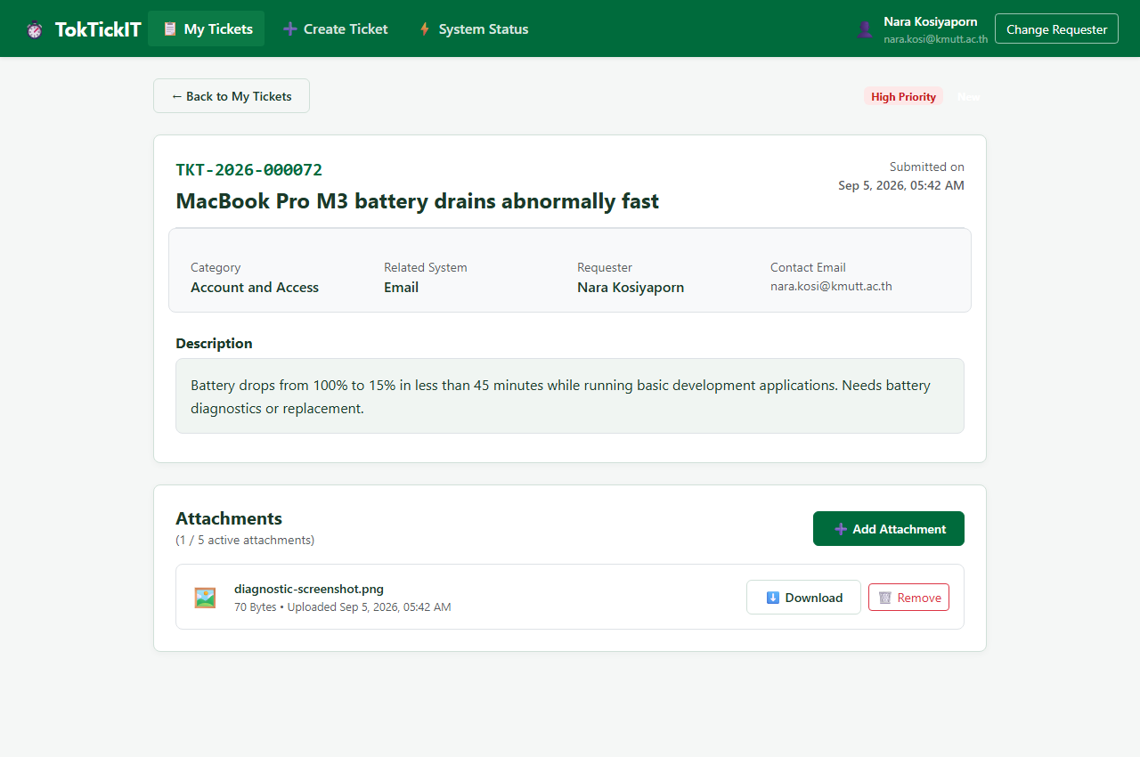
Figure 14: Uploading valid PNG screenshot updates active counter to '1 / 5 active attachments' and enables Download and Remove buttons.

Figure 15: Soft-Removal Modal with Mandatory Audit Reason
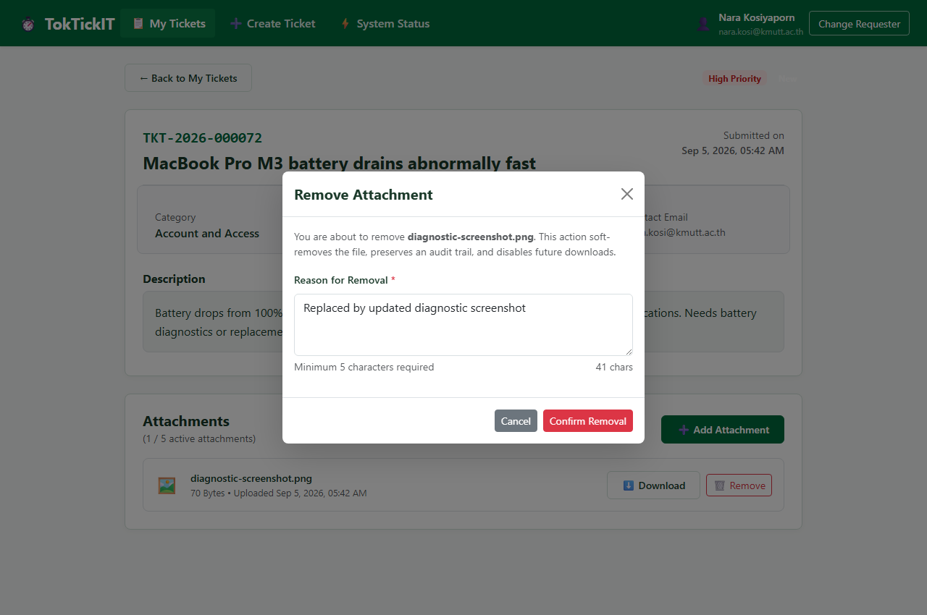
Figure 15: Soft-removal modal prompting for audit reason (minimum 5 characters).

Figure 16: Soft-Removed State (Audit Quote Displayed, Download Disabled)
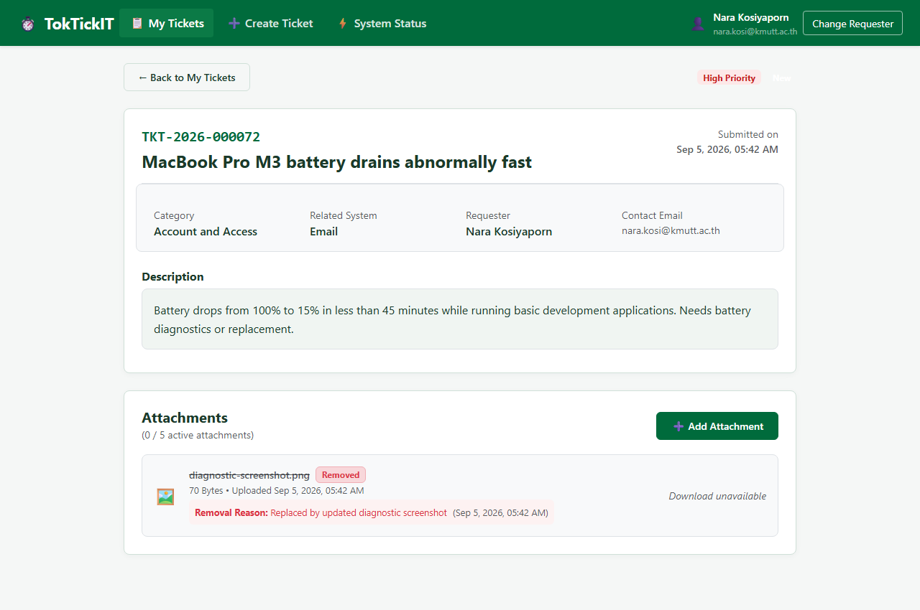
Figure 16: Attachment displays 'Removed' badge, shows audit reason quote and timestamp; download button is disabled with 'Download unavailable' and 410 Gone backend protection.

Answer Part 9: Zen Green UI and Responsive Evidence (5 Points)
UI Specification Link: https://github.com/narakosi-dev/toktickit/blob/main/docs/lab-02/ui-spec.md
Validates the Zen Green Design System tokens (#006B3C primary, #0B7A46 secondary, #EAF6EF pale, #F5F7F6 canvas) and responsive layout across Desktop (1200px), Tablet (800px), and Mobile (375px) with zero horizontal overflow.

Figure 17: Desktop Viewport (1200px Wide)
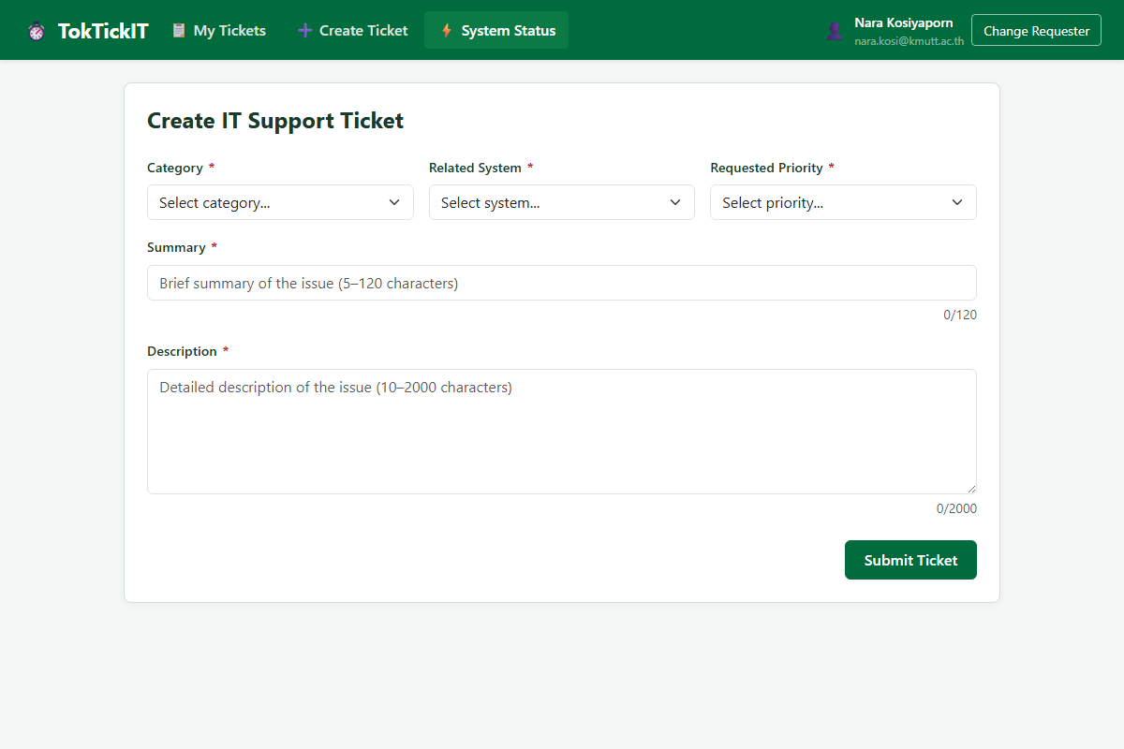
Figure 17: Desktop two-column form layout and wide navbar.

Figure 18: Tablet Viewport (800px Wide)
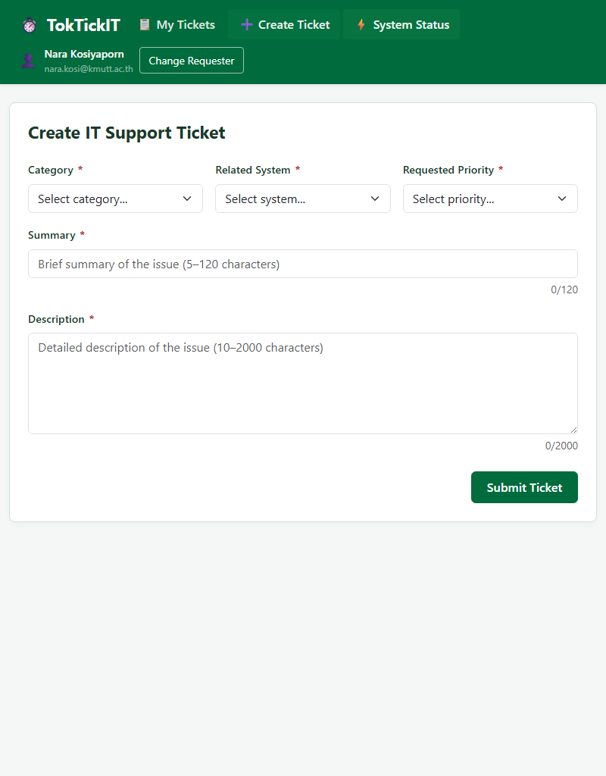
Figure 18: Tablet adaptive layout with touch-friendly controls.

Figure 19: Mobile Viewport (375px Wide) — Create Ticket
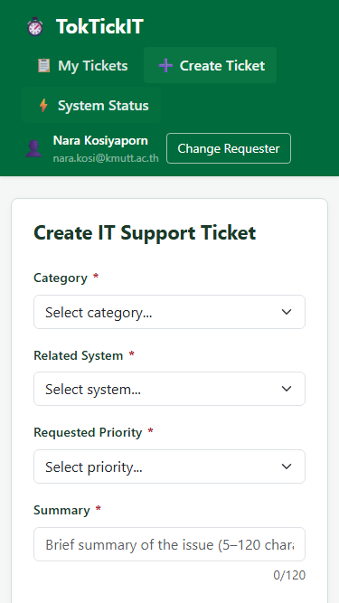
Figure 19: Mobile portrait layout with vertically stacked form controls and zero horizontal overflow.

Figure 20: Mobile Viewport (375px Wide) — My Tickets Cards
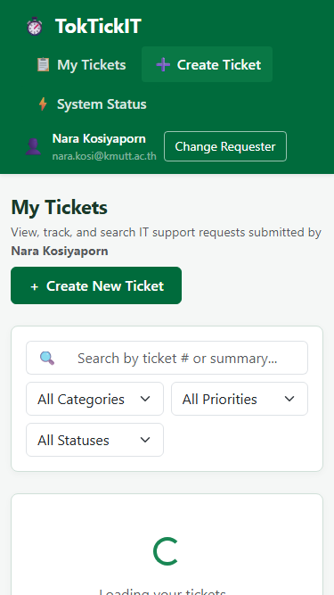
Figure 20: Mobile view of My Tickets converting table rows into responsive ticket cards.

9.2 Completed Visual Checklist
Visual Criteria | Implementation & Verification Details | Status
Color Tokens | #006B3C (Primary), #0B7A46 (Secondary), #EAF6EF (Pale), #F5F7F6 (Canvas) | Pass
Editable vs Read-Only | White background for editable inputs; #F0F5F2 for read-only system date & ticket number | Pass
Validation Placement | Error messages appear directly underneath the corresponding input in dark red (#B02A37) | Pass
Button Hierarchy | Primary (btn-zen-primary), Secondary (btn-zen-secondary), Destructive (btn-danger) | Pass
No Clipping / Overlap | Zero text truncation, zero overlapping buttons, and flex-wrapping header items | Pass
Horizontal Scrolling | Tested at 375px width via Playwright; scrollWidth <= clientWidth with zero horizontal overflow | Pass

