**Tribhuvan University**



**Bachelors of Science in Computer Science and Information Technology**

**(BSc. CSIT)**

**A PROJECT REPORT ON**

**“College Management System”**

##### Submitted to

**Department of Computer Science and Information Technology**

**Lumbini ICT Campus**

In partial fulfillment of the requirements for Bachelors in Computer Science and Information Technology

##### Submitted by

**Chabilal Subedi (TU Reg. No: 5-2-1194-11-2019)**

**Prajwal Kandel (TU Reg. 5-2-1194-124-2019)**

**Naran Bdr Chhetri (TU Reg. No: 5-2-1194-121-2019)**

**Under the Supervision of – Er. Modnath Acharya**

**ACKNOWLEDGEMENT**

Firstly, I would like to express our deep and sincere gratitude to LUMBINI ICT COLLEGE for providing opportunity, necessary resources and guidelines to come up with this project.

I would like to express immense gratitude to our respected teachers for their constant support, enthusiasm been interest in this project despite having hectic schedule. Their advice on technical matters is invaluable and their guidance id very critical for the success of our project.

Also, I grateful and fortunate enough to have Er. Modnath Acharya as my supervisor, who encouraged to go ahead with this project. He helps me as good instructor.

I thank all the people for their help directly and indirectly to complete my project.

Chabilal Subedi

Prajwal Kandel

Naran Bdr Chhetri

**ABSTRACT**

The College Management System (CMS) project is a web-based platform designed to handle various aspects of college administration and management. The system has three primary users: admin, teacher, and student .The admin is responsible for managing the system by adding staffs/teachers, students, courses, faculty, and maintaining their profiles .The teacher has the ability to assign assignments, provides the courses book information to library section, and post informative content and notify the students .The student can access the teacher's provided materials, submit their assignments, can choose the courses as well as provide necessary feedback to the administration .The system facilitates smooth communication and collaboration among different departments, contributing to an optimized administrative workflow.

The system is built on a user-friendly interface that allows for easy navigation between features.

The administrator has full control over the system, including adding, editing, and deleting students, courses and managing the staffs .The teacher can upload their assignments, and respond to students

queries and feedback as well as publish the students timely result. Students and teachers also can take the leave by notifying the administration.

Overall, the College Management System project aims to improve efficiency, transparency, and communication within the college environment. By leveraging technology, the system seeks to simplify administrative tasks, enhance academic processes, and create a more connected and informed educational community.

Contents

CHAPTER 1: INTRODUCTION 1

1.1 Introduction 1

1.2 Statement of the problem 1

1.3 Objectives 2

1.4 Project Question 2

CHAPTER 2: BACKGROUND STUDY 3

2.1 Background Study 3

CHAPTER 3: METHODOLOGY 4

3.1 Requirement Engineering 5

3.1.1 Feasibility Study 5

3.1.2 Requirement Collection 6

3.1.3 Requirement Analysis and Validation 6

3.1.4 Software Requirement Specification 6

3.1.5 Process Modeling 8

3.2 System Design 10

3.2.1 Architecture Design 10

CHAPTER 4: IMPLEMENTATION AND TESTING 12

4.1 Implementation 12

4.1.1 Tools Used 12

REFERENCES 14

**LIST OF FIGURES**

Figure 1: Incrmental Model 4

Figure 2: Use Case Diagram 7

Figure 3: Level-0 DFD 9

Figure 4: Level-1 DFD 9

Figure 5: Level-2 DFD 10

Figure 6: Architectural Design 11

# CHAPTER 1: INTRODUCTION

## Introduction

The College Management System is the ultimate solution to digitize and streamline the day-to-day operations of colleges and universities. From student enrolment system to admission management, courses and staffs management as well as every other process of college operations. It also digitizes routine work of the college such as attendance management system, record keeping system, student mark management system, students and teachers profile management system and feedback handling as well as other small and big operations.

The project has been developed with the goal of making easy teaching and learning as well as changing the paper based work to a fully digital environment. The system has three primary users: admin, teacher, and student .The admin is responsible for managing the system by adding staffs/teachers, students, courses, faculty, and maintaining their profiles .The teacher has the ability to assign assignments, notify the students. The student can submit their assignments, can choose the courses as well as provide necessary feedback to the administration .The system facilitates smooth communication and collaboration among different departments, contributing to an optimized administrative workflow.

The project has been developed with a user-centric approach, ensuring that the system is easy to use and provides an intuitive user interface. The project also uses advanced security protocols to ensure that user data and privacy are protected.

We see the College Management System as a powerful tool that makes things easier for managing the college. It not only helps with administrative work but also builds a lively educational community. This community is all about making learning easy, working together, and adapting to what students and teachers need as things change.

## Statement of the problem

The education sector has undergone significant changes over the years, with the emergence of technology revolutionizing the traditional teaching, learning methods and managing the administration .however, despite the advancements many colleges these days are not able to manage the administration properly. Many colleges still rely on manual methods for tasks such as student enrollment, attendance tracking, and examination management which is time-consuming, prone to errors, and requires extensive paperwork.

Many students and staffs as well still struggle to grasp academic opportunities due to limited access to academic resources and lack of medium to provide feedbacks to the concerned authorities. The CMS aims to address these challenges by providing an interactive and personalized digital platform where all the administration features and services are transparent.

Limited communication channels between students, teachers, and administrators which may result in delayed information dissemination. Potential breaches may compromise sensitive information, leading to privacy concerns. Manual course planning and scheduling processes are also not effective for smooth college management.

In summary, the College Management System will provide the interactive environment for the teachers, students and other staff members by getting knowledge of Students attendance, remarks, exam performances, grades, timetables, notices etc.

## Objectives

The College Management System has the following objectives:

* To create a centralized repository for academic records, and announcements.
* To ensure easy and quick access to information for both administrators and users.
* To generate real-time attendance reports for administrators to monitor trends and patterns.
* To establish a centralized platform for collecting feedback from students and faculty.

## Project Question

Some of the questions that are asked which is used to fulfill the requirement for the project are:

1. What are the requirements need for college management?
2. How the whole system work?
3. How the new technology will have an impact on old System?
4. Why this system is beneficial?

# CHAPTER 2: BACKGROUND STUDY

## 2.1 Background Study

Over time, schools and colleges have changed a lot because of new technologies. These changes bring new challenges in managing administrative tasks. The old ways of doing things, like keeping records by hand, managing leaves, tracking attendance, and collecting feedback, take a lot of time and can have mistakes. Seeing these difficulties, the College Management System project comes in as a smart and timely solution. Its goal is to change the way administrative tasks are done in educational places, making things much better.

Doing administrative tasks the old-fashioned way has its problems. Things like managing and securing student and staffs personal information may not be upto mark, handling leave requests take a long time, attendance records might not be correct, and getting feedback can be slow and not very effective. These issues don't just make it hard for the school or college to run smoothly; they also affect how well students and teachers can learn. The College Management System understands these problems and wants to solve them by using automation and bringing everything together.

As technology gets better, using all-in-one solutions has become really important to make things work better. The College Management System goal is to make everything smooth and centralized, making administrative work easier and improving how well things run. So our project tackles the difficulties faced in managing colleges by offering a personalized, easy-to-use, and supportive system. This aims to improve the overall management of educational institutions.

# CHAPTER 3: METHODOLOGY

Incremental Model is a process of software development where requirements divided into multiple standalone modules of the software development cycle. In this model, each module goes through the requirements, design, implementation and testing phases. Every subsequent release of the module adds function to the previous release. The process continues until the complete system achieved.

To develop a software product, there must be a clear understanding among team representative about when and what to do. Software development life cycle plays the most important role in developing a software. Software life cycle model is a pictorial and diagrammatic representation of the software life cycle. A life cycle model represents all the methods required to make a software product transit through its life cycle stages. It also captures the structure in which these methods are to be undertaken. There are different software models to implement the SDLC like waterfall model, incremental model.

Among this, I have implemented Incremental model because my requirements were not fixed, and incremental model is more flexible to change the requirements. Risk can be easily managed using incremental model.

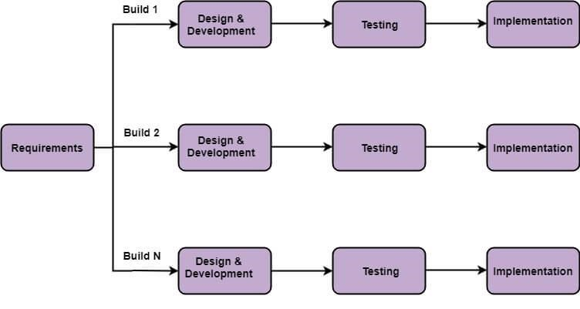

Figure 1: Incrmental Model

## 3.1 Requirement Engineering

### 3.1.1 Feasibility Study

The feasibility study is conducted to determine if this project is viable from a technical, economical, operational and schedule perspective.

For our project, we performed the following feasibility study:

* Technical Feasibility
* Economic Feasibility
* Operational Feasibility
* Schedule Feasibility

**1. Technical Feasibility**

The technical feasibility of the CMS project is high. The required technologies and infrastructure are readily available, and the development team has experience working with these technologies. The project can be developed using open-source software, which will reduce the development costs.

**2. Economic Feasibility**

The economic feasibility of the project is high. The project has the potential to generate revenue through subscription-based models, which will cover the development and operational costs. Additionally, the project can reduce the costs associated with traditional classroom-based learning, such as infrastructure, transportation, and accommodation costs.

**3. Operational Feasibility**

The operational feasibility of the project is high. The project's objectives are well-defined, and the development team has the necessary skills and expertise to deliver the project successfully. The project's success will depend on the availability and engagement of Teacher and students, which can be ensured through effective marketing and outreach strategies.

**3. Schedule Feasibility**

Here, we analyzed the time required to complete the project, identified that the project will fail if it took too long to complete, and determine some targeted milestones and time frames for completion as a guideline only.

|  |  |  |  |  |  |  |  |  |  |  |  |  |  |  |  |  |  |
| --- | --- | --- | --- | --- | --- | --- | --- | --- | --- | --- | --- | --- | --- | --- | --- | --- | --- |
| **S.**  **N** | **Weeks /Stages of project** | **1** | **2** | **3** | **4** | **5** | **6** | **7** | **8** | **9** | **10** | **11** | **12** | **13** | **14** | **15** | **16** |
| **1.** | **Study and**  **Planning** |  |  |  |  |  |  |  |  |  |  |  |  |  |  |  |  |
| **2.** | **Requirement gathering And analysis** |  |  |  |  |  |  |  |  |  |  |  |  |  |  |  |  |
| **3.** | **System design** |  |  |  |  |  |  |  |  |  |  |  |  |  |  |  |  |
| **4.** | **Implementation** |  |  |  |  |  |  |  |  |  |  |  |  |  |  |  |  |
| **5.** | **Testing** |  |  |  |  |  |  |  |  |  |  |  |  |  |  |  |  |
| **6.** | **Documentation** |  |  |  |  |  |  |  |  |  |  |  |  |  |  |  |  |
| **7.** | **Presentation and**  **Report**  **Submission** |  |  |  |  |  |  |  |  |  |  |  |  |  |  |  |  |

### 3.1.2 Requirement Collection

### 3.1.3 Requirement Analysis and Validation

I conduct the review where the supervisor review for analysis and validate.

### 3.1.4 Software Requirement Specification

A Software Requirement Specification (SRS) is a document that defines the functional and nonfunctional requirements of a software system. The SRS for the CMS project should include the following components:

1. **Functional Requirement**

The functional requirements section should describe the system's features and functionalities that meet the stakeholders' needs. Here are some functional requirement of our project:

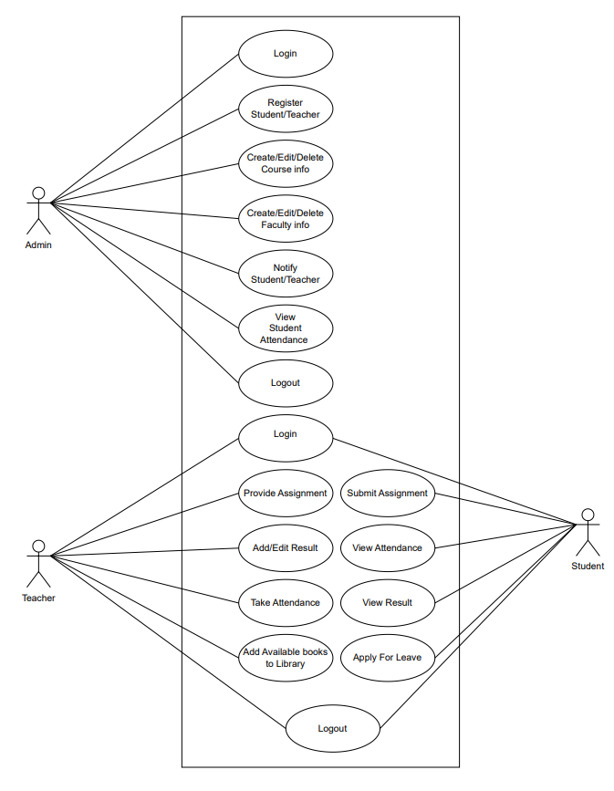

Figure 2: Use Case Diagram

The functional requirements for the Online Tutor project include:

* User registration and login: The system should allow users to register and create accounts. Users should be able to log in to the system using their credentials.
* User management: The system should allow the admin to manage users, including teachers and students. The admin should be able to add, edit, and delete users.
* Course management: The system should allow the admin to manage courses, including adding, editing, and deleting courses.
* Assignment management: The system should allow tutors to create assignments and post them for students. The system should allow students to submit assignments.
* User profile management: The system should allow users to manage their profiles, including updating their personal information and profile pictures.
* Result management: The system should allow teacher to add the result. The system should allow student to view result.

1. **Non-Functional Requirement**

The non-functional requirements section should describe the system's performance, security, and usability standards. The non-functional requirements for the CMS project include:

* Performance: The system should be responsive and load quickly.
* Security: The system should be secure and protect user data and information.
* Usability: The system should be easy to use and navigate.

### 3.1.5 Process Modeling

Data Flow diagram is a graphical representation of flow of data throughout the information system. Data flow diagrams illustrate how data is processed by a system in terms of inputs and outputs. DFD graphically representing the functions, or processes, which capture, manipulate, store, and distribute data between a system and its environment and between components of a system. The visual representation makes it a good communication tool between User and System designer. Structure of DFD allows starting from a broad overview and expands it to a hierarchy of detailed diagram.

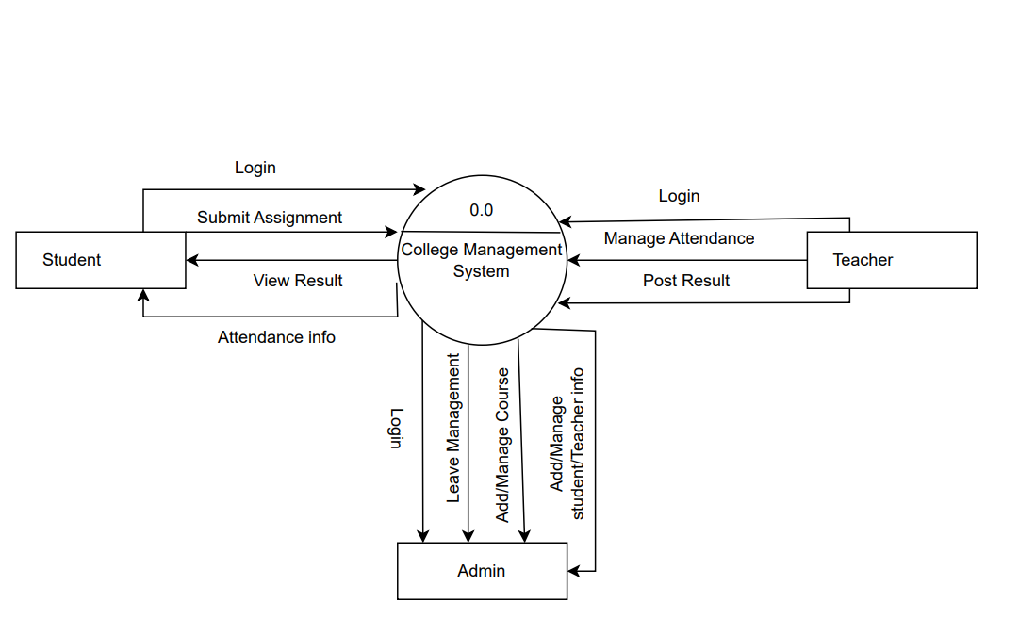

Figure 3: Level-0 DFD

**Level-1(DFD)**

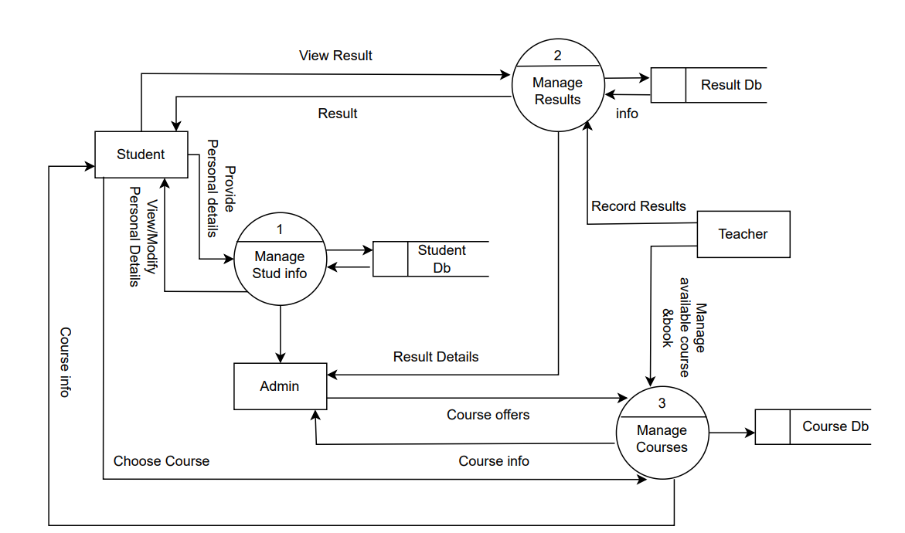

Figure 4: Level-1 DFD

**Level-2(DFD)**

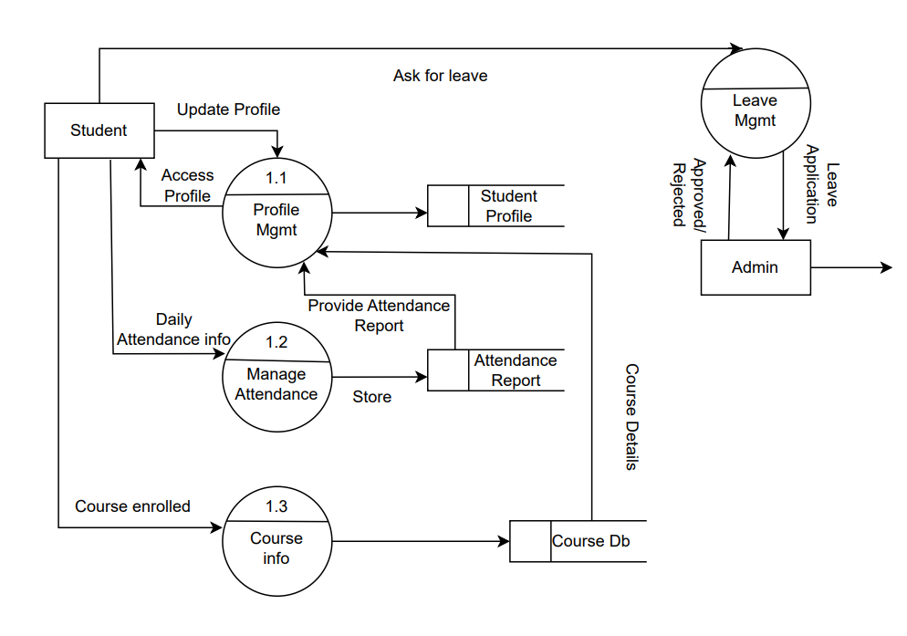

Figure 5: Level-2 DFD

## 3.2 System Design

### 3.2.1 Architecture Design

An architectural diagram for a software project is a visual representation of the system's overall structure and how its components interact with each other. In the case of CMS project, the architectural diagram provides a high-level overview of the system and its various components, including the user interface, database, application server, and external systems or services.

The diagram helps to illustrate how these components fit together and how data flows through the system. It can also help to identify potential bottlenecks or areas of the system that may require optimization.

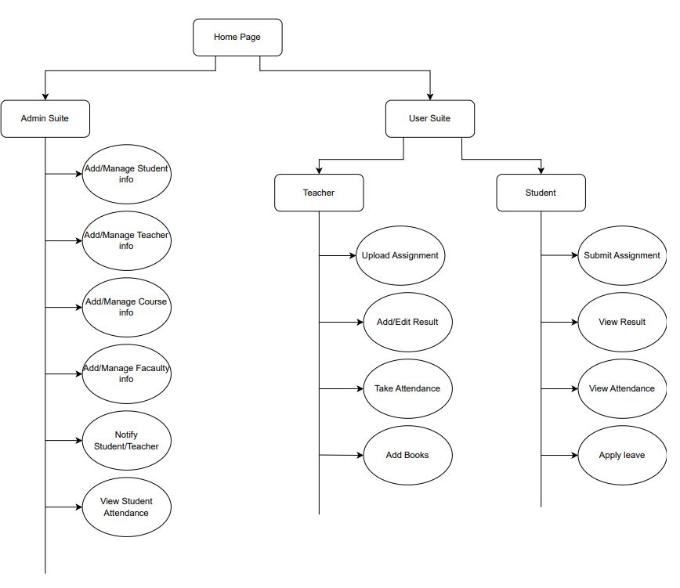

Figure 6: Architectural Design

# CHAPTER 4: IMPLEMENTATION AND TESTING

## 4.1 Implementation

Implementation sees that plans and strategies are turned into action that achieve strategic objective and goals. Implementation is much significant than planning. Strategic implementation critical to a project success, addressing who, where, when, and how of reaching the desired goals and objectives

### 4.1.1 Tools Used

**Front-End Tools**

Front End development and Fronts End programming languages create what a user interacts with HTML, CSS, and JavaScript are the three Front End languages. Each language and tool has their own specific function. Some of the tools used are:

* **CSS:** Stands for "Cascading Style Sheet." Cascading style sheets are used to format the layout of Web pages. They can be used to define text styles, table sizes, and other aspects of Web pages that previously could only be defined in a page's HTML.CSS helps Web developers create a uniform look across several pages of a Web site.
* **HTML:** The Hyper Text Markup Language, or HTML is the standard markup language for documents designed to be displayed in a web browser. It can be assisted by technologies such as Cascading Style Sheets (CSS) and scripting languages such as JavaScript. HTML is a markup language that web browsers use to interpret and compose text, images, and other material into visual or audible web pages. Default characteristics for every item of HTML markup are defined in the browser, and these characteristics can be altered or enhanced by the web page designer's additional use of CSS.
* **JavaScript:** JavaScript is a programming language commonly used in web development. It was originally developed by Netscape as a means to add dynamic and interactive elements to websites. While JavaScript is influenced by Java, the syntax is more similar to C and is based on ECMA Script, a scripting language developed by Sun Microsystems. JavaScript is a client-side scripting language, which means the source code is processed by the client's web browser rather than on the web server. This means JavaScript functions can run after a webpage has loaded without communicating with the server.
* **Bootstrap:** Bootstrap is a giant collection of handy, reusable bits of code written in HTML, CSS, and JavaScript. It’s also a frontend development framework that enables developers and designers to quickly build fully responsive websites. Essentially, Bootstrap saves you from writing lots of CSS code, giving you more time to spend on designing webpage.

**Back-End Tools**

The back end of a website consists of a server, an application, and a database. A back-end developer builds and maintains the technology that powers those components which, together, enable the user facing side of the website to event exist in the first place.

* **Django:** Django is a high-level Python web framework, serving as a robust back-end tool for web development. It follows the model-view-controller (MVC) architectural pattern, streamlining the creation of dynamic, database-driven websites. Django excels in simplifying complex tasks with its built-in features, including an ORM for database interaction, automatic admin interface generation, and a secure authentication system. It promotes rapid development by emphasizing DRY (Don't Repeat Yourself) principles and encourages clean, maintainable code. Its versatility, scalability, and extensive documentation make Django a preferred choice for developers seeking efficiency and reliability in building web applications.

# REFERENCES

[1] "What is Incremental Model in SDLC? Advantages & Disadvantages @ www.guru99.com." [Online]. Available: <https://www.guru99.com/what-is-incremental-model-in-sdlc-advantagesdisadvantages.html>.