通过Nuget安装OpenCvSharp

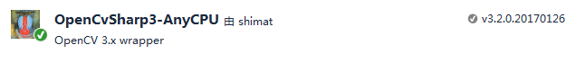

All-in-one包，包含了native OpenCV DLLs