- UTSAV 2026 Event Website
- College Website
- WildTrails Adventure Website
Each project section includes a purpose/design explanation, a screenshot-by-screenshot guide, and an example of how its layout can be implemented.

UTSAV 2026 Event Website
A dark-themed college festival website with a gold accent palette. Screens show the home page, About UTSAV, technical events, cultural competitions, workshops, schedule, coordinators, rules, registration form and footer.

Purpose and design explanation
Use a dark background with gold headings/buttons to match the screenshots. Keep event types in reusable cards and represent the timetable with a semantic table. Registration should use labels, required-field validation, and a secure server endpoint if submissions need to be stored.

Screenshot guide
Screenshot 1 — Home page: festival title and primary navigation introduce the event.

Screenshot 2 — About UTSAV: a short introduction establishes the purpose of the festival.


Screenshot 3 — Technical Events: cards group technical competitions and provide action buttons.
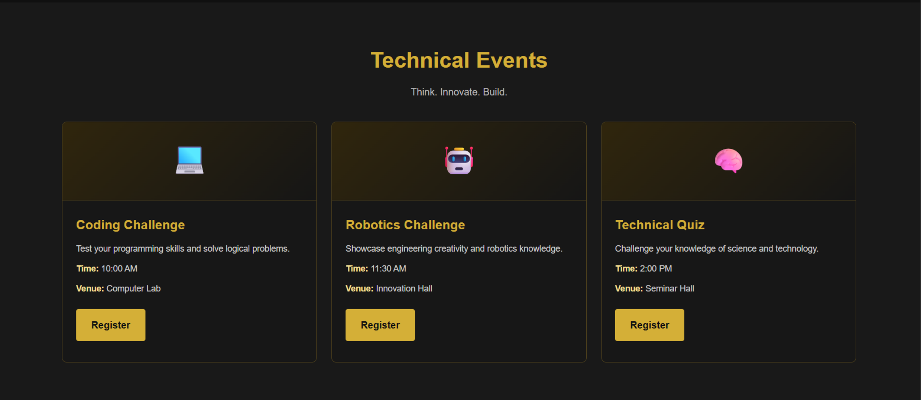
Screenshot 4 — Cultural Competitions: cards present performance and creative categories.
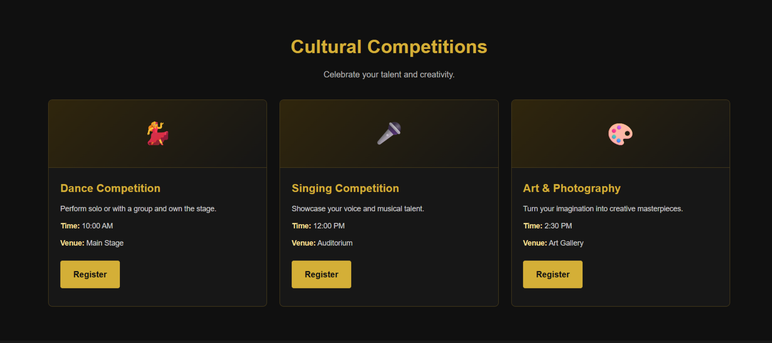

Screenshot 5 — Workshops: cards summarize workshop topics and registration actions.
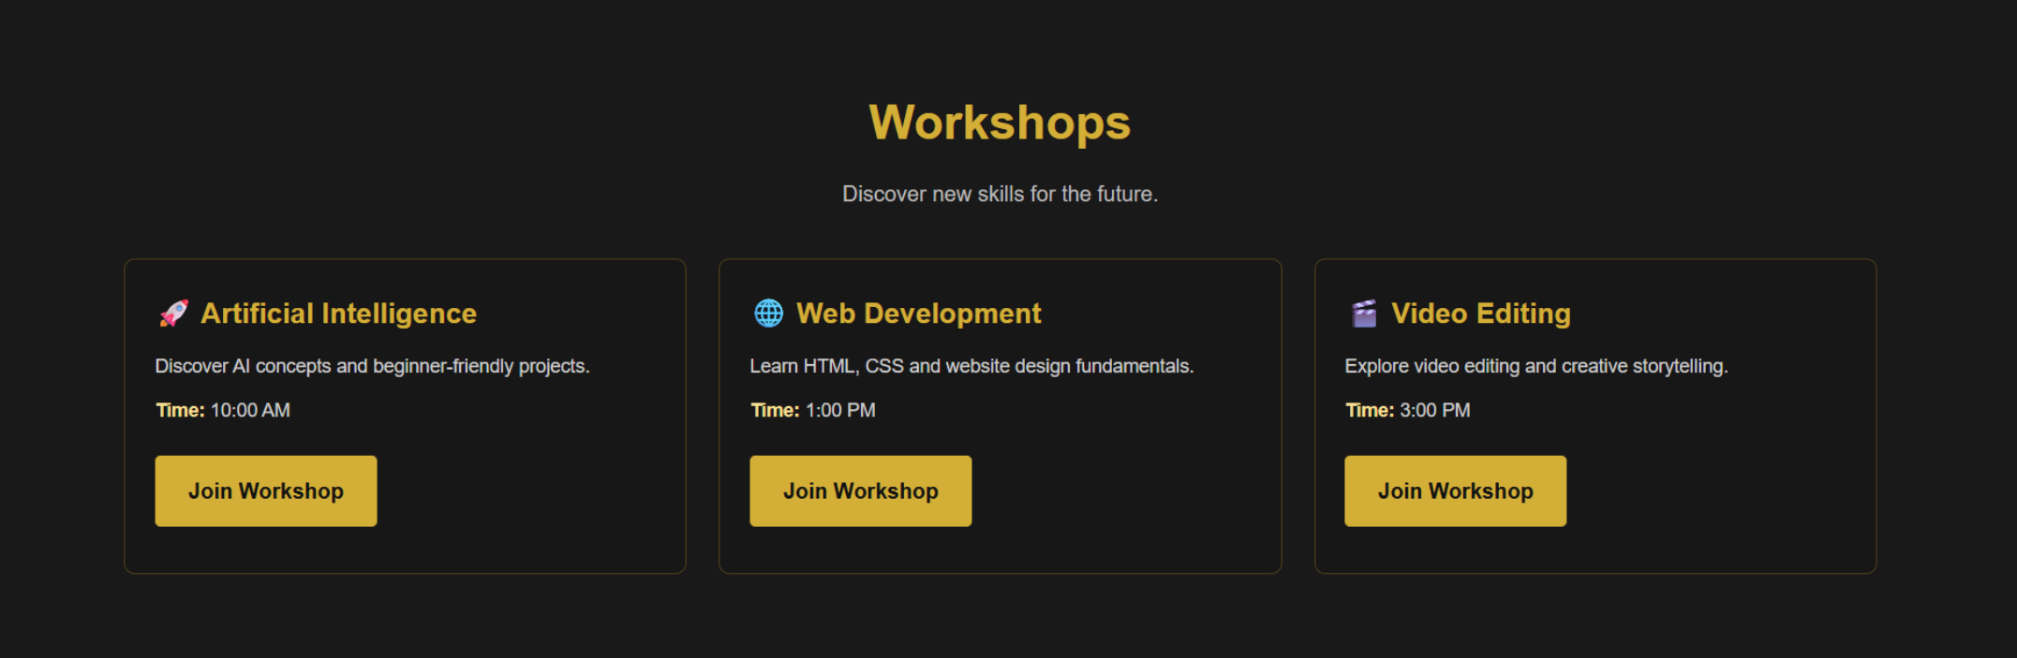
Screenshot 6 — Event Schedule: a table organizes time, event and venue details.
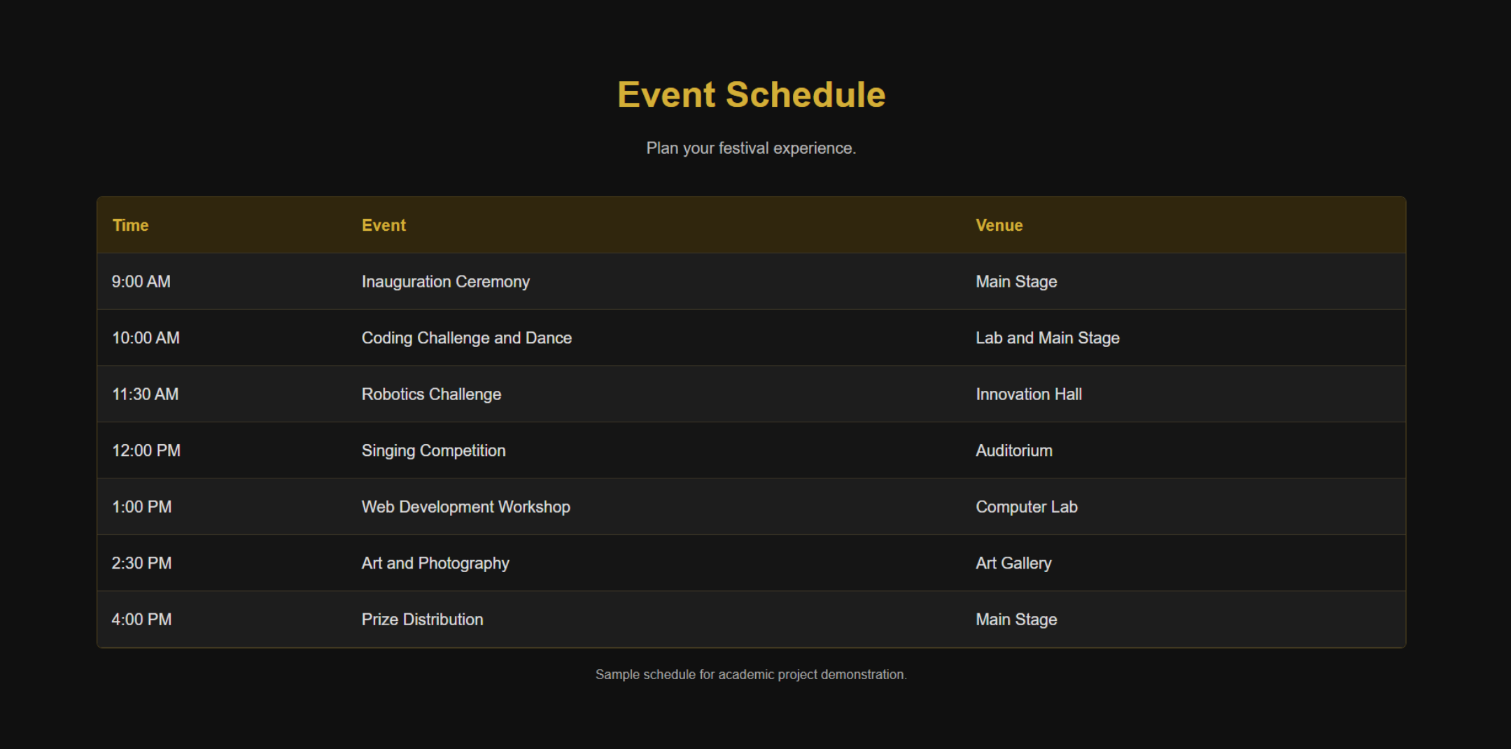

Screenshot 7 — Our Coordinators: grouped contact/organizing roles help visitors find the right team.
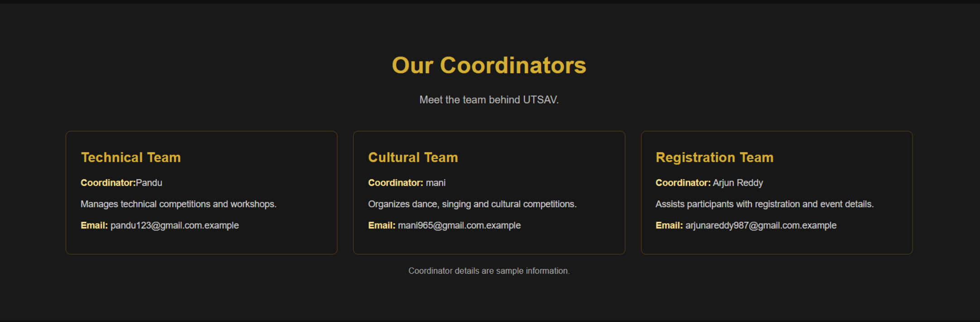
Screenshot 8 — Rules & Regulations: a numbered or bulleted list makes participation rules scannable.
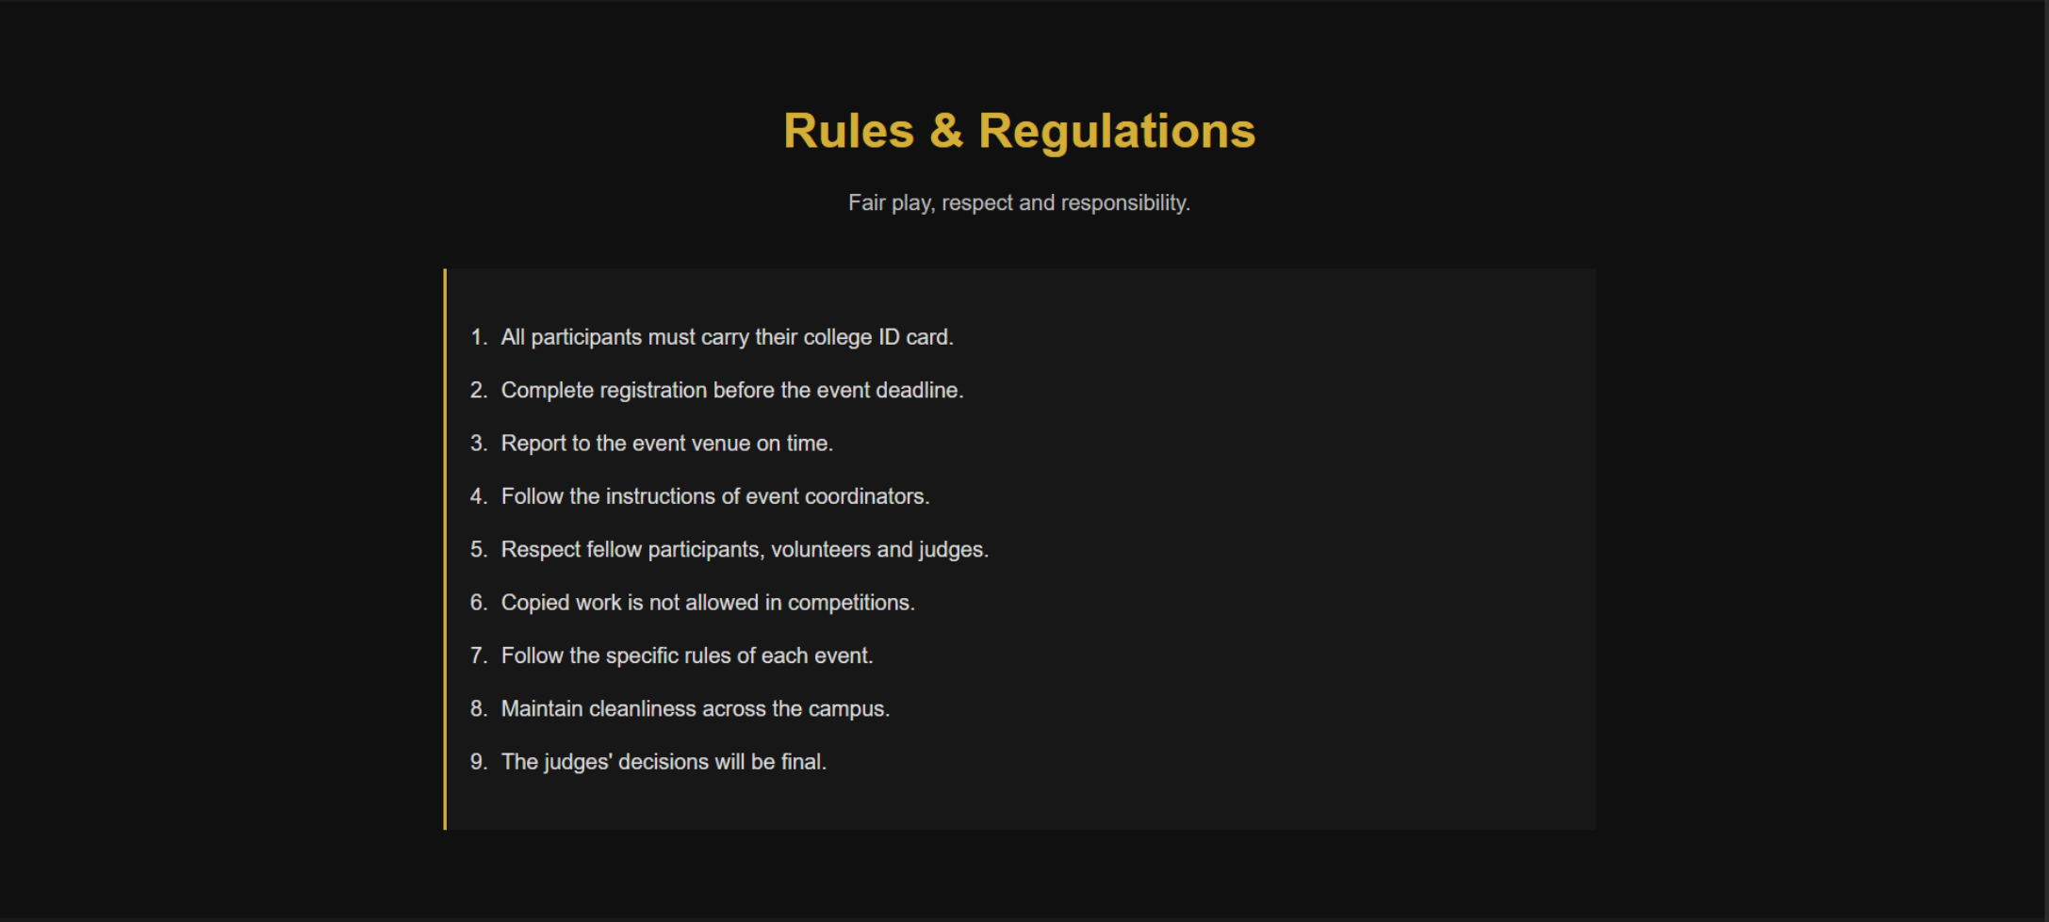

Screenshot 9 — Event Registration: a form collects participant and event information.
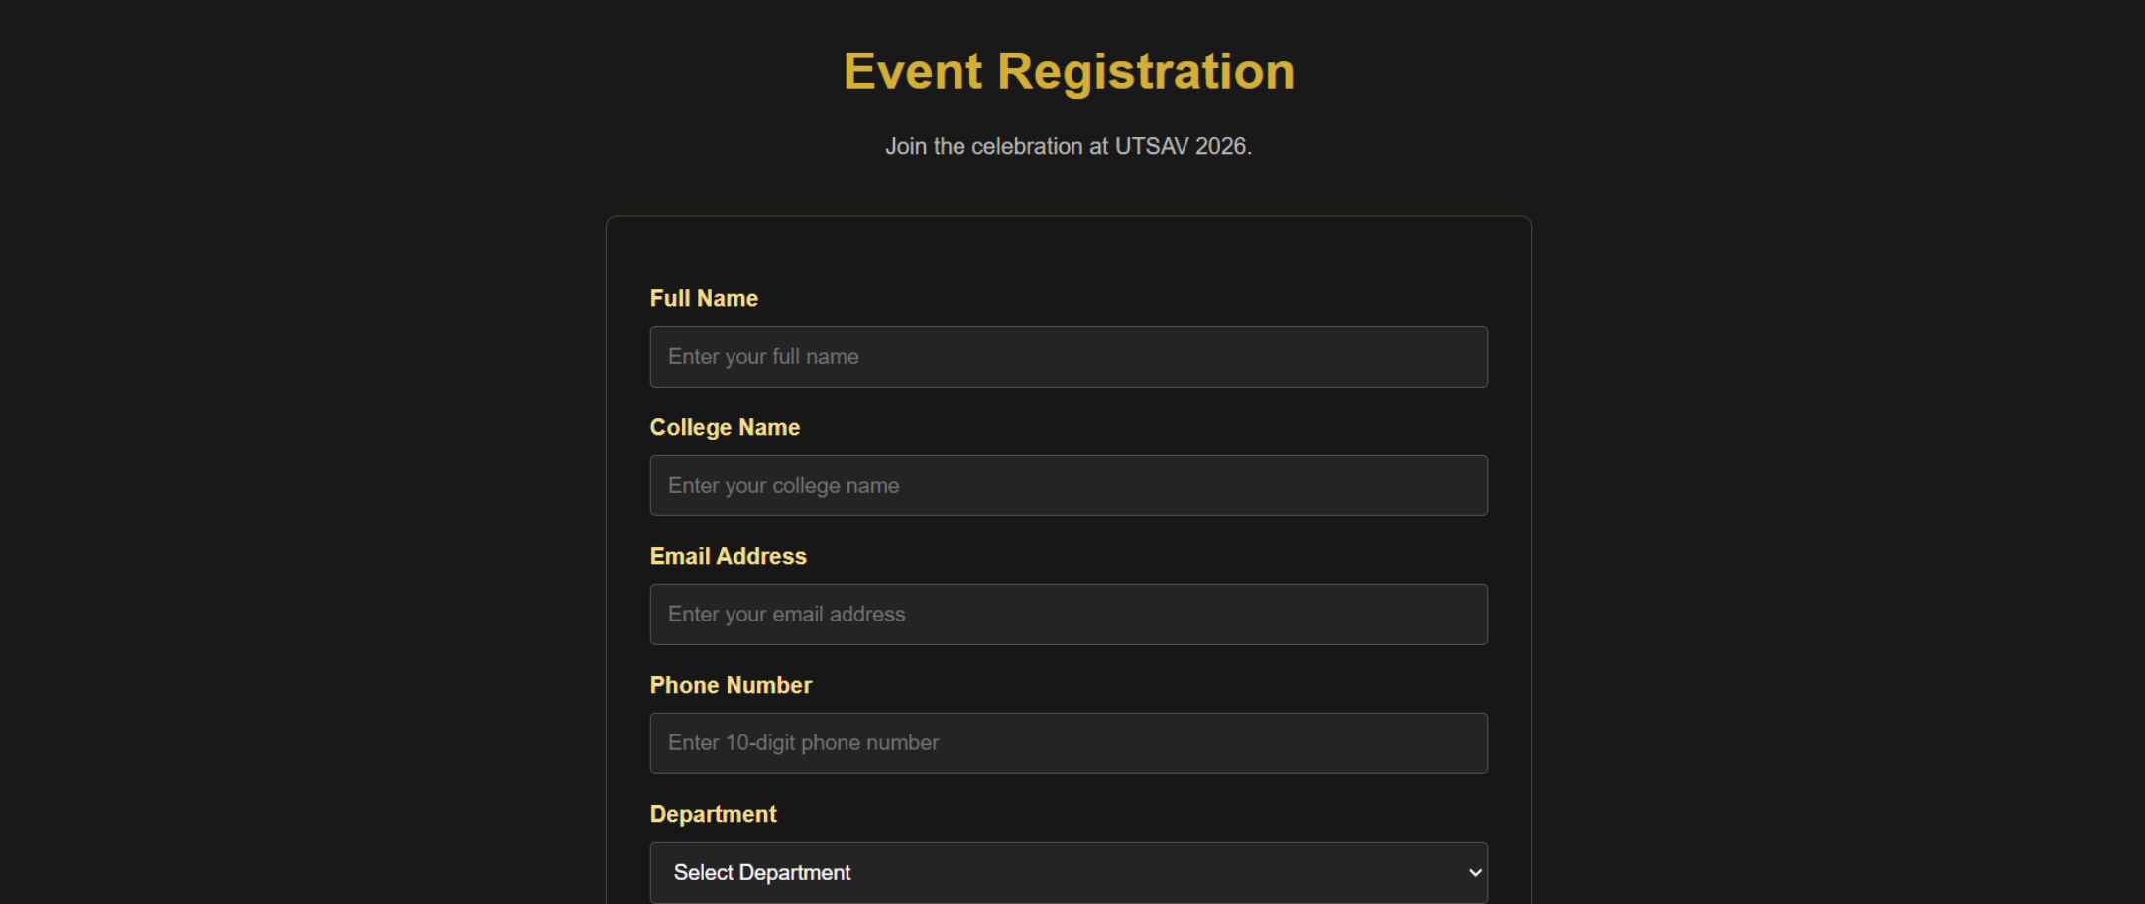
Screenshot 10 — Footer: closes the page with festival identity and supporting links.


Screenshot 11 — Additional page/section shown in the supplied PDF.


Example HTML structure
This generic starter illustrates the shared navigation, hero, card grid and footer structure. Change the labels and content for this project.
<!doctype html>
<html lang="en">
<head>
<meta charset="utf-8">
<meta name="viewport" content="width=device-width, initial-scale=1">
<title>Website</title>
<link rel="stylesheet" href="style.css">
</head>
<body>
<header class="site-header">
<a class="brand" href="#home">UTSAV 2026</a>
<nav aria-label="Main navigation">
<a href="#about">About</a>
<a href="#features">Features</a>
<a href="#schedule">Schedule</a>
<a href="#contact">Contact</a>
</nav>
</header>
<main>
<section class="hero" id="home">
<p class="eyebrow">WELCOME</p>
<h1>Where Talent Meets Excellence</h1>
<p>A short introduction explaining what the site offers.</p>
<a class="button" href="#features">Explore More</a>
</section>
<section id="features">
<h2>Explore the Website</h2>
<div class="cards">
<article class="card"><h3>Feature One</h3><p>Short description.</p></article>
<article class="card"><h3>Feature Two</h3><p>Short description.</p></article>
<article class="card"><h3>Feature Three</h3><p>Short description.</p></article>
</div>
</section>
</main>
<footer id="contact">Contact details and copyright information</footer>
</body>
</html>

Example CSS layout
* { box-sizing: border-box; }
body { margin: 0; font-family: Arial, sans-serif; line-height: 1.6; }
.site-header { display:flex; justify-content:space-between; align-items:center;
gap:1rem; padding:1rem 6%; }
nav { display:flex; flex-wrap:wrap; gap:1rem; }
a { text-decoration:none; }
.hero { text-align:center; padding:5rem 1.5rem; }
.hero h1 { font-size:clamp(2rem, 5vw, 3.5rem); margin:.25rem 0; }
.button { display:inline-block; padding:.7rem 1.2rem; border-radius:4px; }
section { padding:3rem 6%; }
.cards { display:grid; grid-template-columns:repeat(auto-fit,minmax(220px,1fr)); gap:1rem; }
.card { padding:1.2rem; border-radius:8px; }
footer { padding:2rem; text-align:center; }
@media (max-width:600px) {
.site-header { align-items:flex-start; flex-direction:column; }
nav { gap:.6rem; }
}

How the code works
- HTML defines the page sections and content hierarchy.
- CSS controls colors, spacing, typography, cards and responsive layout.
- The grid uses auto-fit/minmax so cards can wrap to fit smaller screens.
- The media query changes the header layout on narrow screens.
- Navigation links jump to sections with matching IDs; buttons can link to registration, admissions or trip details.

College Website
A red-and-white university website. Screens show the welcome page, reasons to choose the college, About section, departments, faculty members, admissions, campus facilities, events and contact information.

Purpose and design explanation
Use a white/light background with red accents for headings, separators and calls to action. Keep information sections consistent, use card grids for departments/facilities, and use clear headings for admissions and contact details. Replace placeholder details with verified institutional information.

Screenshot guide
Screenshot 1 — Home page: university branding, navigation and a prominent welcome message.
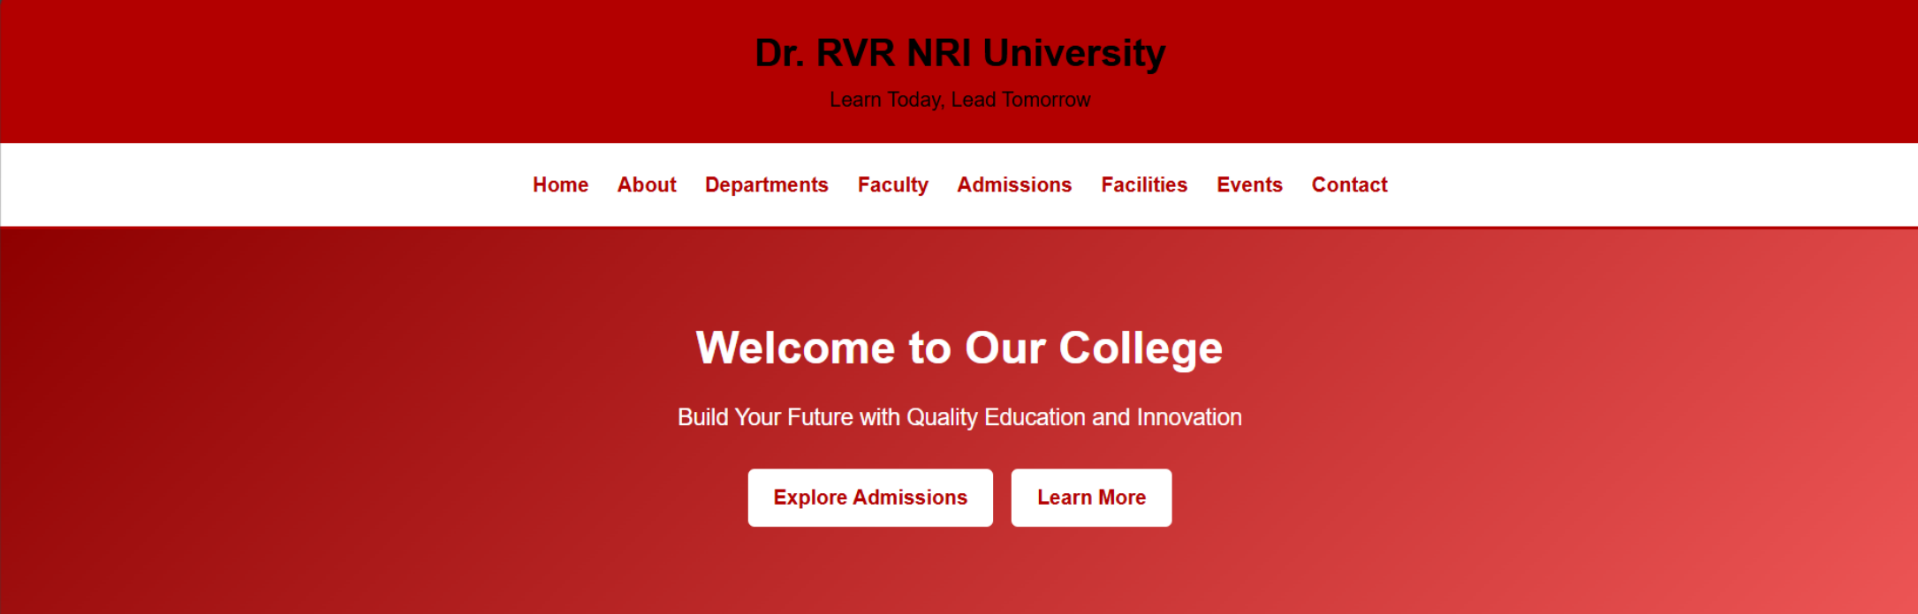
Screenshot 2 — Why Choose Our College: feature cards communicate strengths and benefits.


Screenshot 3 — About Our College: structured text introduces the institution and its values.
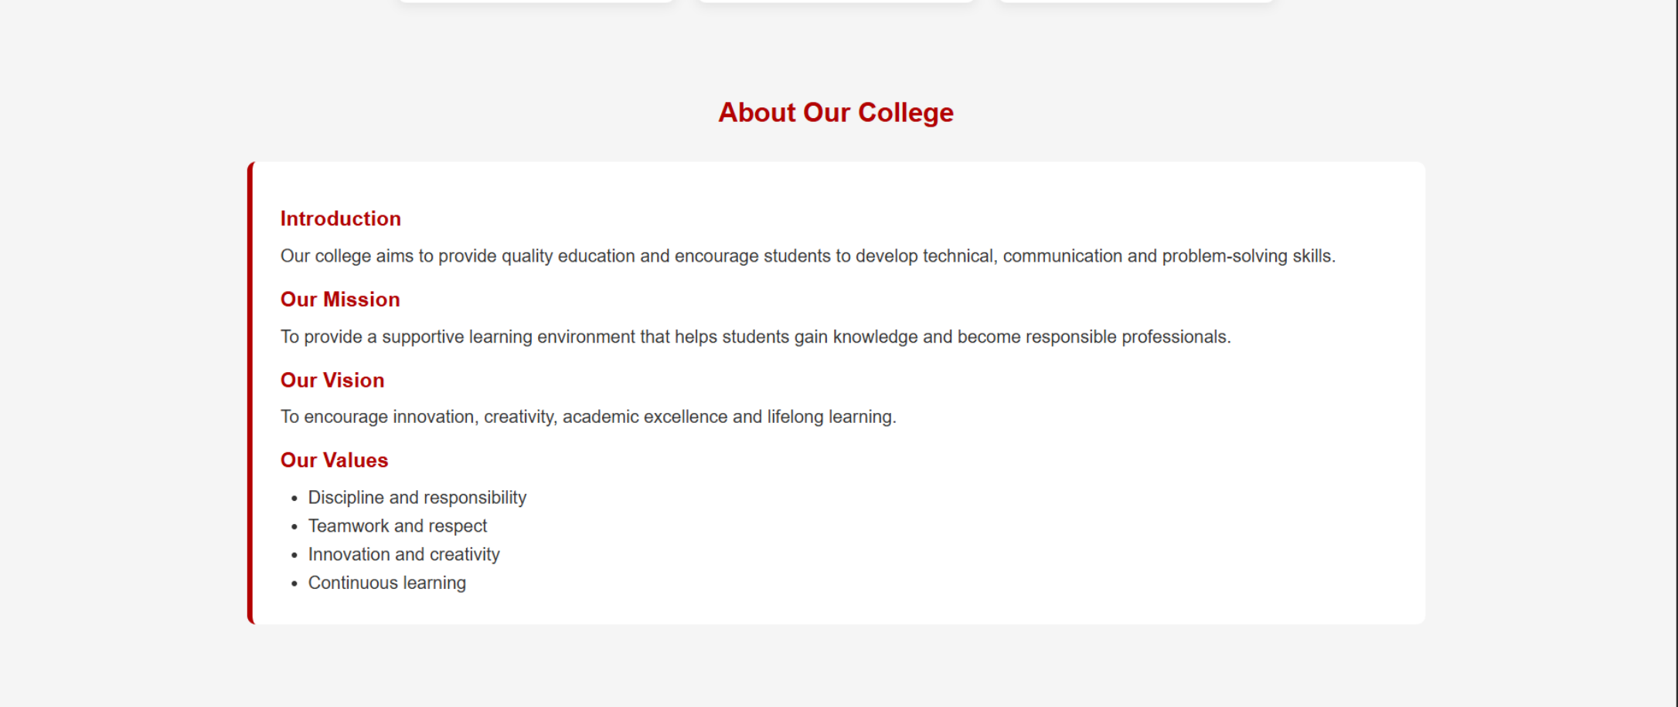
Screenshot 4 — Our Departments: cards list academic departments.
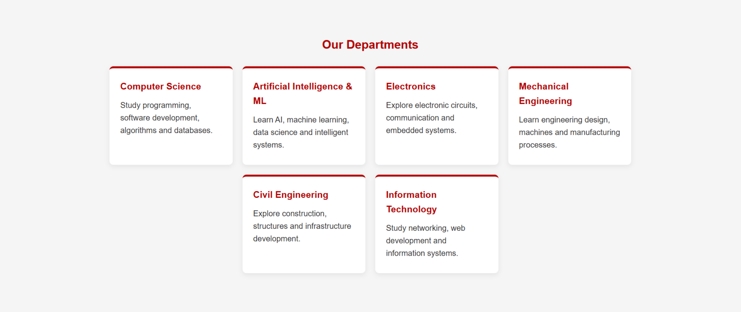

Screenshot 5 — Our Faculty Members: grouped profile cards introduce faculty members.
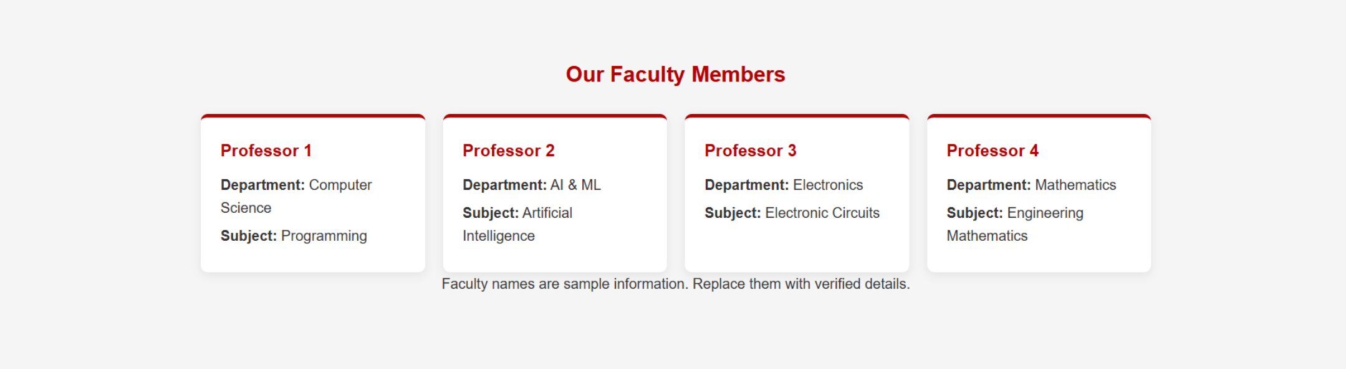
Screenshot 6 — Admissions Information: a content panel explains the admission process.
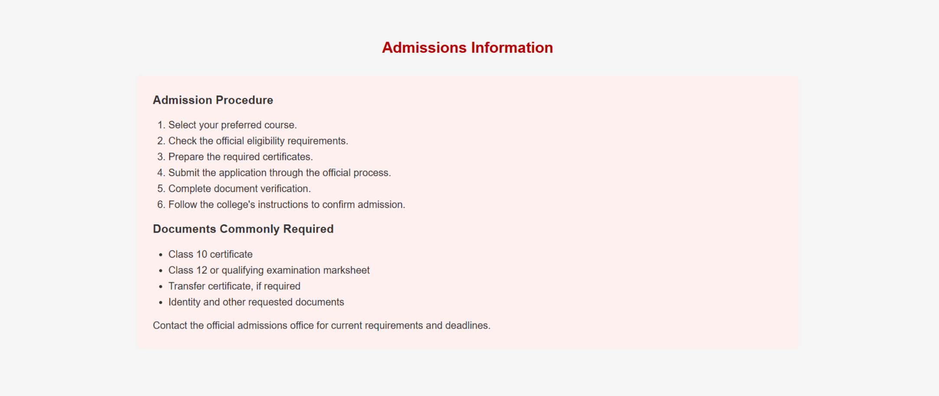

Screenshot 7 — Campus Facilities: cards summarize facilities available to students.
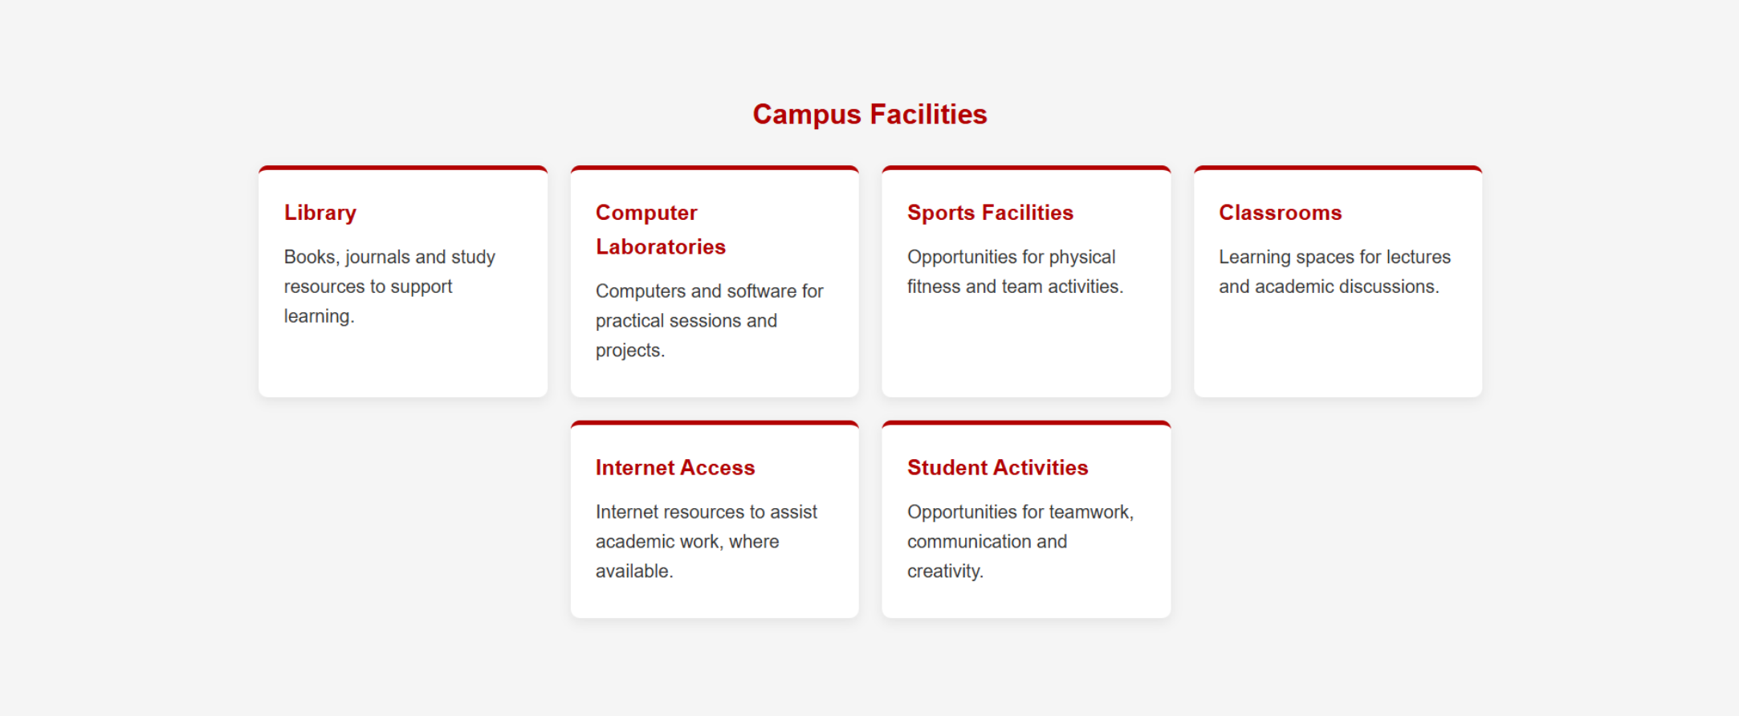
Screenshot 8 — College Events and Activities: cards advertise campus events and activities.
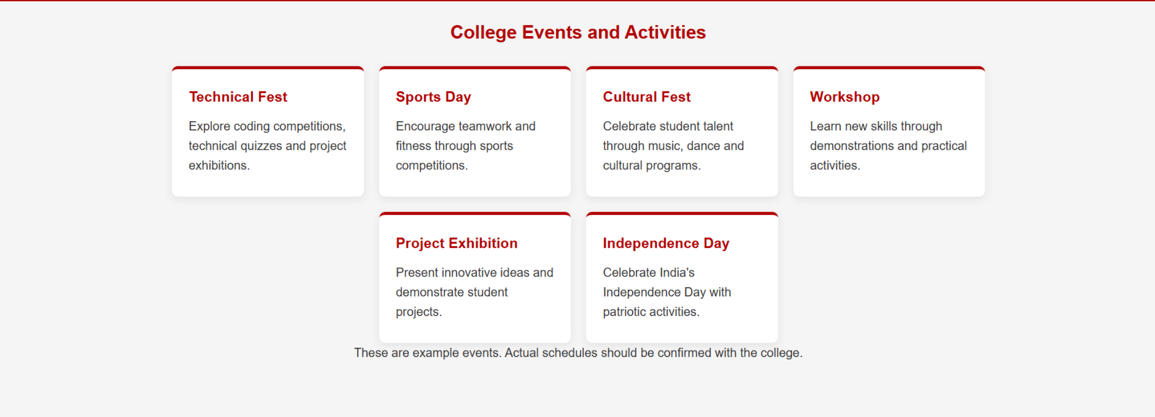

Screenshot 9 — Contact Us: the final section presents institution contact information.
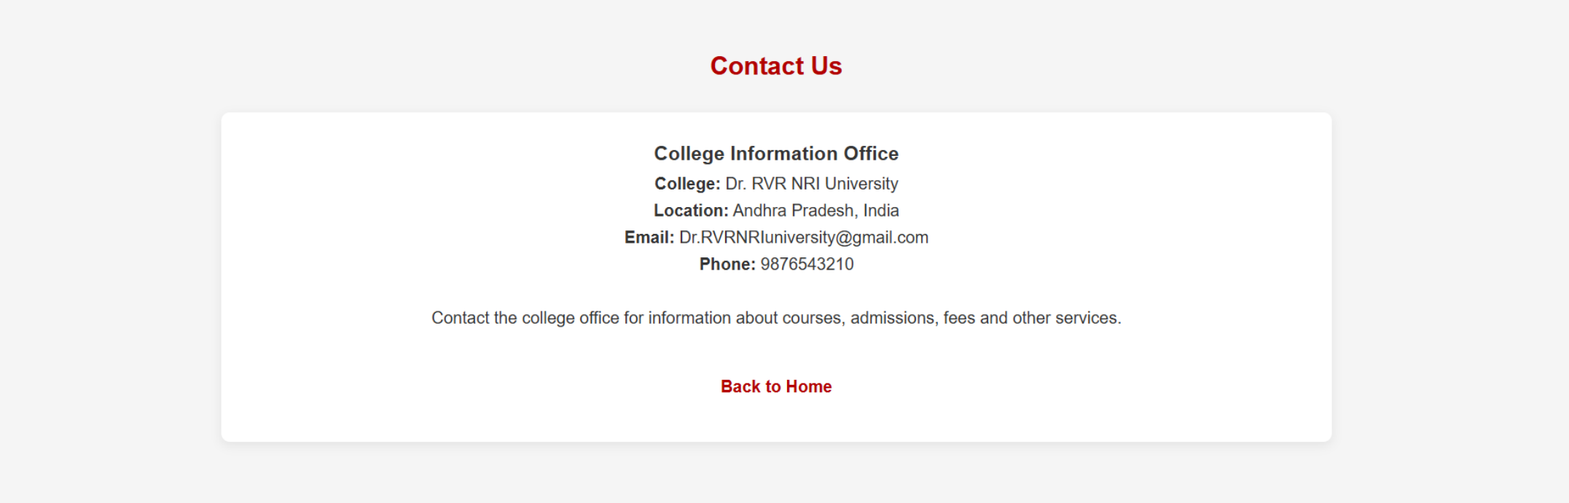

Example HTML structure
This generic starter illustrates the shared navigation, hero, card grid and footer structure. Change the labels and content for this project.
<!doctype html>
<html lang="en">
<head>
<meta charset="utf-8">
<meta name="viewport" content="width=device-width, initial-scale=1">
<title>Website</title>
<link rel="stylesheet" href="style.css">
</head>
<body>
<header class="site-header">
<a class="brand" href="#home">College Name</a>
<nav aria-label="Main navigation">
<a href="#about">About</a>
<a href="#features">Features</a>
<a href="#schedule">Schedule</a>
<a href="#contact">Contact</a>
</nav>
</header>
<main>
<section class="hero" id="home">
<p class="eyebrow">WELCOME</p>
<h1>Welcome to Our College</h1>
<p>A short introduction explaining what the site offers.</p>
<a class="button" href="#features">Explore More</a>
</section>
<section id="features">
<h2>Explore the Website</h2>
<div class="cards">
<article class="card"><h3>Feature One</h3><p>Short description.</p></article>
<article class="card"><h3>Feature Two</h3><p>Short description.</p></article>
<article class="card"><h3>Feature Three</h3><p>Short description.</p></article>
</div>
</section>
</main>
<footer id="contact">Contact details and copyright information</footer>
</body>
</html>

Example CSS layout
* { box-sizing: border-box; }
body { margin: 0; font-family: Arial, sans-serif; line-height: 1.6; }
.site-header { display:flex; justify-content:space-between; align-items:center;
gap:1rem; padding:1rem 6%; }
nav { display:flex; flex-wrap:wrap; gap:1rem; }
a { text-decoration:none; }
.hero { text-align:center; padding:5rem 1.5rem; }
.hero h1 { font-size:clamp(2rem, 5vw, 3.5rem); margin:.25rem 0; }
.button { display:inline-block; padding:.7rem 1.2rem; border-radius:4px; }
section { padding:3rem 6%; }
.cards { display:grid; grid-template-columns:repeat(auto-fit,minmax(220px,1fr)); gap:1rem; }
.card { padding:1.2rem; border-radius:8px; }
footer { padding:2rem; text-align:center; }
@media (max-width:600px) {
.site-header { align-items:flex-start; flex-direction:column; }
nav { gap:.6rem; }
}

How the code works
- HTML defines the page sections and content hierarchy.
- CSS controls colors, spacing, typography, cards and responsive layout.
- The grid uses auto-fit/minmax so cards can wrap to fit smaller screens.
- The media query changes the header layout on narrow screens.
- Navigation links jump to sections with matching IDs; buttons can link to registration, admissions or trip details.

WildTrails Adventure Website
An outdoor-adventure website with nature imagery and green/orange accents. Screens show the landing page, trekking routes, camping adventures, trip schedule, equipment checklist, safety guidelines, packages and a final call to action.

Purpose and design explanation
Use large outdoor images, spacious layouts and green/orange accents. Use responsive cards for routes and packages, and tables or lists for schedules and checklists. Booking/payment functionality is not confirmed by the screenshots and would need separate implementation.

Screenshot guide
Screenshot 1 — Landing page: large nature imagery and a bold headline set the adventure theme.
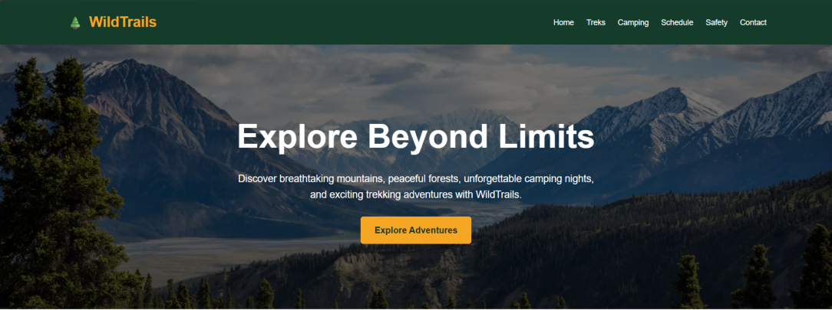
Screenshot 2 — Popular Trekking Routes: route cards combine photos, short summaries and action buttons.
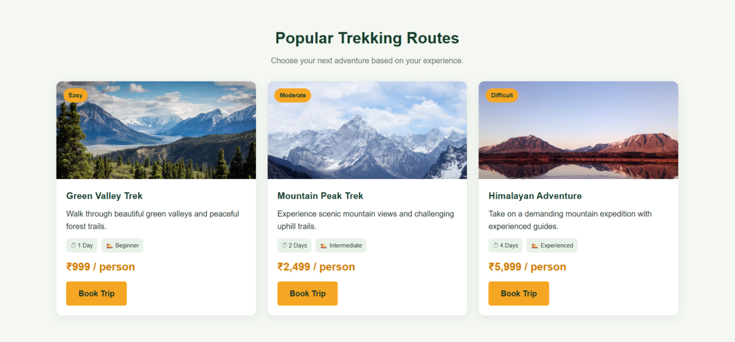

Screenshot 3 — Camping Adventures: image-led cards introduce camping options.
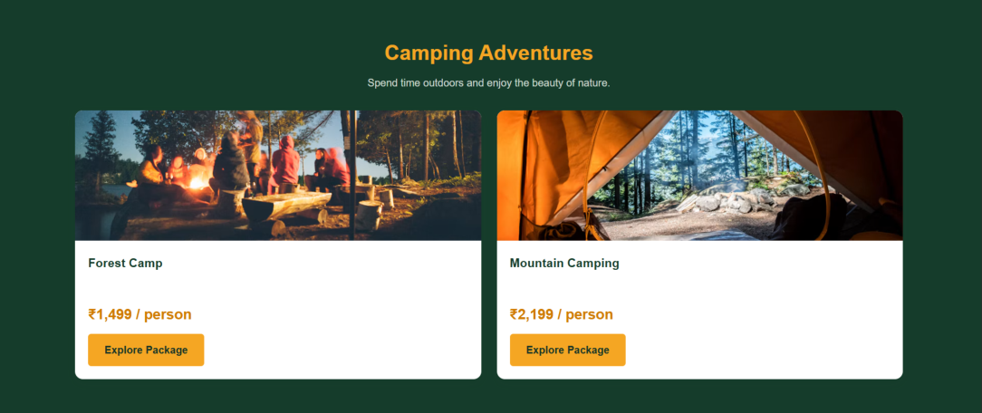
Screenshot 4 — Trip Schedule: a table makes dates or trip details easy to compare.
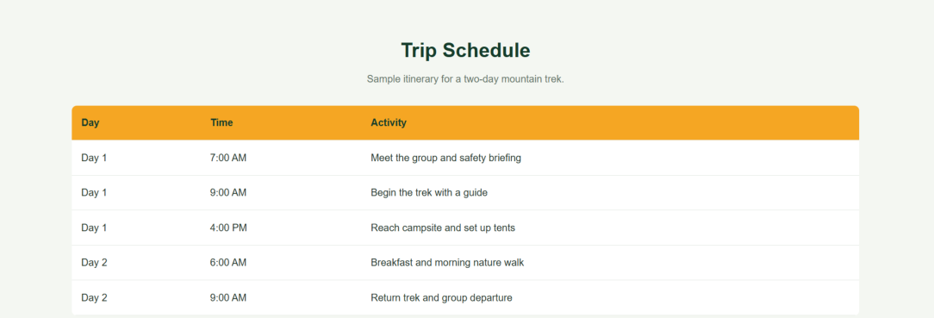

Screenshot 5 — Equipment Checklist: checklist groups help visitors prepare for a trip.
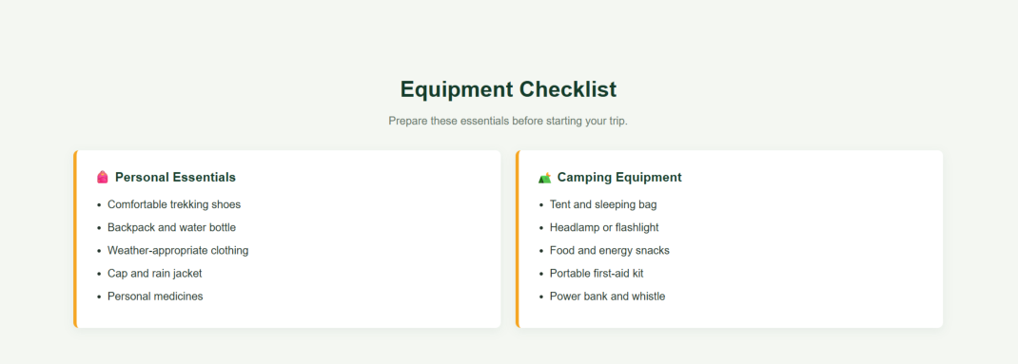
Screenshot 6 — Safety Guidelines: concise guidance is separated into readable blocks.
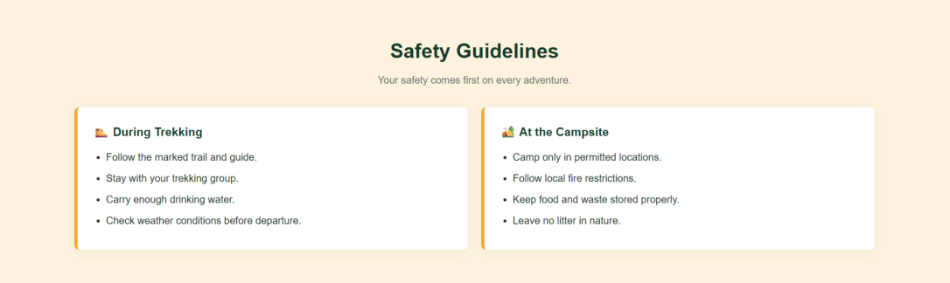

Screenshot 7 — Adventure Packages: package cards summarize different trip options.
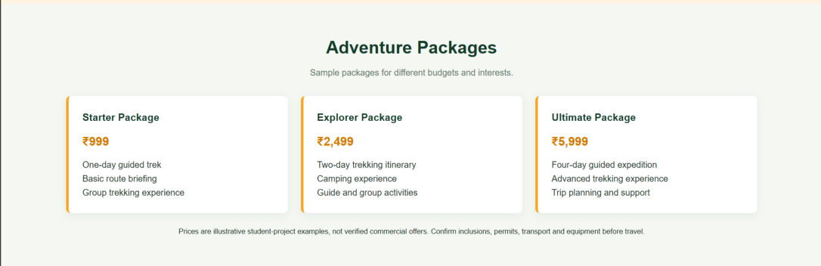
Screenshot 8 — Final call to action: invites visitors to take the next step.


Example HTML structure
This generic starter illustrates the shared navigation, hero, card grid and footer structure. Change the labels and content for this project.
<!doctype html>
<html lang="en">
<head>
<meta charset="utf-8">
<meta name="viewport" content="width=device-width, initial-scale=1">
<title>Website</title>
<link rel="stylesheet" href="style.css">
</head>
<body>
<header class="site-header">
<a class="brand" href="#home">WildTrails</a>
<nav aria-label="Main navigation">
<a href="#about">About</a>
<a href="#features">Features</a>
<a href="#schedule">Schedule</a>
<a href="#contact">Contact</a>
</nav>
</header>
<main>
<section class="hero" id="home">
<p class="eyebrow">WELCOME</p>
<h1>Explore Beyond Limits</h1>
<p>A short introduction explaining what the site offers.</p>
<a class="button" href="#features">Explore More</a>
</section>
<section id="features">
<h2>Explore the Website</h2>
<div class="cards">
<article class="card"><h3>Feature One</h3><p>Short description.</p></article>
<article class="card"><h3>Feature Two</h3><p>Short description.</p></article>
<article class="card"><h3>Feature Three</h3><p>Short description.</p></article>
</div>
</section>
</main>
<footer id="contact">Contact details and copyright information</footer>
</body>
</html>

Example CSS layout
* { box-sizing: border-box; }
body { margin: 0; font-family: Arial, sans-serif; line-height: 1.6; }
.site-header { display:flex; justify-content:space-between; align-items:center;
gap:1rem; padding:1rem 6%; }
nav { display:flex; flex-wrap:wrap; gap:1rem; }
a { text-decoration:none; }
.hero { text-align:center; padding:5rem 1.5rem; }
.hero h1 { font-size:clamp(2rem, 5vw, 3.5rem); margin:.25rem 0; }
.button { display:inline-block; padding:.7rem 1.2rem; border-radius:4px; }
section { padding:3rem 6%; }
.cards { display:grid; grid-template-columns:repeat(auto-fit,minmax(220px,1fr)); gap:1rem; }
.card { padding:1.2rem; border-radius:8px; }
footer { padding:2rem; text-align:center; }
@media (max-width:600px) {
.site-header { align-items:flex-start; flex-direction:column; }
nav { gap:.6rem; }
}

How the code works
- HTML defines the page sections and content hierarchy.
- CSS controls colors, spacing, typography, cards and responsive layout.
- The grid uses auto-fit/minmax so cards can wrap to fit smaller screens.
- The media query changes the header layout on narrow screens.
- Navigation links jump to sections with matching IDs; buttons can link to registration, admissions or trip details.

How to run and customize the example
- Create a project folder and save the HTML as index.html.
- Save the CSS example in a file named style.css and connect it using the link element in the HTML head.
- Open index.html in a modern browser to preview the static page.
- Replace generic text with the actual event, college or travel information shown in the screenshots.
- Add real image files and reference them with img elements or CSS background-image rules.
- For working registration/booking forms, implement server-side validation, data storage and privacy/security controls; a visual form alone does not submit or store data.

Conclusion
The supplied screenshots show three distinct website concepts: a festival event portal, a college information site, and an adventure travel site. Their page structures can be implemented with reusable HTML sections and responsive CSS. The original source code was not included in the PDFs, so the code samples are learning examples rather than exact source recovery.

