CURRICULUM
VITAE

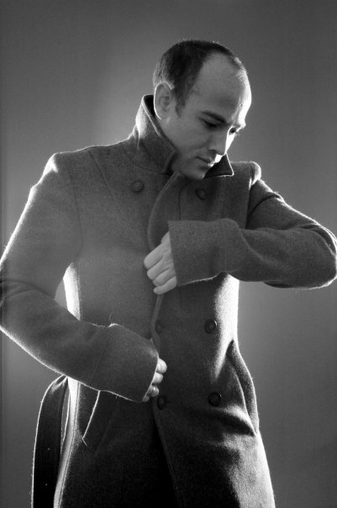

REUBEN TURKIE

REUBEN TURKIE

10 Newport Street
Victoria Park
Bristol
BS3 4ST

07793144403 / 01179720214

iinfo@rtphotography.me.uk / rturkie@me.com

Date of Birth: 18 May 1979

Personal Attributes:
Extremely self motivated young individual, with plenty of initiative and spark. With management experience I have good leadership skills as well as being an excellent group worker. Good track record with sales targets, as well as having a creative and business minded personality. Having worked in the capacity of sales leader I have also implemented sales targets and staff incentives. Strategic fundraising, marketing and PR have been an integral role of mine within employment and being self-employed also. My creative drive has seen my professional photography career through the past 8 years in varying capacity as both freelance contact and full time. I am focused, well organised, ambitious and prepared to learn and excel in any given task or field. With outstanding social and communication skills, I have the ability to adopt my presentational and public relations skills always. Good fun to be around, patient and vibrant character. I have an excellent attendance and punctuality history in all employment.

I also have a full UK driver’s license.

EDUCATION:
University of Westminster, Harrow Campus. | Sept 1999 - June 2002 | BA Hons – Photographic and Digital Arts
Christ The King Sixth Form College, Lewisham, London. | Sept 1996 – June 1998 | 3 A Levels: Photography A; Media Studies C; English D.
Thomas Tallis School, Kidbrooke, London. | Sept 1990 – June 1995 | 12 GCSEs: English Lit/Lang A/B; Drama A; S.R.E. B; Music B; Maths C; Sciencex2 C/C; History C; Graphics D; I.T. D; Italian E.

Extra Curricular Education / Courses
London College Of Printing | Summer 94 | Assistant to audio visual technician
Royal Academy Of Dramatic Arts | Summer 94 | Summer course in which I got to direct and act in a Ken Campbell script, performed on stage at R.A.D.A.’s in house theatre.

PROFESSIONAL EXPERIENCE

Company / Job Title | Period | Job Description
RT Photography  Managing Director and Photographer.  (Self Employed – Full Time) | Jul 06 – Present | Managing Director and Photographer. Generating new business, marketing and client liaison. Applying for fundraising through community based initiatives, as well as strategic marketing, PR and business development. Fulfilling all administrative roles such as finance, staff contracts, scheduling and booking co-ordination. Concept development and staff training. Digital retouching and manipulation using creative software ranging from Photoshop CS5, Illustrator to Lightroom and Aperture for MAC. Some web based programming including flash, Dreamweaver and back end management using C Panel and Squirrel Mail. Appointments and scheduling software – ACT V.5 and iCal / Macs’ address book. Recent synchronisation with MACS incredible Mobile Me. Work training of staff, clients and companies alike in Photography and digital retouching using Photoshop CS3.
Epic Photography  Photographer/Studio Manager / Sales leader / Art Editor  (Full Time) | Dec 03 - Jul 06 | Photographer, Studio Manager and Sales Leader, Retoucher, Art and Advertising Design. Art work and layout design for the companies advertising. Senior studio photographer. Training and motivating staff, delegating responsibilities and resolving any disputes. Continual liaison with the Managing Director for new fundraising opportunities. Software usage (as above). With training in both Photography and some limited SAGE finances instructions as well as Excel sales management. Advanced Photoshop retouching and digital manipulation.
Laura Ashley  Sales Leader  (Part Time) | Sept 03 – Dec 03 | Sales Leader. This was a team-building role to reach targets and finding constructive incentives to encourage staff.
Sydney Cultural Council – McDonalds City Eisteddfod. Performing Arts Challenge  Event Staff Coordinator and Assistant Administrator / Graphic Designer.  (Full Time) | June 03 – Aug 03 (3 Month Australian work permit) | Event Staff Coordinator and Assistant Administrator. Working with software such as excel, PowerPoint and ACT for scheduling, finance and general organisation of performances. Although I had a Junior and temporary role, I was included in the planning for funding from the McDonalds sponsorship of the event.

Company / Job Title | Period | Job Description
Cynergy Marketing, Sydney  Corporate Logo Design Commission / BSB and Canvassing Sales  (Full Time) | Mar 03 – May 03 (3 Month Australian work permit) | Charity Sales Person. Business to business sales, of monthly contributions to Sydney City Mission - a homelessness charity organisation. Mobile devices used such as palm pilots. With decent team based training. I also helped implement the design of their new charitable identity in the form of brand and logo design.
Snappy Snaps  Lab Printer / Customer Services  (Part Time) | Aug 02 – Jan 03 | Lab Technician: Operating all lab machines including: C3, C41, E6 printing, digital printing restoration and reproduction. Digital printing and early reprographic and manipulation work. Customer service including design and presentation advice.
Clifton Photographic Company  Studio Photographer  (Freelance) | Aug 02 – Jan 03 | Freelance photographer, doing makeover shoots. Also involved with digital retouching and Photoshop image enhancement. With good training and guidance. Some iPhoto based viewing software.
Double Take Studios  Studio Photographer  (Freelance) | Nov 02 – Jan 03 | Portrait and Portfolio Photographer. File transfers using highest speed USB 2 of that era.
Bama & Co  PA, PR, Marketing and Sales  (Part Time) | Aug. 00 – Jan. 01 & Sept. 01- Feb 02 | Professional Assistant, Public Relations , Marketing and Sales Person. Worked promoting and marketing the company, during its early stages. Also worked as an agent looking for artists to exhibit in the gallery section. Mainly PC and Microsoft Office based.
As Nature Intended – Organic Supermarket  Sales Assistant / Cashier  (Part Time) | Feb 01 – May 01 | Part-time sales assistant/cashier during University education.
Clifton Pro – Lab / Paul Guest  Photography  Customer Relations and  Assistant Manager  (Part Time) | Jun 01 – Sept 01 | Lab Technician: Laboratory technician operating C – 41 and E6 developing and printing machines. Digital printing and early reprographic and manipulation work. Customer service including design and presentation advice. Summer holiday.

Company / Job Title | Period | Job Description
Jessops – The World Photographic Centre  Sales Assistant (Part Time) | Nov 99 – Jun 00 | Photographic Advice / Customer Service
Bonusprint  Sales Assistant (Full Time) | Aug – Dec 98 | Photographic Advice / Customer Service: Photographic Advisor / Mini Lab Technician and Printer / Customer Service
Metro Video Soho  Runner  (Full Time) | Jun – Aug 98 | Runner / Video duplications, installing Avid digital editing suites.
United Colors Of Beneton  (Full Time) | Oct. 96 – Dec. 97 | Sales Assistant.
Interactive PR  PR / Marketing  (Full Time) | Jul – Sept 96 | Assistant PA / PR and Marketing: Promoting, marketing and handling tours / events for various pop and independent bands including – Backstreet Boys, 911 and Osmosis. Mainly PC and Microsoft Office based.
Live TV (Full Time Work Experience -Semi – Paid) | April – Jul 96 | Assistant Researcher / On – line editor and directing raw footage.
W.H. Smith  (Full Time) | Oct 95 – Feb 96 | Sales Assistant

PROFESSIONAL AND CHARACTER REFERENCES AVAILABLE ON REQUEST

