**ALOHA TOURS AND TRAVELS**

**ABSTRACT**

Aloha Tours and Travels project provides great chances for users to obtain rich information. Particularly, tourists want to easily get tremendous information about their tourism plans. Therefore, in this paper, we aim to design a tourism resources management system and guide the tourists to plan their travel routes. In general if any user plans for any tour they must consult any traveling agency for purchasing package. At the same time the user has to do traveling reservations from source to destination, hotel reservations at destination place and other travel reservations from destination to other places, this involves lot of manual work. For all these type of reservations must be done by user by standing lot of time in a queue. To avoid these problems to reduce the manual work to the user new project was developed i.e. Aloha Tours and Travels.

Keywords: Tours, booking ,payment ,bill ,reviews

**EXISTING METHOD**

In the existing system, all the records are not kept perfectly because all the work is done manually, so keeping up to date details of the places is not perfectly followed .User can view the places and need to search for he places and book the places. Manually a person has to go and search for the places in a particular place ,it will take a lot of time to do such process, in the existing system. It will consumes money also.

**Drawbacks:**

* It is time consuming.
* Manual searching.
* Data is secured.

**PROPOSED METHOD**

Aloha Tours and Travels is the project which gives all the required facilities to their customers when they are ready to plan for any tour. By using this portal the user can book any places and also it provides help to the users .User can book the places and give the review regarding to that tour. Then other users can easily get the feedback of that place by viewing the review.

**Advantages:**

* Data will be stored systematically and accurately.
* Computerized work.
* Easy to analyze the tours and reviews
* Reducing the transport cost.

**HARDWARE & SOFTWARE REQUIREMENTS**

# H/W SYSTEM CONFIGURATION:-

# Processor - I3/Intel Processor

* RAM - 4GB (min)
* Hard Disk - 160GB
* Key Board - Standard Windows Keyboard
* Mouse - Two or Three Button Mouse
* Monitor - SVGA

**S/W SYSTEM CONFIGURATION:-**

* Operating System : Windows 7/8/10
* Application Server : Tomcat 9.0
* Front End : React js ,Html, Css
* Scripts : JavaScript.
* Technology : Node Js
* Database : My SQL 6.0
* Database Connectivity : JDBC

**ARCHITECTURE**

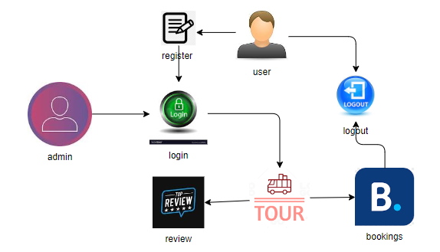

**SYSTEM ANALYSIS**

**MODULES:**

**1. Admin:**

Admin login with their credentials. Admin can add the details of tourist place that can view the customers .

**View Tours:** Admin can view the tours added by him

**View Customers:** Admin can view the newly added customers .

**View Bookings:** Admin can view all the bookings that are done by the customer.

**2. User:**

User can register and login with the correct credentials, user can view the places, that are added by the admin

**Book Tour:** User can book the tour that are added by the admin. After book the tour user need to pay amount for the booking. User able to give the review for the particular tourist place.

**My bookings:**  After booking completed user can view the booking that are done by him/her.

**Settings:** User can change the profile by changing their details and by adding photo.

**My Reviews:**  User can view the reviews that are give by him/her.

**Billing:**  User can able to view the billing details.