**FARMER ASSISTANT PORTAL**

**ABSTRACT**

The amazing developments in science and technology have raised the bar for human living standards. Without these improvements, the entire planet will be physically congested. Compared to other projects now in existence, this project is innovative in that it simplifies the process of getting farming. Java has been used to implement this project. The project's goal is to create an application software to lessen the human labour involved in keeping track of the farming of different crops consumed by people and getting farming on different ways based on

seasonal wise. The fast changing environment, including difficult market conditions and a high exposure to financial risks are major reasons for changing production policy. Farm Management Systems appear to be a powerful tool to deal with the new conditions. However, farmers still rely more on their intuition than on proper management tools, when it comes to running a farm business. Many farmers do not use Farm management for various reasons, like lack of knowledge and the complexity of many available farm managements. In particular for small to medium-sized farms and for multifunctional farms appropriate farm management hardly exist.

**Keywords:** Farming, Crops, Products , Admin, Customer, Orders etc.

**STATEMENT ABOUT THE PROBLEM**

The successful implementation of the Farmer Assistant Portal will empower farmers with knowledge, resources, and connections necessary to thrive in their agricultural pursuits. This digital solution has the potential to elevate agricultural productivity, boost rural economies, foster sustainable practices, and enhance the overall quality of life for farmers and their communities.

**WHY IS THE PARTICULAR TOPIC CHOSEN?**

Farmer Assistant Portal is chosen to leverage technology to uplift agricultural practices, enhance the livelihoods of farmers, bridge information gaps, promote sustainability, and contribute to rural development and economic growth. It represents a holistic approach to tackling the multifaceted challenges faced by farmers in today's complex agricultural landscape.

**SCOPE**

The scope of the Farmer Assistant Portal is vast, aiming to provide a holistic solution that empowers farmers with the tools, knowledge, and connections they need to enhance their agricultural practices, increase productivity, and improve their livelihoods. The specific scope can be tailored based on the target audience, geographical region, and technological capabilities.

**OBJECTIVE OF THE PROJECT:**

The objective of the Farmer Assistant Portal project is to empower farmers with the knowledge and resources they need to make informed decisions, implement modern practices, and thrive in their agricultural pursuits, thereby creating a positive impact on their lives and the agricultural sector as a whole.

**Existing System**

People now a days use a manual process for buying products and required things, due to some reasons. They have got used to the manual process and they can go along with it even though there are concerns associated with it. They are reluctant to change their current process since it will be an extra effort. The farm management for a new solution. However, the customers face immense problems with the current procedure of using this manual process to getting formation items.

**Disadvantages**

**1.** **Not User Friendly:** The existing system is not user friendly because the retrieval of data is very slow and data is not maintained efficiently.

**2.** **Difficulty in report generating:** We can’t able see the all the tourism places information. And the people not get at the time of searching for tour.

**3.** **Manual control:** people may be get some wrong information from diffrent resources .

**4.** **Time consuming:** Every work is done manually so we cannot get the information in the middle of the tour or as per the requirement because it is very time consuming.

**3.3 Proposed System**

To overcome the problem with an existing system, we are implementing an application called farm management system using java. Using this application customers can get all the products information via through his own accounts. After that customer can able to add products to the cart and buy the required things through online.

**3.4 Advantages**

**1.** **User Friendly:** - The proposed system is user friendly because the retrieval and storing of data is fast and data is maintained efficiently. Moreover the graphical user interface is provided in the proposed system, which provides user to deal with the system very easily.

**2.** **Reports are easily generated:** reports can be easily generated in the proposed system so user can get information at anytime

**3. Very less work:** The proposed system requires very less work. All the data is fetched into the computer immediately and reports can be generated through computers. Moreover work becomes very easy because there is no need to keep data on papers.

**4. Computer operator control:** Computer operator control will be there so no chance of errors. Moreover storing and retrieving of information is easy. So work can be done speedily and in time.

**PROJECT FLOW:**

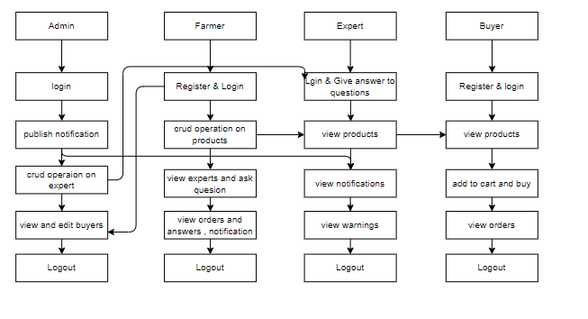

**SOFTWARE FRONT END REQUIREMENTS**

# **H/W CONFIGURATION:**

# Processor - I3/Intel Processor

Hard Disk - 160GB

Key Board - Standard Windows Keyboard

Mouse - Two or Three Button Mouse

Monitor - SVGA

RAM - 8GB

**S/W CONFIGURATION:**

Operating System : Windows 7/8/10

Frontend : React JS

Programming Language : Java

Libraries : Spring boot

IDE/Workbench : IntelliJ IDEA

Technology : java 1.7+

Server Deployment : Tomcat Server

**MODULES/IMPLEMENTATION**

**Admin:**

Operation-**Login:** Admin will login into the application by entering the valid details like (username and password).

**Publish Notification:** Admin can publish the notifications.

**CRUD Operations on Expert:** Admin can manage expert like add, read, update, delete.

**View Buyers:** Admin can view all the buyers and also edit

**Farmer:**

Operation-**Login:** Farmer will login into the application by entering the valid details like (username and password).

**View Profile:** Farmer can view and update his profile.

**CRUD Operations on Product:** Farmer can manage product like add, read, update, delete.

**View Expert:** Farmer can view expert and ask questions.

**View Orders:** Farmer can view all orders.

**View Question & Answers:** Farmer can view all questions and answers.

**View Notification:** Farmer can view all notifications.

**Expert:**

**View Question&&Answers:** Expert can view questions and answers and respond to questions.

**View Products:** Expert can view all the products.

**View Notifications:** Expert can view all the notifications.

**View Warnings:** Expert can view all the warnings.

**Buyer:**

**View Products:** Buyer can view all the products.

**Add to cart:** Buyer can add the products to cart and buy.

**View Orders:** Buyer can view all the orders.