**FARMER’S BUDDY**

**ABSTRACT:**

This abstract outlines the key aspects of a farmer's soil check and addresses the doubts and concerns commonly associated with a farming project. The soil check is a crucial step in understanding the soil's composition and quality, which directly impacts the success and productivity of agricultural endeavors. By conducting a comprehensive soil analysis, farmers can make informed decisions regarding crop selection, fertilization strategies, and overall land management practices. Additionally, addressing doubts and concerns related to farming projects is essential for ensuring optimal planning and execution, as it helps farmers overcome potential challenges and achieve desired outcomes. This abstract provides a brief overview of the significance of soil testing and addresses common doubts faced by farmers during the implementation of farming projects.

**Keywords**: Farming, Soil checking, questions, answers, Farmer , Panchayath.

**STATEMENT ABOUT THE PROBLEM**

The current state of the farmer's soil quality assessment is inadequate, leading to suboptimal farming practices and reduced crop yields. There is a lack of accessible and accurate information about the soil composition, nutrient levels, and overall health, making it difficult for farmers to make informed decisions regarding fertilization, irrigation, and crop selection. This knowledge gap not only hampers the farmers' productivity but also has long-term negative implications for the environment and sustainability of agriculture

**WHY IS THE PARTICULAR TOPIC CHOSEN?**

Soil is a fundamental component of agriculture and plays a crucial role in determining crop productivity, nutrient availability, and overall plant health. Understanding the soil's composition and health is essential for making informed decisions related to fertilization, irrigation, and crop selection.

**SCOPE:**

The scope of the project "Farmers Buddy" can vary depending on the specific objectives and features of the application. Develop a methodology for proper soil sampling, including determining the sampling locations, depth, and quantity of soil samples needed for accurate analysis. Farmers may question the nutrient status of their soil and how to address nutrient deficiencies effectively.

**OBJECTIVE OF THE PROJECT:**

The objective of a farmer's Buddy check is to accurately assess the quality and health of the soil in order to optimize farming practices and improve crop yields. By conducting soil tests, farmers can determine the nutrient content, pH levels, organic matter, and other important parameters that directly impact plant growth. The goal is to provide farmers with actionable information and recommendations to make informed decisions regarding fertilization, irrigation, soil amendments, and crop selection. Ultimately, the objective is to enhance agricultural productivity, promote sustainable farming practices, and ensure long-term soil health

E**xisting System**

While soil checking provides numerous benefits, there are also some potential disadvantages to consider.

* 1. **Disadvantages**

**Cost**: Soil checking can involve expenses related to soil sampling kits, laboratory testing, and data analysis. The cost of conducting regular soil tests may be a barrier for small-scale or resource-constrained farmers, limiting their access to this valuable information.

**Time and Effort**: Soil checking requires time and effort to collect soil samples, send them for analysis, and interpret the results. This process can be time-consuming, especially for farmers with large land areas or limited labor resources.

**Complexity and Technical Knowledge**: Interpreting soil test results and understanding the recommendations can be challenging for farmers with limited scientific or technical knowledge. It may require additional training or support to effectively utilize the information obtained from soil checking.

**Limited Scope**: Soil checking provides insights into soil nutrient levels, pH, and some other parameters. However, it may not capture all aspects of soil health or factors that can influence crop growth, such as soil microbial activity, organic matter quality, and disease presence. Additional testing or assessments may be required to obtain a comprehensive understanding of soil conditions.

**Variability and Sampling Error**: Soil characteristics can vary significantly within a field due to factors like topography, soil texture, and management practices. Soil sampling at a few locations may not capture this variability accurately, potentially leading to sampling errors and misrepresentations of the overall soil condition.

**3.3 Proposed System**

The "Farmers Buddy" is a proposed system aimed at assisting farmers in various aspects of their agricultural activities. It leverages technology to provide valuable information, resources, and tools to enhance farm management, productivity, and profitability. While the specific features can vary, here are some key components that could be included in the Farmers Buddy system

**3.4 Advantages**

**Optimized Fertilization**: Soil checking allows farmers to assess the nutrient levels in their soil accurately. By knowing the nutrient deficiencies or excesses, farmers can apply fertilizers more precisely, avoiding wastage and reducing environmental impact.

**Improved Crop** **Productivity**: Soil checking helps farmers understand the soil's pH, organic matter content, and other parameters crucial for crop growth. By optimizing these factors, farmers can improve crop productivity and quality, leading to higher yields and better market value.

**Cost Savings**: By conducting soil checks, farmers can determine the precise nutrient requirements of their soil. This helps in avoiding unnecessary or excessive fertilization, reducing input costs, and maximizing resource utilization.

**Environmental** **Protection**: Soil checking helps farmers adopt more sustainable practices by minimizing nutrient runoff and leaching. By applying fertilizers judiciously, farmers can protect water bodies from contamination and reduce the ecological impact of farming.

**Applicability of Recommendations**: Farmers may have doubts about whether the recommended practices and amendments based on soil test results are suitable for their specific crops, local conditions, and farming systems.

**PROJECT FLOW:**

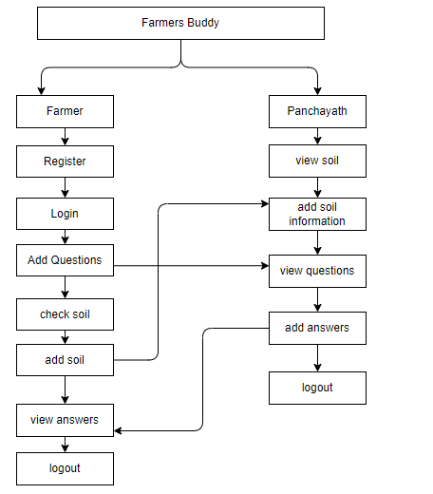

**SOFTWARE FRONT END REQUIREMENTS**

# **H/W CONFIGURATION:**

# Processor : - I3/Intel Processor

# Operating System : Windows 7/8/10

# Server side Script : react, CSS, Bootstrap & JS

# Programming Language : JavaScript

# Libraries : Node Js

# IDE/Workbench : VS Code

**S/W CONFIGURATION:**

Technology : JavaScript

Server Deployment : tomacat Server

Database : mongodb

**MODULES/IMPLEMENTATION**

**Farmer:**

Operation-**Register:** Farmer will register into the application by entering the valid details like (first Name, last Name ,phone number , email Address and password).

Operation-**Login:** Admin will login into the application by entering the valid details like (username and password).

Operation-**Manage Soil:** Add & Check

**Add Soil:** Farmer will add the soil with their details like(soil type, season, phosporous content ,nitrogen content , fertilizer per year , cost ).

**Add Question:** Farmer will add the questions with their details like(question)

**Check Soil:** The Famer will check the soil by giving the type of the soil and season.

Operation - **Sign out :** After completion of work he/she can logout the application.

**Panchayath :** Panchayathcan access the application by entering their login information

Operation - **Sign in:** Panchayathcan access the application by entering their login information (default login credentials like username and password )

Operations -**View Soil:** He/she will see the soil details and add some information about the soil

Operations -**View Question:** He/she will see the questions raised by the farmer and add answers to that question.

Operation - **Sign out :** After completion of work he/she can logout the application.