**Home services**

**ABSTRACT:**

There is very big need in the daily life with the electricians and plumbers and mechanics and painters and daily labors, there is no proper communication with them, if any need with them we need to search with different ways in offline. It may take time. Sometimes we could not find worker when we actually needed. There is no proper platform to communicate with them for work needs. If we try to find worker from local, he might have not skilled up to mark. To overcome, this app very much needs if any need occurred to user, he can raise the request and choose the available list of workers and select based on their experience and charges on what he can offer to the worker, other side workers can get the request based on their location. Both the application user and skilled workers listed with app get mapped based on nearest locations. Makes their transactions.

**KEYWORDS:** Home services, Find a worker, Plumber required, Help you, Skilled workers needed.

**STATEMENT ABOUT THE PROBLEM**

There is very big need in the daily life with the electricians and plumbers and mechanics and painters and daily labors, there is no proper communication with them, if any need with them we need to search with different ways in offline. It may take time. Sometimes we could not find worker when we actually needed. There is no proper platform to communicate with them for work needs. If we try to find worker from local, he might have not skilled up to mark.

**WHY IS THE PARTICULAR TOPIC CHOSEN?**

Modern lifestyles are often busy, leaving little time for household chores and maintenance tasks. Home services save time by outsourcing these responsibilities to professionals. Home services offer convenience by bringing skilled professionals to your doorstep, eliminating the need to travel or spend time searching for service providers.

**SCOPE:**

The scope of home services continues to evolve, driven by changing consumer needs, technological advancements, and sustainability considerations. These services aim to enhance the quality of life, improve home safety and functionality, and provide convenience and peace of mind to homeowners and residents.

**OBJECTIVE OF THE PROJECT:**

the primary objectives of home services are to enhance the quality of life, provide support and solutions for homeowners and residents, and contribute to the safety, functionality, and value of homes. These services cater to a broad spectrum of home-related needs, from routine maintenance and repairs to extensive renovations and home security.

**EXISTING METHOD**

**SYSTEM ANALYSIS & FEASIBILITY STUDY**

**EXISTING SYSTEM**

People have to find them physically by visiting their work places and homes and sometimes they will be not available at their places and will be went on work. In this type of scenarios, user work gets delayed.

**DISADVANTAGES**

* Time delays while searching for servicing people.
* If we are new to that area it’s difficult to find them.

**PROPOSED SYSTEM**

Home services' lets you choose your own staff who have well knowledge in their tasks. Our staff includes Carpenters, plumbers, gardeners, construction labor, electrician, fitting and pest etc., we give you the staff that belongs to your own city where you live, so that they can provide you services 24/7 without making you to wait for much time.

**ADVANTAGES**

* We can choose the workers based on their Ratings.
* They can provide us services 24/7 without making you to wait for much time.

**PROJECT FLOW:**

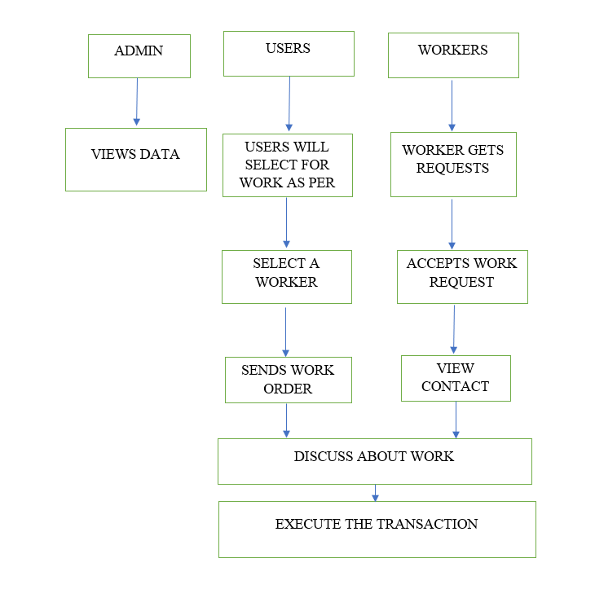

**SOFTWARE FRONT END REQUIREMENTS**

**Hardware Requirements**

# Processor - I3/Intel Processor

Hard Disk - 160GB

Key Board - Standard Windows Keyboard

Mouse - Two or Three Button Mouse

Monitor - SVGA

RAM - 8GB

* 1. **Software Requirements:**

Operating System : Windows 7/8/10

Server side Script : Angular JS

Programming Language : java

Libraries : spring boot

IDE/Workbench : IntelliJ, visual studio

Technology : java

**SYSTEM SPECIFICATIONS**

# **H/W CONFIGURATION:**

# Processor - I3/I5/Intel Processor.

* RAM - 4GB (min).
* Hard Disk - 128 GB.
* Key Board - Standard Windows Keyboard.
* Mouse - Two or Three Button Mouse.
* Monitor - Any.

**S/W CONFIGURATION:**

* Operating System : Windows 7+.
* Server-side Script : python.
* IDE : Web application Studio.

**MODULES/IMPLEMENTATION**

**MODULES:**

**Step 1:**

Open Web application Studio

**Step2:**

Choose a virtual device or Physical device from the menu

**Step3:**

Click on the project Run

**Step4:**

View the application performance on virtual or Physical device.