**Home services**

**PROBLEM STATEMENT**

There is very big need in the daily life with the electricians and plumbers and mechanics and painters and daily labors, there is no proper communication with them, if any need with them we need to search with different ways in offline. It may take time. Sometimes we could not find worker when we actually needed. There is no proper platform to communicate with them for work needs. If we try to find worker from local, he might have not skilled up to mark.

**ABSTRACT**

There is very big need in the daily life with the electricians and plumbers and mechanics and painters and daily labors, there is no proper communication with them, if any need with them we need to search with different ways in offline. It may take time. Sometimes we could not find worker when we actually needed. There is no proper platform to communicate with them for work needs. If we try to find worker from local, he might have not skilled up to mark. To overcome, this app very much needs if any need occurred to user, he can raise the request and choose the available list of workers and select based on their experience and charges on what he can offer to the worker, other side workers can get the request based on their location. Both the application user and skilled workers listed with app get mapped based on nearest locations. Makes their transactions.

**KEYWORDS:** Home services, Find a worker, Plumber required, Help you, Skilled workers needed.

**INTRODUCTION**

Convergence of information technology and communication technology has created an environment where we can access information, get services online from anywhere anytime even at the state of mobility. Such access to information and online services is possible just by the use of our finger tips through mobile applications. These mobile applications can be grouped as personal, perishable, transaction oriented, location specific, corporate and entertainment. “Web application for Home Services” is a mobile application built for Web application users, which is catered to the requirements of a Client who wants to provide domestic home services online by bringing together the users and service providers. The registered users can demand a service available through the application and based on the users’ location, the nearest service provider is allotted to cater the users’ request for service. Locating the user and the service provider is done by using the GPS (Global Positioning System) that gives the exact location on the earth. The applications’ simple and straight forward interface; instant service; feature for rating and sending feedback, makes it incredibly useful and relatively easy to use for all users.

**LITERATURE SURVEY**

Literature survey is the most important step in software development process. Before developing the tool, it is necessary to determine the time factor, economy n company strength. Once these things are satisfied, ten next steps are to determine which operating system and language can be used for developing the tool. Once the programmers start building the tool the programmers need lot of external support. This support can be obtained from senior programmers, from book or from websites. Before building the system, the above consideration is taken into account for developing the proposed system.

1. **Blais M., Lapierre S.D. and Lapierre G. , 2003. Solving a home-care districting problem in an urban setting. Journal of Operational Research Society, vol. 54, p.1141-1147.**

The model is estimated on the basis of more than 7000 requests for home care in the northern part of the Netherlands. In the modeling of Home Care, emphasis has been placed on the differentiation of clients and products. They find for instance that elderly chronically ill applicants have a greater chance of being referred for domestic help only, while applicants with psychosocial disorders are more liable to be offered packages that include social support. Patients discharged from hospital have a greater chance of a referral to domestic help only when they are slightly disabled, and are more likely to be offered packages including physical care when they are more disabled. The model has a range of policy applications in assessing the impact of changes in the health care system on the volume and structure of the demand for home care services. Examples are presented of the consequences of the ageing population and earlier discharge from hospitals on demand for home care packages. This (Bibbi Thomé et al., 2003) study is a review of the empirical literature for the description of home care as a phenomenon and as a concept, especially with regard to who the care recipients are, what actions and assessments are performed and what effects are achieved for the care recipient in terms of functional health status and quality of life (QoL). Clémentz C. et al., (2008) presented the application of concepts, methods and tools of systems engineering to production systems of home care. Javier Bajo et al., (2010) describe a case study in Home Care scenarios applying an abstract architecture and a computational model for large scale open multi-agent systems based on a service-oriented approach. The architecture used is THOMAS, which specifically addresses the design of Home Care systems.

1. **Benzarti E., (2012), Home Health Care Operations Management: Applying the districting approach to Home Health Care, PhD Thesis.**

A case study example was employed as an illustration of the usage of THOMAS components and services. Bashir B. et al., (2011 a) presented a unified model for Home Care and health care System. In their model, they integrated Home care in the traditional health care network so that optimal decisions can be made for all patients. For this purpose, they introduced an intermediate structure called Evaluation Center between hospitalization and home care which can result in a much better use of health care system. The Evaluation Centers consisting of a team of case managers, operation research specialists and doctors for each population locality can be added. These centers can align health care case managers with family physicians through a formalized and structured partnership to create health teams uniquely equipped to provide optimal patient care. Their objective is to assign patients either to a traditional hospital network or home care service. They will study each patient case in coordination with his family physician and patient himself.

1. **Benzarti E., Sahin E. and Dallery Y., 2010. Modelling Approaches for the home health care districting problem. MOSIM, 2010.**

The HC service is rapidly growing in the France and in other countries around the world. HC can be provided directly by the state or an independent provider with the aim of achieving best value, in terms of quality and cost. The drive to maximize quality and minimize costs creates a need for care-worker scheduling algorithms to support the planning process by reducing costs, improving customer service and reducing the cost of planning, etc. Patrik Eveborn et al., (2006) focused on a staff planning problem arising in Sweden where people receive home care from the local authorities. The objective was to develop visiting schedules for care providers that incorporate some restrictions and soft objectives. They described the development of a decision support system LAPS CARE to aid the planners.

**SYSTEM ANALYSIS & FEASIBILITY STUDY**

**EXISTING SYSTEM**

People have to find them physically by visiting their work places and homes and sometimes they will be not available at their places and will be went on work. In this type of scenarios, user work gets delayed.

**DISADVANTAGES**

* Time delays while searching for servicing people.
* If we are new to that area it’s difficult to find them.

**PROPOSED SYSTEM**

Home services' lets you choose your own staff who have well knowledge in their tasks. Our staff includes Carpenters, plumbers, gardeners, construction labor, electrician, fitting and pest etc., we give you the staff that belongs to your own city where you live, so that they can provide you services 24/7 without making you to wait for much time.

**ADVANTAGES**

* We can choose the workers based on their Ratings.
* They can provide us services 24/7 without making you to wait for much time.

**Architecture:**

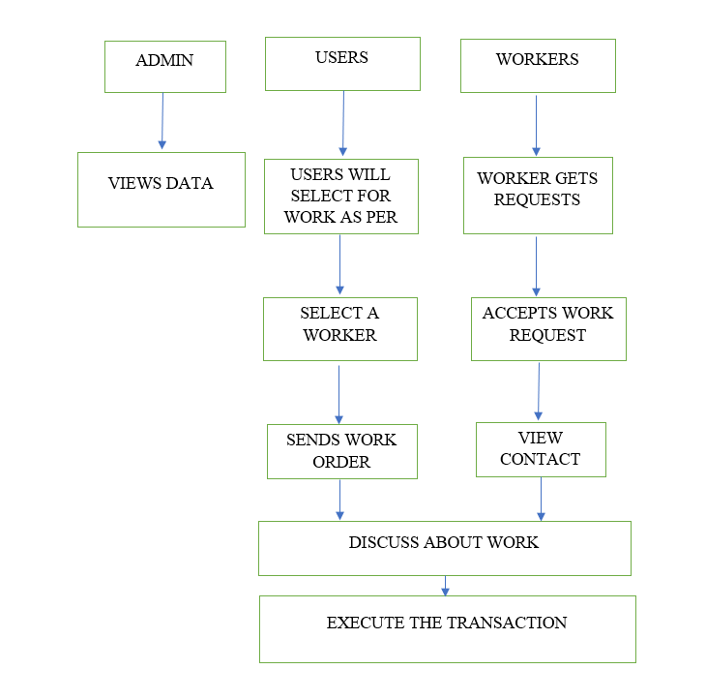

**METHODOLOGY AND ALGORITHMS:**

# **1 . Naive Bayes Classifier:**

Naive Bayes classifiers are a collection of classification algorithms based on **Bayes’ Theorem**. It is not a single algorithm but a family of algorithms where all of them share a common p

**SOFTWARE DEVELOPMENT LIFE CYCLE – SDLC:**

In our project we use waterfall model as our software development cycle because of its step-by-step procedure while implementing.

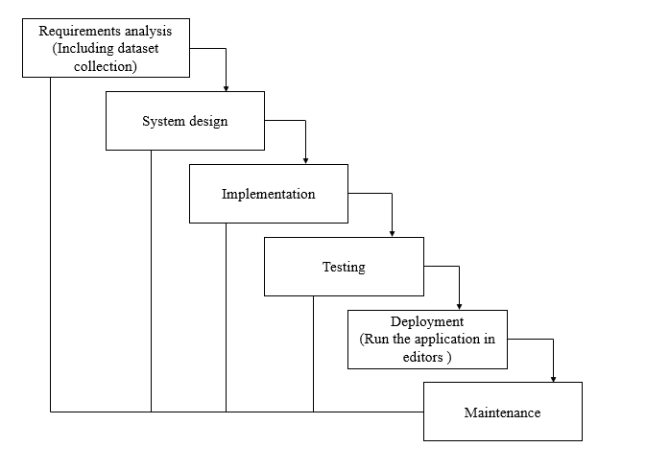

**Fig1**: Waterfall Model

* **Requirement Gathering and analysis** − All possible requirements of the system to be developed are captured in this phase and documented in a requirement specification document.
* **System Design** − the requirement specifications from first phase are studied in this phase and the system design is prepared. This system design helps in specifying hardware and system requirements and helps in defining the overall system architecture.
* **Implementation** − with inputs from the system design, the system is first developed in small programs called units, which are integrated in the next phase. Each unit is developed and tested for its functionality, which is referred to as Unit Testing.
* **Integration and Testing** − All the units developed in the implementation phase are integrated into a system after testing of each unit. Post integration the entire system is tested for any faults and failures.
* **Deployment of system** − Once the functional and non-functional testing is done; the product is deployed in the customer environment or released into the market.
* **Maintenance** − There are some issues which come up in the client environment. To fix those issues, patches are released. Also, to enhance the product some better versions are released. Maintenance is done to deliver these changes in the customer environment.

**FEASIBILITY STUDY**

The feasibility of the project is analysed in this phase and business proposal is put forth with a very general plan for the project and some cost estimates. During system analysis the feasibility study of the proposed system is to be carried out. This is to ensure that the proposed system is not a burden to the company. For feasibility analysis, some understanding of the major requirements for the system is essential.

Three key considerations involved in the feasibility analysis are

* ECONOMICAL FEASIBILITY
* TECHNICAL FEASIBILITY
* SOCIAL FEASIBILITY

**Economic feasibility:**

This study is carried out to check the economic impact that the system will have on the organization. The amount of fund that the company can pour into the research and development of the system is limited. The expenditures must be justified. Thus, the developed system as well within the budget and this was achieved because most of the technologies used are freely available. Only the customized products had to be purchased.

### Technical feasibility:

This study is carried out to check the technical feasibility, that is, the technical requirements of the system. Any system developed must not have a high demand on the available technical resources. This will lead to high demands on the available technical resources. This will lead to high demands being placed on the client. The developed system must have a modest requirement, as only minimal or null changes are required for implementing this system.

**Social feasibility:**

The aspect of study is to check the level of acceptance of the system by the user. This includes the process of training the user to use the system efficiently. The user must not feel threatened by the system, instead must accept it as a necessity. The level of acceptance by the users solely depends on the methods that are employed to educate the user about the system and to make him familiar with it. His level of confidence must be raised so that he is also able to make some constructive criticism, which is welcomed, as he is the final user of the system.

**SYSTEM REQUIREMENTS SPECIFICATION**

**Functional and non-functional requirements:**

Requirement’s analysis is very critical process that enables the success of a system or software project to be assessed. Requirements are generally split into two types: Functional and non-functional requirements.

**Functional Requirements**: These are the requirements that the end user specifically demands as basic facilities that the system should offer. All these functionalities need to be necessarily incorporated into the system as a part of the contract. These are represented or stated in the form of input to be given to the system, the operation performed and the output expected. They are basically the requirements stated by the user which one can see directly in the final product, unlike the non-functional requirements.

Examples of functional requirements:

1. Authentication of user whenever he/she logs into the system
2. System shutdown in case of a cyber-attack
3. A verification email is sent to user whenever he/she register for the first time on some software system.

**Non-functional requirements**: These are basically the quality constraints that the system must satisfy according to the project contract. The priority or extent to which these factors are implemented varies from one project to other. They are also called non-behavioral requirements.  
They basically deal with issues like:

* Portability
* Security
* Maintainability
* Reliability
* Scalability
* Performance
* Reusability
* Flexibility

Examples of non-functional requirements:

1. Emails should be sent with a latency of no greater than 12 hours from such an activity.
2. The processing of each request should be done within 10 seconds
3. The site should load in 3 seconds whenever of simultaneous users are > 10000

**SYSTEM SPECIFICATIONS**

# **H/W CONFIGURATION:**

# Processor - I3/I5/Intel Processor.

* RAM - 4GB (min).
* Hard Disk - 128 GB.
* Key Board - Standard Windows Keyboard.
* Mouse - Two or Three Button Mouse.
* Monitor - Any.

**S/W CONFIGURATION:**

* Operating System : Windows 7+.
* Server-side Script : Java
* IDE : Intellij IDEA or Eclipse
* Database : My Sql
* Server : Tomcat 9.0
* Front end : HTML , CSS , JS

**SYSTEM DESIGN**

## **Input Design:**

In an information system, input is the raw data that is processed to produce output. During the input design, the developers must consider the input devices such as PC, MICR, OMR, etc.

Therefore, the quality of system input determines the quality of system output. Well-designed input forms and screens have following properties −

* It should serve specific purpose effectively such as storing, recording, and retrieving the information.
* It ensures proper completion with accuracy.
* It should be easy to fill and straightforward.
* It should focus on user’s attention, consistency, and simplicity.
* All these objectives are obtained using the knowledge of basic design principles regarding −
  + What are the inputs needed for the system?
  + How end users respond to different elements of forms and screens.

### Objectives for Input Design:

The objectives of input design are −

* To design data entry and input procedures
* To reduce input volume
* To design source documents for data capture or devise other data capture methods
* To design input data records, data entry screens, user interface screens, etc.
* To use validation checks and develop effective input controls.

**Output Design:**

The design of output is the most important task of any system. During output design, developers identify the type of outputs needed, and consider the necessary output controls and prototype report layouts.

### Objectives of Output Design:

The objectives of input design are:

* To develop output design that serves the intended purpose and eliminates the production of unwanted output.
* To develop the output design that meets the end user’s requirements.
* To deliver the appropriate quantity of output.
* To form the output in appropriate format and direct it to the right person.
* To make the output available on time for making good decisions.

**MODULES:**

**Step 1:**

Open Web application Studio

**Step2:**

Choose a virtual device or Physical device from the menu

**Step3:**

Click on the project Run

**Step4:**

View the application performance on virtual or Physical device.

**UML DIAGRAMS**

UML stands for Unified Modelling Language. UML is a standardized general-purpose modelling language in the field of object-oriented software engineering. The standard is managed, and was created by, the Object Management Group.

The goal is for UML to become a common language for creating models of object-oriented computer software. In its current form UML is comprised of two major components: a Meta-model and a notation. In the future, some form of method or process may also be added to; or associated with, UML.

The Unified Modelling Language is a standard language for specifying, Visualization, Constructing and documenting the artefacts of software system, as well as for business modelling and other non-software systems.

The UML represents a collection of best engineering practices that have proven successful in the modelling of large and complex systems.

The UML is a very important part of developing objects-oriented software and the software development process. The UML uses mostly graphical notations to express the design of software projects.

**GOALS:**

­­­­­ The Primary goals in the design of the UML are as follows:

1. Provide users a ready-to-use, expressive visual modelling Language so that they can develop and exchange meaningful models.
2. Provide extendibility and specialization mechanisms to extend the core concepts.
3. Be independent of particular programming languages and development process.
4. Provide a formal basis for understanding the modelling language.
5. Encourage the growth of OO tools market.
6. Support higher level development concepts such as collaborations, frameworks, patterns and components.
7. Integrate best practices.

**USE CASE DIAGRAM**

* A use case diagram in the Unified Modeling Language (UML) is a type of behavioral diagram defined by and created from a Use-case analysis.
* Its purpose is to present a graphical overview of the functionality provided by a system in terms of actors, their goals (represented as use cases), and any dependencies between those use cases.
* The main purpose of a use case diagram is to show what system functions are performed for which actor. Roles of the actors in the system can be depicted.

**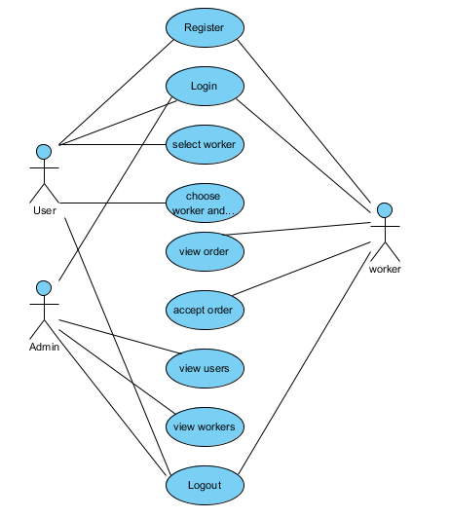**

**CLASS DIAGRAM**

In software engineering, a class diagram in the Unified Modeling Language (UML) is a type of static structure diagram that describes the structure of a system by showing the system's classes, their attributes, operations (or methods), and the relationships among the classes. It explains which class contains information

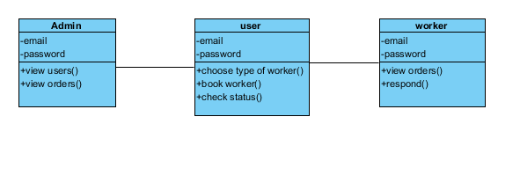

**SEQUENCE DIAGRAM**

* A sequence diagram in Unified Modeling Language (UML) is a kind of interaction diagram that shows how processes operate with one another and in what order.
* It is a construct of a Message Sequence Chart. Sequence diagrams are sometimes called event diagrams, event scenarios, and timing diagrams

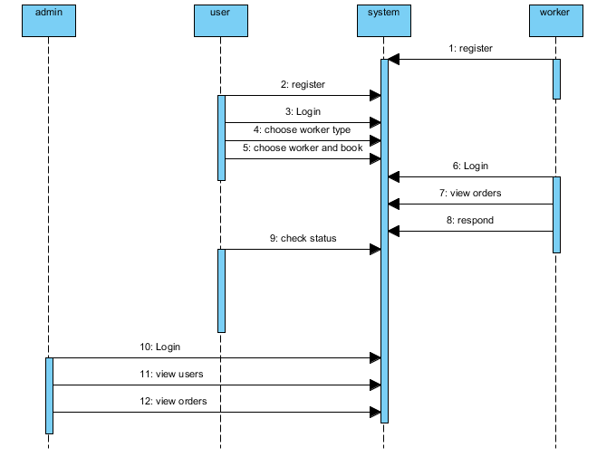

**COLLABORATION DIAGRAM:**

In collaboration diagram the method call sequence is indicated by some numbering technique as shown below. The number indicates how the methods are called one after another. We have taken the same order management system to describe the collaboration diagram. The method calls are similar to that of a sequence diagram. But the difference is that the sequence diagram does not describe the object organization whereas the collaboration diagram shows the object organization.

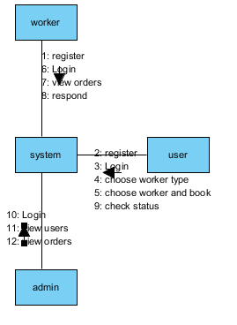

**DEPLOYMENT DIAGRAM**

Deployment diagram represents the deployment view of a system. It is related to the component diagram. Because the components are deployed using the deployment diagrams. A deployment diagram consists of nodes. Nodes are nothing but physical hardware’s used to deploy the application.

****

**ACTIVITY DIAGRAM:**

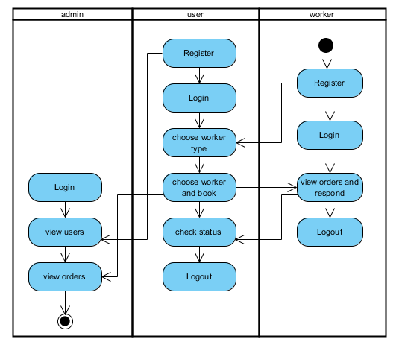

Activity diagrams are graphical representations of workflows of stepwise activities and actions with support for choice, iteration and concurrency. In the Unified Modelling Language, activity diagrams can be used to describe the business and operational step-by-step workflows of components in a system. An activity diagram shows the overall flow of control.

**COMPONENT DIAGRAM**:

A component diagram, also known as a UML component diagram, describes the organization and wiring of the physical **c**omponents in a system. Component diagrams are often drawn to help model implementation details and double-check that every aspect of the system's required function is covered by planned development.

**ER DIAGRAM:**

An Entity–relationship model (ER model) describes the structure of a database with the help of a diagram, which is known as Entity Relationship Diagram (ER Diagram). An ER model is a design or blueprint of a database that can later be implemented as a database. The main components of E-R model are: entity set and relationship set.

An ER diagram shows the relationship among entity sets. An entity set is a group of similar entities and these entities can have attributes. In terms of DBMS, an entity is a table or attribute of a table in database, so by showing relationship among tables and their attributes, ER diagram shows the complete logical structure of a database. Let’s have a look at a simple ER diagram to understand this concept

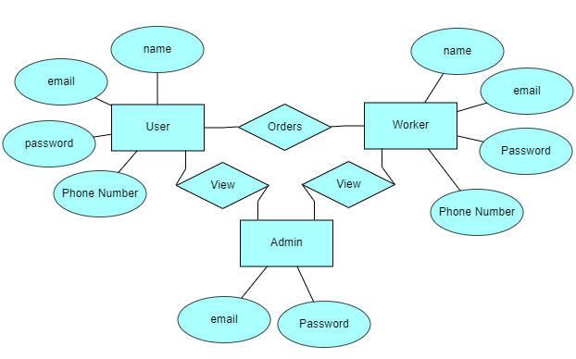

**DFD DIAGRAM:**

A Data Flow Diagram (DFD) is a traditional way to visualize the information flows within a system. A neat and clear DFD can depict a good amount of the system requirements graphically. It can be manual, automated, or a combination of both. It shows how information enters and leaves the system, what changes the information and where information is stored. The purpose of a DFD is to show the scope and boundaries of a system as a whole. It may be used as a communications tool between a systems analyst and any person who plays a part in the system that acts as the starting point for redesigning a system.

**Context level diagram:**

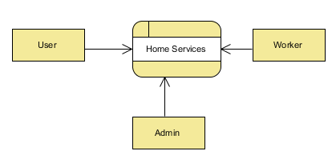

**Level 1 diagram :**

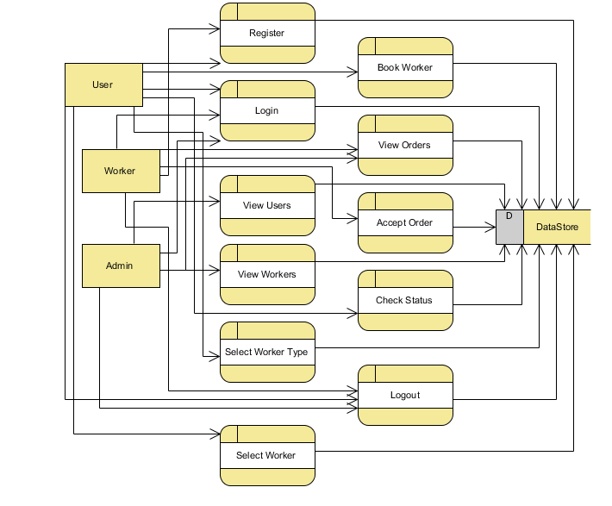

**Level 2 diagram :**

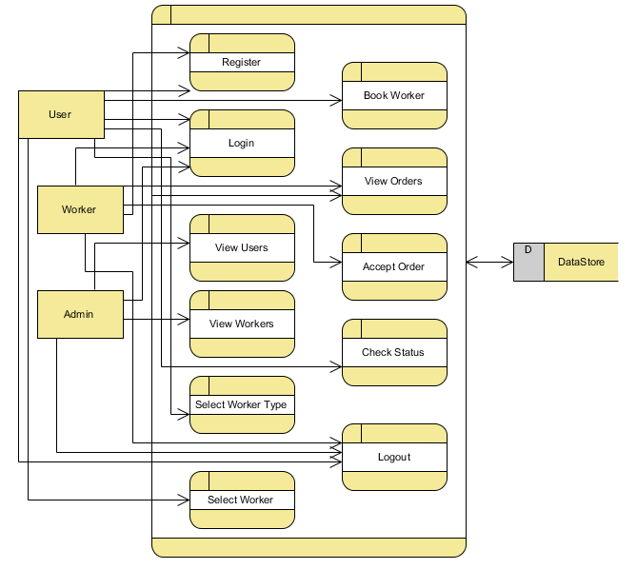

**SCREEN SHOTS OF THE PROJECT:**

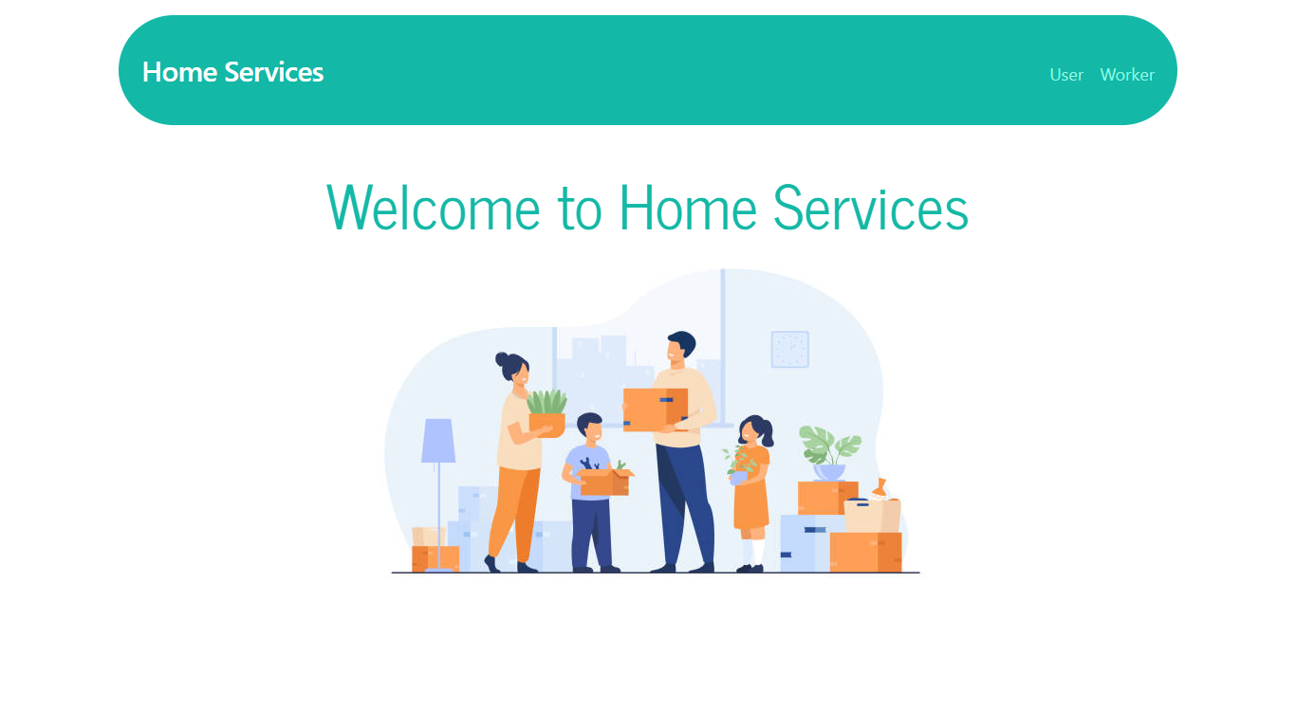

**Home:** This is the home page.

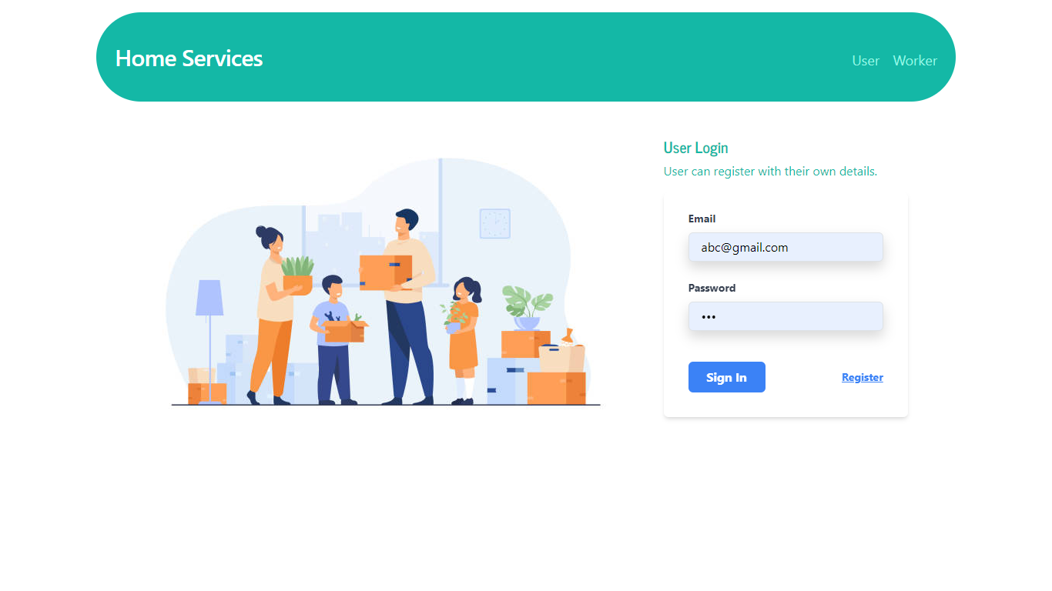

**User Login and Register:** This is the page for both login and register for the user.

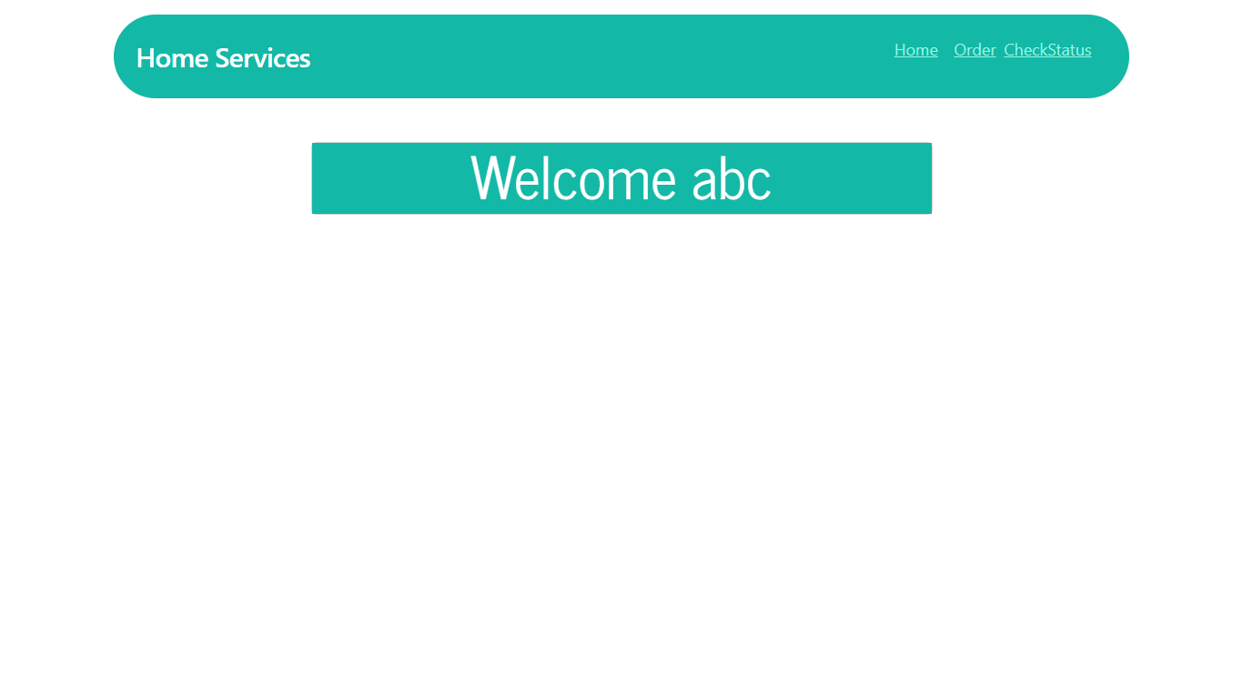

**User Home :** This is the user home page.

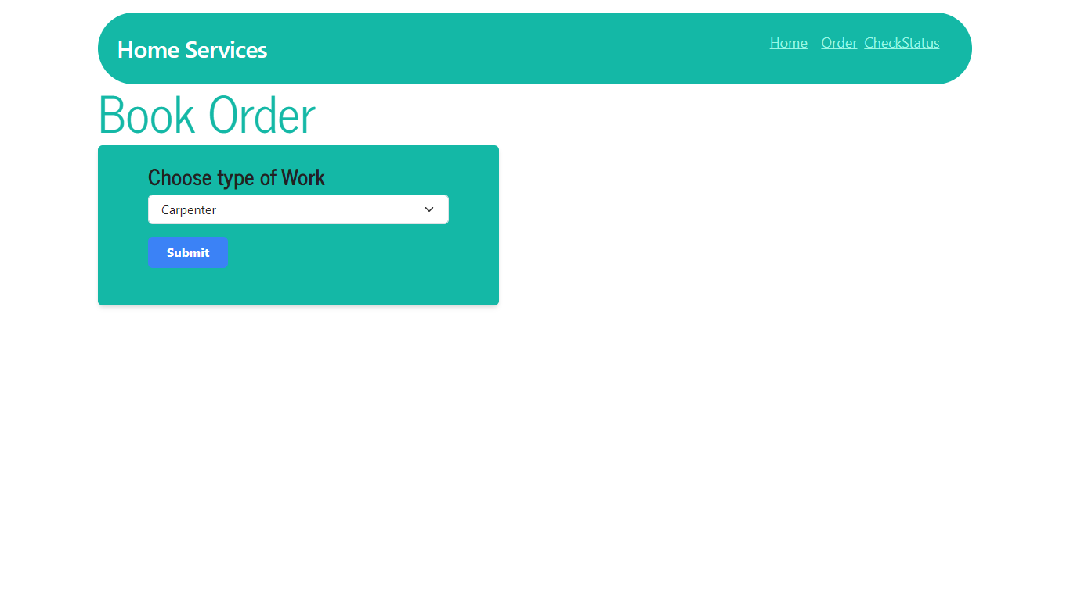

**User Order :**  In this page user can choose the type of work.

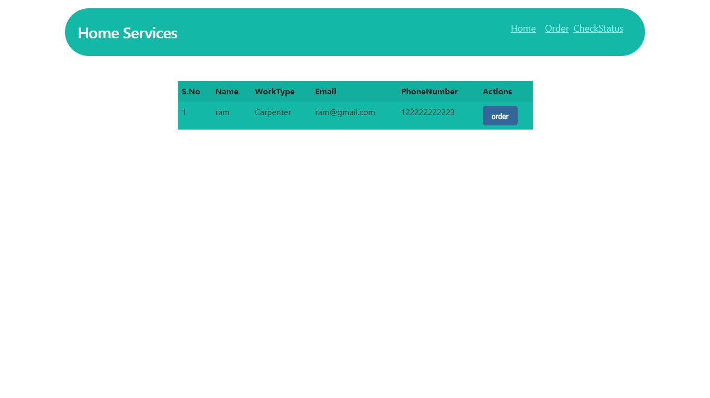

**User Order :**  In this page user can choose particular worker and then order.

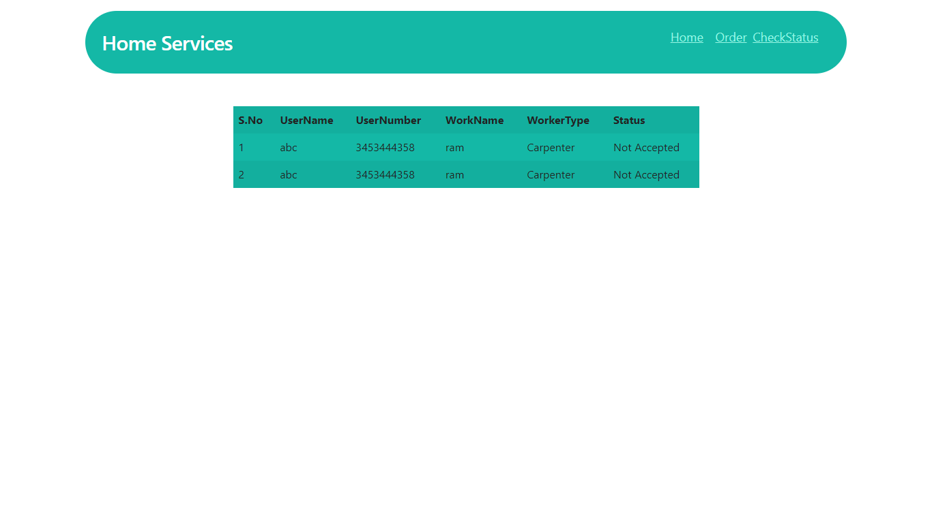

**User Check Status :** Here user can check the status after booking the worker.

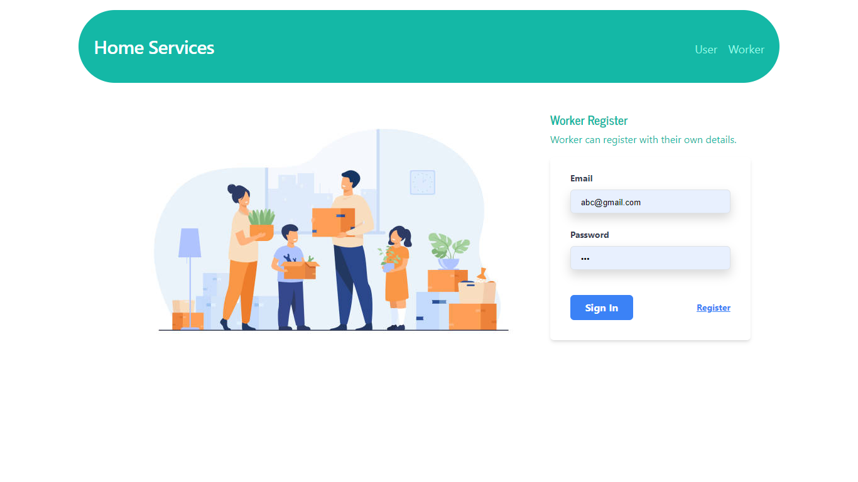

**Worker Login and Register:** This is the page for both login and register for the worker.

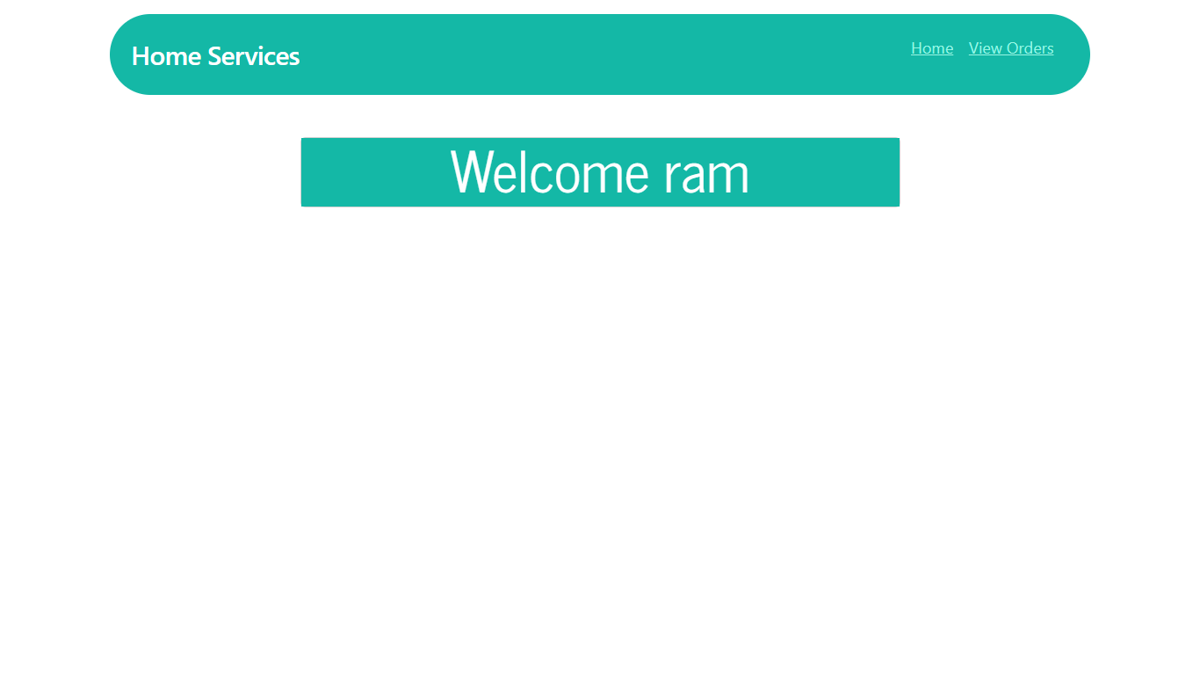

**Worker Home:** This is the home page of worker.

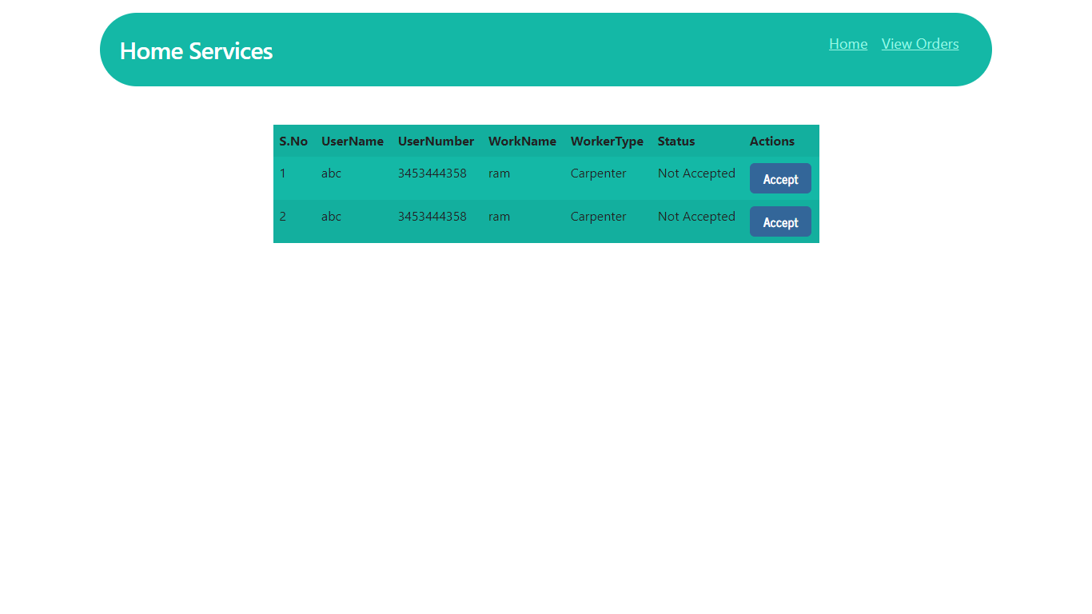

**Worker accept order:** In this page worker can accept the order by the particular user.

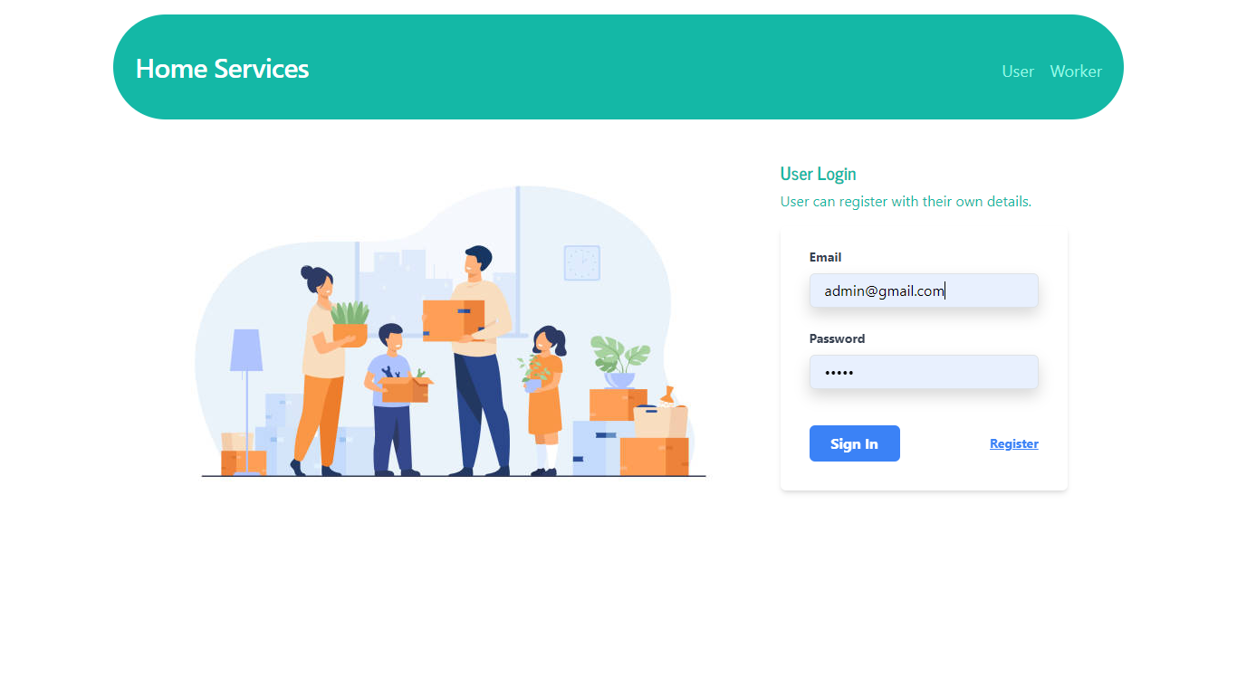

**Admin Login :** Admin can login directly with default credentials with [admin@gmail.com](mailto:admin@gmail.com) and admin.

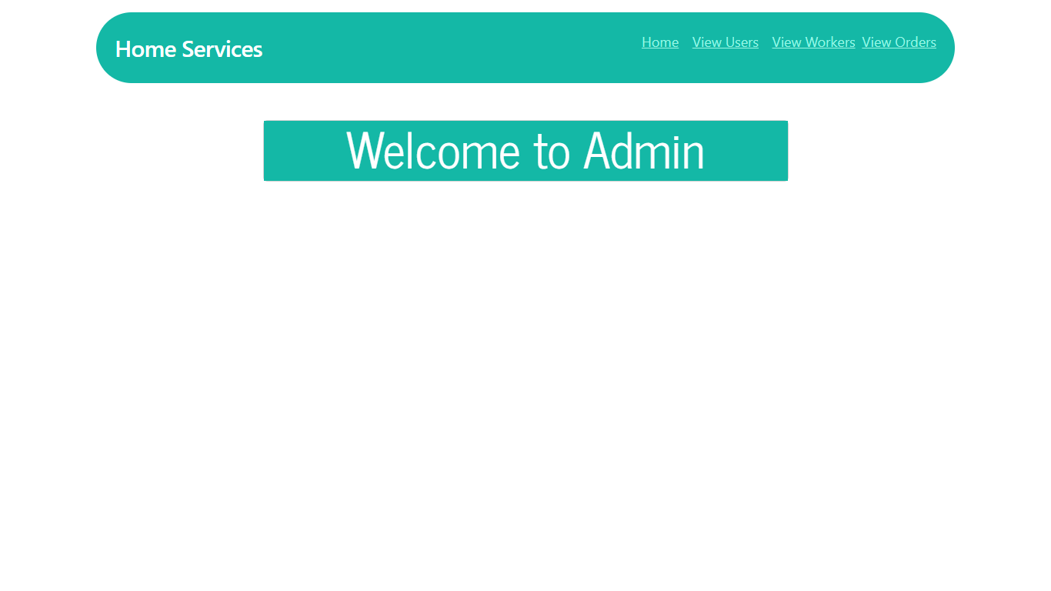

**Admin Home:** This is the admin home page.

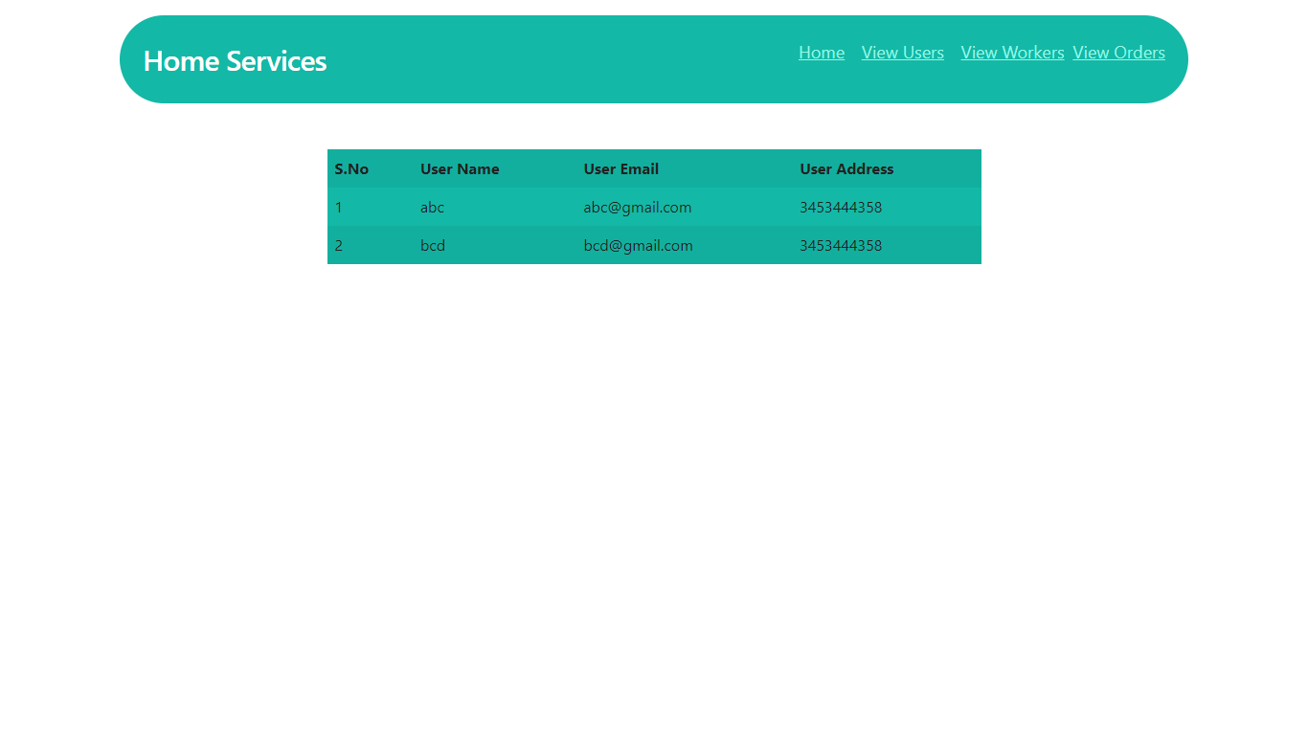

**Admin view users :** Here admin can view all the users.

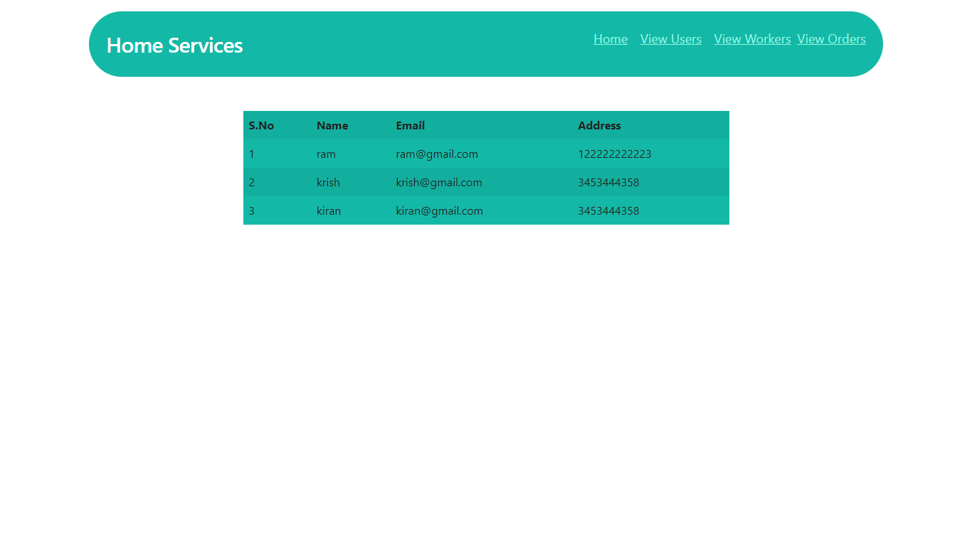

**RESULTS:**

**1 Order Table**

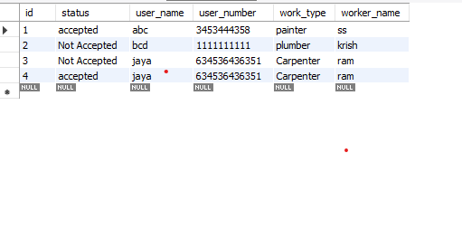

* 1. **.User Table**

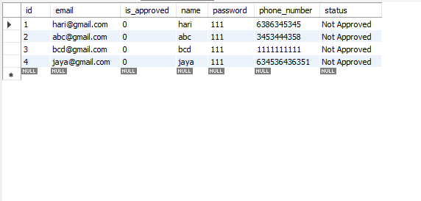

**3.Worker Table**

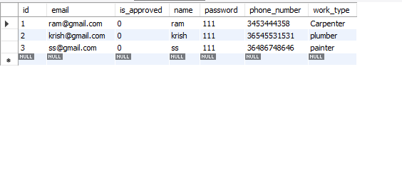

**Admin view workers:**  admin can view all the workers here.

**REFERENCES**

1. Benzarti E., Sahin E. and Dallery Y., 2010. Modelling Approaches for the home health care districting problem. MOSIM, 2010.
2. Benzarti E., (2012), Home Health Care Operations Management: Applying the districting approach to Home Health Care, PhD Thesis.
3. Blais M., Lapierre S.D. and Lapierre G. , 2003. Solving a home-care districting problem in an urban setting. Journal of Operational Research Society, vol. 54, p.1141-1147.

[1] (2012) Web application developer website. [Online]. Available:

http://developer.web application.com/guide/topics/location/index.html.

[2] (2013) Nutiteq website. [Online]. Available: http://www.nutiteq.com/nutiteq-sdk/comparison/

[3] (2013) Open Street Map website. [Online] Available: http://wiki.openstreetmap.org/wiki/Web application

[1] (2012) Web application developer website. [Online]. Available:

http://developer.web application.com/guide/topics/location/index.html.

[2] (2013) Nutiteq website. [Online]. Available: http://www.nutiteq.com/nutiteq-sdk/comparison/

[3] (2013) Open Street Map website. [Online] Available: http://wiki.openstreetmap.org/wiki/Web application

1. Pradeep Kothari, Web application Application Development, DreamTech Press.
2. Wallace Mc Clure, Jonathan Dick and Chris Hardy, Professional Web application Programming with Mono for Web application, Wrox Publication.
3. Dr. Ashok Talukder, Ms. Roopa Yavagal, Mr. Hasan Ahmed: Mobile Computing, Technology, Applications and Service Creation, 2nd Edition, Tata McGrawHill, 2010.
4. Web application SDK: A software development kit that enables to create applications for Web application platform. Available: http://www.webopedia.com/TERM/A/Web application\_SDK.ht ml
5. Eclipse: Is famous for Java Integrated Development environment. Available: https://eclipse.org/ide/ [6] MySQL: Is an open source relational database management system (RDBMS). Available: https://en.wikipedia.org/wiki/MySQL.
6. Facilitykart: Is India’s’ most trusted hyper local aggregator for handyman and Home need services like AC, RO, Home Appliances, Electrical, Plumbing, Carpentry etc. Available: http://facilitykart.com.

**BIBLIOGRAPHY:**

This Java Development Kit(JDK) allows you to code and run Java programs. It's possible that you install multiple JDK versions on the same PC. But It’s recommended that you install only latest version.

## How to install Java for Windows

Following are the steps for JDK 8 free download for 32 bit or JDK 8 download 64 bit and installation

**Step 1)** Go to [link](https://www.oracle.com/java/technologies/javase-downloads.html). Click on JDK Download for Java

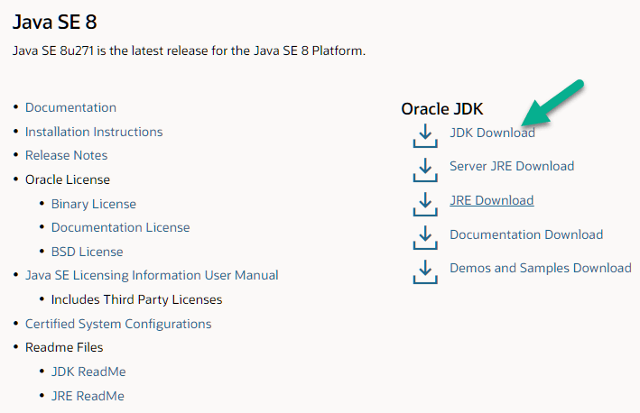

**Step 2)** Next,

1. Accept License Agreement
2. Download Java 8 JDK for your version 32 bit or JDK 8 download for windows 10 64 bit.

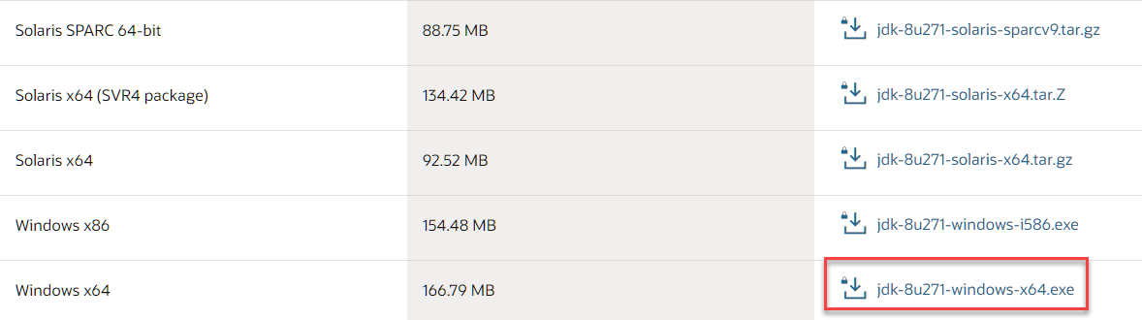

**Step 3)** when you click on the Installation link the popup will be open. Click on I reviewed and accept the Oracle Technology Network License Agreement for Oracle Java SE and you will be redirected to the login page. If you don't have an oracle account you can easily sign up by adding basics details of yours.

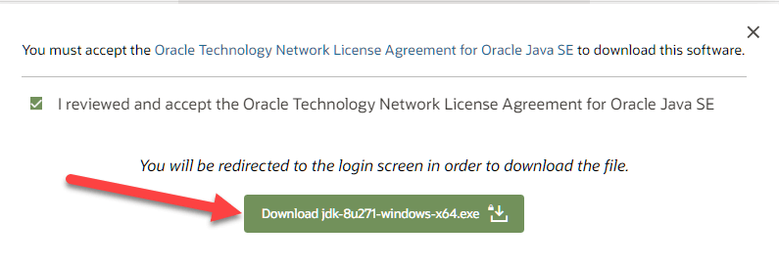

**Step 4)** Once the Java JDK 8 download is complete, run the exe for install JDK. Click Next

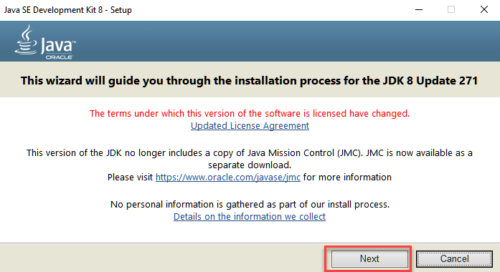

**Step 5)** Select the PATH to install Java in Windows and click next.

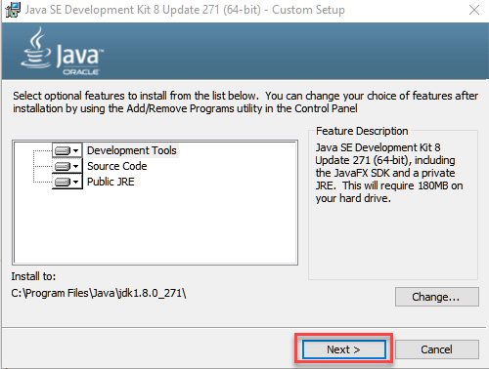

**Step 6)** Once you install Java in windows, click close

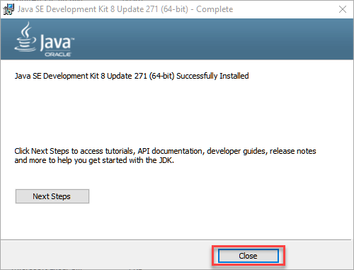

## How to set Environment Variables in Java: Path and Class path

The PATH variable gives the location of executable like javac, java etc. It is possible to run a program without specifying the PATH but you will need to give full path of executable like **C:\Program Files\Java\jdk-13.0.1\bin\javac A.java** instead of simple **javac A.java**

The CLASSPATH variable gives location of the Library Files.

Let's look into the steps to set the PATH and CLASSPATH

**Step 1)** Right Click on the My Computer and Select the properties

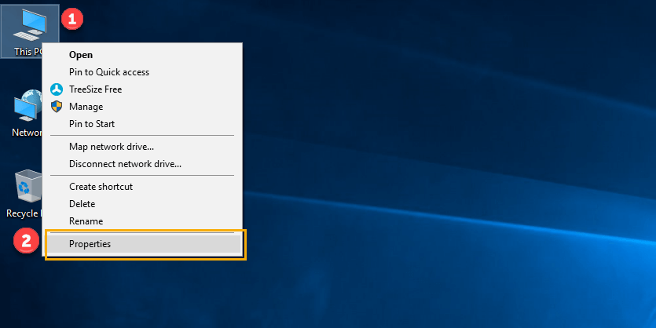

**Step 2)** Click on advanced system settings

**Step 3)** Click on Environment Variables

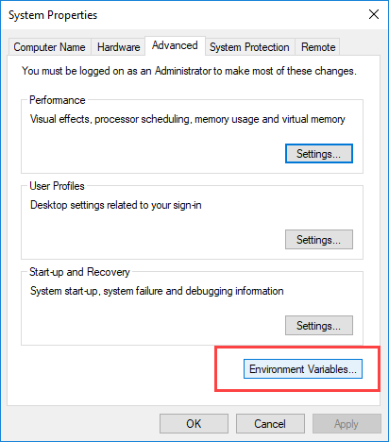

**Step 4)** Click on new Button of User variables

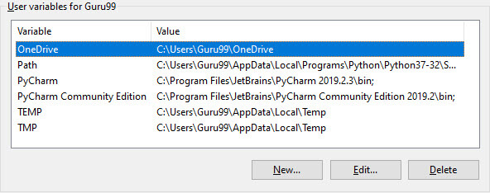

**Step 5)** Type PATH in the Variable name.

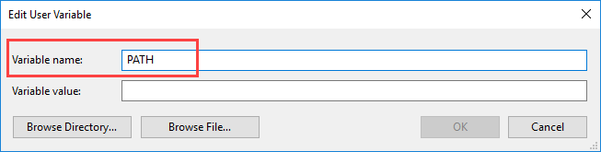

**Step 6)** Copy the path of bin folder which is installed in JDK folder.

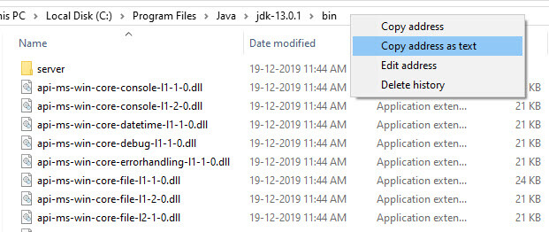

**Step 7)** Paste Path of bin folder in Variable value and click on OK Button.

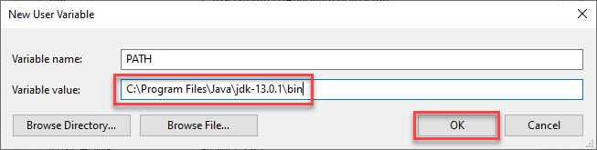

**Note:** In case you already have a PATH variable created in your PC, edit the PATH variable to

PATH = <JDK installation directory>\bin;%PATH%;

Here, %PATH% appends the existing path variable to our new value

**Step 8)**You can follow a similar process to set CLASSPATH.

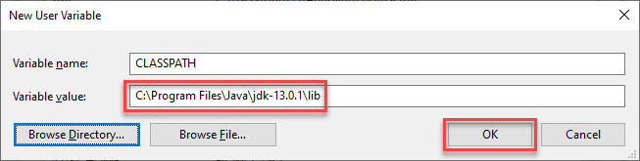

**Note:** In case you java installation does not work after installation, change classpath to

CLASSPATH = <JDK installation directory>\lib\tools.jar;

**Step 9)** Click on OK button

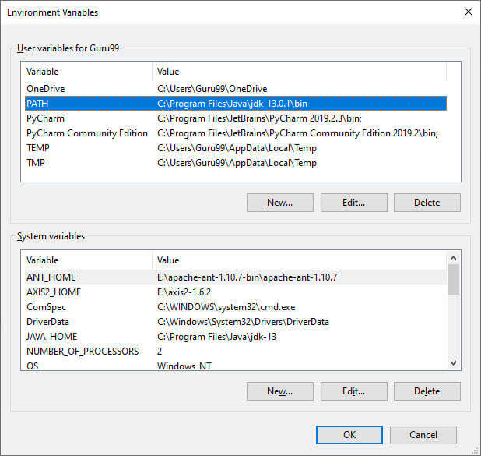

**Step 10)** Go to command prompt and type javac commands.

If you see a screen like below, Java is installed.

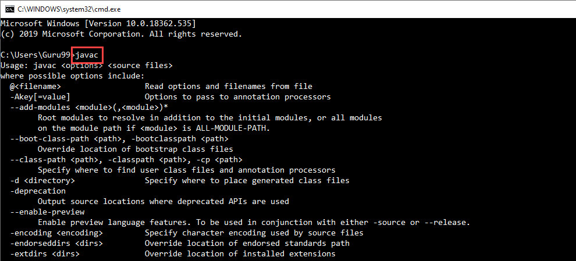

## Eclipse: (Oxygen)

The Eclipse download requires about 300 MB of disk space; keep it on your machine, in case you need to re-install Eclipse. When installed, Eclipse requires an additional 330 MB of disk space.

### Downloading

1.Click [Eclipse](http://www.eclipse.org/downloads/packages)

The following page will appear in your browser. In this handout we will download **Eclipse IDE for Eclipse Committers** for Windows 32 Bit; if your computer uses Windows, continue below; otherwise choose either **Mac Cocoa** or **Linux** instead.

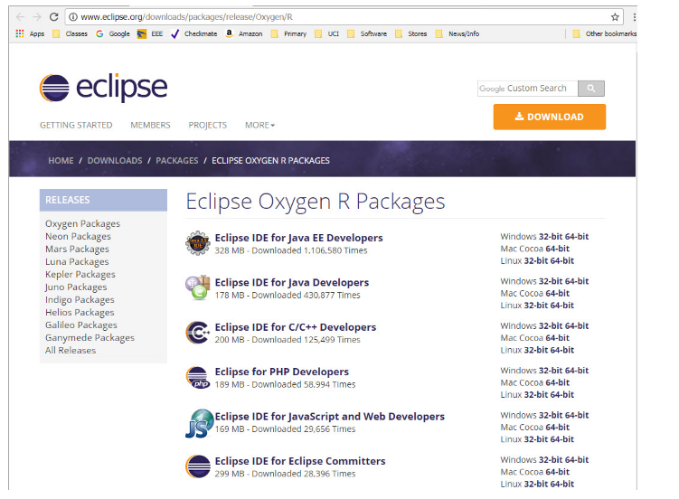

1. It is critical that Java, Python, and Eclipse are either all 32 Bit or are all 64 Bit (and only if your Machine/OS supports 64 Bit): I think it easiest to use 32 Bit for everything.
2. Click the **32-Bit** (after Windows) to the right of the **Eclipse IDE for Eclipse Committers**.
3. You will see the following page (don't worry about the name of the institution underneath the orange **DOWNLOAD** button).

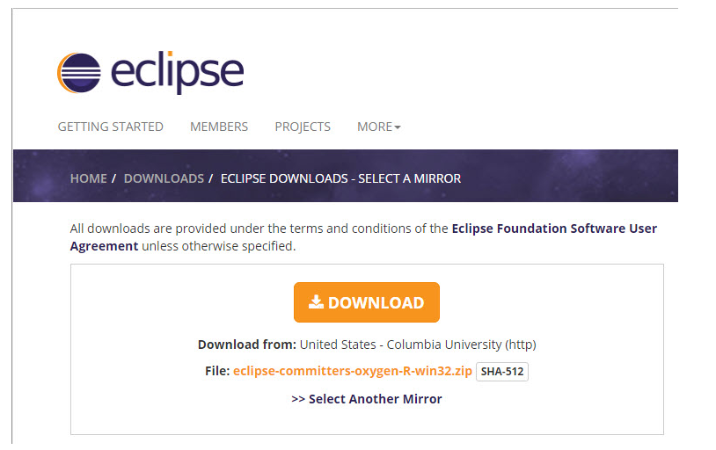

Click the orange **DOWNLOAD** button. The site named here, in orange to the right of the button: **United States - Columbia University (http)** is the random one chosen by the download page this time; yours may differ.

This file should start downloading in your standard download folder, while showing a splash screen about donating to Eclipse. This file is about 300 Mb so it might take a while to download fully if you are on a slow internet connection (it took me about 5 minutes over a cable modem). Don't worry about the exact time as long as the download continues to make steady progress. In Chrome progress is shown on the bottom-left of the window, via the icon

https://www.ics.uci.edu/~pattis/common/handouts/pythoneclipsejava/images/eclipseoxygen/downloadprogress.jpg

The file should appear as

https://www.ics.uci.edu/~pattis/common/handouts/pythoneclipsejava/images/eclipseoxygen/downloadfile.jpg

Terminate the tab browsing this webpage.

1. Move this file to a more permanent location, so that you can install Eclipse (and reinstall it later, if necessary).
2. Start the **Installing** instructions directly below.

Unzip **eclipse-committers-oxygen-R-win32.zip**, the file that you just downloaded and moved.  
On my machine (running Windows 7), I can

* Right-click the file.
* Hover over the **IZArc** command from the menu of options.
* Click **Extract Here**

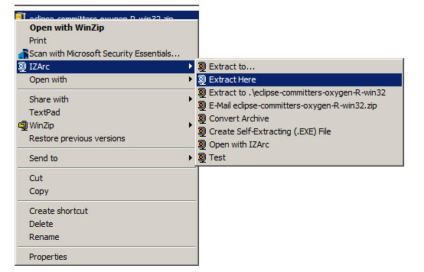

1. If you do not have IZArc or an equivalent unzipping program, here is the web site to download a free copy of [IZarc](http://izarc.org/downloads" \t "_blank).

Unzipping this file creates a folder named **eclipse**; unzipping 250 MB can take a few minutes. You can leave this folder here or move it elsewhere on your hard disk. I recommend putting the downloaded file and resulting folder in the **C:\Program Files\** directory.

1. Create a shortcut on your desktop to the **eclipse.exe** file in this **eclipse** folder:   
   On most Windows machines, you can
   * Right-press the file **eclipse.exe**
   * Drag it to the desktop.
   * Release the right button.
   * Click **Create shortcut here**

Now you are ready to perform a **one-time only** setup of Eclipse on your machine.

1. Double-click the shortcut to Eclipse that you just created above.

The following splash screen will appear



and then an **Eclipse Launcher** pop-up window will appear.

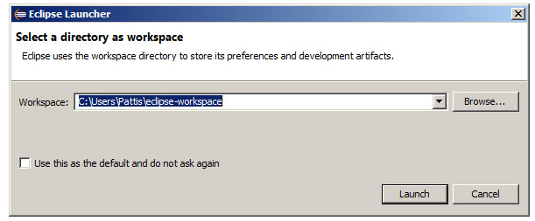

1. In the **Workspace** text box, your name should appear between **C:\Users\** and **\eclipse-workspace**, instead of **Pattis**.

Leave **unchecked** the **Use this as the default and do not ask again** box. Although you will use this same workspace for the entire quarter (checking projects in and out of it), it is best to see this **Workspace Launcher** pop-up window each time you start Eclipse, to remind you where your workspace is located.

In fact, it is a good idea to create on your desktop a shortcut to your workspace folder; but you must click **OK** (see below) before Eclipse creates this folder and you can create a shortcut to it.

1. Click **Launch**.

Progress bars will appear as Eclipse loads.

Eventually the Eclipse workbench will appear with a **Welcome** tab covering it.

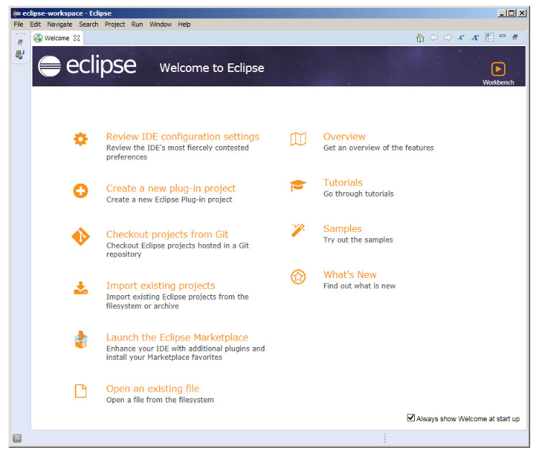

1. Terminate (click **X** on) the **Welcome** tab.

You will not see the **Welcome** tab when you start Eclipse again, after this first time.

1. Click **Help** (on the far right of the line below this window's blue title **eclipse-workspace - Eclipse**) and then click **Install New Software...** in its pull-down menu, as shown below.

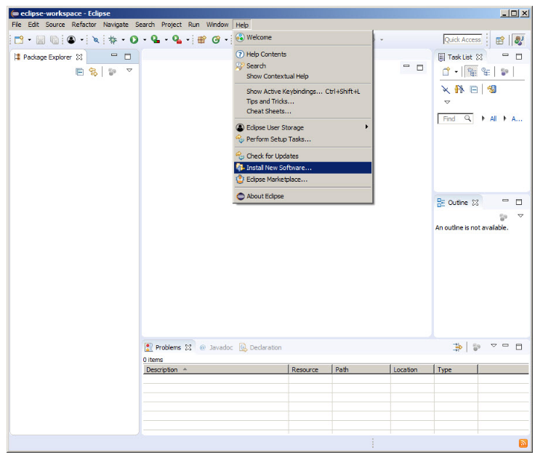

The Install pop-up window will appear.

Click Window (to the left of Help on the far right of the line below this window's blue title eclipse-workspace - Eclipse) and then click Preferences in its pull-down menu, as shown below.

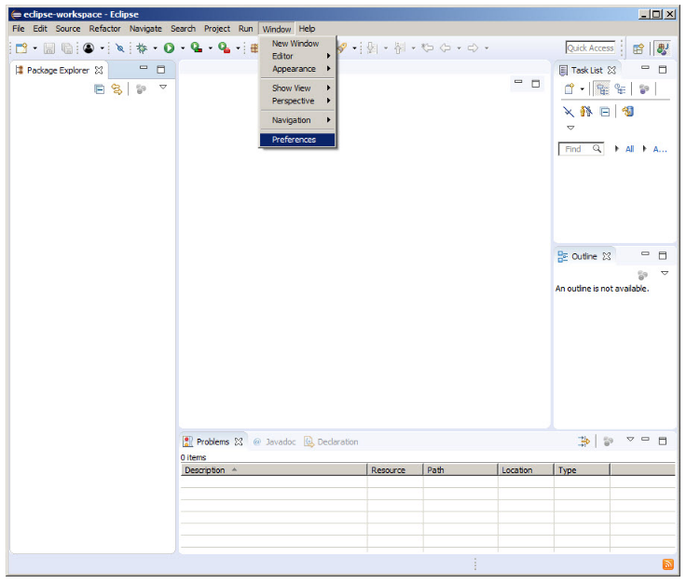

* Create a project.
* Right-click on your project and choose **Properties**.
* Click on **Java Build Path**.
* Click on the **Libraries** tab.
* Click on **Add External JARs...**.
* Navigate to **junit.jar**. It should be in a location such as **...Eclipse 3.0.1\plugins\org.junit\_3.8.1\junit.jar**.
* Select **junit.jar**, click on **Open**, click on **OK**.
* To create a test class:
* Open the New wizard (**File > New >Other...**)
* Select **Java >JUnit** in the left pane and **TestCase** in the right pane and click **Next**.
* Enter the name of your test class and click **OK**.
* To run your test class, select your test class and choose **Run as >JUnit Test** from the **Run** drop-down menu in the toolbar.

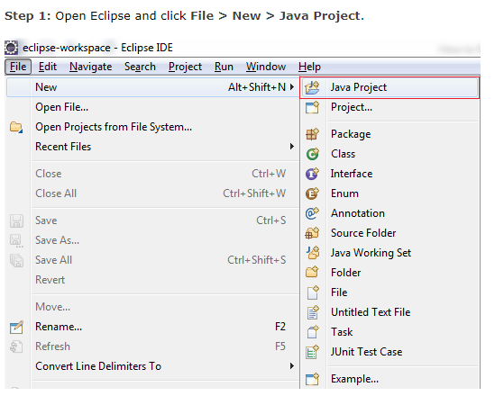

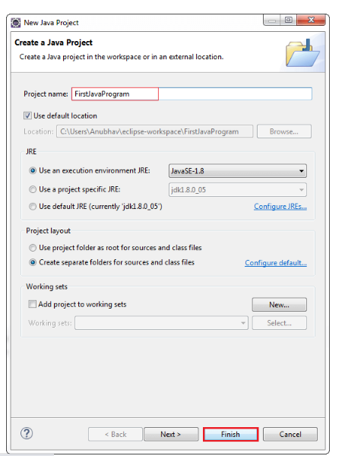

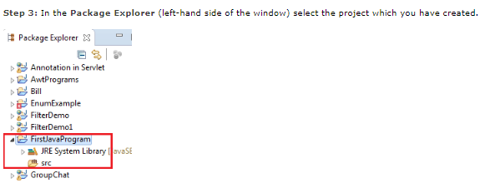

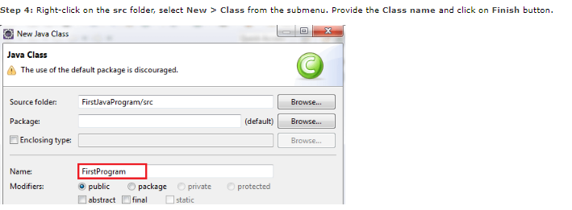

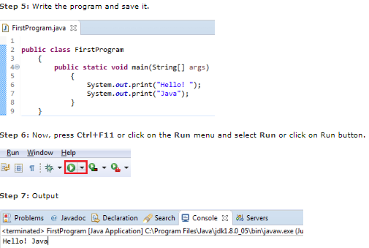

**STEPS FOR EXECUTING THE PROJECTS**

**Step 1:**

Open Eclipse and set the workspace

**Step2:**

Right Click on the project Run As and Run On Tomcat Server

**Step3:**

In middle we got tomcat error that time we need to change port number

**Step4:**

Copy url in Google chrome and Run

**CONCLUSION**

In this project we have successfully proposed a user friendly web application called Placements and Training Centre that will help students to find their placement centres. Here Admin can login with default credentials and view all the users, workers and orders . User register and login with their details . and he can select worker type , select the worker and book particular worker .He will check status worker has accepted or not . Worker can view all orders and can accept the order.