**Photography Website**

**ABSTRACT**

The amazing developments in science and technology have raised the bar for human living standards. Without these improvements, the entire planet will be physically congested. Compared to other projects now in existence, this project is innovative in that it simplifies the process of booking photographer. Java has been used to implement this project. The project's goal is to create an application software to lessen the human labour involved in keeping track of the photographers and booking photographers based on whether they are individual (house) , outside the home or different places. It shows photographer information. Here user can book photographers by through this project. Users need not to go directly to the photographers, here we are added the feature of admin like adding all the photographers, user can check photographers directly he/she can get access through the details.

**Keywords:** Shadowgraphy, Photographer, Booking history, Userbooking, Type of photographs(Portrait, Fashion, Natural, Sports etc )

**INTRODUCTION**

It is a new concept booking photographers using Java, where the other existing methods of booking photographers use Java, PHP, Python, C#, MS Access server. This system is made to keep the records about the bills of the customers. The administrator can manage all the accounts; the registered users like individual customers, commercial customers can only manage their own accounts and they cannot see any details of other customers. This system helps in maintaining the photographers. There are four modules namely Registration, Login, Admin and Photographers screen.

**SOFTWARE DESCRIPTION**

**A. JAVA**

Java is one of the computer languages which is purely object oriented. It has having many features of C++. This language can be used for doing web-based programs. Java supports

• Data abstraction and encapsulation.

• Inheritance.

• Polymorphism.

• Dynamic binding.

**B. BENEFITS AND APPLICATION OF OOPS**

Since oops supports inheritance and polymorphism, it eliminates redundant codes and extend the use of existing classes. Therefore, we can build the programs on a classic working model. This ensures high productivity. Data hiding helps the programmer to build secure applications. It is easy to have multiple objects to co-exist and better possibility of upgradation. Software complexity can easily manage. Following are the features of Java,

• Compiled and interpreted.

• Platform independent and portable.

• Object oriented.

• Robust and secure.

• Distributed.

• Familiar, simple and small.

• Multithreaded and interactive.

• High performance.

• Dynamic and extensible.

Java compiler compiles and interprets the source code and generates machine code that can be directly run by the Java Runtime Environment. Since this code is platform independent it can be ported to any system we use or work on. This features enables the programmer to develop browser programs. Actually, java provides unlimited number of cacheable applets and applications. Each and every thing in java is represented in objects. All the data and objects are resets inside the objects and classes. Java provides many safeguards, it has strict run time and compile time checking. Java provides safeguards to code written it is designed as a garbage collected language relieving the programmers virtually all memory management problems.

**LITERATURE REVIEW**

Literature review is the most important step in software development process. Before developing the tool it is necessary to determine the time factor, economy n company strength. Once these things r satisfied, ten next steps are to determine which operating system and language can be used for developing the tool. Once the [programmers](http://www.blurtit.com/q876299.html) start building the tool the programmers need lot of external support. This support can be obtained from senior programmers, from [book](http://www.blurtit.com/q876299.html) or from websites. Before building the system the above consideration are taken into account for developing the proposed system.

**1) Spencer, D A (1973). The Focal Dictionary of Photographic Technologies. Focal Press. p. 454. ISBN 978-0133227192.**

Photo Phactory is a website designed primarily for use in the Photography industry. This system will allow all categories of Photographers to increase scope of business by promoting themselves. The system also allows to rapidly and without difficulty manage an online list of photographer option which customers can browse and use to place orders with just few clicks. We had seen that now a days there so many Big photographers but with them there are also lots of unrecognized talents, who are in this race. But they don’t get any of the platform to expand up themselves and become Digitalize, So here Photo Phactory is a platform were not only big photographers but also small photographers can Enroll Themselves. Most of the people who are Eager to have casual photoshoot but due to their busy schedule and half knowledge about the photoshoots they can’t have it. Implementing this project can sought there problem. Also Now a day, people are having more photoshoots for different occasion. Online photoshoot booking service system provides convenience for the customers that are nothing special but the general busy people of the society. Through this Abstract you may think that it may be a small project but actually it is a very large and depth platform with Different of variants. Key words: Reducing The Searching efforts, single platform for people & photographer, Digitaliz.

**2. Eder, J.M. (1945) [1932]. History of Photography, 4th. edition [Geschichte der Photographie]. New York: Dover Publications, Inc. pp. 258–59. ISBN 978-0486235868.**

Online Photoshoot Booking Service is a bunch of benefits from the various point of views. As this online application enables the end user to register to the system online, select the photographers of their choice from the menu list, and book shoot online. Also, the payment can be made through online mode or at the time of shoot depending upon the customer’s choice and convenience. The selection made by the customers will be available to the admin. Now this same person will assign the advance to the specialist photographer with the details .As soon as the shoot is completed the photographer will receive the whole money. Therefore, this system enhances the speed of booking and quality and manner of taking the order from the customer. It provides a better communication platform. The user’s details are stored using the electronic media. Online photoshoot booking service provides photographers online and the customers can easily place the order by just clicking the mouse or by touching a button on their smart phones.

**3. Museums Association of Saskatchewan, Standards for Saskatchewan Museums, Fourth Edition, (Museums Association of Saskatchewan, 2010), 54.**

Photography is the art, application and practice of creating durable [images](https://en.wikipedia.org/wiki/Image) by recording light or other [electromagnetic radiation](https://en.wikipedia.org/wiki/Electromagnetic_radiation), either electronically by means of an [image sensor](https://en.wikipedia.org/wiki/Image_sensor), or chemically by means of a light-sensitive material such as [photographic film](https://en.wikipedia.org/wiki/Photographic_film). It is employed in many fields of science, manufacturing (e.g., [photolithography](https://en.wikipedia.org/wiki/Photolithography)), and business, as well as its more direct uses for art, film and video production, recreational purposes, hobby, and mass communication.

Typically, a [lens](https://en.wikipedia.org/wiki/Lens_(optics)) is used to [focus](https://en.wikipedia.org/wiki/Focus_(optics)) the light reflected or emitted from objects into a [real image](https://en.wikipedia.org/wiki/Real_image) on the light-sensitive surface inside a camera during a timed [exposure](https://en.wikipedia.org/wiki/Exposure_(photography)). With an electronic image sensor, this produces an [electrical charge](https://en.wikipedia.org/wiki/Charge-coupled_device) at each [pixel](https://en.wikipedia.org/wiki/Pixel), which is [electronically processed](https://en.wikipedia.org/wiki/Image_processing) and stored in a [digital image file](https://en.wikipedia.org/wiki/Image_file_formats) for subsequent display or processing. The result with [photographic emulsion](https://en.wikipedia.org/wiki/Photographic_emulsion) is an invisible [latent image](https://en.wikipedia.org/wiki/Latent_image), which is later chemically ["developed"](https://en.wikipedia.org/wiki/Photographic_developer) into a visible image, either [negative](https://en.wikipedia.org/wiki/Negative_(photography)) or [positive](https://en.wikipedia.org/wiki/Positive_(photography)) depending on the purpose of the photographic material and the method of [processing](https://en.wikipedia.org/wiki/Photographic_processing). A negative image on film is traditionally used to photographically create a positive image on a paper base, known as a [print](https://en.wikipedia.org/wiki/Photographic_print), either by using an [enlarger](https://en.wikipedia.org/wiki/Enlarger) or by [contact printing](https://en.wikipedia.org/wiki/Contact_print).

**4. "Photography". Vossische Zeitung. 25 February 1839.**

**Photography** is the [art](https://www.wikiwand.com/en/Visual_art), application, and practice of creating durable [images](https://www.wikiwand.com/en/Image) by recording [light](https://www.wikiwand.com/en/Light), either electronically by means of an [image sensor](https://www.wikiwand.com/en/Image_sensor), or chemically by means of a light-sensitive material such as [photographic film](https://www.wikiwand.com/en/Photographic_film). It is employed in many fields of science, manufacturing (e.g., [photolithography](https://www.wikiwand.com/en/Photolithography)), and business, as well as its more direct uses for art, [film](https://www.wikiwand.com/en/Film) and [video production](https://www.wikiwand.com/en/Video_production), recreational purposes, hobby, and [mass communication.](https://www.wikiwand.com/en/Mass_communication)

Typically, a [lens](https://www.wikiwand.com/en/Lens_(optics)) is used to [focus](https://www.wikiwand.com/en/Focus_(optics)) the light reflected or emitted from objects into a real image on the light-sensitive surface inside a [camera](https://www.wikiwand.com/en/Camera) during a timed [exposure](https://www.wikiwand.com/en/Exposure_(photography)). With an electronic image sensor, this produces an [electrical charge](https://www.wikiwand.com/en/Charge-coupled_device) at each [pixel](https://www.wikiwand.com/en/Pixel), which is [electronically processed](https://www.wikiwand.com/en/Image_processing) and stored in a [digital image file](https://www.wikiwand.com/en/Image_file_formats) for subsequent display or processing. The result with [photographic emulsion](https://www.wikiwand.com/en/Photographic_emulsion) is an invisible [latent image](https://www.wikiwand.com/en/Latent_image), which is later chemically ["developed"](https://www.wikiwand.com/en/Photographic_developer) into a visible image, either [negative](https://www.wikiwand.com/en/Negative_(photography)) or [positive](https://www.wikiwand.com/en/Positive_(photography)), depending on the purpose of the photographic material and the method of [processing](https://www.wikiwand.com/en/Photographic_processing). A negative image on film is traditionally used to photographically create a positive image on a paper base, known as a [print](https://www.wikiwand.com/en/Photographic_print), either by using an [enlarger](https://www.wikiwand.com/en/Enlarger) or by [contact printing](https://www.wikiwand.com/en/Contact_print).

**5. National Park Service, NPS Museum Handbook, Part II: Museum Records, “Appendix K: Photography”, (https://www.nps.gov/museum/publications/M HII/mh2appk.pdf) (2000).**

Photographing artefacts is a key aspect of collections documentation (1). Good artefact images lend themselves to a host of important museum functions including artefact identification, condition reports, research requests, and digital content for exhibitions and social media. However, photographs must be of sufficient quality to address the needs of the museum (i.e. will the image be used exclusively in-house for identification? Will the public view the image at any time?). This must be done while balancing the resources available (i.e. equipment, time allowance, and skillset of photographers) (N1) with the type of artefacts being photographed.

**EXISTING SYSTEM**

In the existing system process of booking photography session was done manually by phone calls or drop by at their place. It is hard to track the availability of the photographer and to manage all the bookings made by customers. They are reluctant to change their current process since it will be an extra effort. The Photography border cannot invest a huge amount of money for a new solution. However, the customers face immense problems with the current procedure of using this manual process to booking photographer.

**Disadvantages:**

* Required Manual efforts
* Requires more time

**PROPOSED METHOD**

To overcome the problem with an existing system, we are implementing an application called online photography website system using java. In the proposed system all the data is maintained in the database which is safe and easy to retrieve. Users can book the photographer anytime and anywhere. User can know the location of the photo shoot.

**Advantages:**

* Manual process not required
* Requires less time

**Block diagram:**

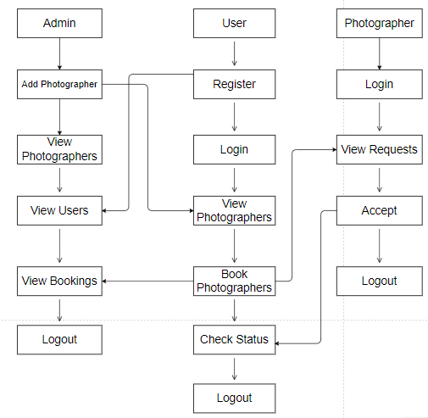

**Fig 1. Block diagram of proposed method**

**ARCHITECTURE**

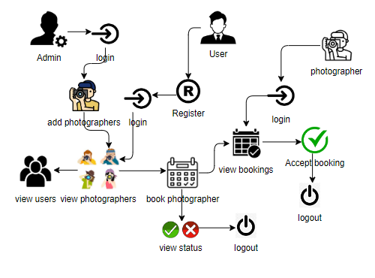

**Fig 2. Architecture diagram**

**MODULES**

This project contains 3 modules namely,

Admin

User

Photographer

1. **Admin:**

Admin must login with valid default credentials, Admin will add the photographers with their personals details later on admin view all the photographers, all registered users and all bookings by user.

1. **User:**

User can register with their own details and login with required details and user can view all photographers were admin added photographers. User can book photographer with their choice and he can check their status whether photographer accepted or not.

1. **Photographer:**

Photographer can login with their details which are added by admin. Photographer can view all requests which are sent by particular user and can accept that request.

**SYSTEM REQUIREMENTS SPECIFICATION**

**Functional and non-functional requirements:**

Requirement’s analysis is very critical process that enables the success of a system or software project to be assessed. Requirements are generally split into two types: Functional and non-functional requirements.

**Functional Requirements**: These are the requirements that the end user specifically demands as basic facilities that the system should offer. All these functionalities need to be necessarily incorporated into the system as a part of the contract. These are represented or stated in the form of input to be given to the system, the operation performed and the output expected. They are basically the requirements stated by the user which one can see directly in the final product, unlike the non-functional requirements.

Examples of functional requirements:

1. Authentication of user whenever he/she logs into the system
2. System shutdown in case of a cyber-attack
3. A verification email is sent to user whenever he/she register for the first time on some software system.

**Non-functional requirements**: These are basically the quality constraints that the system must satisfy according to the project contract. The priority or extent to which these factors are implemented varies from one project to other. They are also called non-behavioral requirements.  
They basically deal with issues like:

* Portability
* Security
* Maintainability
* Reliability
* Scalability
* Performance
* Reusability
* Flexibility

Examples of non-functional requirements:

1. Emails should be sent with a latency of no greater than 12 hours from such an activity.
2. The processing of each request should be done within 10 seconds
3. The site should load in 3 seconds whenever of simultaneous users are > 10000

**SYSTEM SPECIFICATIONS**

**SOFTWARE AND HARDWARE REQUIREMENTS:**

Operating system : Windows 7 or 7+

Ram : 8 GB

Hard disc or SSD : More than 500 GB

Processor : Intel 3rd generation or high or Ryzen with 8 GB Ram

Software’s : Java 8 or high version, Visual studio, Eclipse.

**Usecase diagram**

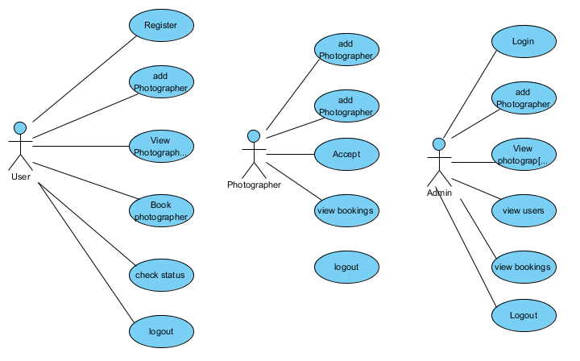

**Class diagram**

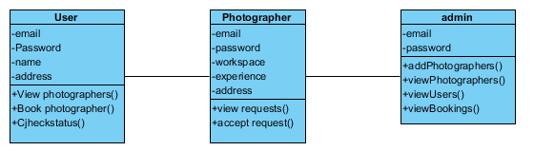

**Deployment diagram:**

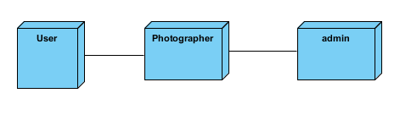

**Component diagram:**

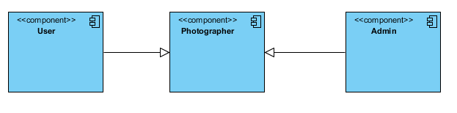

**Activity diagram:**

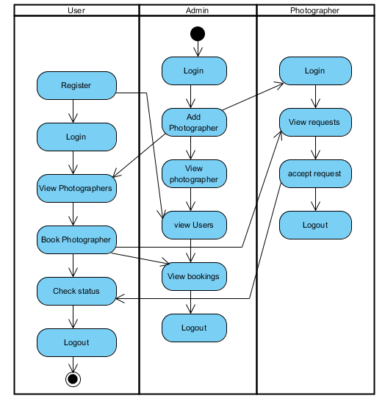

**Sequence diagram:**

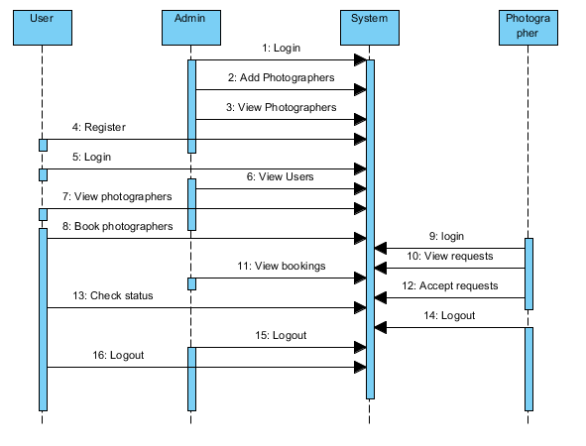

**Collaboration diagram:**

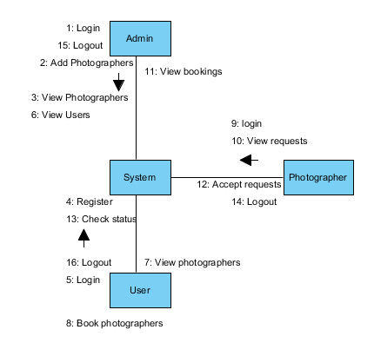

**ER-Diagram:**

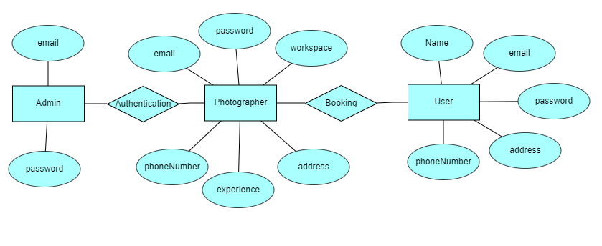

**DFD Diagram:**

**Context level diagram:**

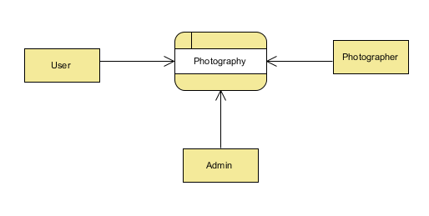

**Level 1 diagram:**

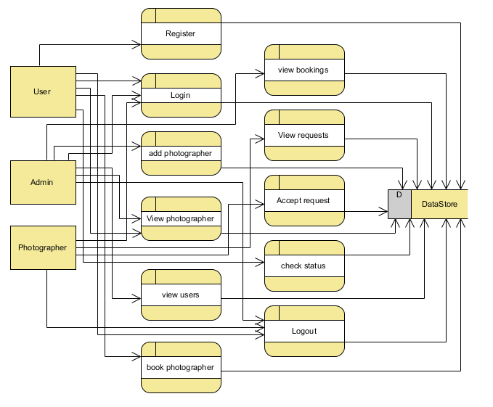

**Level 2 diagram:**

