## What is AngularJS ?

*“AngularJS is a JavaScript framework which simplifies binding JavaScript objects with HTML UI elements.”*

Let us try to understand the above definition with simple sample code.

Below is a simple “Customer” function with “CustomerName” property. We have also created an object called as “Cust” which is of “Customer” class type.

Hide Copy Code

function Customer()   
{  
this.CustomerName = "AngularInterview";  
}  
var Cust = new Customer();

Now let us say the above customer object we want to bind to a HTML text box called as “TxtCustomerName”. In other words when we change something in the HTML text box the customer object should get updated and when something is changed internally in the customer object the UI should get updated.

Hide Copy Code

<input type=text id="TxtCustomerName" onchange="UitoObject()"/>

So in order to achieve this communication between UI to object developers end up writing functions as shown below. “UitoObject” function takes data from UI and sets it to the object while the other function “ObjecttoUI” takes data from the object and sets it to UI.

Hide Copy Code

function UitoObject()   
{  
Cust.CustomerName = $("#TxtCustomerName").val();  
}  
function ObjecttoUi()   
{  
$("#TxtCustomerName").val(Cust.CustomerName);  
}

So if we analyze the above code visually it looks something as shown below. Your both functions are nothing but binding code logic which transfers data from UI to object and vice versa.

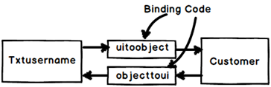

Now the same above code can be written in Angular as shown below. The javascript class is attached to a HTML parent div tag using “ng-controller” directive and the properties are binded directly to the text box using “ng-model” declarative.

So now whatever you type in the textbox updates the “Customer” object and when the “Customer” object gets updated it also updates the UI.

Hide Copy Code

<div ng-controller="Customer">  
<input type=text id="txtCustomerName" ng-model="CustomerName"/>  
</div>

In short if you now analyze the above code visually you end up with something as shown in the below figure.You have the VIEW which is in HTML, your MODEL objects which are javascript functions and the binding code in Angular.

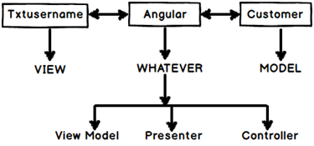

Now that binding code have different vocabularies.

* Some developers called it “ViewModel” because it connects the “Model” and the “View” .
* Some call it “Presenter” because this logic is nothing but presentation logic.
* Some term it has “Controller” because it controls how the view and the model will communicate.

To avoid this vocabulary confusion Angular team has termed this code as “Whatever”. It’s that “Whatever” code which binds the UI and the Model. That’s why you will hear lot of developers saying Angular implements “MVW” architecture.

## Explain Directives in Angular?

Directives are attributes decorated on the HTML elements. All directives start with the word “ng”. As the name says directive it directs Angular what to do.

For example below is a simple “ng-model” directive which tells angular that the HTML textbox “txtCustomerName” has to be binded with the “CustomerName” property.

Hide Copy Code

<input type=text id="txtCustomerName" ng-model="CustomerName"/>

Some of the most commonly used directives are ng-app,ng-controller and ng-repeat.

## What are controllers and need of ng-controller and ng-model in Angular?

“Controllers” are simple javascript function which provides data and logic to HTML UI. As the name says controller they control how data flows from the server to HTML UI.



For example below is simple “Customer” controller which provides data via “CustomerName” and “CustomerCode” property and Add/ Update logic to save the data to database.

|  |
| --- |
| Note: - Do not worry too much about the $scope , we will discuss the same in the next question. |

Hide Copy Code

function Customer($scope)  
{  
 $scope.CustomerName = "Shiv";  
 $scope.CustomerCode = "1001";  
 $scope.Add = function () {  
 }  
 $scope.Update = function () {  
 }  
}

“ng-controller” is a directive.Controllers are attached to the HTML UI by using the “ng-controller” directive tag and the properties of the controller are attached by using “ng-model” directive. For example below is a simple HTML UI which is attached to the “Customer” controller via the “ng-controller” directive and the properties are binded using “ng-model” directive.

Hide Copy Code

<div ng-controller="Customer">  
<input type=text id="CustomerName" ng-model="CustomerName"/><br />  
<input type=text id="CustomerCode" ng-model="CustomerCode"/>  
</div>

## What are expressions in Angular?

Angular expressionsare unit of code which resolves to value. This code is written inside curly braces “{“.

Below are some examples of angular expressions:-

The below expression adds two constant values.

Hide Copy Code

{{1+1}}

The below expression multiplies quantity and cost to get the total value.

Hide Copy Code

The value total cost is {{ quantity * cost }}

The below expression displays a controller scoped variable.

Hide Copy Code

<div ng-controller="CustomerVM">  
The value of Customer code is {{CustomerCode}}   
</div>

The value of Customer code is {{CustomerCode}}

## How can we initialize Angular application data?

We can use “ng-init” directive to achieve the same. You can see in the below example we have used “ng-init” directive to initialize the “pi” value.

Hide Copy Code

<body ng-app="myApp" ng-init="pi=3.14">  
The value of pi is {{pi}}  
</body>

## Explain $scope in Angular?

“$scope” is an object instance of a controller. “$scope” object instance get’s created when “ng-controller” directive is encountered.

For example in the below code snippet we have two controllers “Function1” and “Function2”. In both the controllers we have a “ControllerName” variable.

Hide Copy Code

function Function1($scope)  
{  
$scope.ControllerName = "Function1";   
}  
function Function2($scope)  
{  
$scope.ControllerName = "Function2";  
}

Now to attach the above controllers to HTML UI we need to use “ng-controller” directive. For instance you can see in the below code snippet how “ng-controller” directive attaches “function1” with “div1” tag and “function2” with “div2” tag.

Hide Copy Code

<div id="div1" ng-controller="Function1">  
Instance of {{ControllerName}} created   
</div>  
<div id="div2" ng-controller="Function2">  
Instance of {{ControllerName}} created   
</div>

So this is what happens internally. Once the HTML DOM is created Angular parser starts running on the DOM and following are the sequence of events:-

* The parser first finds “ng-controller” directive which is pointing to “Function1”. He creates a new instance of “$scope” object and connects to the “div1” UI.
* The parser then starts moving ahead and encounters one more “ng-controller” directive which is pointing to “Function2”. He creates a new instance of “$scope” object and connects to the “div2” UI.

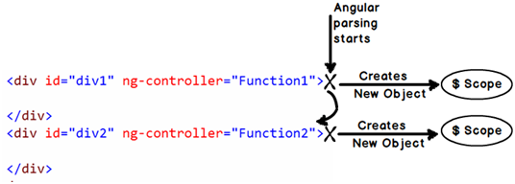

Now once the instances are created, below is a graphical representation of the same. So the “DIV1” HTML UI is binded with “function1” $scope instance and the “DIV2” HTML UI is binded with “function2” $scope instance. In other words now anything changes in the $scope object the UI will be updated and any change in the UI will update the respective $scope object.

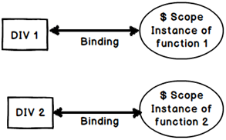

## What is “$rootScope” and how is it related with “$scope”?

“$rootScope” is a parent object of all “$scope” angular objects created in a web page.

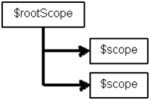

Let us understand how Angular does the same internally. Below is a simple Angular code which has multiple “DIV” tags and every tag is attached to a controller. So let us understand step by step how angular will parse this and how the “$rootScope” and “$scope” hierarchy is created.

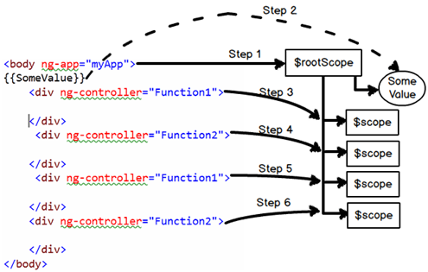

The Browser first loads the above HTML page and creates a DOM (Document object model) and Angular runs over the DOM.Below are the steps how Angular creates the rootscope and scope objects.

* Step 1:- Angular parser first encounters the “ng-app” directive and creates a “$rootScope” object in memory.
* Step 2:- Angular parser moves ahead and finds the expression {{SomeValue}}. It creates a variable
* Step 3:- Parser then finds the first “DIV” tag with “ng-controller” directive which is pointing to “Function1” controller. Looking at the “ng-controller” directive it creates a “$scope” object instance for “Function1” controller. This object it then attaches to “$rootScope” object.
* Step 4:- Step 3 is then repeated by the parser every time it finds a “ng-controller” directive tag. Step 5 and Step 6 is the repetition of Step 3.

If you want to test the above fundamentals you can run the below sample Angular code. In the below sample code we have created controllers “Function1” and “Function2”. We have two counter variables one at the root scope level and other at the local controller level.

Hide Copy Code

<script language="javascript">  
function Function1($scope, $rootScope)   
{  
 $rootScope.Counter = (($rootScope.Counter || 0) + 1);  
 $scope.Counter = $rootScope.Counter;  
 $scope.ControllerName = "Function1";  
}  
function Function2($scope, $rootScope)   
{  
 $rootScope.Counter = (($rootScope.Counter || 0) + 1);  
 $scope.ControllerName = "Function2";  
}  
 var app = angular.module("myApp", []); *// creating a APP*  
 app.controller("Function1", Function1); *// Registering the VM*  
 app.controller("Function2", Function2);  
  
</script>

Below is the HTML code for the same. You can we have attached “Function1” and “Function2” two times with “ng-controller” which means four instances will be created.

Hide Copy Code

<body ng-app="myApp" id=1>  
 Global value is {{Counter}}<br />  
<div ng-controller="Function1">  
 Child Instance of {{ControllerName}} created :- {{Counter}}  
</div><br />  
<div ng-controller="Function2">  
 Child Instance of {{ControllerName}} created :- {{Counter}}  
</div><br />  
<div ng-controller="Function1">  
 Child Instance of {{ControllerName}} created :- {{Counter}}  
</div><br />  
<div ng-controller="Function2">  
 Child Instance of {{ControllerName}} created :- {{Counter}}  
</div><br />  
</body>

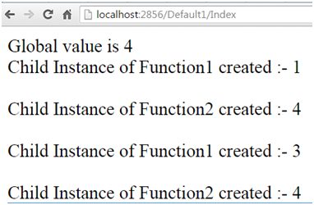

Above is the output of the code you can see the global variable of root scope has be incremented four times because four instances of $scope have been created inside “$rootScope” object.

## Explain the concept of digest cycle, watchers and dirty checking?

Angular is a MVW framework. It helps us to bind the model and the view. In other words when any change happens in the model the view gets updated. This updation of the model and the view is done by a loop called as digest cycle.

Digest cycle follows four important steps:-

1. Step 1:- Some kind of event is triggered by the end user like typing (onchange), button click etc and due to this activity model value changes.
2. Step 2:- Angular first checks if the new value and old values are same. If they are same he does not do anything. If they are not it then it invokes the digest cycle.
3. Step 3:- Digest cycle then runs through the scope objects to check which objects are getting affected because of this change. Every object in the scope have watchers. Watchers as the name says it listens whether the model has changed or not. Digest cycle informs the watchers about the model change and then watchers synchronize the view with the model data.
4. Step 4 :- In step 3 watchers update the view and due that update its very much possible that the model changes again. Now due to this model change we have to reevaulate the view again. So the digest loop runs once again to ensure that all things are synched up. This second loop which runs is termed as dirty check loop.

Below is the figure where in we have highlighted all the four steps.

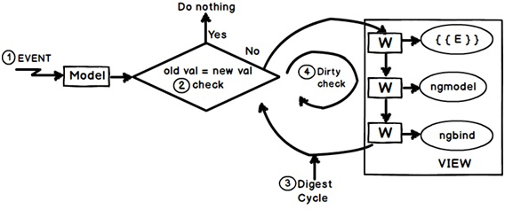

So summarizing definitions for the above three concepts:-

* Digest cycle: - It is a simple loop which updates the model and view.
* Watchers :- They are listeners which are attached to expression and angular directives and fire when the model data changes.
* Dirty check :- This is a extra digest loop which runs to check any cascading left over updates due to the first digest cycle.

## What can be the performance implications of watchers and digest cycle ?

If there lot of unnecessary watchers then digest cycle has to work harder. As per AngularJS team having more than 2000 watchers on Angular screen is a bad practice.

## How can we measureno: of watchers & time spent on digest cycle?

Consider the below simple example where we have two ng-models and three expression. So in all we should have 5 watchers for the below screen

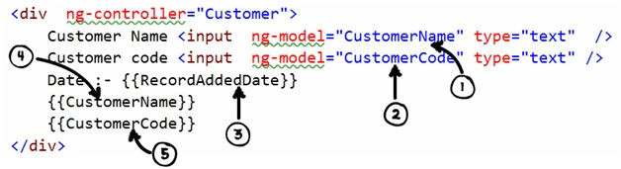

There are lot of great open source tools which help you to figure out the number of watchers , one such tool is the “batarang” tool. It’s a simple Google chrome extension which you can install separately.

Below is a simple snapshot where in we ran the above program , pressed f12 , enabled batarang and below are the results. You can see that he is showing 5 total watchers and for that digest cycle ran for 0.07 MS.

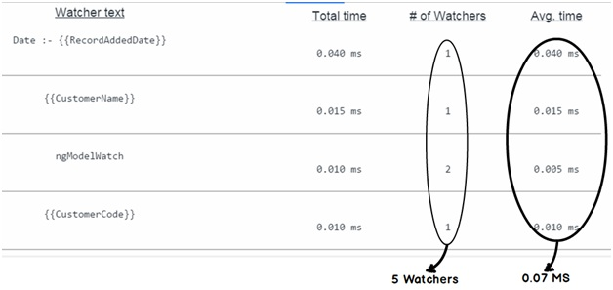

## How can we decrease digest cycle time ?

To decrease digest cycle time you need to decrease the number of watchers. Below are some best practices you can follow to decrease number of watchers :-

* Remove unnecessary watchers.
* Use one time Angular binding. Especially if you see ng-repeat loop apply one time binding.
* Work in batches.
* Cache DOM
* Use Web worker

## Can we force the digest cycle to run manually?

Yes , you can force it to run manually by calling the “$apply()” method.

## Do I need Jquery for Angular?

No , you do not need Jquery for Angular. It’s independent of Jquery.

## How is the data binding in Angular ?

Its two way binding. So whenever you make changes in one entity the other entity also gets updated.

## Explain compile and link phase?

At the heart Angular framework is a parser. A parser which parses the Angular directives and render’s HTML output.

Angular parser works in 3 steps:-

Step 1:- HTML browser parses the HTML and creates a DOM (Document Object Model).

Step 2:- Angular framework runs over this DOM looks at the Angular directives and manipulates the DOM accordingly.

Step 3:- This manipulated is then rendered as HTML in the browser.

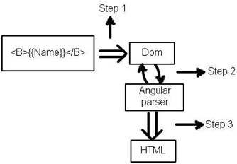

Now the above angular parsing is not so simple as it looks to be. It occurs in two phases “Compile” and “Link”. Firs the compile phase occurs then the link phase.



In compile phase the angular parser starts parsing the DOM and whenever the parser encounters a directive it create a function. These functions are termed as template or compiled functions. In this phase we do not have access to the $scope data.

In the link phase the data i.e. ($scope) is attached to the template function and executed to get the final HTML output.

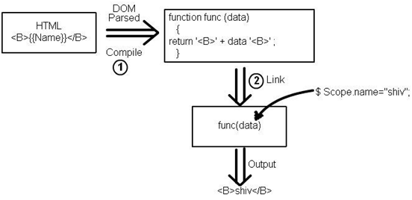

## 

## How do we make HTTP get and post calls in Angular?

To make HTTP calls we need to use the “$http” service of Angular. In order to use the http services you need to make provide the “$http” as a input in your function parameters as shown in the below code.

Hide Copy Code

function CustomerController($scope,$http)  
{  
 $scope.Add = function()  
 {  
 $http({ method: "GET", url: "http://localhost:8438/SomeMethod" }).success(function (data, status, headers, config)  
 {  
 *// Here goes code after success*  
 }  
 }  
}

“$http” service API needs atleast three things:-

* First what is the kind of call “POST” or “GET”.
* Second the resource URL on which the action should happen.
* Third we need to define the “success” function which will be executed once we get the response from the server.

Hide Copy Code

$http({ method: "GET", url: "http://localhost:8438/SomeMethod" }).success(function (data, status, headers, config)  
{  
*// Here goes code after success*  
}

## How do we pass data using HTTP POST in Angular ?

You need to pass data using the “data” keyword in the “$http” service API function. In the below code you can see we have created a javascript object “myData” with “CustomerName” property. This object is passed in the “$http” function using HTTP POST method.

Hide Copy Code

Var myData = {};  
myData.CustomerName = "Test";  
$http({ method: "POST",  
 data: myData,  
 url: "http://www.xyz.com"})  
 .success(function (data, status, headers, config)  
 {  
 *// Here goes code after success*  
 }

## What is dependency injection and how does it work in Angular?

Dependency injection is a process where we inject the dependent objects rather than consumer creating the objects. DI is everywhere in Angular or we can go one step ahead and say Angular cannot work without DI.

For example in the below code “$scope” and “$http” objects are created and injected by the angular framework. The consumer i.e. “CustomerController” does not create these objects himself rather Angular injects these objects.

Hide Copy Code

function CustomerController($scope,$http)  
{  
*// your consumer would be using the scope and http objects*  
}

## How does DI benefit in Angular?

There are two big benefits of DI: - Decoupling and Testing.

Let’s first start with Decoupling. Consider your application has a logger functionality which helps to log errors , warning etc in some central place. This central place can be a file, event viewer, database etc.

Hide Copy Code

function FileLogger()  
{  
 this.Log = function () {  
 alert("File logger");  
 };  
}  
function EventLogger()  
{  
 this.Log = function () {  
 alert("Event viewer logger");  
 };  
}

Now let’s say you have a “Customer” class who wants to use the “Logger” classes. Now which “Logger” class to use depends on configuration.

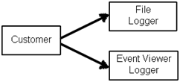

So the code of “Customer” is something as shown below. So depending on the configuration “Customer” class either creates “FileLogger” or it creates “EventLogger” object.

Hide Copy Code

function Customer($scope, Logger)  
{  
 $scope.Logger = {};  
 if (config.Loggertype = "File")  
{  
 $scope.Logger = new FileLogger();  
 }  
 else  
{  
 $scope.Logger = new EventLogger();  
 }  
}

But with DI our code becomes something as shown below. The “Customer” class says he is not worried from where the “Logger” object comes and which type of “Logger” objects are needed .He just wants to use the “Logger” object.

Hide Copy Code

function Customer($scope,$http, Logger)  
{  
 $scope.Logger = Logger;  
}

With this approach when a new “Logger” object gets added the “Customer” class does not have to worry about the new changes because the dependent objects are injected by some other system.

The second benefit of DI is testing. Let’s say you want to test the “Customer” class and you do not have internet connection. So your “$http” object method calls can throw errors. But now you can mock a fake “$http” object and run your customer class offline without errors.The fake object is injected using DI.

## What are services in Angular?

Service helps to implement dependency injection. For instance let’s say we have the below “Customer” class who needs “Logger” object. Now “Logger” object can be of “FileLogger” type or “EventLogger” type.

Hide Copy Code

function Customer($scope,$http, Logger)  
{  
 $scope.Logger = Logger;  
}

So you can use the “service” method of the application and tie up the “EventLogger” object with the “Logger” input parameter of the “Customer” class.

Hide Copy Code

var app = angular.module("myApp", []); *// creating a APP*  
app.controller("Customer", Customer); *// Registering the VM*  
app.service("Logger", EventLogger); *// Injects a global Event logger object*

So when the controller object is created the “EventLogger” object is injected automatically in the controller class.

## Are Service object instances global or local?

Angular Services create and inject global instances. For example below is a simple “HitCounter” class which has a “Hit” function and this function increments the variable count internally every time you call hit the button.

Hide Copy Code

function HitCounter()  
{  
 var i = 0;  
 this.Hit = function ()  
 {  
 i++;  
 alert(i);  
 };  
}

This “HitCounter” class object is injected in “MyClass” class as shown in the below code.

Hide Copy Code

function MyClass($scope, HitCounter)  
{  
 $scope.HitCounter = HitCounter;  
}

Below code advises the Angular framework to inject “HitCounter” class instance in the “MyClass” class. Read the last line of the below code specially which says to inject the inject the “HitCounter” instance.

Hide Copy Code

var app = angular.module("myApp", []); *// creating a APP*  
app.controller("MyClass", MyClass); *// Registering the VM*  
app.service("HitCounter", HitCounter); *// Injects the object*

Now let’s say that the “Controller” “MyClass” is attached to twodiv tag’s as shown in the below figure.

So two instances of “MyClass” will be created. When the first instance of “MyClass” is created a “HitCounter” object instance is created and injected in to “MyClass” first instance.

When the second instance of “MyClass” is created the same “HitCounter” object instance is injected in to second instance of “MyClass”.

Again I repeat the same instance is injected in to the second instance, new instances are not created.

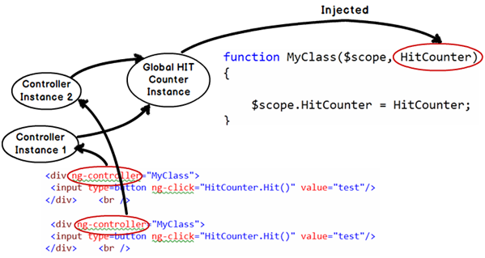

If you execute the above code you will see counter values getting incremented even if you are coming through different controller instances.

## What is a Factory in Angular?

“Factory” in real world means a premise where products are manufactured. Let’s take an example of a computer manufacturing firm. Now the company produces different kinds and sizes of computers likelaptops,desktops, tablets etc.

Now the process of manufacturing the computer products are same with slight variation. To manufacture any computer we need processor, RAM and hard disk. But depending on what kind of final case packing is the final product shapes.

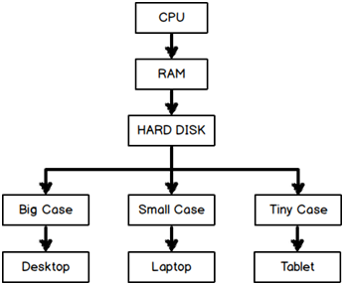

That’s what the use of Factory in Angular.

For example see the below code we have a “Customer”, “Phone” and “Address” class.

Hide Copy Code

function Customer()  
{  
 this.CustomerCode = "1001";  
 this.CustomerName = "Shiv";  
}  
function Phone()  
{  
 this.PhoneNumber = "";  
}  
function Address()  
{  
 this.Address1 = "";  
 this.Address2 = "";  
}

So now we would create different types of “Customer” object types using the combination of “Address” and “Phones” object.

* We would like to combine “Customer” with “Address” and create a “Customer” object which has “Address” collection inside it.
* Or must be we would like to create “Customer” object with “Phone” objects inside it.
* Or must be “Customer” object with both “Phone” and “Address” objects.

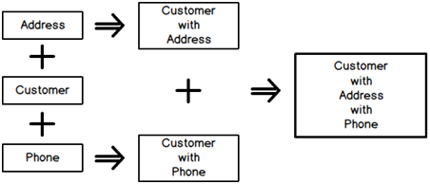

In other words we would like to have different permutation and combination to create different types of “Customer” objects.

So let’s start from bottom. Let’s create two factory function’s one which creates “Address” object and the other which creates “Phone” objects.

Hide Copy Code

functionCreateAddress()  
{  
var add = new Address();  
return add;  
}  
functionCreatePhone()  
{  
var phone = new Phone();  
return phone;  
}

Now let’s create a main factory function which uses the above two small factory functions and gives us all the necessary permutation and combination.

In the below factory you can see we have three functions:-

* “CreateWithAddress” which creates “Customer” with “Address” objects inside it.
* “CreateWithPhone” which creates “Customer” object with “Phone” objects inside it.
* “CreateWithPhoneAddress” which creates “Customer” object with aggregated “Phone” and “Address” objects.

Hide Copy Code

function CreateCustomer() {  
  
return {  
CreateWithAddress: function () {  
varcust = new Customer();  
cust.Address = CreateAddress();  
returncust;  
 },  
CreateWithPhone: function () {  
varcust = new Customer();  
cust.Phone = {};  
cust.Phone = CreatePhone();  
returncust;  
 }  
 ,  
CreateWithPhoneAddress: function () {  
debugger;  
varcust = new Customer();  
cust.Phone = CreatePhone();  
cust.Address = CreateAddress();  
returncust;  
 }  
 }  
 }

Below is a simple “CustomerController” which takes “CustomerFactory” as the input. Depending on “TypeOfCustomer” it creates with “Address” , “Phones” or both of them.

Hide Copy Code

functionCustomerController($scope, Customerfactory)  
 {  
  
 $scope.Customer = {};  
 $scope.Init = function(TypeofCustomer)  
 {  
  
if (TypeofCustomer == "1")  
 {  
 $scope.Customer = Customerfactory.CreateWithAddress();  
 }  
if (TypeofCustomer == "2")  
 {  
 $scope.Customer = Customerfactory.CreateWithPhone();  
 }  
if (TypeofCustomer == "3") {  
 $scope.Customer = Customerfactory.CreateWithPhoneAddress();  
 }  
 }  
 }

You also need to tell Angular that the “CreateCustomer” method needs to be passed in the input. For that we need to call the “Factory” method and map the “CreateCustomer” method with the input parameter “CustomerFactory” for dependency injection.

Hide Copy Code

var app = angular.module("myApp", []); *// creating a APP*  
app.controller("CustomerController", CustomerController); *// Register the VM*  
app.factory("Customerfactory", CreateCustomer);

So if we consume the “CustomerController” in UI , depending on situation it creates different flavors of “Customer” object. You can in the below code we have three different “DIV” tags and depending on the “TypeofCustomer” we are displaying data.

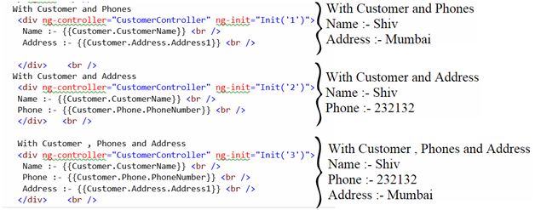

## What is the difference between Factory and Service?

“Factory” and “Service” are different ways of doing DI (Dependency injection) in angular. Please read the previous question to understand what is DI.

So when we define DI using “service” as shown in the code below. This creates a new GLOBAL instance of the “Logger” object and injects it in to the function.

Hide Copy Code

app.service("Logger", Logger); *// Injects a global object*

When you define DI using a “factory” it does not create a instance. It just passes the method and later the consumer internally has to make calls to the factory for object instances.

Hide Copy Code

app.factory("Customerfactory", CreateCustomer);

Below is a simple image which shows visually how DI process for “Service” is different than “Factory”.

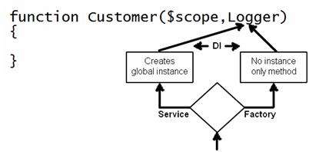

|  |  |  |
| --- | --- | --- |
|  | **Factory** | **Service** |
| Usage | When we want to create different types of objects depending on scenarios. For example depending on scenario we want to create a simple “Customer” object , or “Customer” with “Address” object or “Customer” with “Phone” object. See the previous question for more detailed understanding. | When we have utility or shared functions to be injected like Utility , Logger , Error handler etc. |
| Instance | No Instance created. A method pointer is passed. | Global and Shared instance is created. |

## How are validations implemented in Angular?

Angular leverages HTML 5 validations and new form element types to implement validation.

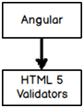

For instance below is a simple form which has two text boxes. We have used HTML 5 “required” validation attribute and a form element of type “email”.

Hide Copy Code

<form name="frm1" id="frm1" >  
Name :- <input type=text name="CustomerName" id="CustomerName" required /> Email :- <input type=email name="Email" id="Email" />  
<input type=submit value="Click here"/>  
</form>

Below are some example of new form elements introduced in HTML 5 and Angular works with almost all of them :-

* Color.
* Date
* Datetime-local
* Email
* Time
* Url
* Range
* Telephone
* Number
* Search

When you run the above HTML inside a browser which understands HTML 5 , you will see your validations and form types in actions as shown in the below browser screen shot.

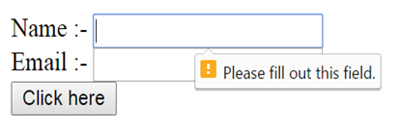

Angular leverages HTML 5 validation attributes and new HTML 5 form elements. Now if we want Angular to handle validation we need first stop HTML 5 to do validation. So for that the first step is to specify “novalidate” attribute on the form tag.

Hide Copy Code

<form name="frm1" novalidate>  
-----  
</form>

So now the HTML will not fire those validations it will be routed to the Angular engine to further take actions.

In other words when end user fills data in the HTML UI , validation events are routed to Angular framework and depending on scenario Angular sets a field called as “$Valid”. So if the validations are fine it sets it to “True” or else its sets it to “False”.

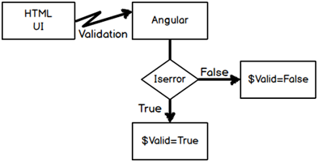

So you can see in the below code we have attached the angular controller and models to the text boxes. Watch the code of the button it has “ng-disabled” attribute which is set via the “$Valid” property in a NEGATED fashion.

Negated fashion means when there is no error it should enable the button and when there are errors that means it’s false it should disable the button.

Hide Copy Code

<form name="frm1" novalidate>  
Name:-<input type=text ng-model="Customer.CustomerName" name="CustomerName" required />  
Email :- <input type=email ng-model="Customer.Email" name="Email" />  
<input type=submit value="Click here" ng-disabled="!(frm1.$valid)"/>  
</form>

*Note :- “Name” is needed for the validations to work.*

## How to check error validation for a specific field?

To check for a specific field you need to use the below DOM code.

Hide Copy Code

!frm1.CustomerName.$valid

## What does SPA (Single page application) mean?

SPA is a concept where rather loading pages from the server by doing post backs we create a single shell page or master page and load the webpages inside that master page.

## How can we implement SPA with Angular?

By using Angular routes.

## How to implement routing in Angular?

Implementing Angular route is a five step process: -

Step 1: - Add the “Angular-route.js” file to your view.

Hide Copy Code

<script src="~/Scripts/angular-route.js"></script>

Step 2: - Inject “ngroute” functionality while creating Angular app object.

Hide Copy Code

var app = angular.module("myApp", ['ngRoute']);

Step 3: - Configure the route provider.

In route provider we need to define which URL pattern will load which view. For instance in the below code we are saying “Home” loads “Yoursite/Home” view and “Search” loads “YourSite/Search” view.

Hide Copy Code

app.config(['$routeProvider',  
 function ($routeProvider) {;  
  
 $routeProvider.  
 when('/Home, {  
 templateUrl: 'Yoursite/Home',  
 controller: 'HomeController'  
 }).  
 when('/Search', {  
 templateUrl: YourSite/Search',  
 controller: 'SearchController'  
 }).  
 otherwise({  
 redirectTo: '/'  
 });  
 }]);

Step 4: - Define hyperlinks.

Define hyper link with the “#” structure as shown below. So now when user clicks on the below anchor hyperlinks, these actions are forwarded to route provider and router provider loads the view accordingly.

Hide Copy Code

<div>  
<a href="#/Home">Home</a><br />  
<a href="#/Search"> Search </a><br />  
</div>

Step 5: - Define sections where to load the view.

Once the action comes to the router provider it needs a place holder to load views. That’s defined by using the “ng-view” tag on a HTML element. You can see in the below code we have created a “DIV” tag with a place holder. So the view will load in this section.

Hide Copy Code

<div ng-view>  
  
</div>

So if we summarize angular routing is a three step process (Below is a visual diagram for the same): -

* Step 1: - End user clicks on a hyperlink or button and generates action.
* Step 2: - This action is routed to the route provider.
* Step 3: - Router provider scans the URL and loads the view in the place holder defined by “ng-view” attribute.

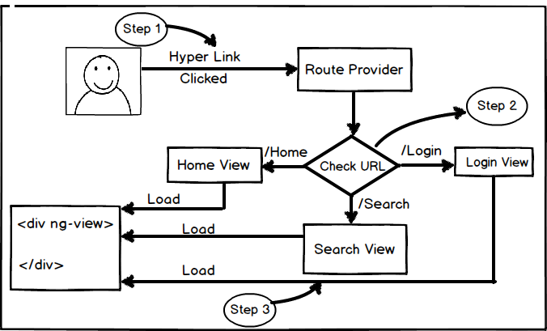

## How to implement SPA using angular-UI route?

Angular UI route helps to implement SPA concept using the concept of STATES. The main goal of SPA is navigating from one view to other view without reloading the main page. Angular UI route visualizes every view as a STATE. When you want to navigate from one view to other view you can either use the STATE names or use URL.

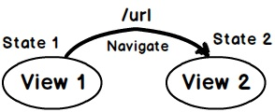

So let’s say we want to navigate from “Home.htm” view to About.htm” view so we can define two states “Home” and “About” and link them to the respective HTML page as shown below.

You can also specify URL by which you can move between these states by using “url” property as shown in the below code.

Hide Copy Code

myApp.config(function ($stateProvider, $urlRouterProvider) {  
 $stateProvider  
 .state('Home', {  
 url: '/HomePage',  
 templateUrl: 'Home.htm'  
 })  
 .state('About', {  
url: '/About',  
 templateUrl: 'About.htm'  
 })};

Now once the states are defined to we need to use “ui-sref” and if you want to navigate using url provide “url” value in the “href” of the anchor tag.

We also need to provide "<ui-view>" tag to define in which location we want to load the views.

Hide Copy Code

<a ui-sref="About" href="#About">Home</a>  
<a href="#Home">About</a>  
<ui-view></ui-view>

Below is the complete code if HTML , please ensure you have also referenced of “Angular-UI” js file. You can also see “App.js” file , this file has code which defines the states.

Hide Copy Code

<script src="Scripts/angular.js" type="text/javascript"></script>  
<script src="Scripts/angular-ui-router.js" type="text/javascript"></script>  
<script src="Scripts/App.js" type="text/javascript"></script>  
  
<body ng-app="myApp">  
<a ui-sref="About" href="#About">Home</a>  
<a href="#Home">About</a>  
<ui-view></ui-view>  
</body>  
</html>

## Can we load HTML content rather than a full page ?

Yes, you can load simple HTML content by using “template” property as shown in the highlighted code below.

Hide Copy Code

myApp.config(function ($stateProvider, $urlRouterProvider) {  
 $stateProvider  
 .state('About', {  
url: '/About',  
template: '<b>This is About us</b>'  
 })};

## How can we create controllers and pass parameters in Angular UI route?

To create a controller we need to use “controller” property of the state provider. To specify parameters you can put the parameter name after the url. In the below code you can see ‘Id’ parameter after the url and also you can see how validations are applied on these parameters using regex.

Hide Copy Code

myApp.config(function ($stateProvider, $urlRouterProvider) {  
 $stateProvider  
 .state('State1', {  
 url: '/SomeURL/{Id:[0-9]{4,4}}',  
 template: '<b>asdsd</b>',  
 controller: function ($scope, $stateParams) {  
 alert($stateParams.Id);  
 }  
 });

## How to implement nested views using Angular UI route?

First let us understand the concept of nested views. We want to navigate as follows in SPA. From main view we want to navigate to some view and in that view we want to load some other view.

Angular UI Router helps to define nested states. Below is the code of “MainView” in which we have defined one more state “View” and in that we have two child states “View.SubView1” and “View.SubView2” which points to different views.

Hide Copy Code

myApp.config(function ($stateProvider, $urlRouterProvider) {  
 $stateProvider  
 .state("View", {  
 templateUrl: 'View.htm'  
 })  
 .state('View.SubView1', {  
 template: '<b>Sub view 1</b>'  
 }).state('View.SubView2', {  
 template: '<b>Sub view 2</b>'  
 });  
});

In the parte view we can now define navigation to child states i.e. “View.SubView1” and “View.SubView2”.

Hide Copy Code

<a ui-sref="View.SubView1" href="#View.SubView1">Sub view 1</a>  
<a ui-sref="View.SubView2" href="#View.SubView1 ">Sub view 2</a>  
<div ui-view></div>

## How can we create a custom directive in Angular?

Till now we have looked in to predefined Angular directives like “ng-controller”,”ng-model” and so on. But what if we want to create our own custom Angular directive and attach it with HTML elements as shown in the below code.

Hide Copy Code

<div id=footercompany-copy-right></div>

To create a custom directive we need to use the “directive” function to register the directive with angular application. When we call the “register” method of “directive” we need to specify the function which will provide the logic for that directive.

For example in the below code we have created a copy right directive and it returns a copy right text.

*Please note “app” is an angular application object which has been explained in the previous sections.*

Hide Copy Code

app.directive('companyCopyRight', function ()  
{  
return  
{  
 template: '@CopyRight questpond.com '  
 };  
});

The above custom directive can be later used in elements as shown in below code.

Hide Copy Code

<div ng-controller="CustomerViewModel">  
<div company-copy-right></div>  
</div>

## What kind of naming conventions is used for custom directives?

For angular custom directive the best practice is to follow camel casing and that also with atleast two letter’s. In camel case naming convention we start with a small letter, followed by a capital letter for every word.

Some example of camel cases are “loopCounter” , “isValid” and so on.

So when you register a custom directive it should be with camel case format as shown in the below code “companyCopyRight”.

Hide Copy Code

app.directive('companyCopyRight', function ()  
{  
return  
{  
 template: '@CopyRight questpond.com '  
 };  
});

Later when this directive is consumed inside HTML before each capital letter of camel case we need to insert a “-“ as specified in the below code.

Hide Copy Code

<div company-copy-right></div>

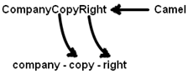

If you are making a one letter prefix like “copyright” it’s very much possible that tomorrow if HTML team creates a tag with the same name, it will clash with your custom directive. That’s why angular team recommends camel case which inserts a “-“ in between to avoid further collision with future HTML tag’s.

## What are the different custom directive types in AngularJS?

There are different flavors of Angular directives depending till what level you want to restrict your custom directive.

In other words do you want your custom directive to be applied only on HTML element or only on an attribute or just to CSS etc.

So in all there are four different kinds of custom directives:-

* Element directives (E)
* Attribute directives (A)
* CSS class directives (C)
* Comment directives (M)

Below is a simple custom directive implementation at the element level.

Hide Copy Code

myapp.directive('userinfo', function()  
{  
 var directive = {};  
 directive.restrict = 'E';  
 directive.template = "User : {{user.firstName}} {{user.lastName}}";  
 return directie;  
});

The “restrict” property is set to “E” which means that this directive can only be used at element level as shown in the code snippet below.

Hide Copy Code

<userinfo></userinfo>

If you try to use it at an attribute level as shown in the below code it will not work.

Hide Copy Code

<div userinfo></div>

So “E” for element, “A” for attribute, “C” for CSS and “M” for comments.

## What if I want custom directives to be applied on element as well as attributes ?

Hide Copy Code

directive.restrict = 'EA';

## Can I set an Angular directive template to a HTML web page?

Yes, you can set template to page directly by using “templateUrl” property of the directive as shown in the code snippet below.

Hide Copy Code

directive.templateUrl = "/templates/footer.html";

## Explain $q service, deferred and promises?

Promises are POST PROCESSING LOGICS which you want to execute after some operation / action is completed. While deferred helps to control how and when those promise logics will execute.

We can think about promises as “WHAT” we want to fire after an operation is completed while deferred controls “WHEN” and “HOW” those promises will execute.

For example after an operation is complete you want to a send a mail, log in to log file and so on. So these operations you will define using promise. And these promise logics will be controlled by deferred.

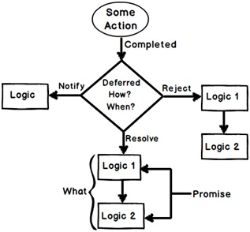

We are thankful to [www.stepbystepschools.net](http://www.stepbystepschools.net/) for the above image.

So once some action completes deferred gives a signal “Resolve”, “Reject” or “Notify” and depending on what kind of signal is sent the appropriate promise logic chain fires.

“$q” is the angular service which provides promises and deferred functionality.

Using promises, deferred and “q” service is a 4 step process:-

* Step 1:- Get the “q” service injected from Angular.
* Step 2 :- Get deferred object from “q” service object.
* Step 3 :- Get Promise object from deferred object.
* Step 4 :- Add logics to the promise object.

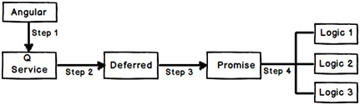

Below is the angular code for the above 4 steps.

Hide Copy Code

*// Step 1 :- Get the "q" service*  
 function SomeClass($scope,$q) {  
  
*// Step 2 :- get deferred from "q" service*  
 var defer = $q.defer();  
*// step 3:- get promise from defer*  
 var promise = defer.promise;  
*// step 4 :- add success and failure logics to promise object*  
promise.then(function () {  
 alert("Logic1 success");  
 }, function () {  
 alert("Logic 1 failure");  
 });  
  
promise.then(function () {  
 alert("Logic 2 success");  
 }, function () {  
 alert("Logic 2 failure");  
 });  
  
 }

So now depending on situations you can signal your promise logics via deferred to either fire the success events or the failure events.

Hide Copy Code

*// This will execute success logics of promise*   
defer.resolve();

Hide Copy Code

*// This will execute failure logics of promise  
defer.reject();*

What is an interceptor? What are common uses of it?

Interceptors are AngularJS’s most ﬂexible method for defining application‐level rules (security purpose) for handling HTTP requests. Suppose we wanted to attach the HTTP response status to the body of every HTTP response or we want to determine whether incoming HTTP request is valid or not. We can do this easily by using $httpProvider service provider; by implementing interceptor.

var appModule = angular.module("appModule", []);

var interceptorFunctions=function () {

return {

request: function (configObject) {

configObject.url = "productInfo.json";

return configObject;

},

requestError: function(configObject) {

console.log(configObject);

return configObject;

},

response: function (responseObject) {

console.log(responseObject);

return responseObject;

},

responseError: function(responseObject) {

console.log(responseObject);

return responseObject;

}

}

};

/*configure config function*/

appModule.config(function ($httpProvider) {

$httpProvider.interceptors.push(interceptorFunctions);

});

/*here we define controller*/

appModule.controller("CtrlInterceptor", function ($scope, $http) {

$scope.loadItems = function () {

$http.get("no_existence_of_file.json").success(function (responseObject) {

$scope.products = responseObject;

});

}

});

As in the preceding code, HTTP interceptors are defined as an array on the $httpProvider provider. Because providers can only be accessed in config () functions, interceptors must be defined in a config () function. Usually we insert factory functions that return objects with properties such as request, response, requestError, responseError.

But in this case, we define interceptorFunctions() function that return object which contains all the above properties and pass this $httpProvider.interceptors.push() method.

The function we have assigned to the request property illustrate how an interceptor can change a request by changing the requested URL to productInfo.json file, here we do not consider what was passed to the $http service method. To do this, we just change URL property of the config object and return this object as result so that it can be passed to the next interceptor.For the response interceptor, we just print responses object data to the browser’s console; that we received from the server. We can also do other stuff with this object that received from server before sending it to the browser.

The responseError property interceptor function which will be called when previous response interceptor throws an error.And requestError property interceptor function which will be called when the previous request interceptor throws an error.