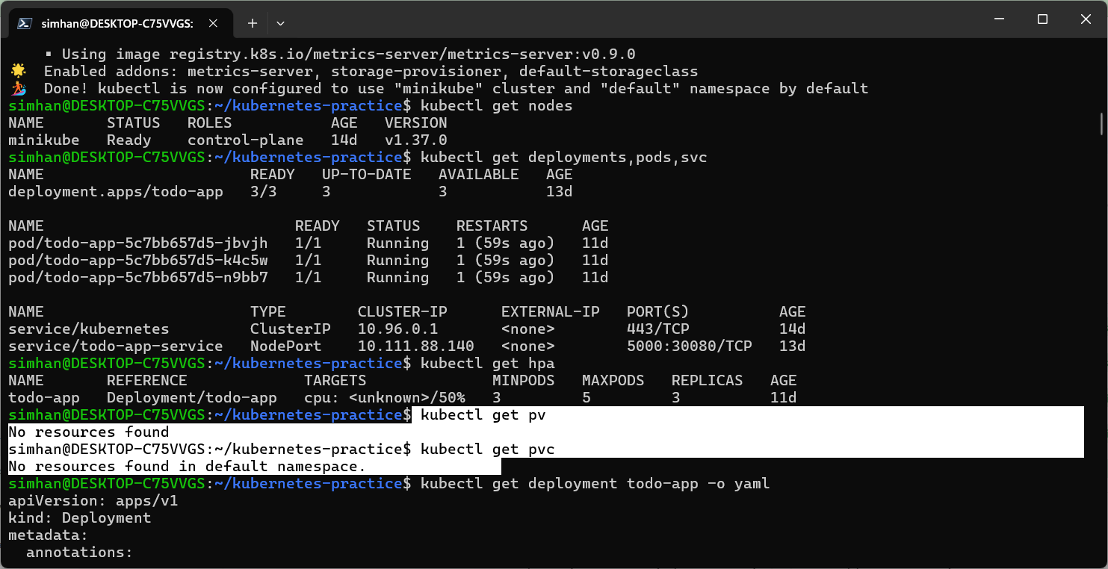
No pv and pvc in minikube initially.
Week4-storage created and yaml files for pv and pvc have been created.
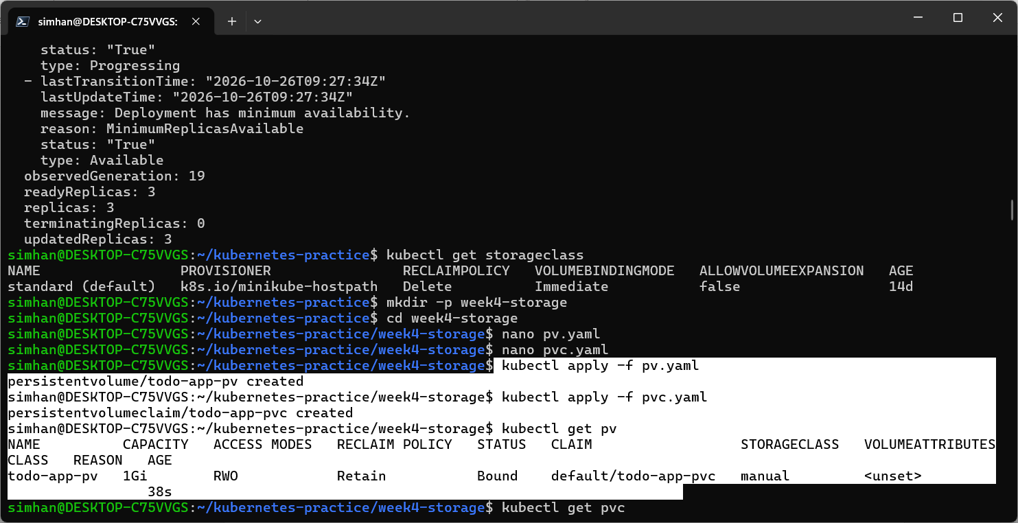
Applied the pv and pvc.
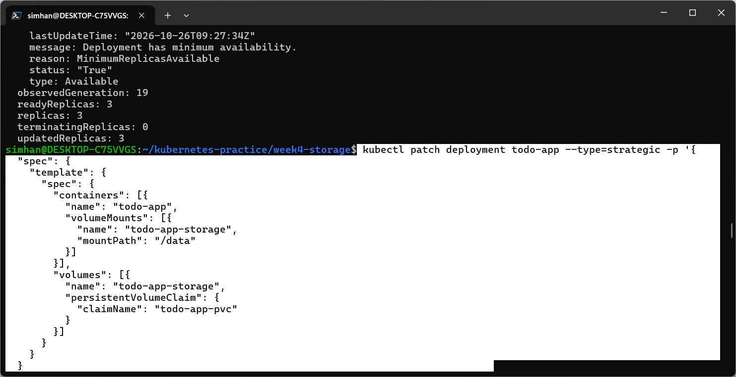
Some patch work added for pvc.
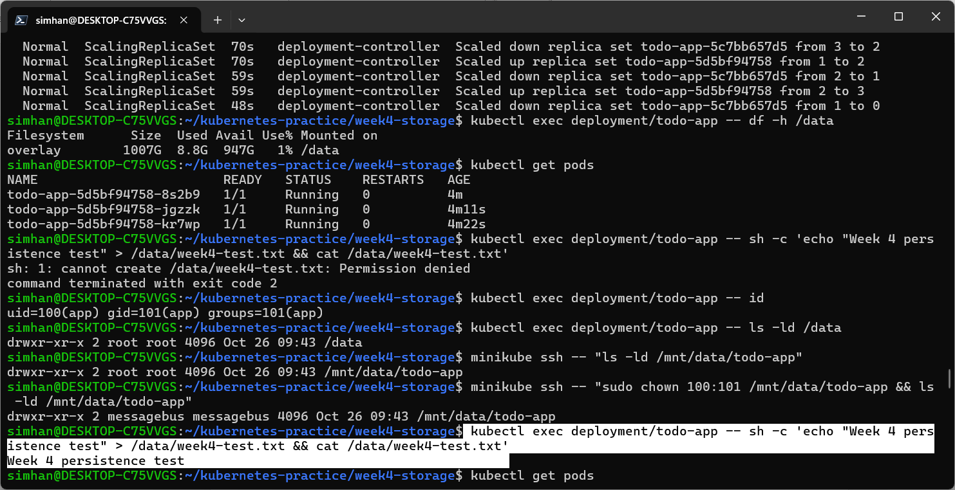
Executed the pvc successfully.
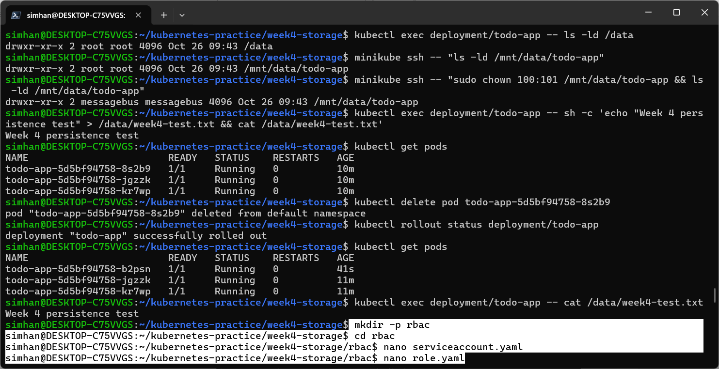
New directory for rbac created successfully and files serviceaccount and role added successfully.

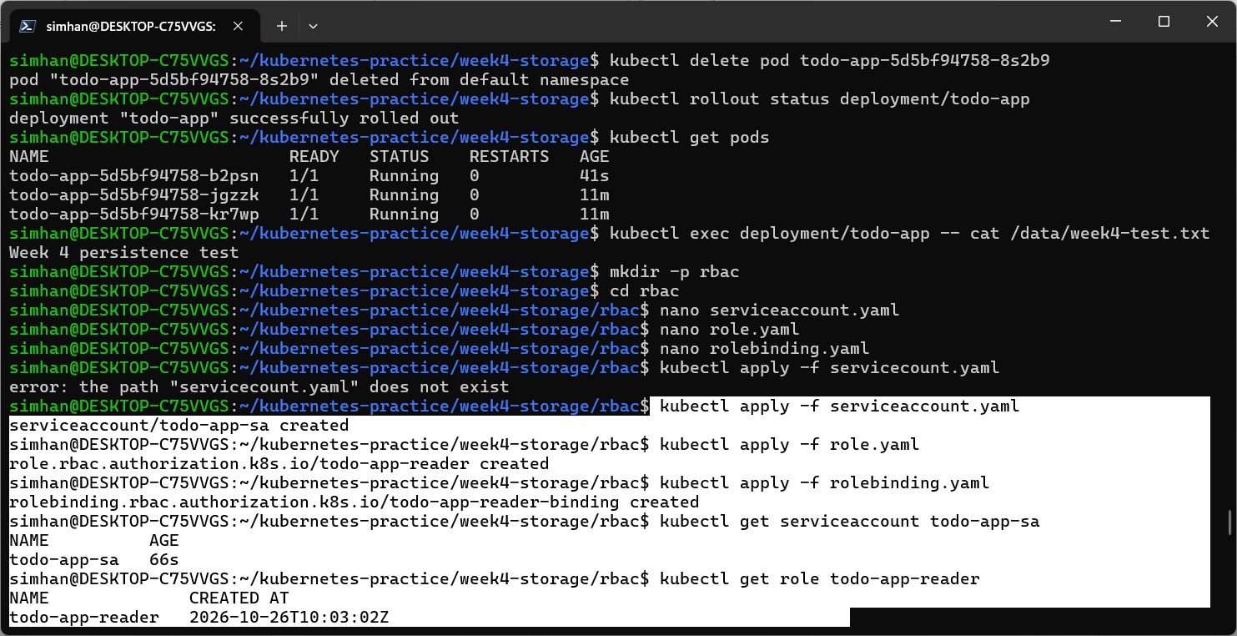
Changes applied successfully.
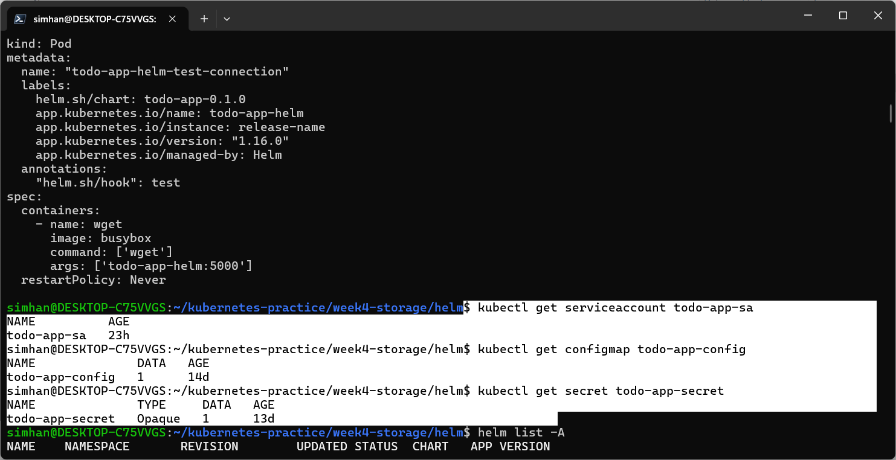
Vital parameters checked.
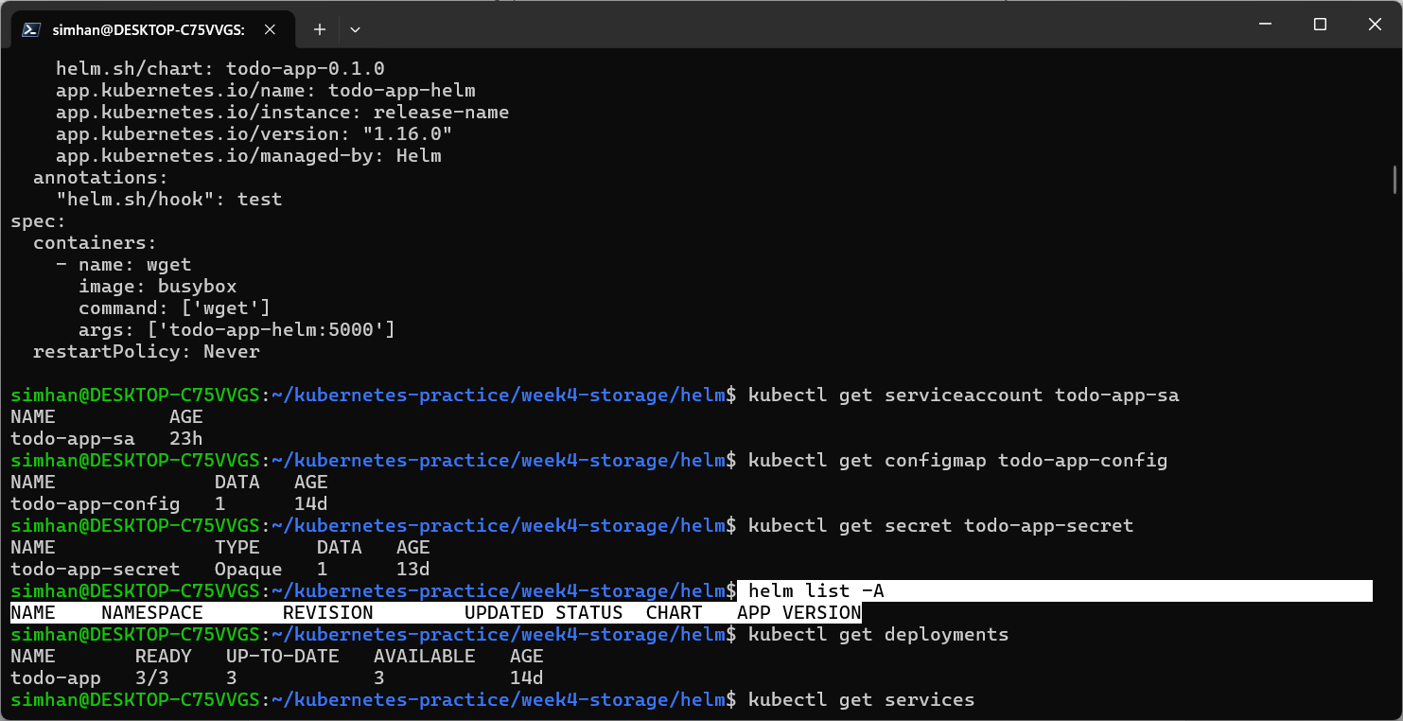
No previous helm release installed.
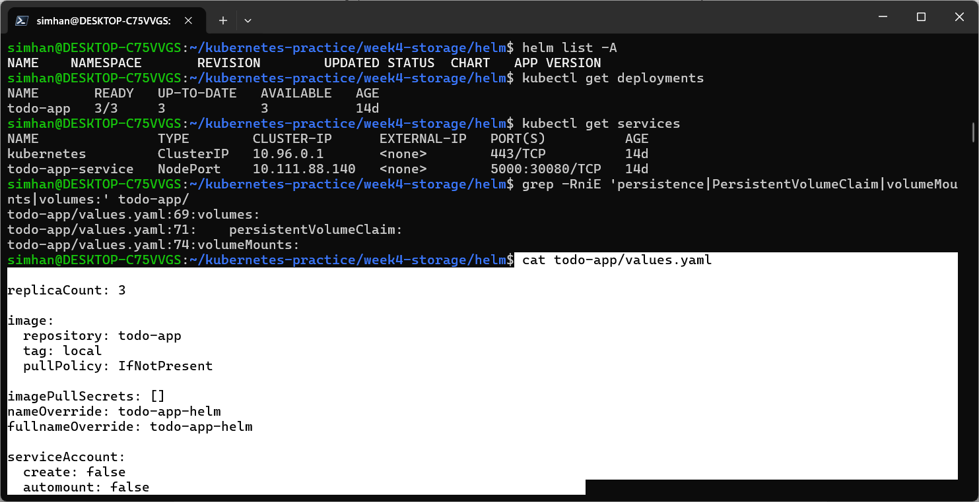
Error in deployments.yaml file.
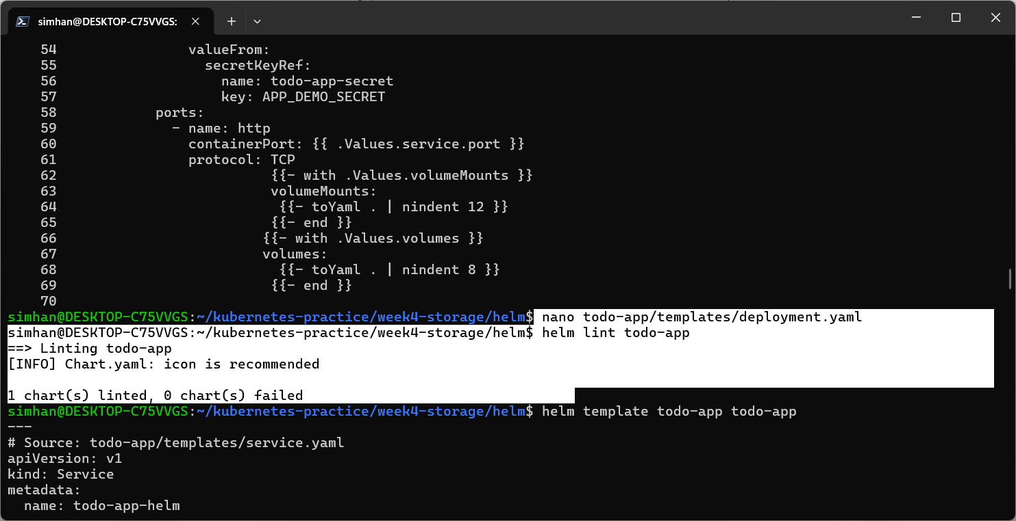
After error correction successfully lint working.
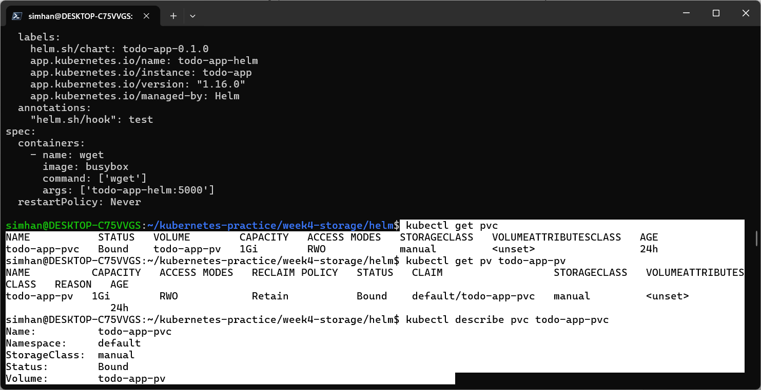
Details of the PVC.
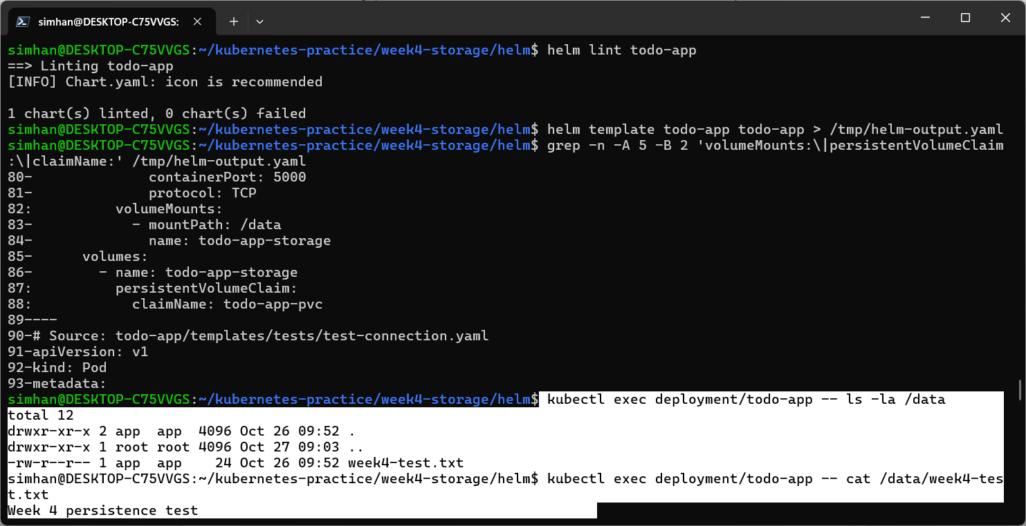
Helm chart successfully working and lint is successful.
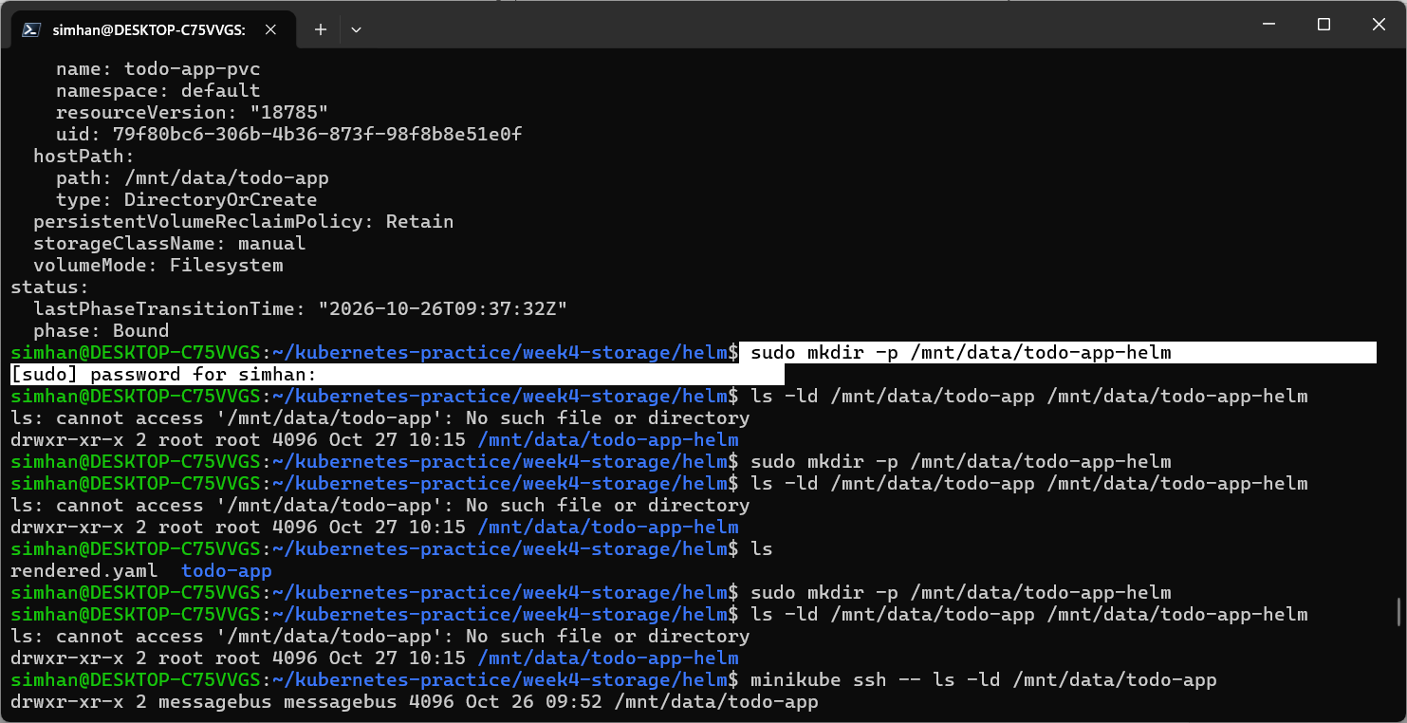
Created separated helm directory for the helm release.
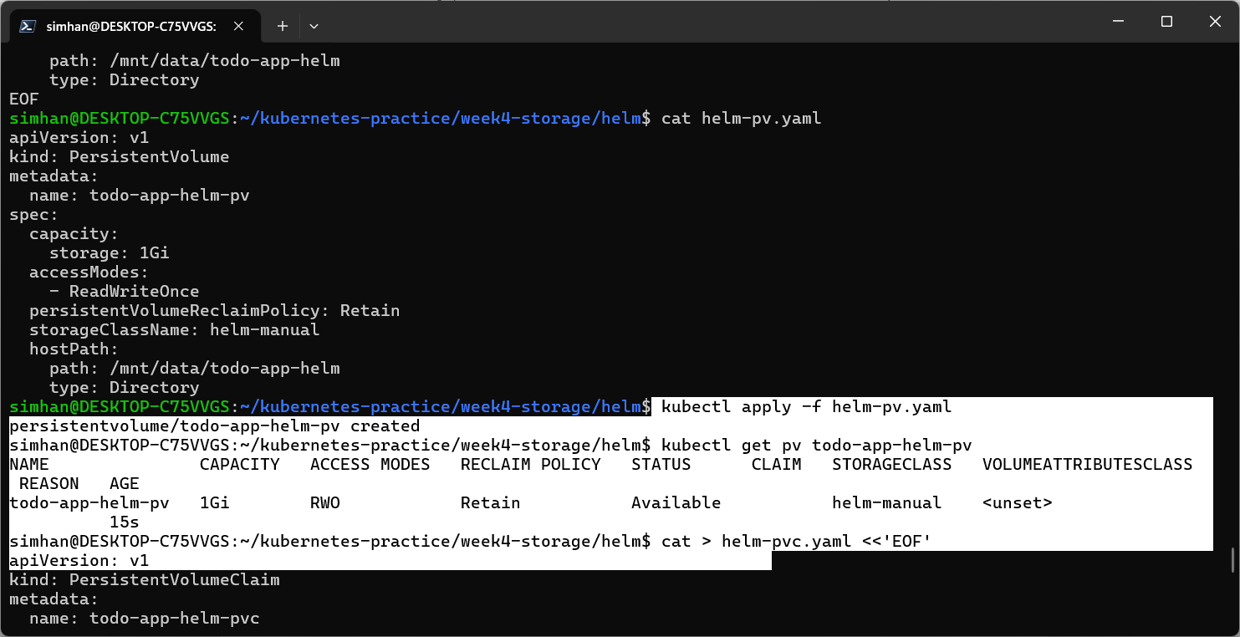
Applied separately without changing the original directory.
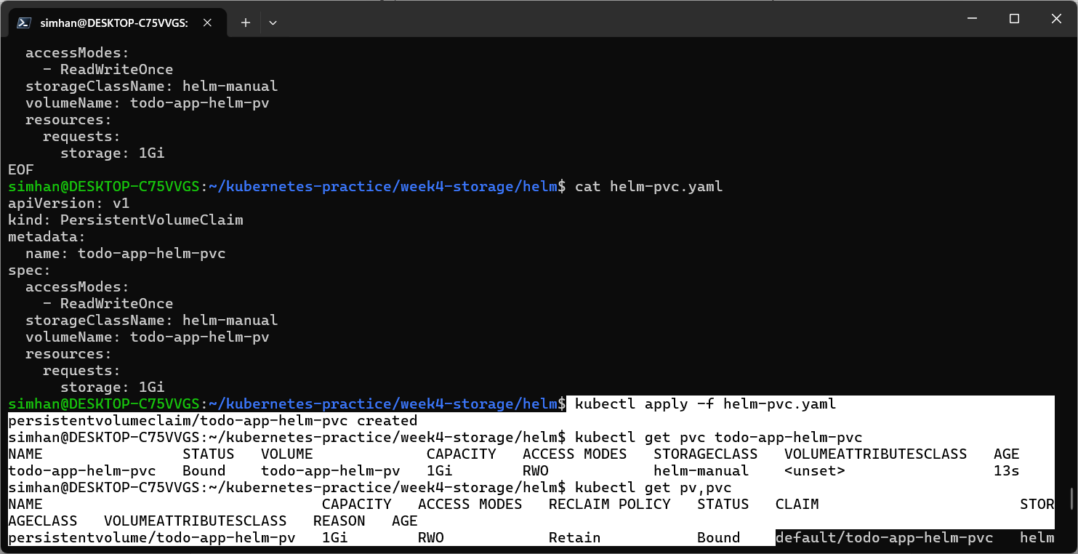
After successful application.
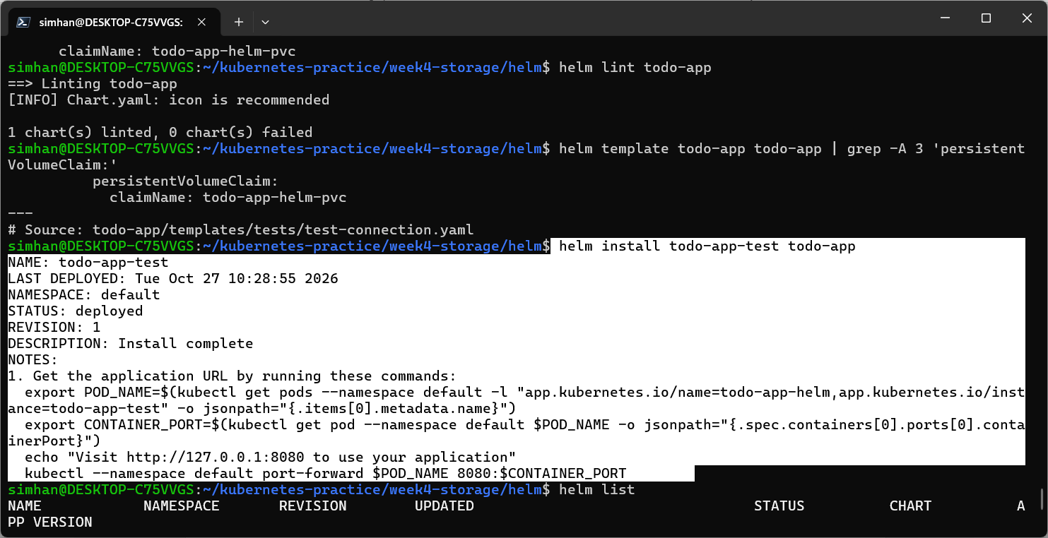
Helm release installed in separate directory.
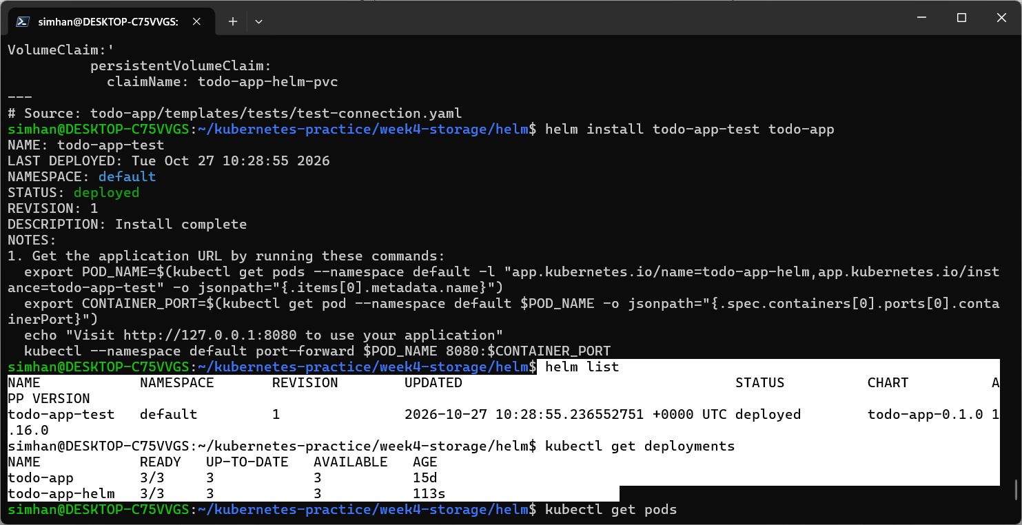
Helm release showing in separate directory.
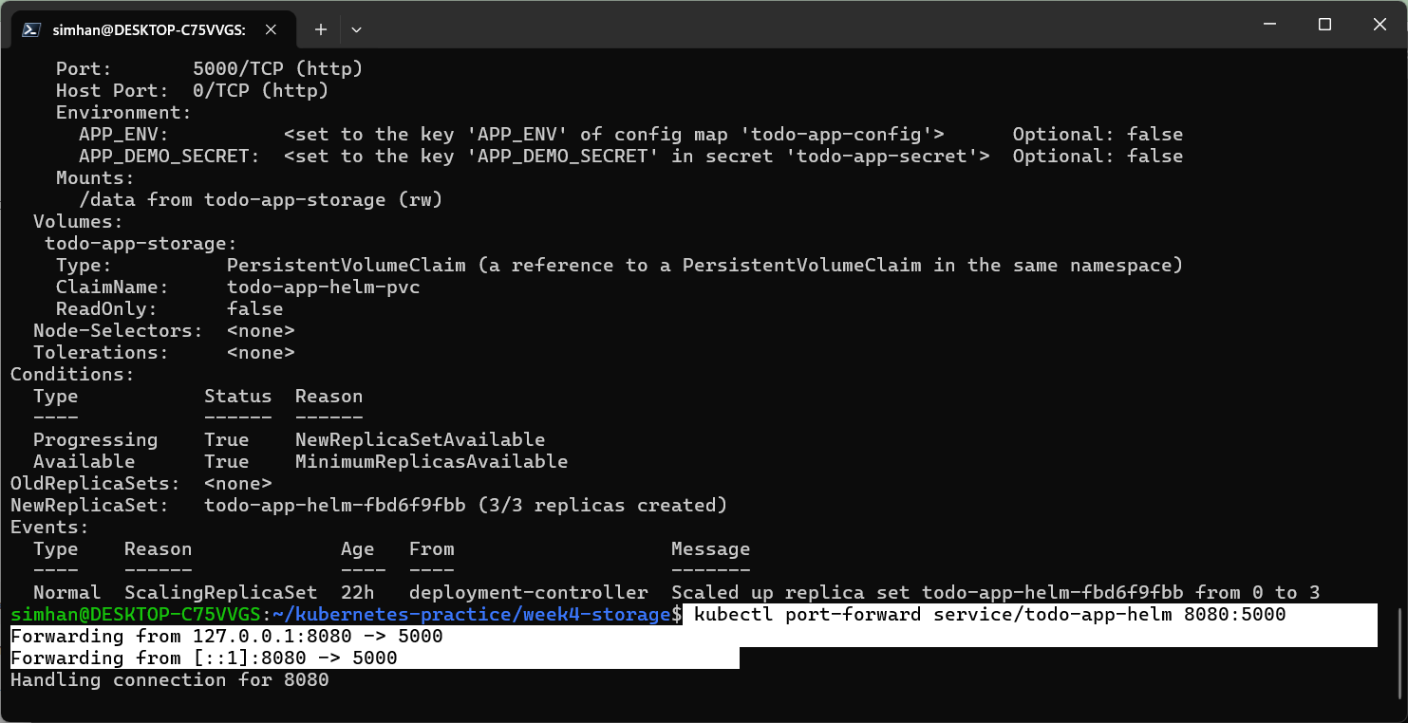
Port forwarding from 8080 to 5000
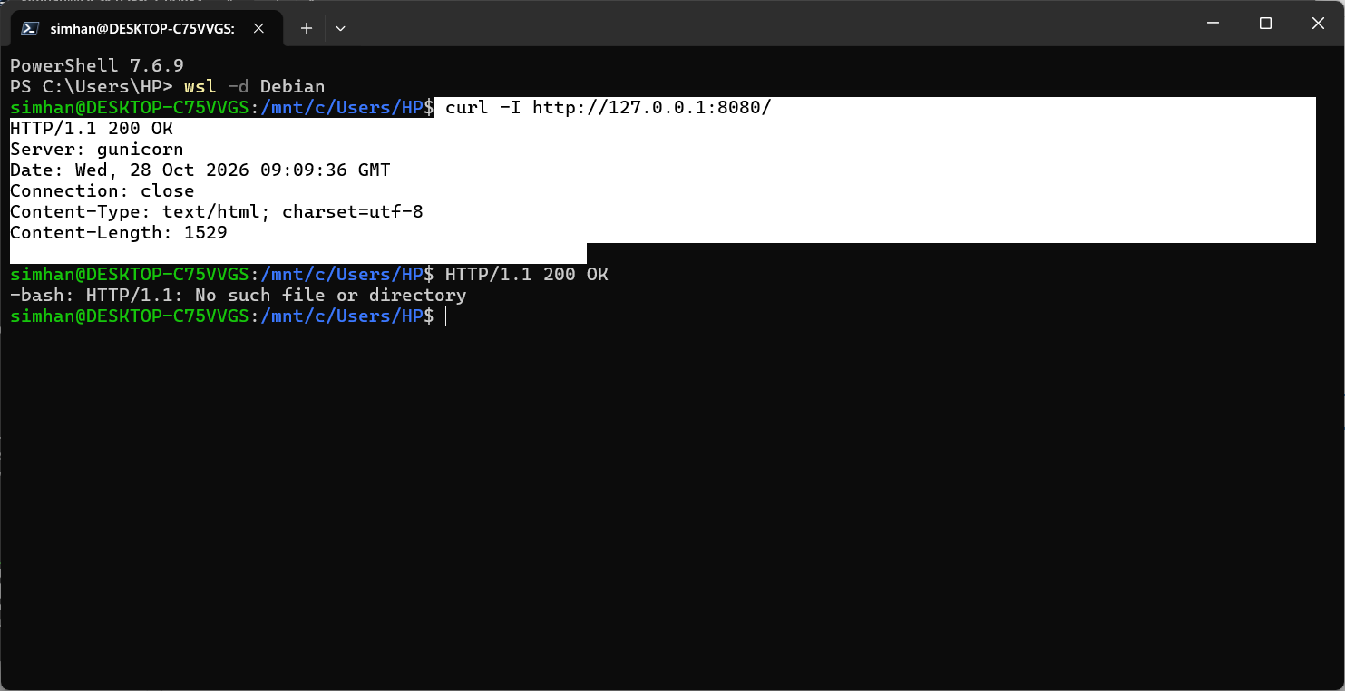
Suceesful port forwarding.
Installed Prometheus and Grafana to monitor the todo-app.

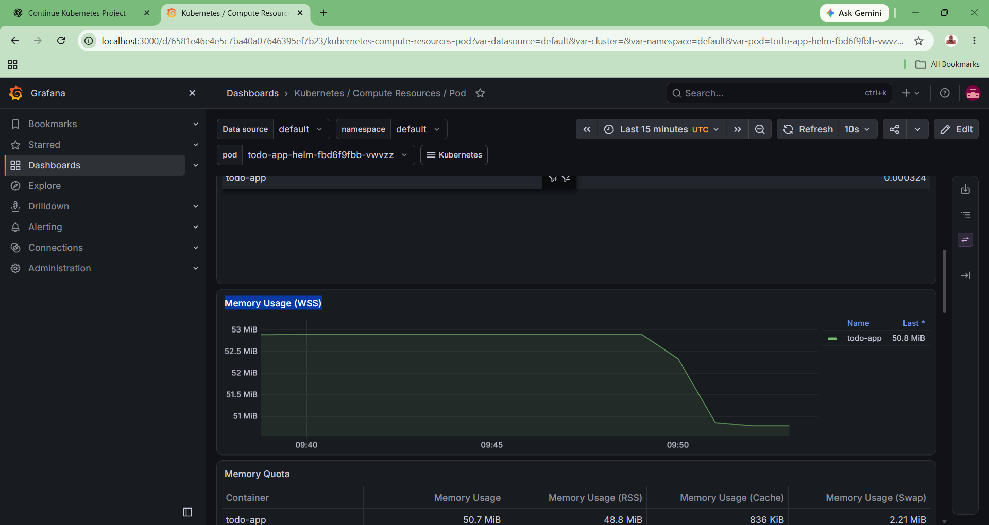

Successful metrics monitoring.

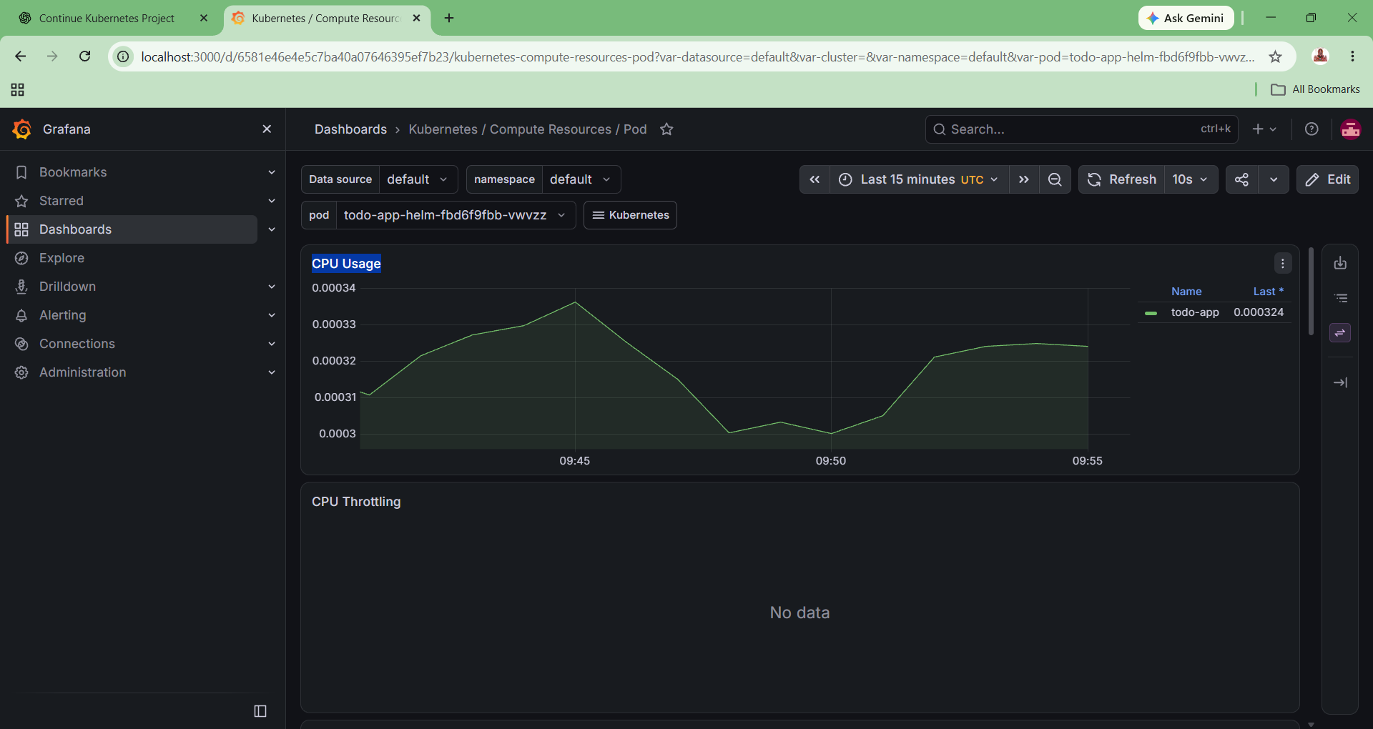
Cpu usage monitoring.

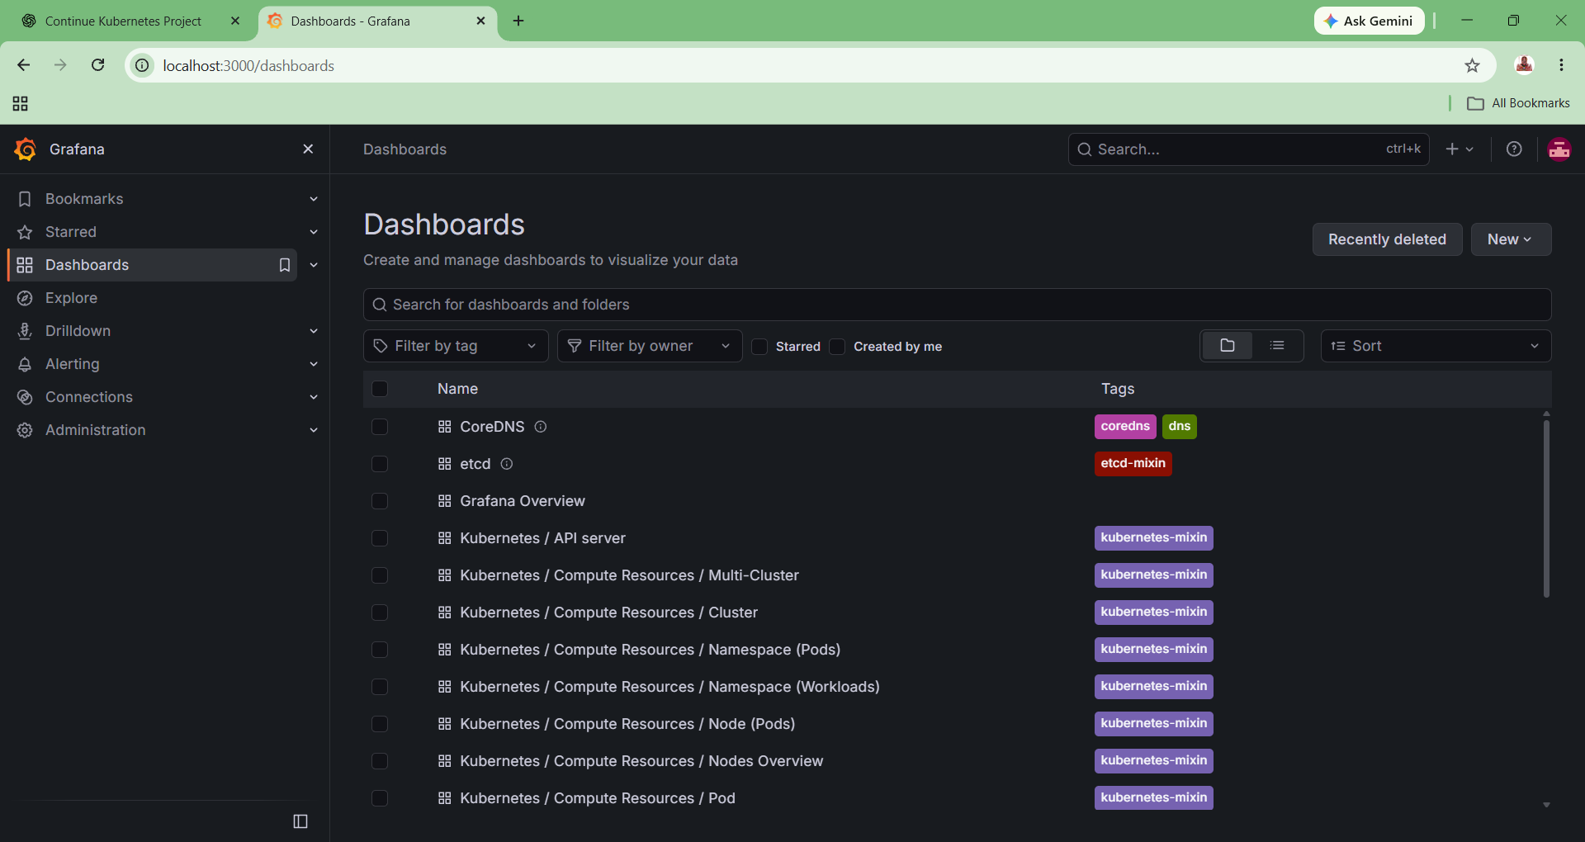
23 dashboards created for todo-app using Prometheus stack.
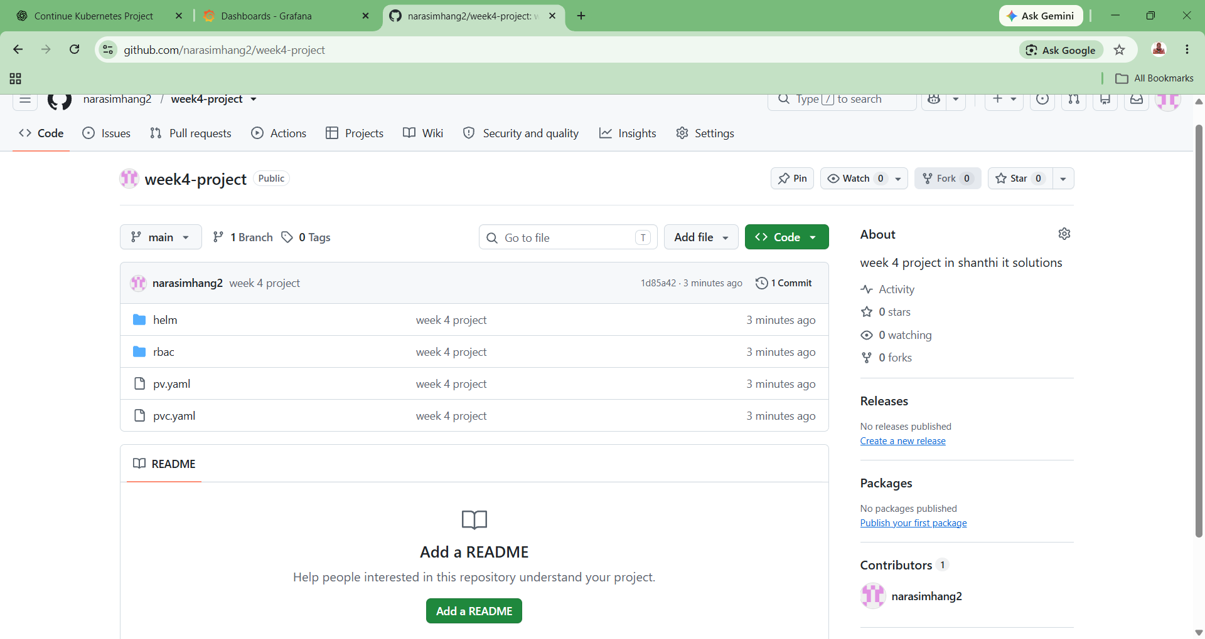
Files pushed to github successfully.

