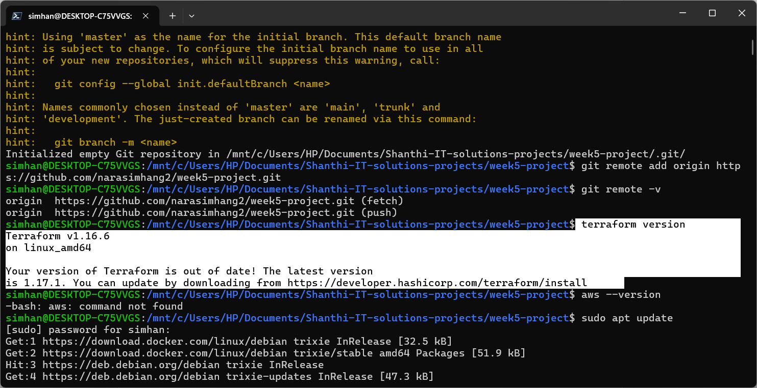
Terraform installed successfully.
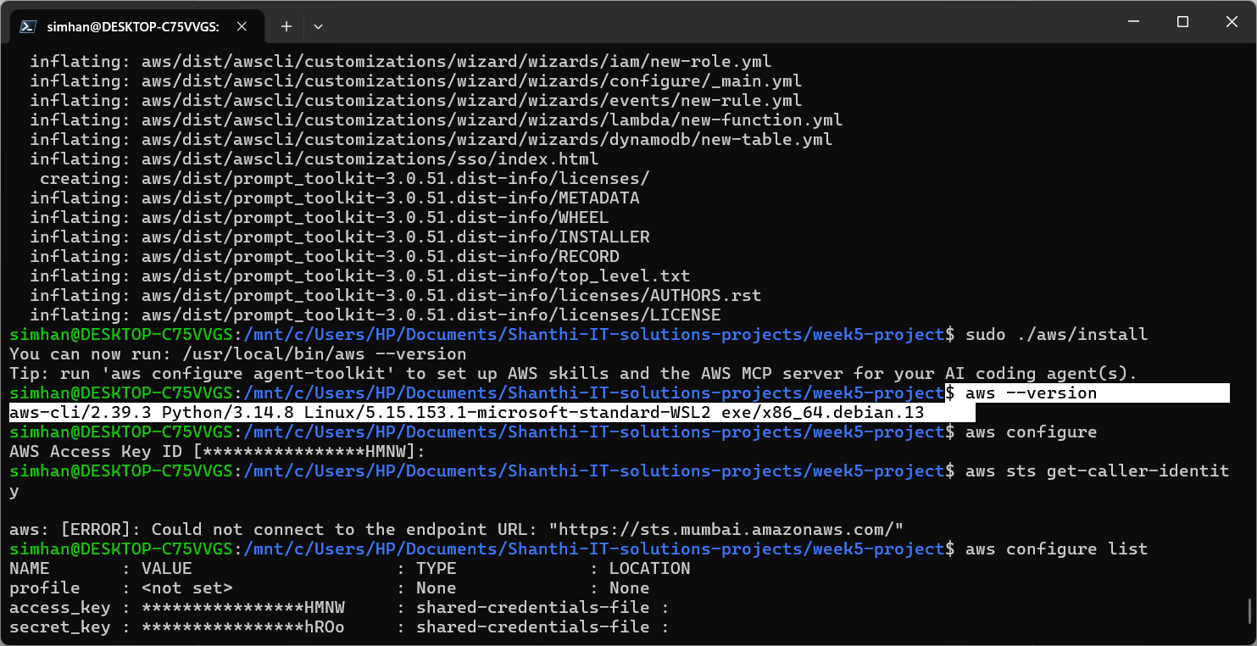
Aws cli installed successfully.
Unable to create amazon linux using terraform. I have modified main.tf to create Debian OS using terraform.

Terraform apply worked successfully.

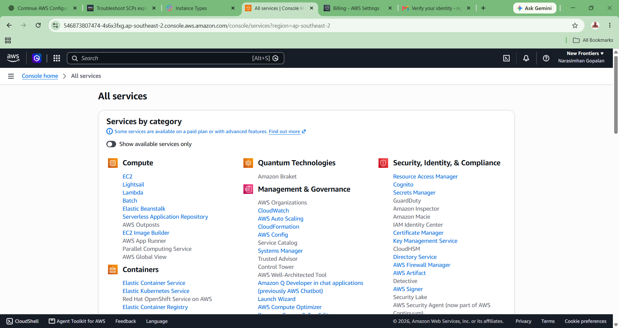
Suspended AWS account reactivated successfully.
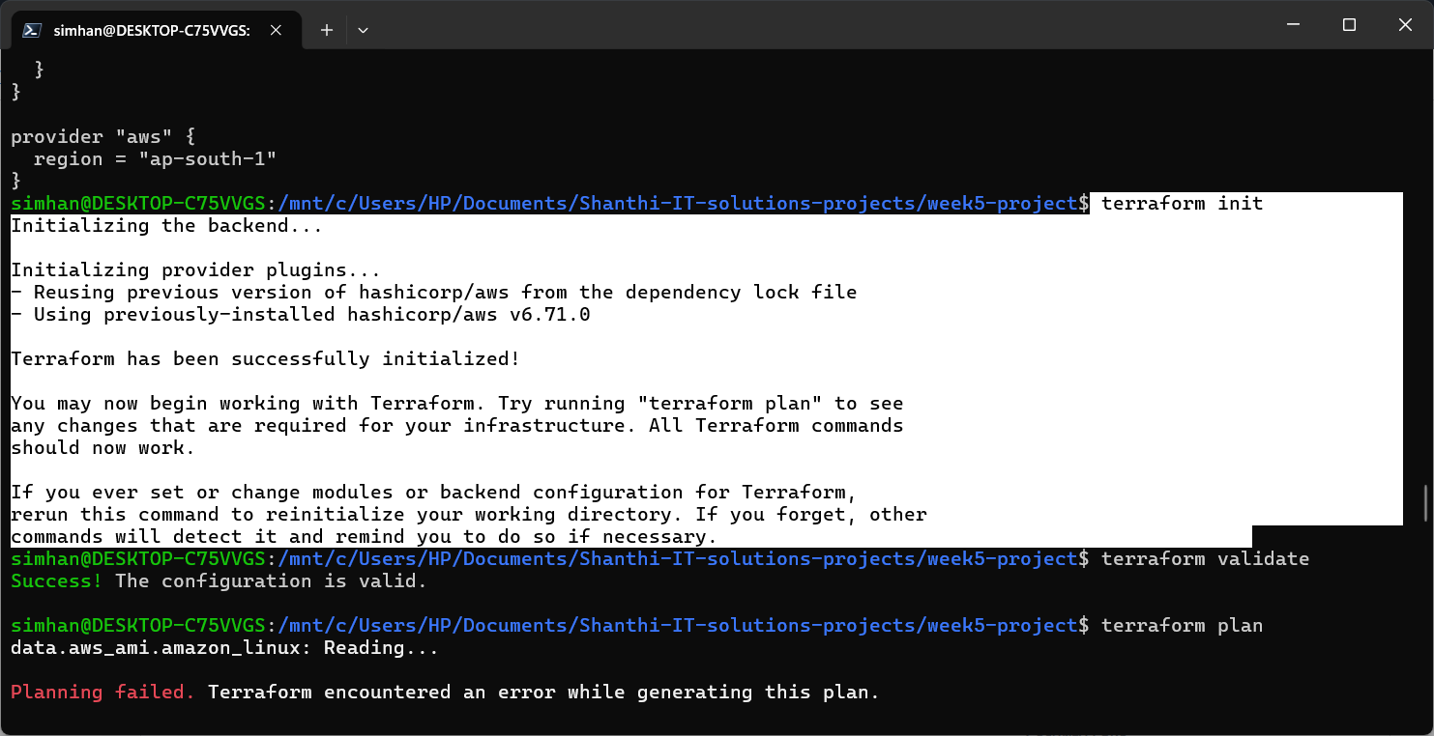
Terraform initialised successfully.
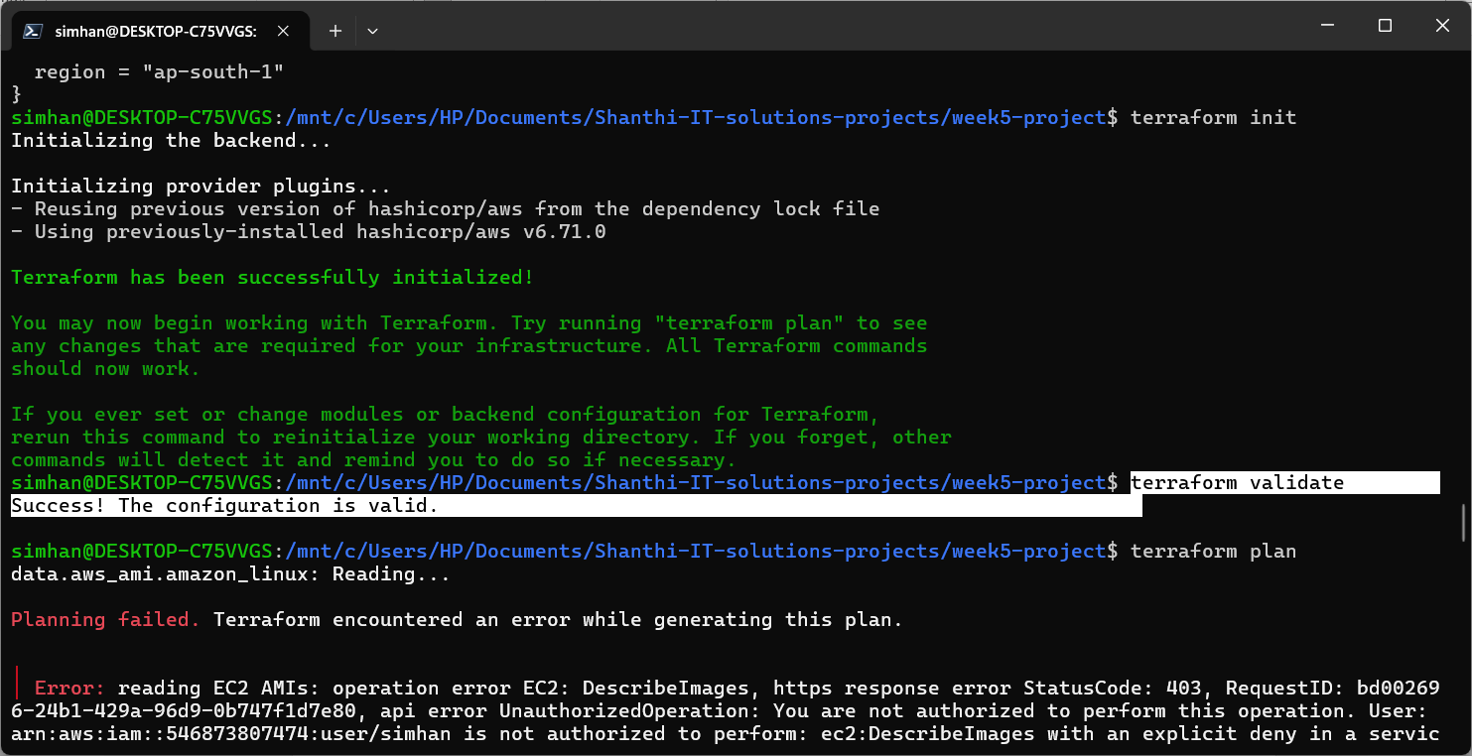
Terraform validated successfully.
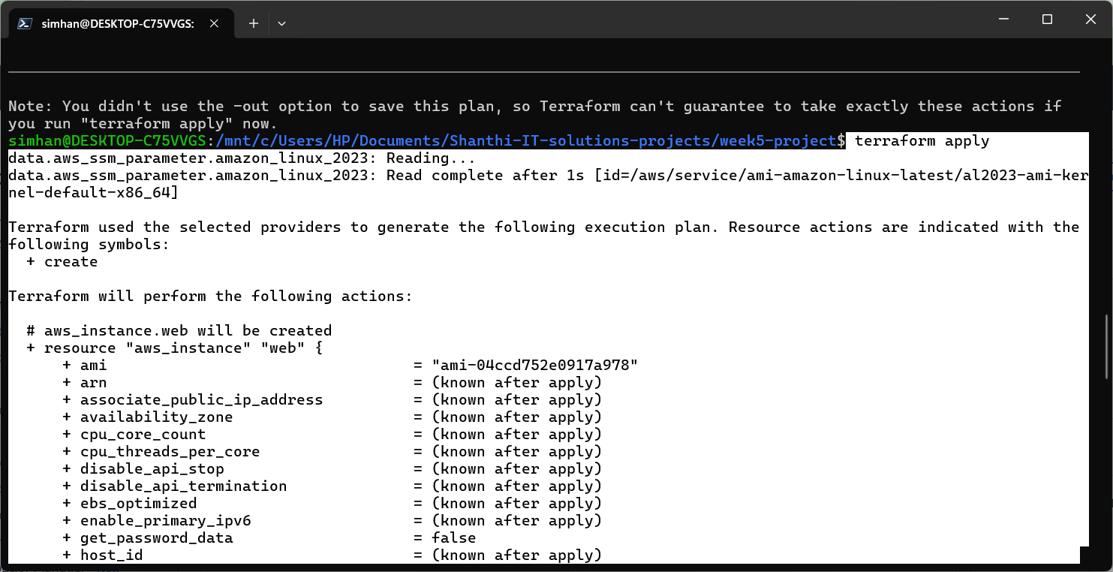
Terraform Apply worked successfully.
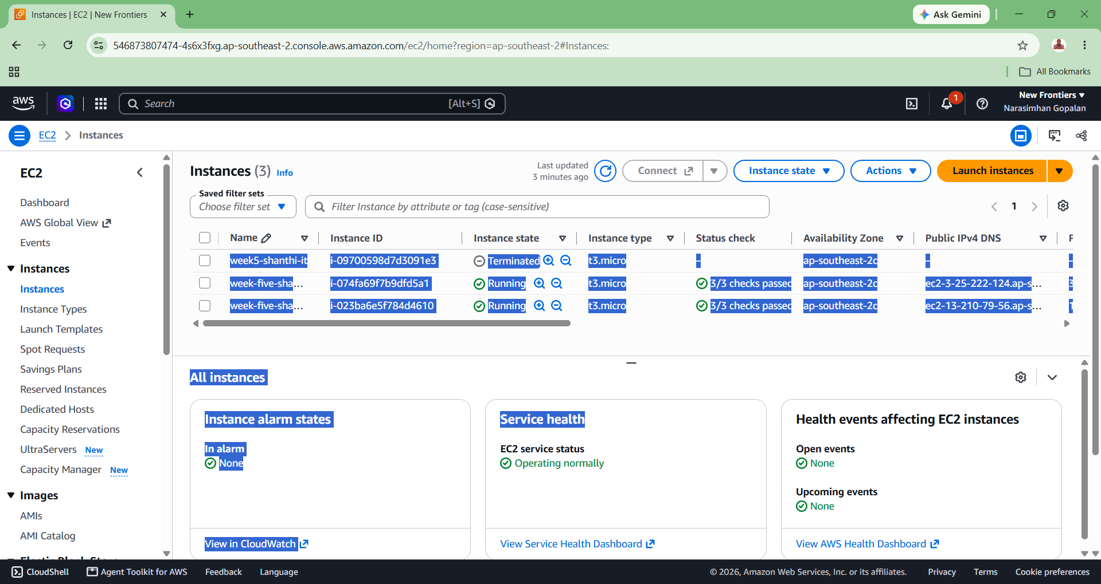
One Debian os ec2 instance created successfully.

