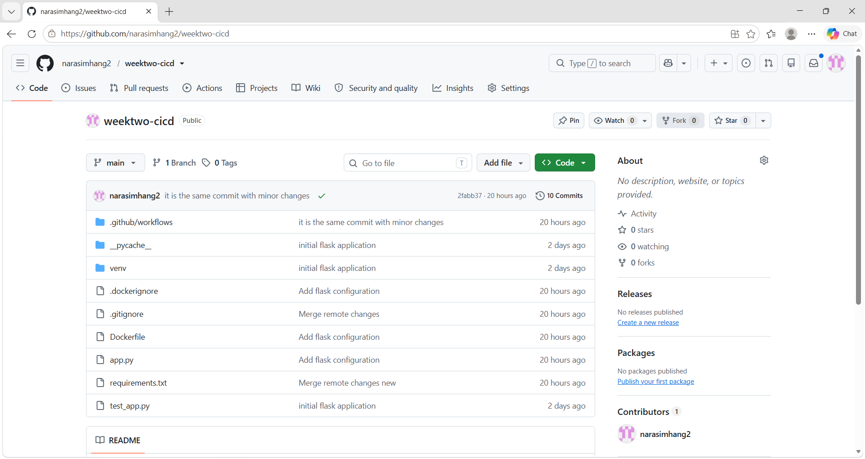
Files pushed to github

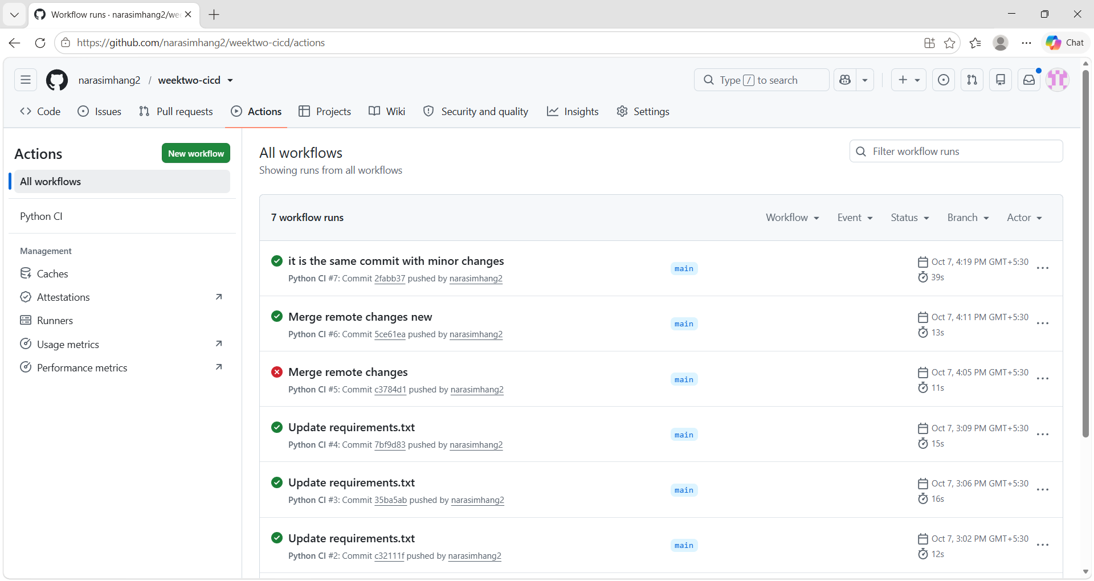
Successful trigger of Github Actions.
d---- 06-10-2026 17:00 __pycache__
d---- 07-10-2026 14:54 .github
d---- 06-10-2026 17:00 .pytest_cache
d---- 06-10-2026 16:58 venv
-a--- 07-10-2026 15:51 59 .dockerignore
-a--- 07-10-2026 16:02 42 .gitignore
-a--- 07-10-2026 15:43 1021 app.py
-a--- 07-10-2026 15:50 202 Dockerfile
-a--- 07-10-2026 16:10 21 requirements.txt
-a--- 06-10-2026 16:55 267 test_app.py

Files in the local path as git and successfully pushed to github.
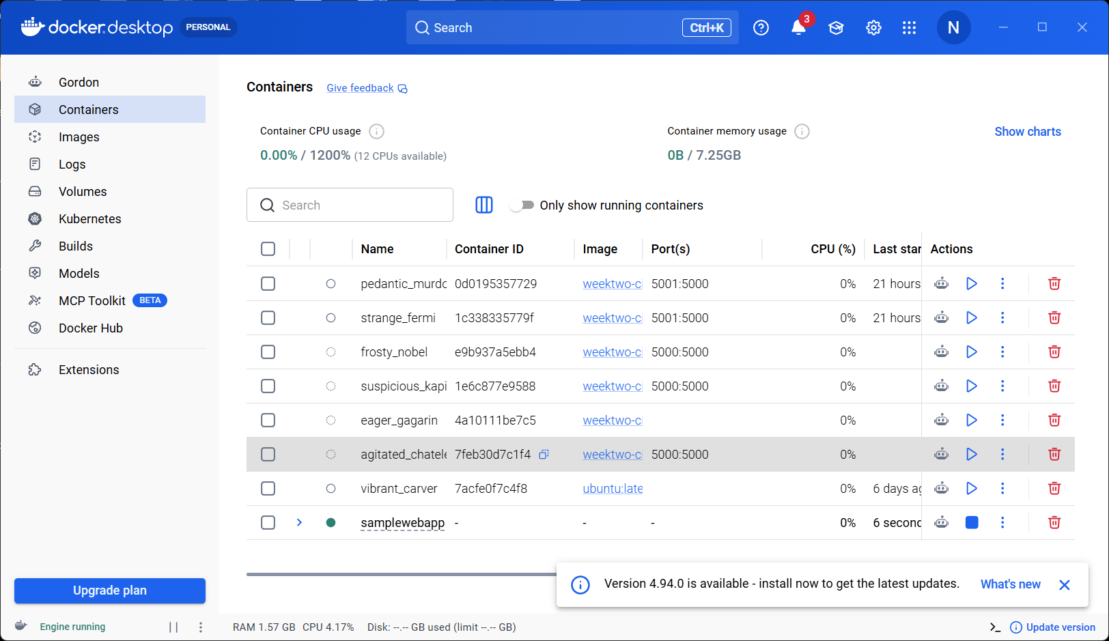

Image built using docker
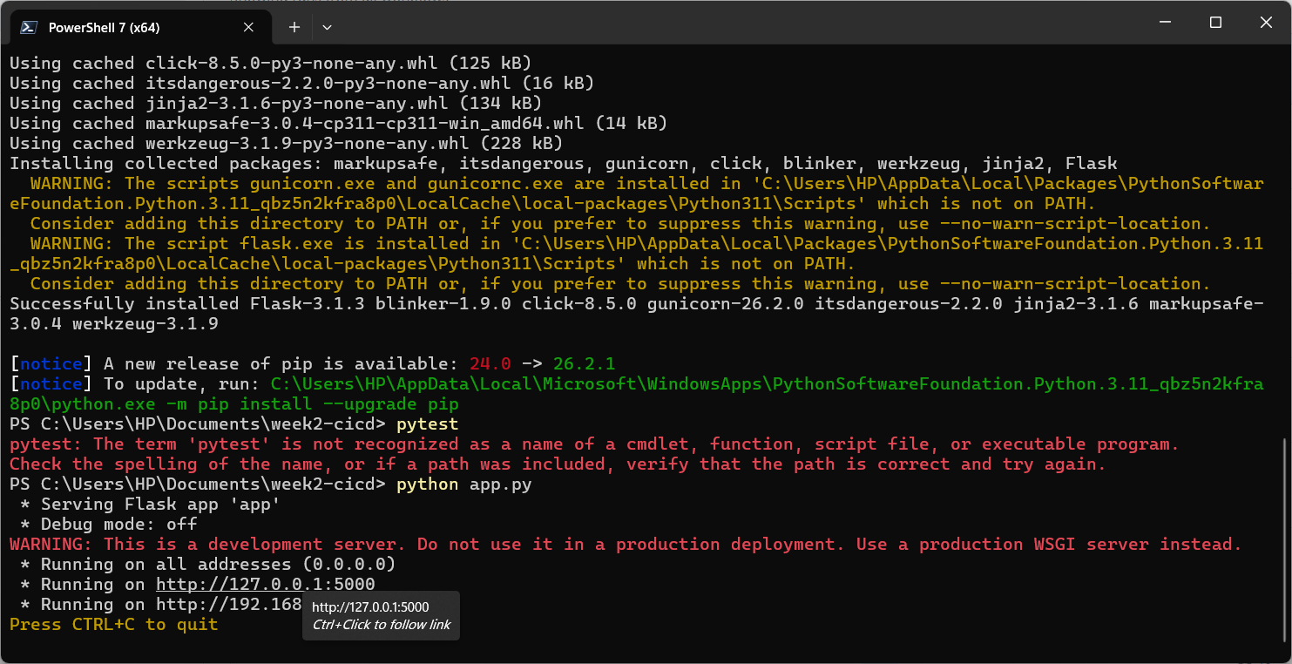

App link
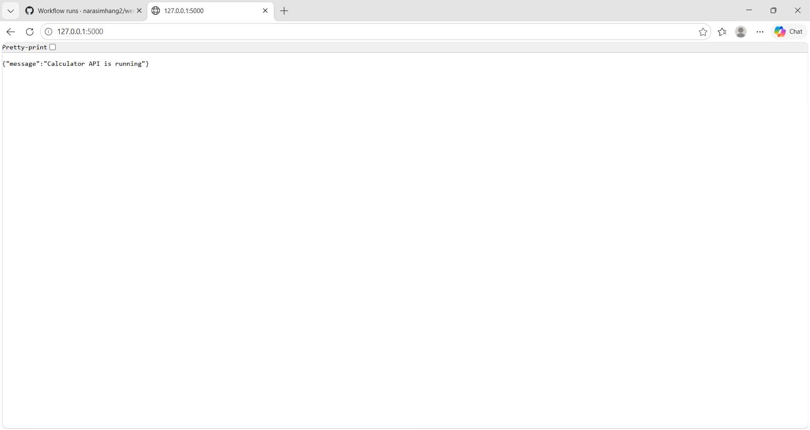

App working successfully.
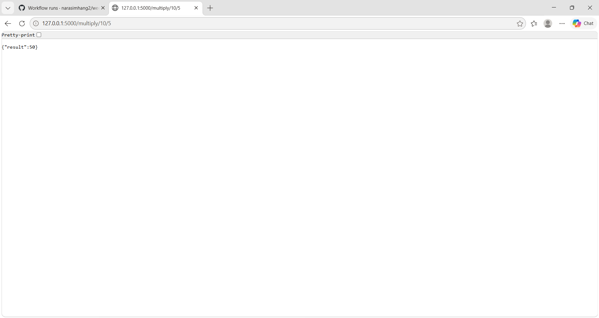

Sample mathematical calculation.

