1. Differences between website and web Applications?

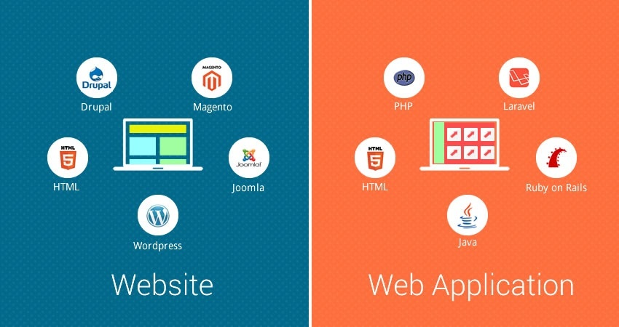

The main difference between the web site and web application is user interaction.

1. Website is defined by its content.
2. Web app is defined by its user interaction.

|  |  |
| --- | --- |
| Web application | Web site |
| After deployment individual files cannot update. | After deployment individual files can update. |
| Web Application Establish dependencies in multiple projects. | Web site cannot establish dependencies in multiple projects. |
| Cannot use c# and VB in single page. | Use both c# and VB in single page |
| Web application is much difficult than web site. | Website is easier than create web application. |

1. Differences between HTML4 and HTML5?

|  |  |  |
| --- | --- | --- |
|  | HTML4 | HTML5 |
| 1. | DOCTYPE declaration too lengthy and refers to an external resource. | DOCTYPE declaration is simple and in one line, for example:-<!DOCTYPE html> |
| 2. | No multimedia supporting tags. Third party Plug ins are used | Introduced dedicated tags for multimedia like <audio>,<video> |
| 3. | Applet tag that was used to display applets in browsers was removed. | Object tag was added to display applet type items. |
| 4. | HTML4 is compatible with almost all web browsers. | HTML5 being a newer version is not compatible with all the browsers. |

1. List out HTML tags?

**HTML TAG TYPES**

**1. Paired Tags**

**2. Unpaired Tags**

**3. Block level Tag**

**4. In line level Tag**

|  |  |
| --- | --- |
| **PAIRED TAGS** | **UNPAIRED TAGS** |
| If any HTML Tag has a separate opening and separate closing tags is called paired tags.  EX-b,u,I,div,etc | If any HTML Tag has both opening and closing tag in single tag then such HTML TAG is known as called un paired tag.  EX-br,hr,ing, img etc |
| <Head> | <br> |
| </Head> | <hr> |
| <Body> | <hi> |
| </Body> | <img>image |
| <P> | <link> |
| </p> | <span> |
| <U> |  |
| <I> |  |
| <DIV> |  |
| <h1> |  |
| <h2> |  |
| <h3>…..<h6> |  |
| <li> |  |

|  |  |
| --- | --- |
| **HTML BLOCKLEVEL TAG** | **HTML IN LINE LEVEL TAG** |
| * If HTML tag always displays that content on new fresh line and occupies the complete available width | * If an HTML Tag occupies that exact amount of space required to display to the content on the browser |
| EX-head,Tags,p,div,etc….. | Ex-b,u,I,font,span |
|  |  |

1. List out no SQL databases?

There are 4 basic types of no SQL databases

|  |  |  |  |
| --- | --- | --- | --- |
| Key value | Column based | Document database | Graph database |
| In a key-value no SQL database, all of the data within consists of an indexed key and a value. | In column based no SQL database, DB is designed for storing data cables as sections of columns of data, rather than as rows of data. | This no SQL data base expands the key value stores where documents contain more complex in that they contain data and each document is assigned a unique key, which is used to retrieve the document. | This no SQL data base is designed for data whose relations are well represented as a graph and has elements which are interconnected , with an undetermined number of relations b/w them. |
| Examples:-  .Dynamo DB  .Cassandra | Examples:-  .H base  .SAP HANA | Examples:-  .Mango DB  .Couch DB | Examples:-  .Polyglot  .Neo4j |

1. Differences between compiler and interpreter?

|  |  |  |
| --- | --- | --- |
| Comparison | Compiler | Interpreter |
| Input | It takes an entire program at a time. | It takes a single line of code or instruction at a time. |
| Output | It generates intermediate object code. | It does not produce any intermediate object code. |
| Working mechanism | The compilation is done before execution. | Compilation and execution takes place simultaneously. |
| Speed | Comparatively faster | slower |
| Memory | Memory requirement is more due to creation of object code. | It requires less memory as it does not create intermediate object code. |
| Errors | Display all errors after compilation, all at the same time. | Display error of each line one by one. |
| Error detection | Difficult | Easier comparatively |
|  |  |  |
| Pertaining programming languages | C, c++, c#, type script using compiler. | PHP, Perl, Python, Ruby uses an interpreter. |