EXPERIMENT-9

224G1A0558 C NARASIMHALU

Primary key :

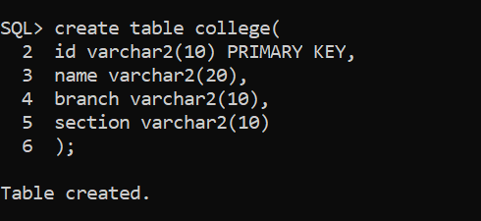

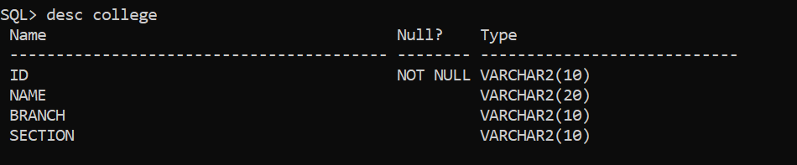

Foreign key :

