1. People wishing to participate in the betting process can enter the match id and the team number (1 or 2) that they wish to bet on.

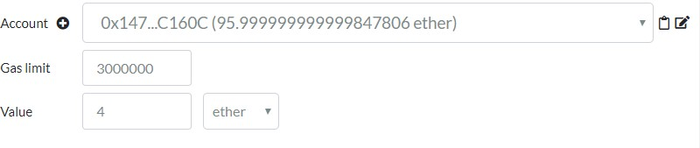Participant 1:

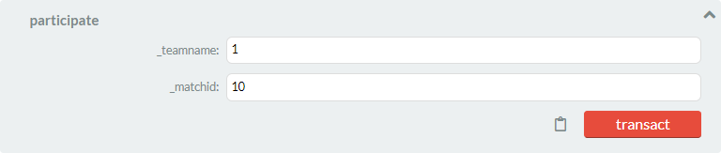

Participant 2:

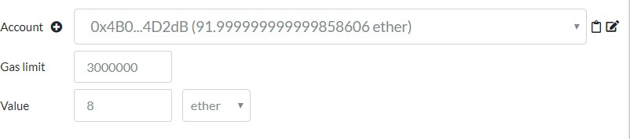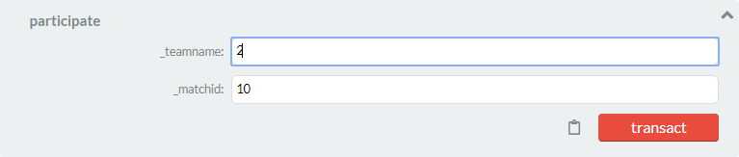

Participant 3:

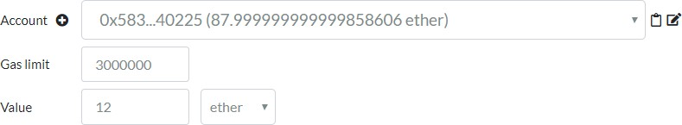

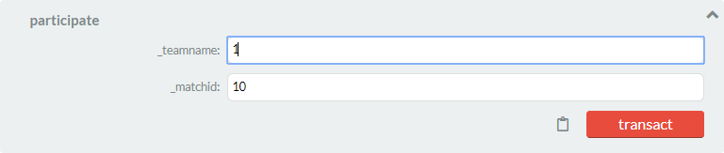

1. Declaration of winner after the match is played.

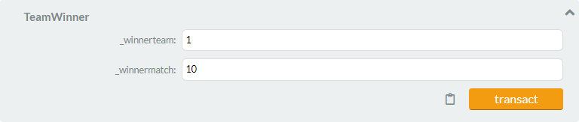

1. Calculating the no. of winners



1. Disbursing the funds to the winners



1. Grand total amount collected for betting



1. Admin who manages the deployment of the contract and disbursement of funds



1. Number of participants



1. Participant details

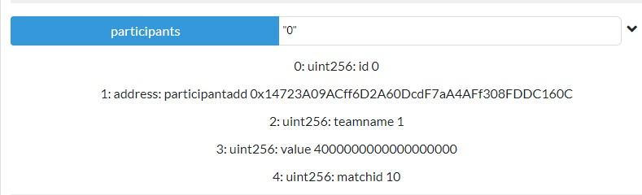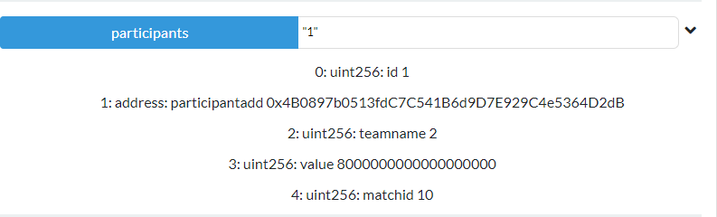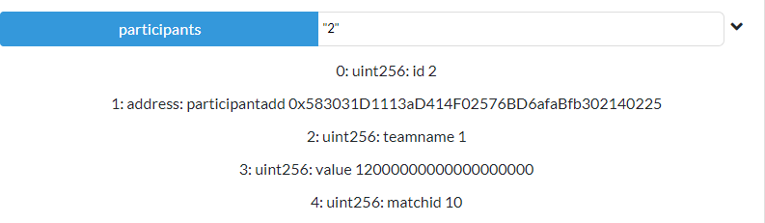

1. No. of winners



1. Winning team of the match



1. Account balance after the disbursement of funds to the winning participants

