**Before running app:**

1. In order to run this web app, a conection to database should be established. So, first of all, create a database in your SQL SERVER using the script provided in bookdb.txt file. (This script works for SQL SERVER only).
2. Change ConnectionString in Web.Config file. This is what I have done:

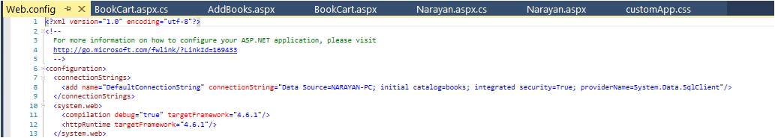

Here,

Data source: name of my databse server

Initial Catalog: name of my database

Integrated security: true, if you use just windows authentication to access your server. (if not, google for options)

1. Make sure you have add this namespace: using System.Data.SqlClient; at the top of

each .cs page where db connection is required.

Logic part:

Narayan.aspx.cs

1. Loading products from database:

First of all, a product class is created so that its objects can be inserted into a list.

Then,

void LoadProduct(string query) method receives details about each book, convents them to book object properties and adds each book object to:

public List<Product> productList = new List<Product>();

1. Displaying products on page:

Using foreach loop, Narayan.aspx page is filled with book object from productList.

1. Adding items to cart

This code inside loop on Narayan.aspx page:

<p style="margin-bottom:60px; color:white;">

<a href="Narayan.aspx?pro_id=<%=product.id%>&action=add" class="button btn-success btn-block" Type="button" style="padding:5px;">Add to Cart</a>

</p>

sends product id to query string (on browser) on each click. And that number is used in :

void LoadCart(string pid)

and that method populates :

static List<string> sentToCart = new List<string>();

(to send books’ id to next page by assigning to Session and also to show count on cart sign) (See LoadCart method.)

1. Querying books in cart and populating cart page

On BookCart.aspx.cs, another class (product1) is created and with its objects, a list

public List<Product1> CList = new List<Product1>();

is added to the top. And using Session, from where id of each book in cart is retrieved, each book with the id is queried from the database and those book objects are added to the CList.

Then, the CList is looped to populate cart page. (see BookCart.aspx)

1. Removing items from cart

Here, I have created a <a> link to remove button and when clicked, it sends concerned book’s id number to query string. The id number from query string is accessed by:

void Removecartitems()

and the related book is removed from Clist.

NOTICE!

I hit the wall here. Remove functionality is not working. If you are able to make it work, I will offer you a reward!

1. The AddBooks page is awesome (in terms of fucitonality).

In case of img field, see where images are kept in the project). Try it.