FIRST PAGE WHERE USER HAVE TO PROVIDE CREDENTIAL FOR LOGIN IF HE / SHE NOT REGISTERED

OR SIGNUP THEY WILL FIRST SIGNUP THEMSELF BY SELECTED SIGNUP FORM AS SHOWN BELOW:-

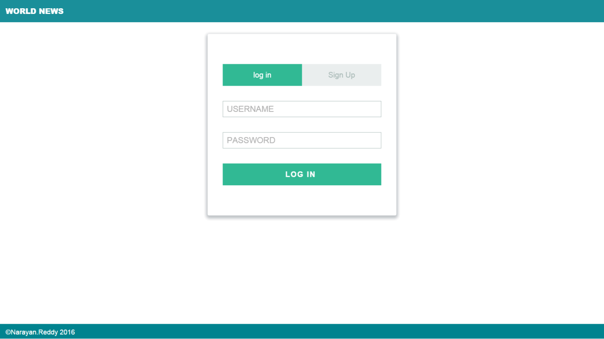

THIS IS USER SIGNUP FORM WHERE USER HAVE TO REGISTER THEMSELF BY FILLING THIS SIGNUP FORM:-

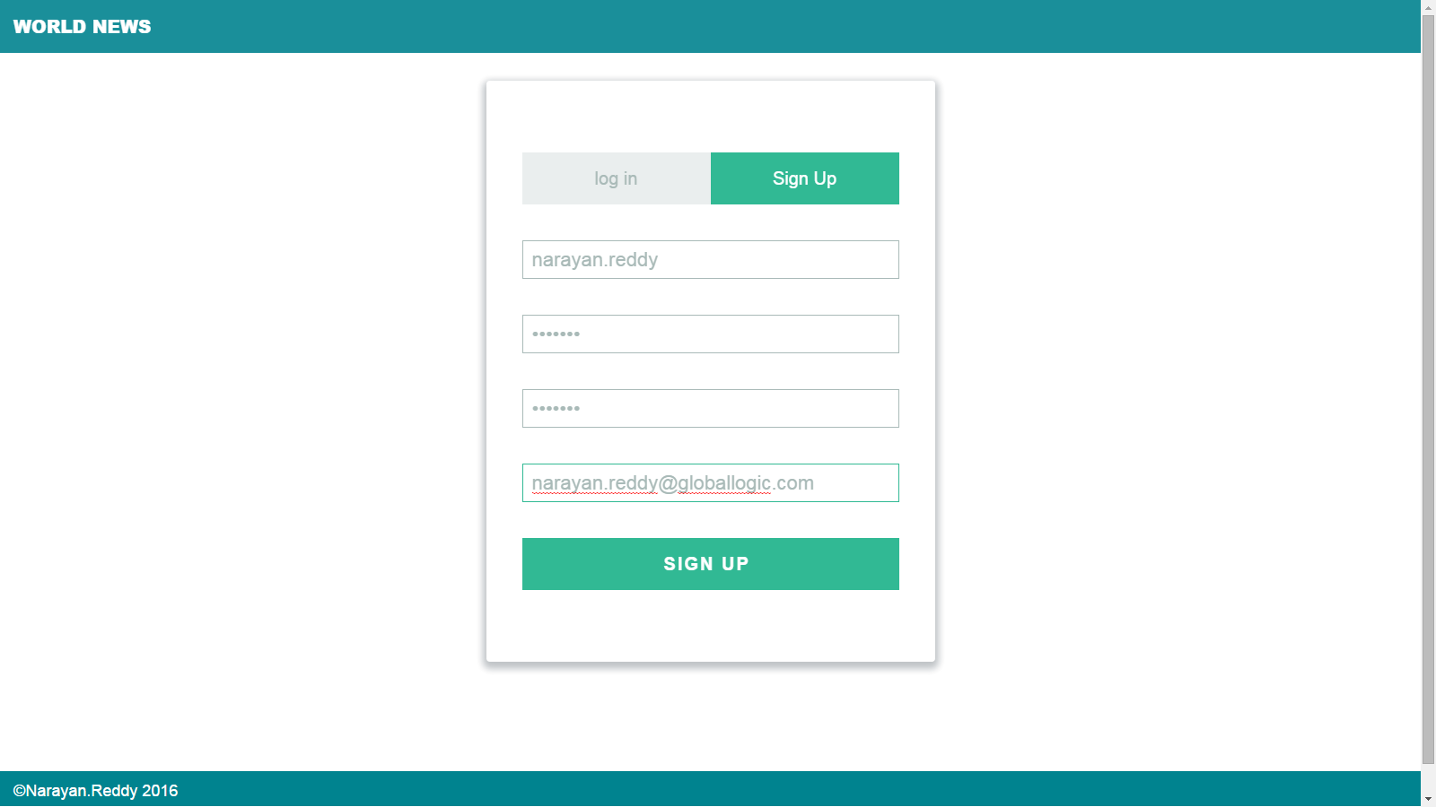

THE FIRST DASHBOARD LOOKS LIKE THIS WHERE USER HAVE TO SELECT CATEGORY FOR CATEGORY LIST:-

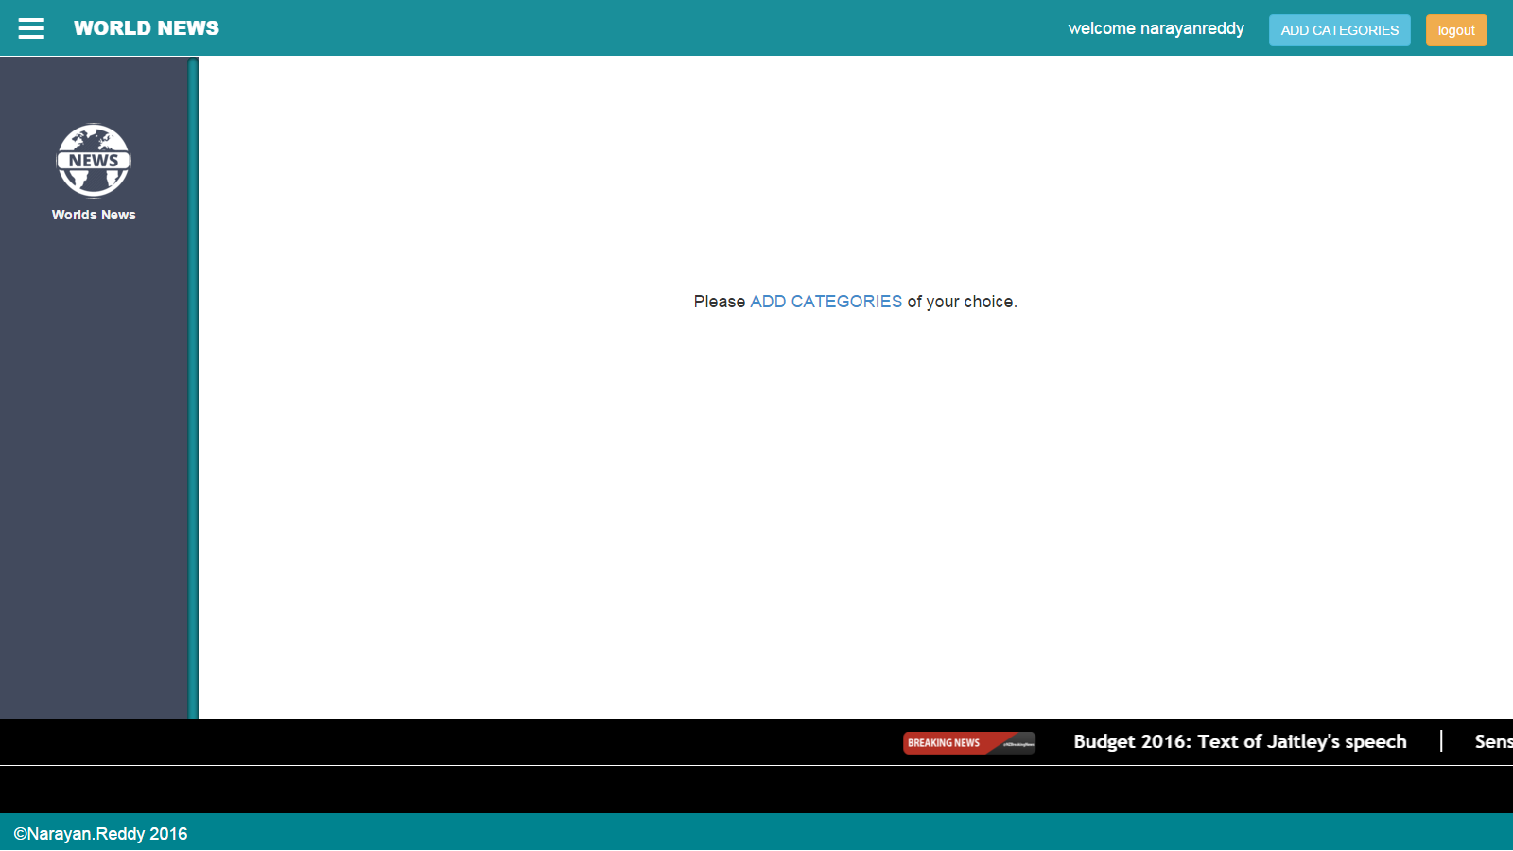

THIS IS MODEL WHERE USER HAVE TO SELECT CATEGORY FROM CATEGORIES LIST DRAG AND DROP IN SELECTEDCATEGORIES:-

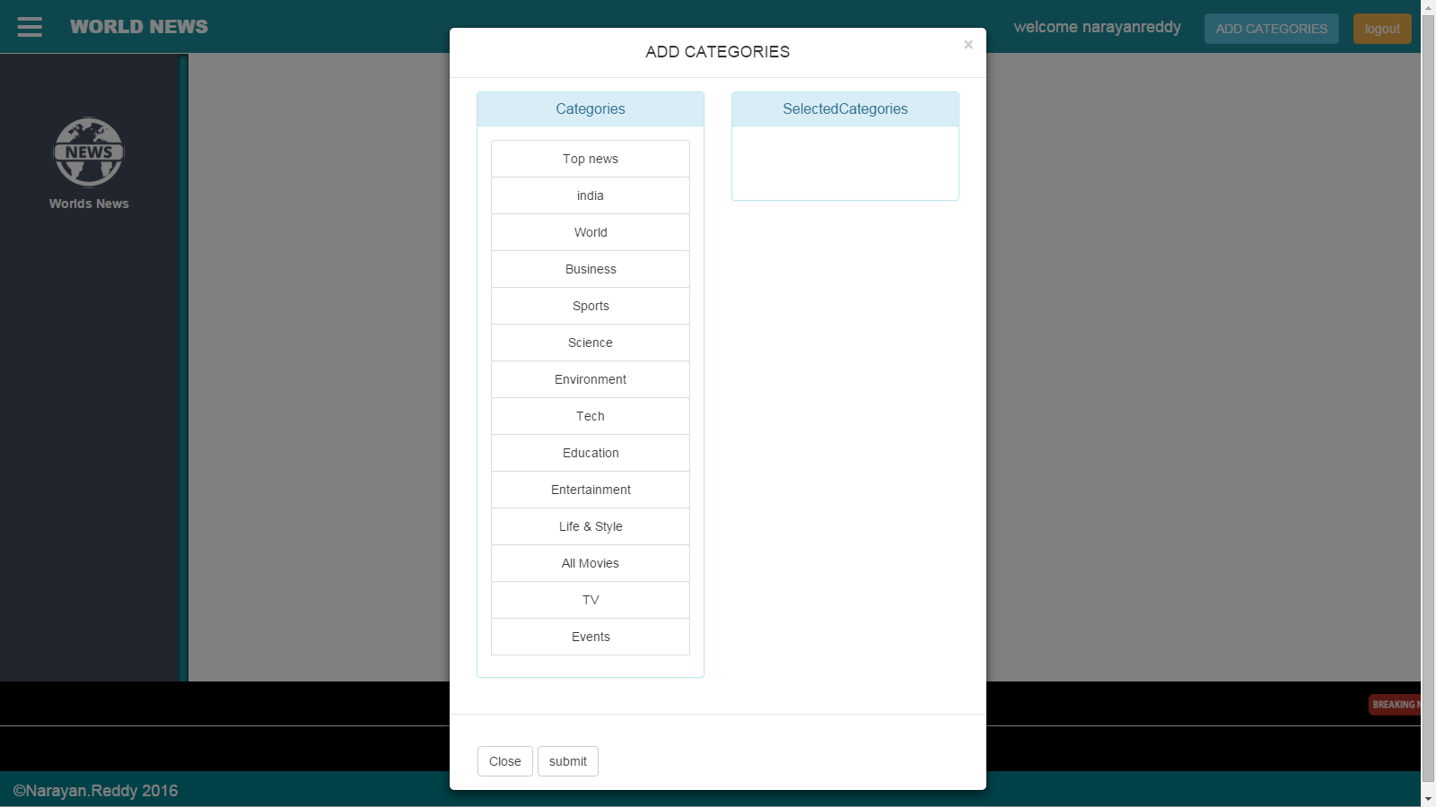

THIS IS AFETR SELECTING CATEGORY FROM CATEGORIES LIST:-

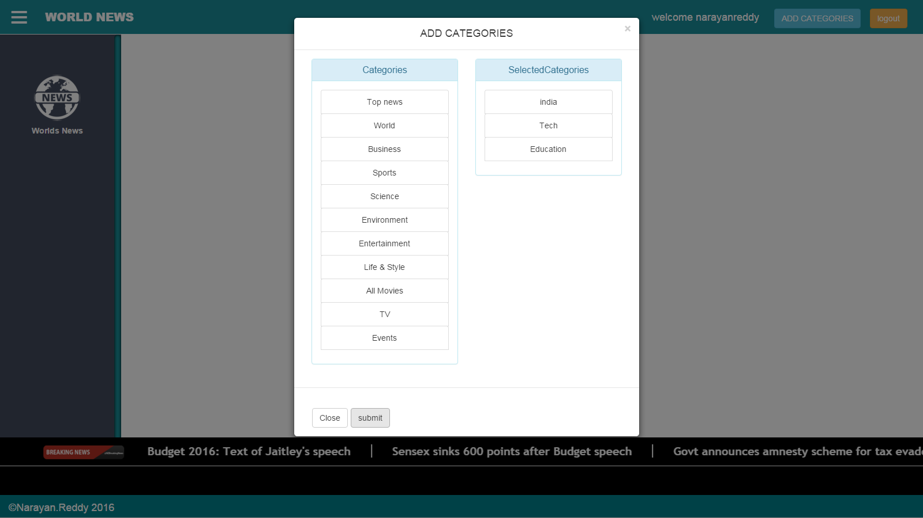

AFTER SUBMITING THE CATEGORIES FORM IT REDIRCTS TO DASHBOARD WITH UPDATED CATEGORIES LIST AND DETAILS:-

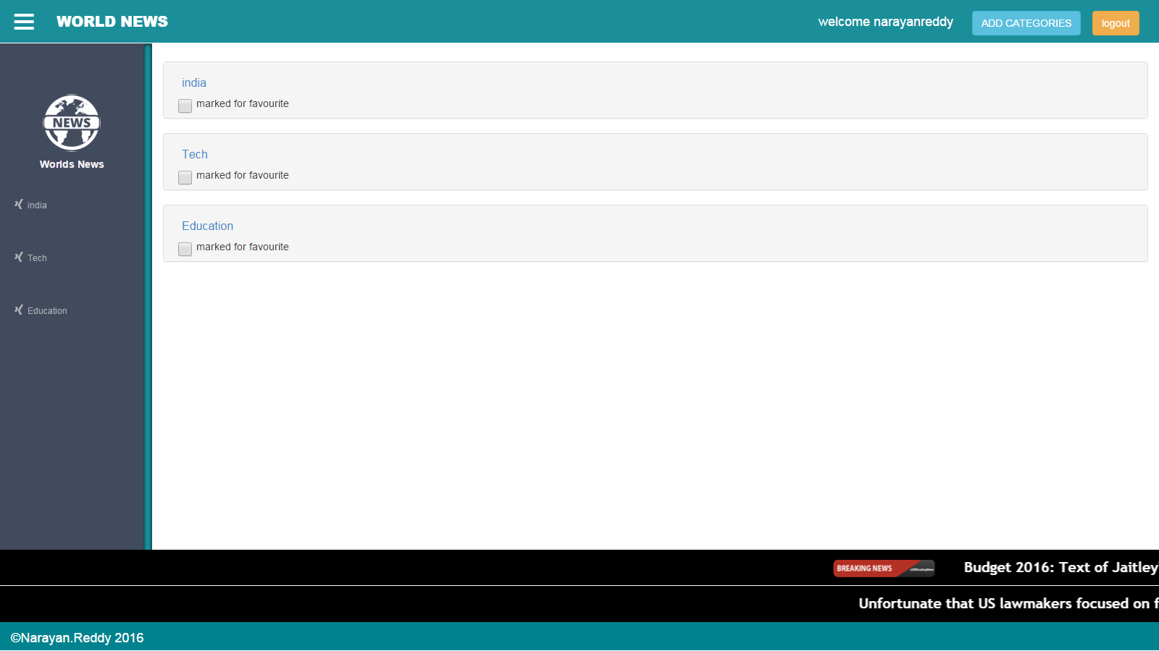

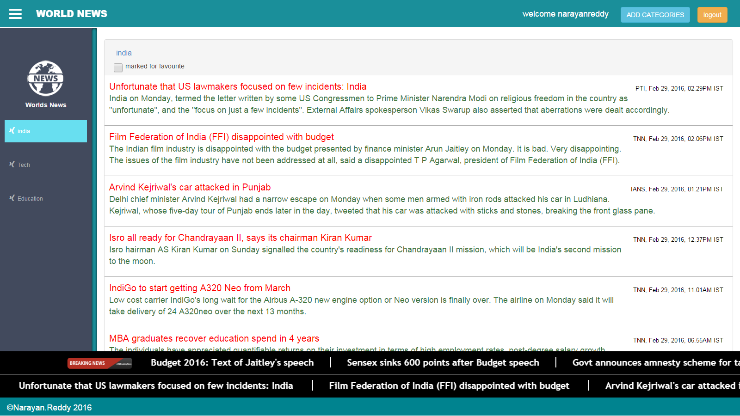

ON SELECTING PARTICULAR CATEGORY IT SHOWS DETAILS:-

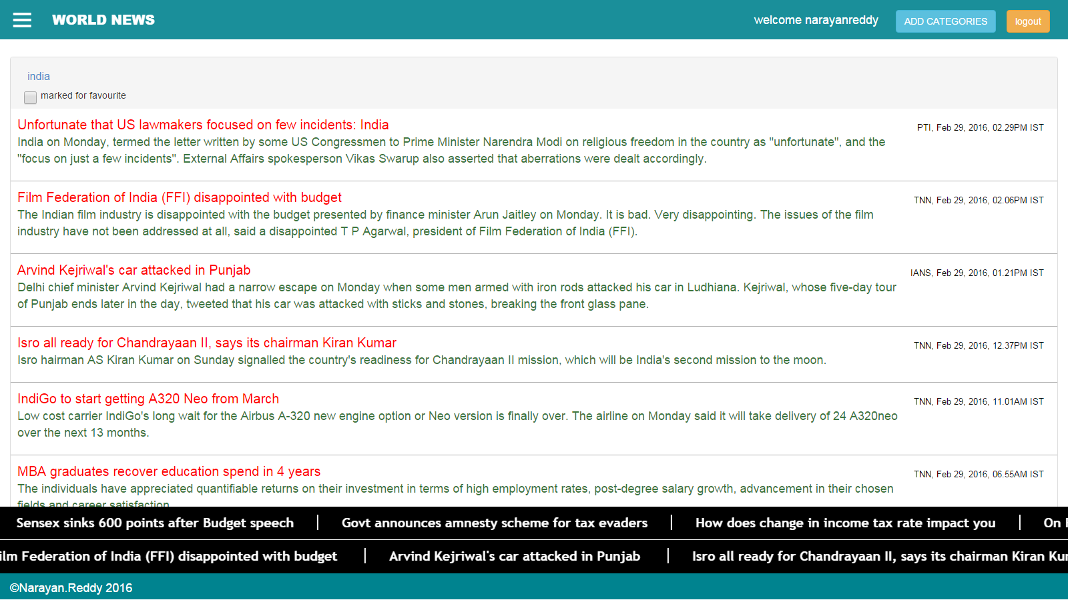

ON SELECTING PARTICULAR NEWS FROM PARTICULAR CATEGORY IT SHOWS DETAILS OF THAT NEWS IN MODEL BOX.

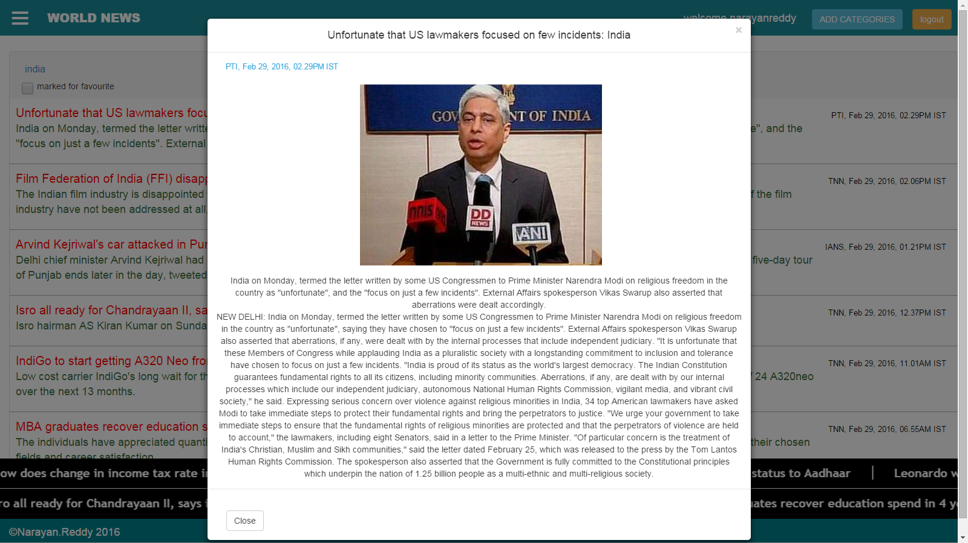

AND AT THE END OF THIS PAGE IT SHOWS TWO SCROLLER ONE FOR BREAKING NEW AND ANOTHER FOR FAVOURITE NEWS SELECTED BY USER:-

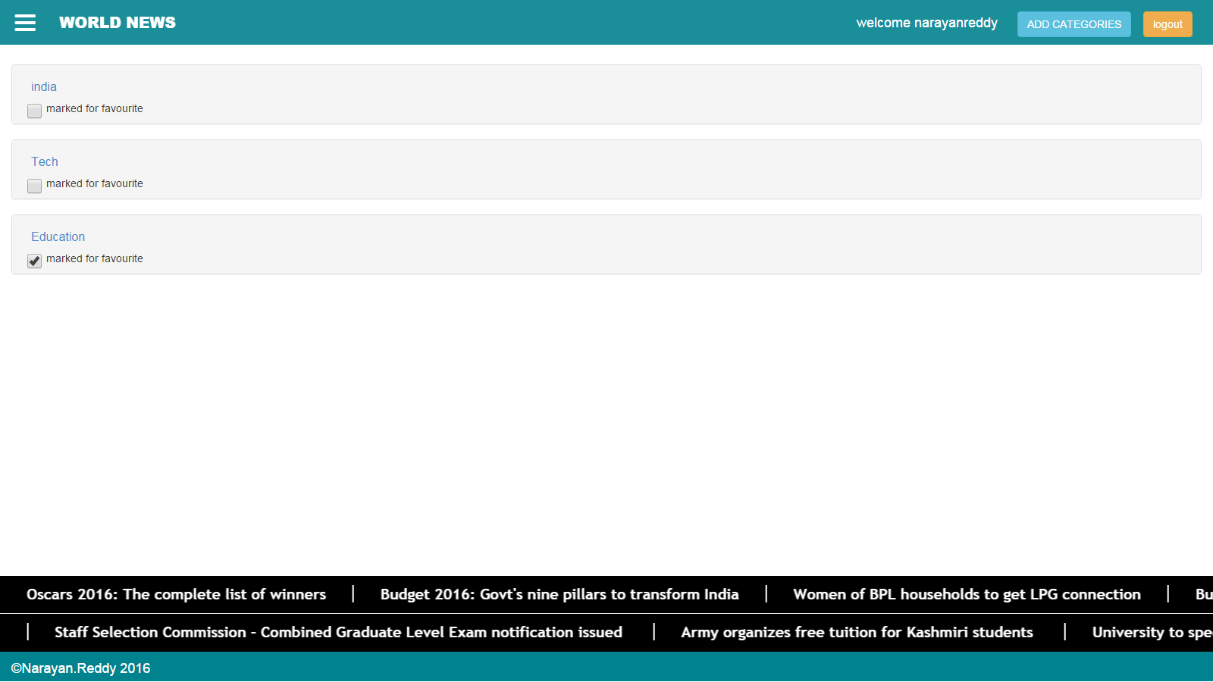

LOGIN PAGE FOR EXISTING USER:-

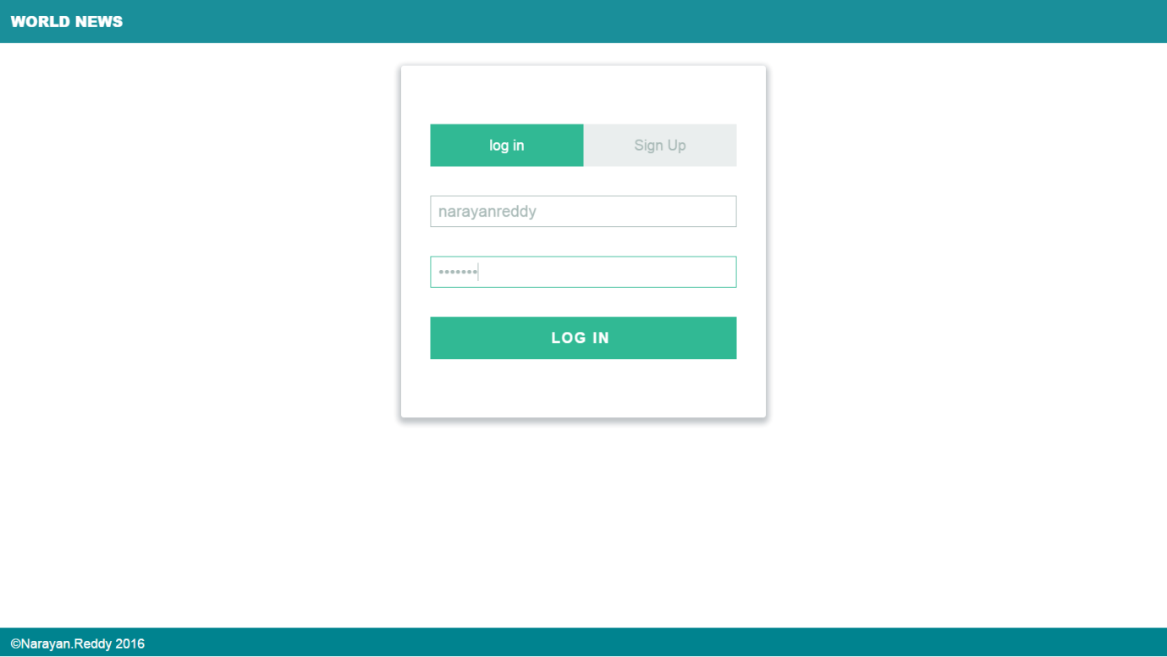

DASHBOARD FOR EXISTING USER:-

