1. EXECUTIVE SUMMARY
These four frameworks serve different purposes but overlap in the agent orchestration space:
- LangChain = The foundational toolkit (model wrappers, tools, RAG, prompt management)
- LangGraph = State machine orchestration layer built ON TOP of LangChain
- CrewAI = Role-based multi-agent framework (fastest to demo)
- AutoGen/AG2 = Conversation-first multi-agent framework (Microsoft-backed)
Key insight: LangGraph is actually part of the LangChain ecosystem. You don't choose "LangChain OR LangGraph" — you choose whether you need LangGraph's state machine on top of LangChain's toolkit.

2. LANGCHAIN

What It Is
The broadest, most mature LLM application framework. Originally a simple chain library (Input → Prompt → LLM → Output), it has evolved into a sprawling ecosystem with hundreds of integrations.

Core Architecture (Three Concentric Rings)
- Foundation Layer: LangChain core + LCEL (LangChain Expression Language)
  - Model wrappers, prompt templates, document loaders, retrievers, output parsers
- Runtime Layer: LangGraph (stateful orchestration) + Deep Agents (opinionated agent harness)
- Operational Layer: LangSmith (observability), LangSmith Fleet (no-code), LangServe (deployment), LangFlow (visual builder)

Key Concepts
- Chains: Linear pipelines of LLM calls. Simple but break when you need branching, retries, or human approval
- LCEL (LangChain Expression Language): Compositional syntax for building chains declaratively
- Tools: External functions agents can call (search, calculators, APIs)
- Retrievers: Connect to vector stores for RAG (Retrieval-Augmented Generation)
- Output Parsers: Structured output extraction from LLM responses

Strengths
- Largest integration ecosystem (hundreds of model providers, vector stores, APIs)
- Most mature community and documentation
- LangSmith provides best-in-class observability and evaluation
- Modular — swap models, tools, or retrievers with minimal code changes
- Production-tested at scale

Weaknesses
- "Chain" abstraction is too simple for complex agent workflows
- Can feel bloated if you only need basic tool calling
- LCEL has a learning curve
- Not opinionated about agent architecture — you build your own patterns

Best Use Cases
- RAG applications (document Q&A, knowledge bases)
- Applications needing maximum integration flexibility
- Teams that need to swap between OpenAI, Anthropic, Google models frequently
- Building custom agent patterns from scratch
- Any app that needs LangSmith observability

When NOT to Use
- Simple single-agent tool use (vendor SDKs are cleaner)
- When you need built-in multi-agent orchestration (use LangGraph on top)
- When you want minimal dependencies

2026 Status
- ~31,000 GitHub stars for LangGraph (built on LangChain)
- LangChain ecosystem is the most widely adopted in enterprise
- Transition from "Chains" to "Graphs" is the defining architectural shift of 2026

3. LANGGRAPH

What It Is
LangChain's graph-based agent orchestration layer. You define workflows as explicit state machines with nodes, edges, and shared state. Think of it as an assembly line where every station (node) performs a specific task, and the conveyor belt (edges) moves the car (state) forward.

Core Primitives
- StateGraph: The builder. Instantiate with a state schema, add nodes/edges, compile
- State: A TypedDict or Pydantic BaseModel shared across all nodes. Every node reads from it and writes updates to it
- Node: A Python function that receives current state and returns partial updates. Can be plain functions, LangChain Runnables, or compiled subgraphs
- Edge: A transition between nodes
  - Normal edge: Unconditional (A → B always)
  - Conditional edge: Routing function decides next node based on current state
- START / END: Special markers for entry and exit points
- Checkpointer: Persistence layer. Writes state after every node transition. Enables resume after crashes
- Interrupt: Pauses execution mid-node. State is checkpointed. Can resume hours or days later with Command(resume=...)
- Send: Parallel fan-out primitive. Dispatches multiple nodes simultaneously

How State Flows
plain
START → Node A (reads state, does work, returns updates) → Edge → Node B → ... → END
- State is NOT copied between nodes — it's updated in place
- Nodes only return the fields they change; LangGraph merges the rest
- Default reducer: "last write wins"
- For accumulating fields (like message lists), use custom reducers (e.g., operator.add)

Strengths
- Production reliability: Checkpointing, durable execution, resume after crashes
- Full observability: Every state transition is inspectable and auditable
- Human-in-the-loop: Native interrupt() primitive for approval workflows
- Time-travel debugging: Replay from any checkpoint
- Explicit control: No hidden agent-to-agent chatter — you define every transition
- Best for regulated industries: Full audit trails via LangSmith
- Streaming: Per-node token streaming
- Subgraphs: Split large graphs into testable, maintainable subgraphs

Weaknesses
- Steeper learning curve: You're modeling a state machine, not a conversation
- More boilerplate: A first working agent takes 80–150 lines vs. CrewAI's 30–60
- Slower initial development: More upfront design required
- Less natural for emergent collaboration: Hard to model "agents debating" as a state machine

Best Use Cases
- Production workflows requiring audit trails (finance, healthcare, compliance)
- Long-running workflows that pause for human approval (hours/days)
- Complex branching logic with retries and error recovery
- Mission-critical systems where every decision must be inspectable
- Workflows that need to resume after server crashes
- Any workflow that maps naturally to a flowchart

When NOT to Use
- Quick prototypes or demos (CrewAI is faster)
- Conversational agent teams that need emergent debate (AutoGen is better)
- Simple linear pipelines (overkill)

2026 Status
- ~31,000 GitHub stars
- Most-adopted framework for stateful production workflows
- LangSmith Deployment offers managed hosting with persistent state storage
- The "year of Stateful Orchestration" — LangGraph is the defining architecture of 2026

4. CREWAI

What It Is
A role-based multi-agent framework. You define agents by role (e.g., "Researcher," "Writer," "Editor"), assign them tasks, and let the framework handle coordination. Think of it as an org chart.

Core Concepts
- Agent: Defined by role, goal, backstory, and tools. Reads like a job description
- Task: A specific assignment given to an agent. Has description, expected output, and optional context
- Crew: A team of agents working together. Orchestrated by a process type
- Process Types:
  - Sequential: Tasks execute one after another (default, best for beginners)
  - Hierarchical: Manager agent coordinates workers. Best for complex multi-agent systems
- Tools: Custom functions agents can use. Can force tool output as direct task result
- Human in the Loop: Interactive checkpoints for critical decisions
- Async Kickoff: Parallel execution for performance optimization
- Replay Tasks: Error recovery by replaying failed tasks
- Bring Your Own Agent: Integrate external agents/models into CrewAI workflows
- Multimodal Agents: Process images, audio, video alongside text

How It Works
plain
Crew (Manager/Process)
├── Agent 1: Researcher (role, goal, tools)
│ └── Task: "Research topic X"
├── Agent 2: Writer (role, goal, tools)
│ └── Task: "Write article based on research"
└── Agent 3: Editor (role, goal, tools)
└── Task: "Edit and finalize"
- Agents can delegate tasks, ask questions, and build on each other's work
- Framework handles inter-agent communication automatically

Strengths
- Fastest to working demo: 30–60 lines of code for a multi-agent system
- Intuitive mental model: Roles map naturally to human teams
- Lowest learning curve: Role/goal/backstory reads like a job description
- Built-in collaboration: Agents delegate and communicate out of the box
- Good for content creation workflows: Writer + editor + fact-checker patterns
- Human-readable agent definitions: Easy for non-engineers to understand

Weaknesses
- Less control over coordination: Hidden agent-to-agent chatter
- Token costs: 3–5× higher than single-agent due to inter-agent communication
- Limited observability: Harder to debug than LangGraph's explicit state machine
- Production hardening is on you: Less built-in checkpointing and recovery
- Smaller ecosystem: Fewer integrations than LangChain
- Limited streaming support

Best Use Cases
- Content creation pipelines (research → draft → edit → publish)
- Rapid prototyping and proof-of-concepts
- Workflows that map to human roles naturally
- Teams with non-engineers who need to understand agent structure
- Marketing copy generation, report writing, creative workflows

When NOT to Use
- Regulated industries needing full audit trails
- Long-running workflows requiring pause/resume
- When token cost is a primary concern
- Complex branching logic with many conditionals

2026 Status
- Small but growing ecosystem
- Medium production maturity
- Excellent multi-agent support but limited checkpointing
- Best for velocity over control

5. AUTOGEN / AG2

What It Is
Microsoft's conversation-first multi-agent framework (now called AG2, formerly AutoGen). Agents interact through structured dialogue. The core abstraction is that coordination is a conversational problem, not an orchestration problem.

Core Concepts
- ConversableAgent: The fundamental building block. Can send/receive messages and generate replies using LLMs, tools, or human input. Base class for all agents
- GroupChat: Primary coordination pattern. Multiple agents in a shared conversation thread. A "selector" decides who speaks next
- Nested Chats: Conversations within conversations for sub-tasks
- Sequential Chats: Predefined turn-taking patterns
- Swarms: Dynamic agent teaming patterns
- Human in the Loop: UserProxyAgent pattern for seamless human integration
- Tools: External programs registered and invoked by agents
- Code Execution: Agents can write, run, and iterate on code in sandboxes
- LLMConfig: Unified configuration for different LLM providers

How GroupChat Works
plain
GroupChat (shared conversation thread)
├── Selector: "Who speaks next?"
├── Agent 1: Coder
├── Agent 2: Reviewer
├── Agent 3: Fact-checker
└── Human (optional, via UserProxyAgent)
- Each turn: selector picks next speaker → agent responds → conversation history grows → repeat
- Agents can critique, correct, and improve each other's outputs

Strengths
- Best for code generation: Agents write, execute, and iterate on code
- Natural for research tasks: Debate, peer review, adversarial workflows
- Emergent collaboration: Agents can discover new approaches through dialogue
- Microsoft ecosystem: Deep Azure OpenAI, M365, Azure AI Content Safety integration
- Human-in-the-loop: UserProxyAgent is a first-class pattern
- Good for quality-sensitive offline workflows: Thoroughness over speed

Weaknesses
- Token cost explosion: Every agent turn involves full conversation history. 4 agents × 5 rounds = 20+ LLM calls minimum
- Unpredictable costs: Hard to cap total token usage in open-ended conversations
- Selector is the kingmaker: Bad selection logic ruins results regardless of agent quality
- Latency: Not suitable for real-time use cases like customer support
- Breaking changes: 0.4 → 1.0 (AG2) rewrite introduced significant API changes
- Less mature observability: Compared to LangGraph + LangSmith
- Limited streaming support

Best Use Cases
- Code generation with critic agents (write → review → fix)
- Research workflows with debate dynamics
- Complex analytical tasks requiring peer review
- Data analysis (analyst + validator pattern)
- Microsoft/Azure-native deployments
- Offline, quality-sensitive workflows where thoroughness > speed

When NOT to Use
- High-volume, real-time applications (customer support, chatbots)
- When token cost must be tightly controlled
- When you need deterministic, auditable execution (LangGraph is better)
- When you need fast response times

2026 Status
- AG2 (v1.0) went GA in February 2026
- Event-driven core, async-first execution, pluggable orchestration
- Growing ecosystem but smaller than LangChain
- Microsoft Research actively uses it in internal projects

Dimension | LangChain | LangGraph | CrewAI | AutoGen/AG2
Primary Role | Foundation toolkit | State machine orchestrator | Role-based multi-agent | Conversation-first multi-agent
Built On | Standalone | LangChain | Standalone | Standalone
Mental Model | Toolbox | Assembly line / Flowchart | Org chart | Group chat
Learning Curve | Medium-High | Medium | Low-Medium | Medium
Lines to First Agent | 50–100 | 80–150 | 30–60 | 60–100
Production Maturity | High | High | Medium | Medium
Ecosystem Size | Very Large | Large (part of LangChain) | Small | Growing
Multi-Agent Support | Good (via LangGraph) | Good | Excellent | Excellent
State Persistence | Manual | Built-in checkpointing | Task outputs passed sequentially | In-memory (configurable)
Human-in-the-Loop | Manual | Native interrupt() | Interactive checkpoints | UserProxyAgent
Observability | LangSmith (best) | LangSmith (best) | Limited | Limited
Streaming | Good | Per-node streaming | Limited | Limited
Token Cost Control | Manual | Explicit (per node) | High (3–5×) | Very High (unpredictable)
Error Recovery | Manual | Time-travel + replay | Replay tasks | Limited
Model Agnostic | Yes | Yes | Yes | Yes
Best For | RAG, broad integrations | Production, compliance, HITL | Fast demos, content creation | Code gen, research, debate

AGENT ANATOMY: Role, Goal, Backstory
Think of an AI agent like hiring an employee. You wouldn't just say "do this task" — you'd give them a job title, tell them what success looks like, and explain why they're the right person for the job. That's exactly what these three components do.

1. ROLE (The Job Title)
What it is: The identity or function the agent performs.
Think of it as: "What would this agent's business card say?"
Examples:
- "Senior Research Analyst"
- "Technical Writer"
- "Code Reviewer"
- "Customer Support Specialist"
Why it matters: The role shapes the agent's tone, expertise, and default behavior. A "Senior Research Analyst" will be thorough and cite sources. A "Creative Copywriter" will be punchy and persuasive.
How to write a good one:
- Use a specific title, not a generic one ("Senior Python Developer" > "Coder")
- Include seniority level if it affects thoroughness
- Keep it to 3–5 words

2. GOAL (The Mission)
What it is: The single, clear outcome the agent must achieve.
Think of it as: "What does 'done' look like for this agent?"
Examples:
- "Find and summarize 5 credible sources on quantum computing advances in 2026"
- "Write a 500-word blog post that explains blockchain to a non-technical audience"
- "Review this Python function for bugs, security issues, and PEP 8 compliance"
Why it matters: The goal is the agent's North Star. Every action, tool call, and decision should serve this goal. Vague goals = vague results.
How to write a good one:
- Be specific and measurable
- Include scope boundaries ("up to 5 sources," "500 words," "Python only")
- State the output format if it matters
- One goal per agent (don't overload)

3. BACKSTORY (The Context)
What it is: The personality, experience, and motivation that make the agent unique.
Think of it as: "Why is this person good at this job? What makes them tick?"
Examples:
- "You have 10 years of experience in financial journalism and a reputation for spotting market trends before they hit mainstream news. You are meticulous about fact-checking and always cite your sources."
- "You are a former startup CTO who now specializes in making complex technical concepts accessible to business leaders. You write with clarity and avoid jargon."
- "You are a detail-oriented code reviewer who has worked on mission-critical systems at NASA. You never let a potential null pointer exception slide."
Why it matters: The backstory injects personality, expertise level, and behavioral guardrails. It prevents generic, robotic responses and shapes how the agent approaches problems.
How to write a good one:
- 2–4 sentences max
- Mention relevant experience and expertise level
- Include 1–2 personality traits that affect output style
- Add behavioral rules ("always cite sources," "never assume," "ask clarifying questions")
- Make it believable — specific details work better than vague superlatives

Component | Formula | Example
Role | [Seniority] + [Function] + [Domain] | "Senior Financial Research Analyst"
Goal | Action + What + For Whom + Format/Scope | "Analyze Q2 2026 earnings reports and produce a 1-page summary for retail investors"
Backstory | Experience + Expertise + Style + Rules | "15 years on Wall Street. Known for clear, jargon-free analysis. Always includes risk warnings."

TASK ANATOMY: Description + Expected Output
Think of a task as a work order you hand to an agent. Just like assigning work to a human, you need to say what to do and what "done" looks like.

1. DESCRIPTION (The Instructions)
What it is: Clear, specific instructions about what the agent must do.
Think of it as: "Here is exactly what I need you to do, step by step."
Key Points:
- Be specific — vague descriptions = vague results
- Include context the agent needs (data, constraints, source material)
- Mention tools the agent should use if relevant
- State the scope (what to include AND what to exclude)
Bad: "Research AI trends" Good: "Research the top 3 AI agent frameworks trending in 2026. Focus on GitHub stars, enterprise adoption, and key differentiators. Use web search. Limit to frameworks released before June 2026."

2. EXPECTED_OUTPUT (The Deliverable)
What it is: A precise definition of the final output format, structure, and quality standards.
Think of it as: "This is exactly what I want back in my hands."
Key Points:
- Specify format (bullet list, report, JSON, table, code block)
- Define structure (sections, length, headings)
- Set quality criteria (cited sources, code comments, tone)
- Include examples if the format is non-standard
Bad: "A summary" Good: "A structured report with: (1) Executive Summary (3–5 bullets), (2) Comparison Table (framework, stars, best use case), (3) Recommendation (1 paragraph). Use markdown. Total length: 300–400 words."

WHY BOTH MATTER
Component | Answers | Prevents
Description | "What should I do?" | Agents going off-task or missing scope
Expected Output | "What should it look like?" | Inconsistent format, wrong structure, vague deliverables
Component | Formula | Example
Description | Action + Topic + Scope + Tools/Constraints | "Analyze Q2 2026 Tesla earnings. Focus on revenue, margins, and guidance. Use financial data tools. Exclude stock price predictions."
Expected Output | Format + Structure + Length + Quality Rules | "Structured analysis: Key Metrics table, 3 Risk Factors bullet list, 1-paragraph Outlook. Max 400 words. Use markdown."
Without Expected Output: Agent returns a paragraph when you needed a table, or 2,000 words when you wanted 200.
Without Description: Agent guesses what you meant and produces irrelevant work.

CREW EXECUTION FLOW
Think of a Crew as a project manager running a team meeting. It decides who does what, in what order, and how they hand off work.

THE TWO PROCESS TYPES
Process | How It Works | Best For
Sequential | Task 1 → Task 2 → Task 3. Output of Task 1 becomes context for Task 2. | Linear workflows, beginners, simple pipelines
Hierarchical | Manager agent coordinates workers. Manager assigns tasks, reviews output, reassigns if needed. | Complex multi-agent systems, quality control, delegation

SEQUENTIAL FLOW (Step-by-Step)
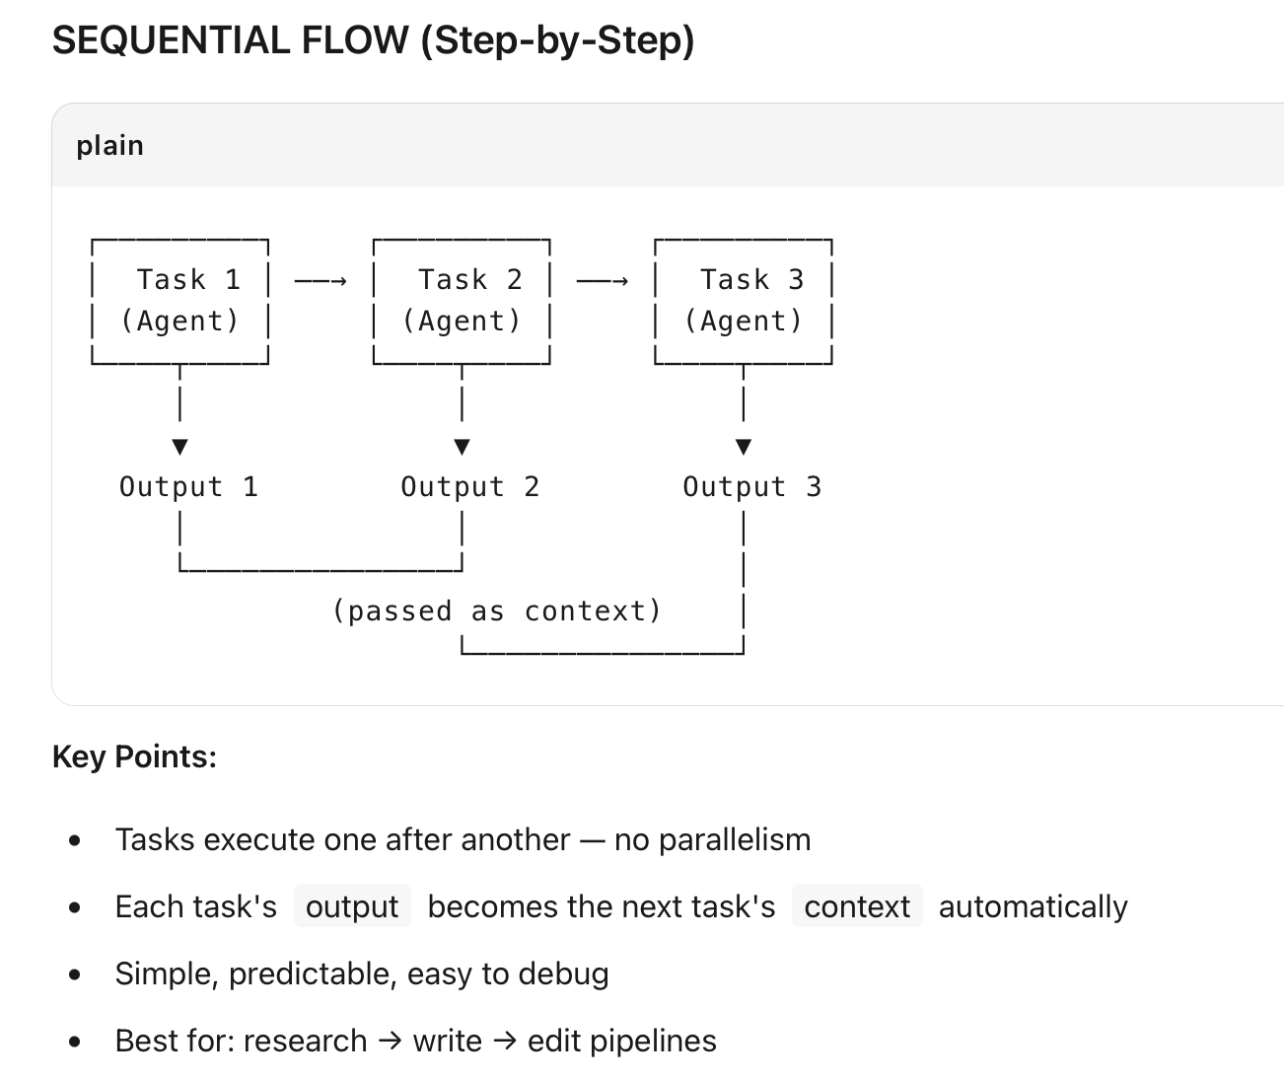
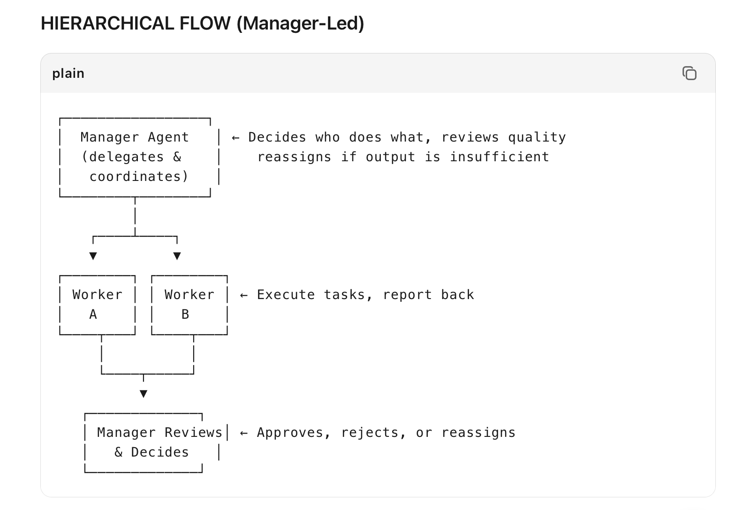
Key Points:
- Manager agent has a special role: goal is to coordinate the crew
- Manager assigns tasks to workers based on their roles
- Manager reviews output and can re-delegate if quality is poor
- More flexible than sequential but uses more tokens
- Best for: complex projects with unclear task ordering upfront

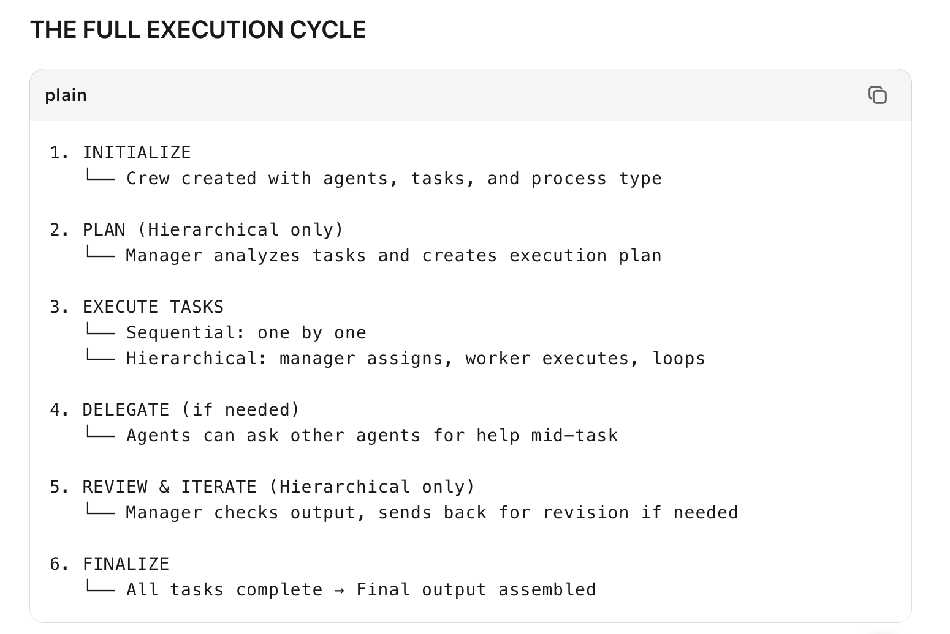
Step | What Happens
Task 1 completes | Output saved to task object
Task 2 starts | Automatically receives Task 1's output as context
Task 2 completes | Output saved, passed to Task 3
Final task | Combines all previous outputs into final deliverable
Key Rule: Context is cumulative. Task 3 sees outputs from Task 1 AND Task 2.

KEY CONFIGURATION POINTS
Parameter | What It Controls
process=Process.sequential | Linear execution
process=Process.hierarchical | Manager-led execution
manager_agent | Required for hierarchical — the coordinator
context on Task | Manual injection of extra data into a task
async_execution=True | Run tasks in parallel (when no dependencies)
human_input=True | Pause for human approval before this task

Situation | Use
Fixed order: research → draft → edit | Sequential
Need a boss to check quality | Hierarchical
Tasks have clear dependencies | Sequential
Tasks are independent, can run parallel | Sequential + async_execution
Complex project, task order unclear | Hierarchical
Need human approval mid-flow | human_input on specific task

