Report: Optimising NYC Taxi Operations
Include your visualisations, analysis, results, insights, and outcomes. Explain your methodology and approach to the tasks. Add your conclusions to the sections.

Data Preparation
  - Loading the dataset
    - Sample the data and combine the files
The source data contains twelve monthly Parquet files for 2023
- For each of the 12 monthly Parquet files, timestamps (tpep_pickup_datetime) were parsed to extract pickup_date and pickup_hour.
- A 5% random fraction (frac=0.05, random_state=8) was sampled from each hour of every single day across all 12 months.
- This procedure generated an initial pool of approximately 1,896,400 records
- From this pool, a uniform final sample of 300,000 records were randomly extracted (random_state=8) and exported to nyc_taxi_2023_sampled.csv. This ensures every hour of every day in 2023 is proportionately represented.

Data Cleaning

Fixing Columns
    - Fix the index
- The index was reset using df.reset_index(drop=True) to ensure continuity.
- Column store_and_fwd_flag was examined, it had 3.26% missing values and does not contribute to taxi dispatching or fare optimization, so it was dropped.

    - Combine the two airport_fee columns
- The schema contained duplicate airport fee airport_fee (92.06% missing) and Airport_fee (11.21% missing).
- The two fields were reconciled by taking the row-wise maximum value and assigning the result to airport_fee. Finally dropping the redundant Airport_fee column

Handling Missing Values
    - Find the proportion of missing values in each column
After data cleanup we are left with 299,985 records where proportion of missing values are calculated as (sum of count / total records) * 100 :
- passenger_count: 3.262% (9,786 null values)
- RatecodeID: 3.262% (9,786 null values)
- congestion_surcharge: 3.262% (9,786 null values)
- All remaining monetary and temporal fields had 0.00% missing values

    - Handling missing values in passenger_count
- The 9,786 null passenger entries were imputed using the dataset median (1.0 passenger).
- An additional 4,737 records with passenger_count == 0 were identified. Because a taxi in meter service must carry at least one passenger, these zero values were also imputed with the median of 1.0.

    - Handle missing values in RatecodeID
- The 9,786 null values in the categorical RatecodeID column were imputed using the mode (1.0 = Standard rate, which represents over 93% of all trips).

    - Impute NaN in congestion_surcharge
- The surcharge is an additional charge on the fare. Missing entries indicate the surcharge was not triggered, hence the 9,786 null records were imputed with $0.00.

Handling Outliers and Standardising Values
    - Check outliers in payment type, trip distance and tip amount columns
The initial descriptive statistics ‘df.describe()’ showed several extreme
value:
- Payment Type Outliers: Identified 9,784 invalid payment type records (values outside the range 1-6), representing the most significant data quality issue (~3.27% of the dataset). These were removed to ensure only valid payment types remain in the analysis.
- Trip Distance Outliers: Found 3 extreme distance outliers with trip distances exceeding 250 miles, which were removed as they represent unrealistic taxi rides that skew analysis and don't reflect typical NYC taxi operations.
- Zero Fare Trips: Identified 16 records with zero fare but valid payment types and positive trip distances (potential free trips or test rides). These were retained for analysis rather than removed, as they may represent legitimate business transactions despite being anomalous.
- Tip Amount Outliers: Identified 386 records having tip amount more than the fare amount. 2 records having tip amount whereas fare amount is zero. All these were retained for analysis as tip amount can be valid and free trip also customer can pay tip.

Exploratory Data Analysis

General EDA: Finding Patterns and Trends
    - Classify variables into categorical and numerical
- Categorical variables include VendorID, RatecodeID, store_and_fwd_flag, PULocationID, DOLocationID and payment_type.
- Numerical variables include passenger_count, trip_distance, fare_amount, extra, mta_tax, tip_amount, tolls_amount, improvement_surcharge, total_amount, congestion_surcharge and airport_fee.
- tpep_pickup_datetime and tpep_dropoff_datetime timestamps are datetime variables.
    - Analyse the distribution of taxi pickups by hours, days of the week, and months
Hour, Days and Month were extracted into separate column and count is taken for each one of them to find out the number of pickup in each category.
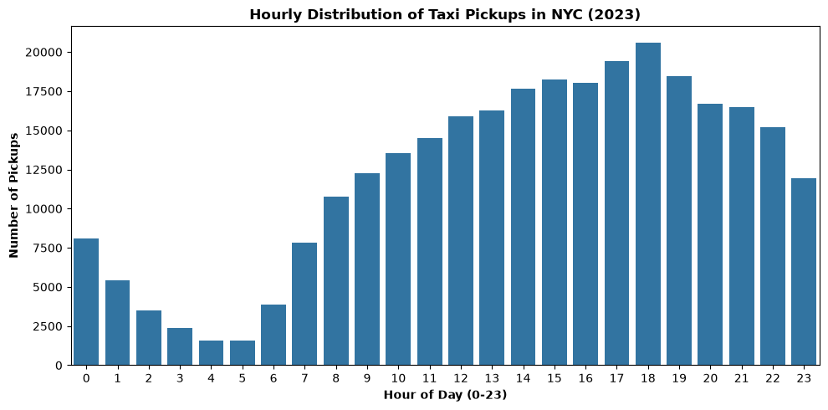
- Hourly Analysis : Peak at 18:00 (20,614 trips); lowest at 05:00 (1,578). Strong evening surge (17:00–19:00), steady night demand until 23:00, and lowest activity 04:00–06:00
Figure 1: Hourly Distribution Of Taxi Pickup
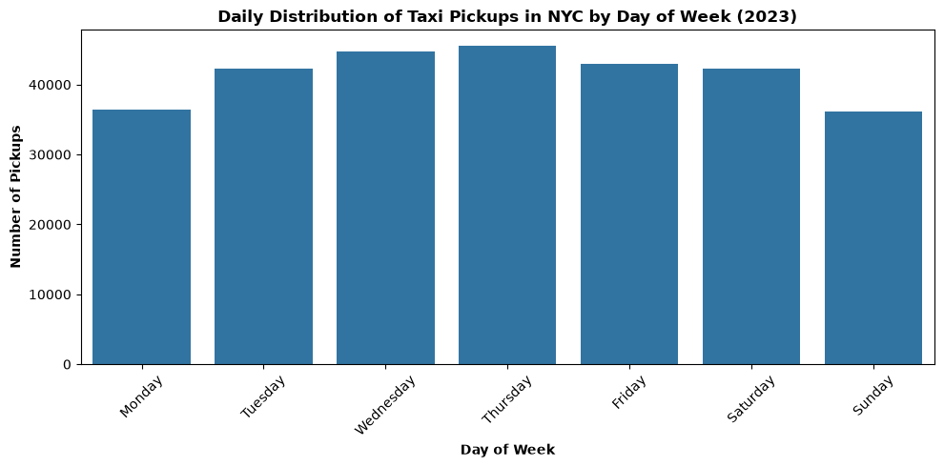
- Day of Week Analysis: Peak on Thursday (45,546 trips); lowest on Sunday (36,084). Demand is strongest Wednesday–Friday.
Figure 2 : Daily Distribution Of Taxi Pickups

- Monthly Analysis: Peak in May (26,692 trips); lowest in September (21,329). Activity is strongest in spring and holiday months, with a late-summer dip.
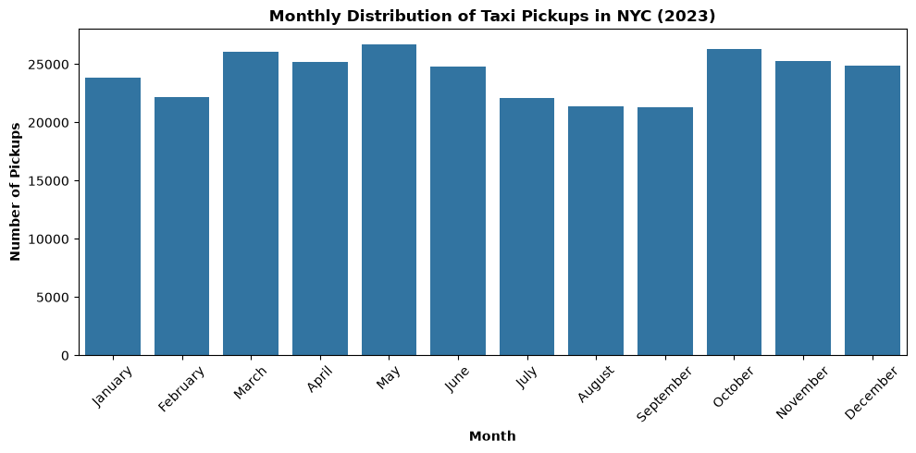
Figure 3 : Monthly Distribution Of Taxi Pickups

    - Filter out the zero/negative values in fares, distance and tips
A non-zero subset was created excluding trips where zero fare amount, zero trip distance or zero total amount.
- The fare amount field has 67 zero values and no negative values.
- The tip amount field has 64,696 zero values and no negative values
- The total amount field has 36 zero values and no negative values.
- The trip distance field has 3,320 zero values and no negative values.
    - Analyse the monthly revenue trends
Monthly revenue was calculated as the sum of total_amount as revenue which is grouped by pickup_month.
- Highest Revenue Month: May with total revenue $772,017.41.
- Lowest Revenue Month: February with total revenue $593,590.30
- Average Monthly Revenue: $688,874.70 on sampled data.

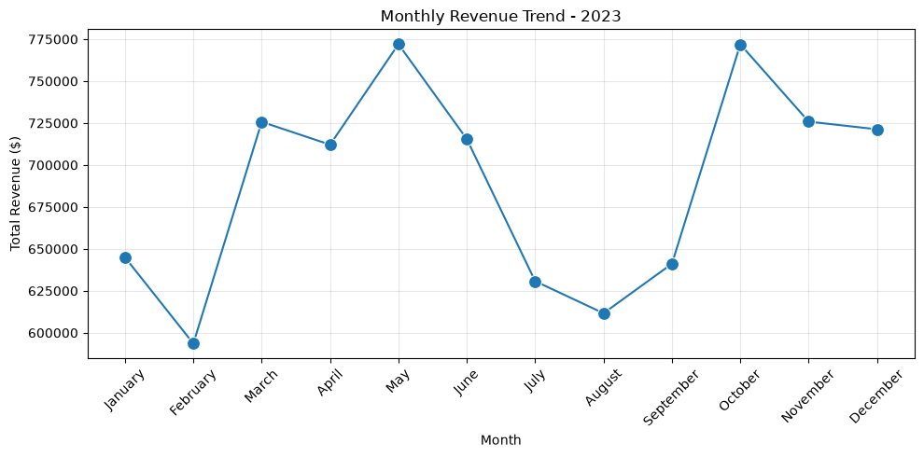
Figure 4 : Monthly Revenue Trend

    - Find the proportion of each quarter’s revenue in the yearly revenue
AA quarter column was added to classify each record into Q1–Q4. The revenue percentage for each quarter was then calculated as (sum of total_amount for the quarter ÷ total revenue) × 100. This calculation was performed using the sample data.
Results shows Q4 and Q2 dominate in revenue generation
- Q1 (Jan–Mar): $1,964,287.19 (23.76%)
- Q2 (Apr–Jun): $2,199,585.93 (26.61%)
- Q3 (Jul–Sep): $1,883,526.18 (22.79%)
- Q4 (Oct–Dec): $2,219,097.10 (26.84%)
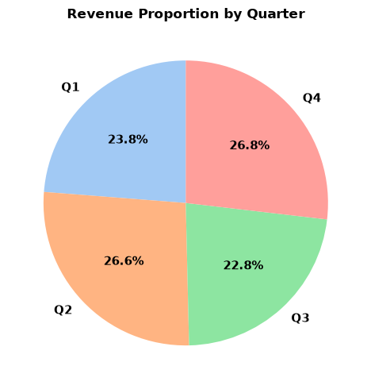
Figure 5 : Quarterly Revenue Proportion

    - Analyse and visualise the relationship between distance and fare amount
The relationship between trip_distance and fare_amount was analysed using a scatter plot and correlation matrix on records with positive trip distance.
- Trip distance and fare amount had a strong positive relationship, with a correlation of 0.94
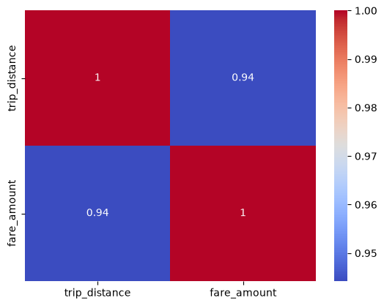
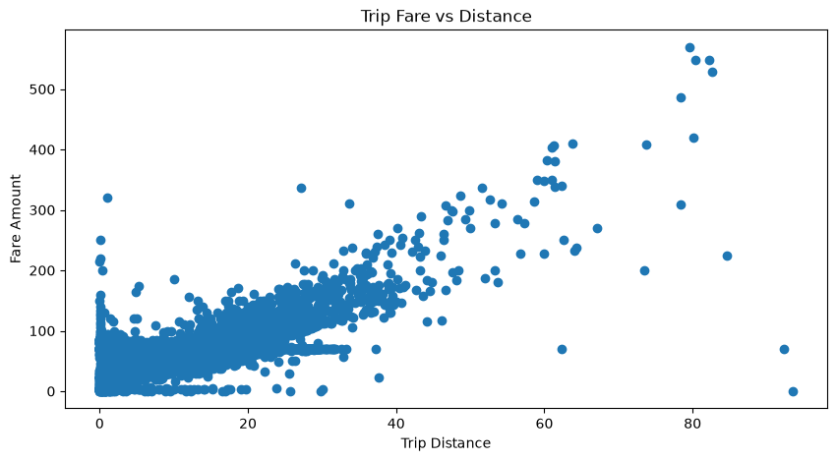
- This indicates that distance is a major driver of fare amount and provides a useful basis for distance-aware pricing and revenue forecasting.
Figure 6: Correlations between fare and distance
Figure 7 : Trip Fare vs Distance

    - Analyse the relationship between fare/tips and trips/passengers
Relationship between various feature like (duration, passenger count and fare amount) ,( tips and trip distance ) were extracted from the sampled data. The result indicate that distance is much more informative for fare and tip behavior than passenger count, while trip duration has a comparatively modest relationship with fare.
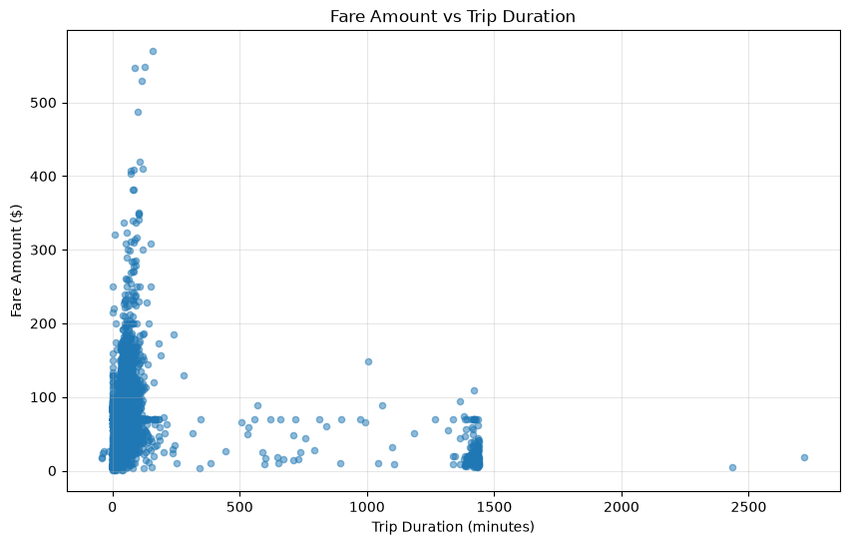
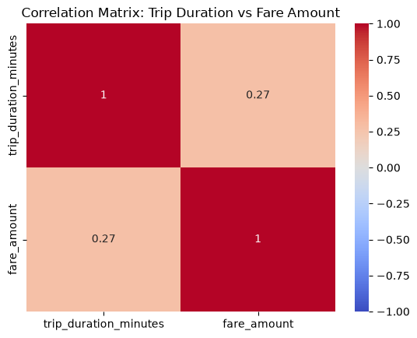
- Duration vs. Fare: Fare amount had a weak positive correlation with trip duration (0.27)
Figure 8 : Fare Amount vs Trip Distance
Figure 9 :Correlation Between Duration and Fare

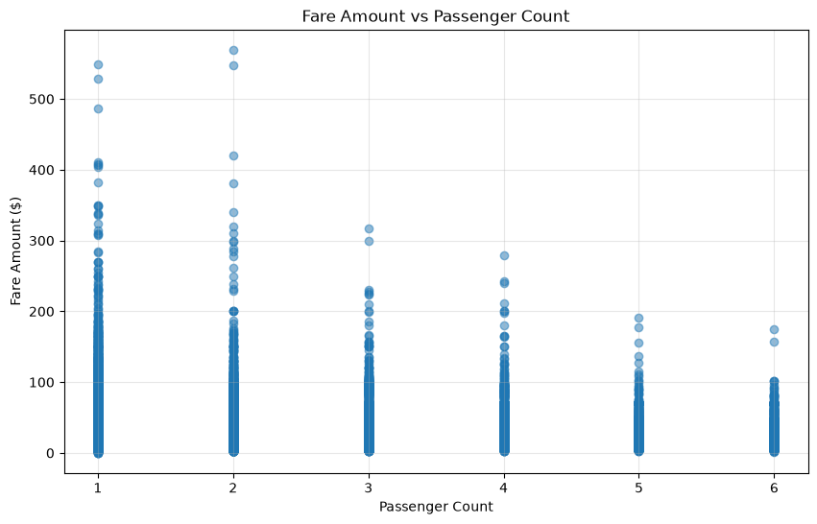
- Passenger Count vs. Fare: virtually no correlation with passenger count (0.04).
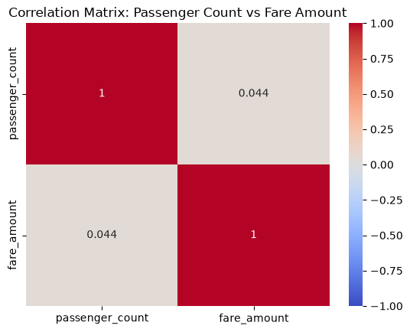
Figure 10 : Correlation Between Passenger count and Fare
Figure 11 : Fare vs Passenger Count

- Tip Amount vs. Trip Distance: Tip amount had a stronger positive correlation with trip distance (0.59).
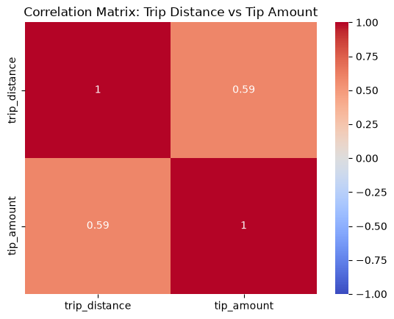
Figure 12 : Tip vs Distance
Figure 13 : Correlation Between Tip and Distance
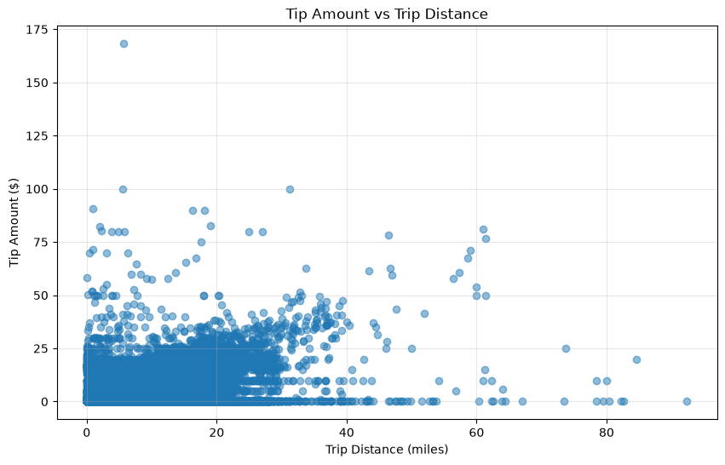
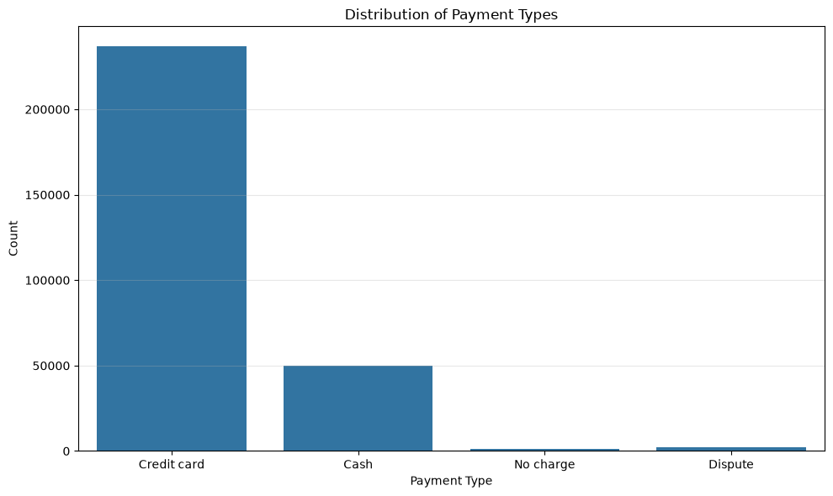
    - Analyse the distribution of different payment types
Credit-card payment is the dominant payment method in the cleaned sample. Cash represented a smaller but material share, while no-charge and dispute transactions were much less common. The payment-type distribution supports the fact digital card payment behavior is an important part for customer experience analysis
Figure 14 : Payment Type Distributions
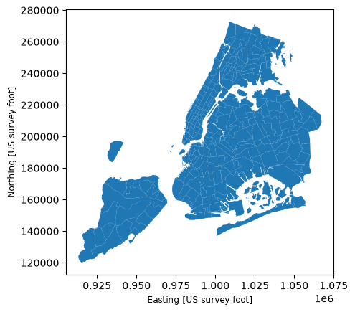
    - Load the taxi zones shapefile and display it
The taxi_zones.shp file was loaded with GeoPandas. The zone dataset provides LocationID, zone, borough and geometry, which were used for geographic analysis and mapping.
Figure 15 : Taxi Zones
    - Merge the zone data with trips data
Trip records sample were merged with zone data set using a left join on PULocationID = LocationID. LocationID column was later on dropped considering it as a duplicate value to PULocationID .
    - Find the number of trips for each zone/location ID
The number of trips for each LocationID was calculated using a group-by count on PULocationID and sorted in descending order to identify the locations generating records having top pick up zones
- Top pick up zones:
JFK Airport (Zone 132) - trips 15,326
Midtown Center (Zone 161) - trips 13,637
Upper East Side South (Zone 237) - trips 13,769
Upper East Side North (Zone 236) - trips 12,153
Midtown East (Zone 162) – trips 10,589

    - Add the number of trips for each zone to the zones dataframe
The trip-count along with aggregated (pickup_counts and dropoff_counts) were merged into the zones data frame using LocationID. Zero count was added to Zones having no trips in the sampled dataset.
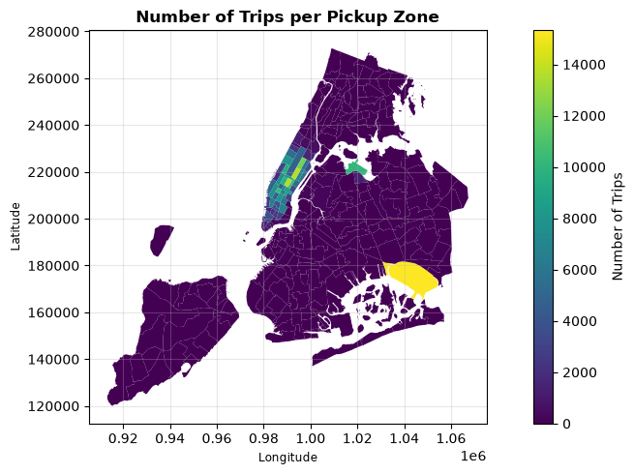
    - Plot a map of the zones showing number of trips A choropleth map was prepared using the trip count as the geographic variable. Darker areas in map represent zones having high pickup demand in the sampled data set.
Figure 16 : Trips in each zone
    - Conclude with results
Geographic analysis highlights the areas with the greatest taxi demand, supporting effective cab placement and dispatch planning.
- Taxi demand varies significantly by time, day, and season, with the highest activity during evening hours, midweek, and May.
- Revenue generally follows trip volume, with Q4 generating the highest quarterly revenue and Q3 the lowest.
- Trip distance is the strongest factor influencing fare and tip amounts, while passenger count has almost no effect on fare.
- JFK Airport is the busiest pickup location, highlighting its importance as a major transportation hub.
- Credit cards dominate payment methods, indicating a strong preference for cashless transactions.
- Over 90% of Yellow Taxi operations are concentrated within Midtown Manhattan and airport travel corridors..

Detailed EDA: Insights and Strategies
    - Identify slow routes by comparing average speeds on different routes
For each record, the trip duration was first calculated, followed by the speed using total trip distance ÷ total trip duration. Each record was then labelled with a route in the format PuLocationId → DOLocationID. Finally, the average speed for each route was calculated by grouping the records by route and using: Average speed = sum of total trip distance ÷ sum of total trip duration for each route
- Route-level analysis identified significant speed variations by pickup hour, with several route/hour combinations showing exceptionally low average speeds that may indicate bottlenecks or anomalous long-duration trips
- Slowest route in each hour are below:
Hour of Day | Route (From → To) | Average Speed
0 | 9722 → 74 | 0.7768
1 | 48 → 132 | 0.0581
2 | 138 → 129 | 1.8557
3 | 113 → 246 | 0.0534
4 | 144 → 186 | 0.0882
5 | 40 → 106 | 3.5772
6 | 10 → 218 | 0.4483
7 | 10 → 10 | 0.1552
8 | 211 → 48 | 1.2121
9 | 146 → 226 | 0.0939
10 | 42 → 42 | 0.4198
11 | 244 → 177 | 0.2349
12 | 207 → 207 | 0.4045
13 | 229 → 41 | 0.0245
14 | 264 → 74 | 0.0545
15 | 116 → 116 | 0.1644
16 | 48 → 145 | 0.1692
17 | 211 → 125 | 0.1315
18 | 97 → 97 | 0.6272
19 | 28 → 219 | 0.1105
20 | 132 → 193 | 0.5718
21 | 158 → 14 | 0.3889
22 | 114 → 211 | 0.8091
23 | 138 → 264 | 0.0099
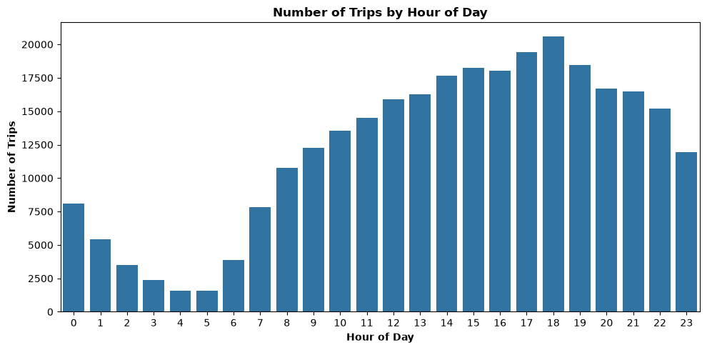
    - Calculate the hourly number of trips and identify the busy hours
A count was taken on total number of trip based on the pickup_hour. Hourly sampled trip counts ranged from 1,578 at 05:00 to 20,615 at 18:00. The busiest hour was 18:00, followed by 17:00 (19,432), 19:00 (18,466), 15:00 (18,234), and 16:00 (18,023).
Figure 17: No. Of Trips By Hour Of Day

    - Scale up the number of trips from above to find the actual number of trips

The working dataset represents a 5% sample, an approximate actual trip count was estimated by dividing the sampled hourly count by 0.05 The five busiest hours were estimated at approximately 412,300 trips at 18:00, 388,640 at 17:00, 369,320 at 19:00, 364,680 at 15:00 and 360,460 at 16:00. These are sample-based scaled estimates, not direct counts of the full annual dataset.
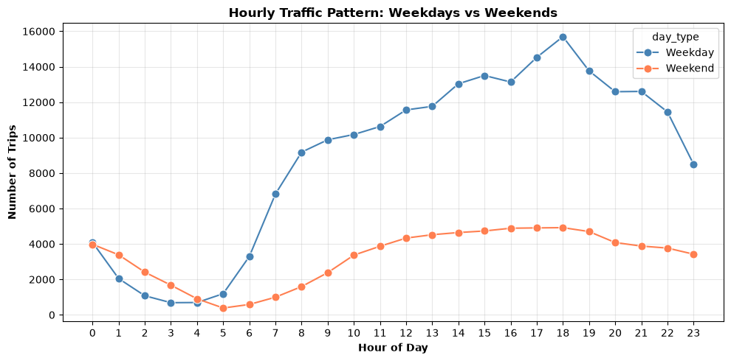
    - Compare hourly traffic on weekdays and weekends
Weekday traffic was substantially higher during the daytime and evening commute periods. The weekday peak was 18:00 with 15,695 sampled trips, compared with 4,920 on weekends. Weekend activity was relatively stronger during late-night/early-morning hours than weekday activity. These differences support separate weekday and weekend fleet schedules.
Figure 18 : Weekday vs Weekend Hourly Traffic Pattern

    - Identify the top 10 zones with high hourly pickups and drops
The top 10 pickup and drop-off LocationIDs were identified using value_counts to determine the most frequently used pickup and drop locations. The corresponding zone names were then obtained from the merged taxi-zone table
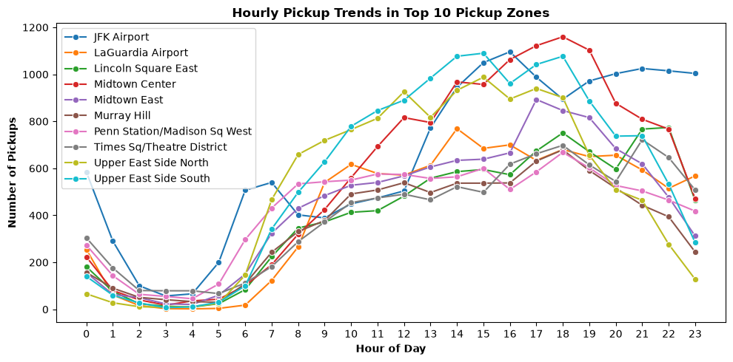
- The highest pickup zones were JFK Airport (15,326), Upper East Side South (13,769), Midtown Center (13,637), Upper East Side North (12,153), Midtown East (10,589), Penn Station/Madison Sq West (10,193), LaGuardia Airport (10,116), Lincoln Square East (9,678), Times Sq/Theatre District (9,656), and Murray Hill (8,608).
Figure 19 : Pickup Trends in Top 10 Pickup Zones
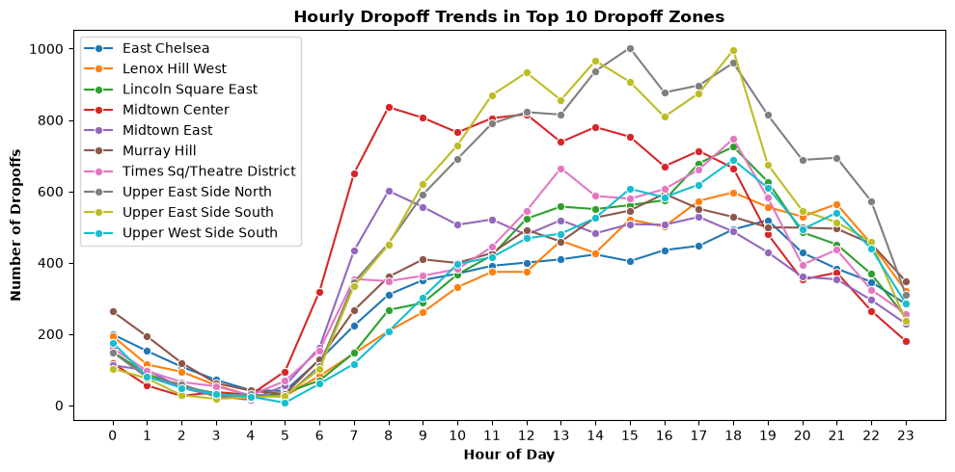
- The highest drop-off zones were Upper East Side North (12,734), Upper East Side South (12,150), Midtown Center (11,325), Times Sq/Theatre District (8,898), Murray Hill (8,687), Midtown East (8,308), Lincoln Square East (8,283), Upper West Side South (8,202), Lenox Hill West (7,788), and East Chelsea (7,354).
Figure 20 : DropOff Trends in Top 10 DropOff Zones

    - Find the ratio of pickups and dropoffs in each zone
The merged zone data was grouped by zone, and the total number of pickups and drop-offs from each zone was calculated using the sampled data
Pickup/drop-off imbalance was especially pronounced at East Elmhurst (8.07), JFK Airport (4.41), LaGuardia Airport (2.89), and Penn Station/Madison Sq West (1.57). Several low-volume zones had zero pickups and therefore a ratio of zero. These ratios can be used to identify zones where vehicles may need repositioning after completing trips.
    - Identify the top zones with high traffic during night hours
Night hour is considered between 23:00–05:00,
- During this time the leading pickup zones were East Village (2,442), JFK Airport (2,101), West Village (2,020), Clinton East (1,542), Lower East Side (1,507), Greenwich Village South (1,403), Times Sq/Theatre District (1,226), Penn Station/Madison Sq West (998), East Chelsea (988), and Midtown South (988).
- Leading drop-off zones included East Village (1,372), Clinton East (1,030), Murray Hill (1,026), Gramercy (907), East Chelsea (856), Yorkville West (841), Lenox Hill West (805), West Village (781), Sutton Place/Turtle Bay North (696), and Midtown South (676).
- This information can be used for better positioning the cabs during night time
    - Find the revenue share for nighttime and daytime hours
Night hours (23:00–05:00) generated $953,708.35, compared with $7,434,940.07 during daytime hours (05:00–23:00), for total analyzed revenue of $8,388,648.42. The resulting revenue shares were 11.37% at night and 88.63% during the day.
    - For the different passenger counts, find the average fare per mile per passenger
- First, the fare per mile was calculated for each record as fare amount ÷ trip distance. The fare per mile per passenger was then calculated as fare per mile ÷ passenger count. Finally, the average fare per mile per passenger was obtained by grouping the records by passenger count and calculating the mean
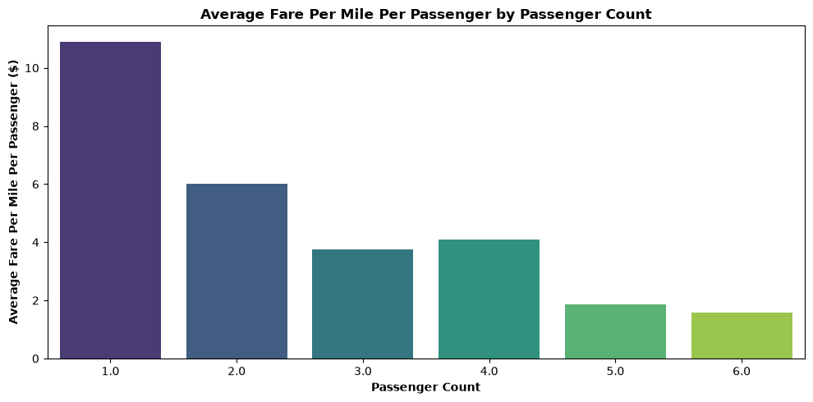
- Average fare per mile per passenger declined as passenger count increased: $10.91 for one passenger, $6.01 for two, $3.77 for three, $4.10 for four, $1.86 for five and $1.59 for six passengers. This reflects that the fare is not proportionally increased with the number of passengers
Figure 21 : Average Fare Per Mile Per Passenger

    - Find the average fare per mile by hours of the day and by days of the week
- Average fare per mile varied across hours, with relatively high sampled values in the early-morning and mid-afternoon periods and lower values around the morning/evening commute peaks.
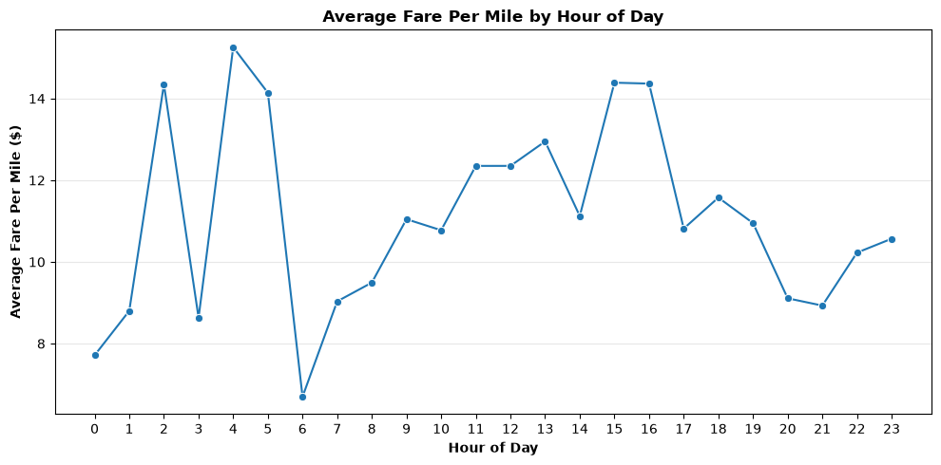
- By day, Friday had the highest average fare per mile at $12.30, followed by Sunday at $11.62; Monday was lowest at $10.56 in the output
Figure 22 : Average Fare Per Mile By Hour
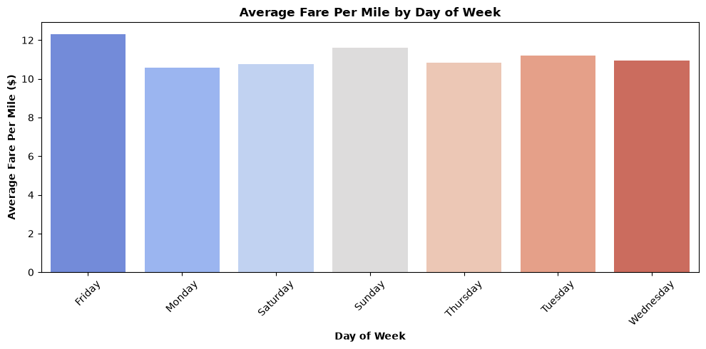
Figure 23 : Average Fare Per Mile By Day
    - Analyse the average fare per mile for the different vendors
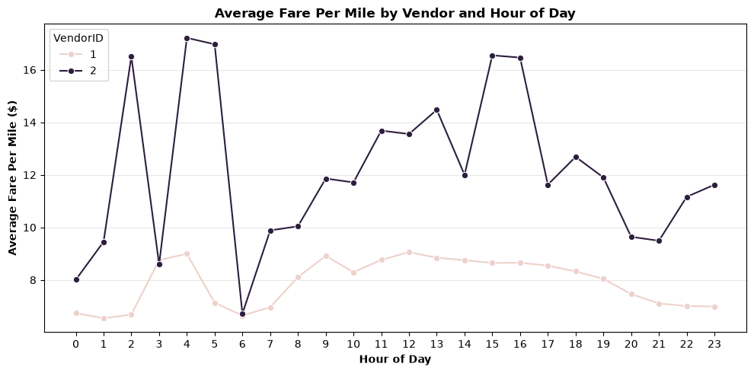
- The sampled data have two vendor with ID(1,2).
Vendor-level fare-per-mile patterns differed by hour. Vendor 2 generally showed higher average fare per mile than Vendor 1 in many hours, particularly during several low-volume early-morning periods. These differences should be interpreted together with the underlying trip mix and distance distribution rather than as a standalone measure of vendor performance
Figure 24 : Average Fare By Vendor and Hour

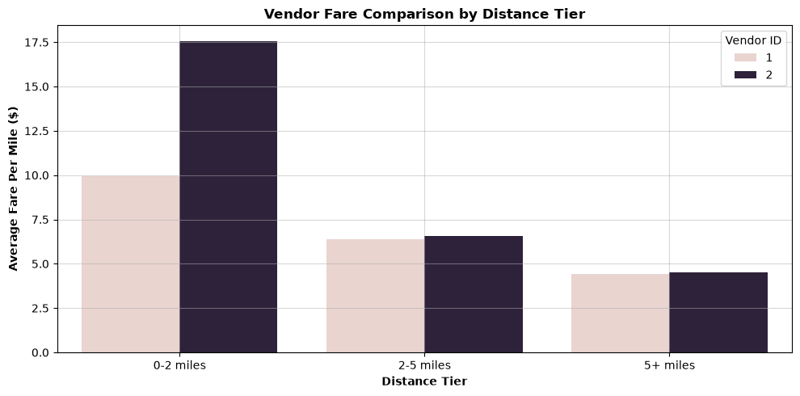
    - Compare the fare rates of different vendors in a distance-tiered fashion
Distance-tier analysis showed that average fare per mile declines as trip length increases for both vendors. For 0–2 miles, Vendor 1 averaged $9.94/mile and Vendor 2 $17.57/mile. For 2–5 miles the values were $6.39 and $6.56, respectively. For trips above 5 miles they were $4.41 and $4.51. The largest vendor difference therefore occurred for short trips.
Figure 25 : Vendor Fare Comparison

    - Analyse the tip percentages
Average tip percentage was about 12.08% for trips up to 18.7 miles, then declined for longer distance bands. By passenger count, averages were broadly around 10–12%, with the lowest observed average for four passengers (10.43%). Tip percentage also varied by pickup hour, reaching about 12.68% at 21:00 and falling to about 10.02% at 05:00. Low-tip trips (<10%) were more common at 18:00 and used cash more often, while high-tip trips (>25%) were more commonly observed around noon and used credit cards

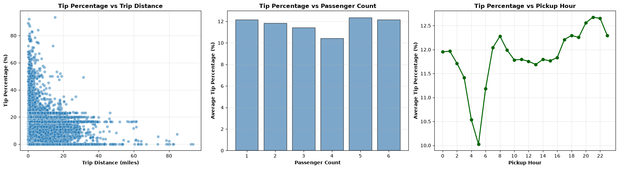
Figure 26 : Tip Percentage vs (Trip Distance, Passenger Count, Pickup Hour)
    - Analyse the trends in passenger count
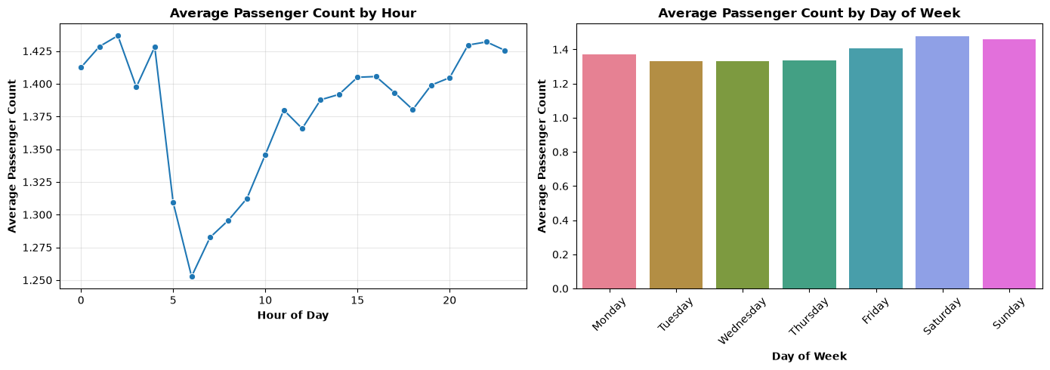
Average passenger count varied modestly by hour. The lowest hourly average was about 1.25 at 06:00, while late-night hours were around 1.41–1.43. By day, Saturday had the highest average passenger count (1.48), followed by Sunday (1.46), while Tuesday and Wednesday were about 1.33. This suggests passenger occupancy is higher on weekends even though total trip demand is lower
Figure 27 : Average Passenger Count By Hour and Day

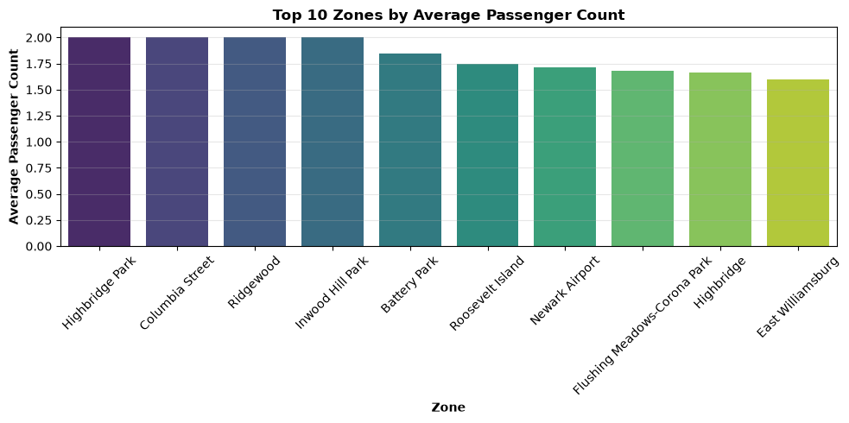
    - Analyse the variation of passenger counts across zones
Average passenger count was calculated for each pickup zone and combined with trip volume. The highest average passenger counts were found in several low-volume zones, including Columbia Street, Highbridge Park, Inwood Hill Park and Ridgewood at 2.0 passengers per trip. Battery Park also had a relatively high average of 1.85 across 136 trips
Figure 28 : Top !0 Zones Based On Avg Passenger Count

    - Analyse the pickup/dropoff zones or times when extra charges are applied more frequently.
Extra-charge was calculated for extra, mta_tax, tolls_amount, improvement_surcharge, congestion_surcharge, and airport_fee by identifying trips where each charge was greater than zero. MTA tax was present in 99.07% of trips, improvement surcharge in 99.97%, congestion surcharge in 92.46%, and airport fee in 8.75%. Congestion-surcharge frequency was highest around 18:00 and 02:00, while airport-fee frequency was particularly high around 05:00–06:00 and 23:00. Several Manhattan zones, including Battery Park, Brooklyn Navy Yard, Lenox Hill West, Upper East Side South, and Sutton Place/Turtle Bay North, recorded congestion-surcharge rates above 99%.
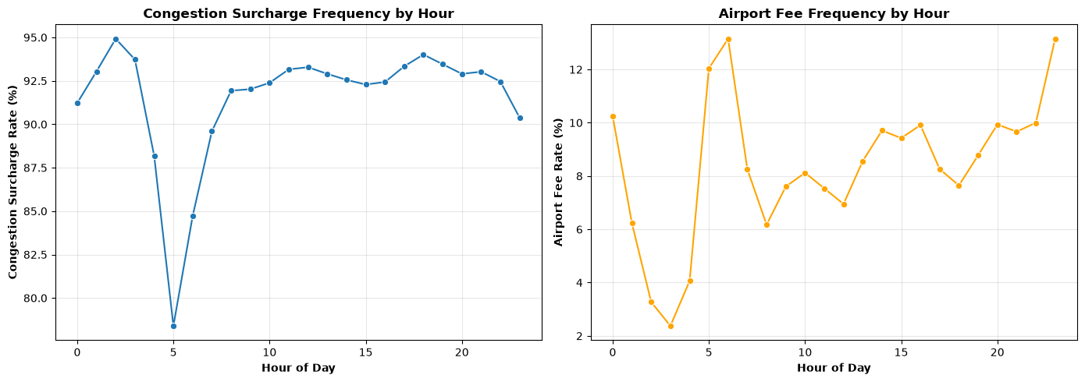
Figure 29 : Extra Charge Frequency

Conclusions

Final Insights and Recommendations
    - Recommendations to optimize routing and dispatching based on demand patterns and operational inefficiencies.
- Peak Hours: 4 PM - 9 PM
  - Increase the fleet by 30-35% during peak hours.
  - Keep more vehicles in Manhattan CBD and major transportation hubs.
  - The busiest time is around 6 PM, with about 20,614 pickups.
  - Start predicting demand about 2 hours before the peak.
  - Manage driver shifts so enough drivers are available during busy periods.
  - Reduce customer wait time using the above metrics.
- Off-Peak Hours: 10 AM - 4 PM and Early Morning
  - Use fewer vehicles when demand is low.
  - Keep only about 10-15% of the fleet available during very low-demand periods.
  - Schedule maintenance or driver breaks during this period to improve operational efficiency.
- Weekday vs Weekend
Weekdays:
- Weekdays have about 20-25% higher demand than weekends.
- Thursday has high demand, with about 45,546 pickups.
- During the morning (6 AM - 9 AM), keep about 50% of vehicles near residential and business areas.
- During the evening (4 PM - 7 PM), move more vehicles toward the CBD and business areas.
Weekends:
- Keep more taxis near entertainment and shopping areas.
- Route Optimization
  - Identify routes where the average speed is low during peak hours.
  - For each route, identify 2-3 alternative routes.
- Zone-Based Dispatching
High Pickup Areas:
- JFK Airport - 15,326 pickups (highest volume)
- Penn Station/Madison Square West - 10,193 pickups
- Grand Central Terminal - Major transit hub with consistent demand
- Manhattan CBD - Concentrated business and commercial activities
High Drop-Off Areas:
- Manhattan CBD - Primary destination for morning commutes
- Penn Station/Grand Central - Major transit connection points
- Airports (JFK, LaGuardia, Newark) - Destinations for long-distance trips
- Upper East/West Side - Residential areas receiving evening drop-offs
- Keep more fleet in high-demand areas.
- Move vehicles to zones where there are more pickups than drop-offs.

    - Suggestions on strategically positioning cabs across different zones to make best use of insights uncovered by analysing trip trends across time, days and months.

- High-Demand Zones
  - Key high-demand areas include Manhattan CBD, JFK Airport, Penn Station, and Grand Central.
  - Keep most of the fleet in these areas during peak hours, especially 7-9 AM and 5-7 PM.
  - Focus on areas with high customer demand and high-value trips.
  - Expected results: reduce customer wait time, increase vehicle utilization, and increase average fare and trip volume.
- Outer Boroughs: Queens and Brooklyn
  - Allocate about 30-35% of the fleet to these areas.
  - Keep vehicles available throughout the day and move more vehicles to high-demand areas during the 5-7 PM peak.
  - Demand may be more stable due to lower competition from other services.
- Airport Zones
  - Key airport zones include JFK, LaGuardia, and Newark.
  - Allocate around 10-15% of the fleet to airport trips.
  - Since airport trips are generally longer and higher-value but less frequent, pre-arrange drivers to reduce vehicle waiting time.
- Time-Based Fleet Positioning
  - Morning (6-9 AM): Keep about 50% of the fleet near residential areas, train stations, and transit stations to serve work commuters.
  - Midday (10 AM-3 PM): Spread vehicles across the CBD and other service areas, using around 20% of the baseline fleet.
  - Evening (4-7 PM): Increase fleet presence in the CBD, airport connections, and other high-demand areas, keeping around 45% of the fleet there.
  - Night (8 PM-5 AM): Use a smaller fleet focused on entertainment, bars, and nightlife areas while keeping vehicles ready for demand increases.
- Pickup and Drop-Off Ratio
  - Use the pickup-to-drop-off ratio to determine where vehicles should be repositioned.
  - High-pickup areas such as JFK Airport, Penn Station/Madison Sq West, Grand Central Terminal, and Times Square/Port Authority require more vehicles and may use driver incentives when supply is low.
  - High drop-off areas such as Manhattan CBD, Upper East/West Side, Penn Station/Grand Central, and airports should have sufficient vehicles for subsequent trips.
  - Reposition empty vehicles to nearby high-demand areas and use time-of-day patterns for pre-positioning.

    - Propose data-driven adjustments to the pricing strategy to maximize revenue while maintaining competitive rates with other vendors.

- Peak Hours: 7-9 AM and 5-7 PM
  - Trip distance and fare have a strong positive relationship, with a correlation of 0.95.
  - Demand is higher during peak hours, so use surge pricing, particularly for longer trips.
- Off-Peak Hours: 10 AM-3 PM
  - Reduce base fares by around 5-10% to attract price-sensitive customers.
  - Lower prices can help increase trip volume during periods of lower demand.
- Night Hours: 11 PM-5 AM
  - Consider 10-20% higher pricing during night hours.
  - Although night trips contribute only about 23.5% of total revenue, lower vehicle availability and competition may support higher prices.
- Zone-Based Pricing
  - High-demand zones such as JFK Airport, Penn Station, Grand Central, and Manhattan CBD can have higher surcharges to balance high demand and limited vehicle supply.
  - Medium-demand areas such as Queens and Brooklyn can receive small discounts during off-peak hours and moderate premiums during peak hours.
- Distance-Based Pricing
  - Use higher pricing for short trips, standard pricing for medium trips, and a lower per-mile rate for longer trips to encourage long-distance bookings.
- Passenger Count Pricing
  - Passenger count has very little relationship with fare, with a correlation of only 0.04.
  - Introduce a fixed surcharge for additional passengers to generate extra revenue without significantly increasing the base fare.
- Payment Method Strategy
  - Credit cards are the most common payment method.
  - A 5% cash-payment discount could be used to encourage cash usage.
  - Since trip distance and tips have a positive correlation of 0.59, encourage card payments for longer trips where tipping may be higher.
- Vendor-Based Optimization
  - Compare fares across vendors for different trip-distance ranges.
  - Give better-performing vendors favorable commission rates and match high-revenue trips with the best vendor and vehicle combinations using historical data.

