**i-SHOP**

**(Smart Shopping)**

**Abstract:**

Existing system of shopping where normally customer need to physically go to the retail shop and buy the products that customers want. Online shopping is an easy and comfortable way of shopping from a large range of products at home. It understands customer buying habits and traits to predict future trends.

**Existing System:**

Existing system of shopping where normally customer need to physically go to the retail shop and buy the products that customers want.

* Customer needs to visit the retail store physically.
* Enquire for products availability.
* Have to wait in the queue if have lot of customers.
* Search for product in the store physically.
* Need to make a purchase requisition.

**Draw Backs:**

* Customer needs to allocated time physically to visit the store.
* Unable to find products easily.
* Unable to filter products by price range.
* Wait for billing.

**Proposed System:**

Online shopping is an easy and comfortable way of shopping from a large range of products. It allows Customer to view, search and buy products from home using internet.

**Advantage of proposed system:**

* **Time saving**
* **Price range compare**
* **Reviews of items available**
* **Large variety of products**
* **Easily payment method**
* **Need not stand on queue**
* **Home delivery**

**Modules and their role:**

This smart shopping model is divided into 9 modules

* Registration Module

The Registration Module which allows users and customers to register

* Products Browse Module

the customers easy access to search the website for their preferred products

* Products Search Module
* The Shopping cart Module

Which has multiple currency capability to allow customers to use the website in their preferred currency.

* Shipping and Billing Module

**which allows the vendor to control the amount of shipping charges.**

* Payment

The Payment Module allows the customer many methods to make payments.

* Admin User Management
* Admin Catalos Management
* Admin Order Management Module

the admin of i-shop model to manage, control and monitor the overall website in a seamless manner.

State transition Diagram

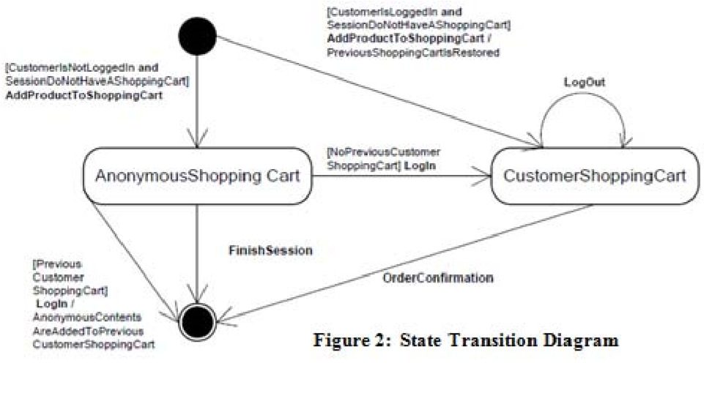

System Configuration:

Hardware Configuration:

|  |  |  |
| --- | --- | --- |
| Serial no | Hardware | Configuration |
| 1 | Operating System | Window 7 and above |
| 2 | RAM | 2GB |
| 3 | Processor speed | Intel |
| 4 |  |  |
| 5 |  |  |

Software Configuration

|  |  |  |
| --- | --- | --- |
| Serial No | Software | Configuration |
| 1 | Mark Up Language | HTML |
| 2 | Style Sheet | CSS,Bootstrap |
| 3 | Client SIde | JavaScript, jquery and angular |
| 4 | Server Side | Node Js |
| 5 | Data Base | Mongo DB |
| 6 | Middleware | Express |
| 7 | CMS[IDE] | Visual Studio Code |
| 8 | Web Server | IIS |
| 9 | Browser | Chrome, Safari, Edge and Internet Explorer |

Project request Flow Diagram: