GIT-GITHUB TASK-2
1.Install Git
Step 1: Download Git
a. Open your web browser.
b. Go to the official Git website:
https://git-scm.com/install/windows
c. Click Download for Windows.
Step 2: Run the Installer
a. Double-click the downloaded .exe file.
b. Click Yes if prompted
Step 3: Open Git Bash
Verify git installation: $ git –version
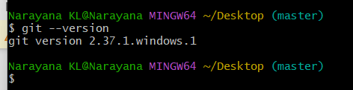
2.Create a repo in github with README.md and .ignore file.
A. The purpose of creating a GitHub repository with a
README.md and .gitignore file is to organize the project,
provide project information, and prevent unwanted files from
being tracked by Git.
Step 1: Sign in to GitHub
a. Open your web browser.
b. Go to https://github.com
c. Sign in with your GitHub account.
Step 2: Create a New Repository
a. Click the + icon in the top-right corner.
b. Select New repository.
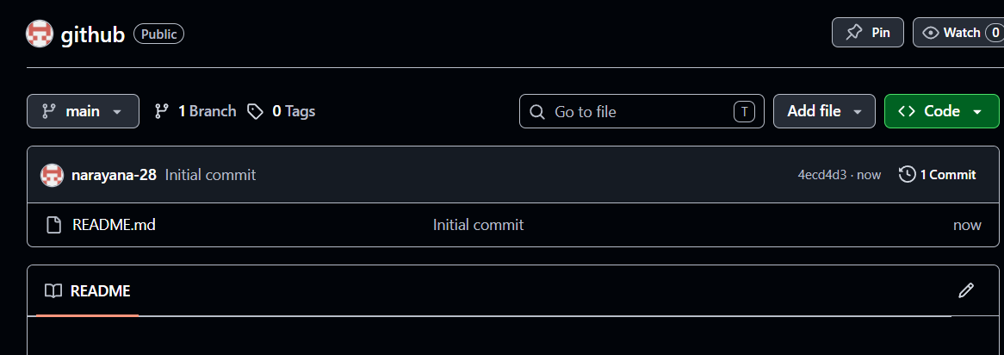
3.Clone the created repo to local.
The purpose of cloning a repository is to create a
complete local copy of the GitHub repository, including all
files, folders, branches, and commit history, so you can work on
the project locally.
Step 1: Navigate to the Destination Folder
Move to the folder where you want to store the repository
Step 2: Clone the Repository
Run the following command:
$ git clone git@github.com:narayana-28/github.git
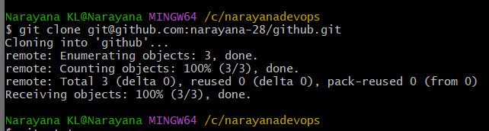

4.Create two files in local repo
Using touch command we can create two files
$ touch devops1.txt devops2.txt
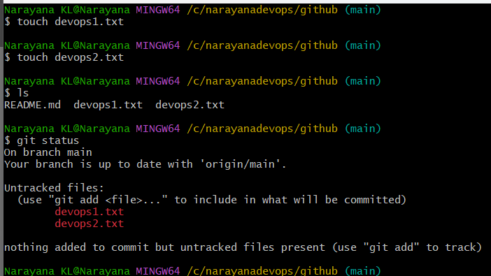
5.Commit two files and push to central Repository.
Step 1: After creating two files, Check the status for untracking
files
$ git status

Step 2: Add the files to tracking files using command
$ git add .

Step 3: Commit the files
$ git commit -m “Added devops files”
Step 4: push the files into github repository
$ git push -u origin main
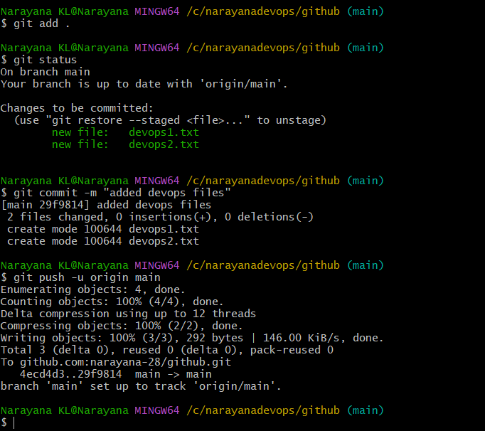

6. Create a branch in local and create a sample file and push to
central.
Step1: create a new branch
$ git branch feature1
$ git branch –list
Step2: Switch current branch new branch
$ git checkout feature1
Expected o/p: Switched to branch ‘feature1’
Step3: Create a sample1 file
$ touch sample
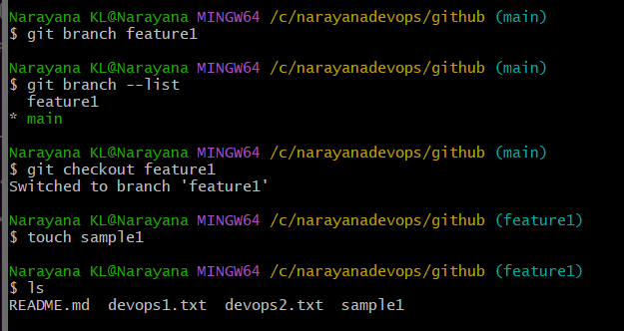
Step4: Check the Untracking files
$ git status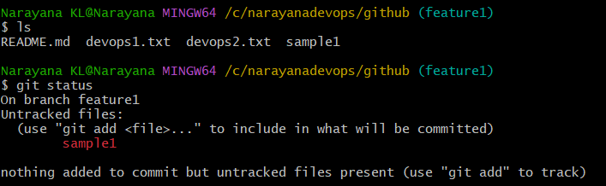
$ git add .
Step5: Commit the file
$ git commit -m “add sample file”
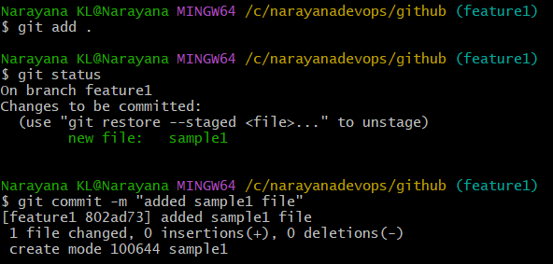
Step6: push into github repo
$ git push -u origin feature
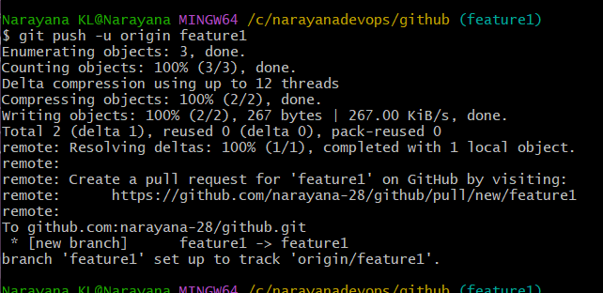
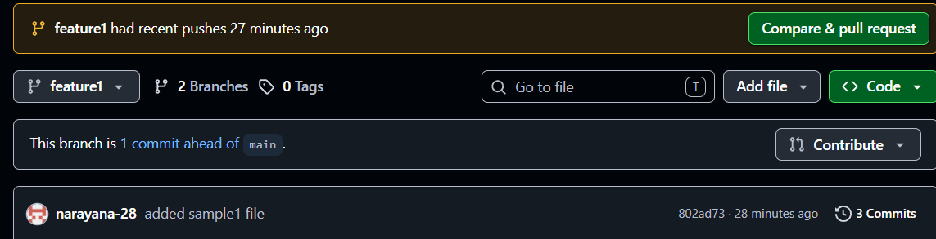

7. Create a branch in github and clone that to local.
Step 1: Create a New Branch
1. Click the Branch drop-down in github(it usually shows
main).
2. Type the new branch name.
Ex. hotfix1
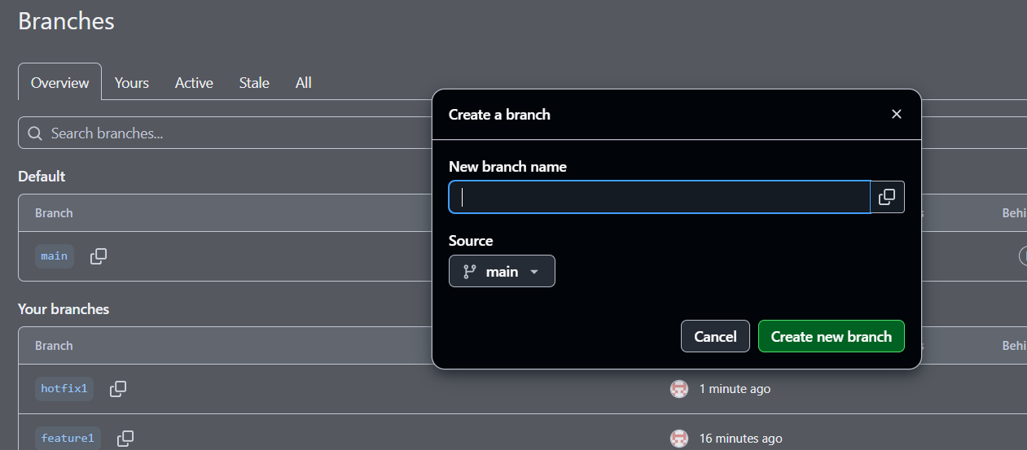
Step2: Clone into gitbash
$ git clone git@github.com:narayana-28/github.git
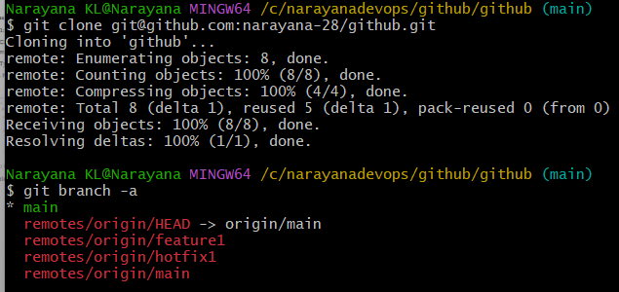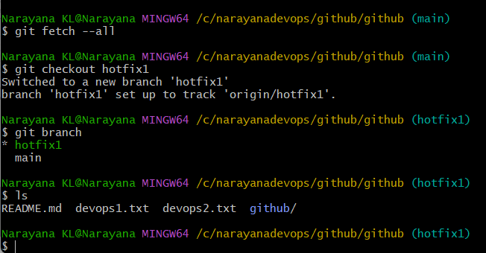
8. Merge the created branch with master in git local.
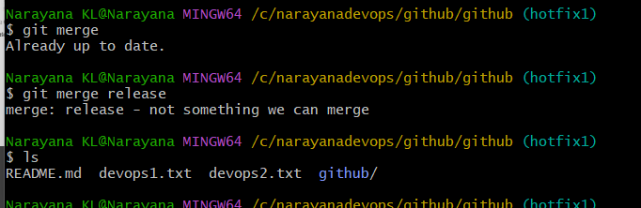
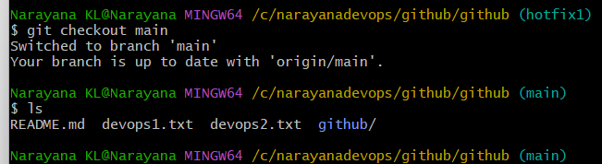
9. Merge the created branch with main in github by sending a
pull request.
Step 1: Check your current branch
git branch

Step 2: Switch to main
git checkout main

Step 3: Update main
Always pull the latest changes before merging.
git pull origin main

Step 4: Merge feature2
git merge feature2
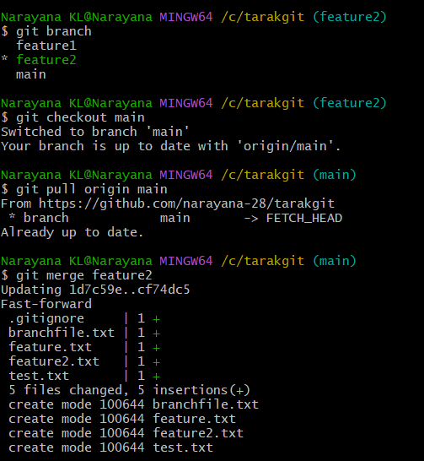
Step 5: Verify the merge
git log --oneline --graph --all
Example:
* 7f7f720 Added feature2.txt
* 4c7d1d2 Initial commit
Step 6: Push main
git push origin main
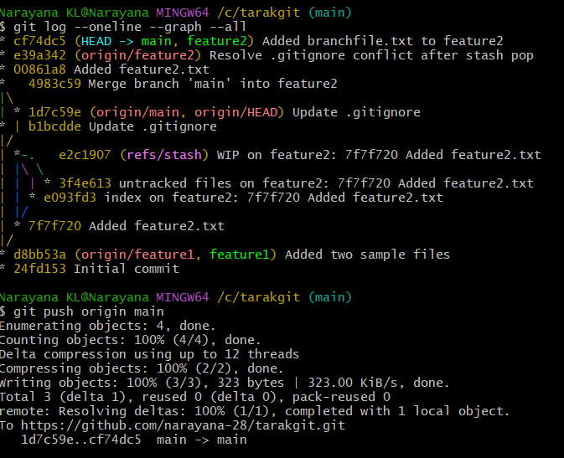
Now the remote main branch contains the merged changes.
10. Create a file in local and send that to a branch in GitHub
Switch to the branch.
git checkout feature2
Create file.
echo "Hello Git" > demo.txt
Add
git add demo.txt or git add .
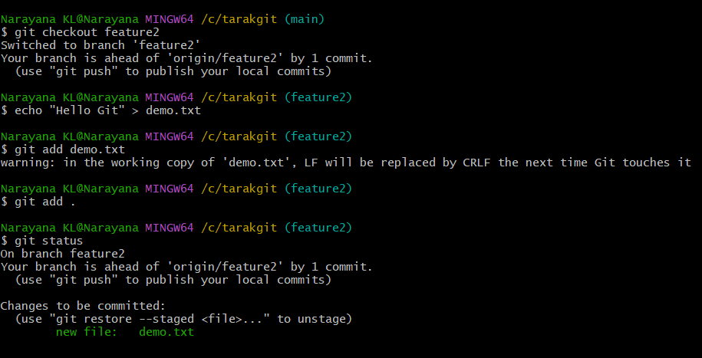
Commit
git commit -m "Added demo.txt"
Push
git push origin feature2
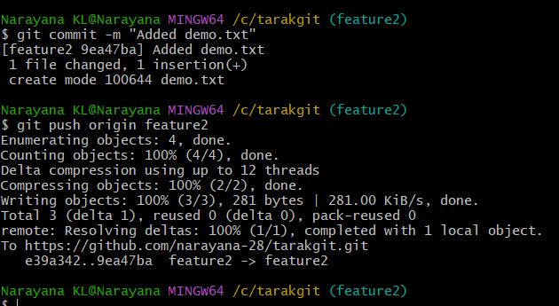

11. Clone only one branch from GitHub
git clone --branch feature2 --single-branch https://github.com/USERNAME/REPOSITORY.git
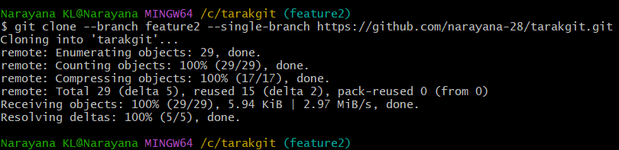
12. Create a password file and make Git ignore it
Create the file.
touch passwords.txt
Open .gitignore
vi .gitignore
Add
passwords.txt
Save.
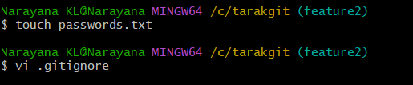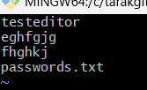
Verify :git status
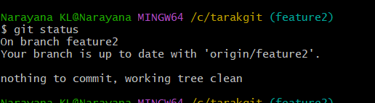
passwords.txt should not appear.

13. Make a commit and reset it without losing changes
Create file.
echo "Testing reset" > reset.txt
git add reset.txt
git commit -m "Testing reset"
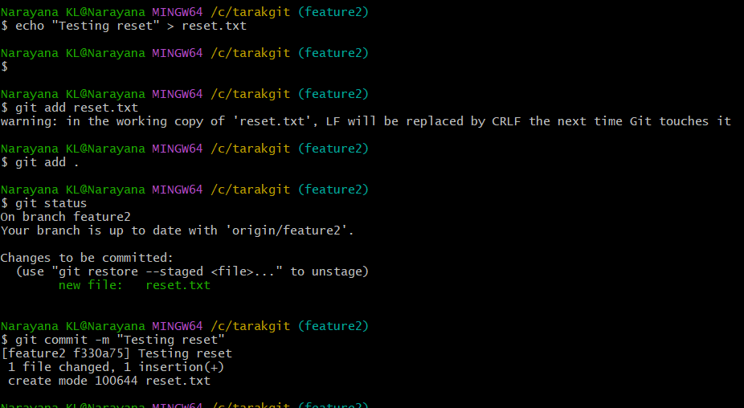
Undo commit but keep changes.
git reset --soft HEAD~1
To keep changes unstaged:
git reset HEAD~1
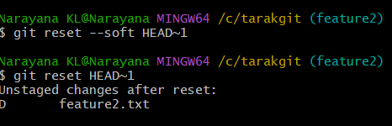
14. Revert a committed commit
See commit history.
git log --oneline
Example
a123456 Added demo
Revert
git revert a123456
Push
git push origin main
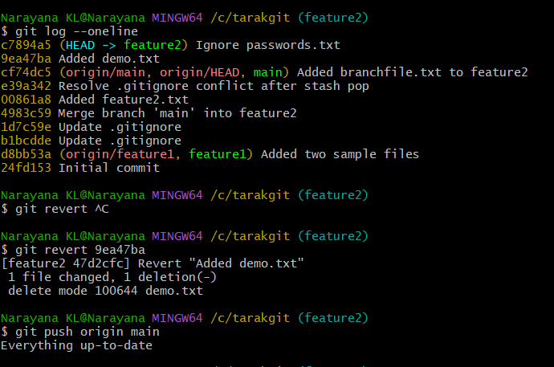
15. Stash changes and work on another file
Modify a file.
Check status.
git status
Stash changes.
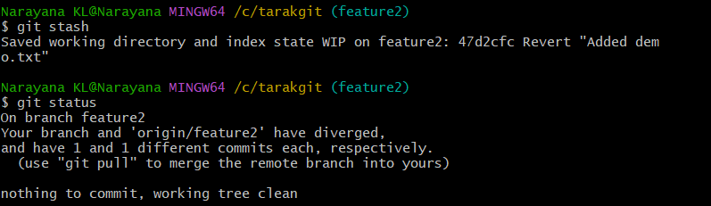
git stash
Now work on another file.
echo "New work" > another.txt
Commit normally.
git add .
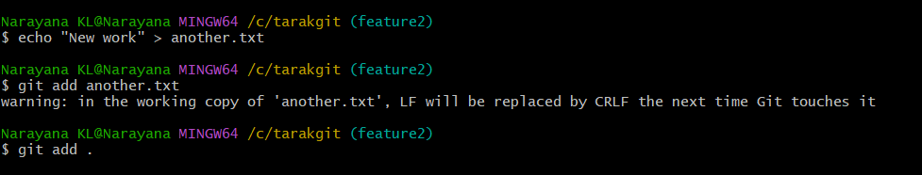
git commit -m "Added another file"
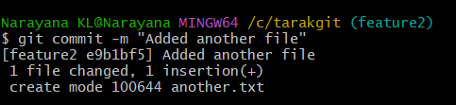
16. Restore stashed changes
View stash list.
git stash list
Restore :git stash pop
or git stash apply
Continue editing the restored files.
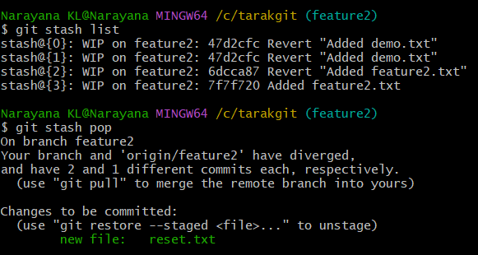
17. Generate SSH key and configure GitHub
Generate SSH key.
ssh-keygen -t ed25519 -C "your-email@example.com"
Press Enter for all prompts.
Start SSH agent.
eval "$(ssh-agent -s)"
Add key.
ssh-add ~/.ssh/id_ed25519
View public key.
cat ~/.ssh/id_ed25519.pub
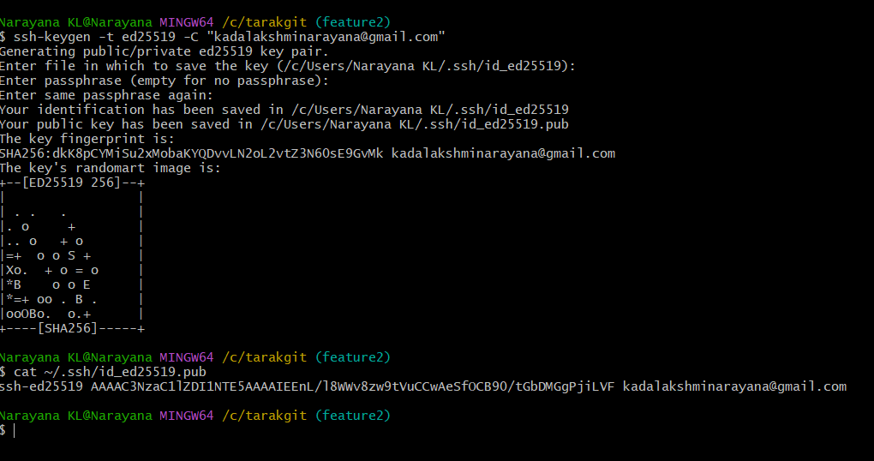
Copy it.
GitHub:
- Settings
- SSH and GPG Keys
- New SSH Key
- Paste key
- Save
Test.
ssh -T git@github.com
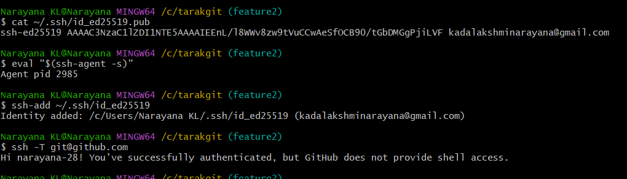

18. Configure GitHub Webhooks
- Open your repository.
- Go to Settings.
- Click Webhooks.
- Click Add webhook.
- Payload URL:
http://your-server:8080/github-webhook/
- Content type:
application/json
- Choose:Just the push event
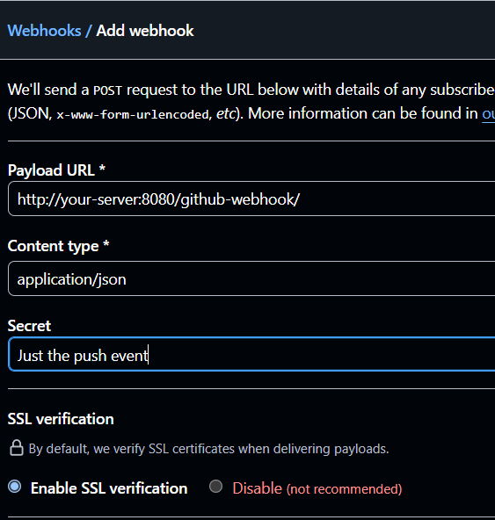

- Click Add webhook.
Used mainly for Jenkins CI/CD.
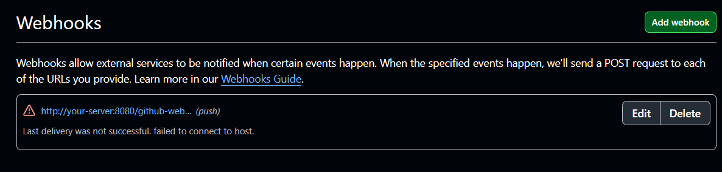

19. Basic understanding of the .git directory
The hidden .git folder stores the repository metadata.
Important contents:
.git/
├── HEAD -> Current branch
├── config -> Repository configuration
├── objects/ -> Git objects (commits, trees, blobs)
├── refs/ -> Branches and tags
├── logs/ -> Reflog history
├── index -> Staging area
├── hooks/ -> Client-side hook scripts
├── packed-refs -> Packed references
└── COMMIT_EDITMSG -> Last commit message
To view:
ls -la .git
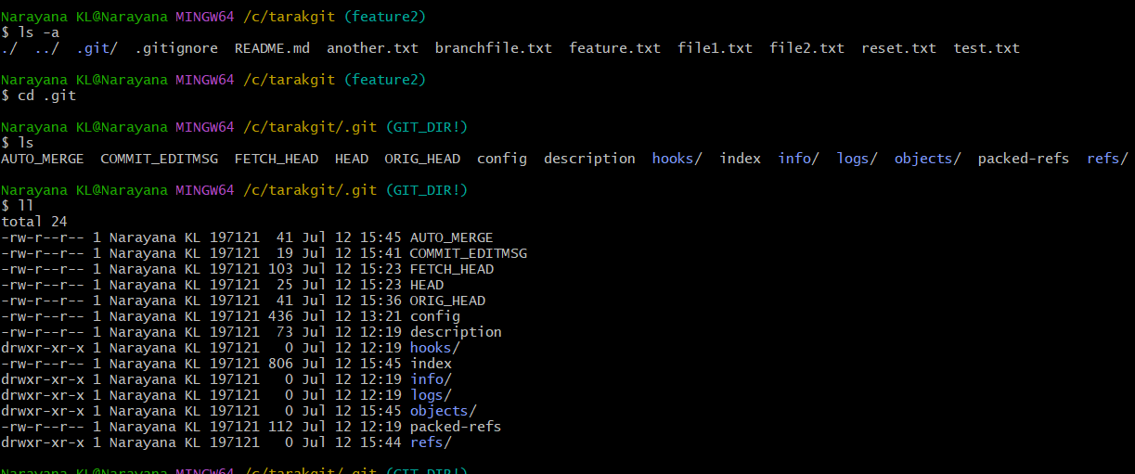
20. Check all Git logs
Normal log.
git log
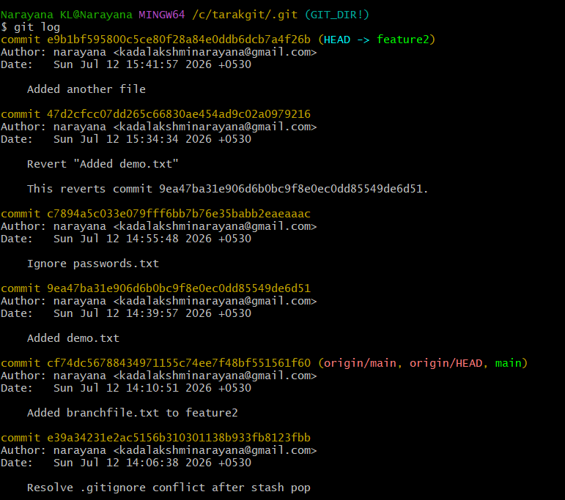
One line.
git log –oneline
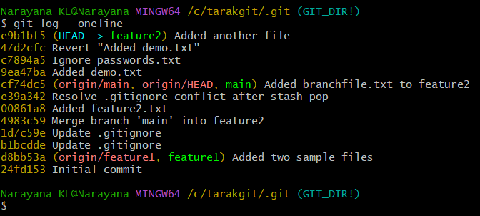
Graph.
git log –graph
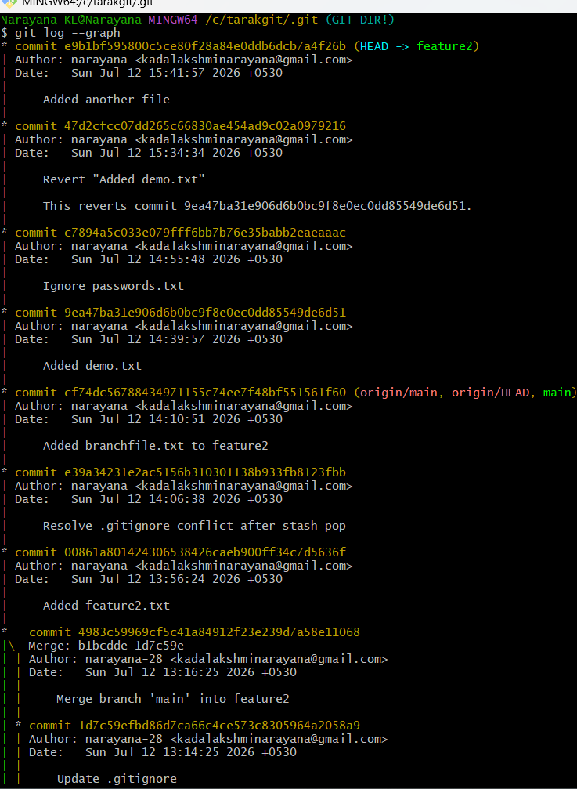
Graph with all branches.
git log --graph --oneline –all

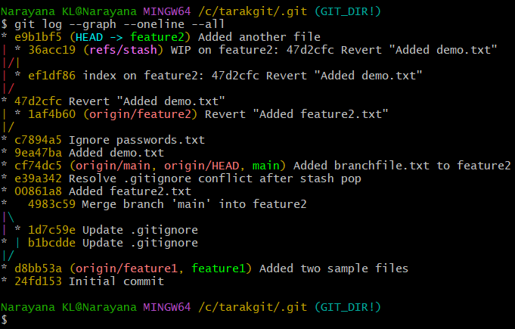
Show changes.
git log -p
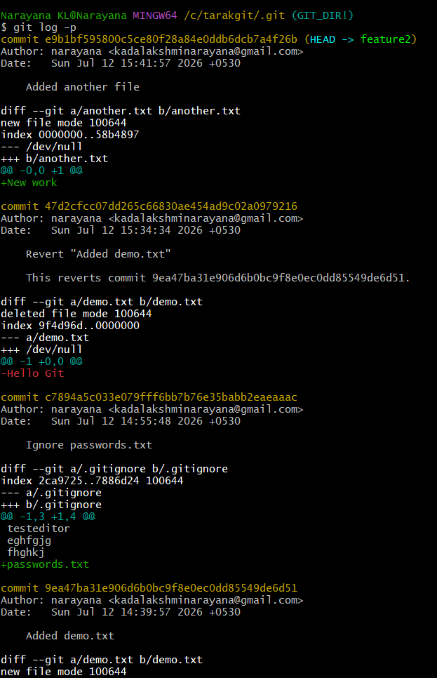
Reflog.
git reflog

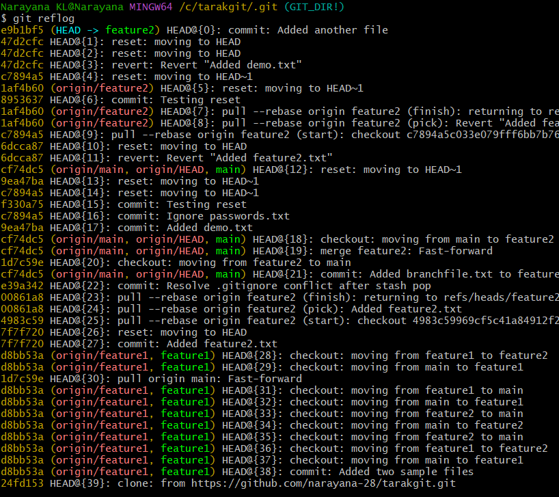

21. Rename the last commit message
If not pushed:
git commit --amend -m "New Commit Message"
If already pushed:
git push --force
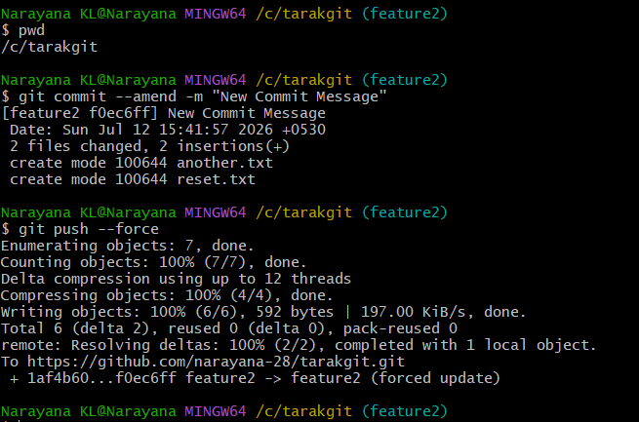
22. Merge multiple commits into one (Squash)
Suppose the last 3 commits need to become one.
git rebase -i HEAD~3
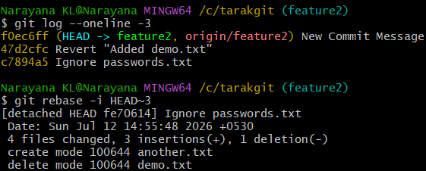
Editor opens:
pick c7894a5 Ignore passwords.txt
pick 47d2cfc Revert "Added demo.txt"
pick f0ec6ff New Commit Message
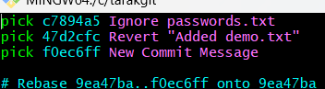

Change to:
pick c7894a5 Ignore passwords.txt
squash 47d2cfc Revert "Added demo.txt"
squash f0ec6ff New Commit Message
Save and exit.
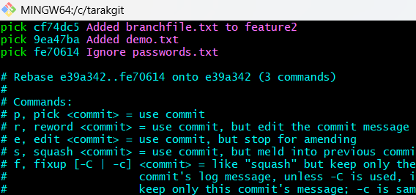
Enter a new combined commit message.
Push:
git push –force
