Kubernetes-02
Task 1 — Create a Simple Pod Using YAML
Objective
Create a Pod named firstpod with one nginx container.

Step 1 — Create the YAML file
In your Kubernetes working directory, create:
firstpod.yml
Put this content inside:
apiVersion: v1
kind: Pod
metadata: name: firstpod
spec: containers: - name: nginx
image: nginx
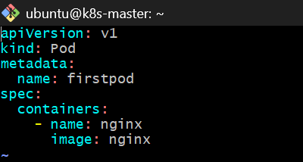
What each section means
apiVersion: v1
Uses the Kubernetes core API version.
kind: Pod
Tells Kubernetes that we want to create a Pod.
metadata: name: firstpod
The Pod's name will be: firstpod
spec:
containers: Defines the containers that will run inside the Pod.
- name: nginx
image: nginx
Creates one container named nginx using the nginx image.

Step 2 — Deploy the Pod
Run: kubectl apply -f firstpod.yml
Expected: pod/firstpod created
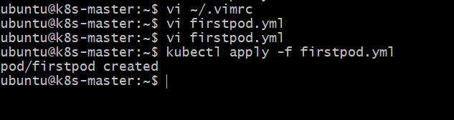
Step 3 — Verify the Pod
Run: kubectl get pods
You should see something similar to:
NAME READY STATUS RESTARTS AGE
firstpod 1/1 Running 0 10s
The important values are: READY 1/1
STATUS Running
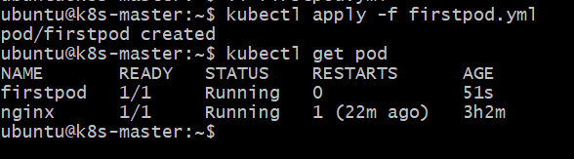Step 4 — Get more information
Run: kubectl get pod firstpod -o wide
This shows additional information such as:
- Pod IP
- Node
- Container status
Step 5 — Check the container logs
Run: kubectl logs firstpod
Because nginx is running in the foreground, you may see nginx startup-related output.
You can also use: kubectl logs firstpod -c nginx
Here -c nginx explicitly tells Kubernetes which container's logs to show.
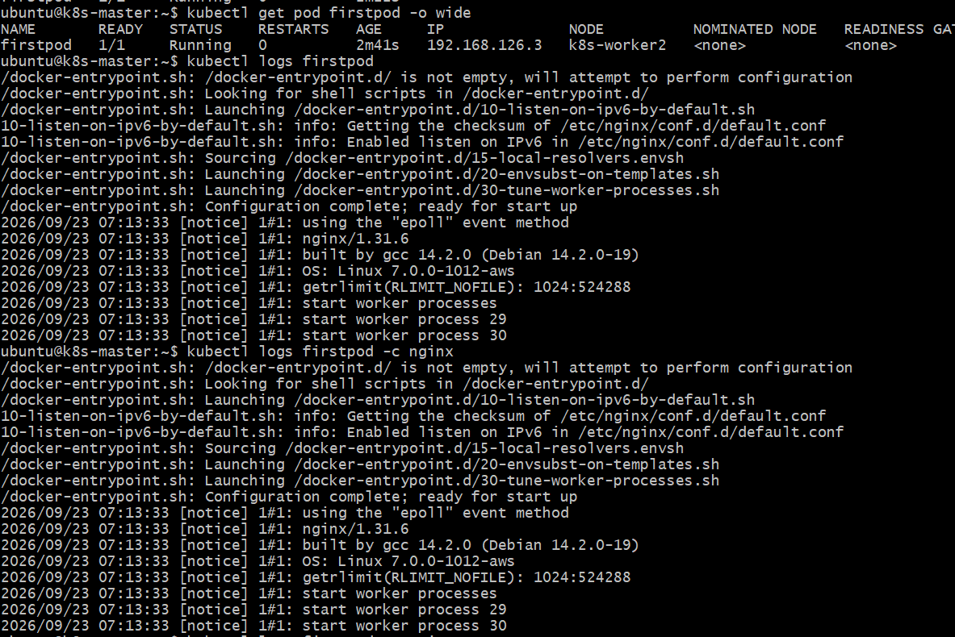Step 6 — Describe the Pod
Run: kubectl describe pod firstpod
Look at these sections:
Name:
Namespace:
Node:
Status:
IP:
Containers:
nginx:
Image:
State:
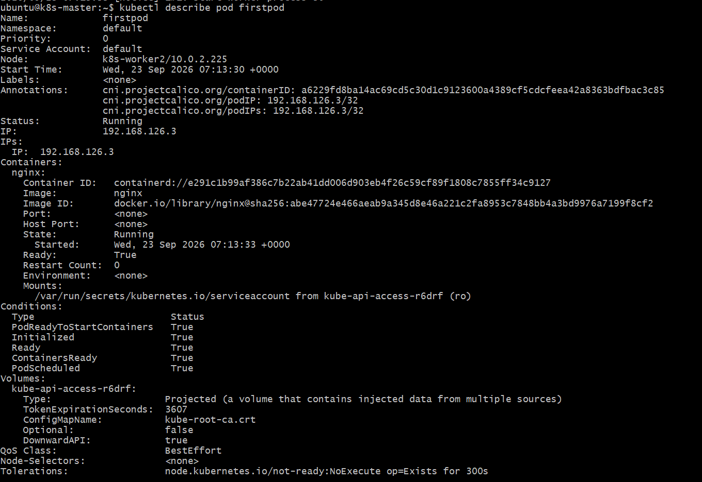
This is especially useful for troubleshooting.Step 7 — Verify the nginx container
You can enter the container with: kubectl exec -it firstpod -- /bin/bash
Inside the container: nginx -v
You should get an nginx version.
Exit: exitStep 8 — Final verification
Run: kubectl get pods
Expected: firstpod 1/1 Running
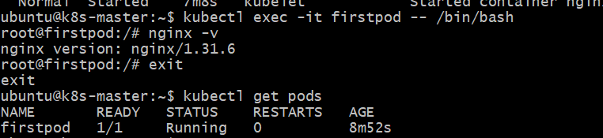
Task 1 is complete when you have successfully verified:
firstpod
|
└── nginx container
|
└── nginx image
Task 2 — Set Environment Variables in a Pod
Objective
Modify firstpod.yml so the nginx container has these environment variables:
myname=sabair
City=Hyderabad
Then verify them using: kubectl exec firstpod -- env
Step 1 — Edit firstpod.yml
Run: vi firstpod.yml
Change it to:
apiVersion: v1
kind: Pod
metadata:
name: firstpod
spec:
containers:
- name: nginx
image: nginx
env:
- name: myname
value: "Narayana"
- name: City
value: "Hyderabad"
Save and exit vi: :wq!
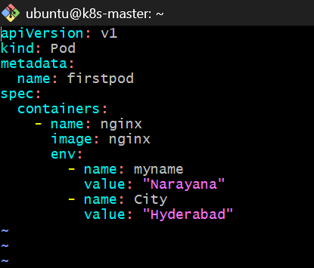Step 2 — Important: recreate the Pod
Because we're changing the Pod specification, the simplest approach for this lab is to delete and recreate it.
Run: kubectl delete pod firstpod
Expected: pod "firstpod" deleted
Then: kubectl apply -f firstpod.yml
Expected: pod/firstpod created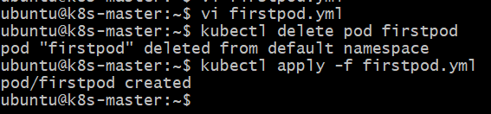Step 3 — Verify the Pod
kubectl get pods
Wait until you see:
firstpod 1/1 Running 0 ...
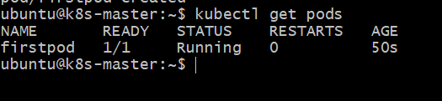Step 4 — Check the environment variables
Run: kubectl exec firstpod -- env
You should find: myname=Narayana
City=Hyderabad
You can also check them individually.
Check myname
kubectl exec firstpod -- printenv myname
Expected: Narayana
Check City
kubectl exec firstpod -- printenv City
Expected: Hyderabad
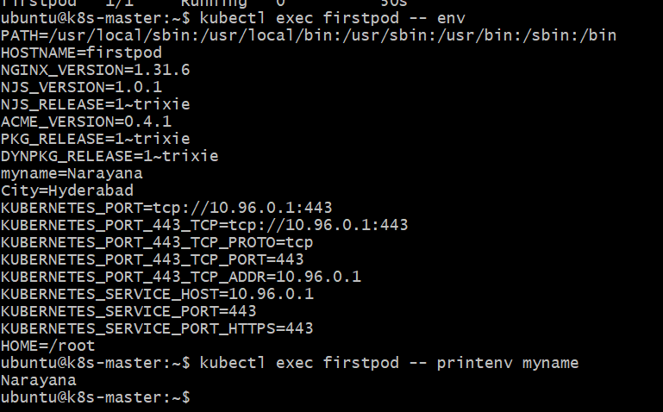Step 5 — Verify using describe
Run: kubectl describe pod firstpod
Under:
Containers:
nginx:
Environment:
you should see: myname: Narayana
City: Hyderabad
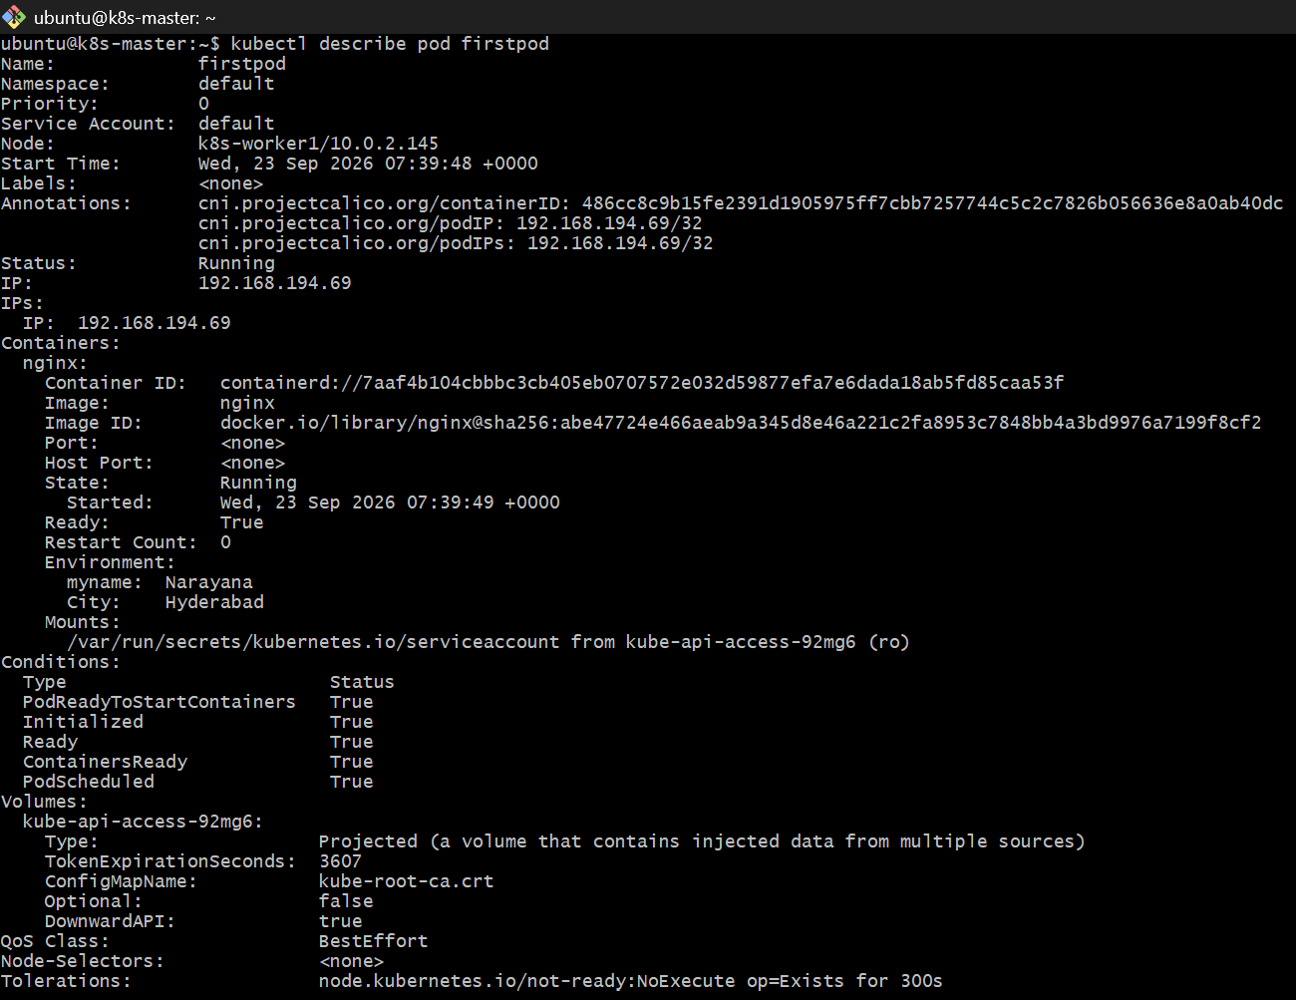
Task 3 — Deploy a Pod with Commands (Args)
Objective
Modify the YAML so the nginx container receives an argument that makes it sleep for 50 seconds.
For this task, we'll use:
command:
- sleep
args:
- "50"
This means the container runs:
sleep 50
instead of starting nginx.
Step 1 — Edit firstpod.yml
nano firstpod.yml
Use: apiVersion: v1
kind: Pod
metadata:name: firstpod
spec:
containers:
- name: nginx
image: nginx
command:
- sleep
args:
- "50"
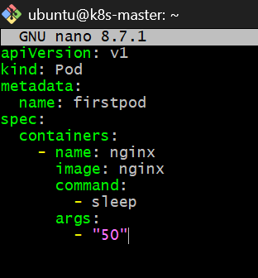
For Task 3, we are replacing the Task 2 environment-variable configuration with the command and args configuration.
Save:
Ctrl + O
Enter
Ctrl + X
Step 2 — Recreate the Pod
kubectl delete pod firstpod
Then: kubectl apply -f firstpod.yml
Check: kubectl get pod firstpod
You may see: firstpod 1/1 Running
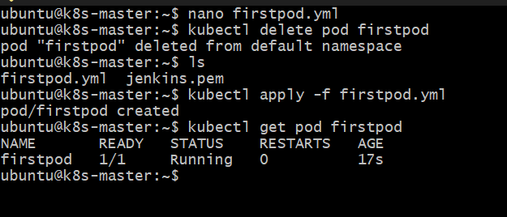
but only for about 50 seconds. After the sleep 50 finishes, the container exits and the Pod will restart because Pods normally use the Always restart policy.
Step 3 — Verify the command/args
Run while the container is running: kubectl describe pod firstpod
Look under:
Containers: nginx:
Command: sleep
Args: 50
This is the main verification required for Task 3.
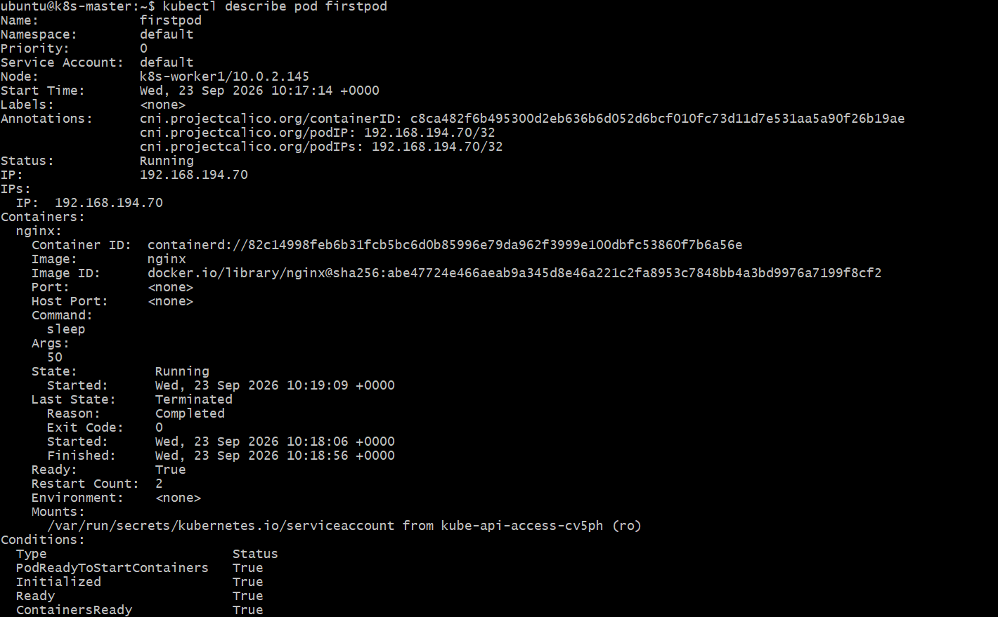
You can also run: kubectl get pod firstpod -o yaml
and look for: command: - sleep
args: - "50"
Important
Because sleep 50 finishes, don't worry if you eventually see:
STATUS CrashLoopBackOff
The important thing for this task is verifying that Kubernetes passed:
Command: sleep
Args: 50
correctly to the container.
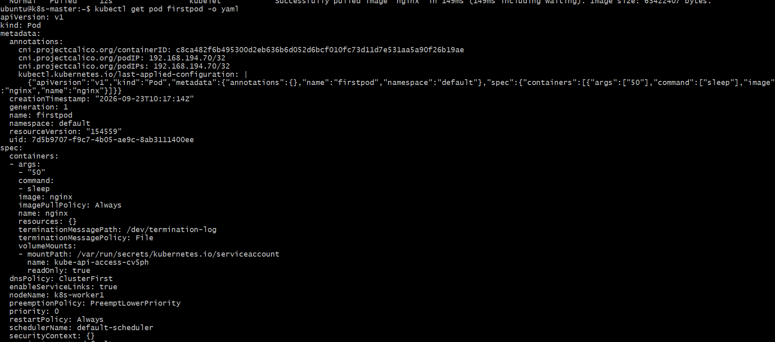
Task 4 — Create a Pod with Two Containers
Now we'll create one Pod containing two nginx containers.
The important Kubernetes concept is:
Containers inside the same Pod share the same network namespace and therefore share the same Pod IP.
We'll create:
firstpod
|
+--------+--------+
| |
nginx-container1 nginx-container2
| |
+------- same ----+
Network
Step 1 — Replace firstpod.yml
Edit: nano firstpod.yml
Use: apiVersion: v1
kind: Pod
metadata:
name: firstpod
spec:
containers:
- name: nginx1
image: nginx
- name: nginx2
image: nginx
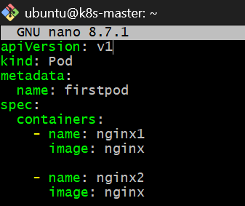
Save: Ctrl + O
Enter
Ctrl + X
Step 2 — Recreate the Pod
Because we're changing the number of containers, delete the existing Pod:
kubectl delete pod firstpod
Then: kubectl apply -f firstpod.yml
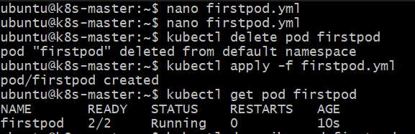
Step 3 — Verify both containers
Run: kubectl get pod firstpod
You should see:
NAME READY STATUS RESTARTS AGE
firstpod 2/2 Running 0 ...
The important part is:
2/2
That means both containers are ready.
Then: kubectl describe pod firstpod
You should see:
Containers:
nginx1:
Image: nginx
State: Running

nginx2:
Image: nginx
State: Running
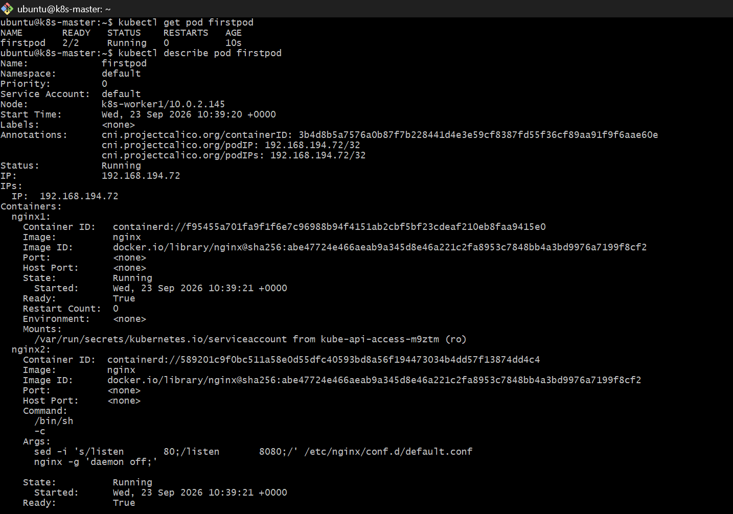
Step 4 — Verify both containers use the same Pod IP
Run: kubectl get pod firstpod -o wide
There will be one Pod IP, for example:
IP 192.168.x.x
Both containers use this same network namespace/IP.
Step 5 — Access each container
Enter the first container: kubectl exec -it firstpod -c nginx1 -- /bin/bash
Check: hostname
Then exit: exit
Enter the second: kubectl exec -it firstpod -c nginx2 -- /bin/bash
Check: hostname
Then: exit
Notice that both containers have the same hostname, because the hostname is based on the Pod.
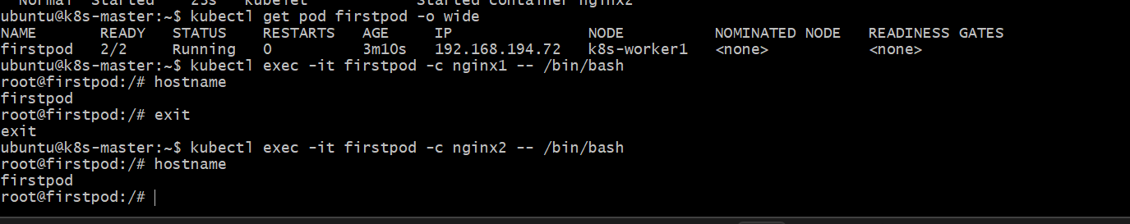
One important correction for the communication test
Your task specifically mentions using telnet between the containers. However, the standard nginx image does not necessarily contain the telnet client, so don't install anything yet.
Step5:Verify shared networking
1. Get the Pod IP
Run: kubectl get pod firstpod -o wide
You should see one Pod IP, for example:
NAME READY STATUS IP
firstpod 2/2 Running 192.168.x.x
That single IP belongs to the Pod, and both containers share it.

2. Check the IP from nginx1
kubectl exec firstpod -c nginx1 -- hostname -i
Example:
192.168.x.x
3. Check the IP from nginx2
kubectl exec firstpod -c nginx2 -- hostname -i
You should get the same IP:
192.168.x.x
That's our first verification:
firstpod
|
|-- nginx1 → 192.168.x.x
|
|-- nginx2 → 192.168.x.x

4. Verify communication through localhost
Because both containers share the same network namespace, nginx1's nginx process is listening on port 80 on the Pod's network namespace.
From nginx2, run:
kubectl exec firstpod -c nginx2 -- curl -I http://127.0.0.1
You should get something similar to:
HTTP/1.1 200 OK
Server: nginx/1.31.6
This is a strong demonstration of shared networking: nginx2 is reaching the nginx server running inside nginx1 through the shared network namespace
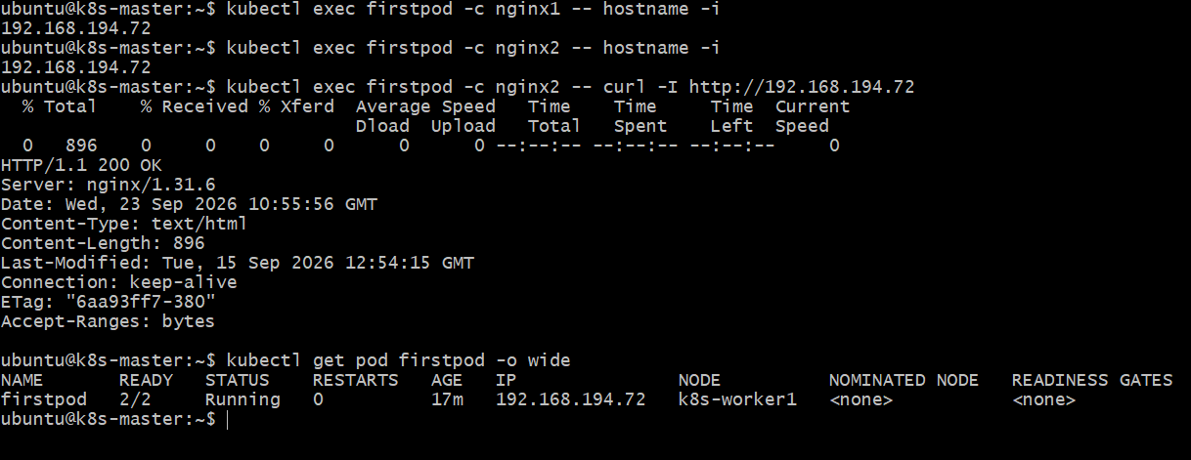
Task 5 — Set Up an Init Container
Objective
Add an init container that sleeps for 30 seconds before the main nginx containers start.
The execution order will be:
Init container
|
| sleep 30 seconds
↓
Init completes
|
↓
nginx1 + nginx2 start
Step 1 — Modify firstpod.yml
Run: nano firstpod.yml
Replace the contents with: apiVersion: v1
kind: Pod
metadata:
name: firstpod
spec:
initContainers:
- name: init-container
image: busybox
command:
- sh
- -c
- "echo Init container started; sleep 30; echo Init container completed"
containers:
- name: nginx1
image: nginx
ports:
- containerPort: 80
- name: nginx2
image: nginx
command:
- sh
- -c
- |
sed -i 's/listen 80;/listen 8080;/' /etc/nginx/conf.d/default.conf
nginx -g 'daemon off;'
ports:
- containerPort: 8080
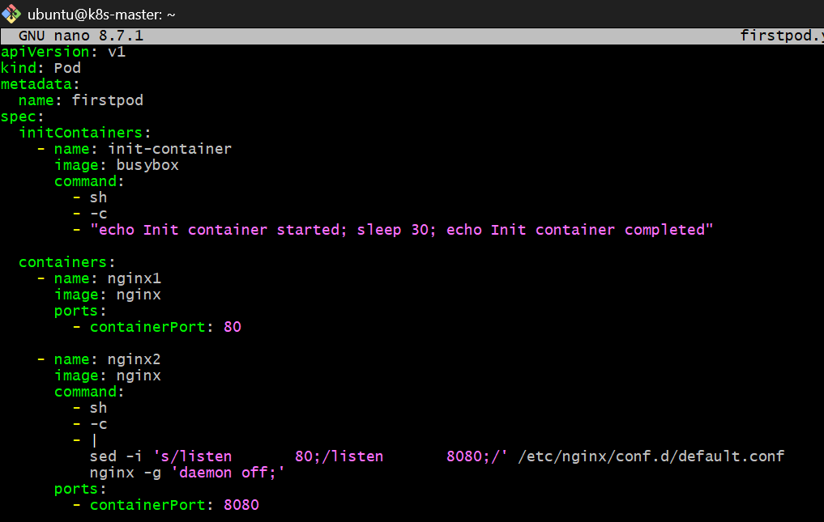
Save and exit: Ctrl + O
Enter
Ctrl + X
What we added
This section is the important part:
initContainers:
- name: init-container
image: busybox
command:
- sh
- -c
- "echo Init container started; sleep 30; echo Init container completed"
The init container:
- Starts.
- Prints Init container started.
- Sleeps for 30 seconds.
- Prints Init container completed.
- Exits successfully.
- Only then are nginx1 and nginx2 started.

Step 2 — Recreate the Pod
Delete the current Pod:
kubectl delete pod firstpod
Create the new one:
kubectl apply -f firstpod.yml
Immediately run:
kubectl get pod firstpod
During the 30-second initialization you may see:
firstpod 0/2 Init:0/1
This means:
0/2 = main containers are not ready yet
Init:0/1 = init container is still running
After approximately 30 seconds:
firstpod 2/2 Running
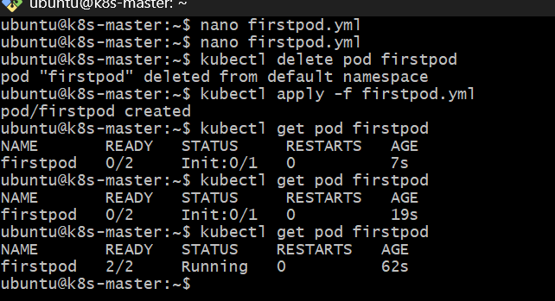Step 3 — Verify the init container
Run: kubectl describe pod firstpod
Look for: Init Containers:
init-container:
You should see:
State: Terminated
Reason: Completed
Exit Code: 0
That proves the init container completed successfully.
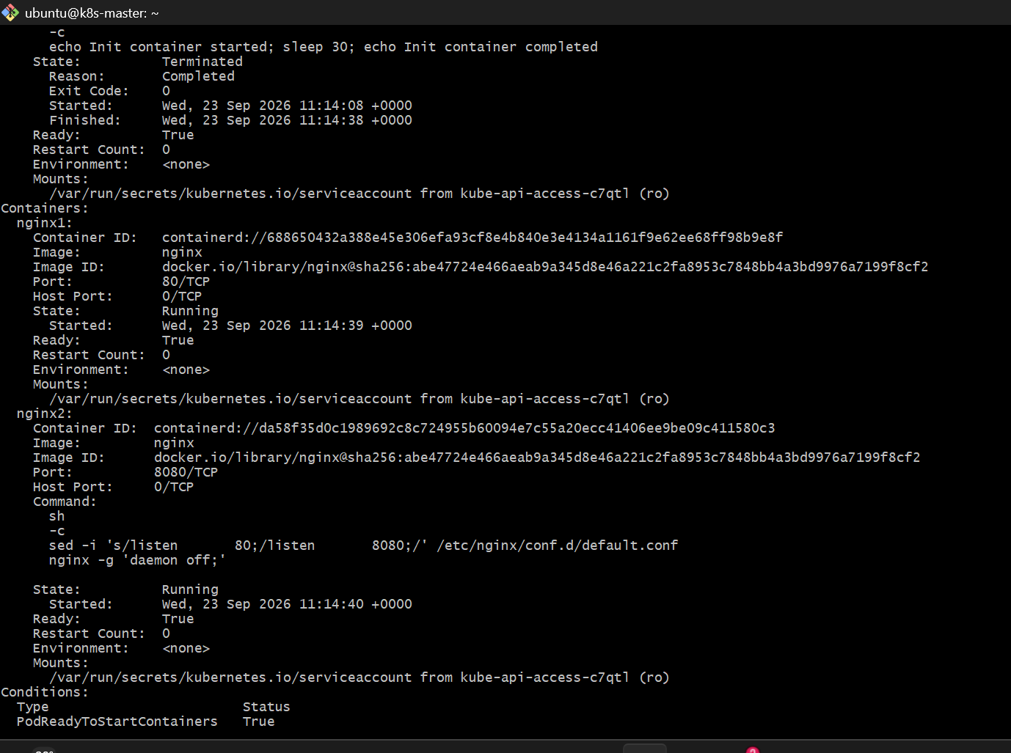Step 4 — Check init container logs
Run: kubectl logs firstpod -c init-container
Expected:
Init container started
Init container completed
This is the most direct verification that the 30-second init container executed successfully.
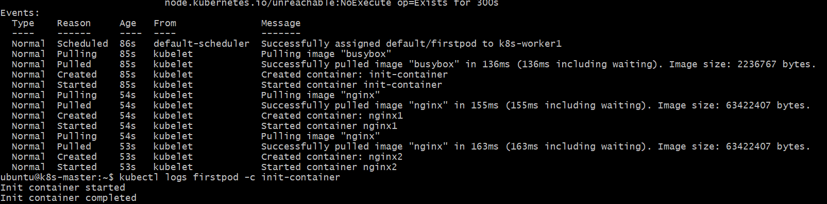
Step 5 — Verify the main containers
Finally:
kubectl get pod firstpod
Expected:
NAME READY STATUS RESTARTS
firstpod 2/2 Running 0
Task 6 — Dry Run YAML
Objective
Learn how to validate a Kubernetes YAML file without actually creating the Pod.
We'll use your existing firstpod.yaml.
Step 1 — Run client-side dry run
kubectl apply -f firstpod.yml --dry-run=client
Expected: pod/firstpod created (dry run)
Step 2 — Generate the object without creating it
After that, run: kubectl apply -f firstpod.yml --dry-run=client -o yaml
This will display the Kubernetes YAML that would be submitted.
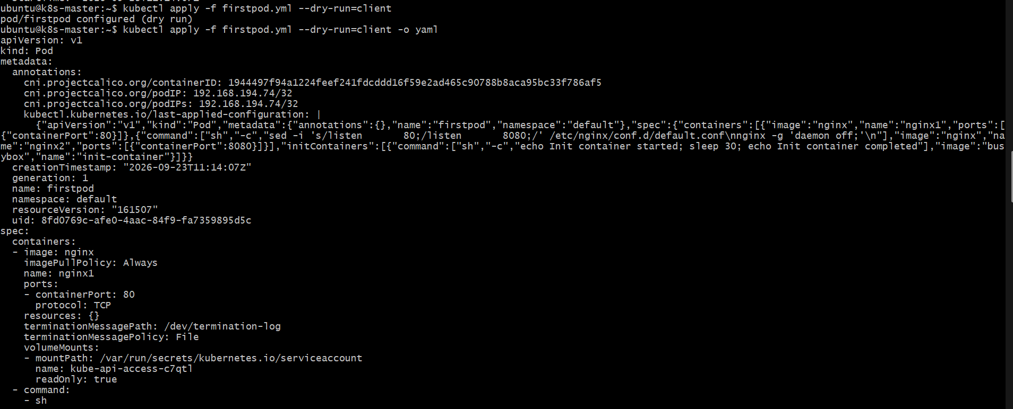
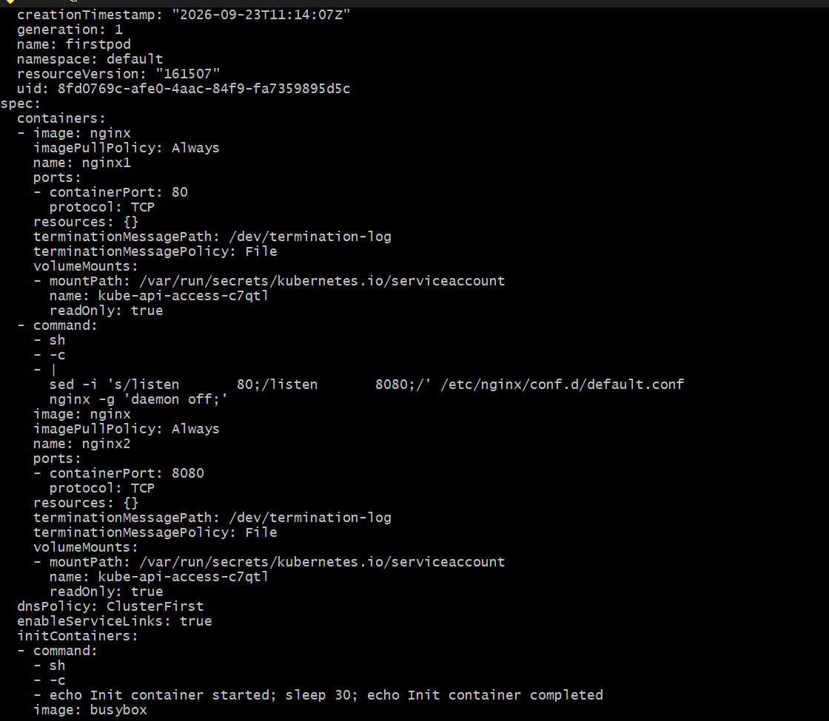
Summary
Requirement | Status
kubectl apply --dry-run=client | ✅
Validate YAML without deployment | ✅
Generate YAML using -o yaml | ✅
Modify YAML with custom requirements | ✅
Verify generated object | ✅

Task 7 — kubectl apply vs kubectl create
We will:
Step 1 — Create createpod.yml
Run: nano createpod.yml
Paste: apiVersion: v1
kind: Pod
metadata:
name: createpod
spec:
containers:
- name: nginx
image: nginx
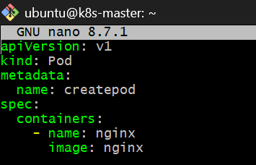
Save in nano:
- Ctrl + O
- Press Enter
- Ctrl + X
Step 2 — Create the Pod
Run: kubectl create -f createpod.yml
Expected: pod/createpod created
Step 3 — Verify
kubectl get pod createpod
Expected: createpod 1/1 Running 0 ...
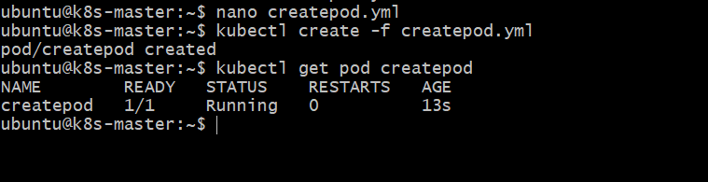
What we've demonstrated
With a new resource: kubectl create -f createpod.yml
➡️ Creates the Pod.
Step 4: Modify createpod.yml
Currently you have:
image: nginx
Let's change it to a specific nginx version:
apiVersion: v1
kind: Pod
metadata:
name: createpod
spec:
containers:
- name: nginx
image: nginx:1.27
Edit: nano createpod.yml
Change only:
nginx
to:
nginx:1.27
Save with:
- Ctrl + O
- Enter
- Ctrl + X
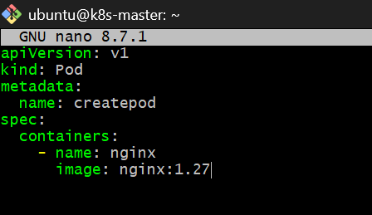
Step 5 — Try kubectl create again
Run: kubectl create -f createpod.yml
You should get: Error from server (AlreadyExists)
That's because create does not update an existing resource.
Step 6 — Now use kubectl apply
Run:
kubectl apply -f createpod.yml
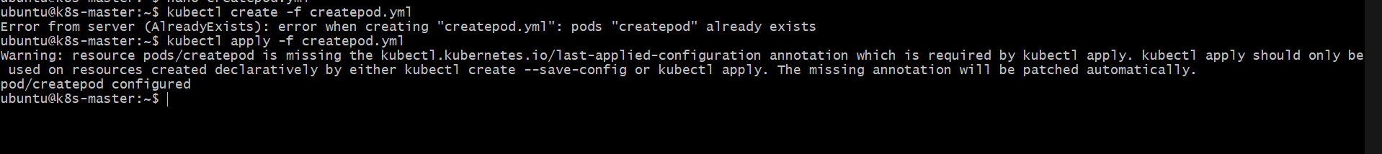
verification
Run: kubectl get pod createpod
and: kubectl describe pod createpod | grep -A5 "Image:"
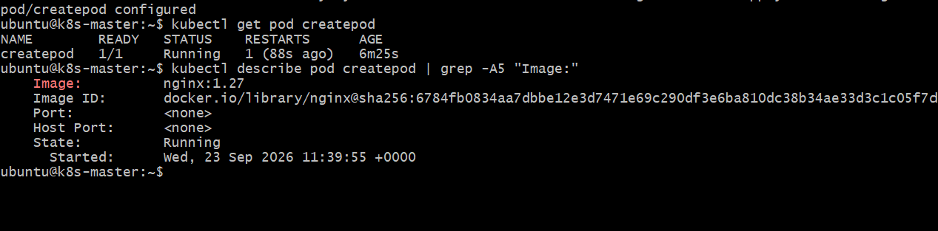
Task 8 — Edit Existing Pod
Objective
Learn how to modify an existing Kubernetes Pod using:
kubectl edit pod
We'll use the createpod Pod from Task 7.
Step 1 — Check the Pod
Run: kubectl get pod createpod
You should see:
NAME READY STATUS RESTARTS AGE
createpod 1/1 Running 0 ...
Step 2 — Open the existing Pod for editing
Run: kubectl edit pod createpod
This opens the Pod definition in the default editor.
Don't change anything yet.
You'll see something similar to:
spec:
containers:
- image: nginx:1.27
name: nginx
Important
Kubernetes Pods have many immutable fields. So we should not randomly modify fields such as:
- container name
- container ports
- Pod networking
- volumes in many cases
For this task, we'll make a safe change that demonstrates the edit command.
One simple option is to add a label under metadata:
metadata:
labels:
environment: dev
However, because kubectl edit can involve editor behavior and indentation, we'll do it step-by-step.
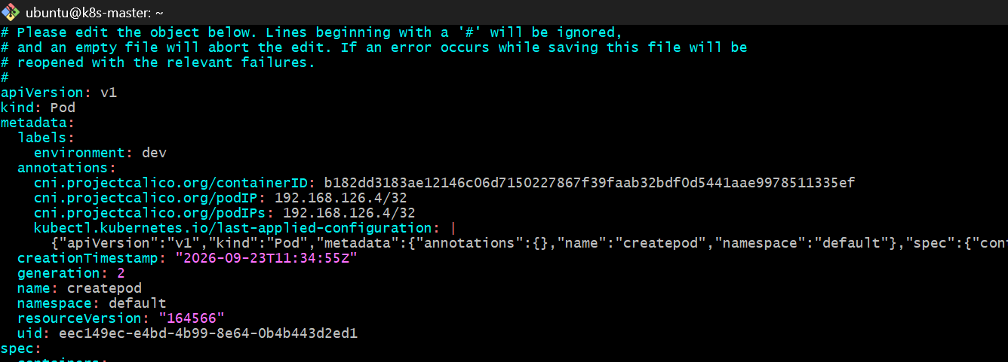
Verify the Pod
Back at the terminal: kubectl get pod createpod --show-labels
You should see something similar to:
NAME READY STATUS RESTARTS AGE LABELS
createpod 1/1 Running 0 ... environment=dev
Step 3 — Verify only the label
kubectl get pod createpod -o jsonpath='{.metadata.labels}'
Expected: map[environment:dev]
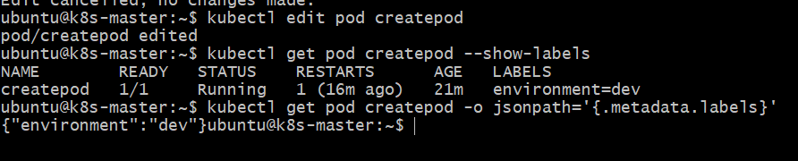
Task 9 — Expose Pod with ClusterIP
Objective
Create a ClusterIP Service to expose the existing createpod Pod inside the Kubernetes cluster.
Our Pod is:
createpod
└── nginx
└── port 80
We'll expose it through:
ClusterIP Service
↓
createpod
↓
nginx :80
Step 1 — Verify the Pod label
We added this label in Task 8:
environment: dev
Run: kubectl get pod createpod --show-labels
You should see: createpod 1/1 Running ... environment=dev
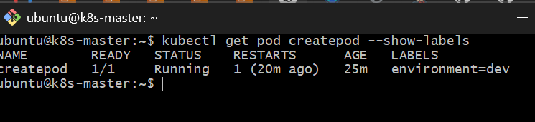
Step 2 — Create the ClusterIP Service
We can create the Service directly with:
kubectl expose pod createpod --name=createpod-service --port=80 --target-port=80 --type=ClusterIP
Expected:
service/createpod-service exposed
What this command means
--name=createpod-service
Service name.
--port=80
Service port.
--target-port=80
Port on the nginx container.
--type=ClusterIP
Service is accessible inside the Kubernetes cluster, not directly from the Internet.
Step 3 — Verify the Service
Run: kubectl get service createpod-service
You should see something similar to:
NAME TYPE CLUSTER-IP EXTERNAL-IP PORT(S)
createpod-service ClusterIP 10.x.x.x <none> 80/TCP
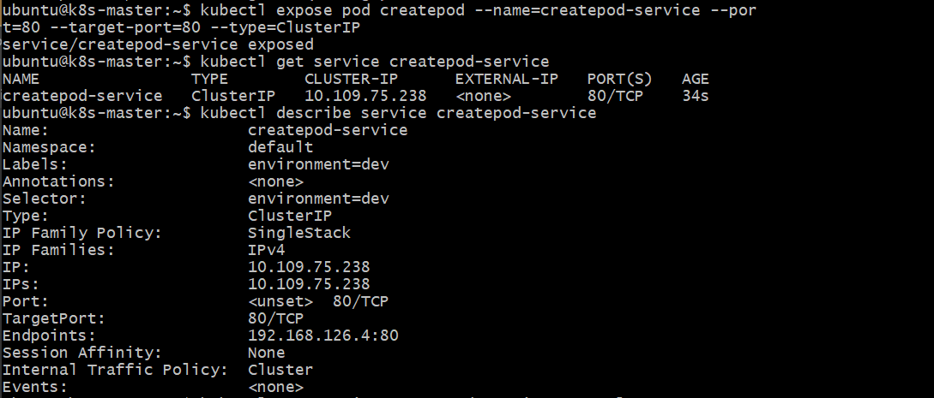
Step 4 — Check the Service details
Run: kubectl describe service createpod-service
Pay attention to:
Type: ClusterIP
Port: 80
TargetPort: 80
Endpoints: <Pod-IP>:80
The Endpoints are particularly important because they prove the Service has found the createpod Pod.
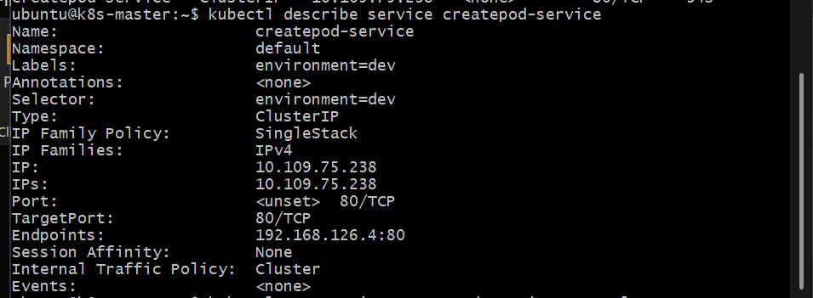
Step 5 — Verify the selector
Run: kubectl get service createpod-service -o yaml
You should find:
selector:
environment: dev
Because our Pod has:
labels:
environment: dev
the Service selects that Pod.
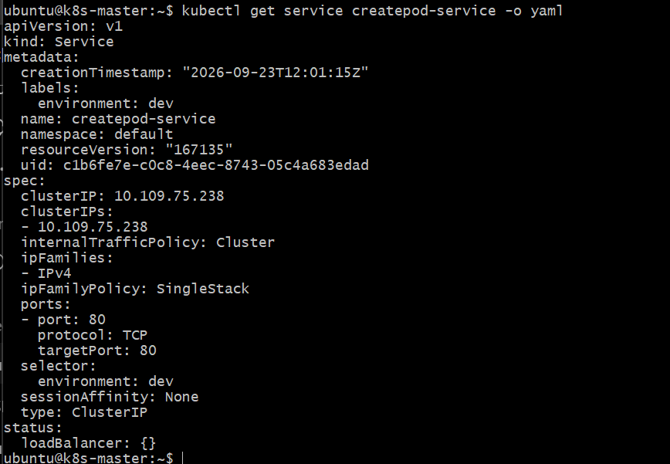
Important concept
Kubernetes Cluster
|
ClusterIP Service
createpod-service
10.x.x.x:80
|
v
createpod Pod
192.168.x.x:80
|
nginx
A ClusterIP is normally reachable only from within the cluster.
Traffic flow
Inside Kubernetes Cluster
|
v
10.109.75.238:80
|
| ClusterIP Service
v
192.168.126.4:80
|
v
createpod
|
v
nginx
Your Service selector:
selector: environment: dev
matches your Pod label: environment=dev
So Kubernetes correctly connected the Service to the Pod.
Task 10 — Resource Requests and Limits
Objective
Learn how to define:
- CPU request
- Memory request
- CPU limit
- Memory limit
We'll use a new Pod so we don't disturb createpod or the ClusterIP Service from Task 9.
Step 1 — Create resourcepod.yml
Run: nano resourcepod.yml
Paste: apiVersion: v1
kind: Pod
metadata:
name: resourcepod
spec:
containers:
- name: nginx
image: nginx
resources:
requests:
cpu: "100m"
memory: "128Mi"
limits:
cpu: "500m"
memory: "256Mi"
Save:
- Ctrl + O
- Enter
- Ctrl + X
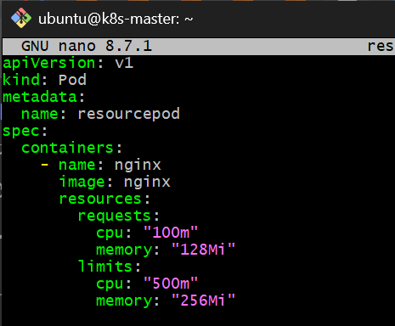
What these values mean
requests:
cpu: "100m"
memory: "128Mi"
Requests = resources Kubernetes reserves for the container.
- 100m CPU = 0.1 CPU
- 128Mi memory = 128 MiB
limits:
cpu: "500m"
memory: "256Mi"
Limits = maximum resources the container can use.
- 500m CPU = 0.5 CPU
- 256Mi memory = 256 MiB
Think: Request = "I need at least this much"
Limit = "Don't let me use more than this"
Step 2 — Create the Pod
Run: kubectl apply -f resourcepod.yml
Expected:
pod/resourcepod created
Step 3 — Verify
Run: kubectl get pod resourcepod
Expected:
NAME READY STATUS RESTARTS AGE
resourcepod 1/1 Running 0 ...
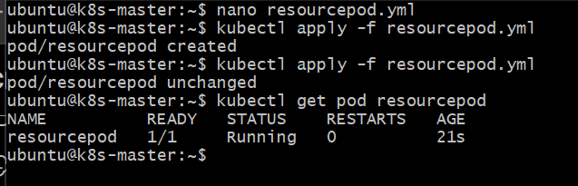
Step 4 — Check resources with describe
Run: kubectl describe pod resourcepod
Find the Containers → nginx → Limits / Requests section.
You should see approximately:
Limits:
cpu: 500m
memory: 256Mi
Requests:
cpu: 100m
memory: 128Mi
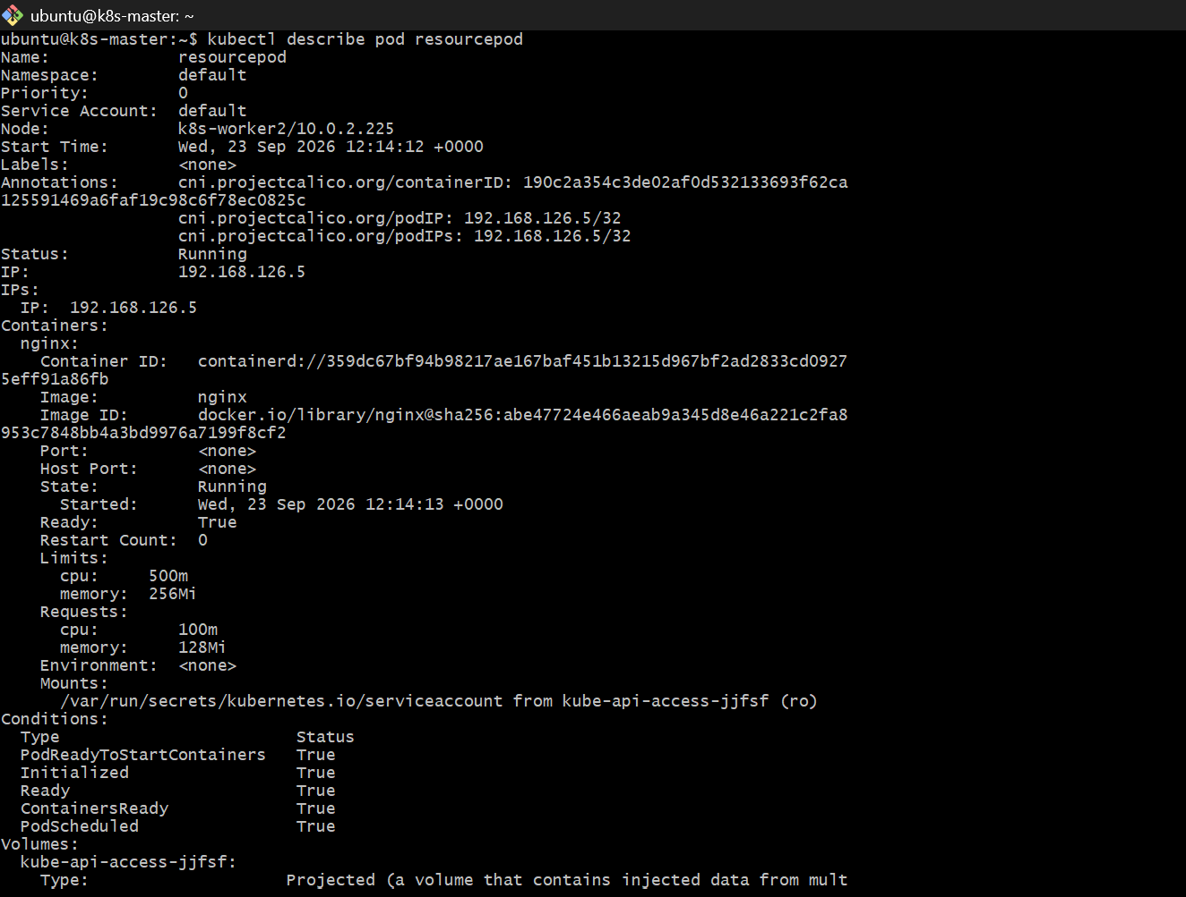
Step 5 — Verify directly from YAML
Run: kubectl get pod resourcepod -o yaml
Look for:
resources:
limits:
cpu: 500m
memory: 256Mi
requests:
cpu: 100m
memory: 128Mi
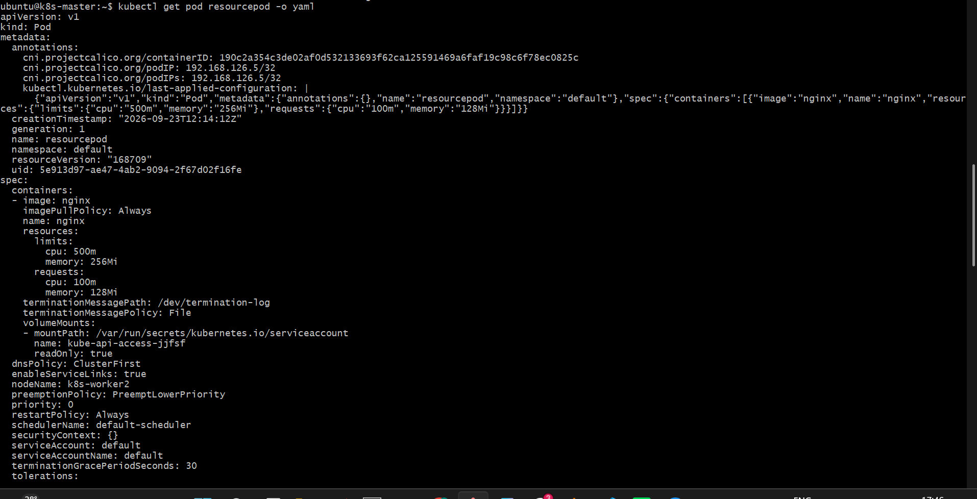
kubectl get pod resourcepod -o yaml | grep -A8 "resources:"
