Kubernetes-09
1.Execute all the steps shown in video.
2.Upgrade k8s cluster from 37.0 to 37.1 Version. Note: Document to upgrade cluster. https://devopscube.com/upgrade-kubernetes-cluster-kubeadm/
PART 1 — Kubernetes Ingress Lab
Architecture we are going to build
Browser
|
| http://example.com
v
+-------------------+
| Ingress Controller |
| NGINX |
+-------------------+
|
| Ingress Rule
v
+-------------------+
| nginx-service |
| :80 |
+-------------------+
|
v
+-------------------+
| nginx Pod |
| :80 |
+-------------------+
Ingress itself is only the Kubernetes API resource containing routing rules; an Ingress Controller must actually implement those rules.
Step 1 — Check your current cluster
Run this on your control-plane node:
kubectl get nodes -o wide
Then: kubectl version
Then:kubectl get pods -A
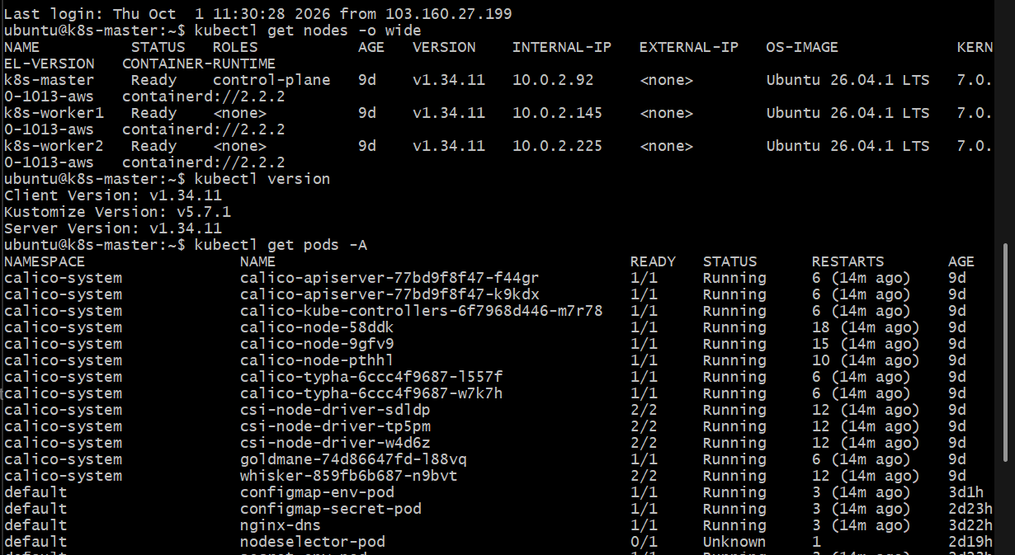
You should see your control-plane and worker nodes.
Also check whether an Ingress Controller already exists:
kubectl get pods -A | grep -i ingress
And: kubectl get ingressclass
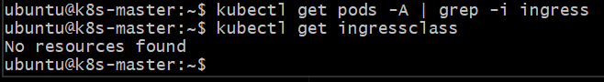
Do not install another controller if one is already running.
This confirms your current cluster does not have an Ingress Controller installed yet: kubectl get pods -A | grep -i ingress
→ no output
kubectl get ingressclass
→ No resources found
So we can install the NGINX Ingress Controller next.
Step 1 — Install NGINX Ingress Controller
Because your cluster is an AWS kubeadm cluster, don't use:
minikube addons enable ingress
That command is only for Minikube.
For your cluster, run: kubectl apply -f https://raw.githubusercontent.com/kubernetes/ingress-nginx/controller-v1.13.3/deploy/static/provider/baremetal/deploy.yaml
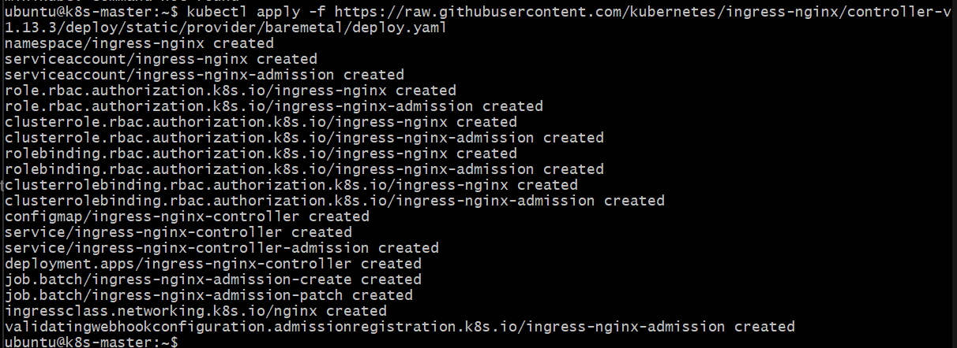
Then wait about 30–60 seconds and run:
kubectl get pods -n ingress-nginx
Then: kubectl get svc -n ingress-nginx
And:kubectl get ingressclass
What we expect
You should eventually see something similar to:
NAME READY STATUS
ingress-nginx-controller-xxxxxxxxx 1/1 Running
and: NAME
nginx
for the IngressClass.
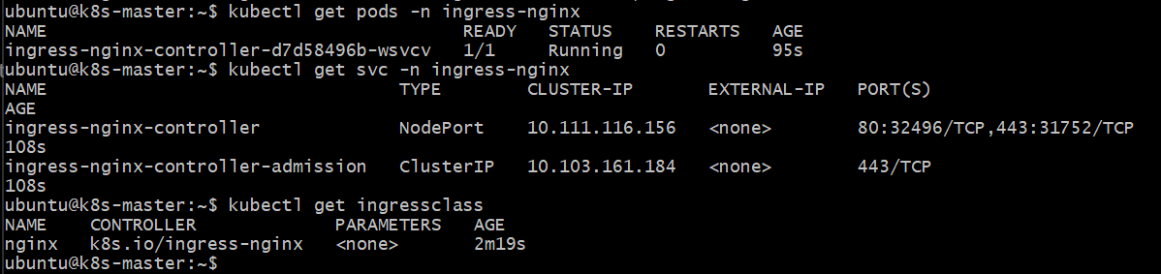
Step 2 — Create a working directory
mkdir -p ~/kubernetes-ingress
cd ~/kubernetes-ingress
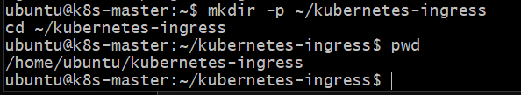
Step 3 — Create the Deployment
Create: vi deployment.yml
Put this: apiVersion: apps/v1
kind: Deployment
metadata:
name: nginx-deployment
spec:
replicas: 2
selector:
matchLabels:
app: nginx
template:
metadata:
labels:
app: nginx
spec:
containers:
- name: nginx
image: nginx:latest
ports:
- containerPort: 80
Save:ESC
:wq
ENTER
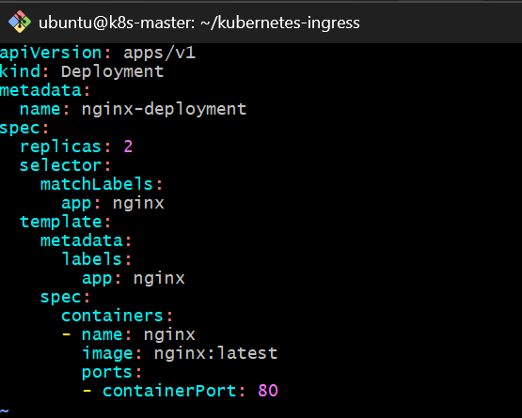
Apply:
kubectl apply -f deployment.yml
Check: kubectl get deployment
Expected:
NAME READY UP-TO-DATE AVAILABLE
nginx-deployment 2/2 2 2
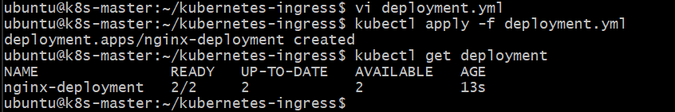
Check Pods: kubectl get pods -o wide
You should have two nginx Pods.
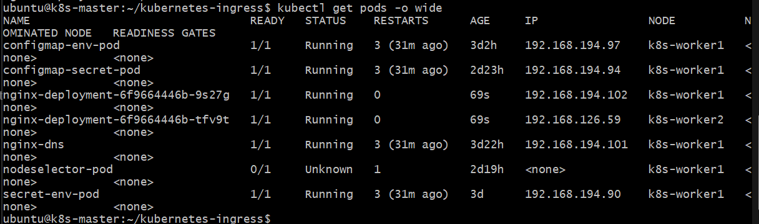
Step 4 — Test the Deployment
Run: kubectl describe deployment nginx-deployment
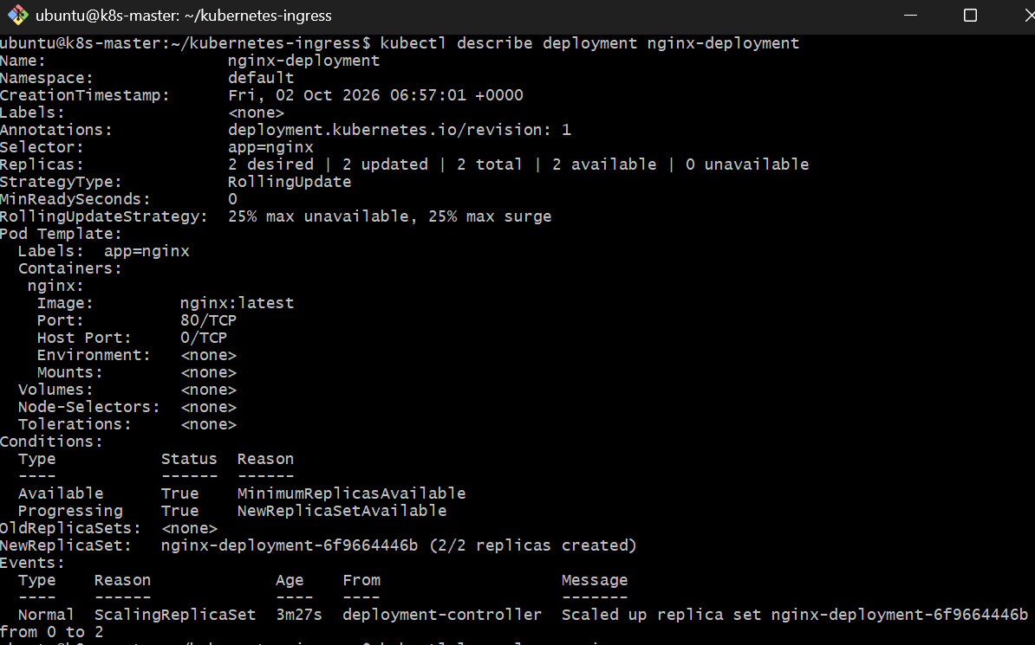
Then: kubectl logs -l app=nginx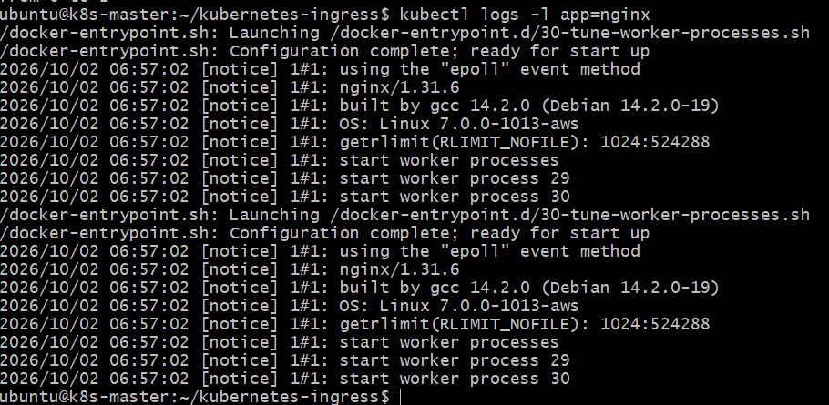
You can also check the Pod: kubectl exec -it <POD-NAME> -- nginx -v

For example: kubectl exec -it nginx-deployment-xxxxx -- nginx -v
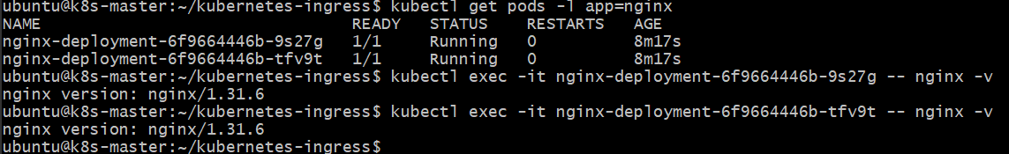
Step 5 — Create the Service
Create: vi service.yml
Use: apiVersion: v1
kind: Service
metadata:
name: nginx-service
spec:
selector:
app: nginx
ports:
- protocol: TCP
port: 80
targetPort: 80
type: ClusterIP
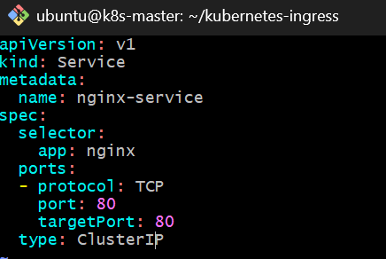
Important
Your video uses:
type: NodePort
nodePort: 30001
That works, but for an Ingress architecture, ClusterIP is normally sufficient because the Ingress Controller routes to the Service internally.
Apply: kubectl apply -f service.yml
Check: kubectl get svc
Expected:
NAME TYPE CLUSTER-IP PORT(S)
nginx-service ClusterIP 10.xxx.xxx.xxx 80/TCP
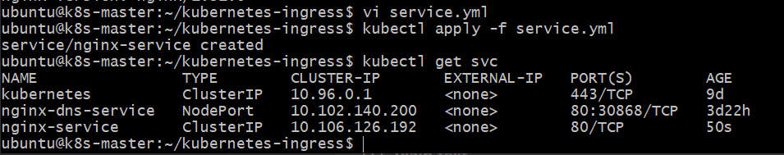
Check endpoints:
kubectl get endpoints nginx-service
You should see your nginx Pod IPs.
Step 6 — Test Service connectivity
First get the Service IP: kubectl get svc nginx-service
Then: kubectl describe svc nginx-service
Most importantly:
kubectl get endpoints nginx-service
If endpoints are present, the Service is correctly connected to the nginx Pods.
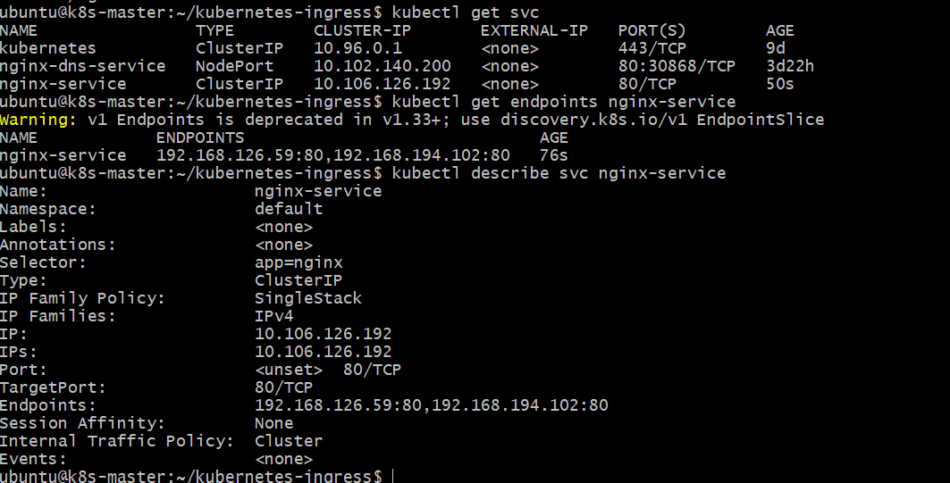
Test from inside the cluster
Create a temporary curl Pod: kubectl run curl-test --image=curlimages/curl:8.10.1 --rm -it -- sh
Inside the temporary Pod, run: curl http://nginx-service
You should receive the nginx HTML page beginning with:
<!DOCTYPE html>
<html>
<head>
<title>Welcome to nginx!</title>
Then exit:
exit
The --rm option automatically removes the temporary Pod.
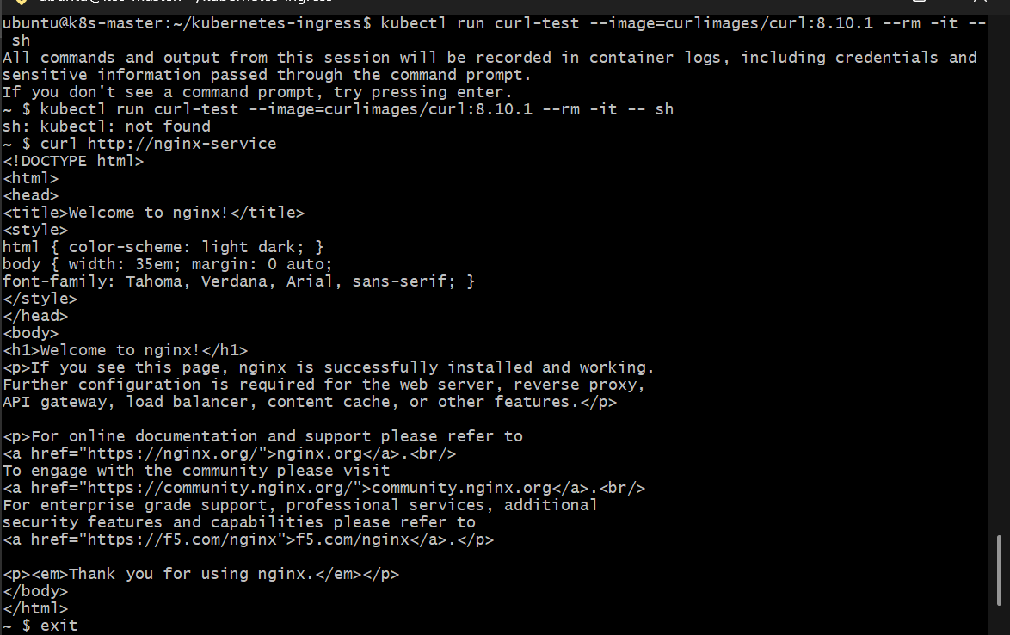Step 7 — Install an Ingress Controller
Your video specifically discusses NGINX.
For Minikube, the video command is:
minikube addons enable ingress
Then: kubectl get pods -n ingress-nginx
However, your main lab environment has been an AWS kubeadm cluster, not Minikube. So don't run minikube addons enable ingress on that cluster.
For the AWS/kubeadm cluster, we need an NGINX Ingress Controller appropriate for that environment.
Before installing anything, run: kubectl get ingressclass
and: kubectl get pods -A | grep ingress
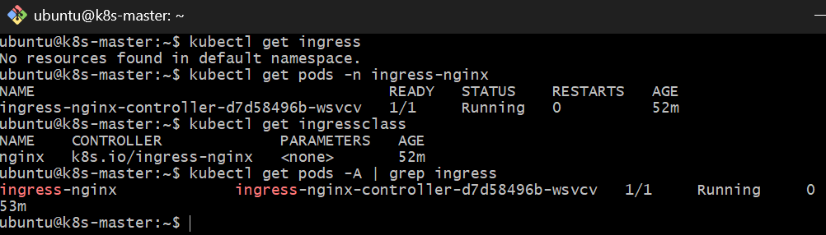
Step 8 — Create the Ingress
Once the NGINX controller is ready, create:
vi ingress.yml
Use this slightly improved version of your video's YAML:
apiVersion: networking.k8s.io/v1
kind: Ingress
metadata:
name: nginx-ingress
spec: ingressClassName: nginx
rules:
- host: example.com
http:
paths:
- path: /
pathType: Prefix
backend:
service:
name: nginx-service
port:
number: 80
The ingressClassName: nginx explicitly tells Kubernetes which Ingress Controller should handle this Ingress. The current Kubernetes documentation recommends specifying the Ingress class.
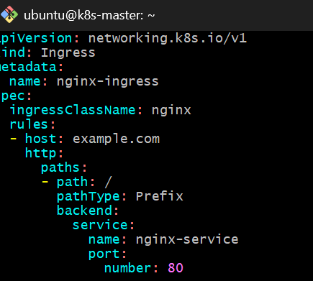
Apply: kubectl apply -f ingress.yml
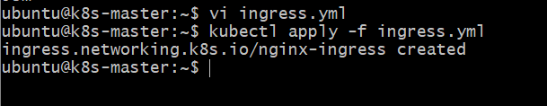
Step 9 — Verify Ingress
Run: kubectl get ingress
Then: kubectl describe ingress nginx-ingress
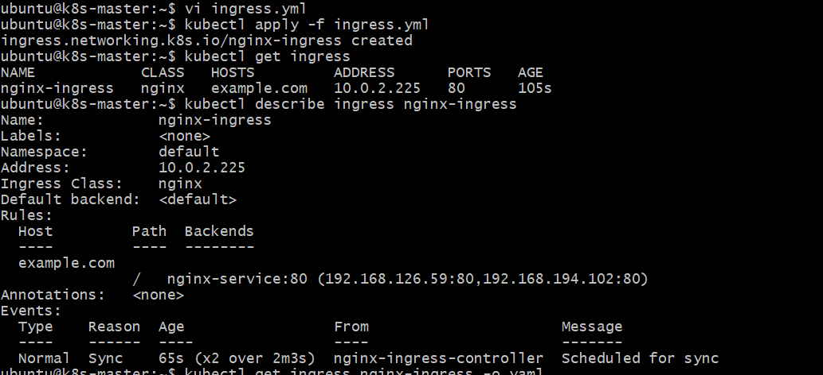

Also: kubectl get ingress nginx-ingress -o yaml
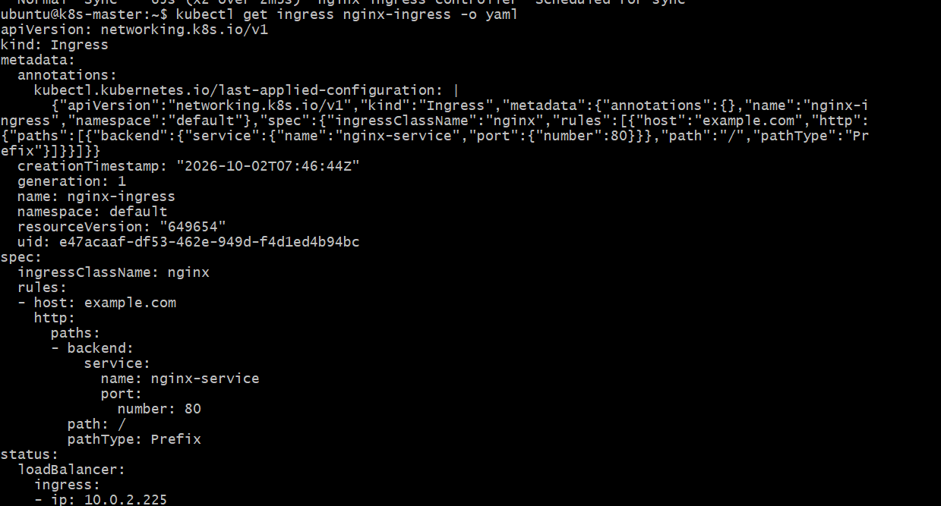
You want to eventually see an address associated with the Ingress Controller.
Step 10 — Test example.com
Because example.com is just the hostname in your lab YAML, your computer needs to send that hostname to your Ingress Controller's address.
First find the Ingress Controller Service:
kubectl get svc -A | grep -i ingress
Depending on the controller installation, you may see something like:
ingress-nginx-controller NodePort
or:
ingress-nginx-controller LoadBalancer
We'll use the actual result from your cluster to determine the test command.
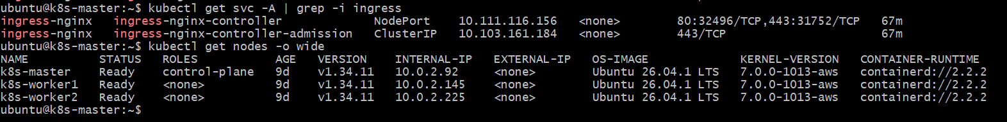
Step 11 — Test using curl
For example, if your Ingress Controller is reachable at: <INGRESS-IP>
you can test the Host header directly: curl -H "Host: example.com" http://<INGRESS-IP>/
Expected response:
<!DOCTYPE html>
<html>
<head>
<title>Welcome to nginx!</title>
...
This proves:
curl
|
| Host: example.com
v
Ingress Controller
|
v
Ingress Rule
|
v
nginx-service
|
v
nginx Pod
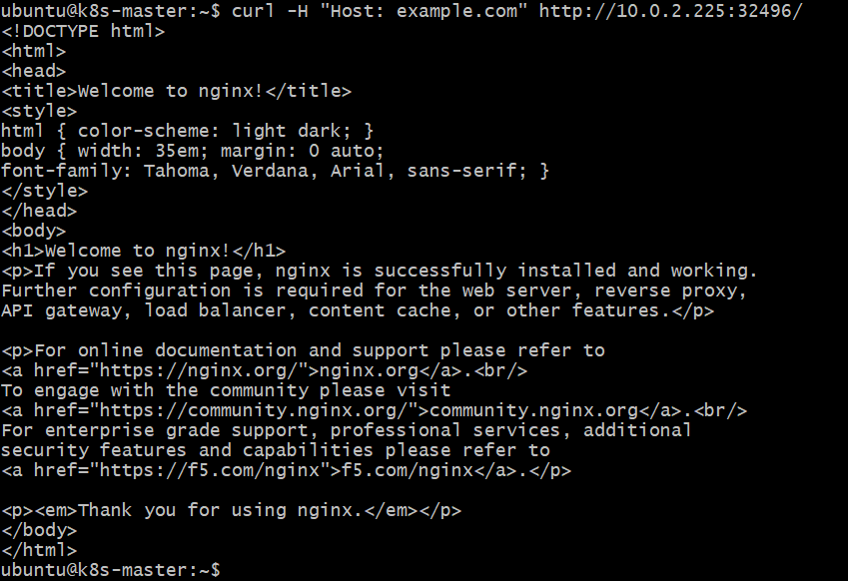
Step 12 — Test with /etc/hosts
If you're testing from your laptop and have an accessible Ingress IP, you can add:
<INGRESS-IP> example.com
to your local hosts file.
On Windows:
C:\Windows\System32\drivers\etc\hosts
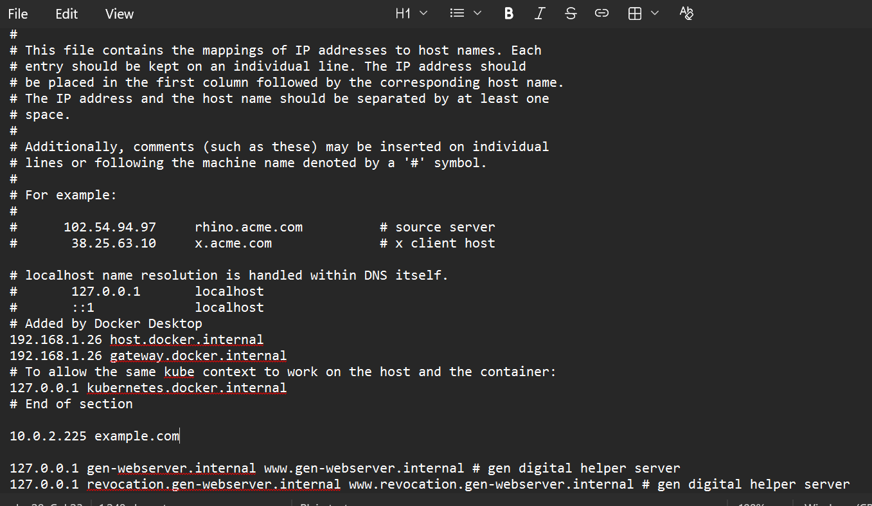
Then: <INGRESS-IP> example.com
After that: http://example.com
should reach the Ingress Controller.
http://example.com:32496/
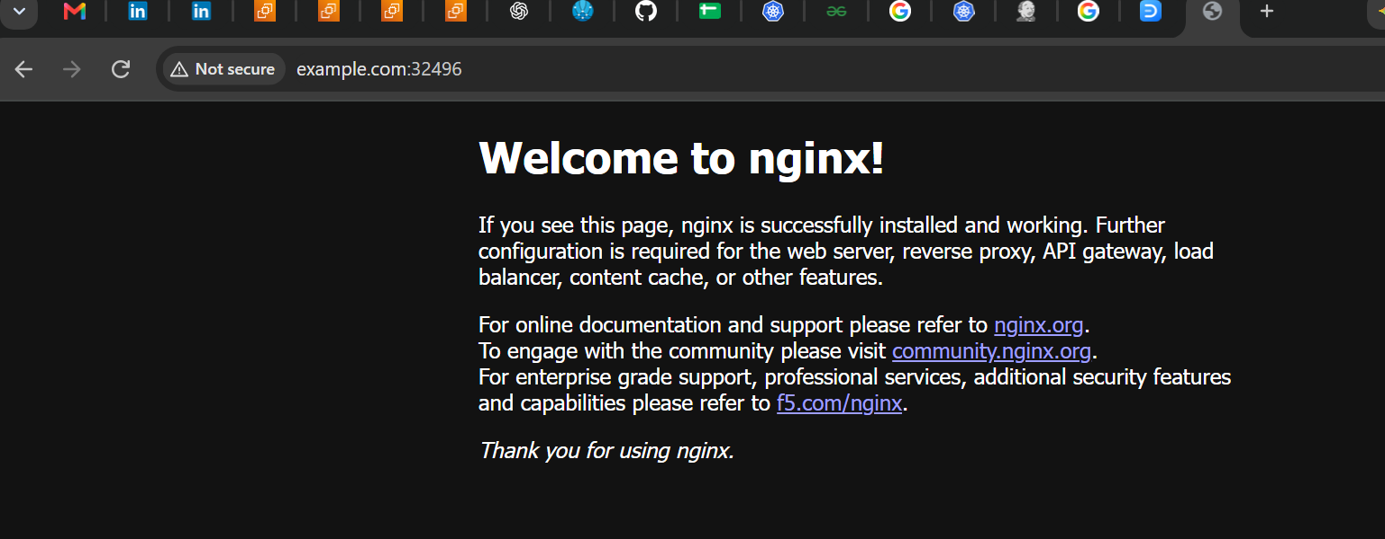
Step 13 — Verify the complete Ingress chain
Run these commands:kubectl get deployment
kubectl get pods -o wide
kubectl get svc
kubectl get endpoints
kubectl get ingress
kubectl get ingressclass
kubectl get pods -A | grep ingress
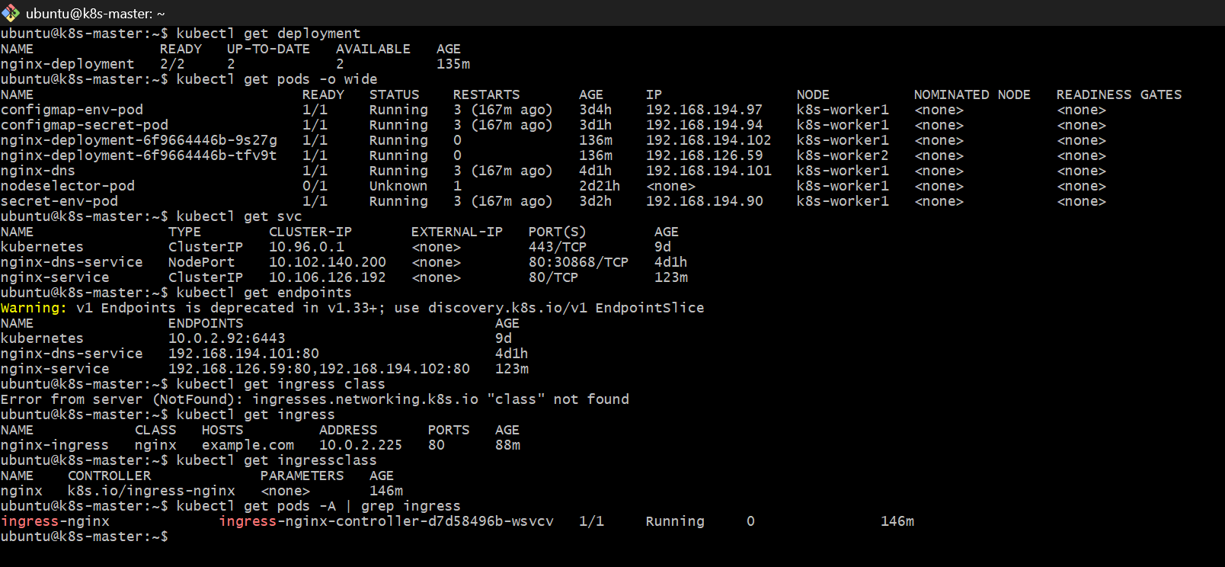
Your final architecture should be:
CLIENT
|
| HTTP
v
+---------------------+
| NGINX INGRESS |
| CONTROLLER |
+---------------------+
|
| Host = example.com
| Path = /
v
+---------------------+
| nginx-ingress |
| Kubernetes Resource |
+---------------------+
|
v
+---------------------+
| nginx-service |
| ClusterIP :80 |
+---------------------+
|
+-------+-------+
| |
v v
nginx Pod nginx Pod
PART 2 — Kubernetes 37.0 → 37.1 Upgrade
Now we move to the second assignment.
VERY IMPORTANT
Your existing cluster is:
Amazon Linux 2023
Kubernetes v1.37.0
So DO NOT execute:
kubeadm upgrade apply v1.28.x
on it.
That would be a downgrade, not the requested upgrade.
For a genuine: 1.26 → 1.28
exercise, we need a cluster currently running:
1.26.x
The supported upgrade path is:
1.26.x
|
v
1.27.x
|
v
1.28.x
Kubernetes' kubeadm documentation explicitly states that skipping minor versions is unsupported.
Upgrade Lab — Step 1
On the 1.26 control-plane node, document the existing state.
kubectl get nodes -o wide
kubectl version
kubeadm version
kubelet --version
kubectl get pods -A
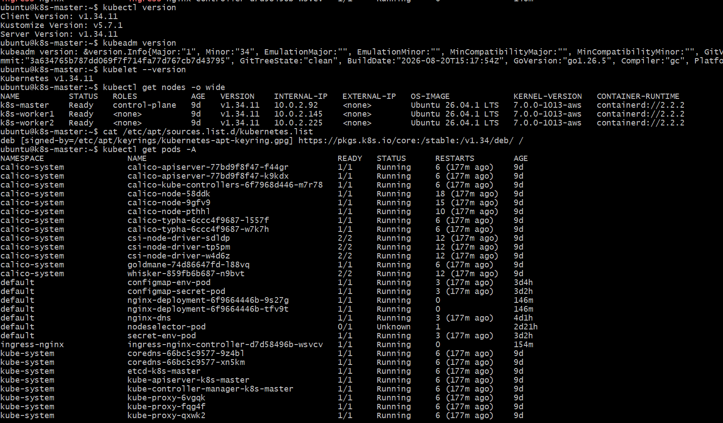
Save the output for your assignment.
Step 2 — Check cluster health
kubectl get nodes
All nodes should ideally be:
Ready
Then:
kubectl get pods -A
Look for failed Pods: kubectl get pods -A | grep -v Running
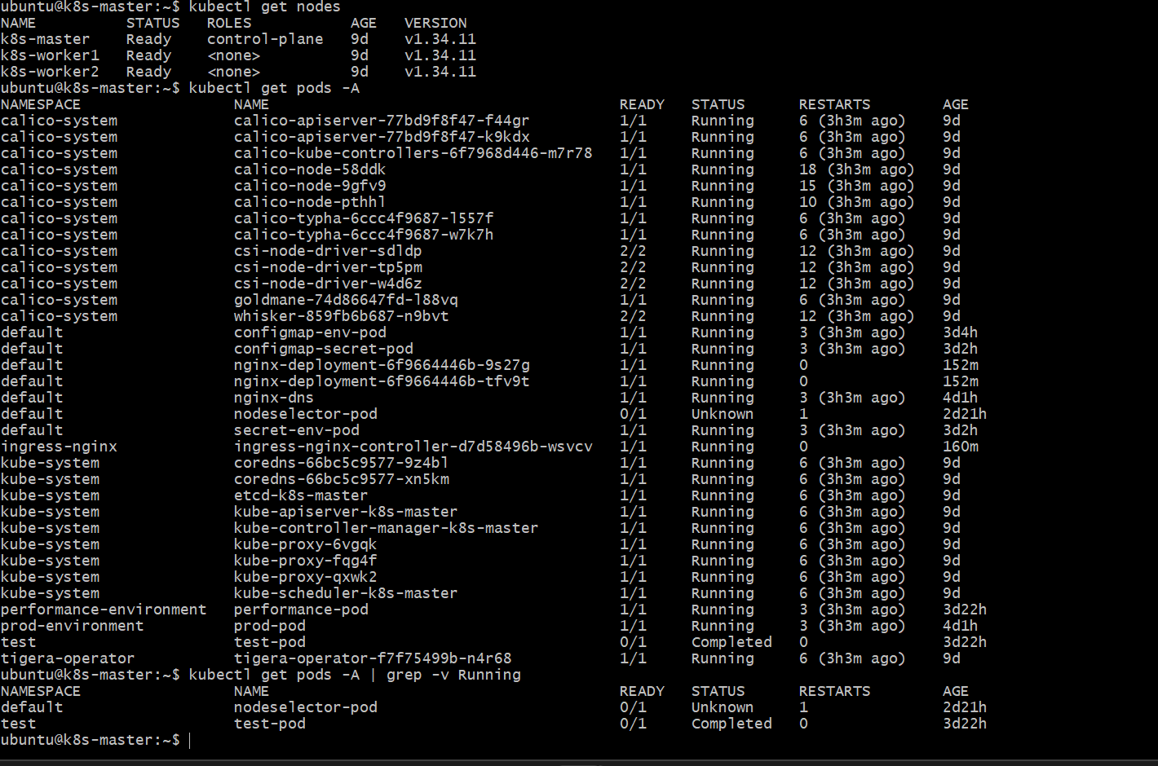
Step 3 — Backup important information
At minimum, record:
kubectl get nodes -o wide > nodes-before-upgrade.txt
kubectl get pods -A > pods-before-upgrade.txt
kubectl get svc -A > services-before-upgrade.txt
kubectl get deployments -A > deployments-before-upgrade.txt
For a production cluster, application/data backups should also be considered before upgrading. The official documentation recommends backups as a best practice.
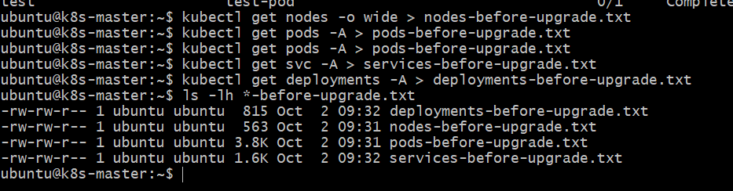
Step 4 — Prepare Control Plane for 1.35.9
We will not jump directly to 1.37.1.
Step 4A — Change Kubernetes APT repository to v1.35
First check the current repository:
cat /etc/apt/sources.list.d/kubernetes.list
If it shows:
v1.34
change it to v1.35:
echo 'deb [signed-by=/etc/apt/keyrings/kubernetes-apt-keyring.gpg] https://pkgs.k8s.io/core:/stable:/v1.35/deb/ /' | sudo tee /etc/apt/sources.list.d/kubernetes.list
Then:
sudo apt update
Finally check:
apt-cache madison kubeadm
We want to confirm that:
1.35.9-1.1
is available.
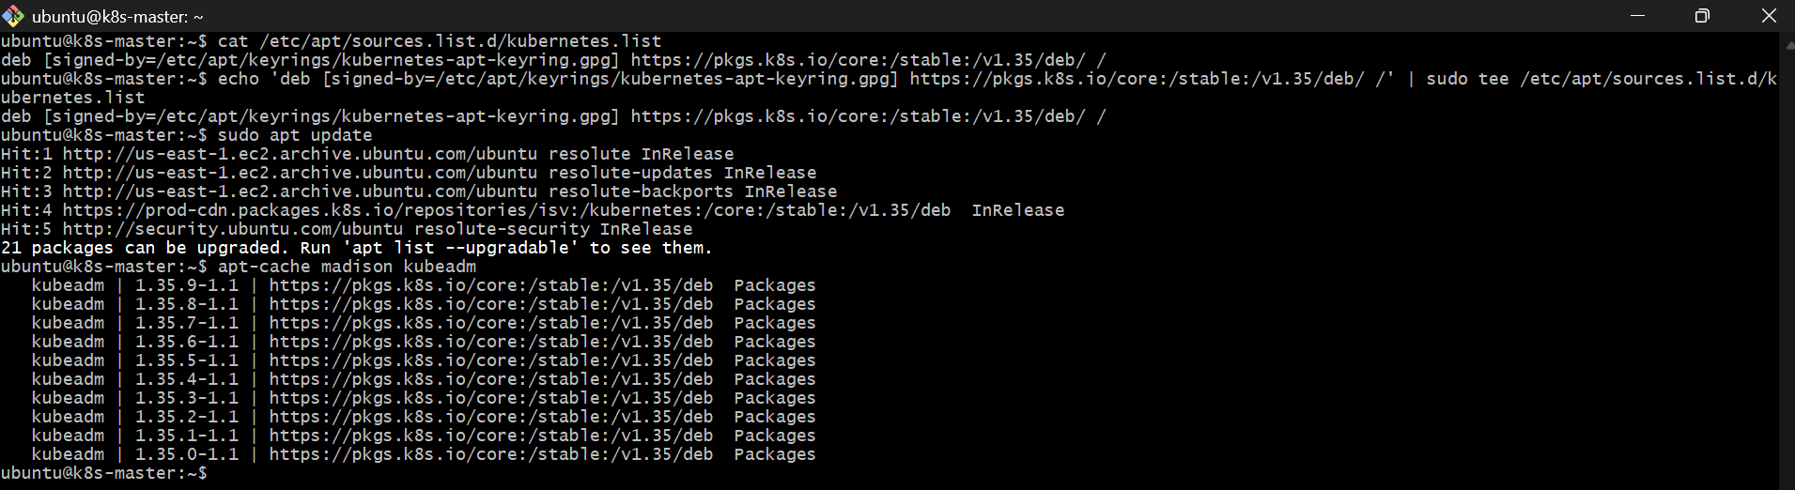
Now we can upgrade only the kubeadm package on the control plane.
Step 4B — Upgrade kubeadm to 1.35.9
Run these commands one at a time on k8s-master.
1. Unhold kubeadm
sudo apt-mark unhold kubeadm
2. Install kubeadm 1.35.9
sudo apt-get install -y kubeadm='1.35.9-1.1'
3. Hold kubeadm again
sudo apt-mark hold kubeadm
4. Verify
kubeadm version
Expected:
GitVersion:"v1.35.9"
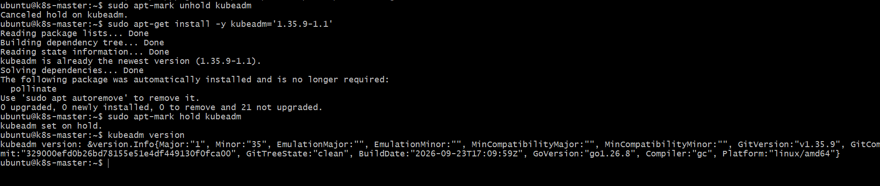
Step 4C — Check Upgrade Plan
Now run: sudo kubeadm upgrade plan
This will perform the preflight and show the available upgrade target.
We expect to see
Cluster version: 1.34.11
kubeadm version: v1.35.9
Target version: 1.35.9
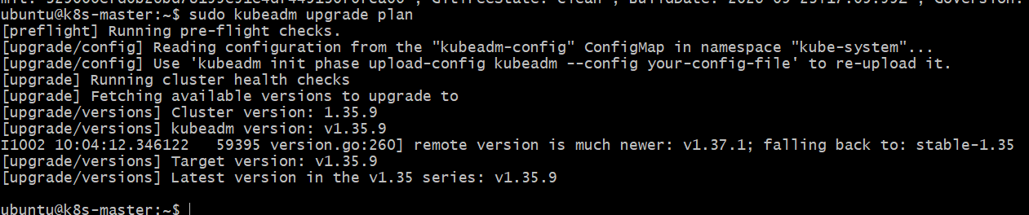
Step 5 — Upgrade Control-Plane kubelet to 1.35.9
First verify the package is available:
apt-cache madison kubelet
You already confirmed earlier that 1.35.9-1.1 is available.
Now run: sudo apt-mark unhold kubelet
Then:
sudo apt-get install -y kubelet='1.35.9-1.1'
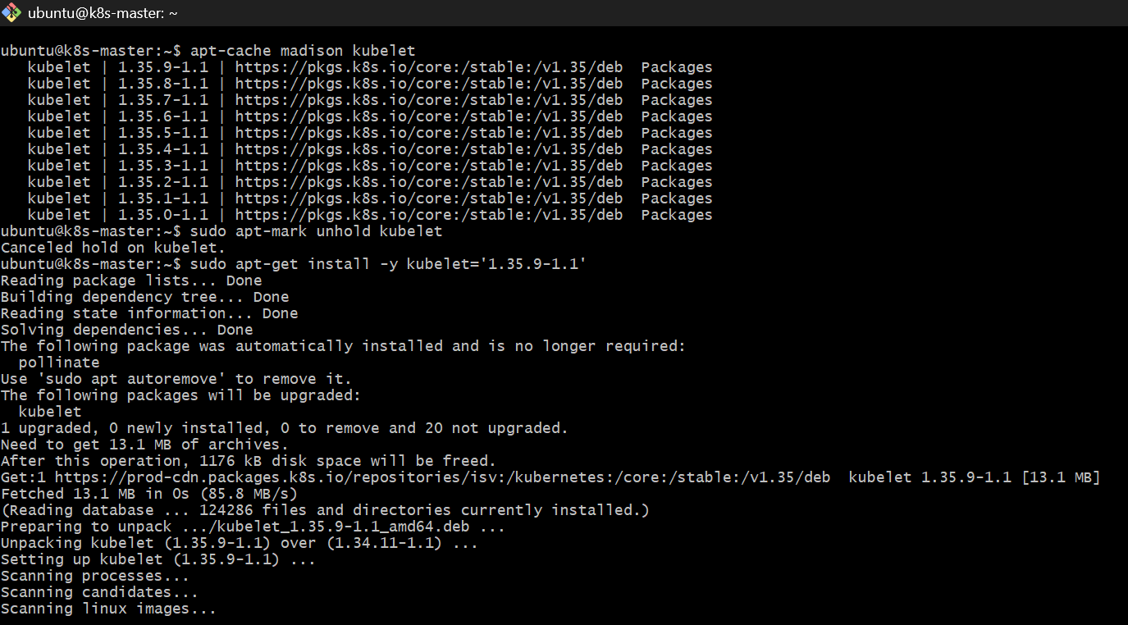
Then hold it: sudo apt-mark hold kubelet
Restart kubelet:
sudo systemctl daemon-reload
sudo systemctl restart kubelet
Verify: kubelet --version
Expected:
Kubernetes v1.35.9
Then: kubectl get nodes
Expected:
NAME STATUS ROLES VERSION
k8s-master Ready control-plane v1.35.9
k8s-worker1 Ready <none> v1.34.11
k8s-worker2 Ready <none> v1.34.11
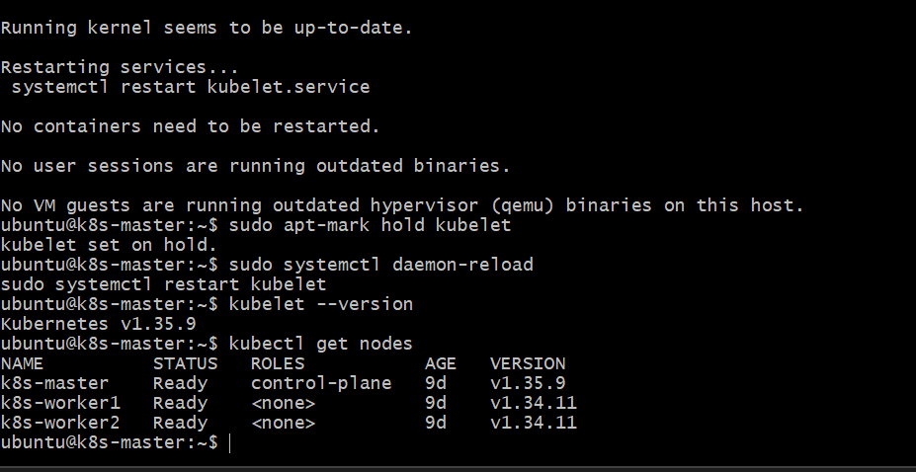
Step 6 — Complete Worker 1 drain
The drain failed because these are standalone Pods without controllers:
- configmap-env-pod
- configmap-secret-pod
- nginx-dns
- secret-env-pod
- performance-pod
- prod-pod
- nodeselector-pod is also standalone, but it is already Unknown
- test-pod is Completed
The controller-managed nginx-deployment Pod and DaemonSet Pods are handled automatically by the drain command.
Because this is an upgrade lab, we can force-drain the standalone Pods. They can be recreated later if needed.
Run only this command on k8s-master:
kubectl drain k8s-worker1 --ignore-daemonsets --delete-emptydir-data --force
Expected output
You should see messages similar to: node/k8s-worker1 already cordoned
Warning: deleting Pods that declare no controller: ...
evicting pod ...
pod/... evicted
node/k8s-worker1 drained
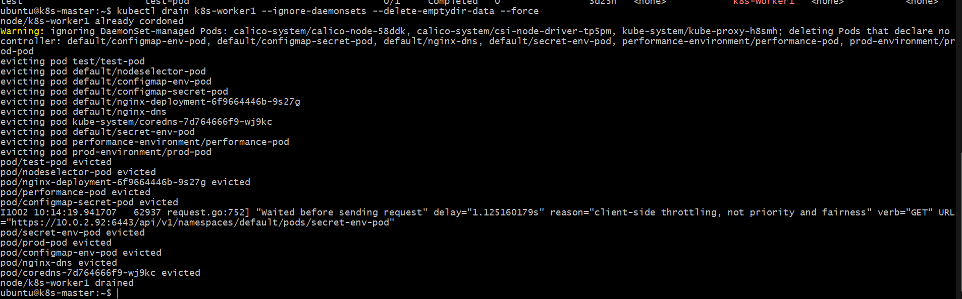
Then verify: kubectl get nodes
Expected:
NAME STATUS ROLES VERSION
k8s-master Ready control-plane v1.35.9
k8s-worker1 Ready,SchedulingDisabled <none> v1.34.11
k8s-worker2 Ready <none> v1.34.11
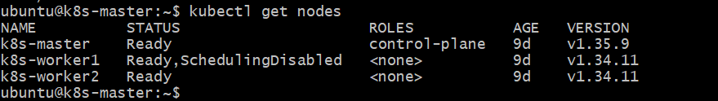
7.1 SSH into worker1
From k8s-master:
ssh -i ~/jenkins.pem ubuntu@10.0.2.145
You should get a prompt similar to:
ubuntu@k8s-worker1:~$
7.2 Check current versions
Run: kubeadm version
kubelet --version
Expected currently:
kubeadm version: v1.34.11
Kubernetes v1.34.11
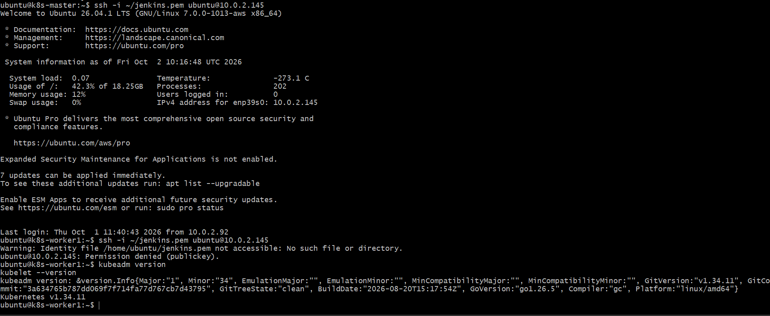
7.3 Change Kubernetes repository to v1.35
Run: cat /etc/apt/sources.list.d/kubernetes.list
If it shows v1.34, replace it with:
echo 'deb [signed-by=/etc/apt/keyrings/kubernetes-apt-keyring.gpg] https://pkgs.k8s.io/core:/stable:/v1.35/deb/ /' | sudo tee /etc/apt/sources.list.d/kubernetes.list
Then: sudo apt update
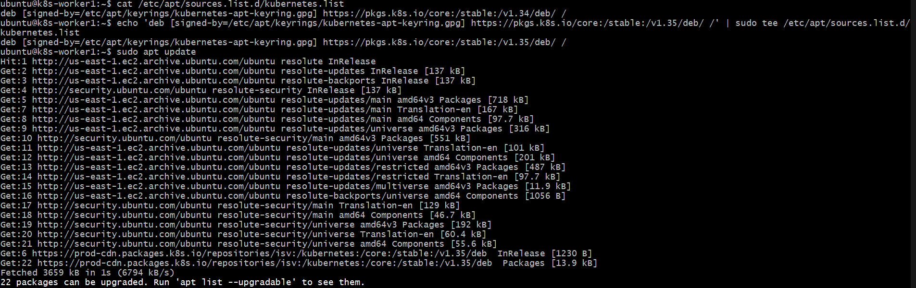
Step 7.4 — Upgrade kubeadm on Worker1
First check the available version:
apt-cache madison kubeadm
You should see 1.35.9-1.1 available.
Then run:
sudo apt-mark unhold kubeadm
sudo apt-get install -y kubeadm='1.35.9-1.1'
sudo apt-mark hold kubeadm
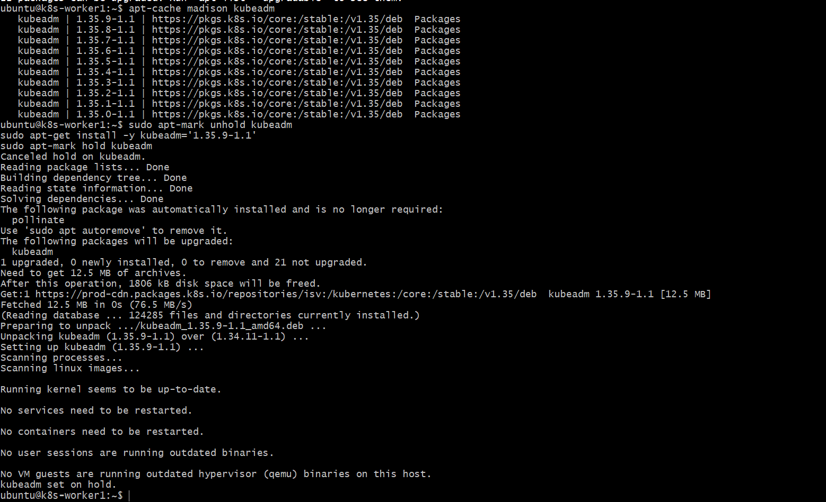
Verify: kubeadm version
Expected:
GitVersion:"v1.35.9"
Step 7.5 — Upgrade the Worker Node configuration
Now run:
sudo kubeadm upgrade node
Expected near the end:
[kubelet-start] Writing kubelet configuration to file ...
[upgrade] SUCCESS! A node in this cluster has been upgraded to "v1.35.9"
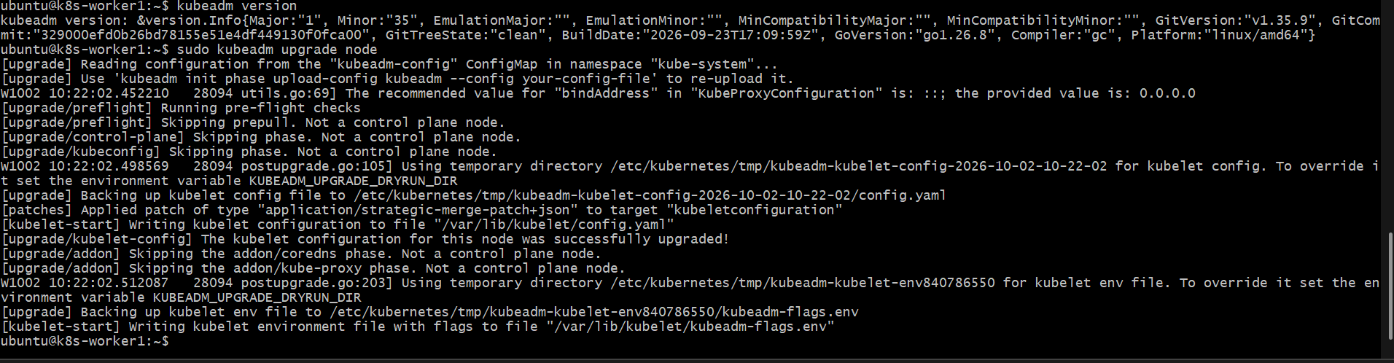
Step 7.6 — Upgrade kubelet
Run:
apt-cache madison kubelet
Confirm 1.35.9-1.1 is available.
Then:
sudo apt-mark unhold kubelet
sudo apt-get install -y kubelet='1.35.9-1.1'
sudo apt-mark hold kubelet

Restart kubelet:
sudo systemctl daemon-reload
sudo systemctl restart kubelet
Verify:
kubelet --version
sudo systemctl is-active kubelet
Expected:
Kubernetes v1.35.9
active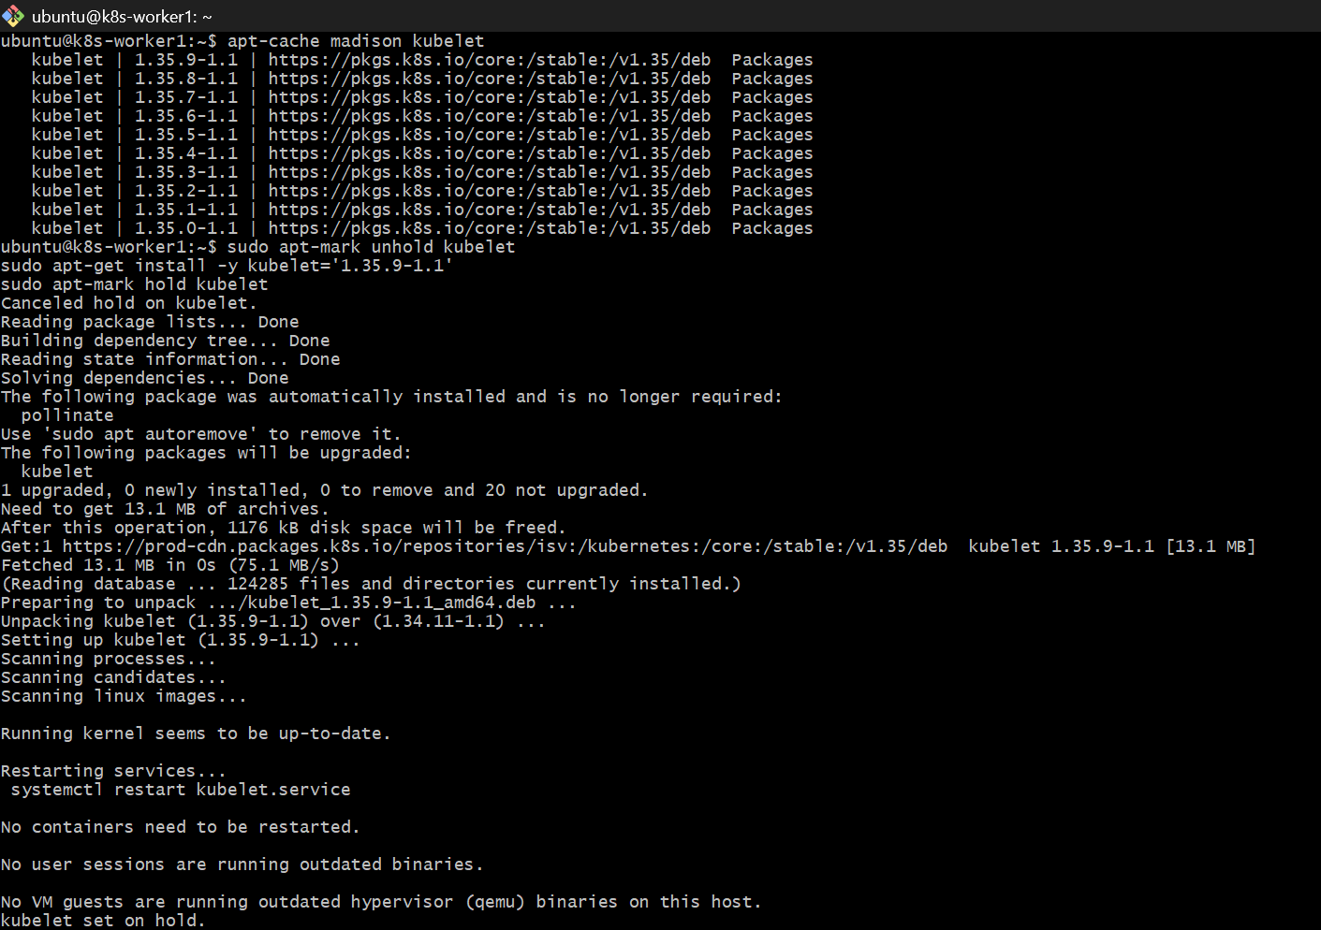
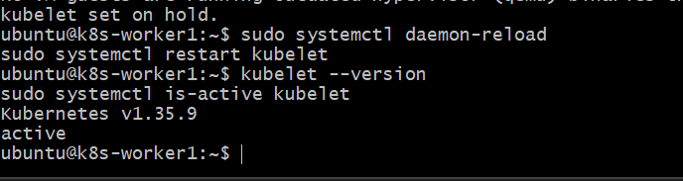
Step 8 — Return to k8s-master
Exit the worker1 SSH session:
exit
You should return to:
ubuntu@k8s-master:~$
Then uncordon worker1:
kubectl uncordon k8s-worker1
Expected:
node/k8s-worker1 uncordoned
Now verify:
kubectl get nodes -o wide
Expected:
NAME STATUS ROLES VERSION
k8s-master Ready control-plane v1.35.9
k8s-worker1 Ready <none> v1.35.9
k8s-worker2 Ready <none> v1.34.11
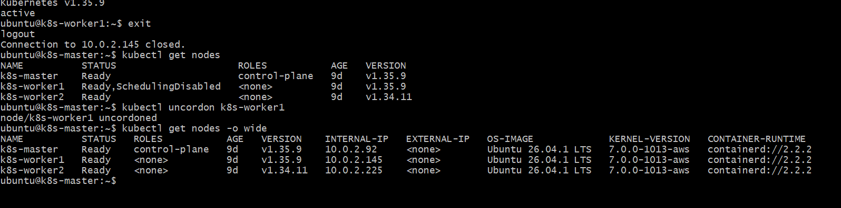
Step 9.1 — Drain Worker2
From k8s-master run: kubectl drain k8s-worker2 --ignore-daemonsets --delete-emptydir-data
If it reports standalone Pods that cannot be deleted, do not force it yet. Send me the output first, just as we did for worker1.
Also verify: kubectl get nodes
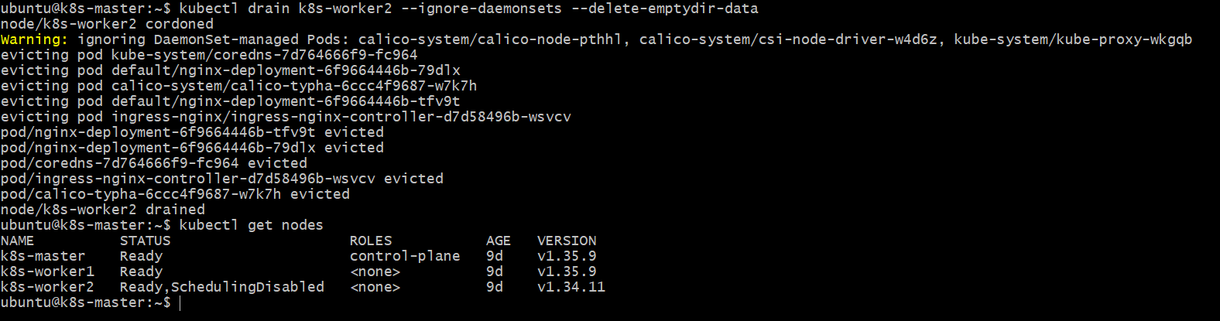
Step 9.2 — SSH into Worker2
From k8s-master: ssh -i ~/jenkins.pem ubuntu@10.0.2.225
Then verify: kubeadm version
kubelet --version
cat /etc/apt/sources.list.d/kubernetes.list
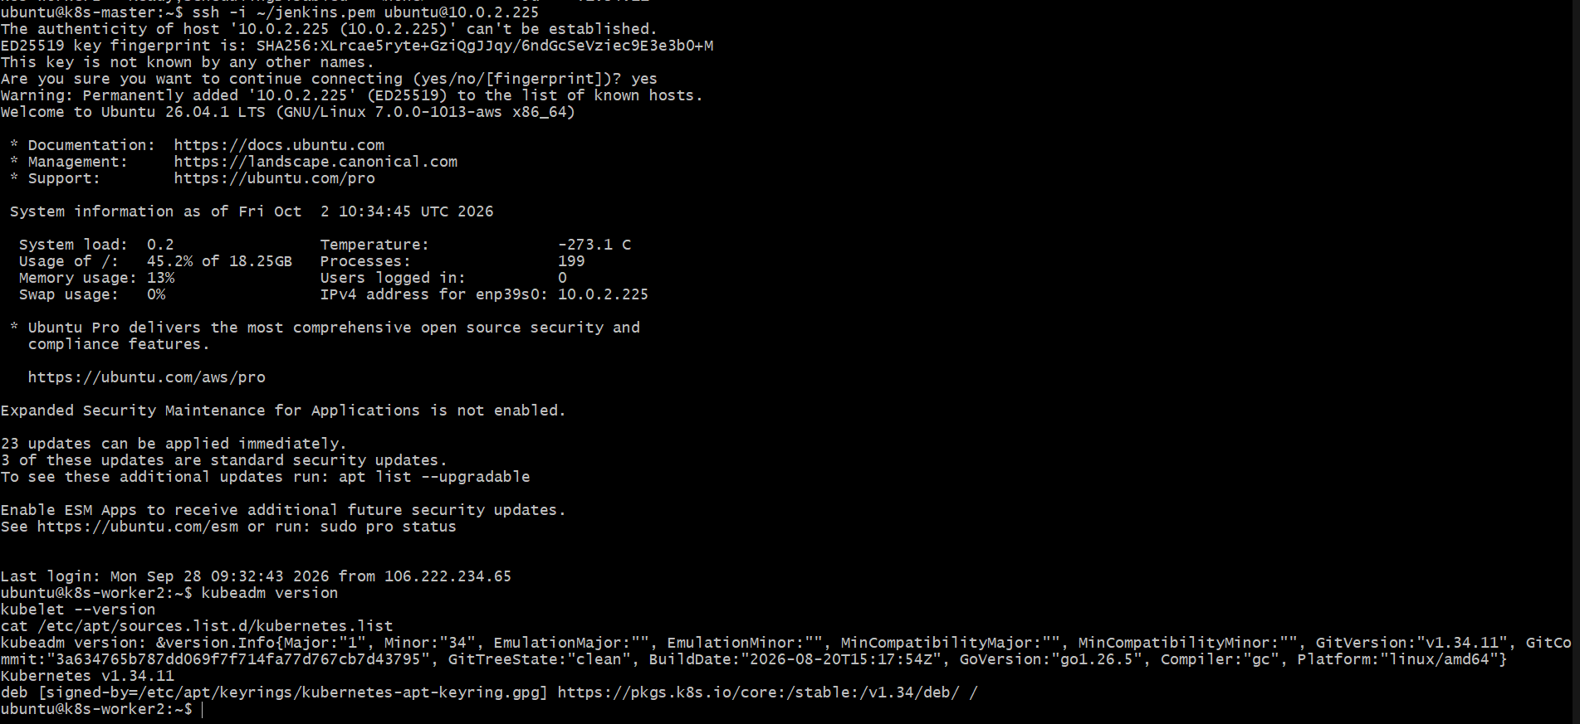
Step 9.3 — Change Worker2 repository to v1.35
Run:echo 'deb [signed-by=/etc/apt/keyrings/kubernetes-apt-keyring.gpg] https://pkgs.k8s.io/core:/stable:/v1.35/deb/ /' | sudo tee /etc/apt/sources.list.d/kubernetes.list
Then: sudo apt update
After that, check the available kubeadm versions:
apt-cache madison kubeadm
You should see: 1.35.9-1.1
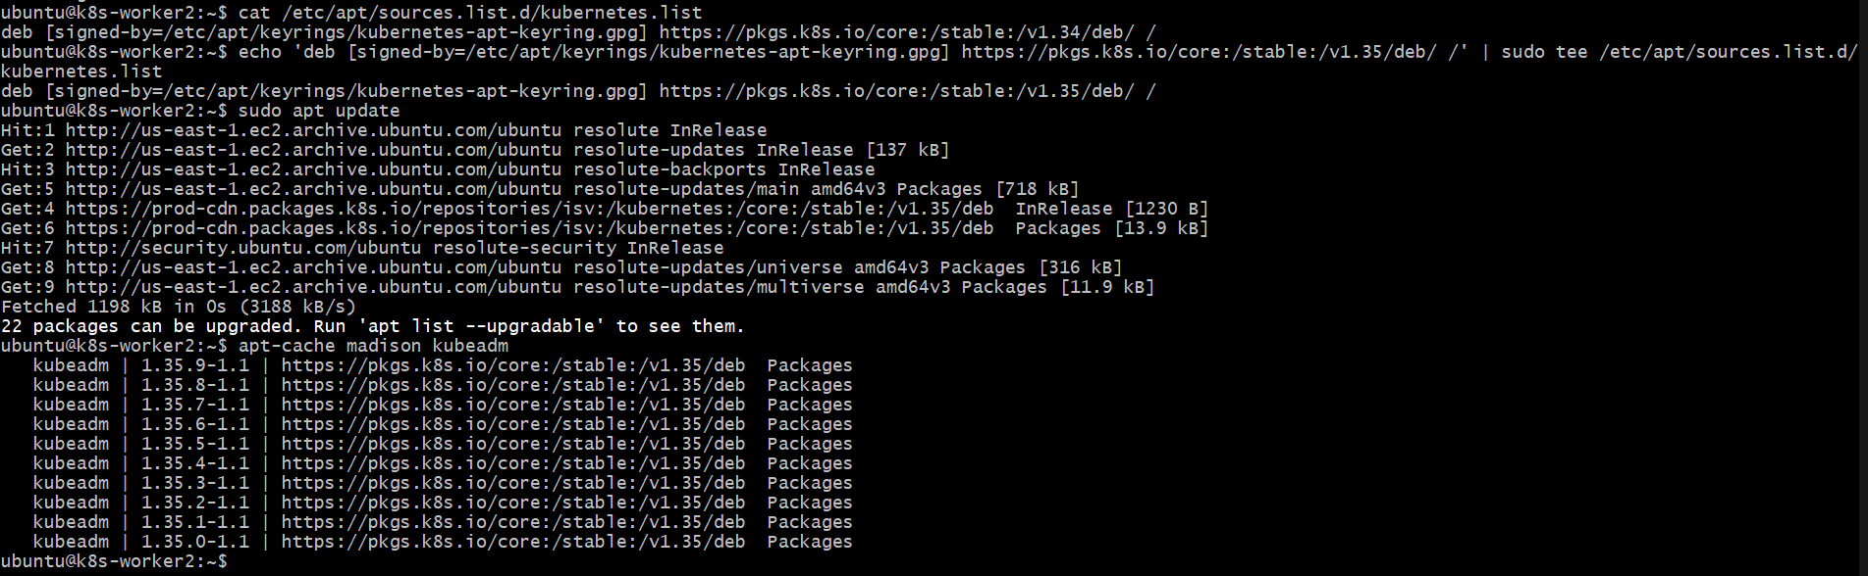
Step 9.4 — Upgrade kubeadm on Worker2
Run:
sudo apt-mark unhold kubeadm
sudo apt-get install -y kubeadm='1.35.9-1.1'
sudo apt-mark hold kubeadm
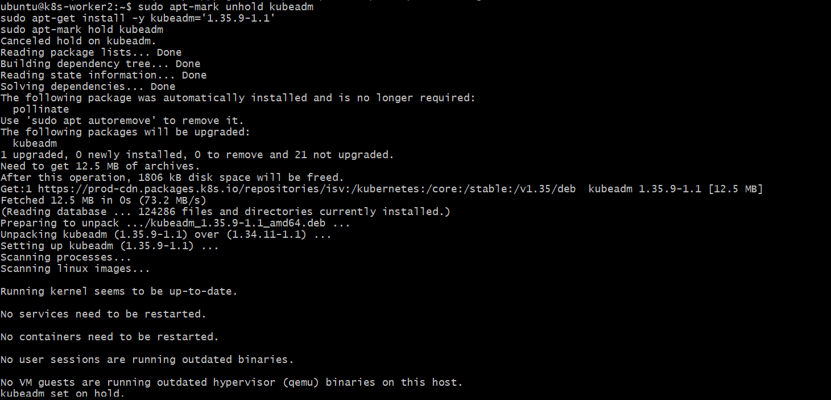
Then verify:
kubeadm version
Expected:
GitVersion:"v1.35.9"
Step 9.5 — Upgrade Worker2 configuration
Run:
sudo kubeadm upgrade node
You should see:
[upgrade/kubelet-config] The kubelet configuration for this node was successfully upgraded!
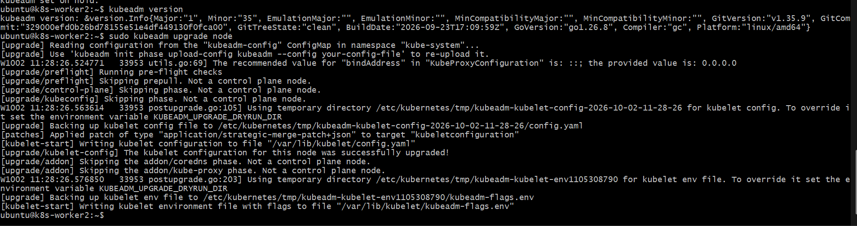
Step 9.6 — Upgrade Worker2 kubelet
First confirm the available version: apt-cache madison kubelet
You should see: kubelet | 1.35.9-1.1
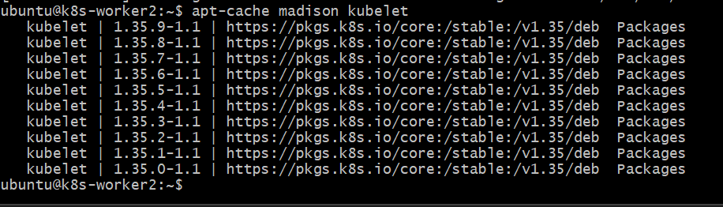
Then install it: sudo apt-mark unhold kubelet
sudo apt-get install -y kubelet='1.35.9-1.1'
sudo apt-mark hold kubelet
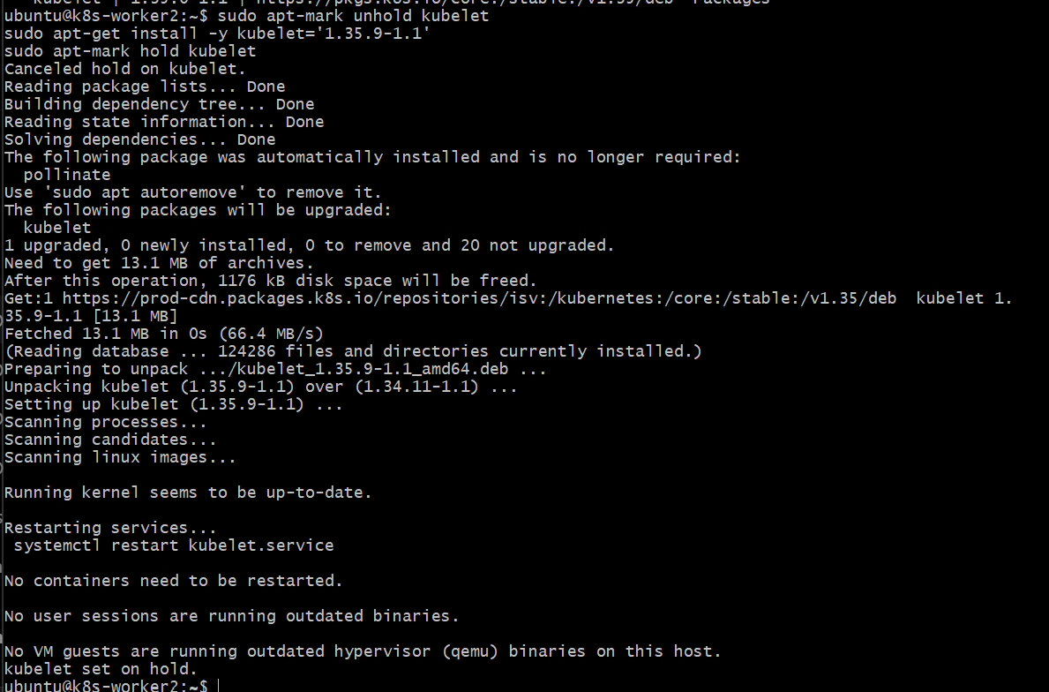
Restart kubelet:
sudo systemctl daemon-reload
sudo systemctl restart kubelet
Verify: kubelet --version
sudo systemctl is-active kubelet
Expected: Kubernetes v1.35.9
Active
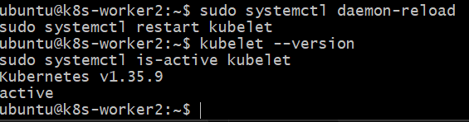
Step 10 — Uncordon Worker2
First exit Worker2: exit
You should return to:
ubuntu@k8s-master:~$
Then run:
kubectl uncordon k8s-worker2
Expected:
node/k8s-worker2 uncordoned
Now verify the cluster:
kubectl get nodes -o wide
Expected:
NAME STATUS ROLES VERSION
k8s-master Ready control-plane v1.35.9
k8s-worker1 Ready <none> v1.35.9
k8s-worker2 Ready <none> v1.35.9
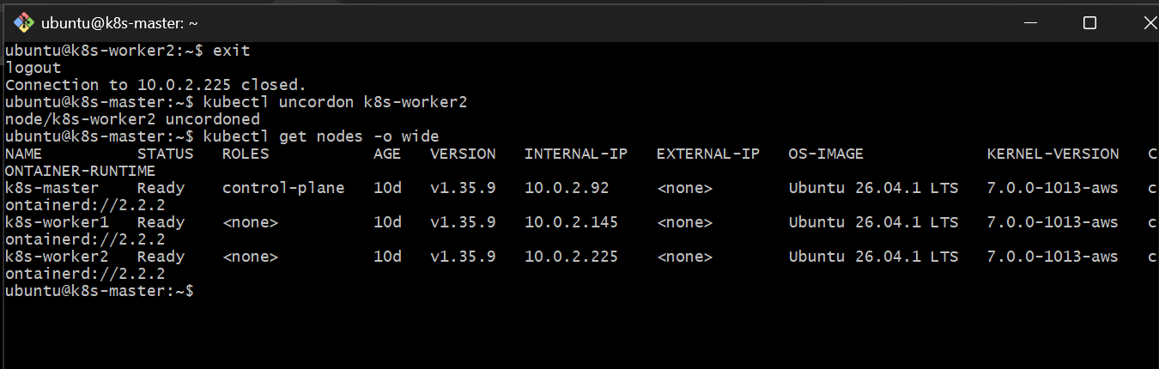
Also run:
kubectl get pods -A
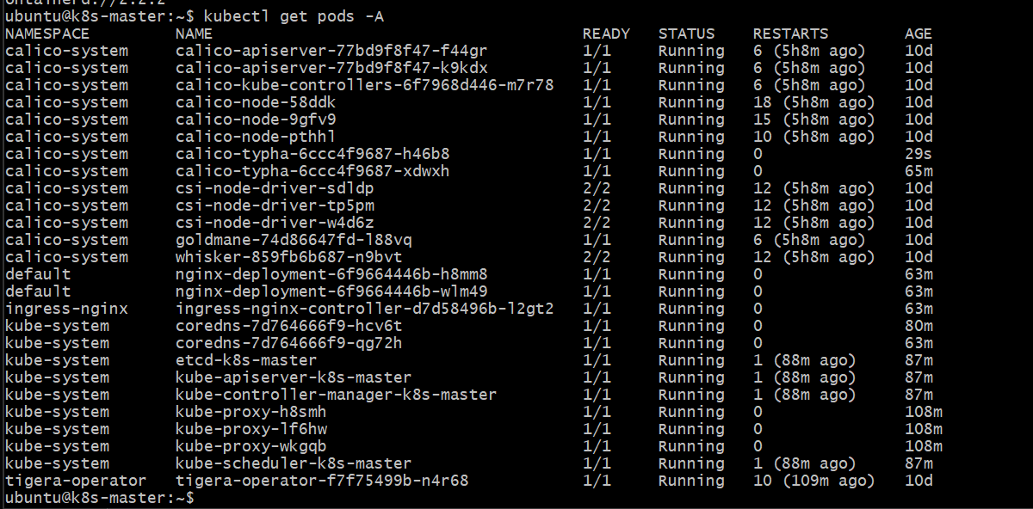
Phase 2 — v1.35.9 → v1.36.5
We will follow the same safe sequence:
Control Plane
↓
kubeadm 1.36.5
↓
API Server 1.36.5
↓
kubelet 1.36.5
↓
Worker 1 drain → upgrade → uncordon
↓
Worker 2 drain → upgrade → uncordon
Step 11 — Prepare Control Plane for v1.36.5
We are currently on:
k8s-master v1.35.9
k8s-worker1 v1.35.9
k8s-worker2 v1.35.9
On k8s-master, first change the Kubernetes repository:
echo 'deb [signed-by=/etc/apt/keyrings/kubernetes-apt-keyring.gpg] https://pkgs.k8s.io/core:/stable:/v1.36/deb/ /' | sudo tee /etc/apt/sources.list.d/kubernetes.list
Then:
sudo apt update
Check available kubeadm versions:
apt-cache madison kubeadm
We want:
1.36.5-1.1
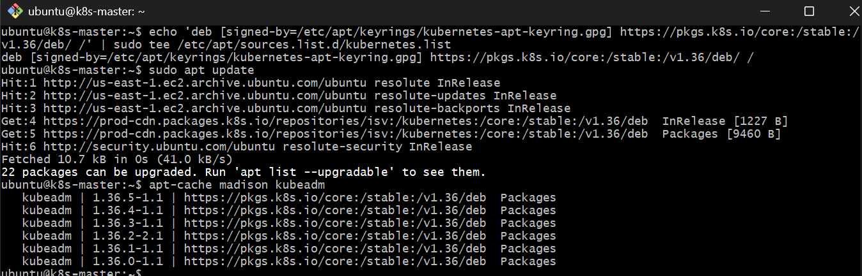
Step 11.1 — Upgrade kubeadm on Control Plane
Run:
sudo apt-mark unhold kubeadm
sudo apt-get install -y kubeadm='1.36.5-1.1'
sudo apt-mark hold kubeadm
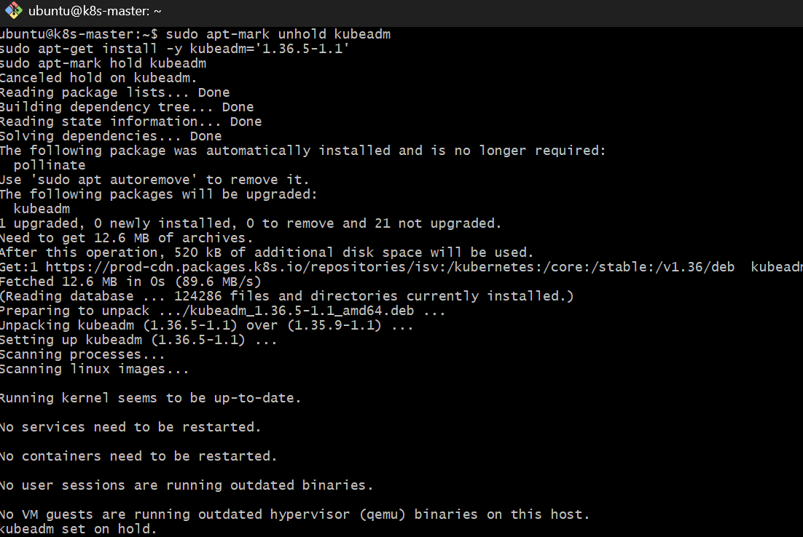
Verify: kubeadm version
Expected: GitVersion:"v1.36.5"
Step 11.2 — Check upgrade plan
Now run:
sudo kubeadm upgrade plan
We want the plan to show:
Current cluster version: v1.35.9
Target version: v1.36.5
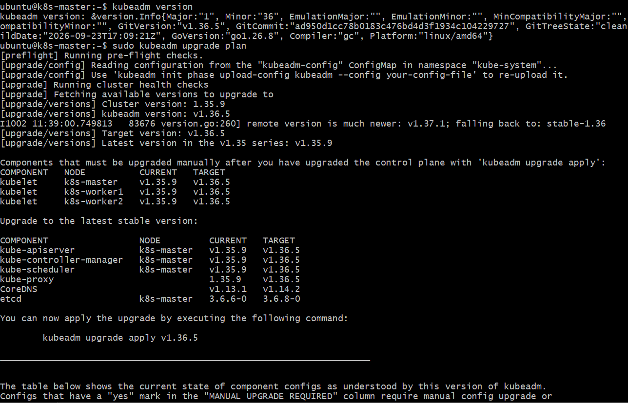
Step 11.3 — Upgrade the Control Plane
Run:
sudo kubeadm upgrade apply v1.36.5
When prompted:
Are you sure you want to proceed? [y/N]:
Enter:
y
This will upgrade:
- kube-apiserver → v1.36.5
- kube-controller-manager → v1.36.5
- kube-scheduler → v1.36.5
- kube-proxy → v1.36.5
- CoreDNS → v1.14.2
- etcd → 3.6.8-0
Important: Do not upgrade the kubelet yet.
After it finishes, run:
kubectl get nodes
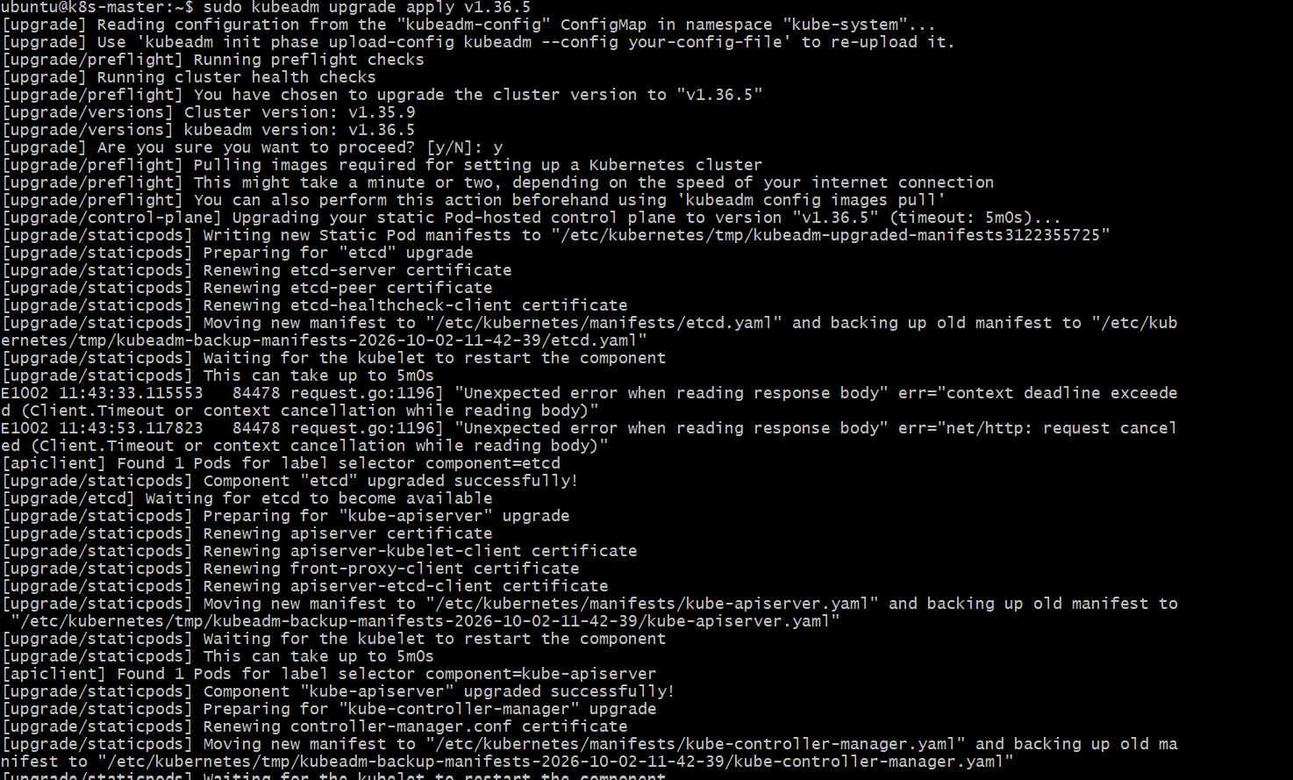
Step 11.4 — Upgrade Control Plane kubelet
First check: apt-cache madison kubelet
Confirm that: 1.36.5-1.1
is available.
Then run:sudo apt-mark unhold kubelet
sudo apt-get install -y kubelet='1.36.5-1.1'
sudo apt-mark hold kubelet
Restart it:
sudo systemctl daemon-reload
sudo systemctl restart kubelet
Verify:
kubelet --version
sudo systemctl is-active kubelet
Expected:
Kubernetes v1.36.5
Active
