Docker - Challenge
Challenge 1 — Create a customized Docker image using a Dockerfile
We will create a custom Nginx image with our own index.html.
Step 1 — Connect to Docker-server
SSH into your Docker-server instance.
ssh -i your-key.pem ec2-user@<DOCKER-SERVER-PUBLIC-IP>
Check Docker: docker --version
You should get something like: Docker version ...
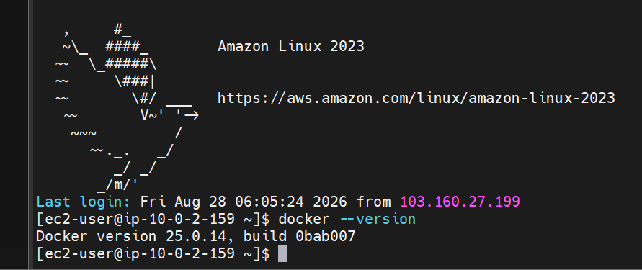Step 2 — Create a project directory
mkdir ~/docker-custom
cd ~/docker-custom
Check: pwd
Expected: /home/ec2-user/docker-custom
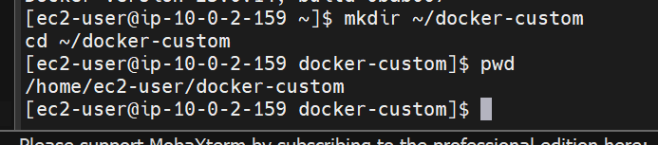
Step 3 — Create index.html
vi index.html
Put this inside: <!DOCTYPE html>
<html>
<head>
<title>My Custom Docker Image</title>
</head>
<body>
<h1>Hello from My Custom Docker Image!</h1>
<p>This page is running inside a customized Nginx Docker container.</p>
</body>
</html>
Save: ESC :wq
ENTER
Check: cat index.html
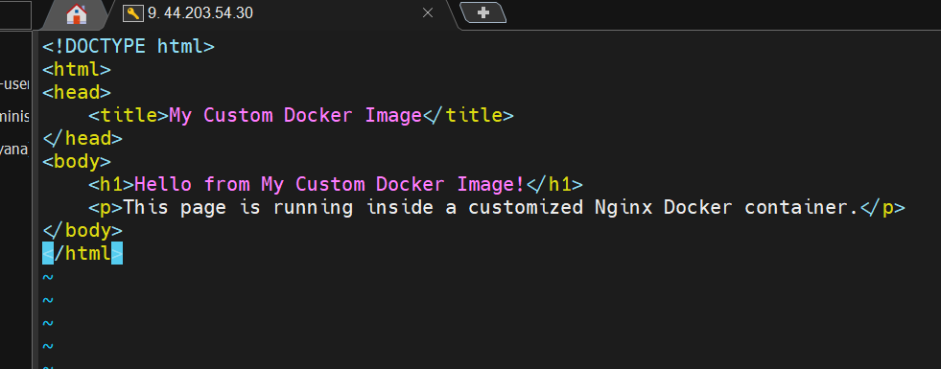
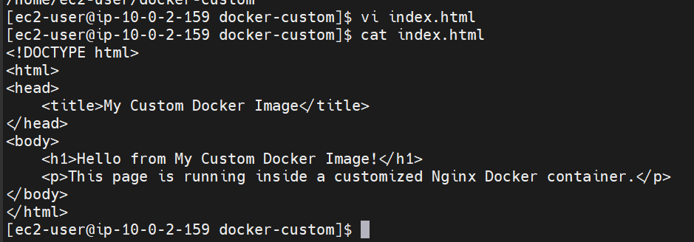

Step 4 — Create the Dockerfile
vi Dockerfile
Put: FROM nginx:latest
COPY index.html /usr/share/nginx/html/index.html
EXPOSE 80
CMD ["nginx", "-g", "daemon off;"]
Save: ESC :wq
ENTER
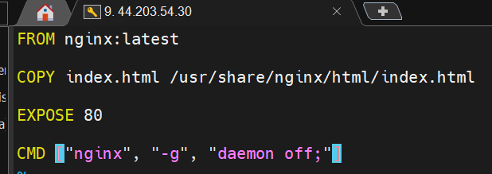
Check: cat Dockerfile
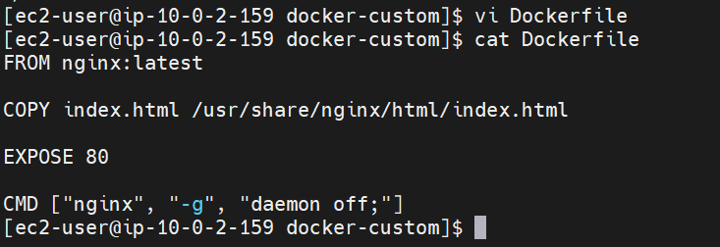
Step 5 — Build the customized image
Run: docker build -t my-custom-nginx:1.0 .
The . means use the current directory as the build context.
At the end you should see something similar to: Successfully tagged my-custom-nginx:1.0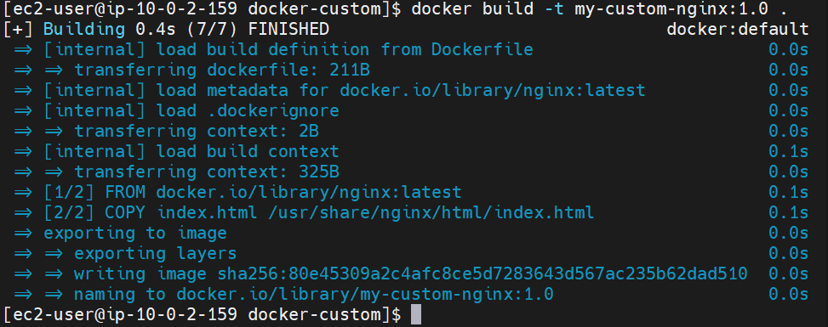
Step 6 — Verify the image
docker images
You should see:
REPOSITORY TAG IMAGE ID CREATED SIZE
my-custom-nginx 1.0 xxxxxxxxxxxx ... ...
nginx latest xxxxxxxxxxxx ... ...
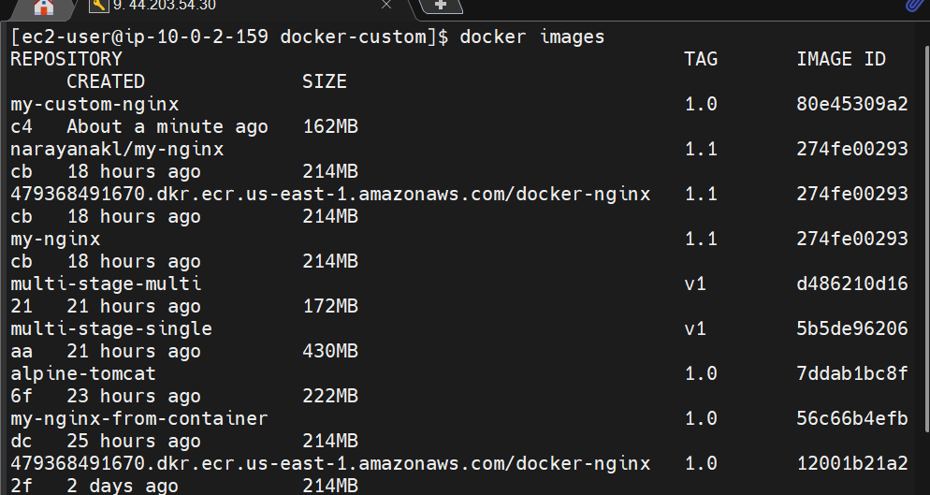
Step 7 — Create a container from our custom image
Use port 8082 so we don't conflict with the containers we created earlier:
docker run -d --name custom-nginx -p 8082:80 my-custom-nginx:1.0
Check: docker ps
You should see: custom-nginx my-custom-nginx:1.0 ... 0.0.0.0:8082->80/tcp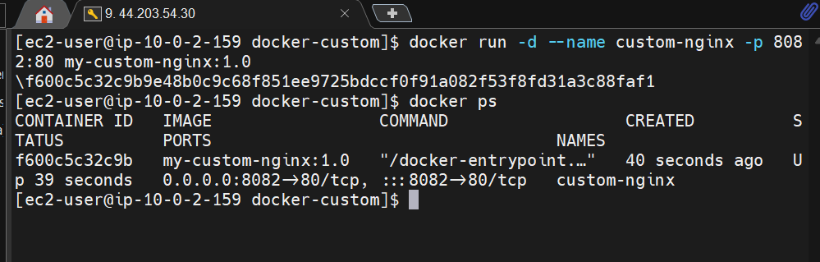
Step 8 — Test the customized website
From the Docker-server itself: curl http://localhost:8082
You should see: <h1>Hello from My Custom Docker Image!</h1>
You can also test: curl http://localhost:8082 | grep "Hello"
Expected: <h1>Hello from My Custom Docker Image!</h1>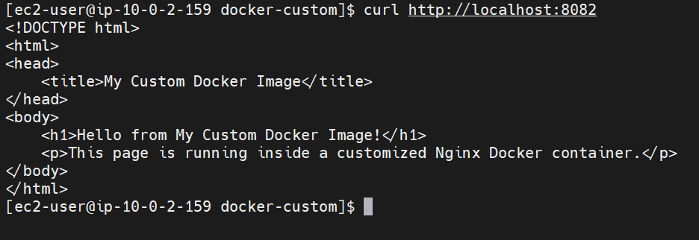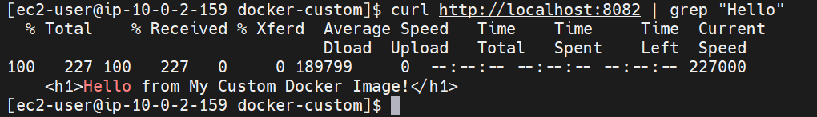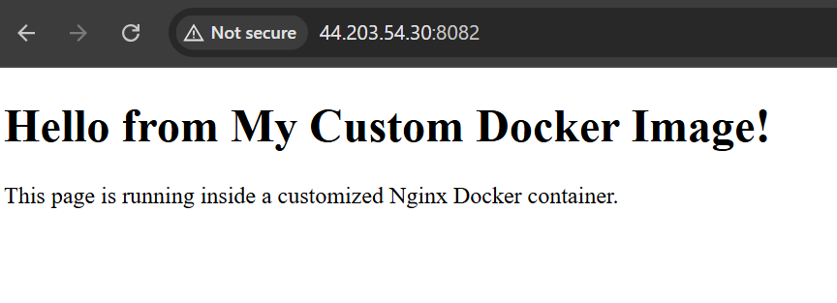
Your flow is:
Dockerfile
↓
docker build
↓
my-custom-nginx:1.0
↓
docker run
↓
custom-nginx container
↓
Nginx serves our customized index.html
2.Push the image to Docker Hub.
Great. We already created: my-custom-nginx:1.0
Now we will push it to Docker Hub. Since we previously used the Docker Hub username narayanakl, we'll use that same repository.
Step 1 — Check the image
On your Docker-server: docker images
You should see: REPOSITORY TAG
my-custom-nginx 1.0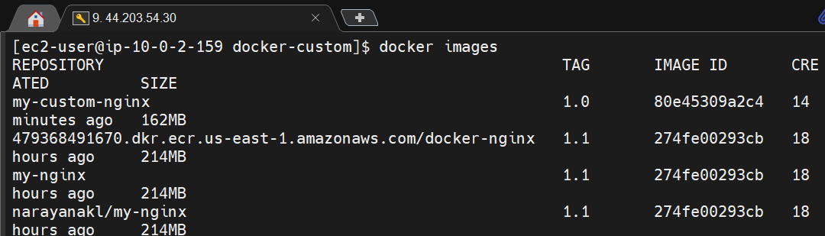
Step 2 — Login to Docker Hub
docker login
Enter your Docker Hub username: Username: narayanakl
For the password, use your Docker Hub password or Personal Access Token.
You should get: Login Succeeded
Step 3 — Tag the image
Docker Hub requires the image to be tagged with your Docker Hub username.
Run: docker tag my-custom-nginx:1.0 narayanakl/my-custom-nginx:1.0
Check: docker images
You should now see: REPOSITORY TAG
my-custom-nginx 1.0
narayanakl/my-custom-nginx 1.0
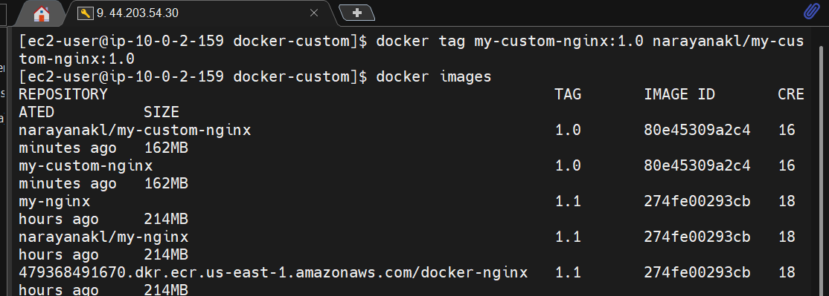

Step 4 — Push to Docker Hub
Run: docker push narayanakl/my-custom-nginx:1.0
You should see layers being uploaded and finally something similar to:
1.0: digest: sha256:xxxxxxxx...
1.0: size: ...
That means the push was successful. ✅
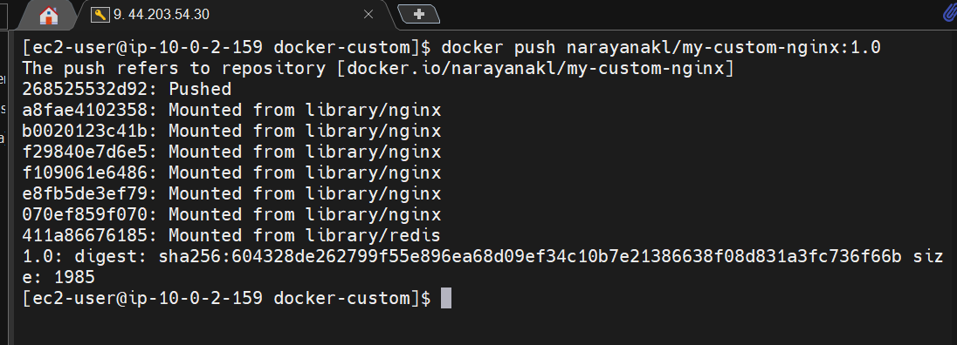
Step 5 — Verify on Docker Hub
Open Docker Hub and check your repositories.
You should have: narayanakl/my-custom-nginx
with tag: 1.0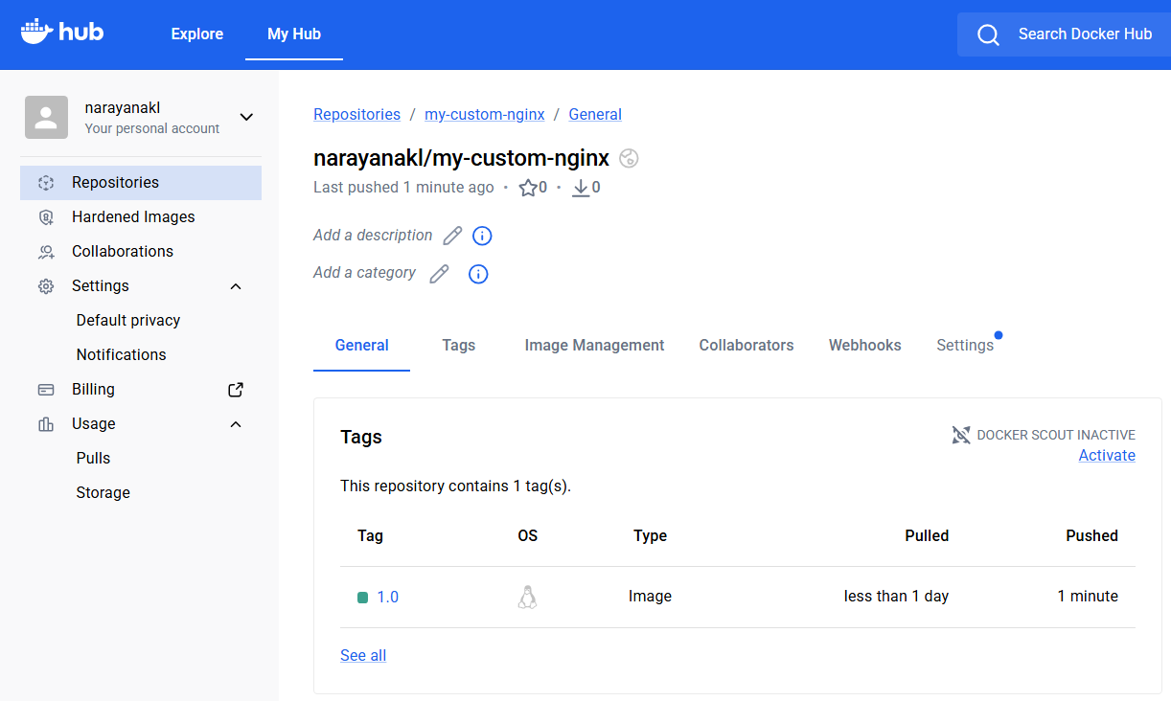
Challenge 2 completed ✅
Your complete flow is now:
Dockerfile
↓
docker build
↓
my-custom-nginx:1.0
↓
docker tag
↓
narayanakl/my-custom-nginx:1.0
↓
docker push
↓
Docker Hub ✅
Yes. We already have the image my-custom-nginx:1.0 and previously worked with ECR on the Docker-server. We'll push the same image to Amazon ECR.
We'll use us-east-1 and the ECR repository docker-nginx that we created earlier.
Challenge 3 — Push the same image to Amazon ECR
Step 1 — Check AWS identity
On Docker-server: aws sts get-caller-identity
You should see your AWS account information.
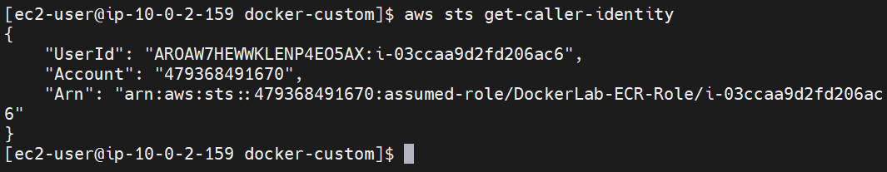
Step 2 — Check the ECR repository
aws ecr describe-repositories \
--repository-names docker-nginx \
--region us-east-1
If it shows: repositoryName: docker-nginx
continue.
If you get RepositoryNotFoundException, tell me before creating anything—we'll handle it.
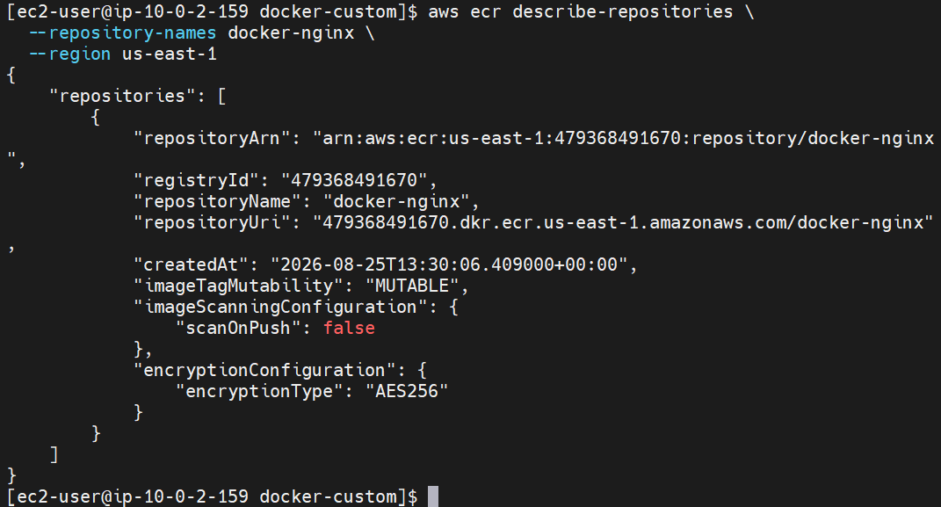
Step 3 — Login Docker to ECR
Run: aws ecr get-login-password --region us-east-1 | \
docker login --username AWS --password-stdin \
$(aws sts get-caller-identity --query Account --output text).dkr.ecr.us-east-1.amazonaws.com
Expected: Login Succeeded
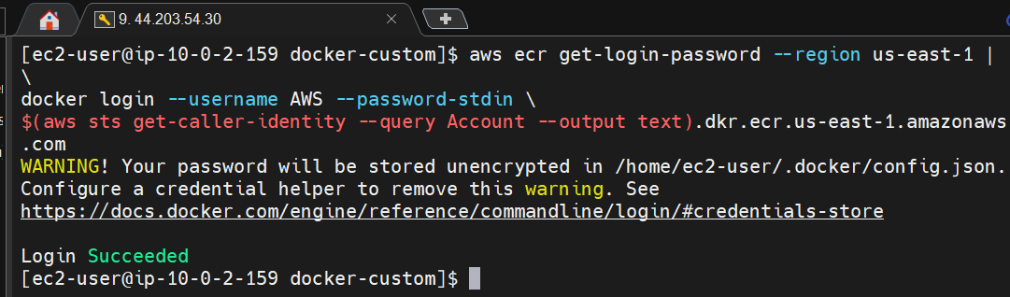
Step 4 — Get your AWS Account ID
aws sts get-caller-identity \
--query Account \
--output text
You'll get something like:
479368491670
Use your actual output, not the example above. 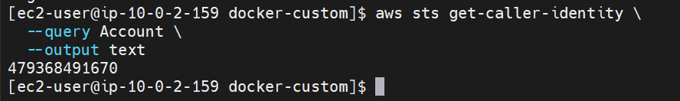
Step 5 — Tag the same image for ECR
First check: docker images
You should have: my-custom-nginx 1.0
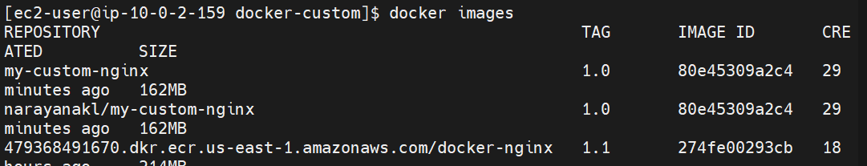
Now tag it: docker tag my-custom-nginx:1.0 \
<ACCOUNT_ID>.dkr.ecr.us-east-1.amazonaws.com/docker-nginx:1.0
For example, if your account ID is 479368491670: docker tag my-custom-nginx:1.0 \
479368491670.dkr.ecr.us-east-1.amazonaws.com/docker-nginx:1.0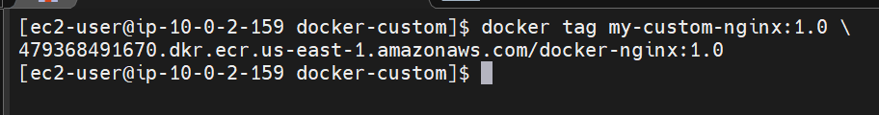
Step 6 — Verify the tag
docker images
You should see something like:
REPOSITORY TAG
my-custom-nginx 1.0
<ACCOUNT_ID>.dkr.ecr.us-east-1.amazonaws.com/docker-nginx 1.0
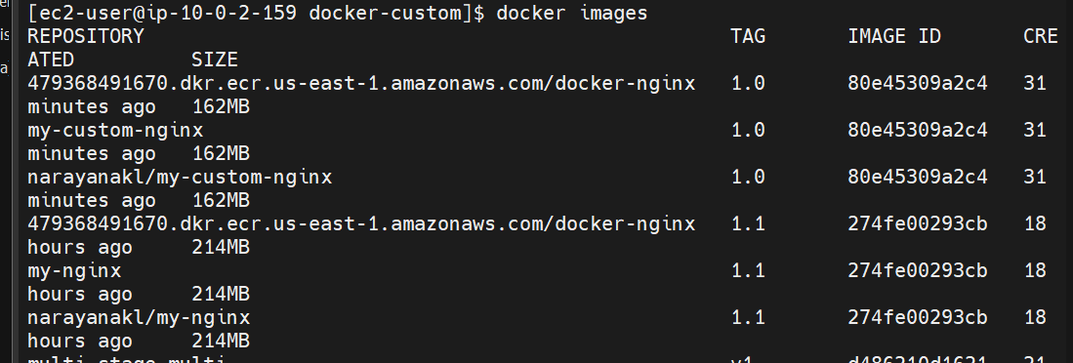

Step 7 — Push the image to ECR
Run: docker push \
<ACCOUNT_ID>.dkr.ecr.us-east-1.amazonaws.com/docker-nginx:1.0
Example: docker push \
479368491670.dkr.ecr.us-east-1.amazonaws.com/docker-nginx:1.0
You should see the Docker layers uploading.
At the end, you'll get something similar to:
1.0: digest: sha256:xxxxxxxxxxxxxxxx
1.0: size: xxxxx
That means push successful ✅
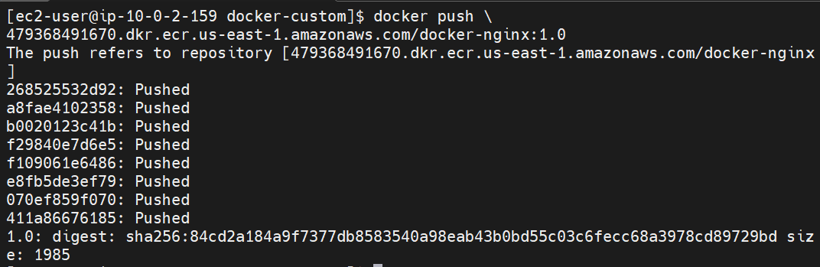
Step 8 — Verify from AWS CLI
aws ecr list-images \
--repository-name docker-nginx \
--region us-east-1
You should see: imageTag: 1.0
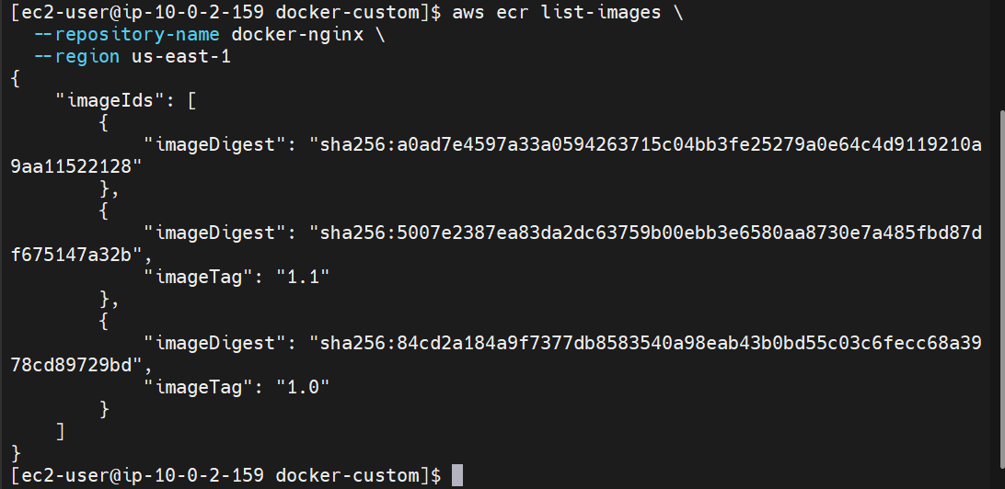
Challenge 3 complete ✅
Your image has now gone through:
Dockerfile
↓
my-custom-nginx:1.0
↓
Docker Hub
↓
Amazon ECR
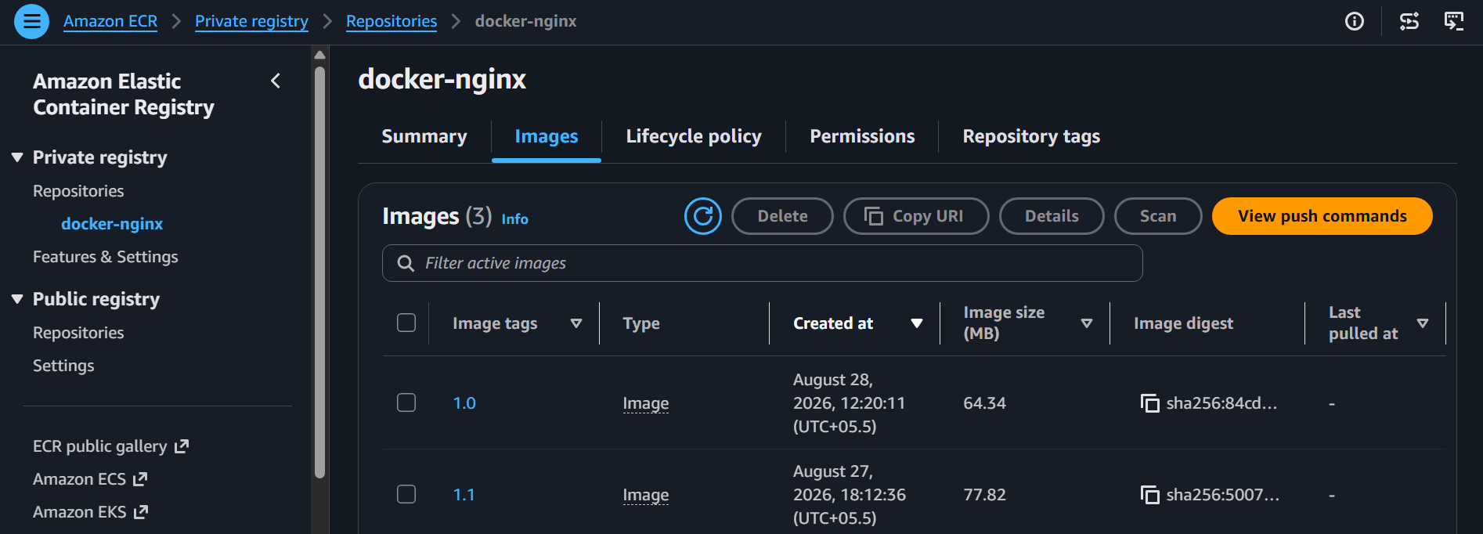
4. Provision one EC2 instance using Terraform and install Jenkins.
For Challenge 4, we'll use the existing Docker-server as our Terraform machine.
Our plan: Docker-server
↓
Install Terraform
↓
Create Terraform files
↓
Terraform creates 1 EC2 instance
↓
Install Jenkins on that EC2
Let's do only Terraform installation first.
Step 1 — Install required tools
Run: sudo dnf install -y yum-utils
Then: sudo dnf config-manager --add-repo https://rpm.releases.hashicorp.com/AmazonLinux/hashicorp.repo
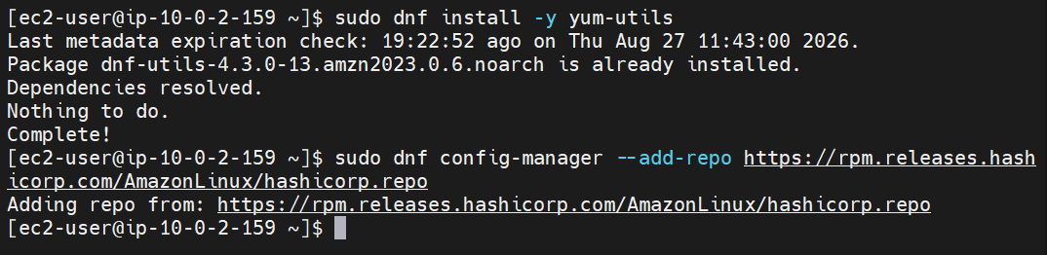
Step 4 — Install Terraform
sudo dnf install -y terraform
Wait for the installation to finish.
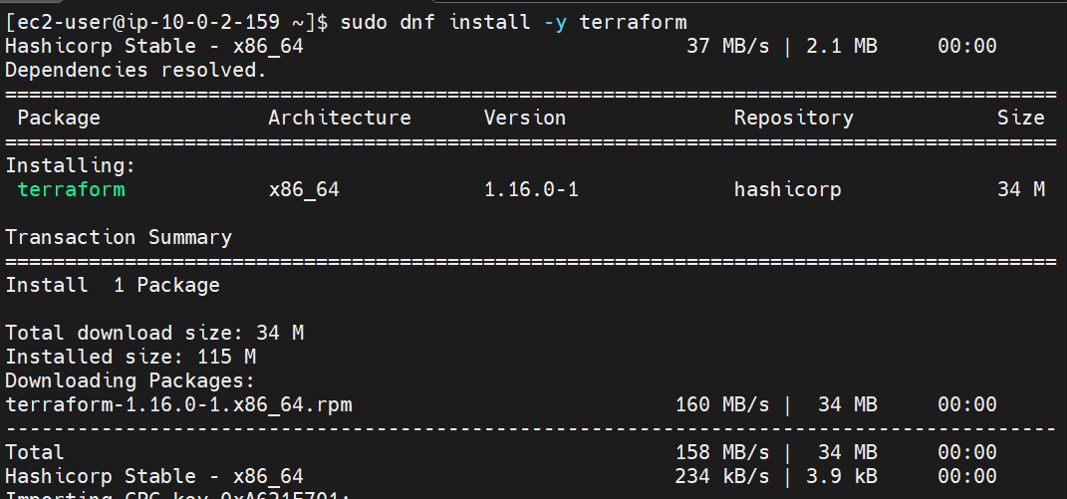
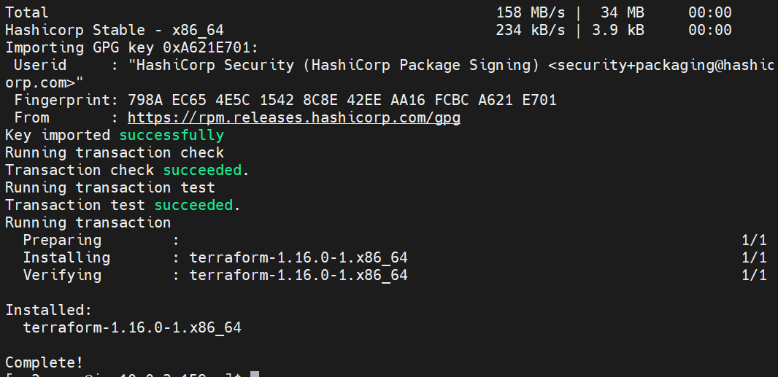

Step 5 — Verify Terraform
terraform --version
You should get something similar to: Terraform v1.x.x
on linux_amd64
Also run: which terraform
Expected: /usr/bin/terraform
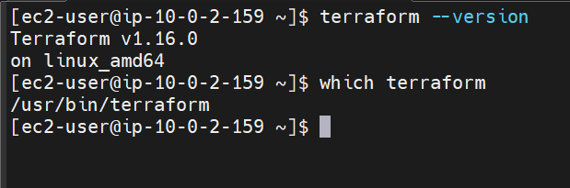
Step 6 — Create Terraform project directory
On Docker-server: mkdir -p ~/terraform-jenkins
cd ~/terraform-jenkins
Check: pwd
Expected: /home/ec2-user/terraform-jenkins
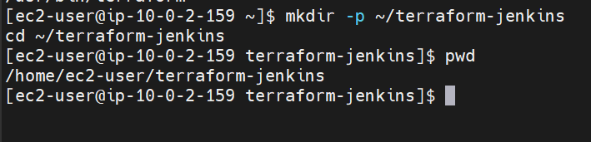
Step 7 — Check AWS access
Before Terraform creates anything, let's confirm that Docker-server can access AWS.
Run: aws sts get-caller-identity
You should see your AWS account and the IAM role/user being used.
Then check your default region: aws configure get region
If it returns: us-east-1
we can continue.
If it returns nothing, don't run aws configure yet. We'll set the region through Terraform. 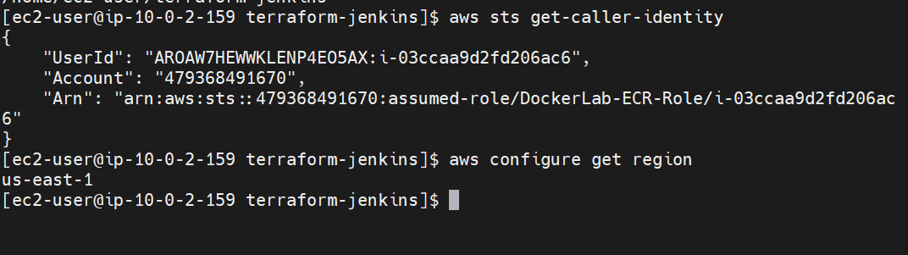
Step 8 — Create main.tf
Run: vi main.tf
Paste this:
terraform {
required_providers {
aws = {
source = "hashicorp/aws"
version = "~> 6.0"
}
}
}

provider "aws" {
region = "us-east-1"
}

resource "aws_security_group" "jenkins_sg" {
name = "terraform-jenkins-sg"
description = "Security group for Jenkins"
vpc_id = "vpc-03b4412156c533bef"

ingress {
description = "SSH"
from_port = 22
to_port = 22
protocol = "tcp"
cidr_blocks = ["0.0.0.0/0"]
}

ingress {
description = "Jenkins"
from_port = 8080
to_port = 8080
protocol = "tcp"
cidr_blocks = ["0.0.0.0/0"]
}

egress {
from_port = 0
to_port = 0
protocol = "-1"
cidr_blocks = ["0.0.0.0/0"]
}

tags = {
Name = "Terraform-Jenkins-SG"
}
}

resource "aws_instance" "jenkins" {
ami = "ami-0c101f26f147fa7fd"
instance_type = "t3.micro"

subnet_id = "subnet-01f14bfb01c15b0cb"
vpc_security_group_ids = [aws_security_group.jenkins_sg.id]

tags = {
Name = "Terraform-Jenkins"
}
}
Save:ESC :wq
ENTER
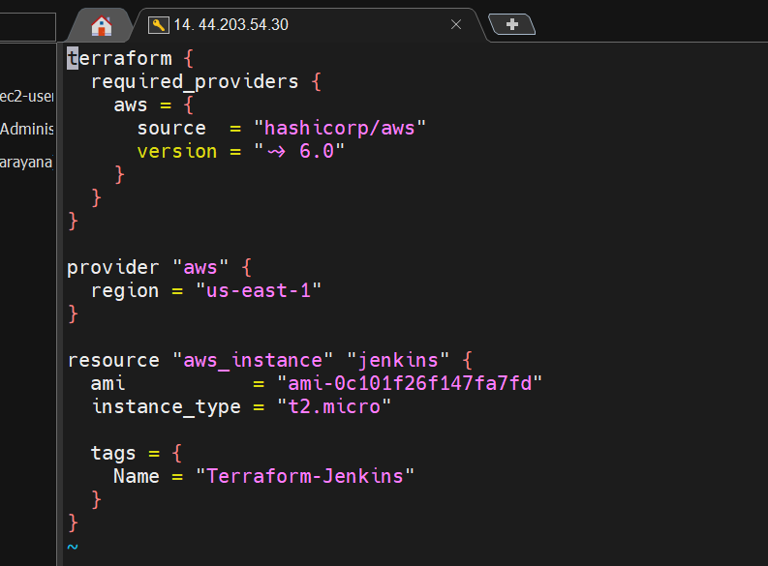
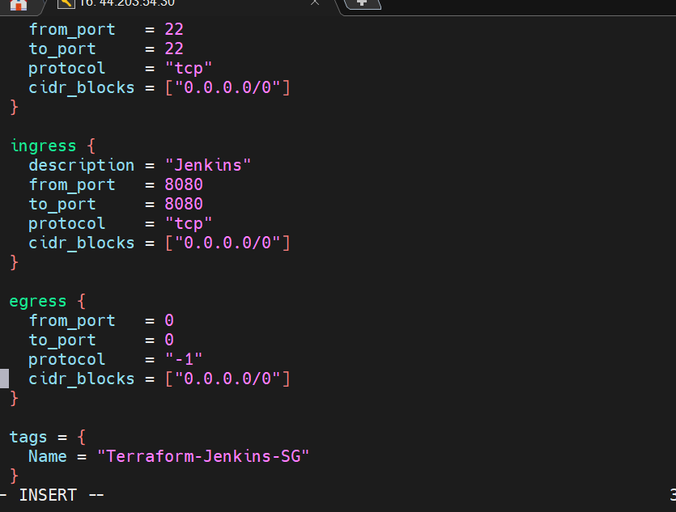
What this does
Terraform will create:
Setting | Value
Region | us-east-1
AMI | Amazon Linux
Instance type | t2.micro
Instance name | Terraform-Jenkins
Important: This first version does not yet install Jenkins. We will add the Jenkins installation after confirming Terraform can successfully create the EC2 instance.

Step 9 — Check the Terraform file
Run:
cat main.tf
Make sure it looks like the configuration above.
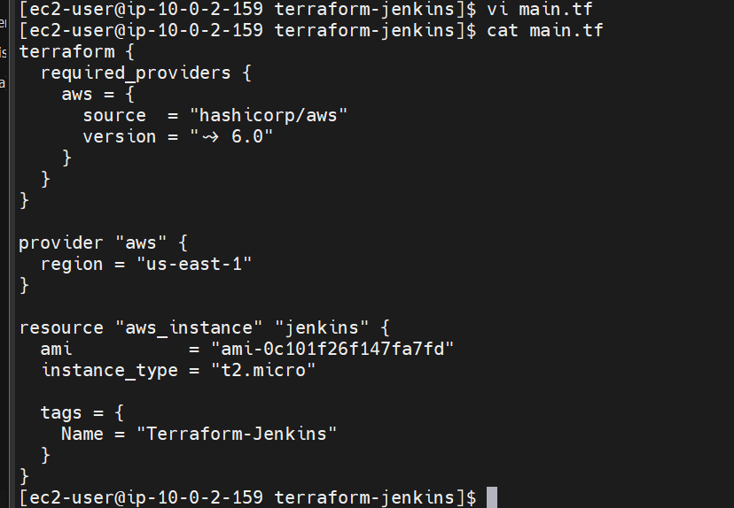

Step 10 — Initialize Terraform
Run: terraform init
You should eventually see: Terraform has been successfully initialized!
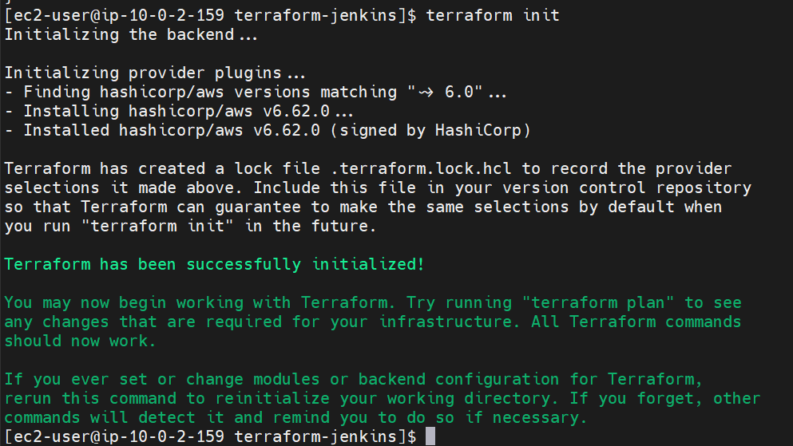
Step 11 — Format the Terraform file
Run: terraform fmt
You should see: main.tf
or no output if it was already formatted.
Then: terraform validate
again.
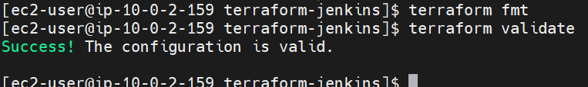
Step 12 — Run Terraform Plan
From: /home/ec2-user/terraform-jenkins
run: terraform plan
Terraform should show something similar to:
Plan: 1 to add, 0 to change, 0 to destroy.
Look for this resource: aws_instance.jenkins
and: instance_type = "t2.micro"
Important
At this stage nothing is created yet.
terraform plan only shows what Terraform intends to create.
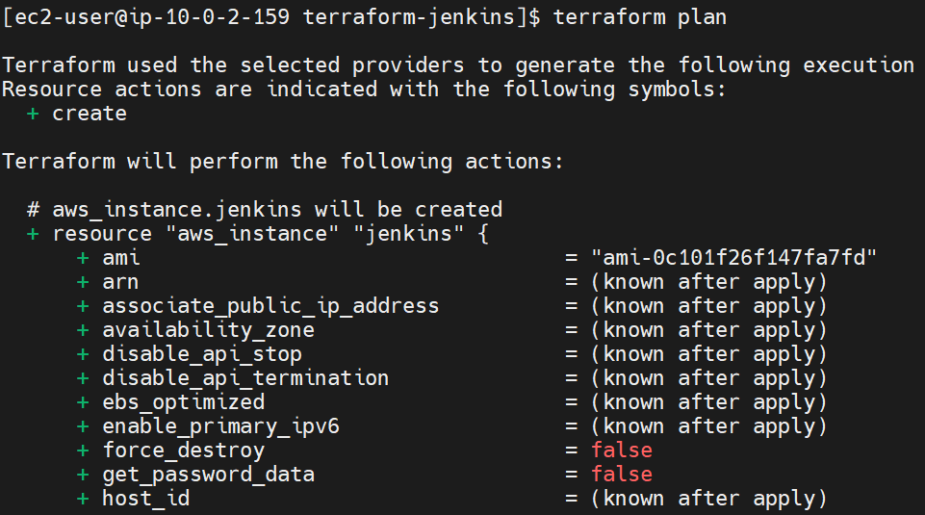
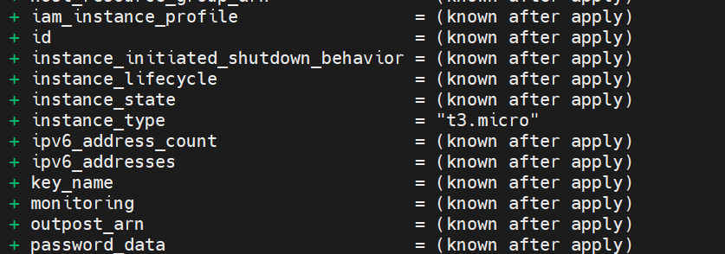Step 13 — Check the plan result
At the bottom, we want: Plan: 1 to add, 0 to change, 0 to destroy.
If you see that, do not run terraform apply yet.
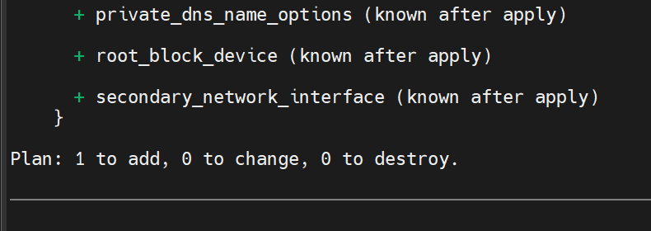
Step 14 — Create the EC2 instance
Now we can actually create it.
Run: terraform apply
Terraform will show the plan again and ask:
Do you want to perform these actions?
Only 'yes' will be accepted to approve.
Type: yes
and press Enter.
Wait for completion
You should eventually see: Apply complete! Resources: 1 added, 0 changed, 0 destroyed.
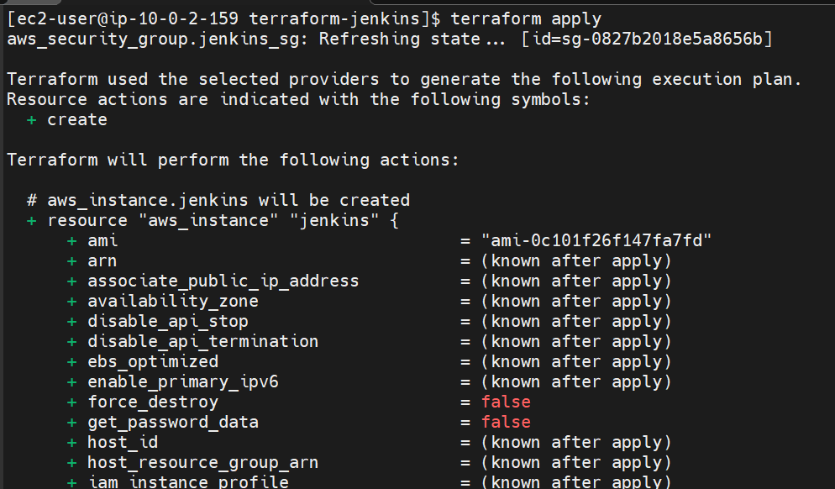
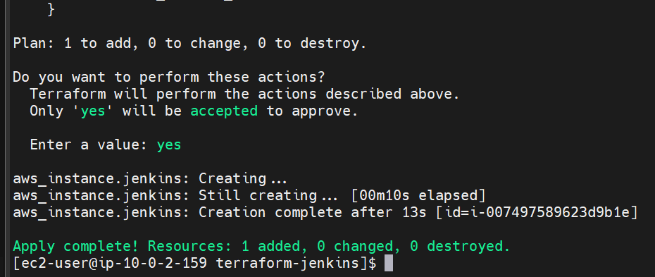
Step 15 — Get the EC2 instance ID
After Terraform finishes: terraform output
We haven't defined outputs yet, so it may not show anything. That's okay.
Instead, run: aws ec2 describe-instances \
--filters "Name=tag:Name,Values=Terraform-Jenkins" \
--query 'Reservations[].Instances[].[InstanceId,PublicIpAddress,State.Name]' \
--output table \
--region us-east-1
You should get something like:
-----------------------------------------
| DescribeInstances |
+------------------+--------------------+
| i-xxxxxxxxxxxxxx | 54.xx.xx.xx |
| | running |
+------------------+--------------------+
Step 16 — Install Jenkins automatically through Terraform
16.1 Edit main.tf
vi main.tf
paste the text below main text:
user_data = <<-EOF
#!/bin/bash
exec > /var/log/jenkins-install.log 2>&1
set -e
echo "===== Starting Jenkins installation ====="
dnf update -y
echo "===== Installing Java 21 ====="
dnf install -y java-21-amazon-corretto wget
echo "===== Checking Java ====="
java -version
echo "===== Downloading Jenkins repository ====="
wget -O /etc/yum.repos.d/jenkins.repo \
https://pkg.jenkins.io/rpm-stable/jenkins.repo
echo "===== Installing Jenkins ====="
dnf install -y jenkins

echo "===== Enabling Jenkins ====="
systemctl enable jenkins
echo "===== Starting Jenkins ====="
systemctl start jenkins
echo "===== Jenkins status ====="
systemctl --no-pager status jenkins
echo "===== Installation completed ====="
EOF
tags = {
Name = "Terraform-Jenkins"
}
}
Save: ESC :wq
ENTER
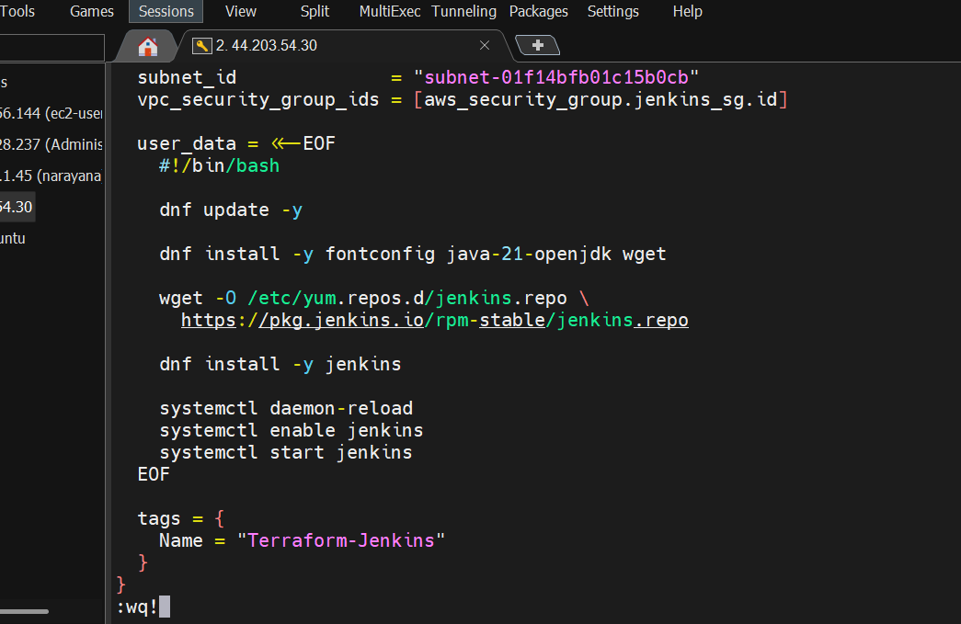
16.2 Format and validate
terraform fmt
Then: terraform validate
Expected: Success! The configuration is valid.
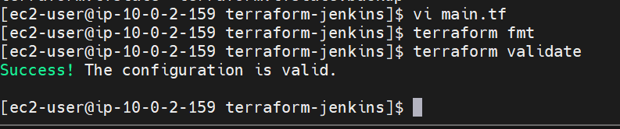
16.3 Check the Terraform plan
Now run: terraform plan
Because we are adding user_data to the existing EC2, Terraform should show that the instance needs to be replaced.
Look for: -/+ aws_instance.jenkins
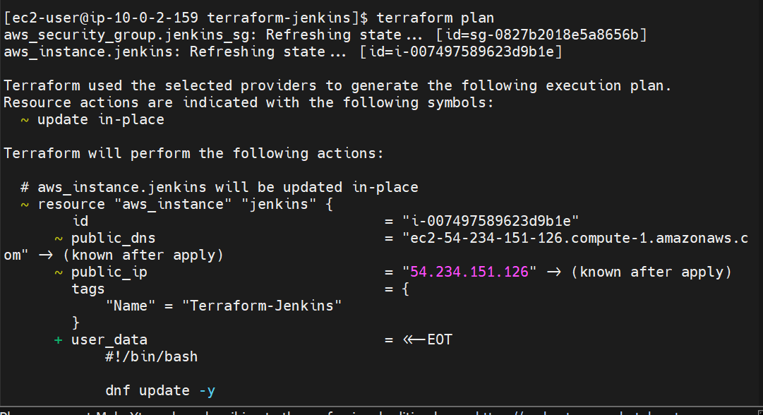
and approximately: Plan: 1 to add, 0 to change, 1 to destroy.
The security group should not be recreated.
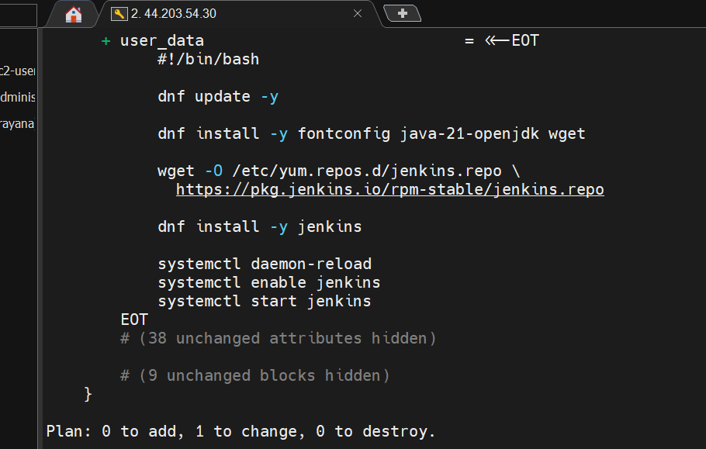
16.4 Apply the change
If the plan looks correct, run: terraform apply
When prompted: Do you want to perform these actions?
type: yes
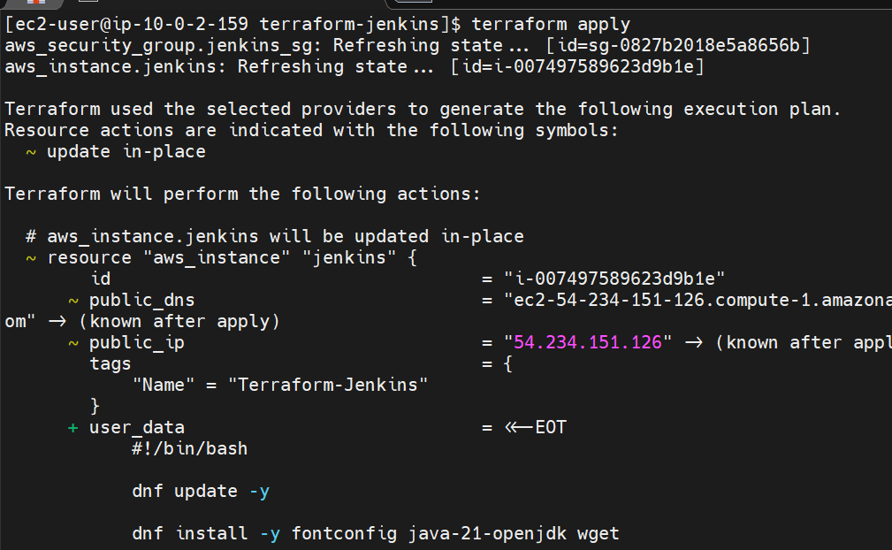
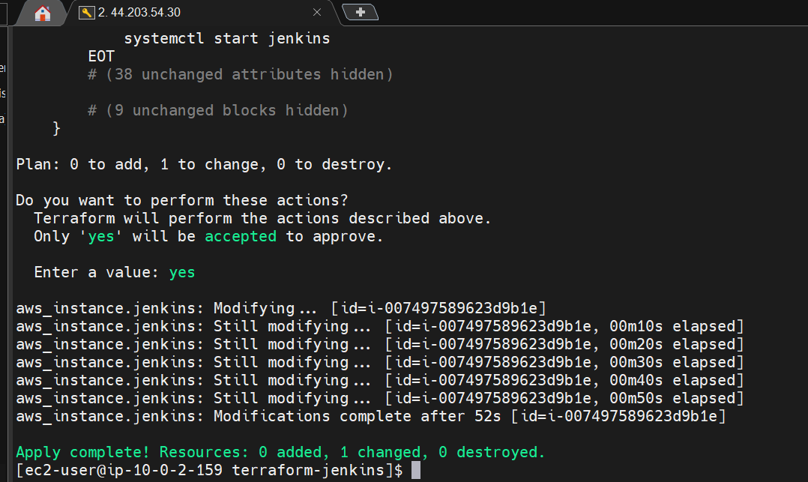
Terraform will:
Destroy old EC2
↓
Create new EC2
↓
Run user_data
↓
Install Java 21
↓
Install Jenkins
↓
Start Jenkins
Wait for:
Apply complete! Resources: 1 added, 0 changed, 1 destroyed.

16.5 Get the new public IP
Run: aws ec2 describe-instances \
--filters "Name=tag:Name,Values=Terraform-Jenkins" \
--query 'Reservations[].Instances[].[InstanceId,PublicIpAddress,PrivateIpAddress,State.Name]' \
--output table \
--region us-east-1
You should get:
| i-xxxxxxxxxxxx | xx.xx.xx.xx | 10.0.2.xx | running |
The public IP will probably be different from 54.234.151.126 because we recreated the instance.
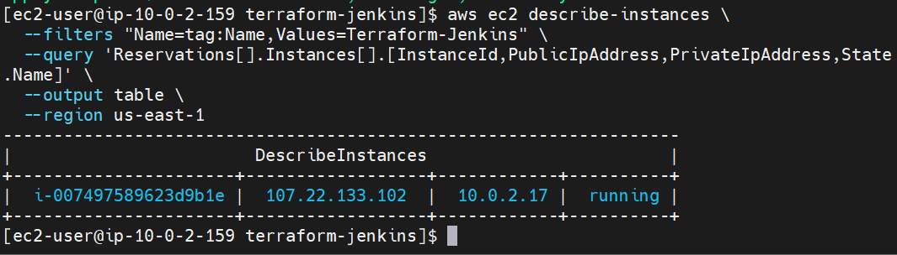

16.6 Wait for Jenkins installation
The EC2 needs a few minutes to execute user_data.
Wait about 2–5 minutes, then open: http://<NEW-PUBLIC-IP>:8080
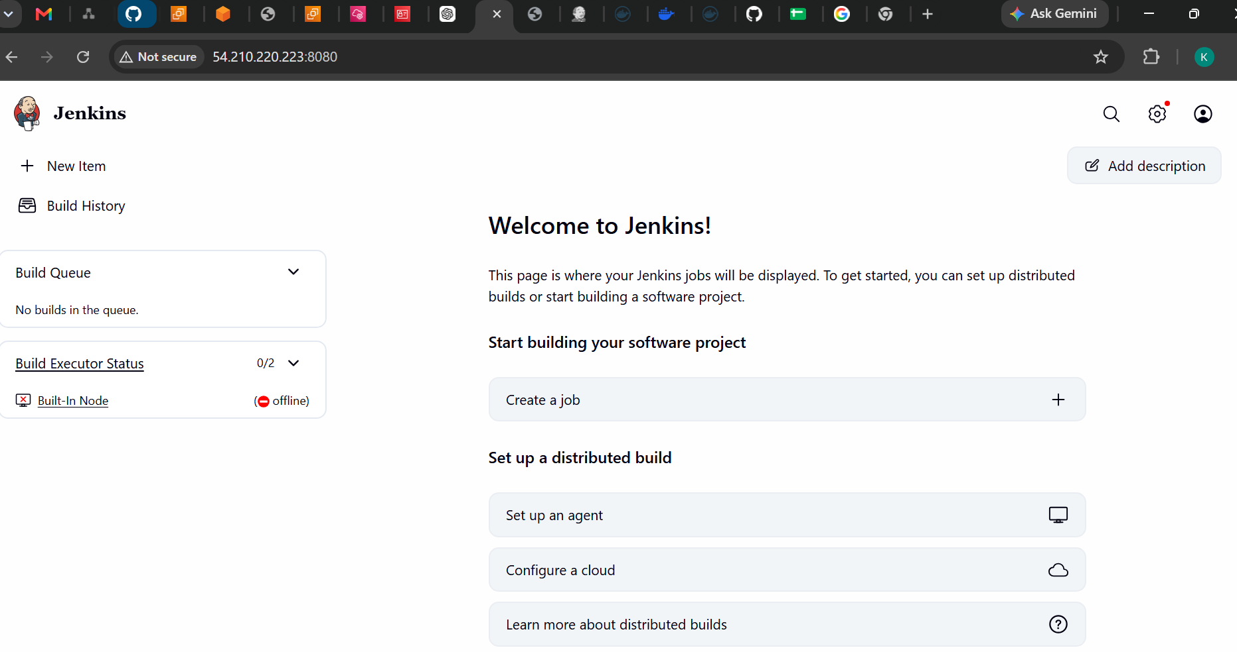16.7 Get the Jenkins initial password
Because we don't have SSH access to this instance, we can retrieve the password through AWS Systems Manager only if the instance has SSM configured.
Before we worry about that, let's first confirm that Jenkins is actually running.
Run this from Docker-server: curl -I http://<NEW-PUBLIC-IP>:8080
A successful Jenkins response will typically contain: HTTP/1.1 403 Forbidden
or: HTTP/1.1 200 OK
A 403 is actually okay at this stage—it means Jenkins is responding.
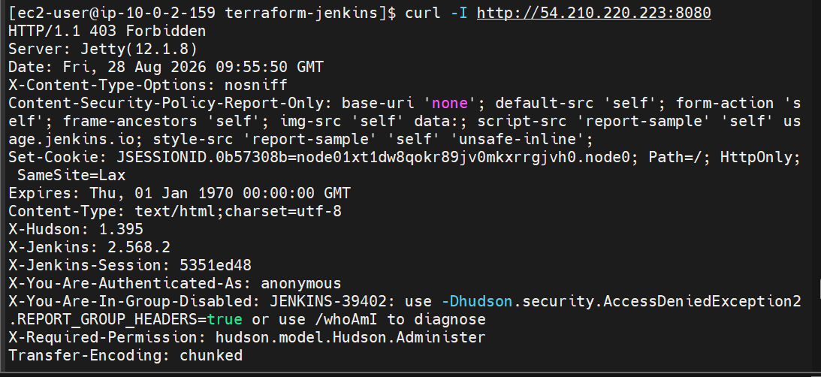
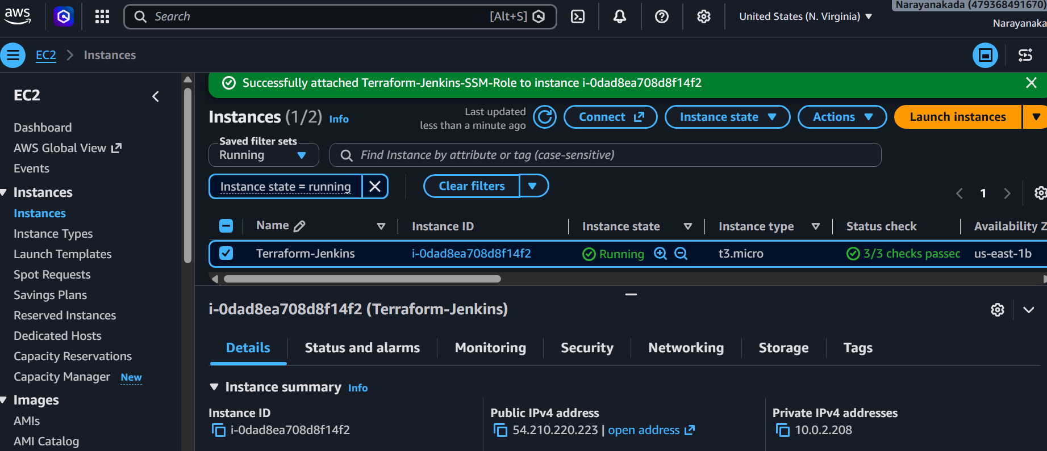

Challenge 5 — Jenkins Docker Build & Push
We will use:
- Source repo: `betawins/Python-app`
- Docker tasks/source examples: `betawins/docker-tasks`
- Docker Hub account: your existing Docker Hub account
- Jenkins EC2: 54.210.220.223
Tasks
Part | Requirement | Status
1 | Frontend Dockerfile → build → run → Docker Hub | ⏳
2 | Java Dockerfile → build → run → Docker Hub | ⏳
3 | Node.js Dockerfile → build with v1 → run → Docker Hub | ⏳
4 | WordPress + MySQL Docker Compose | ⏳
5 | Jenkins job to automate Docker build/push | ⏳
We'll start with the frontend source code.

Step 1 — Clone the source repository
For this challenge, it's better to work on the Docker-server first, because we've already configured Docker there.
SSH into Docker-server and run: cd ~
Then: git clone https://github.com/betawins/Python-app.git
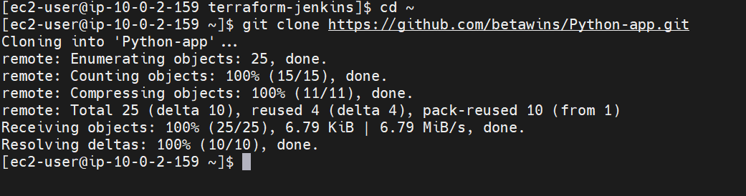
Check: ls
You should see: Python-app
Enter it: cd Python-app
Then: find . -maxdepth 2 -type f
This will show us the actual project structure.
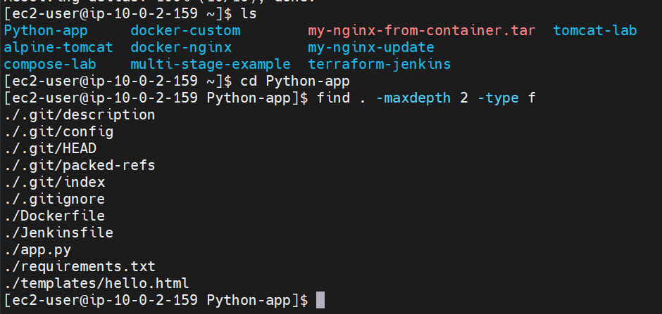
Step 2 — Identify the frontend source
Run: find . -maxdepth 3 -type f | sort
We're looking for files such as: package.json
index.html
src/
public/
or another frontend structure.
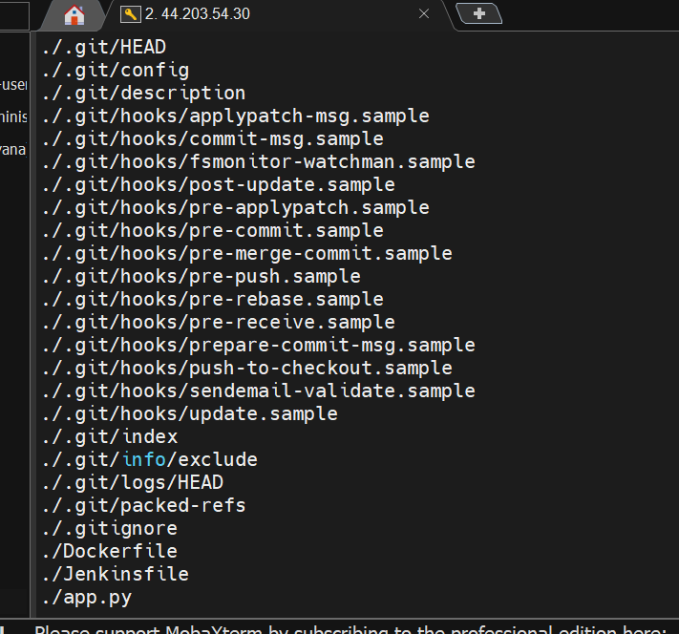
Step 3 — Build the Docker image
You're already inside: ~/Python-app
Run: docker build -t narayanakl/pythonapp:v1 .
At the end you should see something similar to: Successfully tagged narayanakl/pythonapp:v1
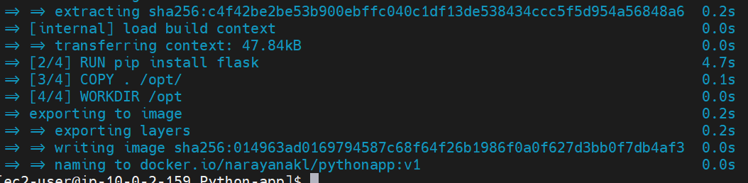
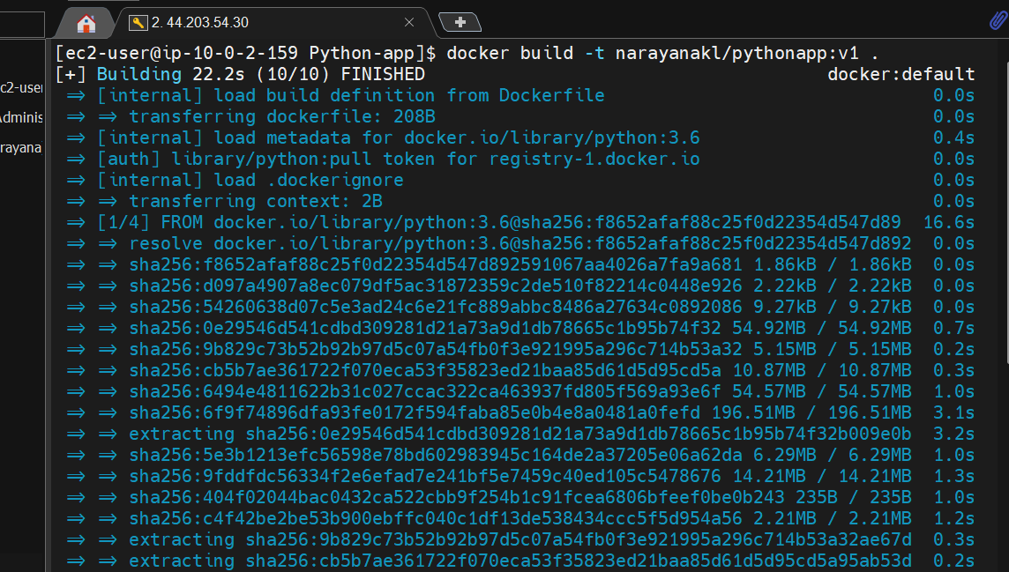
Then verify: docker images | grep pythonapp
Expected: narayanakl/pythonapp v1
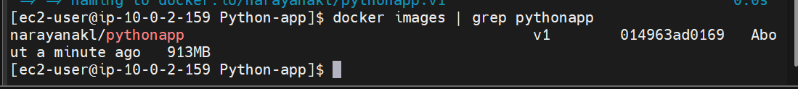
Step 4 — Run the container
Run: docker run -d --name pythonapp -p 8080:8080 narayanakl/pythonapp:v1
Check: docker ps
You should see: pythonapp
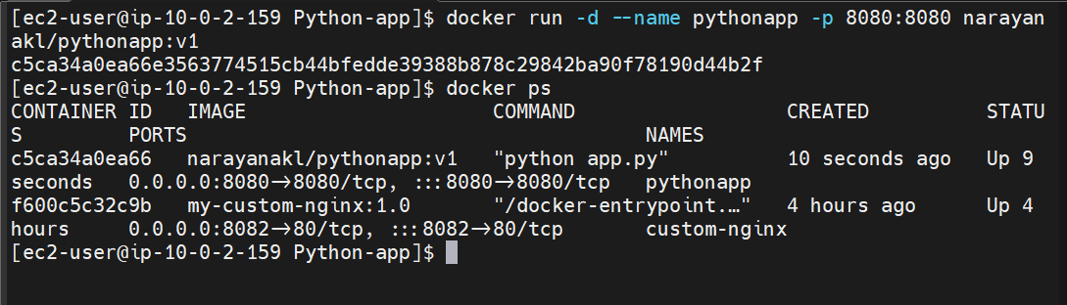

Step 5 — Test the application
Run: curl http://localhost:8080
If the application is working, you'll receive the Flask application's HTML response.
You can also check the logs: docker logs pythonapp
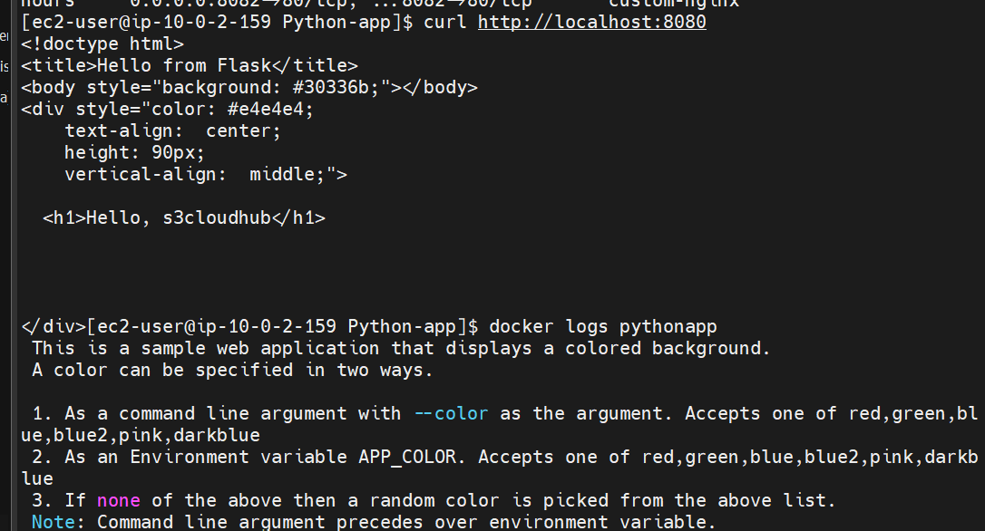

Step 6 — Push to Docker Hub
First log in: docker login
Enter your Docker Hub username: narayanakl
and your Docker Hub password/token.
Then push: docker push narayanakl/pythonapp:v1
You should eventually see: v1: digest: sha256:...
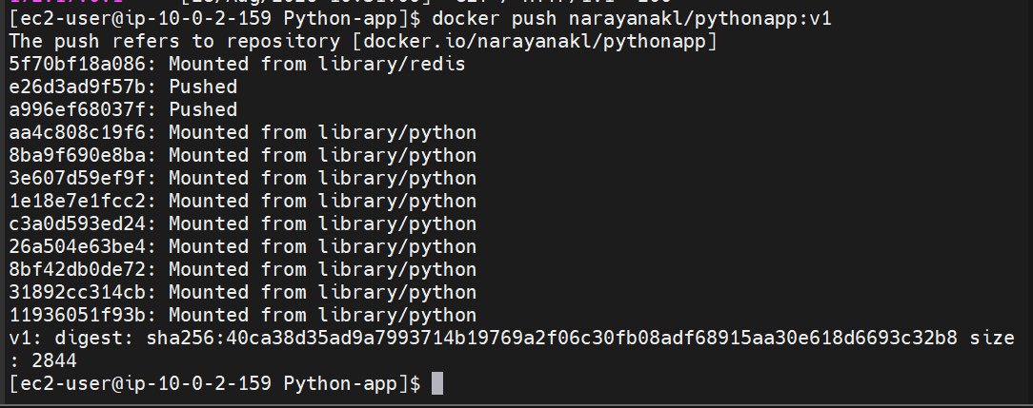
Step 7 — Verify the image
Run: docker images | grep pythonapp
And you can check Docker Hub for: narayanakl/pythonapp:v1
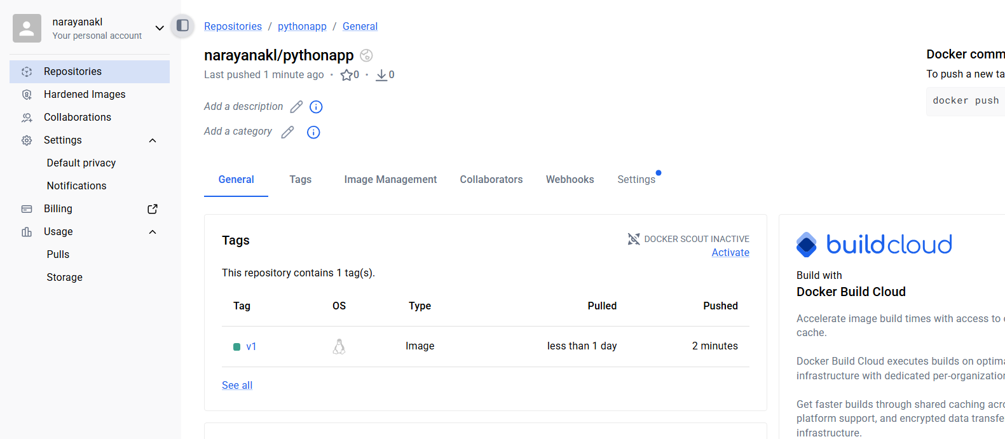
Step 8 — Create the Jenkins Job
Now we'll automate the same process with Jenkins.
Open: http://54.210.220.223:8080
Log in with your admin account.
8.1 Create a new job
Click: New Item
Enter:Python-App-Docker-Build-Push
Select: Pipeline
Click: OK
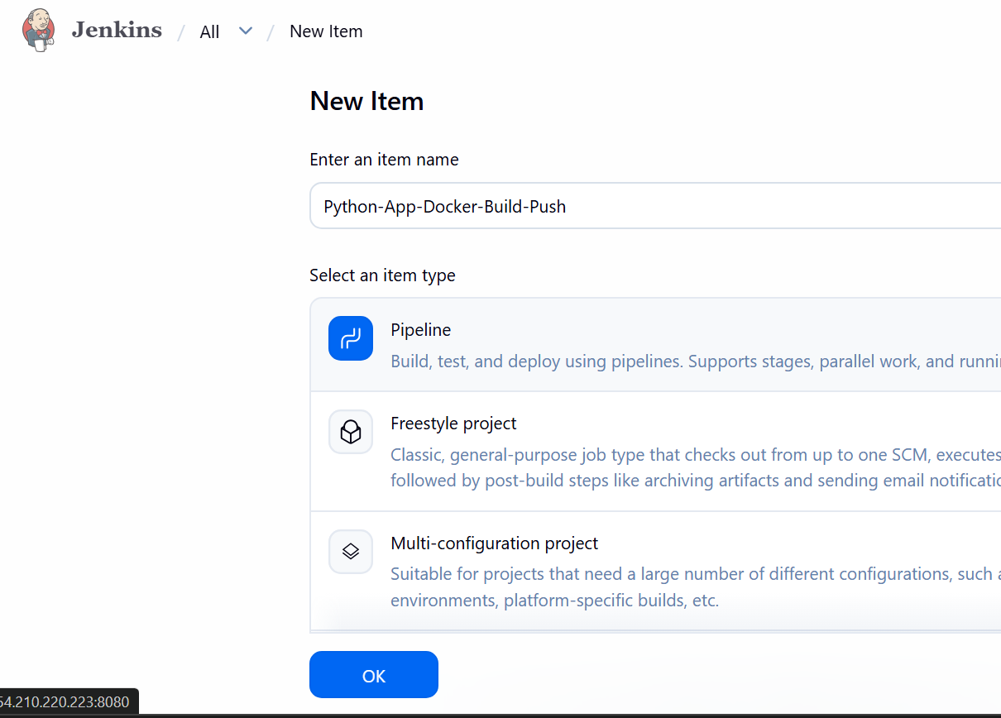
Step 9 — Configure GitHub source
Scroll to the Pipeline section.
For Definition, select: Pipeline script from SCM
For SCM, select: Git
Repository URL: https://github.com/betawins/Python-app.git
Branch:
*/main
If Jenkins says the repository has no main branch, we'll check the actual branch. 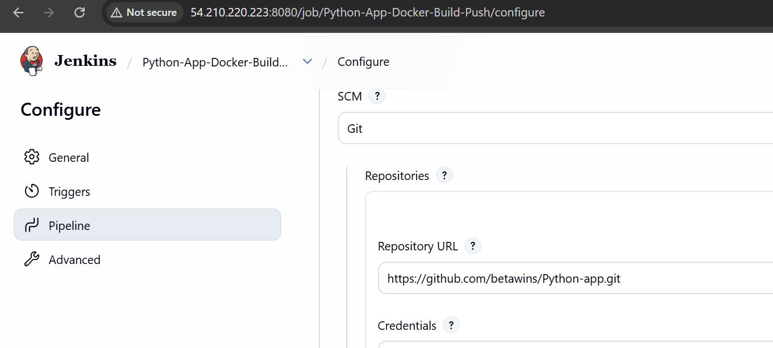
For Script Path: Jenkinsfile

Make sure Docker works on Jenkins EC2
Connect to your Terraform-Jenkins EC2 through AWS Systems Manager.
Run: docker --version
If Docker isn't installed: sudo dnf install docker -y
sudo systemctl enable --now docker
Then give Jenkins permission: sudo usermod -aG docker jenkins
Restart Jenkins: sudo systemctl restart jenkins
Test: sudo -u jenkins docker ps
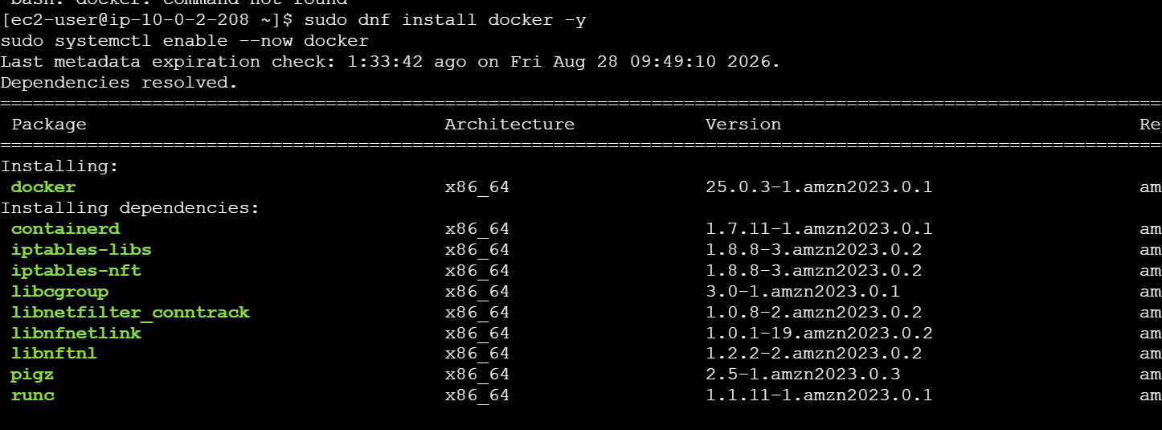
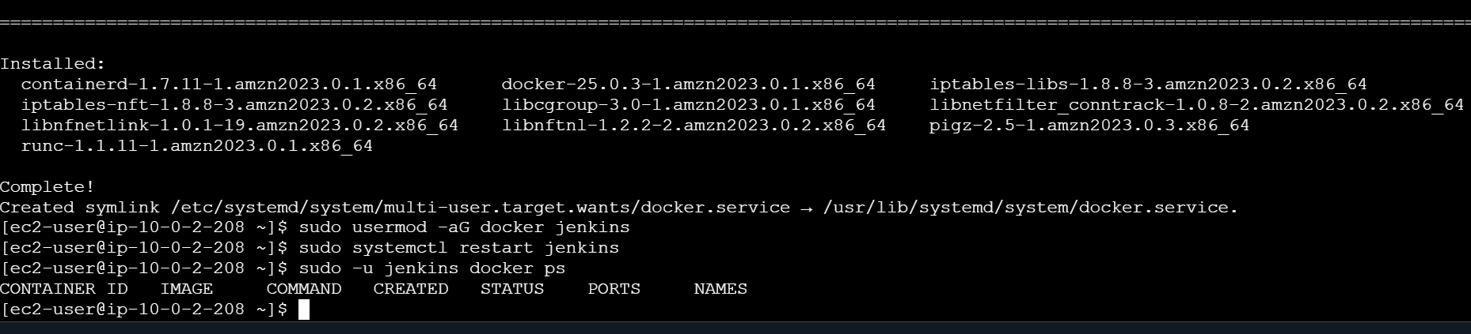
Step 10 — Important Jenkinsfile issue
The repository's existing Jenkinsfile contains: vatsraj/pythonapp:$BUILD_NUMBER
We don't want that because your Docker Hub username is: narayanakl
Also, the Jenkinsfile expects a Jenkins credential named: s3cloudhub-dockerhub
We'll create that credential.
Step 11 — Create Docker Hub credential
In Jenkins: Manage Jenkins → Credentials
Select: Global → Add Credentials
Use: Kind: Username with password
Username: narayanakl
Password: <your Docker Hub password/token>
ID: dockerhub-credentials
Click: Create
Security recommendation
Use a Docker Hub access token rather than your Docker Hub account password.
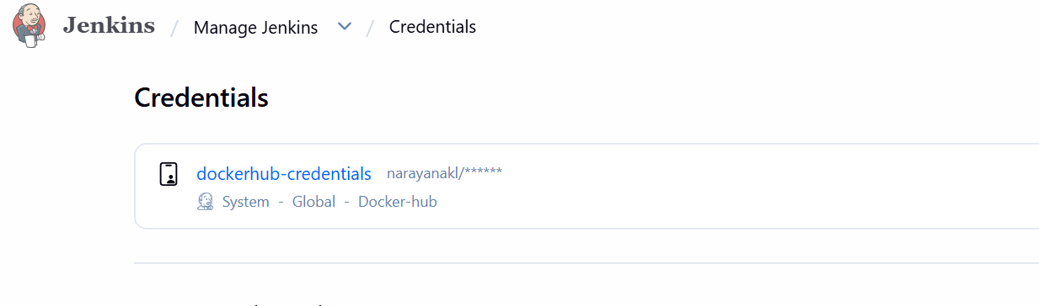

Step 12 — Modify the Jenkinsfile
Because we're using the repository's Jenkinsfile, change it on GitHub so it uses your Docker Hub repository.
On Docker-server, from Python-app:
vi Jenkinsfile
Replace the contents with:
pipeline {
agent any

environment {
DOCKER_IMAGE = 'narayanakl/pythonapp'
}

stages {

stage('Checkout') {
steps {
checkout scm
}
}

stage('Build Docker Image') {
steps {
sh 'docker build -t ${DOCKER_IMAGE}:${BUILD_NUMBER} .'
}
}

stage('Login to Docker Hub') {
steps {
withCredentials([
usernamePassword(
credentialsId: 'dockerhub-credentials',
usernameVariable: 'DOCKER_USERNAME',
passwordVariable: 'DOCKER_PASSWORD'
)
]) {
sh 'echo "$DOCKER_PASSWORD" | docker login -u "$DOCKER_USERNAME" --password-stdin'
}
}
}

stage('Push Image') {
steps {
sh 'docker push ${DOCKER_IMAGE}:${BUILD_NUMBER}'
}
}
}

post {
always {
sh 'docker logout || true'
}
}
}
Save it.
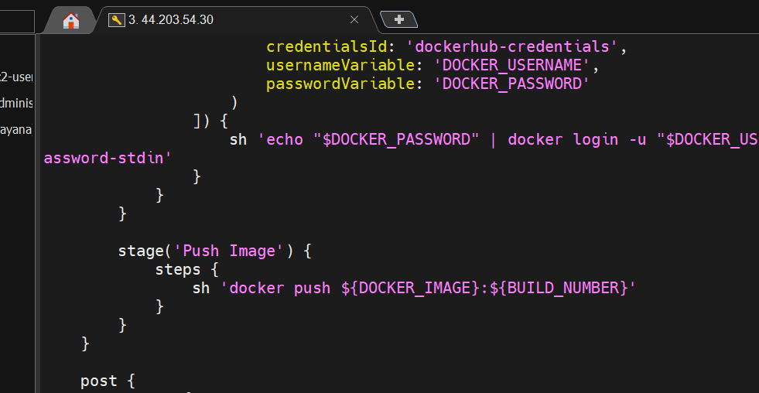
Then commit and push:
git add Jenkinsfile
git commit -m "Update Jenkins Docker Hub pipeline"
git push origin main
step13 -Use Pipeline Script directly
Go to: Jenkins → Python-App-Docker-Build-Push → Configure
Under Pipeline → Definition, select:
Pipeline script
Do not select Pipeline script from SCM for now.
A Script text box will appear.
Paste this:
pipeline {
agent any

environment {
DOCKER_IMAGE = 'narayanakl/pythonapp'
}

stages {

stage('Checkout') {
steps {
git branch: 'main',
url: 'https://github.com/betawins/Python-app.git'
}
}

stage('Build Docker Image') {
steps {
sh 'docker build -t ${DOCKER_IMAGE}:${BUILD_NUMBER} .'
}
}

stage('Login to Docker Hub') {
steps {
withCredentials([
usernamePassword(
credentialsId: 'dockerhub-credentials',
usernameVariable: 'DOCKER_USERNAME',
passwordVariable: 'DOCKER_PASSWORD'
)
]) {
sh 'echo "$DOCKER_PASSWORD" | docker login -u "$DOCKER_USERNAME" --password-stdin'
}
}
}

stage('Push Image') {
steps {
sh 'docker push ${DOCKER_IMAGE}:${BUILD_NUMBER}'
}
}
}

post {
always {
sh 'docker logout || true'
}
}
}
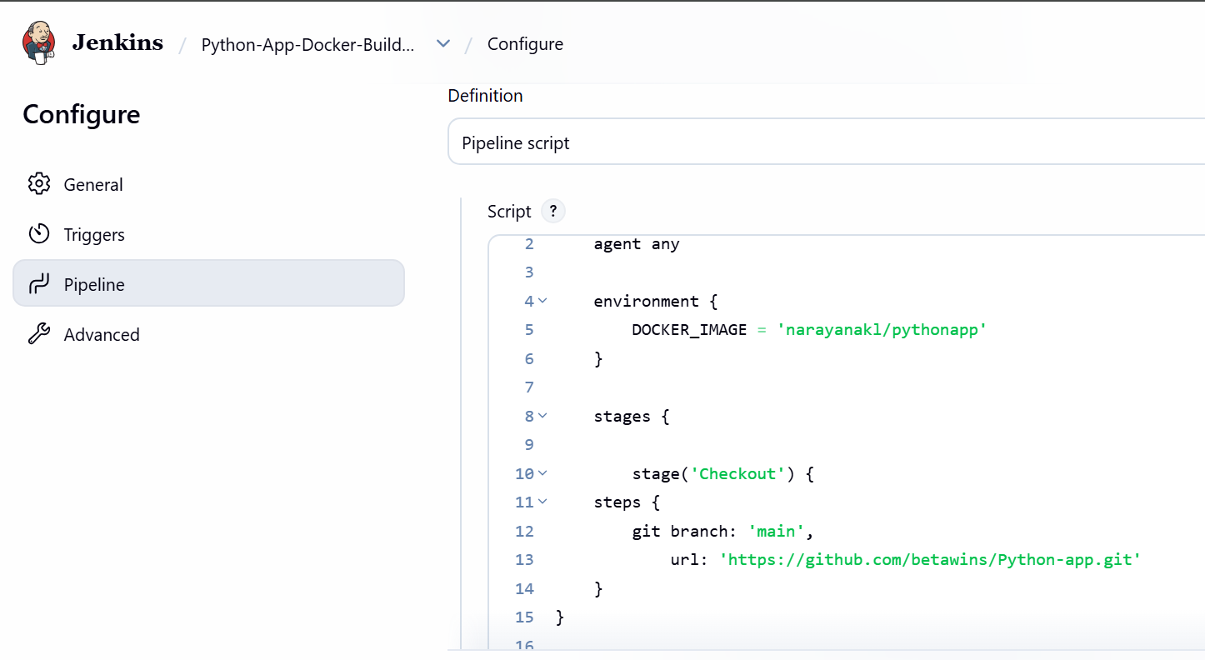
Build again
Click: Build Now
Then: Build #2 → Console Output
This time we expect: Checkout
Build Docker Image
Login to Docker Hub
Push Image
Finished: SUCCESS
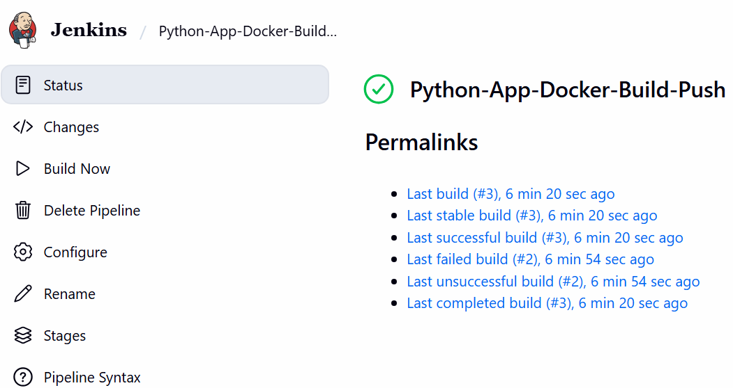
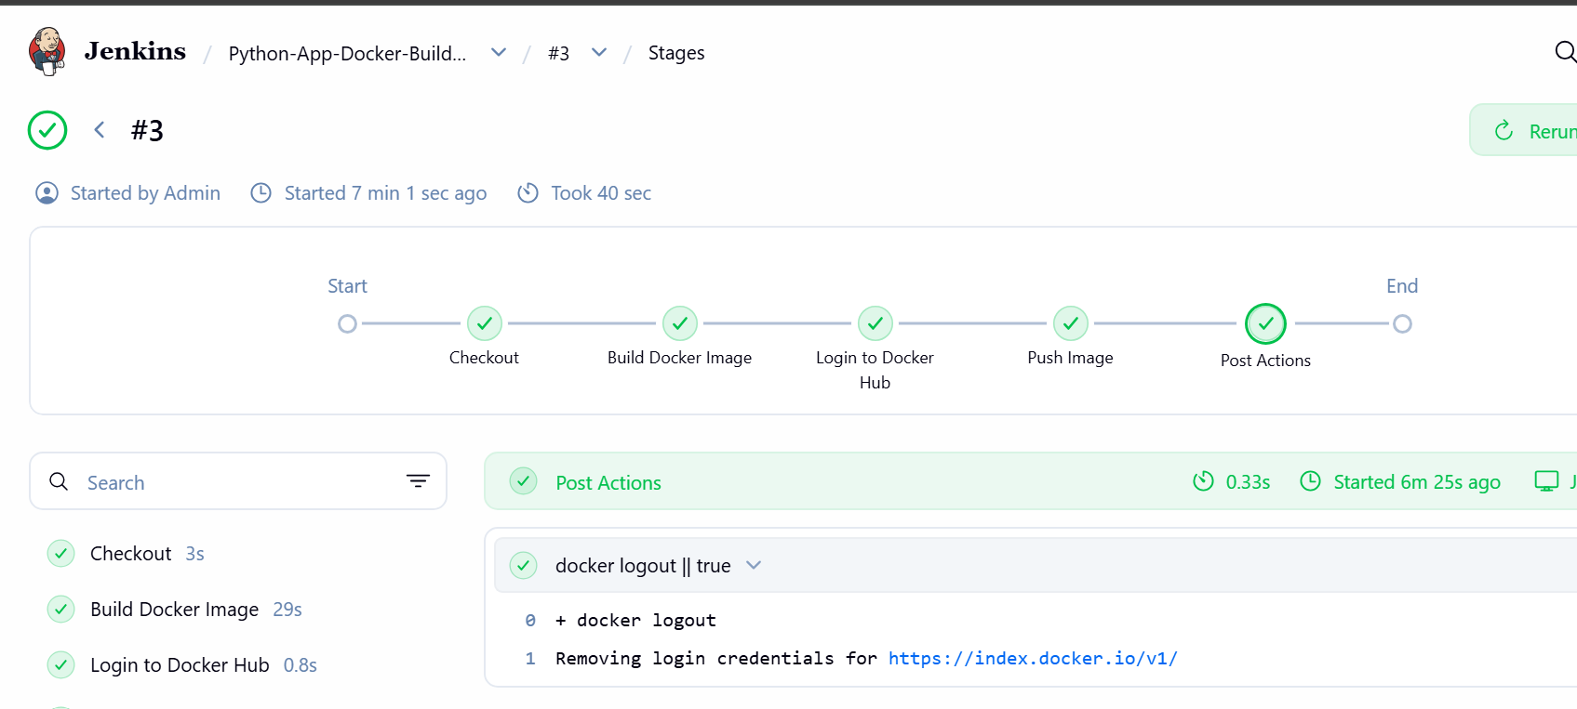
We'll continue with Challenge 5 → Java application.
PART 1 — Find the Frontend based source code
On your Docker/Jenkins server, run:cd ~
git clone https://github.com/betawins/docker-tasks.git
cd docker-tasks
find . -maxdepth 3 -type f | sort
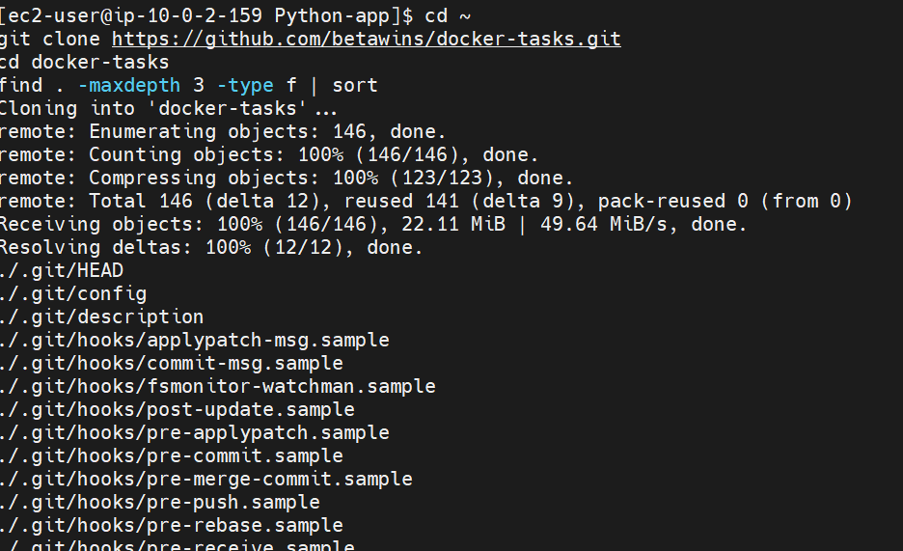
Step 2 — Inspect the Java application
Run: cd ~/docker-tasks/Java_based_source
find . -maxdepth 5 -type f | sort
Then also run: cat pom.xml
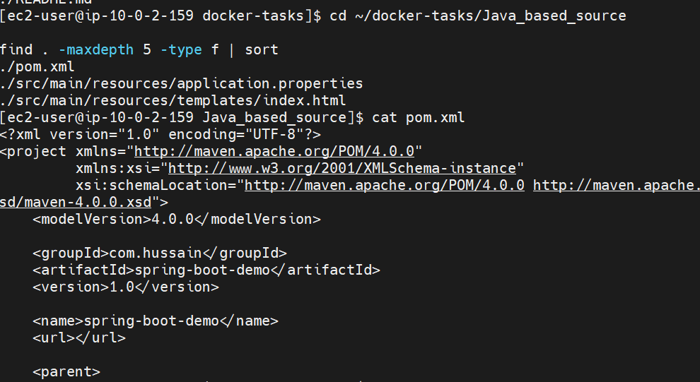
Step 3 — Check the Java source
Your find command didn't show the Java files because they are deeper than 5 levels or may be missing from the repository listing.
Run: cd ~/docker-tasks/Java_based_source
find . -type f | sort
Then specifically: find . -name "*.java" -type f
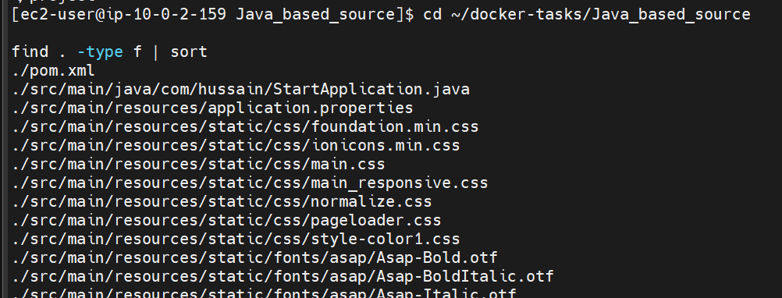
Step 4 — Check the application port
Run:cd ~/docker-tasks/Java_based_source
cat src/main/resources/application.properties
Also run: cat src/main/java/com/hussain/StartApplication.java
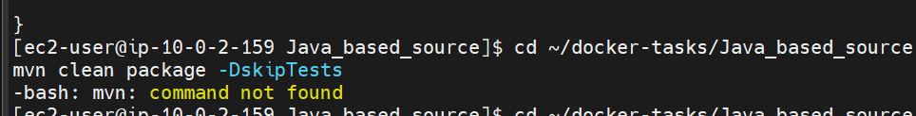
Step 5 — Build the Java application
Before creating the Dockerfile, let's make sure Maven can successfully build it.
Run:cd ~/docker-tasks/Java_based_source
mvn clean package -DskipTests
Wait for it to finish.
Expected result
Near the end you should see: BUILD SUCCESS
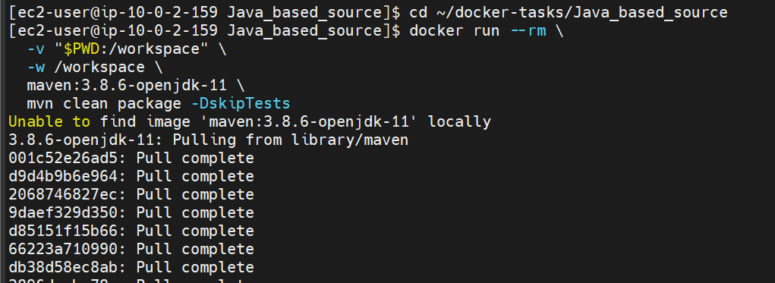
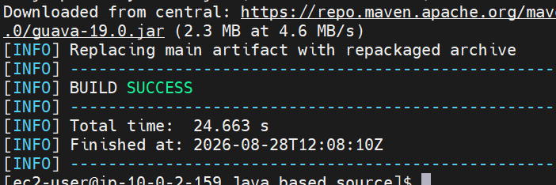
Then run:ls -lh target/
We expect to see: spring-boot-web.jar

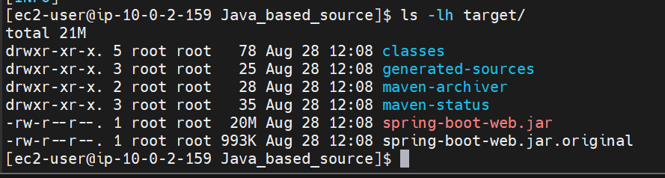
Step 6 — Create the Java Dockerfile
You are already in:~/docker-tasks/Java_based_source
Run:cat > Dockerfile <<'EOF'
FROM eclipse-temurin:11-jre
WORKDIR /app
COPY target/spring-boot-web.jar app.jar
EXPOSE 8080
ENTRYPOINT ["java", "-jar", "app.jar"]
EOF
Check it: cat Dockerfile
You should see: FROM eclipse-temurin:11-jre
WORKDIR /app
COPY target/spring-boot-web.jar app.jar
EXPOSE 8080
ENTRYPOINT ["java", "-jar", "app.jar"]
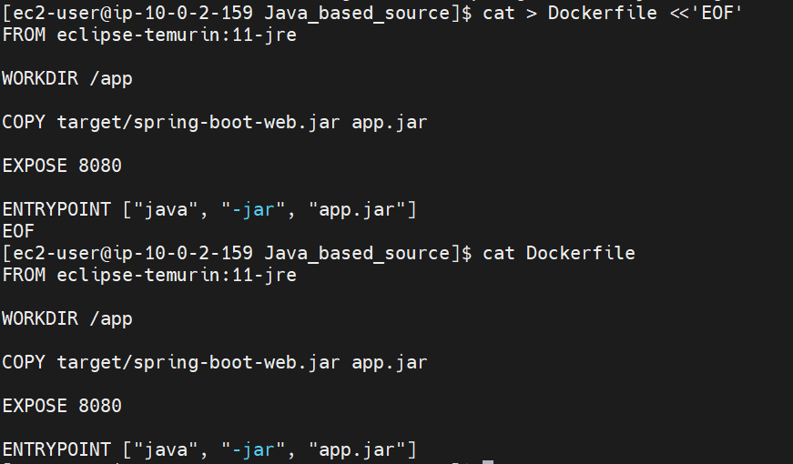
Step 7 — Build the Docker image
Run: docker build -t narayanakl/spring-boot-demo:v1 .
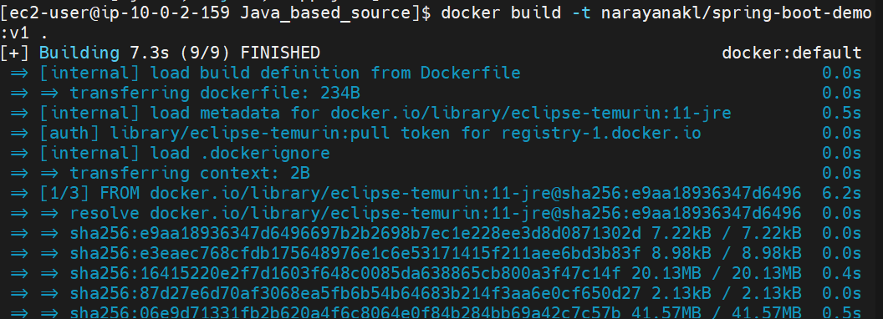
Then verify: docker images | grep spring-boot-demo
Expected: narayanakl/spring-boot-demo v1
Run Java on port 8083
docker run -d --name spring-boot-demo -p 8083:8080 narayanakl/spring-boot-demo:v1
Step 8 — Check both containers
docker ps
You should now have approximately: pythonapp 0.0.0.0:8080->8080/tcp
custom-nginx 0.0.0.0:8082->80/tcp
spring-boot-demo 0.0.0.0:8083->8080/tcp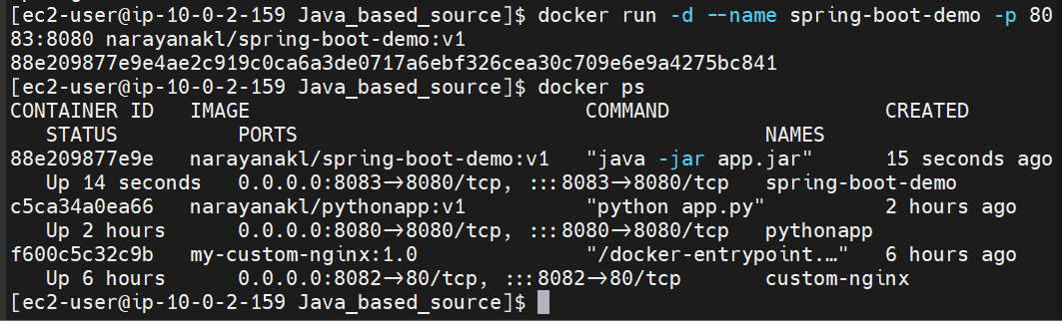
Step 9— Test Java
curl -I http://localhost:8083

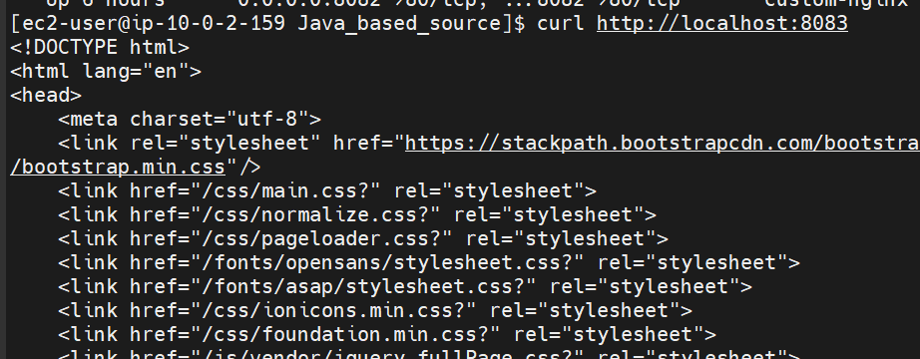
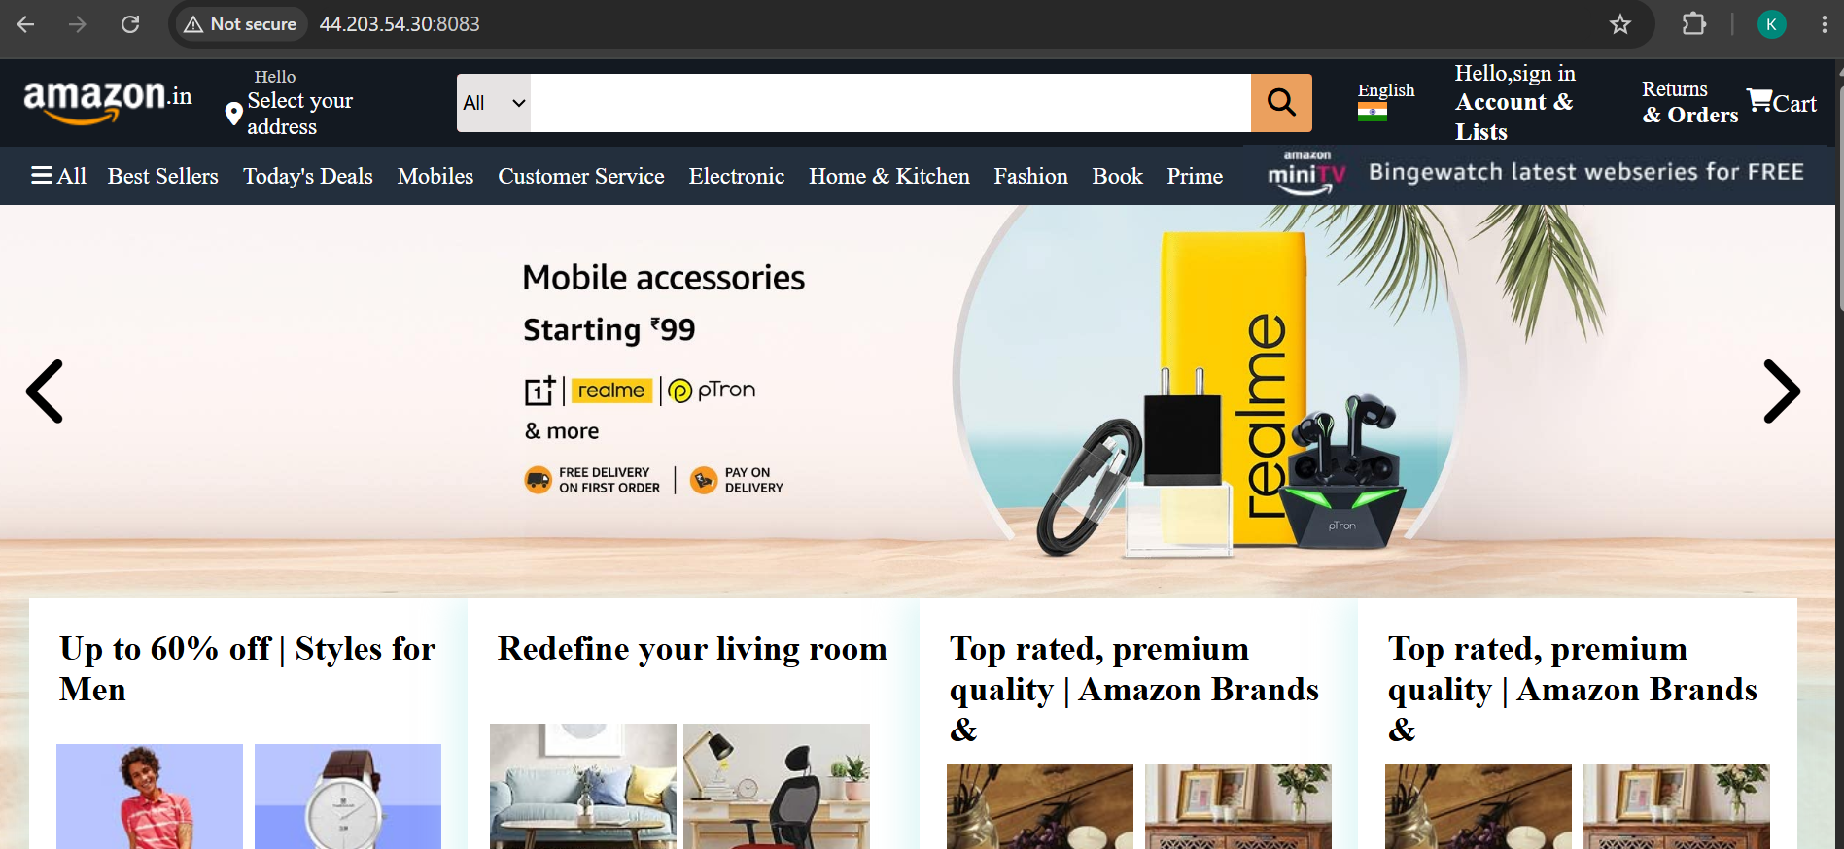
Step 10— Push the Java image to Docker Hub
Run: docker push narayanakl/spring-boot-demo:v1
You should eventually see: v1: digest: sha256:...
Then verify: docker images | grep spring-boot-demo
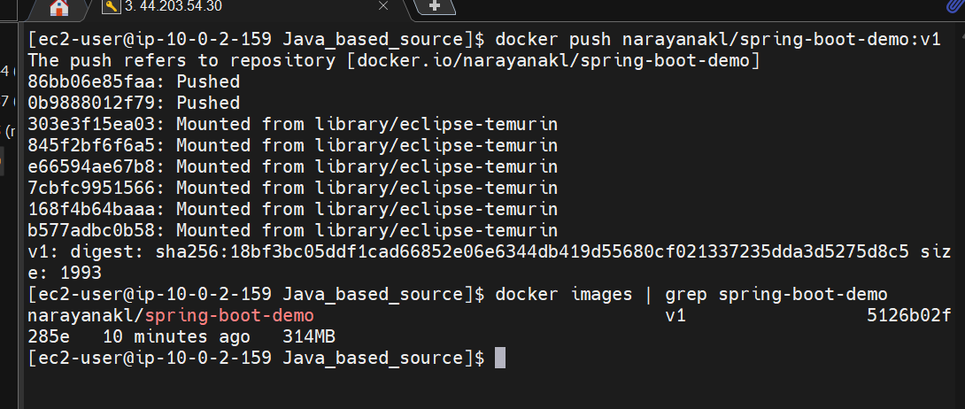
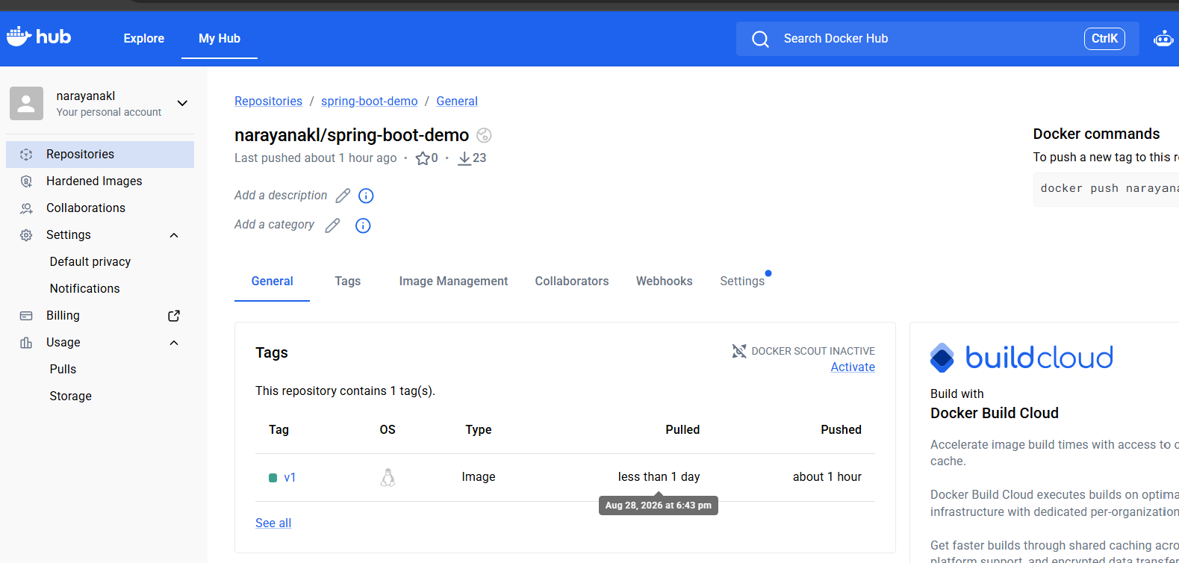
Next step challenge 5
PART 2- Java-based source code
Let's verify that the image can be pulled from Docker Hub, which confirms the push is fully usable.
Run: docker rmi narayanakl/spring-boot-demo:v1
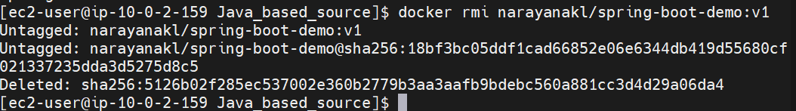
Then: docker pull narayanakl/spring-boot-demo:v1
Then verify: docker images | grep spring-boot-demo
You should see: narayanakl/spring-boot-demo v1 ...
Then run it again: docker run -d --name spring-boot-test -p 8084:8080 narayanakl/spring-boot-demo:v1
Check: docker ps
And: curl http://localhost:8084

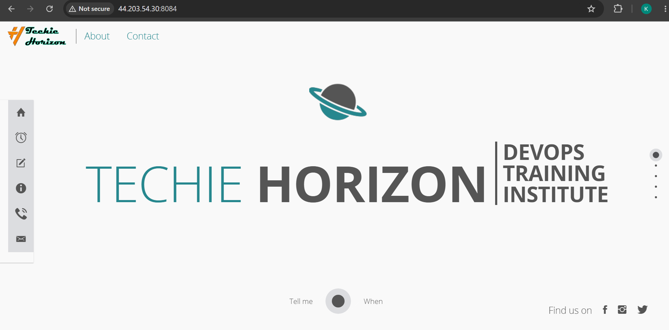
PART-3 Node.js — Step 1: Inspect the application
On Docker-server run: cd ~/docker-tasks/NodeJs_based_source
Check the files: ls -lh
Then: cat package.json
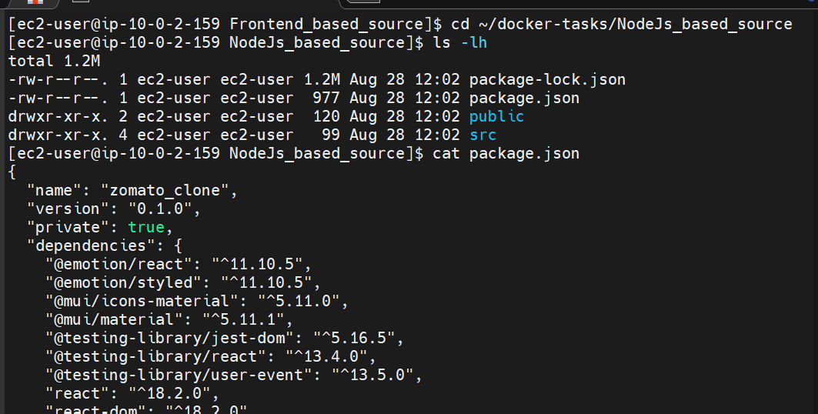
And: cat package-lock.json | head -20
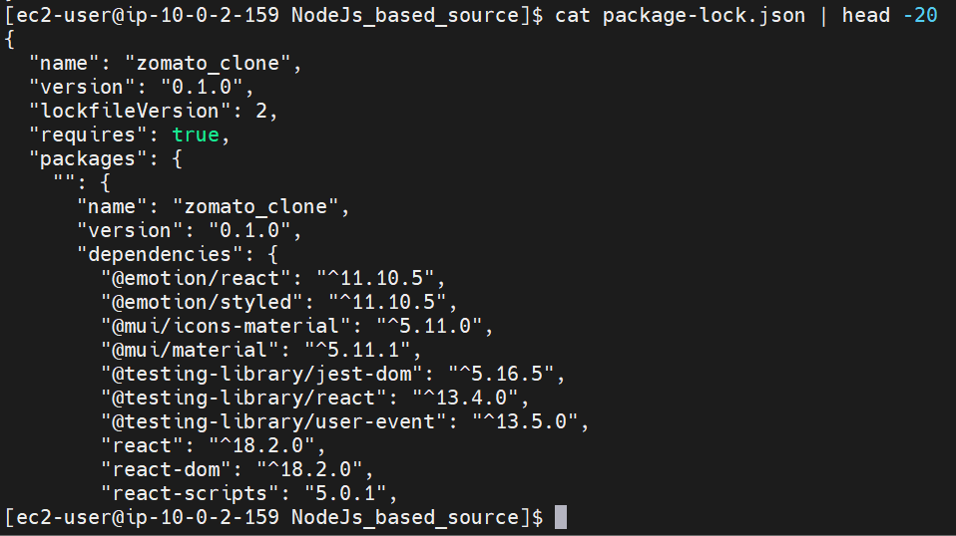
Node.js — Step 3: Create the Dockerfile
You should still be in: ~/docker-tasks/NodeJs_based_source
Run: cat > Dockerfile <<'EOF'
FROM node:20-alpine AS build
WORKDIR /app
COPY package*.json ./
RUN npm install
COPY . .
RUN npm run build
FROM nginx:alpine
COPY --from=build /app/build /usr/share/nginx/html
EXPOSE 80
CMD ["nginx", "-g", "daemon off;"]
EOF
Check it:cat Dockerfile
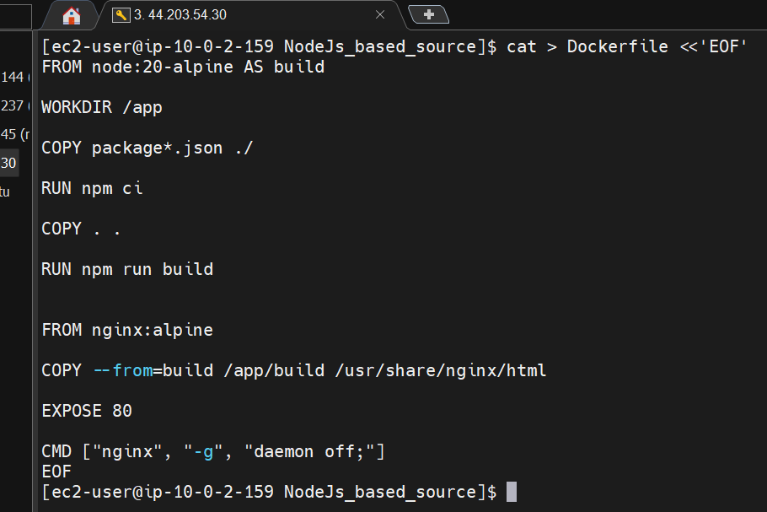
You should see the two-stage build:
Node.js
↓
npm ci
↓
npm run build
↓
React build files
↓
Nginx
↓
Port 80
Node.js — Step 4: Build the image with v1
Run: docker build -t narayanakl/nodeapp:v1 .
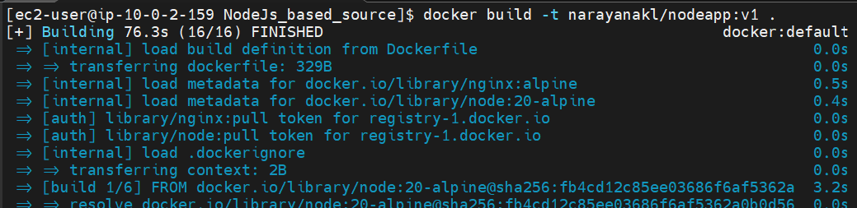
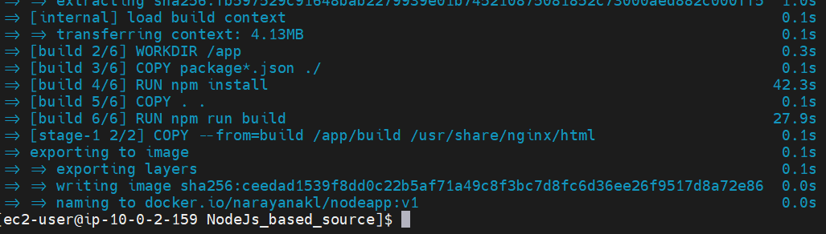
Then verify: docker images | grep nodeapp
Expected: narayanakl/nodeapp v1
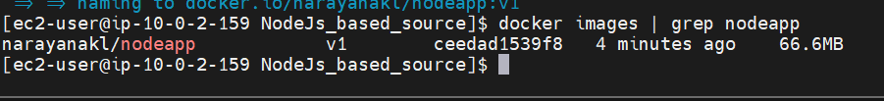
Run the Node.js container
Use port 8086 to avoid your existing containers.
Run: docker run -d --name nodeapp -p 8086:80 narayanakl/nodeapp:v1
Check: docker ps
You should see: nodeapp 0.0.0.0:8086->80/tcp
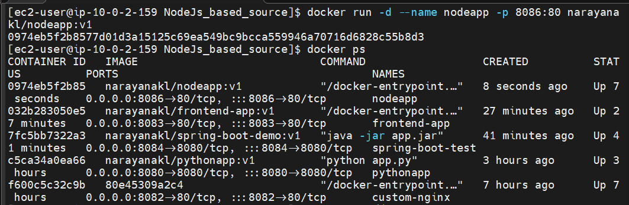
Then test: curl http://localhost:8086
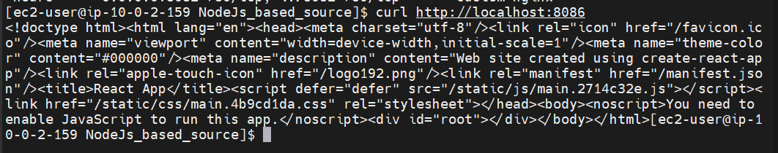

Push Node.js image to Docker Hub
Run:
docker push narayanakl/nodeapp:v1
At the end, you should see something like:
v1: digest: sha256:...

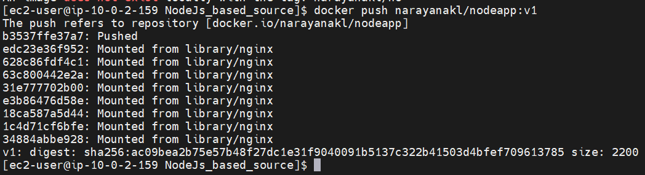
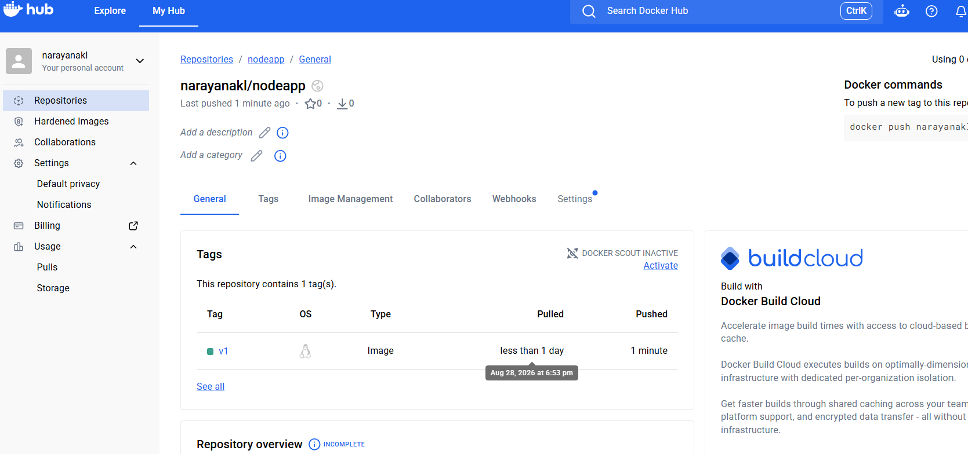
PART-4 Create WordPress + MySQL Compose
On Docker-server : cd ~
mkdir -p wordpress-compose
cd wordpress-compose
Create the Compose file: cat > docker-compose.yml <<'EOF'
services:
db:
image: mysql:8.0
container_name: wordpress-db
restart: always
environment:
MYSQL_DATABASE: wordpress
MYSQL_USER: wordpress
MYSQL_PASSWORD: wordpress123
MYSQL_ROOT_PASSWORD: root123
volumes: - db_data:/var/lib/mysql
wordpress:
image: wordpress:latest
container_name: wordpress
restart: always
ports:
- "8087:80"
environment:
WORDPRESS_DB_HOST: db:3306
WORDPRESS_DB_USER: wordpress
WORDPRESS_DB_PASSWORD: wordpress123
WORDPRESS_DB_NAME: wordpress
depends_on:
- db
volumes:
db_data:
EOF
Check it: cat docker-compose.yml
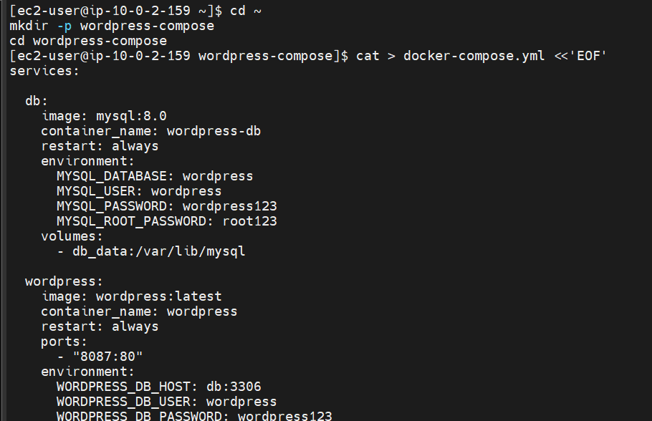
Step 12 — Start WordPress and MySQL
Run: docker compose up -d
Then: docker compose ps
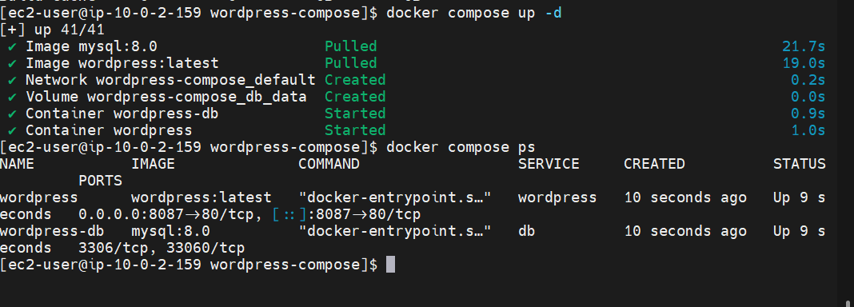
We want to see: wordpress
wordpress-db
with both showing running.
Step 13 — Test WordPress
Run: curl -I http://localhost:8087
You should receive an HTTP response.
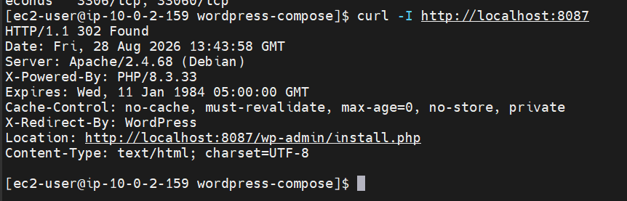
Then open in your browser: http://<DOCKER-SERVER-PUBLIC-IP>:8087
