Kubernetes-10
Task 1 — Create an EKS cluster using eksctl.
You have:
- AWS CLI ✅
- AWS account authenticated ✅
- Region: us-east-1 ✅
- eksctl 0.231.0 ✅
- Git Bash ✅
- eksctl available in PATH ✅
We'll create a small managed-node EKS cluster to keep the lab simple and control cost.

Task 1 — Create EKS Cluster Using eksctl
Architecture
AWS
|
┌───────▼────────┐
│ EKS Cluster │
│ eks-lab-01 │
└───────┬────────┘
|
┌─────────┴─────────┐
│ │
┌──────▼──────┐ ┌──────▼──────┐
│ Worker Node │ │ Worker Node │
│ t3.small │ │ t3.small │
│ us-east-1a │ │ us-east-1b │
└─────────────┘ └─────────────┘
For the first lab, we'll use:
Cluster name : eks-lab-01
Region : us-east-1
Kubernetes : 1.34
Node type : t3.small
Nodes : 2
Cost note: EKS itself has a cluster charge, and the EC2 worker nodes also incur charges. We'll delete the cluster after completing the lab unless you want to keep it for Tasks 3–8.

Step 1 — Verify eksctl
Run: eksctl version
Expected: 0.231.0
You already confirmed this, so we can continue.
Step 2 — Check available EKS Kubernetes versions
Run: aws eks describe-addon-versions \
--region us-east-1 \
--query 'addons[].addonVersions[].compatibilities[].clusterVersion' \
--output text | tr '\t' '\n' | sort -u
You should see supported Kubernetes versions.
For this lab we'll use:
1.34
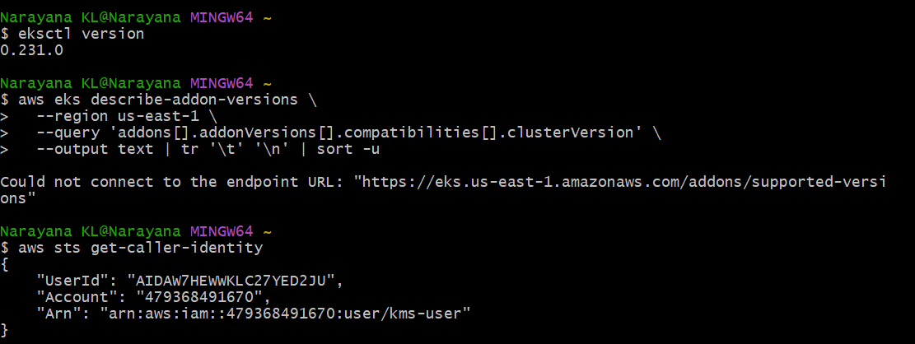
Step 3 — Create the EKS cluster
Run this from Git Bash:
eksctl create cluster \
--name eks-lab-01 \
--region us-east-1 \
--version 1.34 \
--nodegroup-name eks-lab-ng \
--node-type t3.small \
--nodes 2 \
--nodes-min 1 \
--nodes-max 3 \
--managed
What this command does
Option | Meaning
--name eks-lab-01 | EKS cluster name
--region us-east-1 | AWS region
--version 1.34 | Kubernetes version
--nodegroup-name eks-lab-ng | Managed node group
--node-type t3.small | EC2 instance type
--nodes 2 | Start with 2 workers
--nodes-min 1 | Minimum nodes
--nodes-max 3 | Maximum nodes
--managed | Use EKS managed node group
This can take approximately 10–20 minutes.
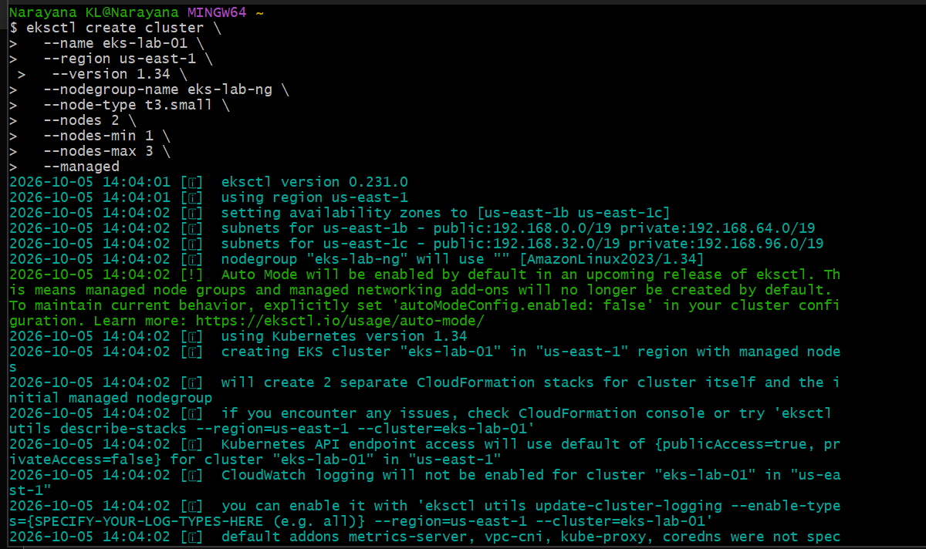
You will see messages similar to:
eksctl version 0.231.0
...
creating EKS cluster "eks-lab-01"
...
creating CloudFormation stack
...
waiting for CloudFormation stack
...
creating nodegroup "eks-lab-ng"
...
waiting for control plane to become ready
...
Do not interrupt the command while it is creating the cluster. 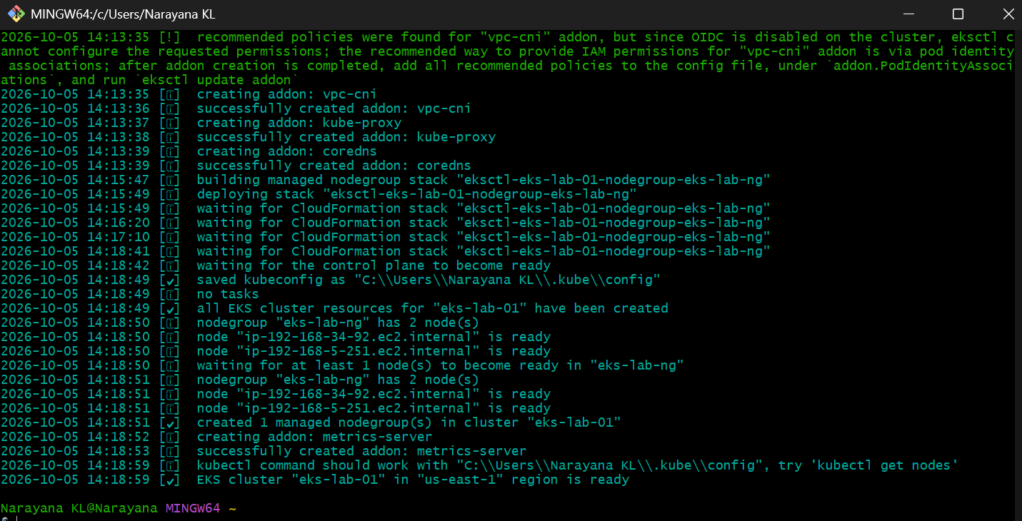
Step 4 — Verify the cluster
After eksctl reports successful creation:
eksctl get cluster --region us-east-1
Expected:
NAME REGION EKSCTL CREATED
eks-lab-01 us-east-1 ...
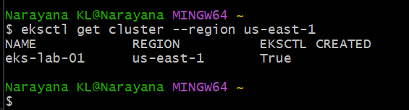

Step 5 — Check AWS EKS directly
Run:
aws eks list-clusters --region us-east-1
Expected:
{
"clusters": [
"eks-lab-01"
]
}
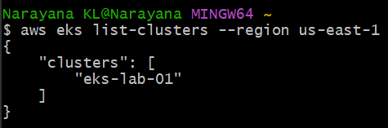
Step 6 — Check kubectl context
eksctl normally configures your kubeconfig automatically.
Run: kubectl config current-context
Expected something similar to:
arn:aws:eks:us-east-1:479368491670:cluster/eks-lab-01

Step 7 — Verify Kubernetes nodes
Run:
kubectl get nodes
Expected:
NAME STATUS ROLES AGE VERSION
ip-10-0-x-x.ec2.internal Ready <none> ... v1.34.x
ip-10-0-x-x.ec2.internal Ready <none> ... v1.34.x
You should have 2 Ready nodes.
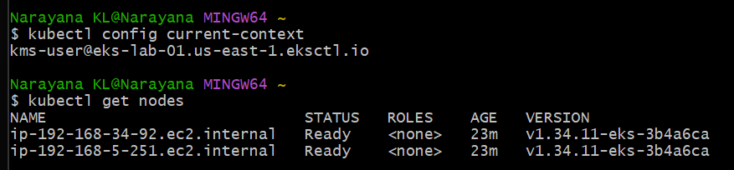

Step 8 — Detailed node information
kubectl get nodes -o wide
This shows:
- Internal IP
- OS
- container runtime
- Kubernetes version
- node name
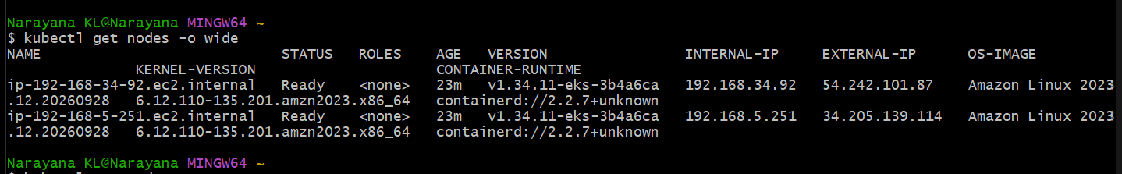
Step 9 — Check all system pods
kubectl get pods -A
You should see namespaces such as: kube-system
and pods for components such as: coredns
kube-proxy
aws-node
The exact pod list can vary because EKS automatically manages several components.
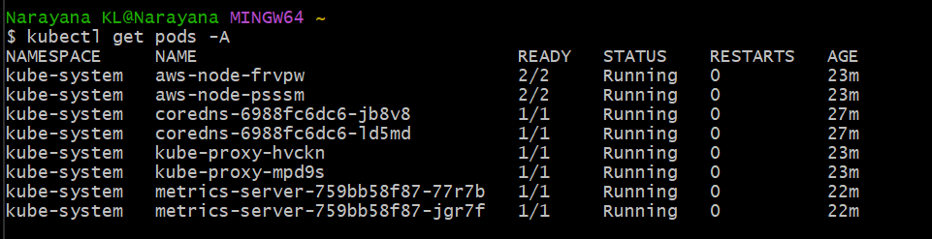
Step 10 — Check EKS cluster information
aws eks describe-cluster \
--name eks-lab-01 \
--region us-east-1 \
--query 'cluster.{Name:name,Status:status,Version:version,Endpoint:endpoint}'
Expected:
{
"Name": "eks-lab-01",
"Status": "ACTIVE",
"Version": "1.34",
"Endpoint": "https://..."
}
The important value is:
Status: ACTIVE
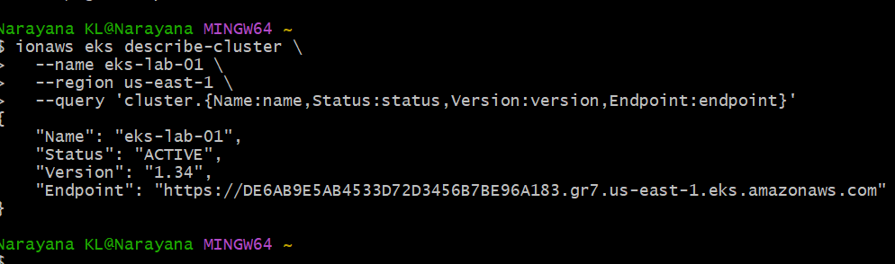Step 11 — Deploy a test application
Create a deployment:
kubectl create deployment nginx \
--image=nginx:latest \
--replicas=2
Check:
kubectl get deployment
Expected:
NAME READY UP-TO-DATE AVAILABLE AGE
nginx 2/2 2 2 ...
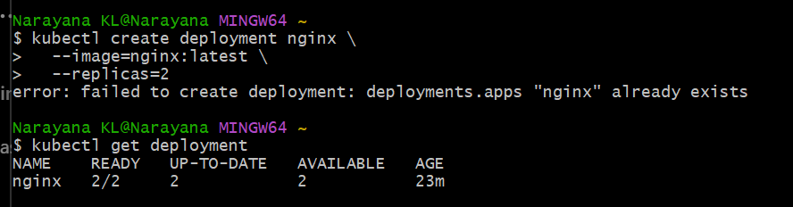
Step 12 — Check the pods
kubectl get pods -o wide
You should see two nginx pods distributed across the nodes, for example:
NAME READY STATUS NODE
nginx-xxxxx-xxxxx 1/1 Running ip-10-0-...
nginx-xxxxx-xxxxx 1/1 Running ip-10-0-...
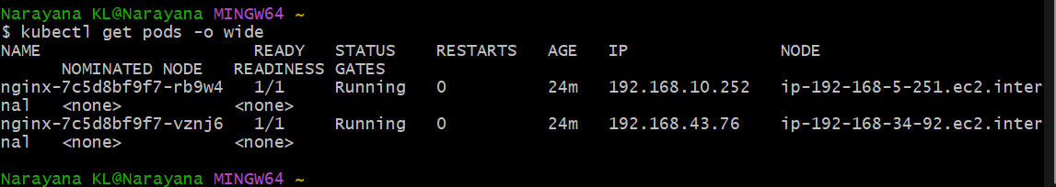Step 13 — Create a Service
Run:
kubectl expose deployment nginx \
--name=nginx \
--port=80 \
--target-port=80 \
--type=LoadBalancer
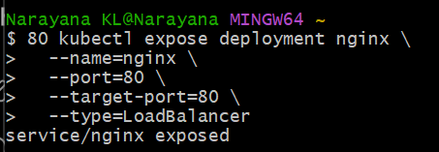
Check:
kubectl get svc
Initially you may see:
NAME TYPE CLUSTER-IP EXTERNAL-IP PORT(S)
nginx LoadBalancer 10.x.x.x <pending> 80:xxxxx/TCP
Wait a little and run:
kubectl get svc nginx
Eventually AWS should provision an external load balancer.
You can check continuously:
kubectl get svc nginx -w
Press:
Ctrl+C
when the external address appears. 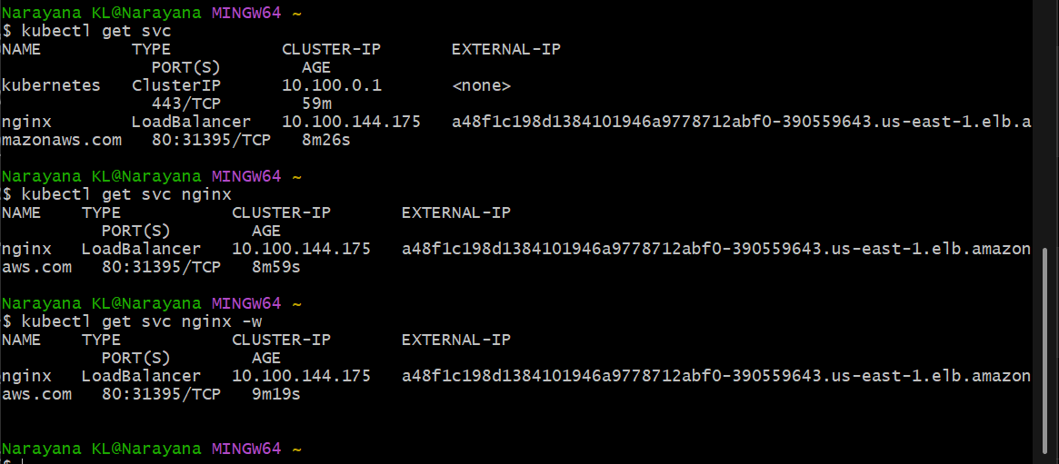
Step 14 — Test nginx
Get the load balancer address:
kubectl get svc nginx
If EXTERNAL-IP contains an AWS load-balancer DNS name, open it in your browser.
You should get: Welcome to nginx!
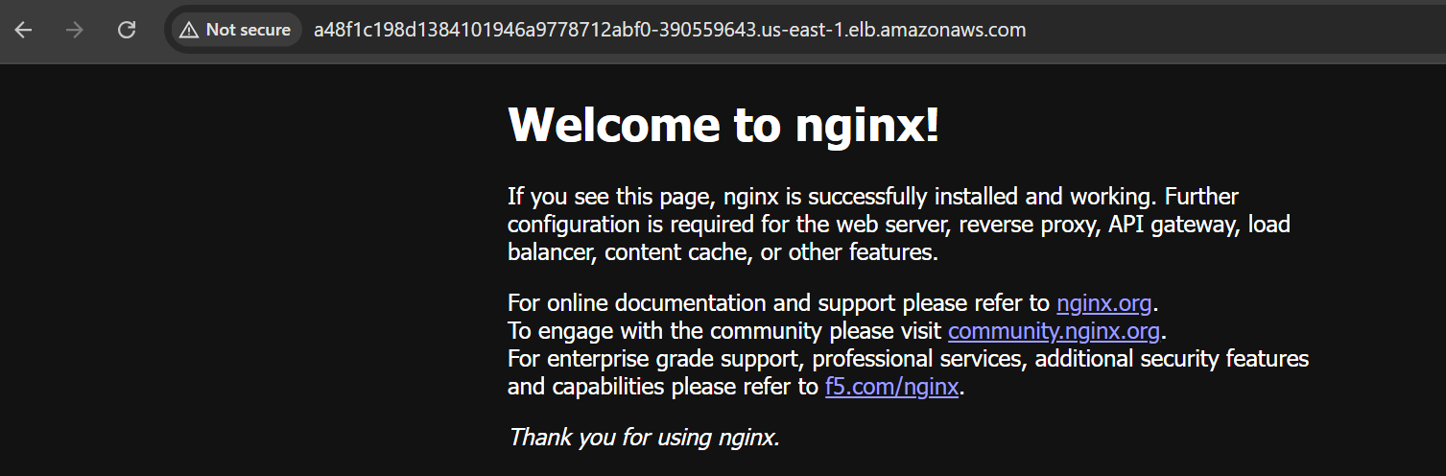
Step 15 — Check EKS managed node group
From AWS:
aws eks list-nodegroups \
--cluster-name eks-lab-01 \
--region us-east-1
Expected:
{
"nodegroups": [
"eks-lab-ng"
]
}
Then:
aws eks describe-nodegroup \
--cluster-name eks-lab-01 \
--nodegroup-name eks-lab-ng \
--region us-east-1 \
--query 'nodegroup.{Status:status,InstanceType:instanceTypes,Desired:scalingConfig.desiredSize,Min:scalingConfig.minSize,Max:scalingConfig.maxSize}'
You should see approximately:
Status ACTIVE
InstanceType [t3.small]
Desired 2
Min 1
Max 3
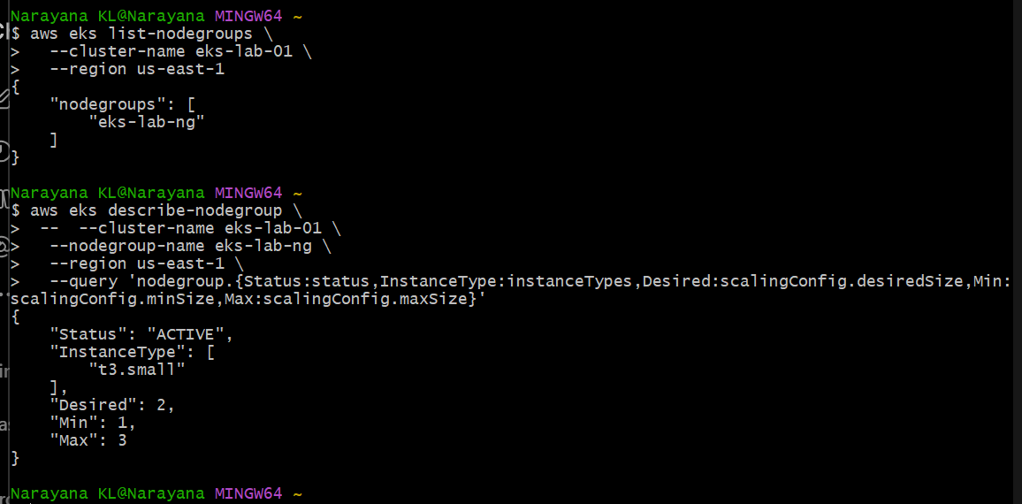
Before creating Task 2
Since your existing eks-lab-01 is consuming EKS/EC2 resources, don't create the second cluster yet.
First, let's record the VPC/subnets created by eksctl.
Run:
aws eks describe-cluster \
--name eks-lab-01 \
--region us-east-1 \
--query 'cluster.resourcesVpcConfig.{VpcId:vpcId,SubnetIds:subnetIds}'
Then run:
aws eks describe-cluster \
--name eks-lab-01 \
--region us-east-1 \
--query 'cluster.roleArn'
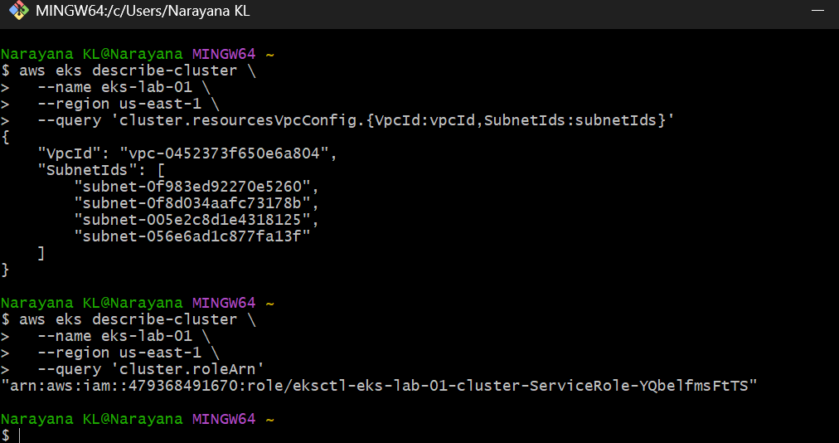
Step 2.1 — Delete the Task 1 test application
Before deleting the cluster, remove the nginx resources:
kubectl delete service nginx
Expected: service "nginx" deleted
Then: kubectl delete deployment nginx
Expected: deployment.apps "nginx" deleted
Verify: kubectl get all
You should see no nginx resources.
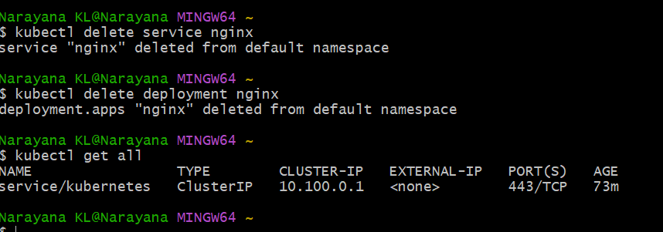

Step 2.2 — Delete the EKS cluster
Use eksctl because it created the cluster and its CloudFormation-managed resources: eksctl delete cluster \
--name eks-lab-01 \
--region us-east-1
This will delete:
- EKS control plane
- Managed node group
- EC2 worker nodes
- Load balancer-related resources created for the cluster
- Cluster networking resources created by eksctl
- CloudFormation stacks associated with the cluster
It can take several minutes.
⚠️ Don't manually delete the VPC first
Let eksctl handle the resources it created.
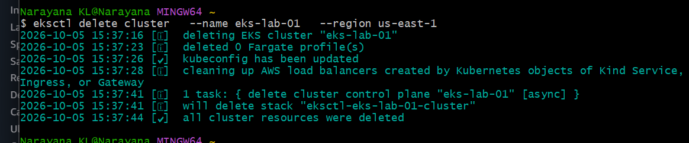
Step 2.3 — Verify deletion
Run:
eksctl get cluster --region us-east-1
Then:
aws eks list-clusters --region us-east-1
Ideally:
{
"clusters": []
}
Also check EC2:
aws ec2 describe-instances \
--region us-east-1 \
--filters "Name=tag:eks:cluster-name,Values=eks-lab-01" \
--query 'Reservations[].Instances[].{ID:InstanceId,State:State.Name}'
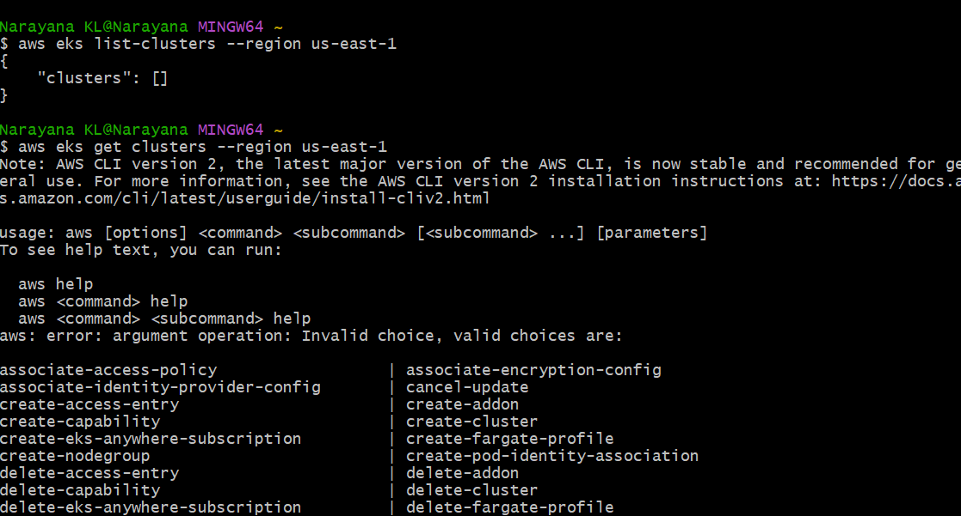
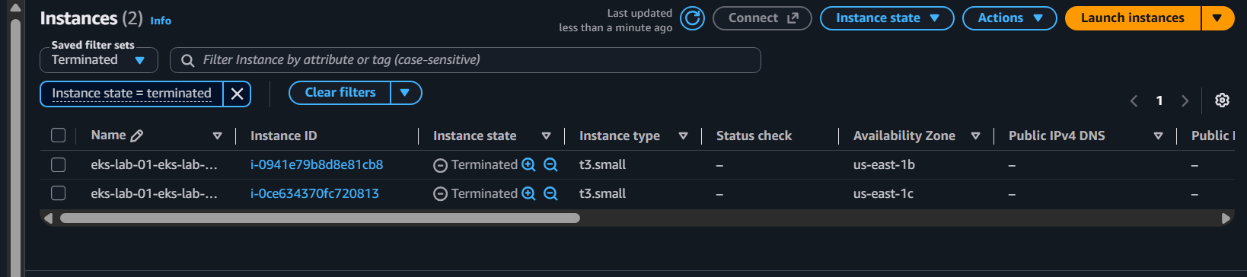
Task 2: Setup EKS Cluster Using AWS Console
Objective
Create an Amazon EKS cluster using the AWS Management Console, configure the networking and managed node group, and verify that the Kubernetes cluster is accessible using kubectl.
Implementation Steps
We will create:
Cluster name : eks-console-01
Region : us-east-1
Kubernetes : 1.34
Node group : eks-console-ng
Instance : t3.small
Desired : 2
Minimum : 1
Maximum : 3
Step 1 — Open EKS Console
Open the AWS Console and select:
Region → US East (N. Virginia) us-east-1
Then go to:
AWS Console → EKS → Clusters → Create cluster

Step 2 — Configure cluster
Select: Creation options
Choose: Create
Name Enter: eks-console-01
Kubernetes version
Select: 1.34
Cluster service role
You need an IAM role for the EKS control plane.
Click:
Create recommended role
AWS will open the IAM role creation page.
Use: Trusted entity:
AWS service
Use case:
EKS - Cluster
Create the role.
A name such as: AmazonEKSAutoClusterRole
is fine.
Return to the EKS cluster creation page and select this role.
Don't use the old eksctl-eks-lab-01-cluster-ServiceRole... role. That belonged to the deleted cluster.
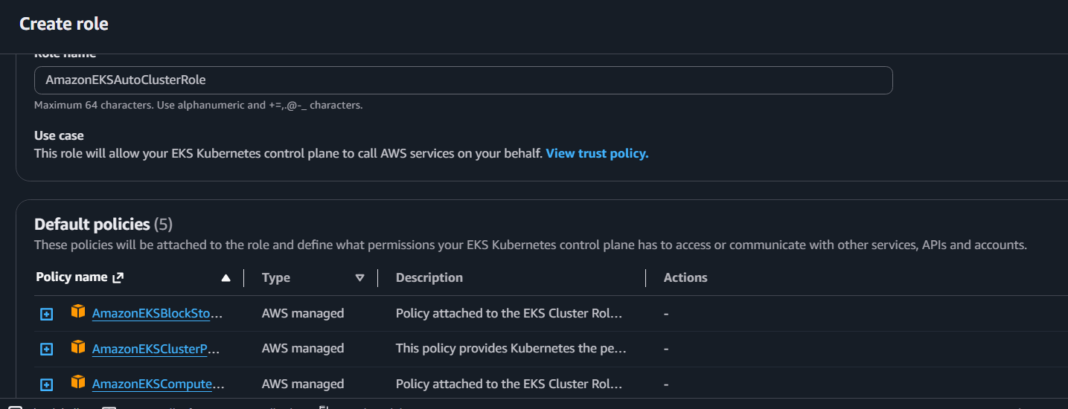
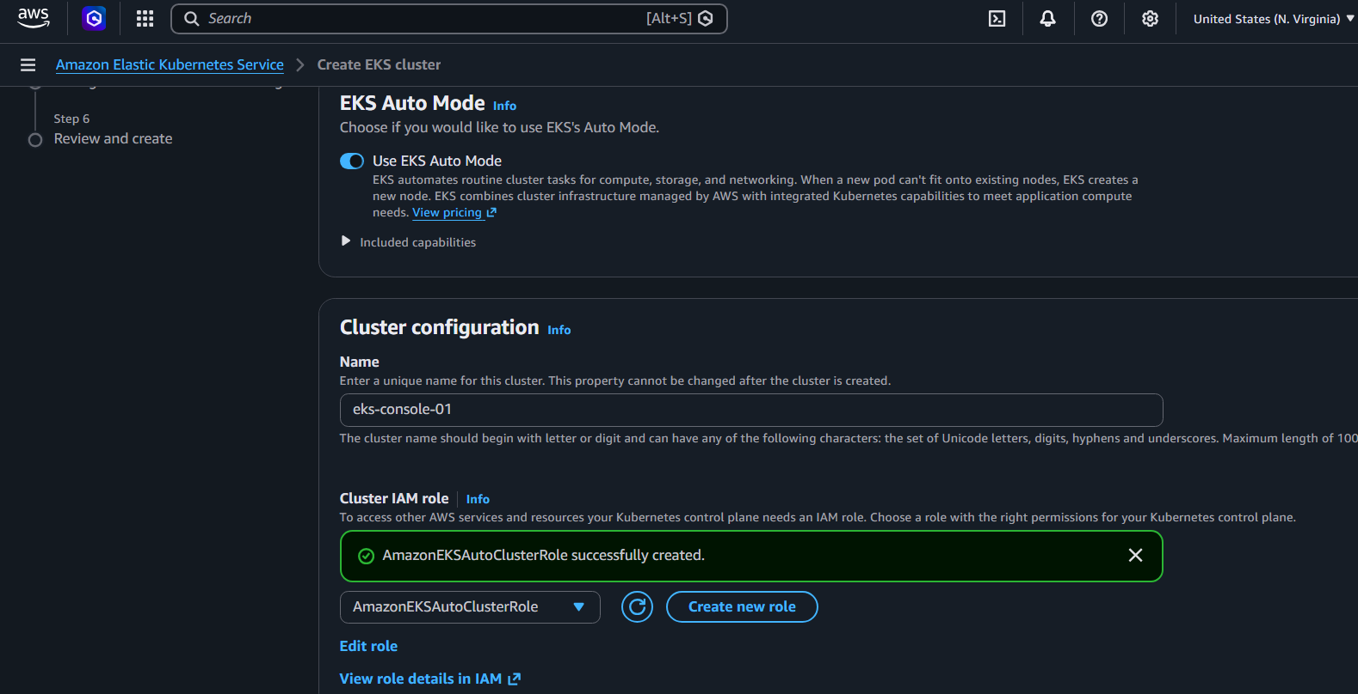
Step 3 — Networking
For the VPC, you have two choices.
Recommended for this lab
Let EKS create/use the networking configuration automatically if the Console offers the default EKS VPC option.
Otherwise select an existing VPC with:
- at least 2 subnets
- subnets in different Availability Zones
- appropriate routing/NAT/Internet access
For simplicity, if the Console shows a suitable default VPC, select it.
The architecture should be:
VPC
|
┌─────────┴─────────┐
│ │
us-east-1a us-east-1b
│ │
Subnet A Subnet B
│ │
EC2 EC2
Cluster endpoint
For the lab, select: Public
This makes connecting your Windows Git Bash kubectl configuration straightforward.]
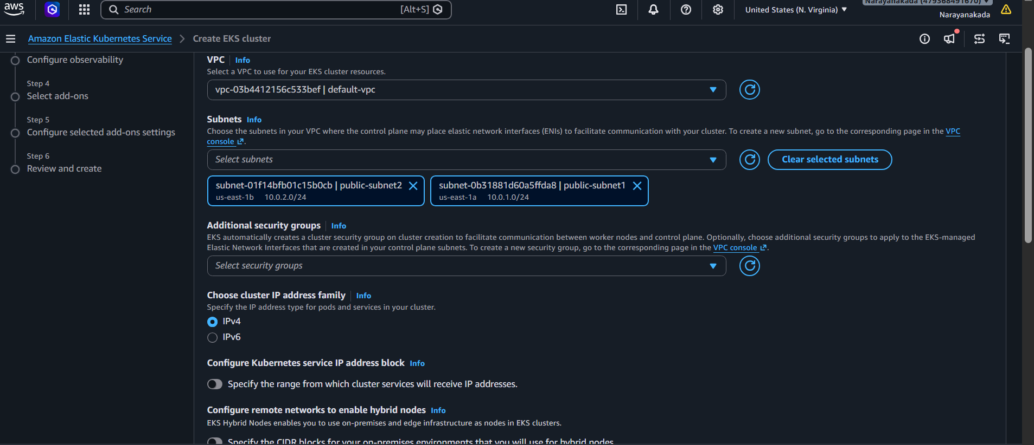

Step 4 — Cluster logging
For this basic lab, you can leave the control-plane logging options at their default.
Later, for production environments, we would enable appropriate:
API
Audit
Authenticator
ControllerManager
Scheduler
logs and send them to CloudWatch.
Click: Next
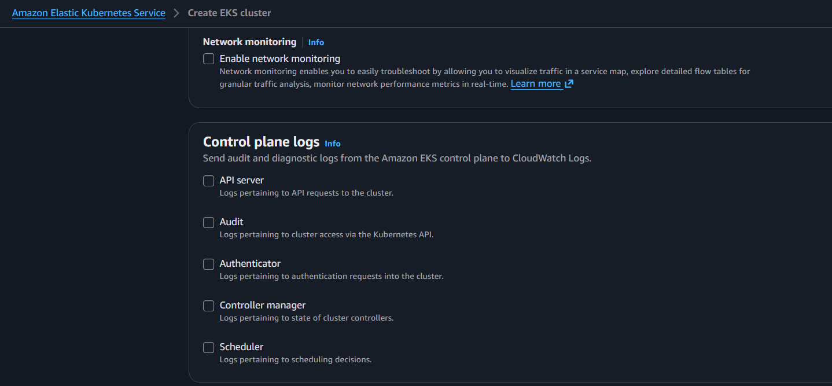
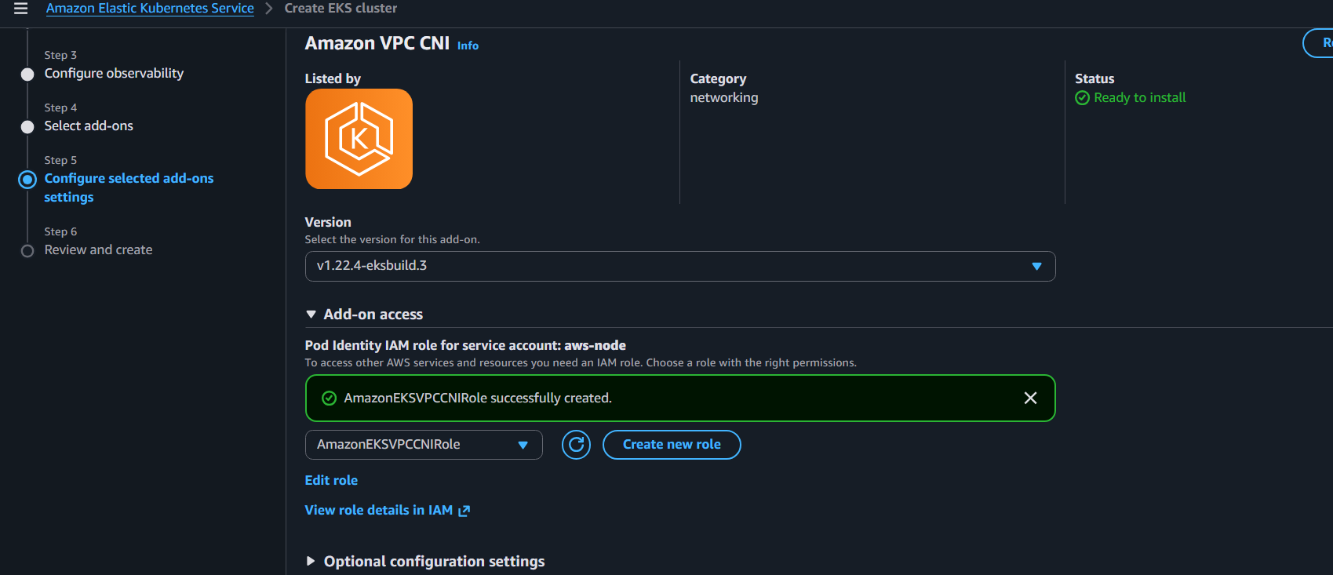

Step 5 — Review
Verify: Name: eks-console-01
Region: us-east-1
Version: 1.34
Endpoint access: Public
Then click: Create
The EKS control plane can take several minutes to become:
ACTIVE

Step 6 — Wait for ACTIVE
Go to: EKS → Clusters → eks-console-01
Wait until:
Status: ACTIVE
⚠️ Don't create the node group until the cluster becomes ACTIVE.
Once you see:
eks-console-01
ACTIVE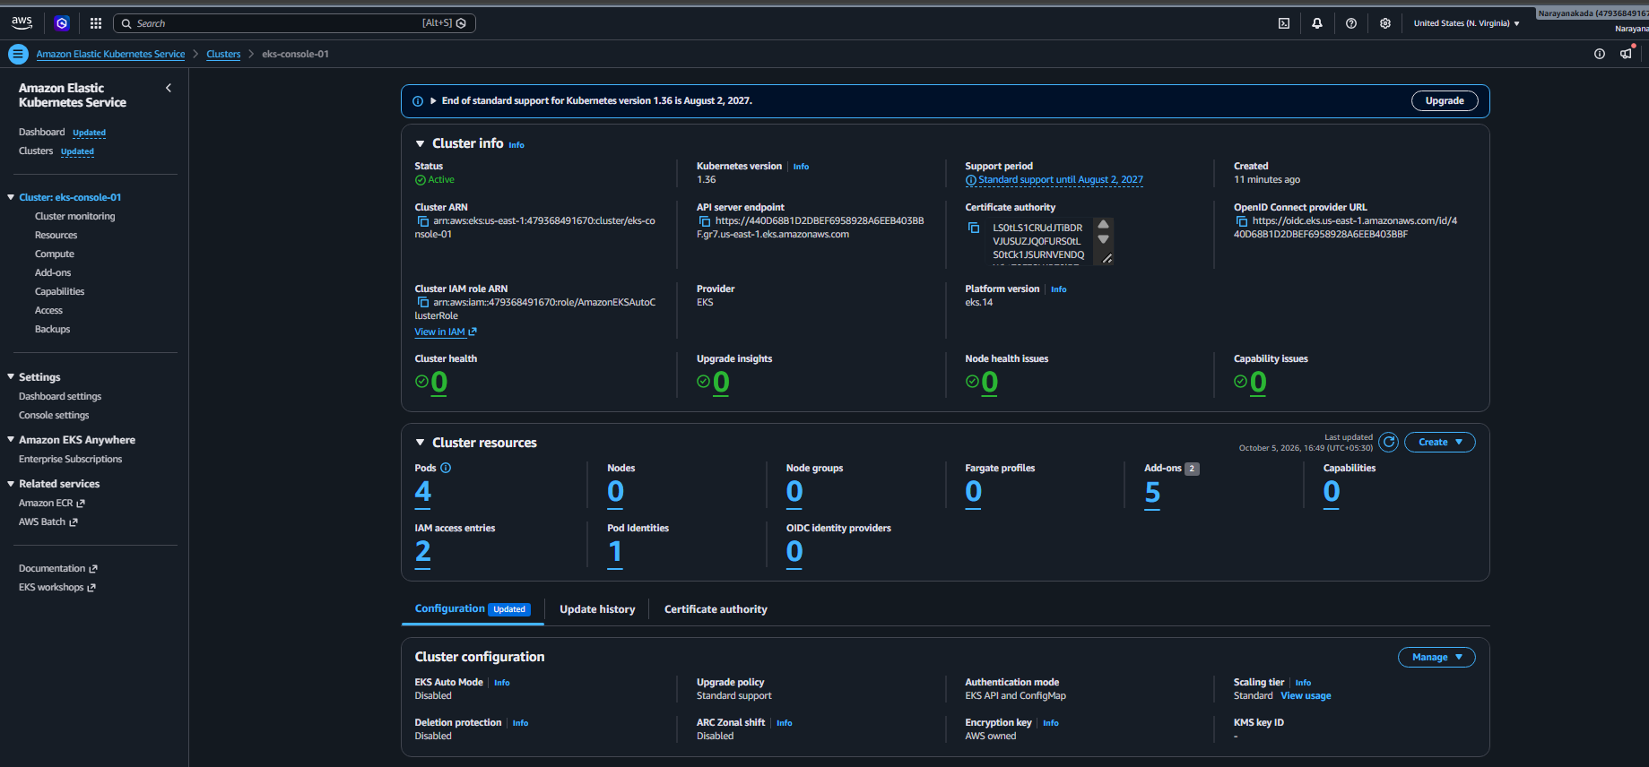
Step 7: Create Managed Node Group
Go to:
EKS → Clusters → eks-console-01 → Compute
You currently have:
Node groups: 0
Click: Add node group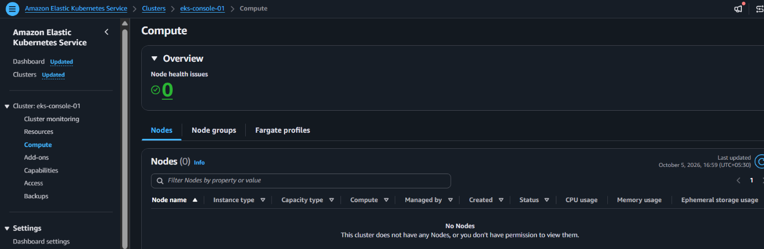

Step 7.1 — Node group configuration
Name
Enter: eks-console-ng
Node IAM role
You need an EC2 node role.
If you already have a suitable EKS node role, select it.
Otherwise click:
Create recommended role
For the node role, AWS should attach the standard policies required for EKS worker nodes, including:
AmazonEKSWorkerNodePolicy
AmazonEC2ContainerRegistryPullOnly
AmazonEKS_CNI_Policy
Use the role created for this node group.
Don't select the AmazonEKSAutoClusterRole. That is the cluster/control-plane role, not the worker-node role.
Click:Next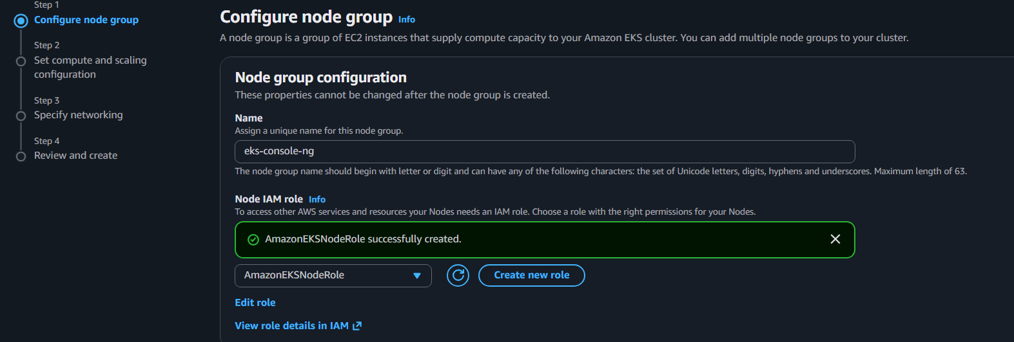

Step 7.2 — Compute and scaling
For AMI type, leave the recommended EKS Linux option.
For architecture:
x86_64
Instance type: t3.small
Disk:
20 GiB
For scaling:
Desired size: 2
Minimum size: 1
Maximum size: 3
So:
eks-console-ng
|
┌─────────┴─────────┐
│ │
Desired = 2 Max = 3
Min = 1
Click: Next
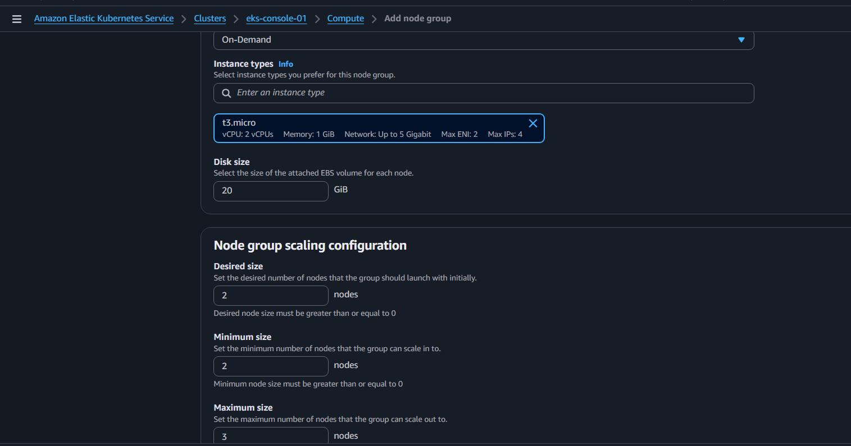
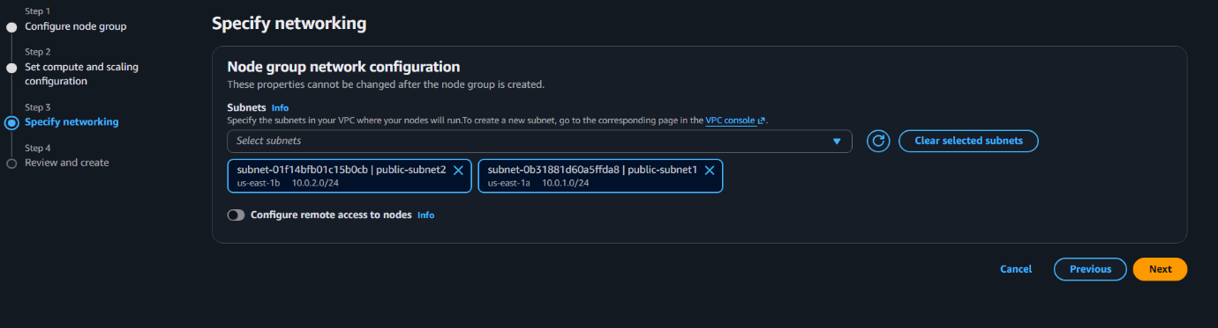Select the available subnets.
Your cluster currently has:
subnet-01f14bfb01c15b0cb
subnet-0b31881d60a5ffda8
Select both subnets.
This allows AWS to distribute nodes across Availability Zones.
You should have approximately:
VPC
|
┌──────────┴──────────┐
│ │
Subnet AZ-1 Subnet AZ-2
│ │
Worker 1 Worker 2
For SSH access:
For this lab, you can leave SSH disabled unless you specifically need direct EC2 access.
Click: Next

Check: Node group name: eks-console-ng
Instance type: t3.small
Desired: 2
Minimum: 1
Maximum: 3
Subnets: 2
Then click:
Create
AWS will start creating the managed node group.
Wait until:
Node group status: ACTIVE
This can take several minutes. 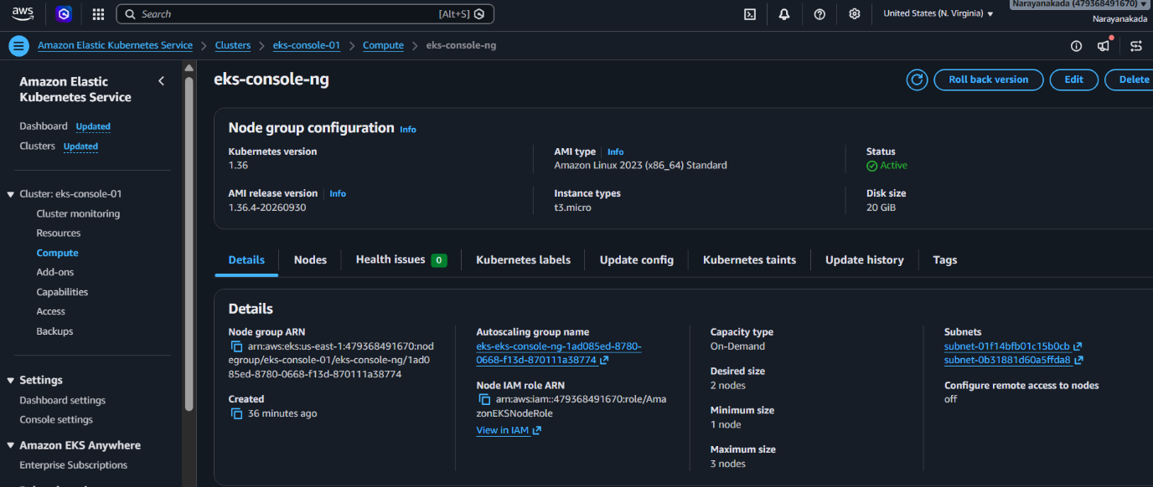

Step 8 — Connect kubectl to the Console cluster
Once the node group is ACTIVE, return to Git Bash.
Run:
aws eks update-kubeconfig \
--region us-east-1 \
--name eks-console-01
Expected:
Added new context arn:aws:eks:us-east-1:479368491670:cluster/eks-console-01

Step 9 — Verify context
kubectl config current-context
Expected:
arn:aws:eks:us-east-1:479368491670:cluster/eks-console-01
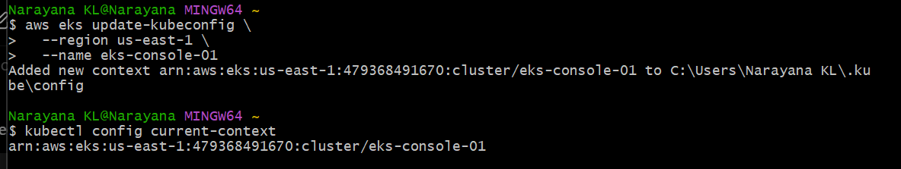
Step 10 — Verify nodes
kubectl get nodes
Expected:
NAME STATUS ROLES AGE VERSION
ip-xxx-xxx-xxx-xxx... Ready <none> ... v1.36.x
ip-xxx-xxx-xxx-xxx... Ready <none> ... v1.36.x
You want: 2 Ready

Step 11 — Check system pods
kubectl get pods -A
You should see EKS networking/system components.
Also specifically check:
kubectl get pods -n kube-system
You should see components such as:
aws-node
coredns
kube-proxy
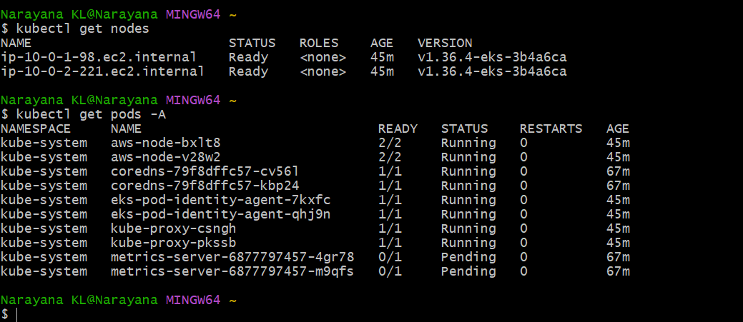
Step 12 — Check node group from AWS CLI
Run:
aws eks list-nodegroups \
--cluster-name eks-console-01 \
--region us-east-1
Expected:
{
"nodegroups": [
"eks-console-ng"
]
}
Then:
aws eks describe-nodegroup \
--cluster-name eks-console-01 \
--nodegroup-name eks-console-ng \
--region us-east-1 \
--query 'nodegroup.{Status:status,InstanceType:instanceTypes,Desired:scalingConfig.desiredSize,Min:scalingConfig.minSize,Max:scalingConfig.maxSize}'
Expected:
{
"Status": "ACTIVE",
"InstanceType": [
"t3.small"
],
"Desired": 2,
"Min": 1,
"Max": 3
}
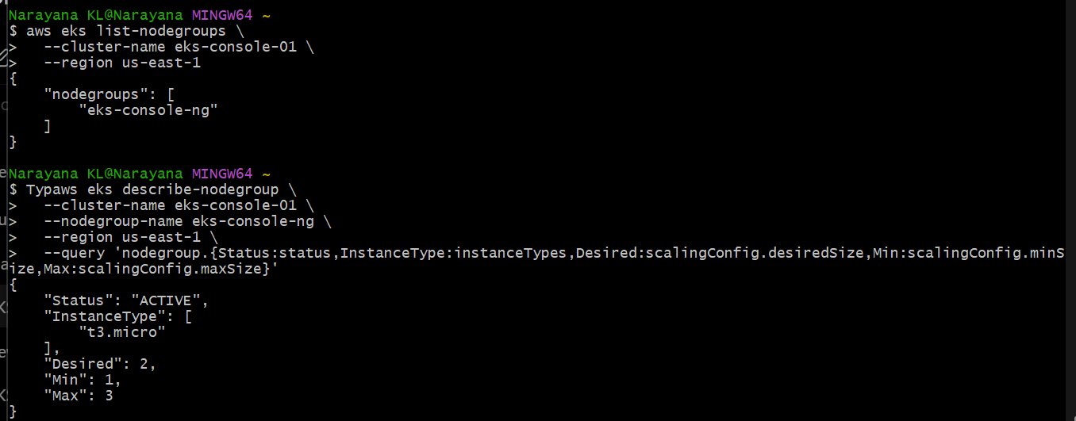

Step 13 — Deploy nginx
Now we'll prove the Console-created EKS cluster works.
kubectl create deployment nginx \
--image=nginx:latest \
--replicas=2
Check:
kubectl get deployment
Expected:
NAME READY UP-TO-DATE AVAILABLE
nginx 2/2 2 2
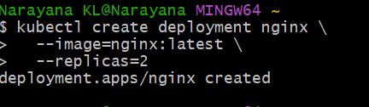
Step 14 — Check pods
kubectl get pods -o wide
You should have:
2 nginx pods
↓
2 EKS worker nodes
Ideally:
nginx-xxxxx → Worker 1
nginx-yyyyy → Worker 2
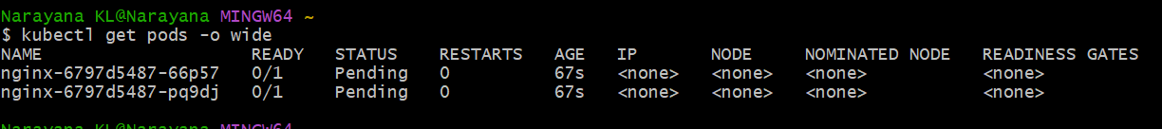
Step 15 — Create LoadBalancer
kubectl expose deployment nginx \
--name=nginx \
--port=80 \
--target-port=80 \
--type=LoadBalancer
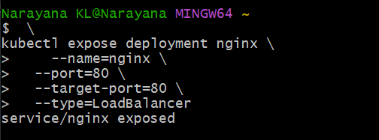
Check:
kubectl get svc nginx
Wait until:
EXTERNAL-IP
contains an AWS load-balancer DNS name.
You can watch it with:
kubectl get svc nginx -w
Press:
Ctrl+C
once the address appears.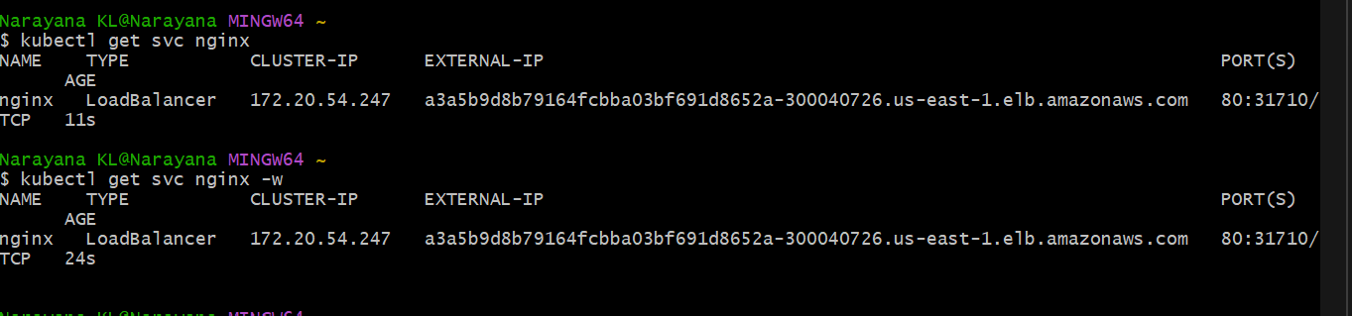

Step 16 — Test
Run:
kubectl get svc nginx
Copy the EXTERNAL-IP DNS name into your browser.
You should see:
Welcome to nginx!
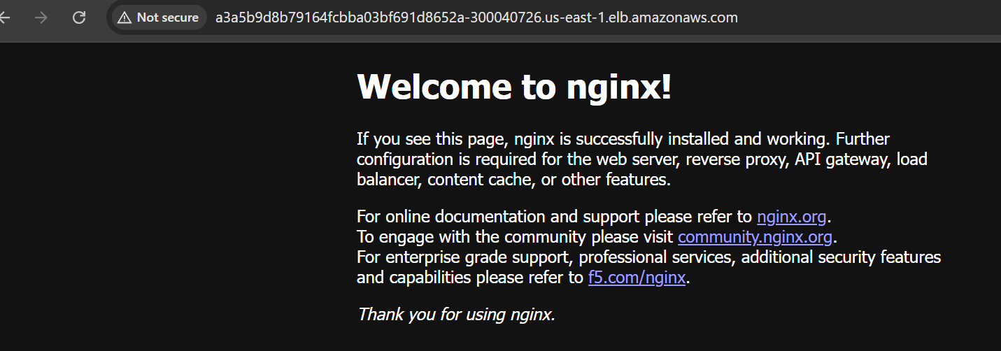
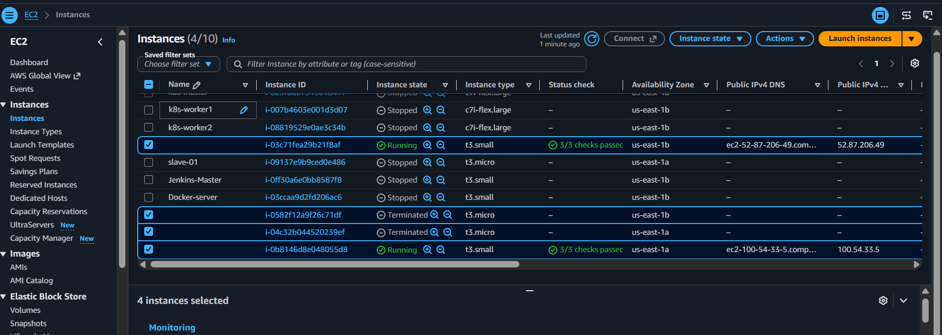
Task 3 Setup—Horizontal Pod Autoscaler (HPA)
Objective
Configure nginx to automatically scale based on CPU:
Minimum Pods = 2
Maximum Pods = 5
Target CPU = 50%
We will configure:
EKS Cluster
|
nginx Deployment
|
┌──────┴──────┐
│ │
Pod 1 Pod 2
│ │
└──────┬──────┘
|
HPA monitors
CPU utilization
|
High CPU → Scale OUT
Low CPU → Scale IN
We'll do this in small steps.
Step 1 — Check Metrics Server
Run: kubectl get deployment metrics-server -n kube-system
Expected:
NAME READY UP-TO-DATE AVAILABLE
metrics-server 1/1 1 1
Then: kubectl top nodes
Expected output similar to:
NAME CPU(cores) CPU% MEMORY(bytes) MEMORY%
ip-10-0-1-50.ec2.internal ... ... ... ...
ip-10-0-2-136.ec2.internal ... ... ... ...
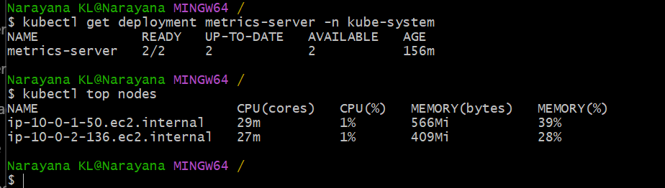
Step 2: Check nginx Deployment
Run: kubectl get deployment nginx
Then: kubectl get pods -l app=nginx
We need to confirm the Deployment and its labels before creating the HPA.
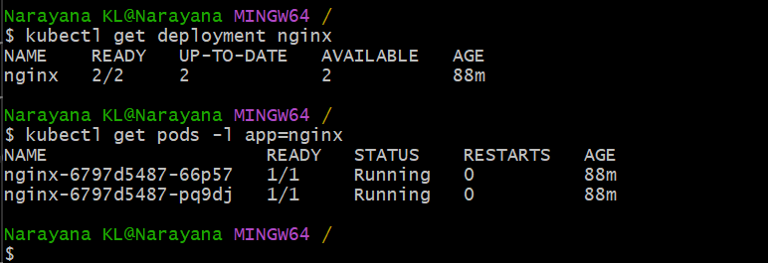
Step 3: Check CPU Requests
HPA based on CPU utilization requires the container to have a CPU request configured.
Run: kubectl get deployment nginx -o yaml | grep -A5 -B2 "resources:"
If nothing is returned, that's okay—we'll add the CPU request in the next step.
Also run: kubectl get deployment nginx -o jsonpath='{.spec.template.spec.containers[0].resources}'
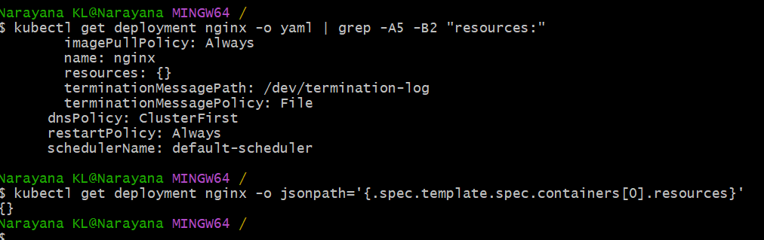
Step 4: Add CPU Request and Limit
We'll set: CPU request = 100m
CPU limit = 500m
Run: kubectl set resources deployment nginx \
--requests=cpu=100m \
--limits=cpu=500m
Expected: deployment.apps/nginx resource requirements updated
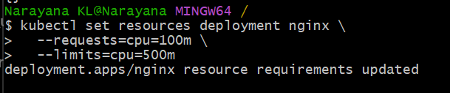
Then verify: kubectl get deployment nginx -o jsonpath='{.spec.template.spec.containers[0].resources}'
Expected: {"limits":{"cpu":"500m"},"requests":{"cpu":"100m"}}
Because changing the Deployment template triggers a rolling update, also run:
kubectl rollout status deployment nginx
Expected: deployment "nginx" successfully rolled out
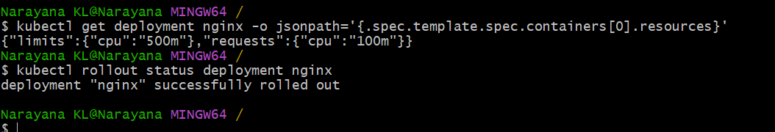
Step 5 — Create the HPA
Run: kubectl autoscale deployment nginx \
--cpu=50% \
--min=2 \
--max=5
Expected: horizontalpodautoscaler.autoscaling/nginx autoscaled
Step 6 — Verify HPA
kubectl get hpa
Expected:
NAME REFERENCE TARGETS MINPODS MAXPODS REPLICAS
nginx Deployment/nginx .../50% 2 5 2
Initially the CPU target may show:
<unknown>/50%
for a short time. Wait 30–60 seconds and check again:
kubectl get hpa
You should eventually see something similar to:
nginx Deployment/nginx 1%/50% 2 5 2
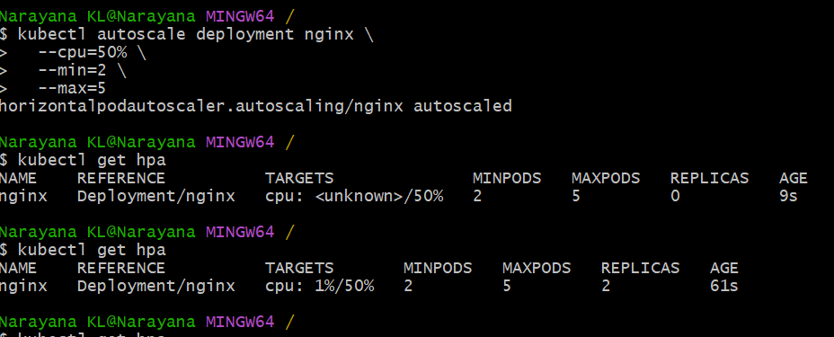
Step 7 — Get detailed HPA information
kubectl describe hpa nginx
Look for: Min replicas: 2
Max replicas: 5
Target CPU utilization: 50%
Also check:
kubectl get hpa nginx -o yaml
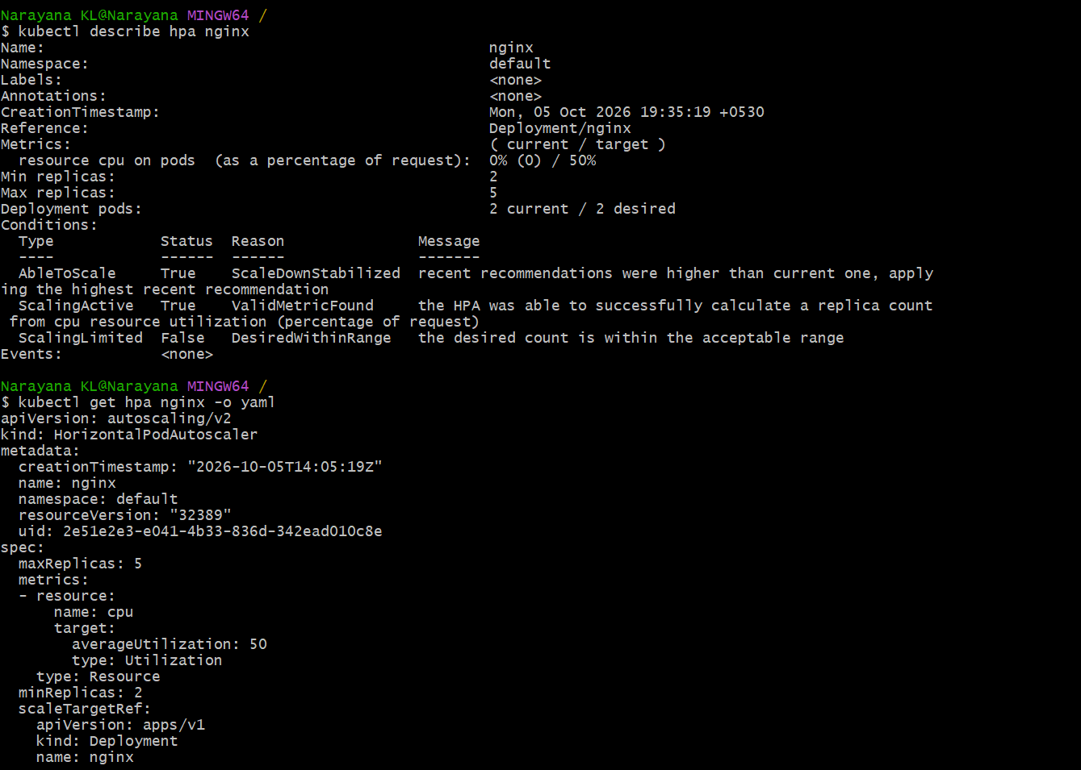
Step 8 — Verify Deployment
kubectl get deployment nginx
Expected:
NAME READY UP-TO-DATE AVAILABLE
nginx 2/2 2 2

Step 9 — Verify Pods
kubectl get pods -l app=nginx -o wide
Expected:
NAME READY STATUS NODE
nginx-... 1/1 Running ...
nginx-... 1/1 Running ...
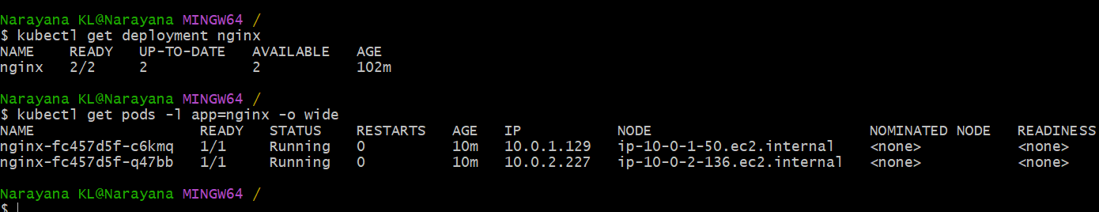
Step 10 — Verify CPU metrics
kubectl top pods -l app=nginx
You should see something similar to:
NAME CPU(cores) MEMORY(bytes)
nginx-... 1m ...
nginx-... 1m ...
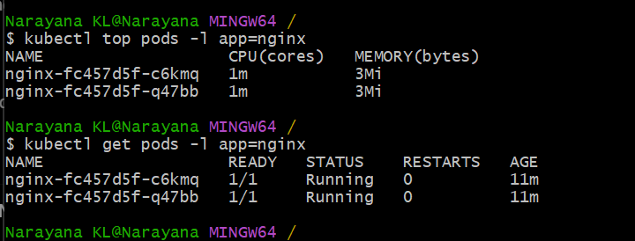
Step 11 — Generate CPU load
Now we'll test whether HPA can scale the application.
First get the nginx pod name: kubectl get pods -l app=nginx
Then start a CPU-intensive process inside one nginx pod:
kubectl exec -it $(kubectl get pod -l app=nginx -o jsonpath='{.items[0].metadata.name}') -- sh -c 'while true; do :; done'
⚠️ This command intentionally runs continuously.
Leave this terminal running.
Open a second Git Bash terminal for the monitoring commands below.
Step 12 — Monitor HPA
In the second terminal:
kubectl get hpa nginx -w
You may initially see:
nginx Deployment/nginx 1%/50% 2 5 2
After CPU increases, you should see the desired replicas increase, for example:
nginx Deployment/nginx 80%/50% 2 5 4
Eventually:
REPLICAS
5
may be reached depending on the load and CPU calculation.
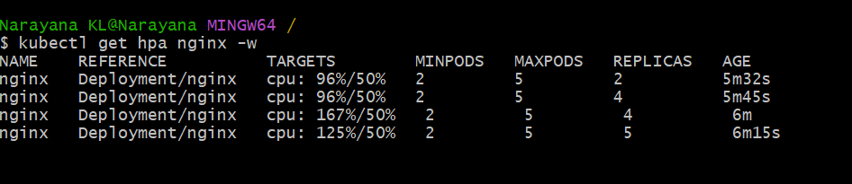
Step 13 — Monitor Pods
In the second terminal:
kubectl get pods -l app=nginx -w
You should see additional nginx pods being created:
nginx-... 1/1 Running
nginx-... 1/1 Running
nginx-... 0/1 Pending
nginx-... 1/1 Running
...
Eventually the number of replicas should increase.
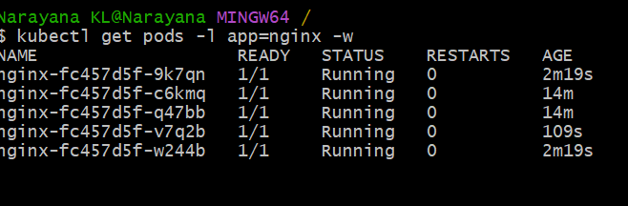
Step 14 — Check HPA details
Stop the HPA watch with:
Ctrl+C
Then:
kubectl describe hpa nginx
Look at the Events section.
You should see scaling activity such as:
SuccessfulRescale
New size: ...
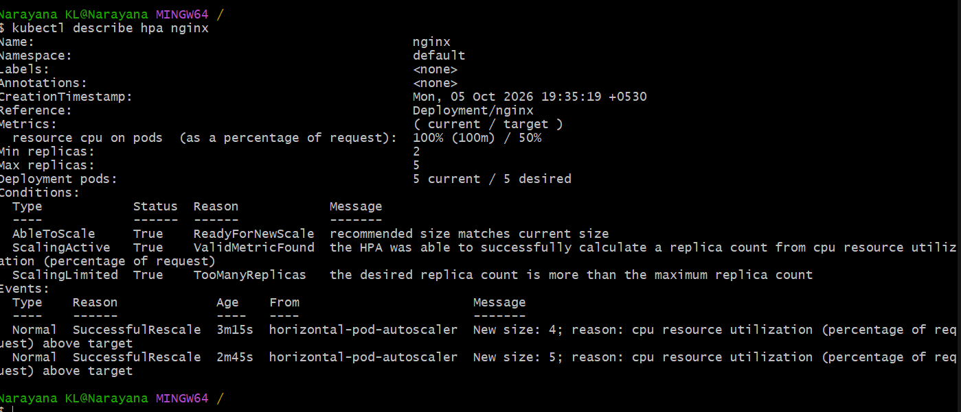
Step 15 — Stop the CPU test
Go back to the first terminal where this command is running:
kubectl exec -it $(kubectl get pod -l app=nginx -o jsonpath='{.items[0].metadata.name}') -- sh -c 'while true; do :; done'
Press:
Ctrl+C
This stops the CPU load.
Step 16 — Wait for scale-down
HPA does not immediately scale down. Kubernetes normally waits before reducing replicas.
Monitor: kubectl get hpa nginx -w
Eventually replicas should return to the minimum:
MINPODS MAXPODS REPLICAS
2 5 2
Then: kubectl get deployment nginx
Expected: NAME READY UP-TO-DATE AVAILABLE
nginx 2/2 2 2
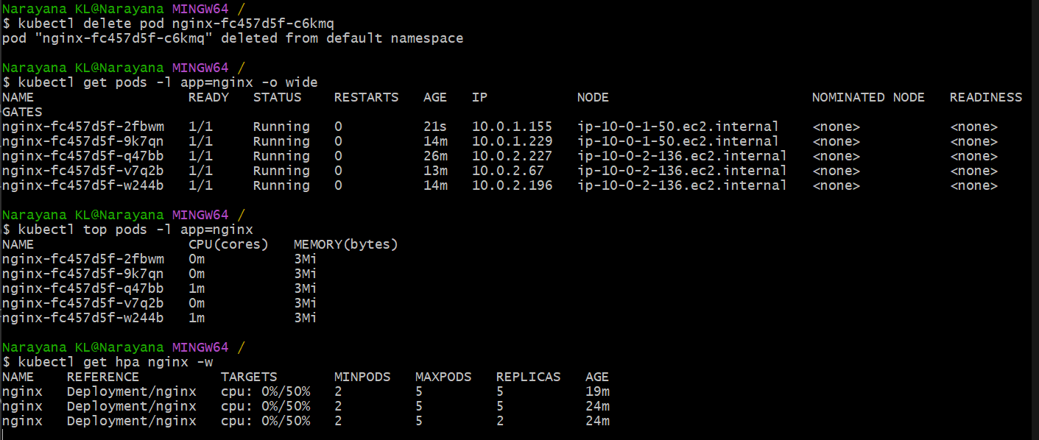
Task 4: Cluster Autoscaler.
AWS currently recommends Cluster Autoscaler with EKS managed node groups, and managed node groups are backed by Auto Scaling Groups. AWS Documentation
Step 4.1 — Check your node group
Run this in Git Bash:
aws eks describe-nodegroup \
--cluster-name eks-console-01 \
--nodegroup-name eks-console-ng-small \
--region us-east-1 \
--query 'nodegroup.{Name:nodegroupName,Min:minSize,Desired:scalingConfig.desiredSize,Max:scalingConfig.maxSize,Status:status,ASG:resources.autoScalingGroups[0].name}' \
--output table
You should now get something like:
| ASG | Desired | Max | Min | Name | Status |
| eks-... | 2 | 2 | 1 | eks-console-ng-small | ACTIVE |

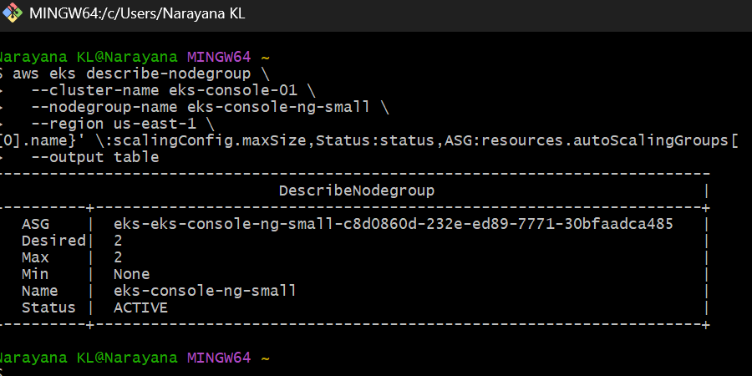
Min showing None is just a query issue; the important values are confirmed.
Step 4.2 — Increase node group maximum to 4
Your current maximum is 2, so Cluster Autoscaler cannot demonstrate scale-out beyond 2 nodes.
Run: aws eks update-nodegroup-config \
--cluster-name eks-console-01 \
--nodegroup-name eks-console-ng-small \
--scaling-config minSize=1,maxSize=4,desiredSize=2 \
--region us-east-1
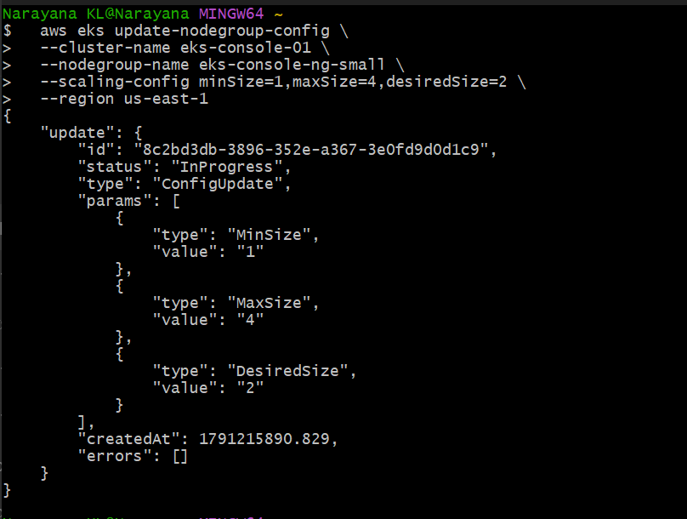
Then check:
aws eks describe-nodegroup \
--cluster-name eks-console-01 \
--nodegroup-name eks-console-ng-small \
--region us-east-1 \
--query 'nodegroup.scalingConfig' \
--output table
Expected:
| desiredSize | maxSize | minSize |
|-------------|---------|---------|
| 2 | 4 | 1 |
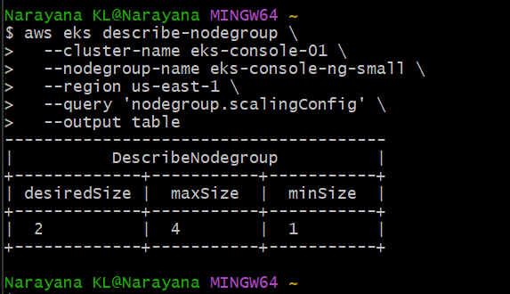
Your node group is now:
Desired = 2
Min = 1
Max = 4
So Cluster Autoscaler can scale the node group from 1 → 4 nodes.
Step 4.3 — Add Cluster Autoscaler tags
We already know the ASG:
eks-eks-console-ng-small-c8d0860d-232e-ed89-7771-30bfaadca485
Run this first:
aws autoscaling create-or-update-tags \
--tags \
ResourceId=eks-eks-console-ng-small-c8d0860d-232e-ed89-7771-30bfaadca485,ResourceType=auto-scaling-group,Key=k8s.io/cluster-autoscaler/enabled,Value=true,PropagateAtLaunch=true \
ResourceId=eks-eks-console-ng-small-c8d0860d-232e-ed89-7771-30bfaadca485,ResourceType=auto-scaling-group,Key=k8s.io/cluster-autoscaler/eks-console-01,Value=owned,PropagateAtLaunch=true \
--region us-east-1
Then verify:
aws autoscaling describe-auto-scaling-groups \
--auto-scaling-group-names eks-eks-console-ng-small-c8d0860d-232e-ed89-7771-30bfaadca485 \
--region us-east-1 \
--query 'AutoScalingGroups[0].Tags[?starts_with(Key, `k8s.io/cluster-autoscaler`)]' \
--output table
Expected tags:
k8s.io/cluster-autoscaler/enabled true
k8s.io/cluster-autoscaler/eks-console-01 owned
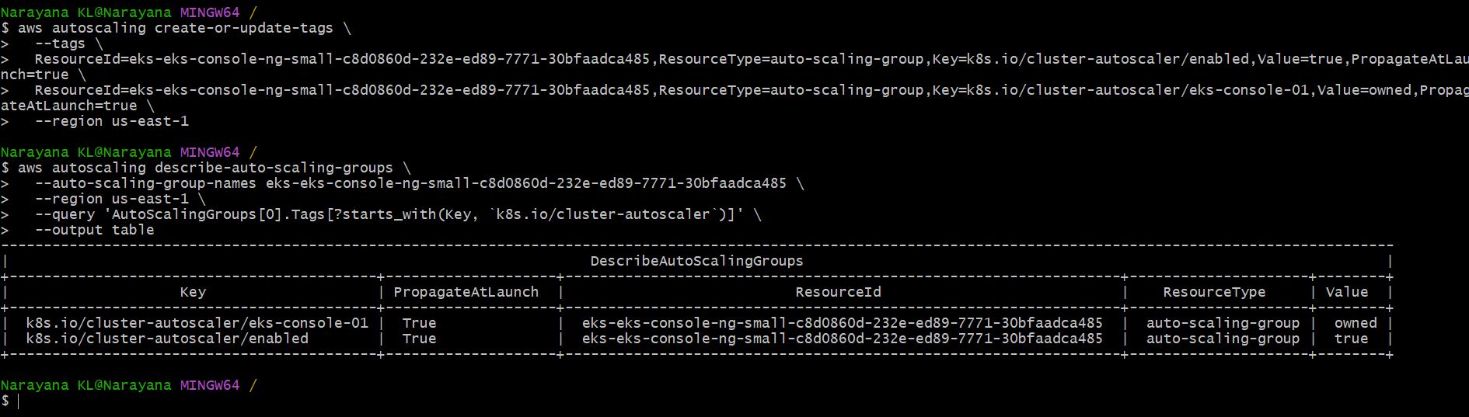
Both required ASG tags are correct. The Cluster Autoscaler uses these tags for ASG auto-discovery. GitHub
Step 4.4 — Create IAM policy for Cluster Autoscaler
We will use EKS Pod Identity, which avoids setting up an OIDC provider. AWS documents Pod Identity as the mechanism for associating an IAM role with a Kubernetes service account. AWS Documentation
First create the policy file in your home directory:
cat > ~/cluster-autoscaler-policy.json <<'EOF'
{
"Version": "2012-10-17",
"Statement": [
{
"Effect": "Allow",
"Action": [
"autoscaling:DescribeAutoScalingGroups",
"autoscaling:DescribeAutoScalingInstances",
"autoscaling:DescribeLaunchConfigurations",
"autoscaling:DescribeScalingActivities",
"autoscaling:DescribeTags",
"ec2:DescribeImages",
"ec2:DescribeInstanceTypes",
"ec2:DescribeLaunchTemplateVersions",
"ec2:GetInstanceTypesFromInstanceRequirements",
"eks:DescribeNodegroup"
],
"Resource": "*"
},
{
"Effect": "Allow",
"Action": [
"autoscaling:SetDesiredCapacity",
"autoscaling:TerminateInstanceInAutoScalingGroup"
],
"Resource": "*"
}
]
}
EOF
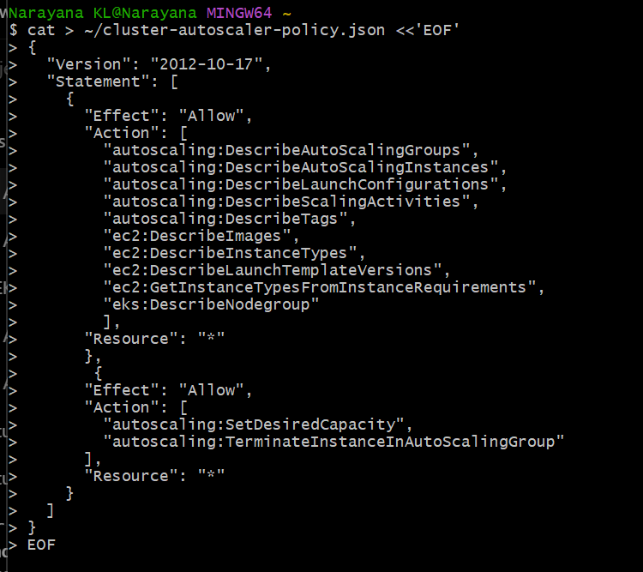
These permissions follow the current Cluster Autoscaler AWS policy guidance. GitHub
Now create the IAM policy:
If your actual Windows user folder is different, first run:
echo "$HOME"
You can also avoid the path issue completely by using the current directory:
cd ~
aws iam create-policy \
--policy-name EKSClusterAutoscalerPolicy \
--policy-document file://./cluster-autoscaler-policy.json
Expected result will contain:
PolicyName: EKSClusterAutoscalerPolicy
Arn: arn:aws:iam::479368491670:policy/EKSClusterAutoscalerPolicy
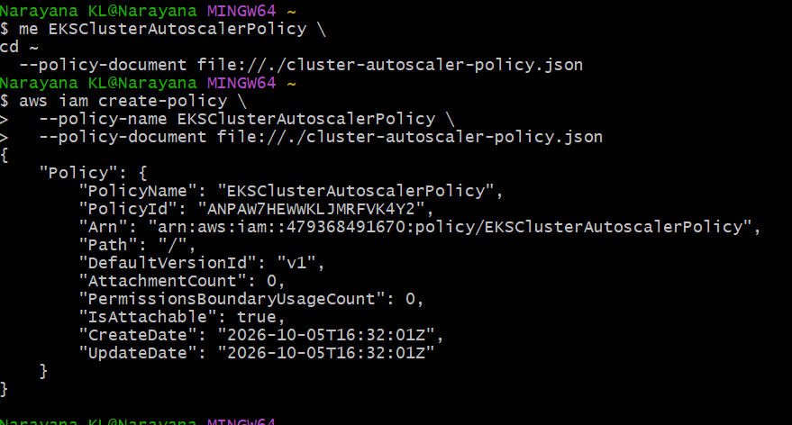
Step 4.5 — Create IAM role
Now we'll create a role that can be assumed by the EKS Pod Identity service.
Run:cat > ~/cluster-autoscaler-trust-policy.json <<'EOF'
{
"Version": "2012-10-17",
"Statement": [
{
"Effect": "Allow",
"Principal": {
"Service": "pods.eks.amazonaws.com"
},
"Action": [
"sts:AssumeRole",
"sts:TagSession"
]
}
]
}
EOF
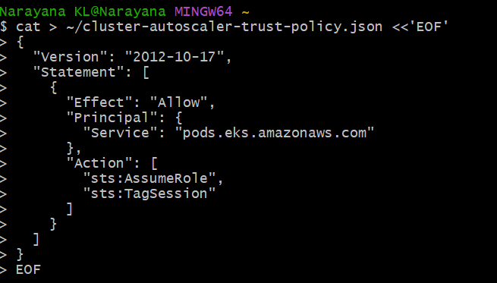
Then:
aws iam create-role \
--role-name EKS-Cluster-Autoscaler-Role \
--assume-role-policy-document file://./cluster-autoscaler-trust-policy.json
Then attach the policy:
aws iam attach-role-policy \
--role-name EKS-Cluster-Autoscaler-Role \
--policy-arn arn:aws:iam::479368491670:policy/EKSClusterAutoscalerPolicy
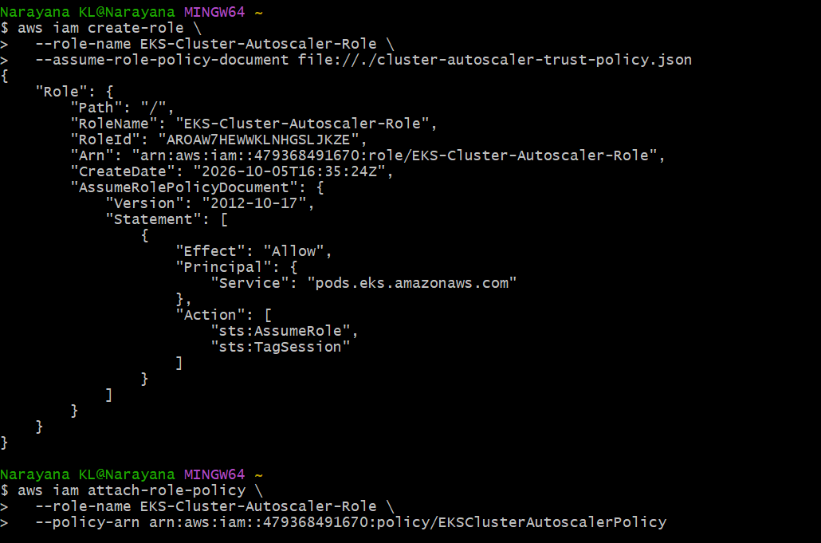
Finally verify:
aws iam get-role \
--role-name EKS-Cluster-Autoscaler-Role \
--query 'Role.{RoleName:RoleName,Arn:Arn}' \
--output table
Expected:
| RoleName | Arn |
| EKS-Cluster-Autoscaler-Role | arn:aws:iam::479368491670:role/... |
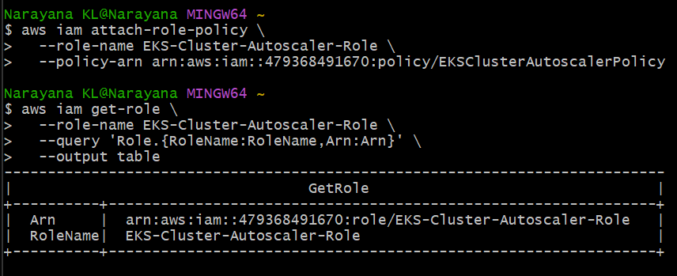
Step 4.6 — Create EKS Pod Identity association
We'll associate this IAM role with the Kubernetes service account that Cluster Autoscaler will use.
Run: aws eks create-pod-identity-association \
--cluster-name eks-console-01 \
--namespace kube-system \
--service-account cluster-autoscaler \
--role-arn arn:aws:iam::479368491670:role/EKS-Cluster-Autoscaler-Role \
--region us-east-1
Expected output will contain something like: "clusterName": "eks-console-01"
"namespace": "kube-system"
"serviceAccount": "cluster-autoscaler"
"roleArn": "arn:aws:iam::479368491670:role/EKS-Cluster-Autoscaler-Role"
"associationId": "a-..."
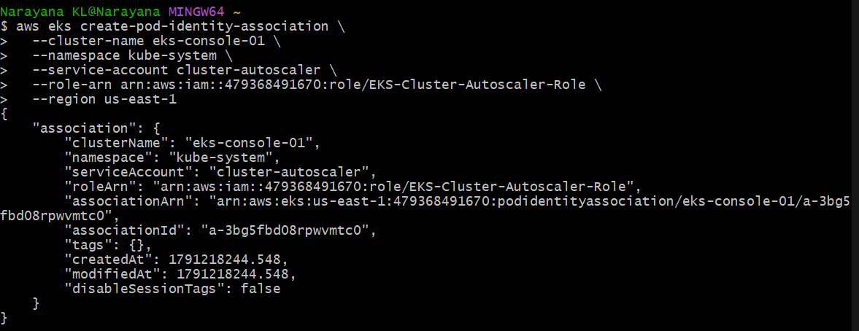
Step 4.7 — Create Cluster Autoscaler ServiceAccount
We'll now create the Kubernetes ServiceAccount. Do not add IAM annotations because we're using EKS Pod Identity.
Run: kubectl create serviceaccount cluster-autoscaler -n kube-system
Then verify: kubectl get serviceaccount cluster-autoscaler -n kube-system
Expected:
NAME SECRETS AGE
cluster-autoscaler 0 ...
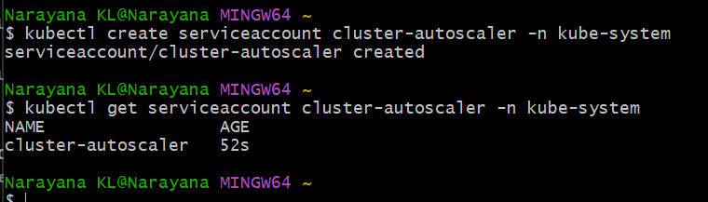
The cluster-autoscaler ServiceAccount is ready and correctly connected through EKS Pod Identity.
Step 4.8 — Deploy Cluster Autoscaler
Because your cluster is Kubernetes 1.36, we'll use the matching Cluster Autoscaler version.
Create the deployment file:
cat > ~/cluster-autoscaler.yaml <<'EOF'
apiVersion: apps/v1
kind: Deployment
metadata:
name: cluster-autoscaler
namespace: kube-system
labels:
app: cluster-autoscaler
spec:
replicas: 1
selector:
matchLabels:
app: cluster-autoscaler
template:
metadata:
labels:
app: cluster-autoscaler
spec:
serviceAccountName: cluster-autoscaler
priorityClassName: system-cluster-critical
containers:
- name: cluster-autoscaler
image: registry.k8s.io/autoscaling/cluster-autoscaler:v1.36.0
command:
- ./cluster-autoscaler
- --cloud-provider=aws
- --cluster-name=eks-console-01
- --balance-similar-node-groups
- --skip-nodes-with-system-pods=false
- --expander=least-waste
- --stderrthreshold=info
- --v=4
resources:
requests:
cpu: 100m
memory: 300Mi
limits:
cpu: 200m
memory: 500Mi
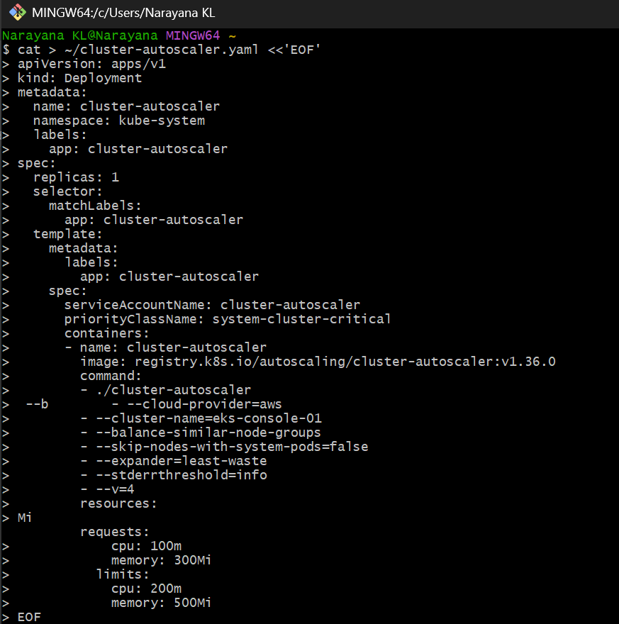
EOF
Apply it:
kubectl apply -f ~/cluster-autoscaler.yaml
Then check:
kubectl get pods -n kube-system -l app=cluster-autoscaler
Expected:
NAME READY STATUS RESTARTS AGE
cluster-autoscaler-xxxxxxxxxx-xxxxx 1/1 Running 0 ...
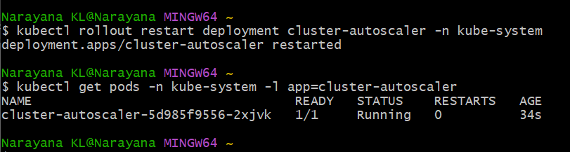
Step 4.9 — Fix Cluster Autoscaler RBAC
Create the RBAC file:
cat > ~/cluster-autoscaler-rbac.yaml <<'EOF'
apiVersion: v1
kind: ServiceAccount
metadata:
name: cluster-autoscaler
namespace: kube-system
---
apiVersion: rbac.authorization.k8s.io/v1
kind: ClusterRole
metadata:
name: cluster-autoscaler
rules:
- apiGroups: [""]
resources:
- nodes
- pods
- services
- replicationcontrollers
- persistentvolumeclaims
- persistentvolumes
verbs:
- get
- list
- watch

- apiGroups: [""]
resources:
- pods/eviction
verbs:
- create

- apiGroups: [""]
resources:
- pods/status
verbs:
- update

- apiGroups: ["apps"]
resources:
- replicasets
- deployments
verbs:
- get
- list
- watch

- apiGroups: ["policy"]
resources:
- poddisruptionbudgets
verbs:
- get
- list
- watch

- apiGroups: ["storage.k8s.io"]
resources:
- storageclasses
- csinodes
verbs:
- get
- list
- watch

- apiGroups: ["autoscaling"]
resources:
- horizontalpodautoscalers
verbs:
- get
- list
- watch

- apiGroups: ["coordination.k8s.io"]
resources:
- leases
verbs:
- create
- get
- update

- apiGroups: ["apps"]
resources:
- daemonsets
verbs:
- get
- list
- watch

---
apiVersion: rbac.authorization.k8s.io/v1
kind: ClusterRoleBinding
metadata:
name: cluster-autoscaler
roleRef:
apiGroup: rbac.authorization.k8s.io
kind: ClusterRole
name: cluster-autoscaler
subjects:
- kind: ServiceAccount
name: cluster-autoscaler
namespace: kube-system
EOF
Apply it:
kubectl apply -f ~/cluster-autoscaler-rbac.yaml
Then verify:
kubectl auth can-i list nodes \
--as=system:serviceaccount:kube-system:cluster-autoscaler
Expected:
yes
Important
We are not recreating the ServiceAccount—it already exists. Applying this file simply ensures the RBAC configuration is present.
Run the commands above and send me the result of:
kubectl auth can-i list nodes \
--as=system:serviceaccount:kube-system:cluster-autoscaler
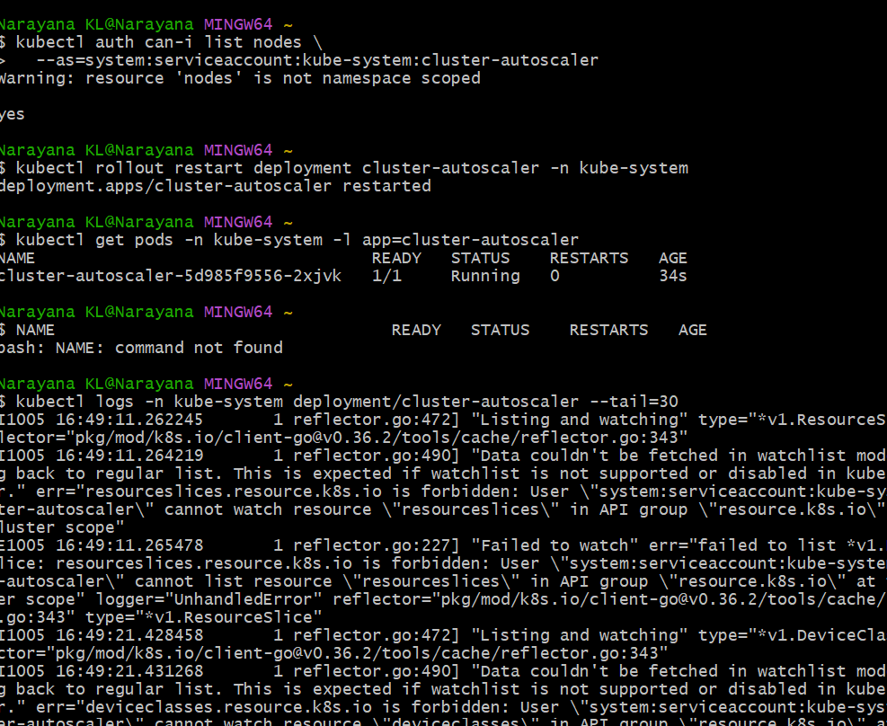
Step 4.10 — Fix ConfigMap permission
Run this single command:
kubectl patch clusterrole cluster-autoscaler --type=json -p='[
{"op":"add","path":"/rules/-","value":{"apiGroups":[""],"resources":["configmaps"],"verbs":["get","list","watch"]}}
]'
Then restart Cluster Autoscaler:
kubectl rollout restart deployment cluster-autoscaler -n kube-system
Wait a few seconds:
kubectl get pods -n kube-system -l app=cluster-autoscaler
You should see:
cluster-autoscaler-xxxxx 1/1 Running
Then check:
kubectl logs -n kube-system deployment/cluster-autoscaler --tail=50
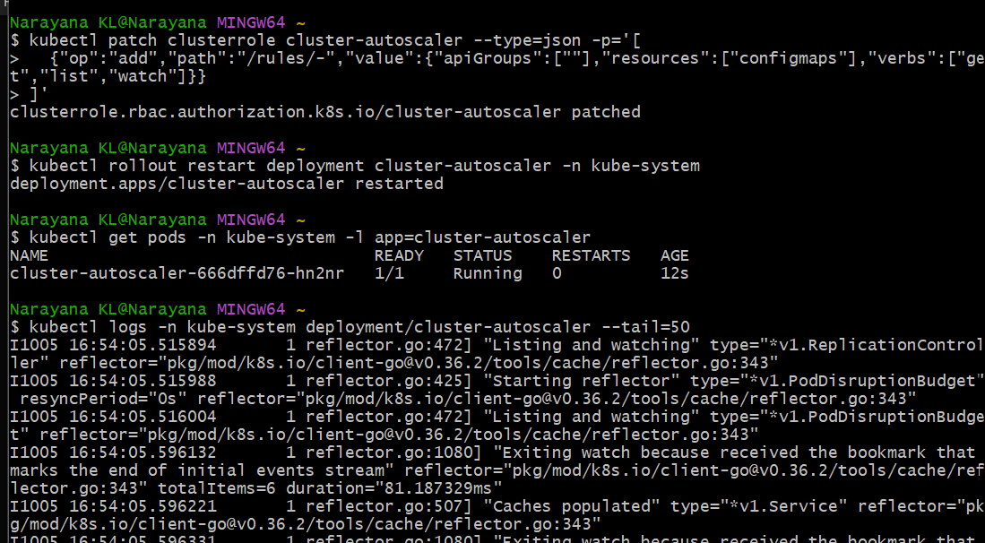
Step 4.11 — Check AWS instances
Run only this command:
aws ec2 describe-instances \
--instance-ids i-0b8146d8e048055d8 i-03c71fea29b21f8af \
--region us-east-1 \
--query 'Reservations[].Instances[].{InstanceId:InstanceId,State:State.Name,PrivateIP:PrivateIpAddress,Subnet:SubnetId}' \
--output table
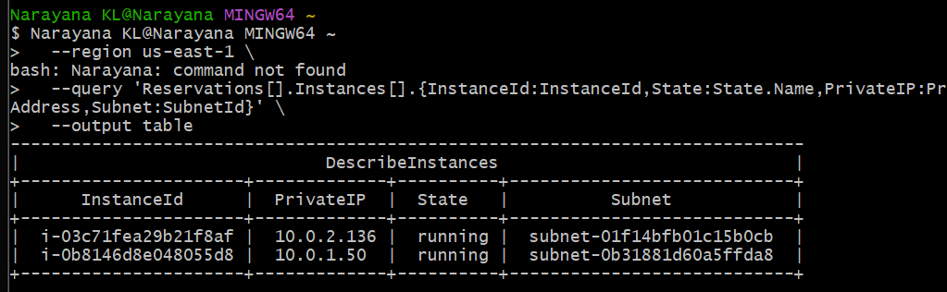
Step 4.12 — Verify Cluster Autoscaler IAM permissions
Run:
aws iam list-attached-role-policies \
--role-name EKS-Cluster-Autoscaler-Role \
--query 'AttachedPolicies[].{PolicyName:PolicyName,PolicyArn:PolicyArn}' \
--output table
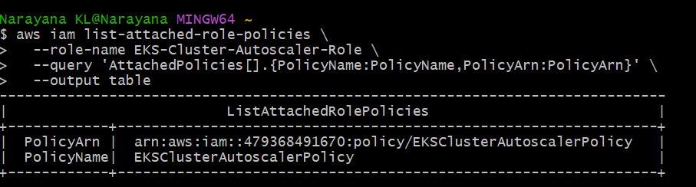
Now let's move to the actual autoscaling test.
Step 4.13 — Check current nodes
Run:
kubectl get nodes -o wide
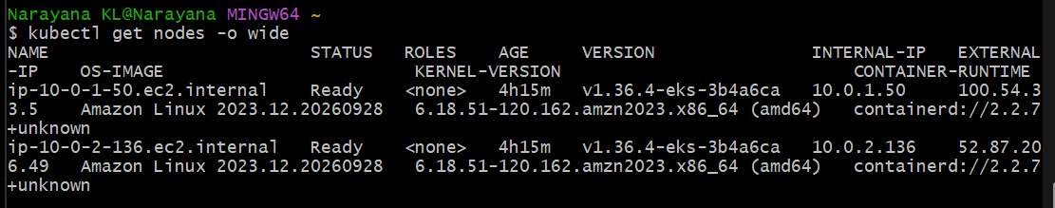
Step 4.14 — Create autoscaling test workload
Run:
kubectl create deployment ca-test --image=nginx --replicas=5
Then:
kubectl get pods -o wide
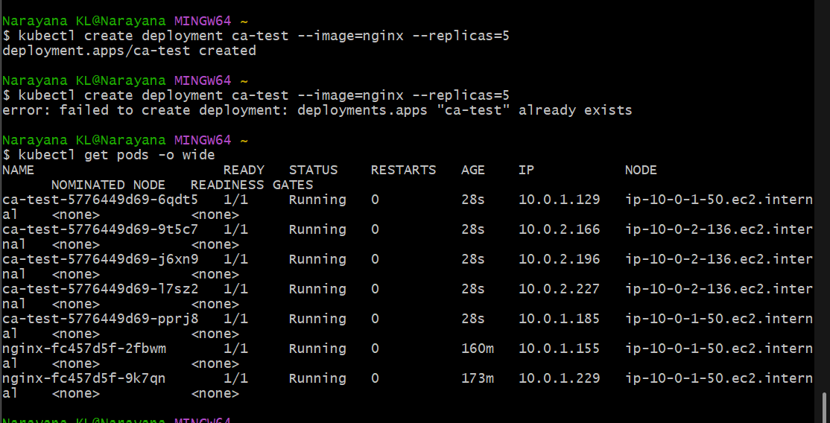
Step 4.15 — Make the test pods require more CPU
Run: kubectl set resources deployment ca-test \
--requests=cpu=1000m,memory=256Mi \
--limits=cpu=1500m,memory=512Mi
Then scale it to 5 replicas again:
kubectl scale deployment ca-test --replicas=5
Now check: kubectl get pods -o wide
You should see some pods become:
Pending
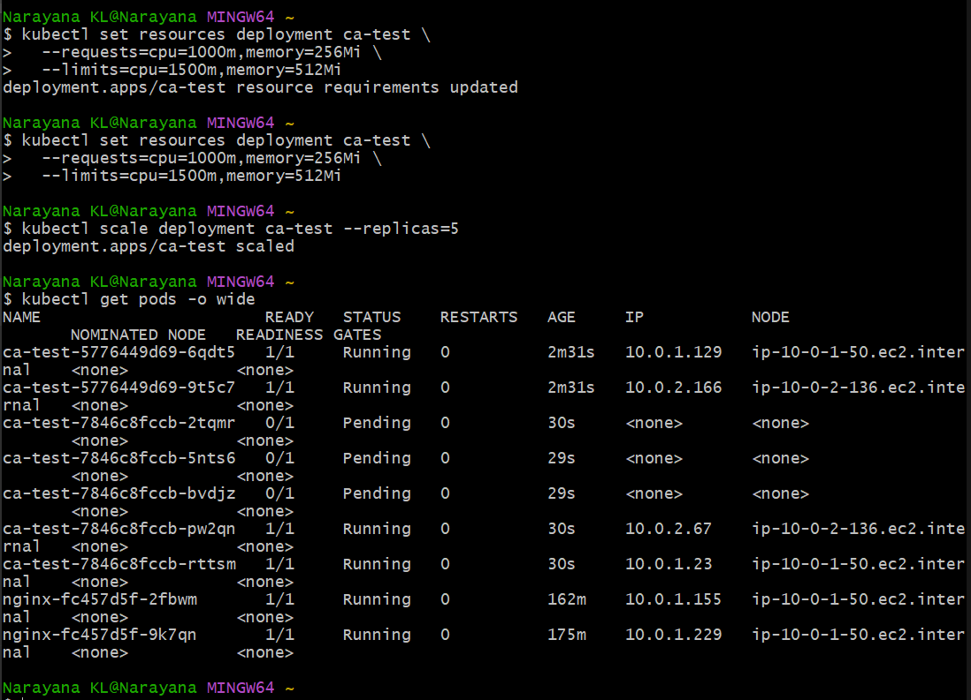
Step 4.16 — Watch Cluster Autoscaler scale out
Run: kubectl get nodes -w
You should initially see the 2 existing nodes. Leave this command running for about 2–3 minutes.
When a new node appears, you should see something like:
ip-10-0-3-xxx.ec2.internal Ready
Press Ctrl+C after you see a new node become Ready.
Then run:
kubectl get nodes
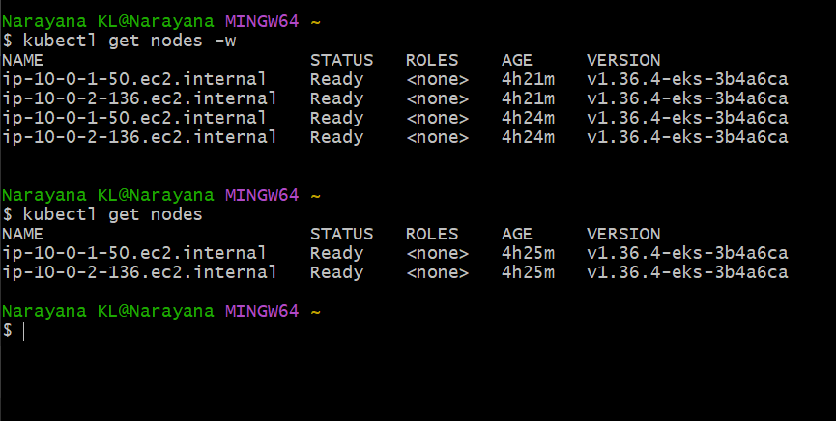
check node group scaling
Run only:
aws eks describe-nodegroup \
--cluster-name eks-console-01 \
--nodegroup-name eks-console-ng-small \
--region us-east-1 \
--query 'nodegroup.scalingConfig'
Expected:
{
"minSize": 1,
"maxSize": 4,
"desiredSize": 2
}
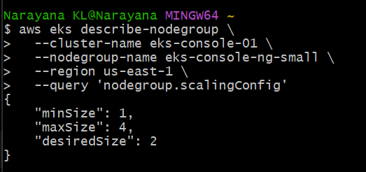
check ASG
Run:
aws autoscaling describe-auto-scaling-groups \
--region us-east-1 \
--query 'AutoScalingGroups[?AutoScalingGroupName==`eks-eks-console-ng-small-c8d0860d-232e-ed89-7771-30bfaadca485`].{Min:MinSize,Max:MaxSize,Desired:DesiredCapacity,Instances:length(Instances)}' \
--output table
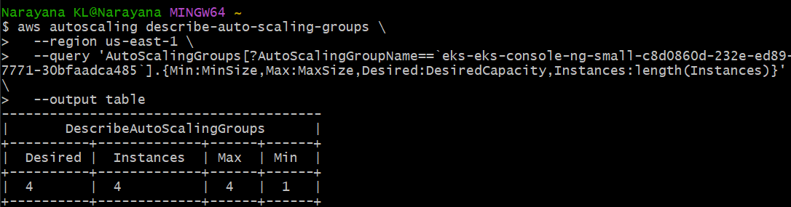
Verify the Kubernetes side
Run:
kubectl get nodes
Then:
kubectl get pods -l app=ca-test -o wide
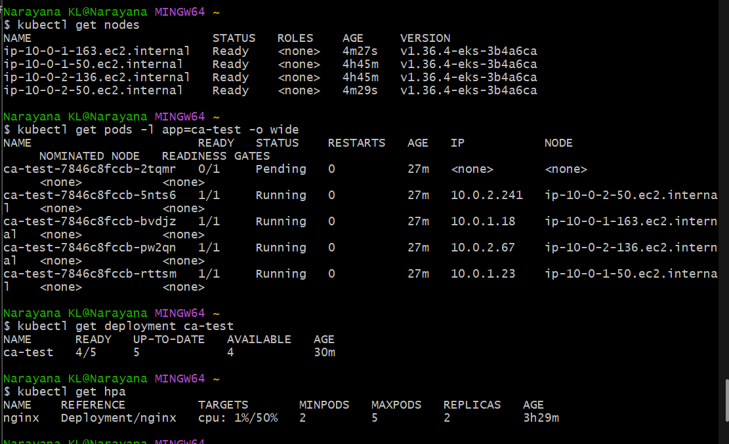
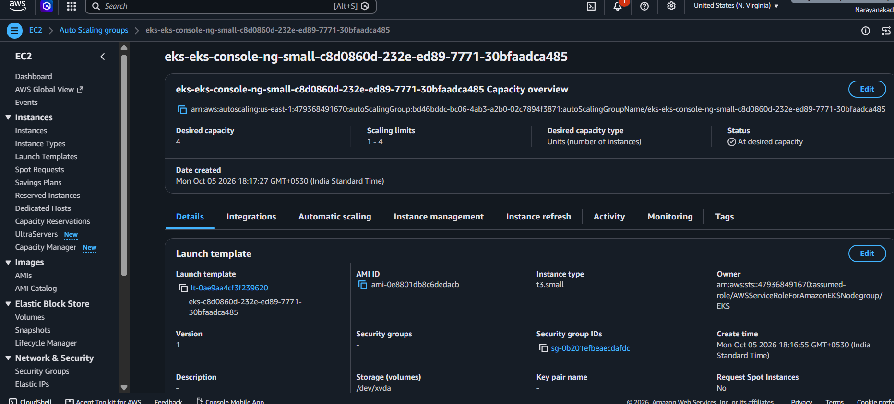
Task 5 — Job and CronJob
We'll start with a simple Kubernetes Job using kubectl, one step at a time.
Run:
kubectl create job demo-job --image=busybox:1.36 -- sh -c 'echo "Hello from Kubernetes Job"; date'
Then:
kubectl get jobs
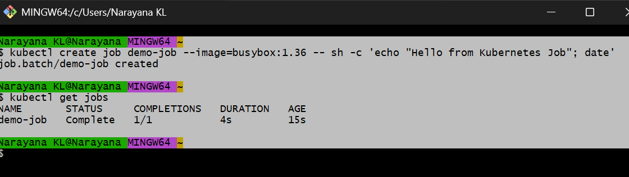
Step 5.2 — Check the Job Pod and logs
Run: kubectl get pods -l job-name=demo-job
Then: kubectl logs job/demo-job
You should see something similar to:
Hello from Kubernetes Job
Mon Oct 6 ...
This demonstrates that a Job creates a Pod and runs it to completion.
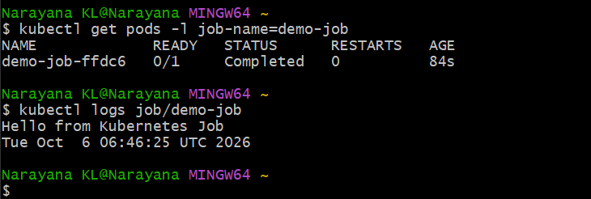
Step 5.3 — Create a CronJob
A CronJob creates Jobs automatically according to a schedule.
For our lab, we'll run it every minute so we can see it working immediately.
Create it with: kubectl create cronjob demo-cronjob \
--image=busybox:1.36 \
--schedule="*/1 * * * *" \
-- sh -c 'echo "Hello from Kubernetes CronJob"; date'
Then check: kubectl get cronjobs
Expected:
NAME SCHEDULE SUSPEND ACTIVE LAST SCHEDULE
demo-cronjob */1 * * * * False 0 ...
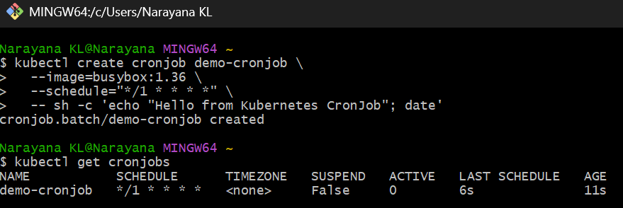
Step 5.4 — Verify the CronJob creates Jobs
Wait about 1 minute, then run: kubectl get jobs
You should see both the original Job and a new Job created by the CronJob, something like:
NAME STATUS COMPLETIONS
demo-job Complete 1/1
demo-cronjob-xxxxx Complete 1/1
Then run: kubectl get pods
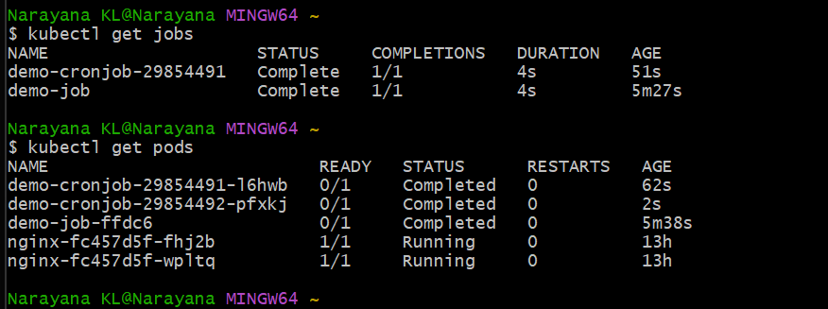
Task 6 — Create Secret and Inject into Pod
We'll demonstrate the common Kubernetes pattern:
Secret
↓
Pod
↓
Environment Variable
↓
Application
Step 6.1 — Create the Secret
Run this in Git Bash: kubectl create secret generic app-secret \
--from-literal=username=admin \
--from-literal=password=K8s@123
Expected: secret/app-secret created
Then verify: kubectl get secret app-secret
Expected:
NAME TYPE DATA AGE
app-secret Opaque 2 ...
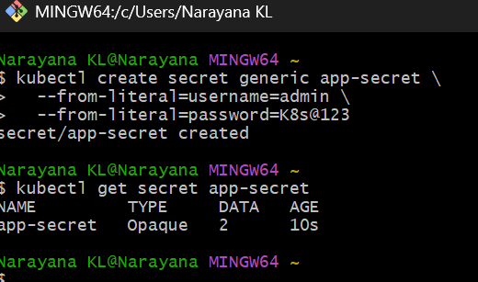
Step 6.2 — Create Pod with Secret injection
Create this file in Git Bash:
cat > secret-pod.yaml <<'EOF'
apiVersion: v1
kind: Pod
metadata:
name: secret-pod
spec:
containers:
- name: app
image: busybox:1.36
command:
- sh
- -c
- |
echo "Pod started"
echo "Username: $APP_USERNAME"
echo "Password: $APP_PASSWORD"
sleep 3600
env:
- name: APP_USERNAME
valueFrom:
secretKeyRef:
name: app-secret
key: username
- name: APP_PASSWORD
valueFrom:
secretKeyRef:
name: app-secret
key: password
EOF
Apply it:
kubectl apply -f secret-pod.yaml
Then check:
kubectl get pod secret-pod
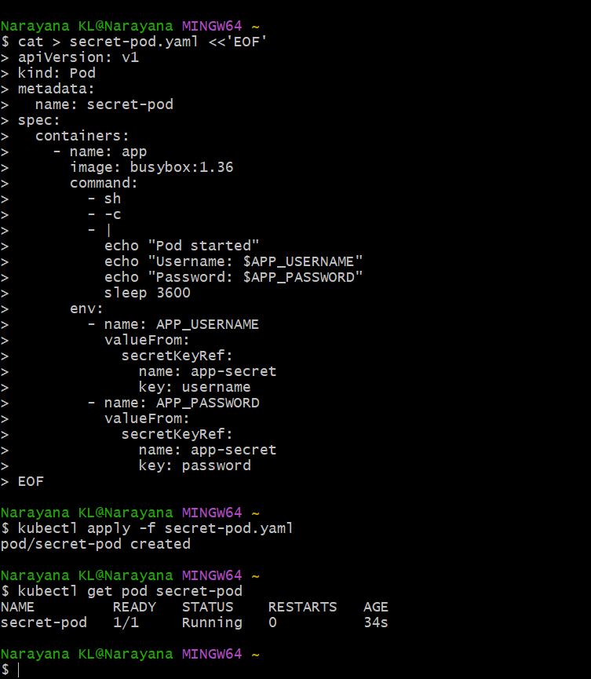
Step 6.3 — Verify Secret values inside the Pod
Run:
kubectl exec secret-pod -- env | grep -E 'APP_USERNAME|APP_PASSWORD'
Expected:
APP_USERNAME=admin
APP_PASSWORD=K8s@123
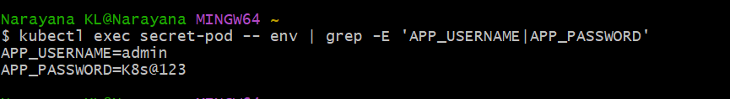
This proves the Kubernetes Secret was injected as environment variables.
Task 7 — Check EKS Add-ons
This task we'll do primarily through the AWS EKS Console, as you requested.
Step 7.1 — Open Add-ons
In AWS Console:
EKS → Clusters → eks-console-01 → Add-ons
You should see the add-ons installed on your cluster, typically including:
- Amazon VPC CNI — networking
- CoreDNS — Kubernetes DNS
- kube-proxy — service networking
- Other EKS-managed add-ons, if installed
For each add-on, look at:
Field | What to check
Name | Add-on name
Status | Should generally be Active
Version | Installed add-on version
Type | EKS managed add-on
Health/issues | Check for warnings
Your task
Open:
EKS → eks-console-01 → Add-ons
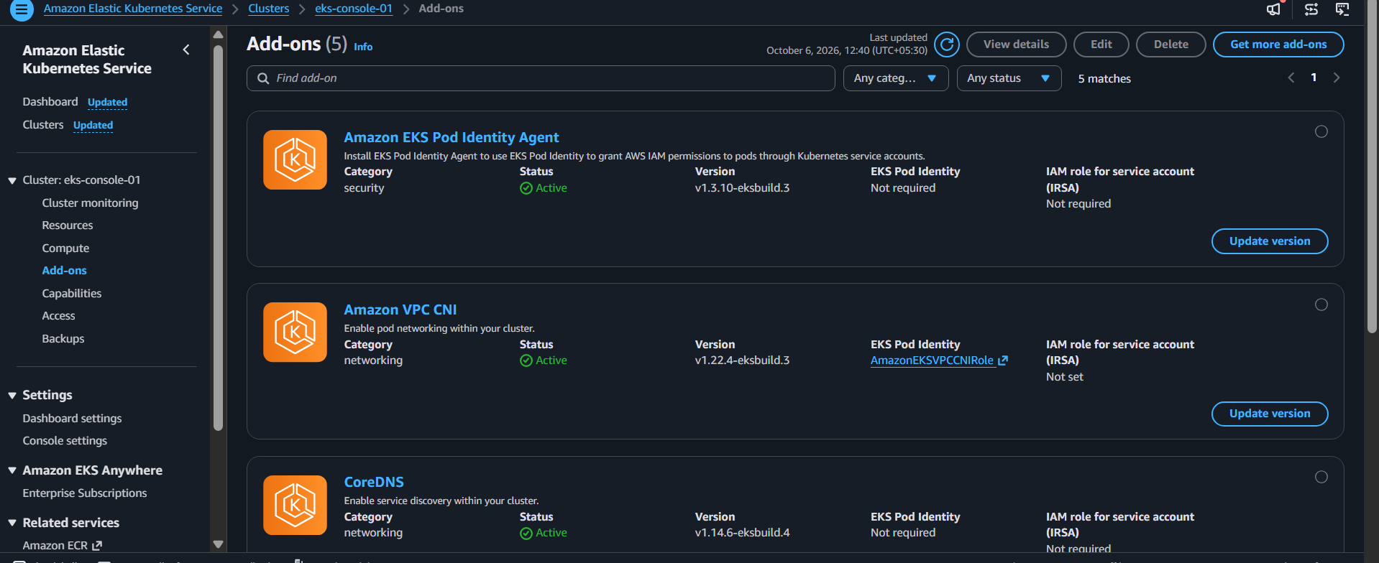
You currently have 5 active add-ons:
Add-on | Version | Category | Purpose | Status
EKS Pod Identity Agent | v1.3.10-eksbuild.3 | Security | Allows Pods to receive AWS IAM permissions through Service Accounts | 🟢 Active
Amazon VPC CNI | v1.22.4-eksbuild.3 | Networking | Provides networking for Kubernetes Pods | 🟢 Active
CoreDNS | v1.14.6-eksbuild.4 | Networking | Provides Kubernetes DNS/service discovery | 🟢 Active
kube-proxy | v1.36.0-eksbuild.25 | Networking | Handles Kubernetes Service networking | 🟢 Active
Metrics Server | v0.9.0-eksbuild.11 | Observability | Provides CPU/memory metrics used by HPA | 🟢 Active
Important connection to our previous tasks
Your Cluster Autoscaler used the EKS Pod Identity Agent to obtain AWS permissions.
Your HPA used the Metrics Server:
HPA
↓
Metrics Server
↓
CPU/Memory metrics
↓
Deployment scaling
And your normal Pod networking depends on:
Pod
↓
Amazon VPC CNI
↓
AWS VPC networking
About the "new versions available" message
The console says:
New versions are available for 2 add-ons.
For this lab, don't update them now.
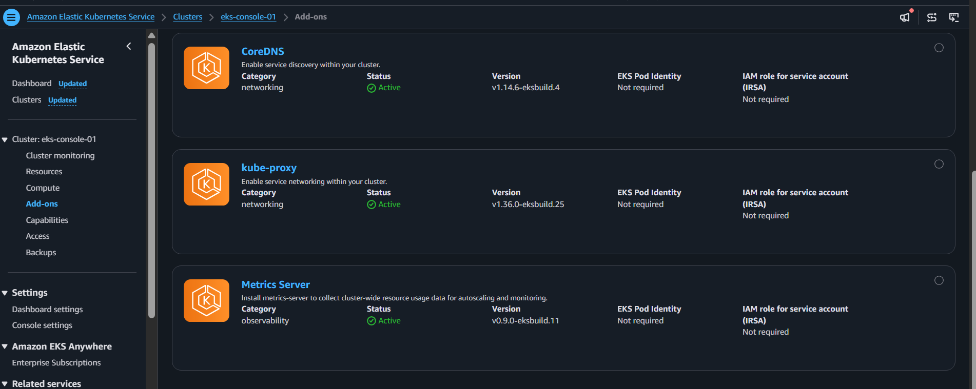
Task 8: Upgrade EKS Cluster
Objective
Upgrade the Amazon EKS cluster from Kubernetes 1.36 to Kubernetes 1.37, including the EKS control plane and managed node group, and verify that all worker nodes and workloads are healthy after the upgrade.
Cluster Details
Item | Value
Cluster Name | eks-console-01
Region | us-east-1
Previous Kubernetes Version | 1.36
New Kubernetes Version | 1.37
Node Group | eks-console-ng-small
Desired Nodes | 4
New AMI Release | 1.37.0-20260930
Update Strategy | Rolling update

Step 1: Check the Current Cluster Version
Before starting the upgrade, verify the existing Kubernetes version:
kubectl version --short
Check the worker nodes:
kubectl get nodes
Expected result:
NAME STATUS ROLES VERSION
ip-10-0-x-x.ec2.internal Ready <none> v1.36.x-eks-...
Step 2: Open the EKS Cluster
- Login to the AWS Management Console.
- Open Amazon EKS.
- Select the eks-console-01 cluster.
- Open the Overview / Cluster info page.
The cluster was initially running Kubernetes 1.36.
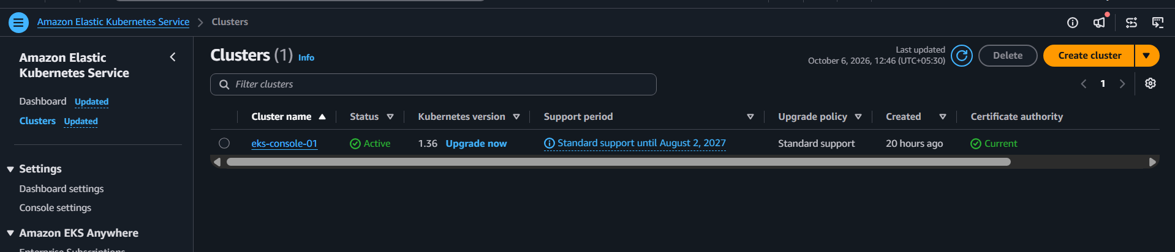
Step 3: Start the Control Plane Upgrade
- On the EKS cluster page, click Upgrade.
- Select Kubernetes version 1.37.
- Review the upgrade information.
- Start the upgrade.
AWS performs the control-plane upgrade while maintaining the managed EKS control plane.
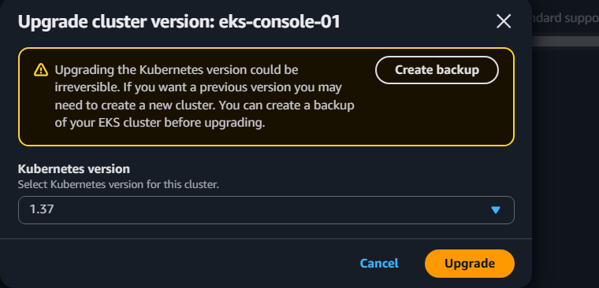
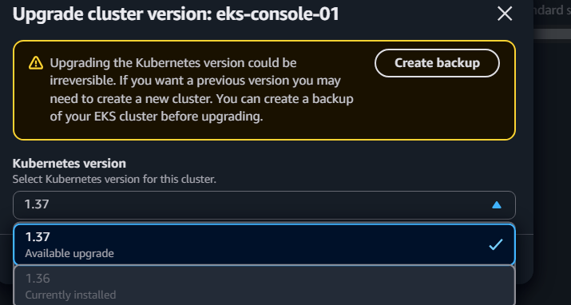
Step 4: Verify the Control Plane Upgrade
After the upgrade completes, check the EKS cluster overview.
Expected:
Cluster Name: eks-console-01
Status: Active
Kubernetes Version: 1.37
At this stage, the control plane is upgraded, but the worker nodes may still be running Kubernetes 1.36.
This is normal because the managed node group requires a separate update.
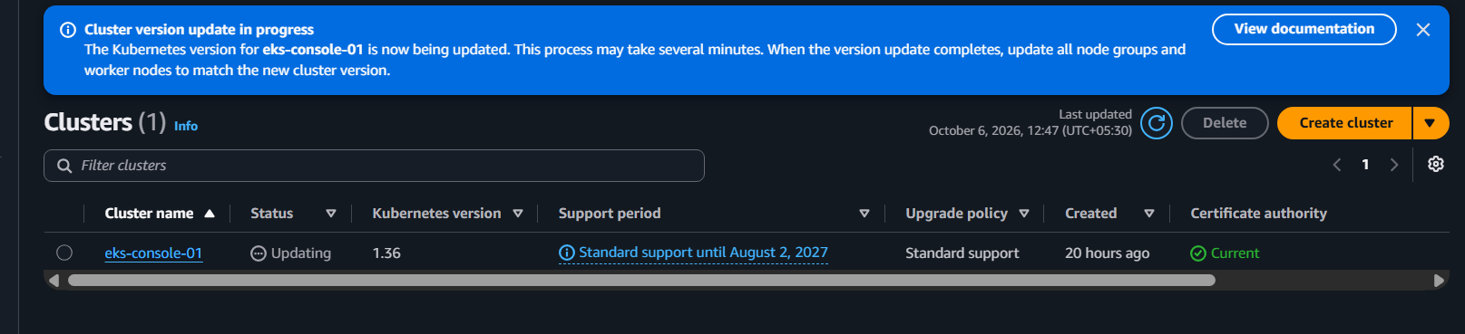
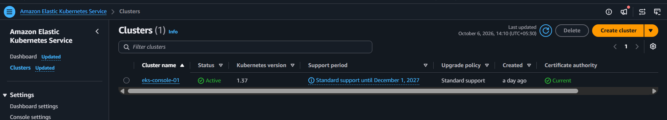
Step 5: Check the Node Group
Navigate to:
EKS → Cluster → Compute → Node groups
Select:
eks-console-ng-small
Before the node update, the node group showed:
Desired size: 4
AMI release: 1.36.4-20260930
Status: Active
AWS indicated that a newer AMI release was available for the Kubernetes 1.37 cluster.
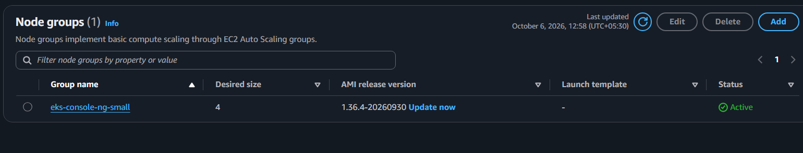
Step 6: Update the Managed Node Group
Click: Update now
The Update node group version screen appears.
Select: Update strategy: Rolling update
Rolling Update
A rolling update replaces the existing worker nodes gradually instead of replacing all nodes at once.
It also respects PodDisruptionBudgets (PDBs) when draining pods.
Click: Update
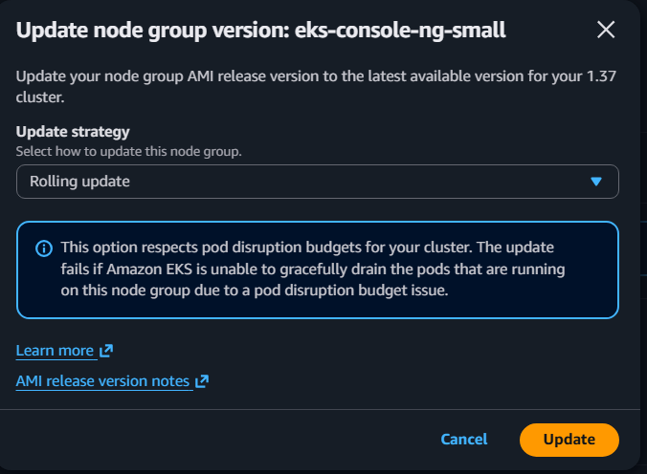
Step 7: Monitor the Node Group Upgrade
Wait for AWS to complete the managed node group update.
The node group eventually showed:
Node Group: eks-console-ng-small
Desired Size: 4
AMI Release: 1.37.0-20260930
Status: Active
During the rolling update, some Kubernetes system pods may temporarily enter Pending or be recreated because nodes are being replaced.
This is expected during the node-group upgrade.
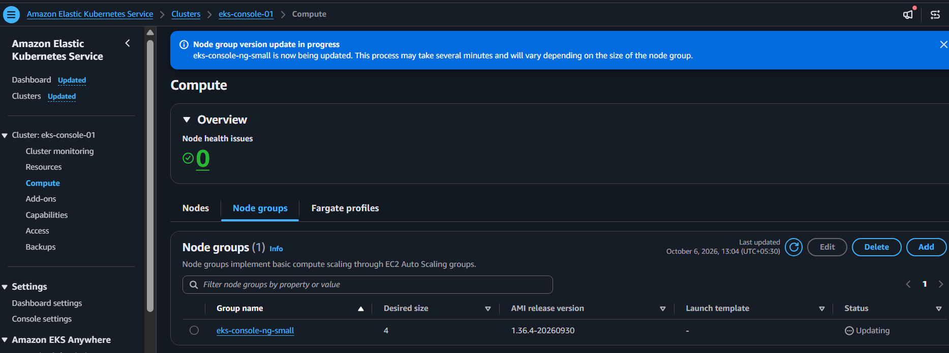
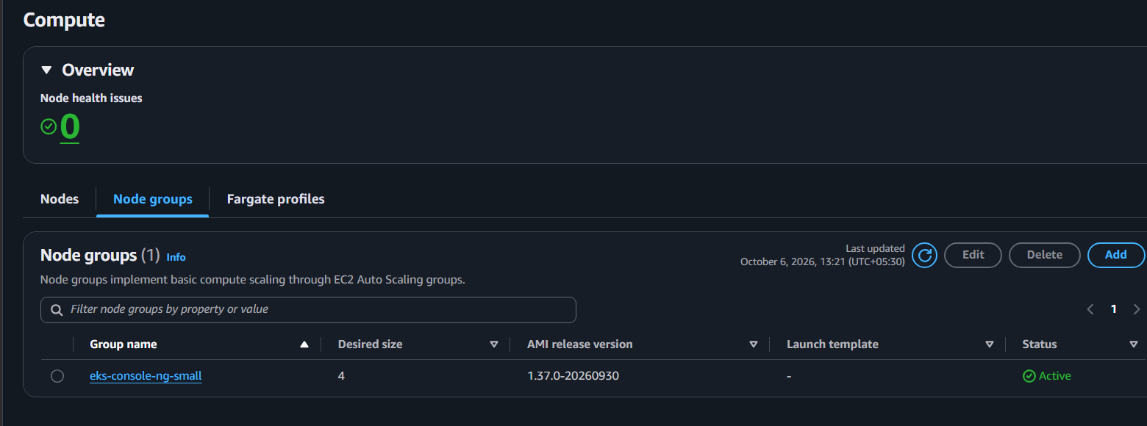
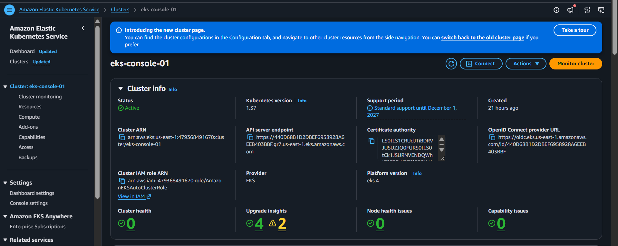
Step 8: Verify Kubernetes Nodes
After the node group upgrade completes, run: kubectl get nodes
Final result:
NAME STATUS ROLES AGE VERSION
ip-10-0-1-243.ec2.internal Ready <none> ... v1.37.0-eks-3b4a6ca
ip-10-0-1-81.ec2.internal Ready <none> ... v1.37.0-eks-3b4a6ca
ip-10-0-2-160.ec2.internal Ready <none> ... v1.37.0-eks-3b4a6ca
ip-10-0-2-228.ec2.internal Ready <none> ... v1.37.0-eks-3b4a6ca
All 4 worker nodes are Ready and running Kubernetes 1.37.
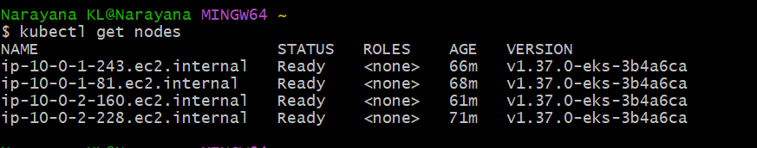
Step 9: Verify All Pods
Run: kubectl get pods -A
Verify that the important workloads are running.
Expected components include:
aws-node Running
cluster-autoscaler Running
coredns Running
eks-pod-identity-agent Running
kube-proxy Running
metrics-server Running
nginx Running
Final verification showed all pods in a healthy Running state.
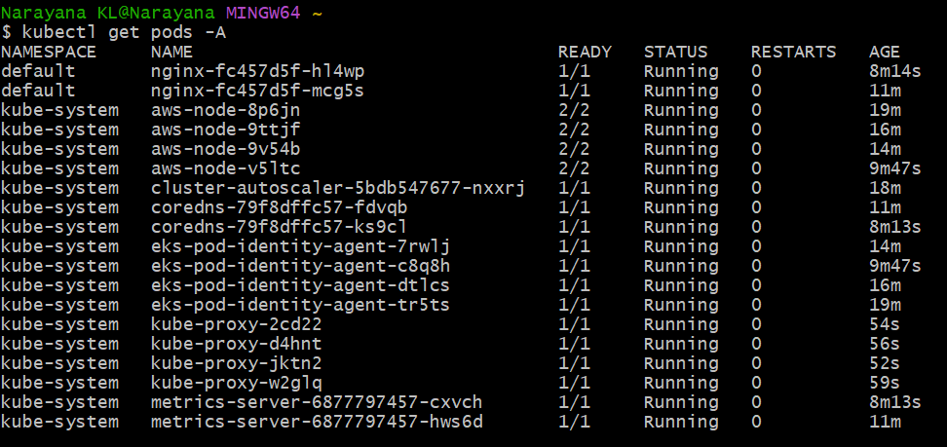
Step 10: Final Verification
The final EKS environment was successfully upgraded:
Cluster: eks-console-01
Kubernetes Version: 1.37
Node Group: eks-console-ng-small
Nodes: 4
Node Status: Ready
AMI Release: 1.37.0-20260930
Node Group Status: Active
The application and Kubernetes system components continued running successfully after the upgrade.
