Kubernetes-04
Task 1 — Deployment with 3 Replicas + Rolling Update
Objective
Create an NGINX Deployment with:
- 3 replicas
- RollingUpdate strategy
- Update NGINX image
- Observe old and new Pods during the update
Step 1 — Create YAML
On k8s-master: nano deployment-rolling.yml
Paste:
apiVersion: apps/v1
kind: Deployment
metadata:
name: rolling-nginx
spec:
replicas: 3
strategy:
type: RollingUpdate
selector:
matchLabels:
app: rolling-nginx
template:
metadata:
labels:
app: rolling-nginx
spec:
containers:
- name: nginx
image: nginx:1.25
ports:
- containerPort: 80
Save:
Ctrl + O → Enter → Ctrl + X
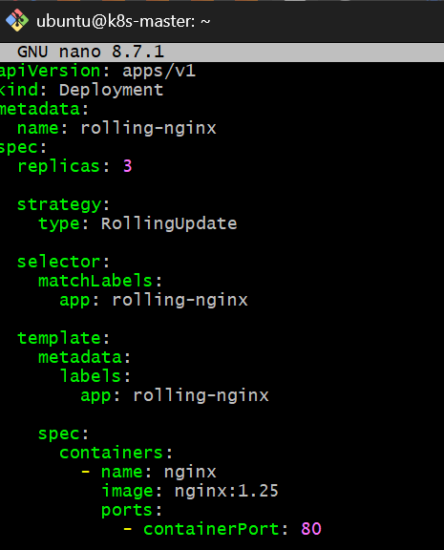

Step 2 — Create Deployment
kubectl apply -f deployment-rolling.yml
Expected: deployment.apps/rolling-nginx created

Step 3 — Check Deployment
kubectl get deployment
You should see:
NAME READY UP-TO-DATE AVAILABLE AGE
rolling-nginx 3/3 3 3 ...
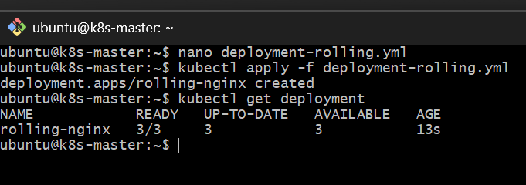
Step 4 — Check Pods
kubectl get pods -o wide
You should have 3 Pods:
rolling-nginx-xxxxx 1/1 Running ... k8s-worker1
rolling-nginx-yyyyy 1/1 Running ... k8s-worker2
rolling-nginx-zzzzz 1/1 Running ... k8s-worker1
The exact names will be different.
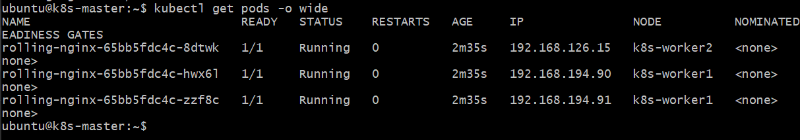
Step 5 — Check ReplicaSet
kubectl get rs
You should see a ReplicaSet created by the Deployment.

Step 6 — Perform Rolling Update
Change the image from:
image: nginx:1.25
to: image: nginx:1.27
You can edit: nano deployment-rolling.yml
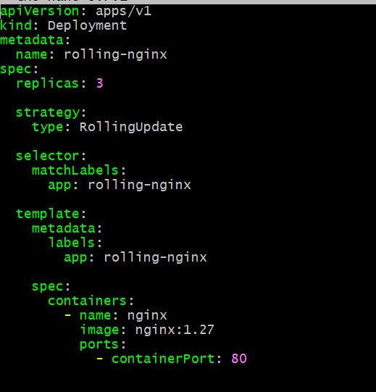
Then apply: kubectl apply -f deployment-rolling.yml
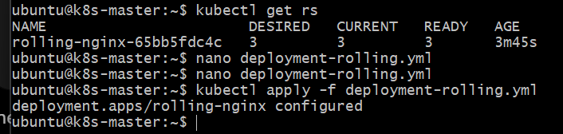
Step 7 — Watch the Rolling Update
Run: kubectl get pods -w
You should see the old Pods being terminated and new Pods being created.
Press: Ctrl + C
when the update finishes.
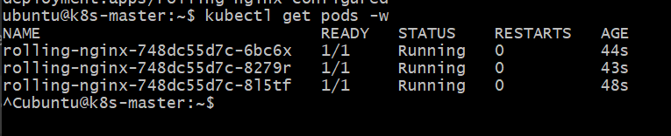

Step 8 — Verify Image
kubectl get deployment rolling-nginx -o wide
And:
kubectl describe deployment rolling-nginx
Look for:
Image: nginx:1.27
StrategyType: RollingUpdate
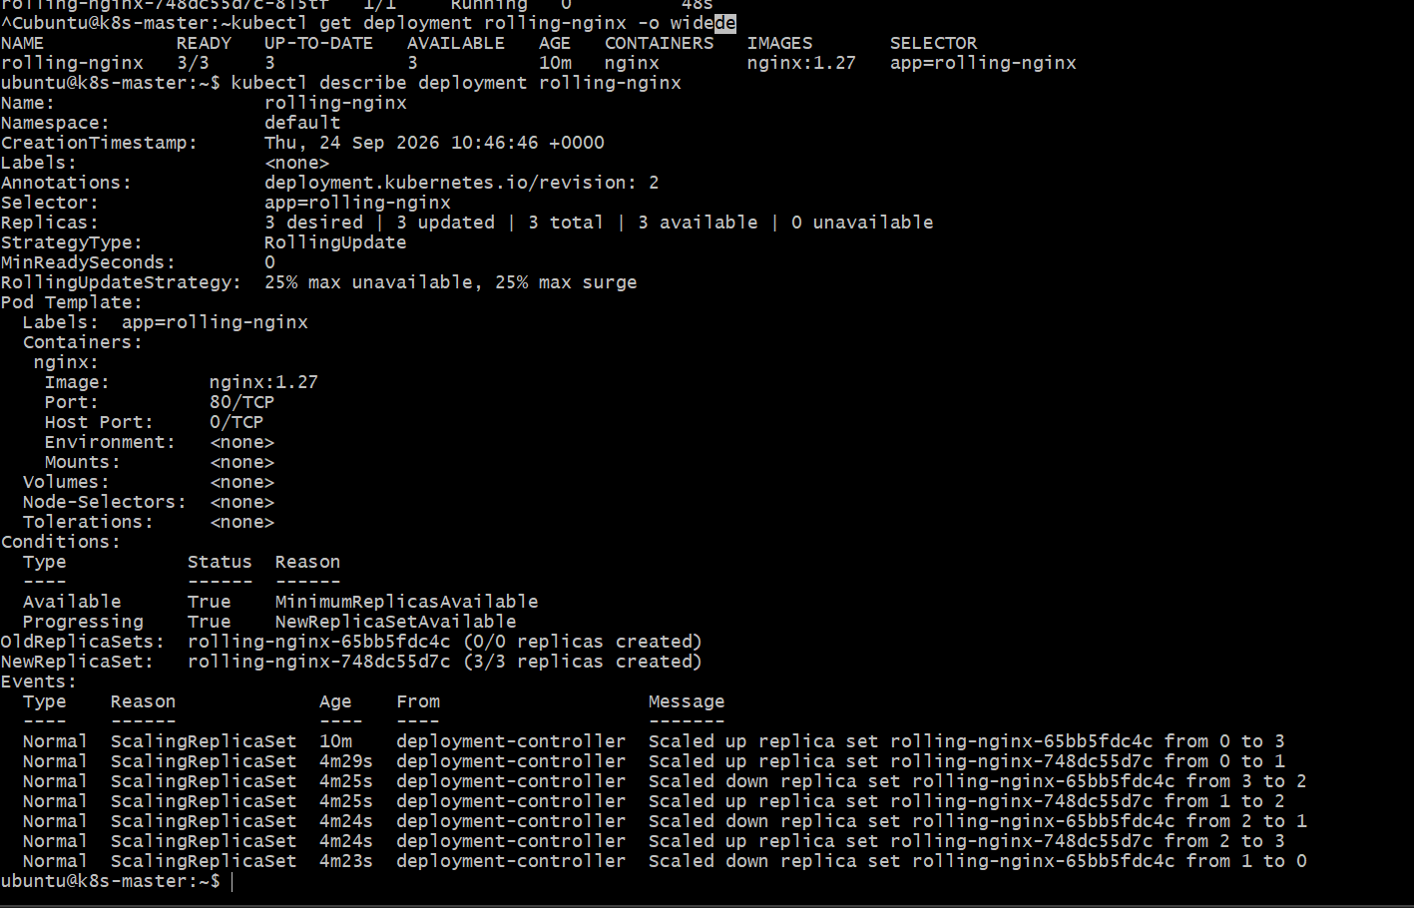
Task 2 — Recreate Strategy
Now let's move to Task 2 only.
Create the file: nano deployment-recreate.yml
Paste exactly: apiVersion: apps/v1
kind: Deployment
metadata:
name: recreate-nginx
spec:
replicas: 3
strategy:
type: Recreate
selector:
matchLabels:
app: recreate-nginx
template:
metadata:
labels:
app: recreate-nginx
spec:
containers:
- name: nginx
image: nginx:1.25
ports:
- containerPort: 80
Save:
Ctrl + O
Enter
Ctrl + X
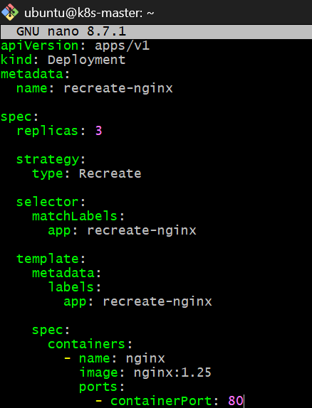
Then run: kubectl apply -f deployment-recreate.yml
Check: kubectl get deployment
Then: kubectl get pods -o wide
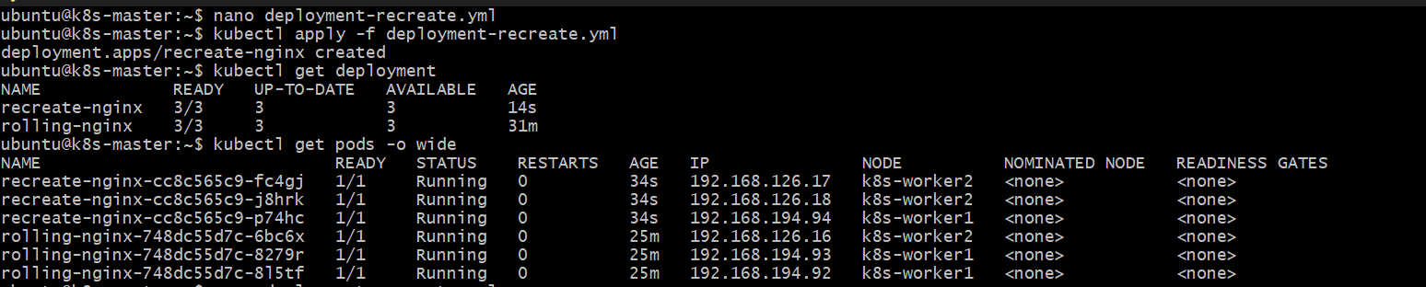
Step 2: Perform the Recreate Update
Currently your image is: image: nginx:1.25
Change it to: image: nginx:1.27
You can edit the file: nano deployment-recreate.yml
Change only: image: nginx:1.25
to: image: nginx:1.27
Save and exit.
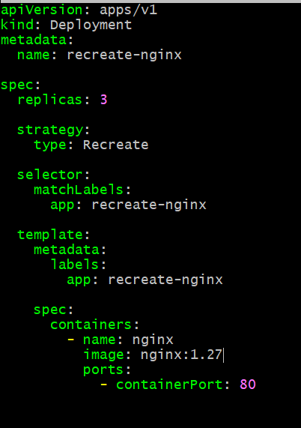Step 3 — Start watching the Pods
This time, use: kubectl get pods -w
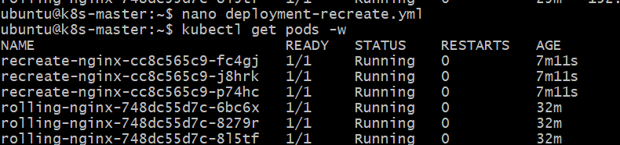
Keep this command running.
In another terminal/session on k8s-master, apply the change:
kubectl apply -f deployment-recreate.yml
If you don't want to open another SSH session, you can also use two commands sequentially, but the second terminal makes the behavior easier to observe. 2nd terminal
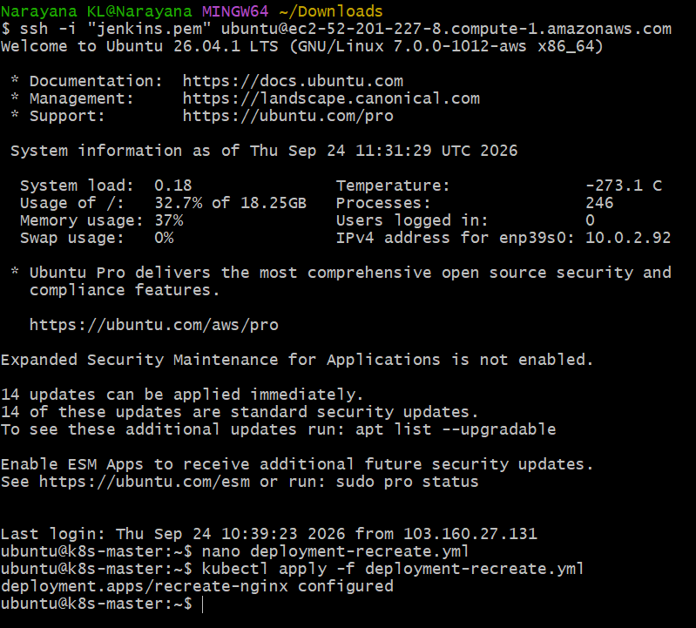
1st terminal
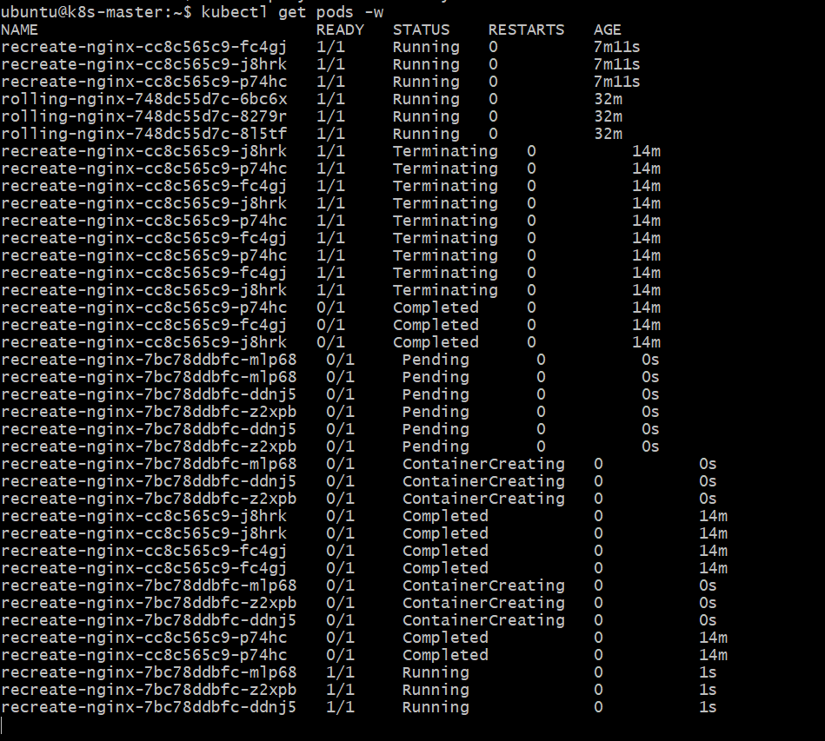

What you should see
Because this is:
strategy:
type: Recreate
Kubernetes will first remove the existing 3 Pods.
You may see:
recreate-nginx-cc8c565c9-fc4gj 1/1 Terminating
recreate-nginx-cc8c565c9-j8hrk 1/1 Terminating
recreate-nginx-cc8c565c9-p74hc 1/1 Terminating
Then there can be a period where:
No recreate-nginx Pods
That is the downtime period.
Then Kubernetes creates the new Pods:
recreate-nginx-xxxxxxxxxx-xxxxx 0/1 ContainerCreating
recreate-nginx-xxxxxxxxxx-yyyyy 0/1 ContainerCreating
recreate-nginx-xxxxxxxxxx-zzzzz 0/1 ContainerCreating
Finally:
recreate-nginx-xxxxxxxxxx-xxxxx 1/1 Running
recreate-nginx-xxxxxxxxxx-yyyyy 1/1 Running
recreate-nginx-xxxxxxxxxx-zzzzz 1/1 Running
So your setup should be:
Terminal 1 Terminal 2
k8s-master k8s-master
| |
| kubectl get pods -w | kubectl apply -f ...
| |
+------------ Kubernetes API -----+
|
+----------+----------+
| |
k8s-worker1 k8s-worker2
Before moving on, let's verify the final state and confirm the Recreate behavior.
In Terminal 1
Stop the watch with:
Ctrl + C
Then run:kubectl get deployment recreate-nginx -o wide
You should see:
READY UP-TO-DATE AVAILABLE
3/3 3 3

Then run: kubectl describe deployment recreate-nginx
Look for: StrategyType: Recreate
and near the bottom, you should see rollout events indicating the old ReplicaSet was scaled down and the new ReplicaSet was scaled up.
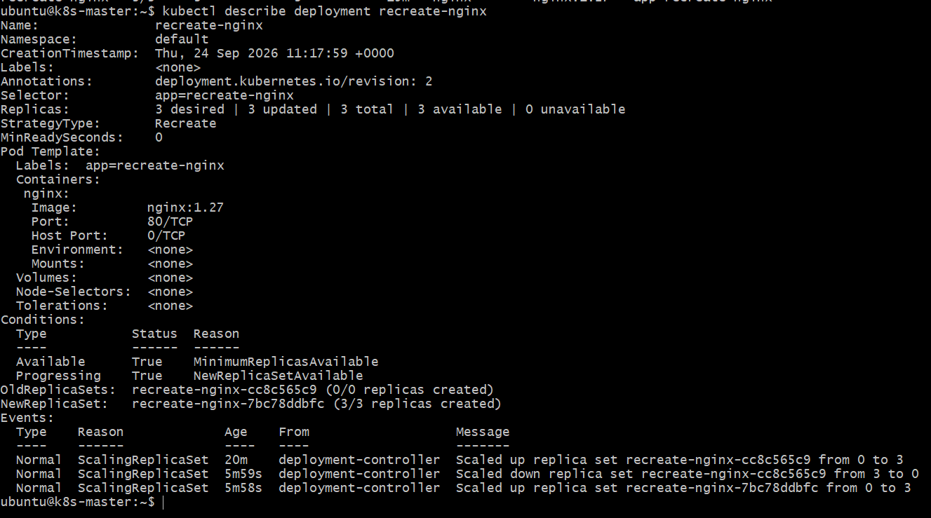
Task 3 — Update and Rollback
Now we'll use your existing rolling-nginx Deployment.
First, run: kubectl get deployment rolling-nginx -o wide
Then: kubectl rollout history deployment/rolling-nginx
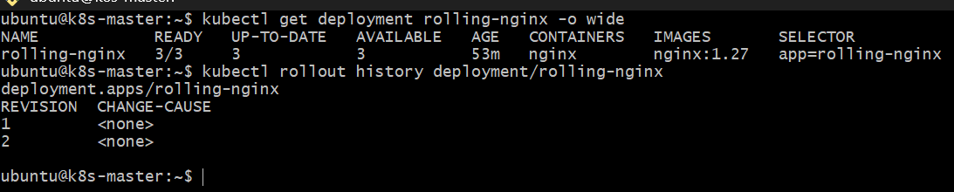
Update and Rollback
We'll first update: nginx:1.27 → nginx:1.28
This will create Revision 3.
Then we'll roll back:
Revision 3 → Revision 2
which should return the Deployment to: nginx:1.27
Step 1 — Update the Deployment
Run: kubectl set image deployment/rolling-nginx nginx=nginx:1.28
You should get: deployment.apps/rolling-nginx image updated

Step 2 — Watch the rollout
kubectl rollout status deployment/rolling-nginx
Expected: deployment "rolling-nginx" successfully rolled out

Step 3 — Verify the new image
kubectl get deployment rolling-nginx -o wide
You should now see: IMAGES
nginx:1.28 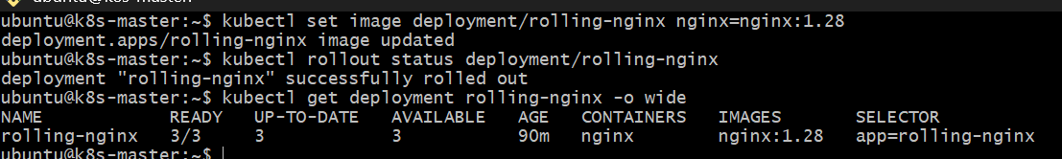
Step 4 — Check history
kubectl rollout history deployment/rolling-nginx
You should now have approximately:
REVISION CHANGE-CAUSE
1 <none>
2 <none>
3 <none>
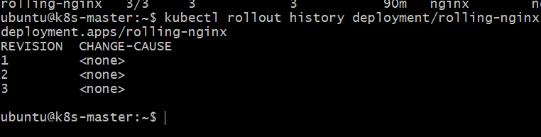Step 5 — Roll back
Now run: kubectl rollout undo deployment/rolling-nginx
Expected: deployment.apps/rolling-nginx rolled backStep 6 — Verify rollback
Run: kubectl rollout status deployment/rolling-nginx
Then: kubectl get deployment rolling-nginx -o wide
The image should be back to: nginx:1.27
You can also verify the Pods: kubectl get pods -o wide
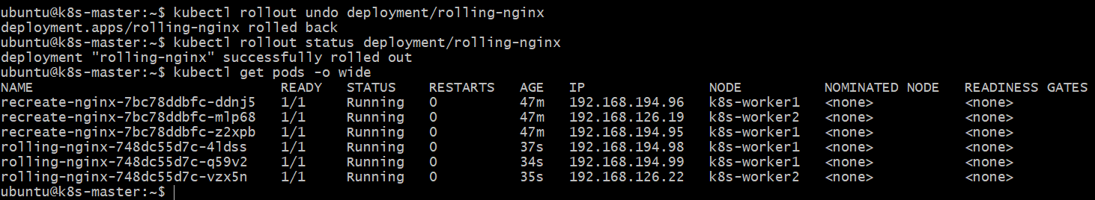The important concept
Before: Revision 1 → nginx:1.25
Revision 2 → nginx:1.27
After update: Revision 3 → nginx:1.28
After rollback: Revision 2 → nginx:1.27
Verify the final image
Run this one command: kubectl get deployment rolling-nginx -o wide
You should now see: IMAGES
nginx:1.27
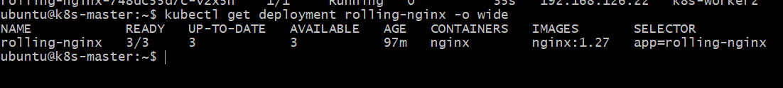
That final check confirms the rollback returned the Deployment to the previous configuration.
Task 4 — Resource Requests and Limits
Now we'll create a separate Deployment called:
resource-nginx
It will have:
- 2 replicas
- CPU request: 100m
- CPU limit: 500m
- Memory request: 128Mi
- Memory limit: 256Mi
Create: nano deployment-resources.yml
Paste: apiVersion: apps/v1
kind: Deployment
metadata: name: resource-nginx
spec: replicas: 2
selector: matchLabels:
app: resource-nginx
template:
metadata:
labels: app: resource-nginx
spec:
containers: - name: nginx
image: nginx:1.27
resources:
requests:
cpu: "100m"
memory: "128Mi"
limits: cpu: "500m"
memory: "256Mi"
ports: - containerPort: 80
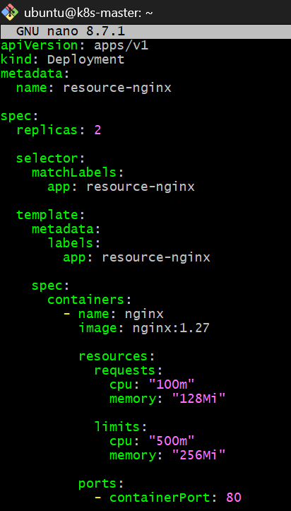
Save and run: kubectl apply -f deployment-resources.yml
Then: kubectl get deployment resource-nginx
And: kubectl get pods -o wide
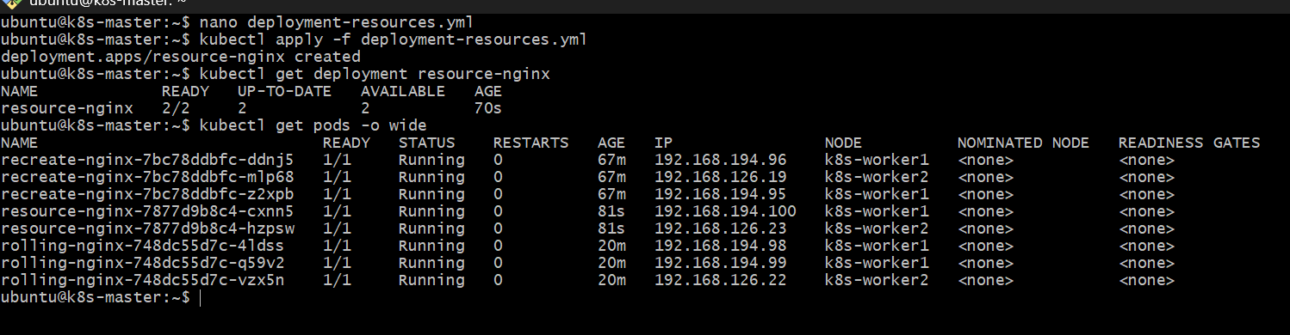
step 1 — Describe one resource Pod
Run: kubectl describe pod resource-nginx-7877d9b8c4-cxnn5
Find this section:
Requests:
cpu: 100m
memory: 128Mi
Limits: cpu: 500m
memory: 256Mi
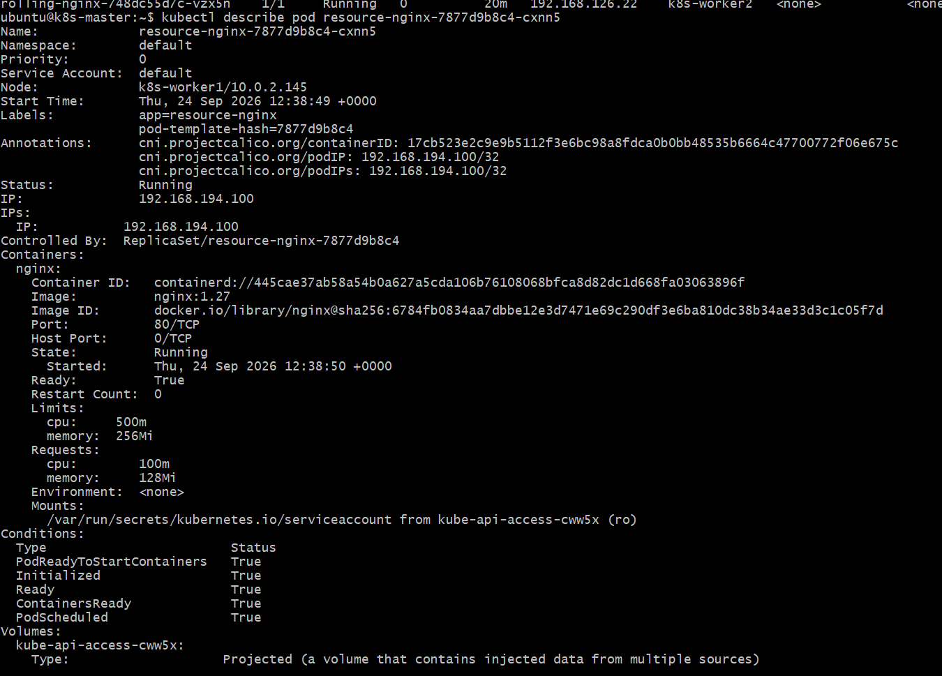
You can also use a shorter command: kubectl get pod resource-nginx-7877d9b8c4-cxnn5 -o yaml
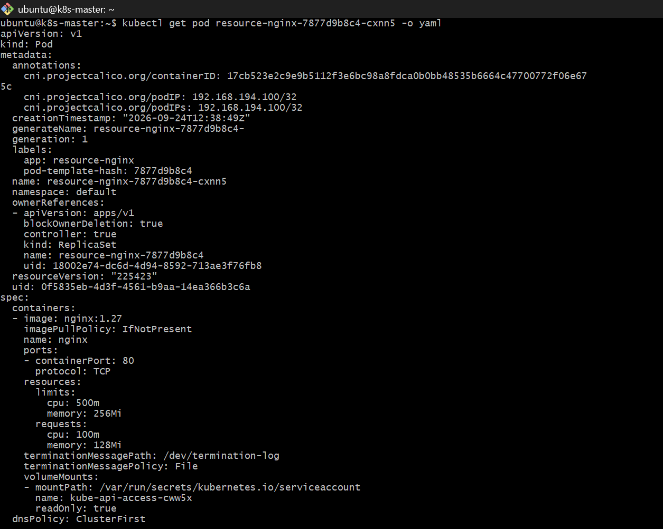
But for learning, I recommend describe.
Step 2 — Check the second Pod too
kubectl describe pod resource-nginx-7877d9b8c4-hzpsw
Both should have the same resource configuration because they were created from the same Deployment template.
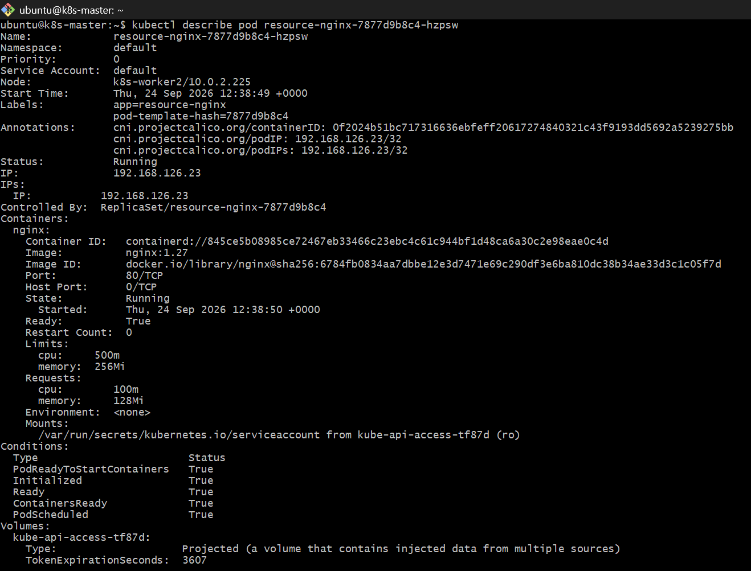

What this task demonstrates
Your YAML says:
resources:
requests:
cpu: "100m"
memory: "128Mi"
limits:
cpu: "500m"
memory: "256Mi"
Think of it as:
Resource | Request | Limit
CPU | 100m | 500m
Memory | 128Mi | 256Mi
Request → Kubernetes uses this when deciding which node can run the Pod.
Limit → maximum resource the container is allowed to consume.
For example:
100m CPU = 0.1 CPU
500m CPU = 0.5 CPU
So your scheduler needs to find a worker with at least the requested:
0.1 CPU
128Mi memory
available for the Pod.
Task 5 — MaxSurge and MaxUnavailable
Now we'll create a Deployment with:
replicas: 4
maxSurge: 1
maxUnavailable: 1
This is important for interviews because these settings control how aggressively Kubernetes performs a RollingUpdate.
Create: nano deployment-surge.yml
Paste: apiVersion: apps/v1
kind: Deployment
metadata:
name: surge-nginx

spec:
replicas: 4
strategy:
type: RollingUpdate
rollingUpdate:
maxSurge: 1
maxUnavailable: 1
selector:
matchLabels:
app: surge-nginx
template:
metadata:
labels:
app: surge-nginx
spec:
containers:
- name: nginx
image: nginx:1.25
ports:
- containerPort: 80
Save and exit.
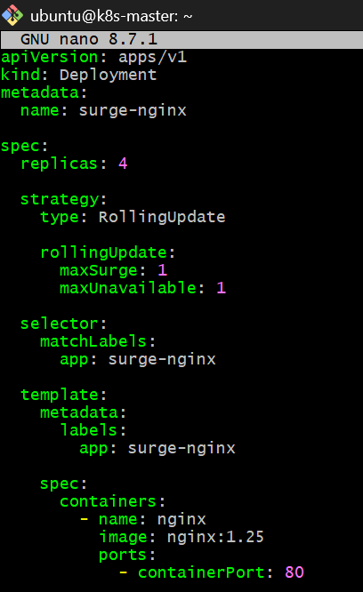
Then: kubectl apply -f deployment-surge.yml
Check: kubectl get deployment surge-nginx
And: kubectl get pods -o wide
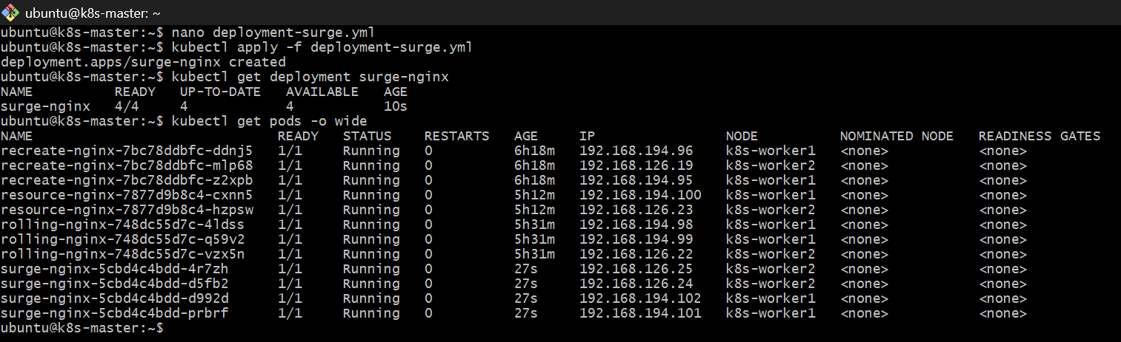
Now observe MaxSurge and MaxUnavailable during an update
We will change the image from: nginx:1.25
to: nginx:1.27
Step 1 — Open another terminal to the same k8s-master
In Terminal 1, run: kubectl get pods -w
Keep this running.
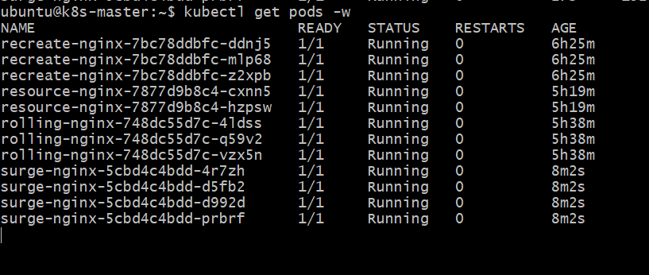
Step 2 — In Terminal 2, update the image
Run: kubectl set image deployment/surge-nginx nginx=nginx:1.27
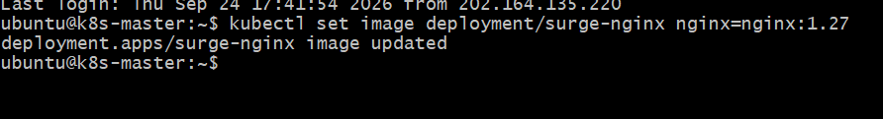
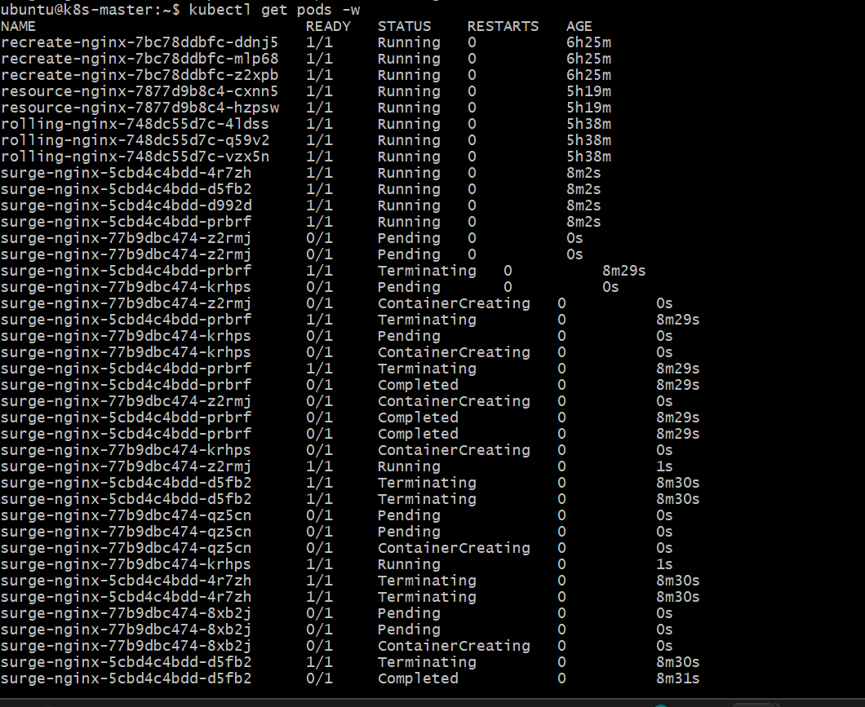
Then: kubectl rollout status deployment/surge-nginx
You should eventually see: deployment "surge-nginx" successfully rolled out
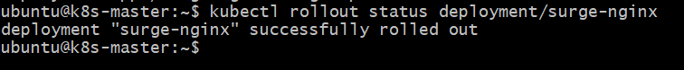
Step 3 — Check the final state
After rollout completes: kubectl get deployment surge-nginx -o wide
and: kubectl get rs
What to observe
During the rollout, Kubernetes is allowed to have:
Desired replicas = 4
maxSurge = 1
So the maximum number of Pods can temporarily be:
4 + 1 = 5 Pods
And: maxUnavailable = 1
means Kubernetes can have at most 1 unavailable Pod, so it aims to maintain at least:
4 - 1 = 3 available Pods
So conceptually:
Desired = 4
Maximum Pods during update = 5
Minimum available Pods = 3
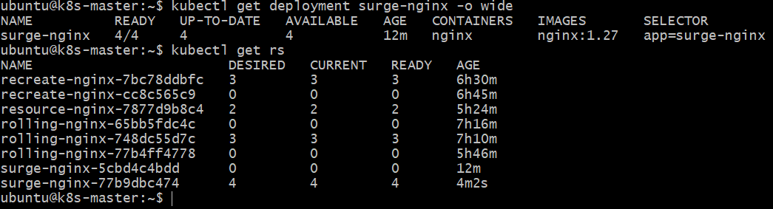
The exact transient state may be too quick to catch with kubectl get pods -w, especially with nginx.
Task 6 — Custom Revision History Limit
Objective
Learn how to control how many old ReplicaSets Kubernetes keeps for a Deployment.
We will use: revisionHistoryLimit: 3
This means Kubernetes keeps up to 3 old revisions of the Deployment for rollback/history purposes.
Important: revisionHistoryLimit: 3 does not mean 3 Pods. It controls old ReplicaSets.
Step 1 — Create the YAML file
On k8s-master: nano deployment-history.yml
Paste: apiVersion: apps/v1
kind: Deployment
metadata:
name: history-nginx
spec:
replicas: 2
revisionHistoryLimit: 3
selector:
matchLabels:
app: history-nginx
template:
metadata:
labels:
app: history-nginx
spec:
containers:
- name: nginx
image: nginx:1.25
ports:
- containerPort: 80
Save:
Ctrl + O → Enter → Ctrl + X
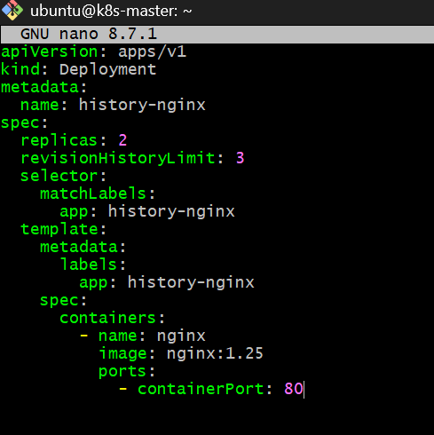
Step 2 — Create the Deployment
Run: kubectl apply -f deployment-history.yml
Then: kubectl get deployment history-nginx
And: kubectl get rs
What we expect
The Deployment should show:
history-nginx 2/2 2 2
And initially there will be one ReplicaSet:
history-nginx-xxxxxxxxxx 2 2 2
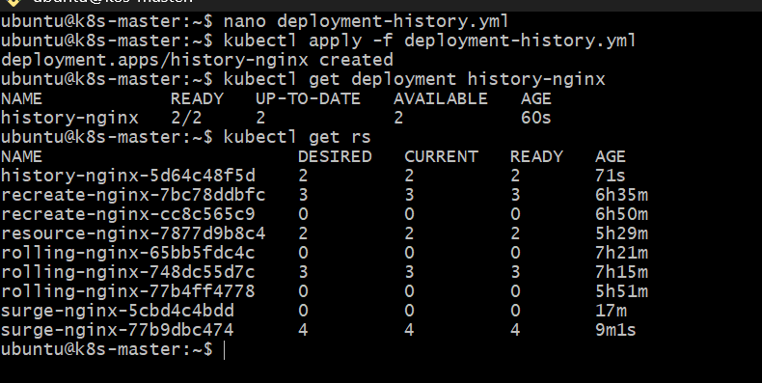
You have: history-nginx 2/2 2 2
And its first ReplicaSet:
history-nginx-5d64c48f5d 2 2 2
Your Deployment has: revisionHistoryLimit: 3
Now we need to create multiple revisions so we can actually observe the history limit.
Step 2 — Create revision 2
Run: kubectl set image deployment/history-nginx nginx=nginx:1.26
Then: kubectl rollout status deployment/history-nginx
Verify: kubectl get rs
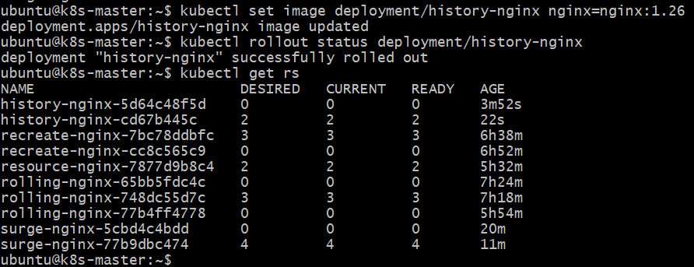
Step 3 — Create revision 3
Run: kubectl set image deployment/history-nginx nginx=nginx:1.27
Then: kubectl rollout status deployment/history-nginx
Verify: kubectl get rs
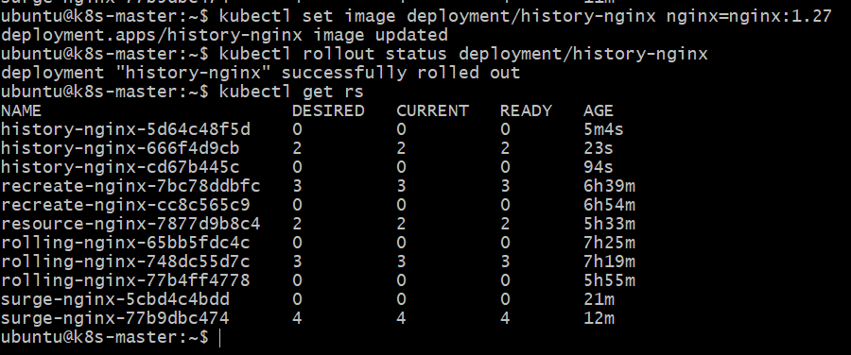
Step 4 — Create revision 4
Run: kubectl set image deployment/history-nginx nginx=nginx:1.28
Then: kubectl rollout status deployment/history-nginx
Finally: kubectl get rs
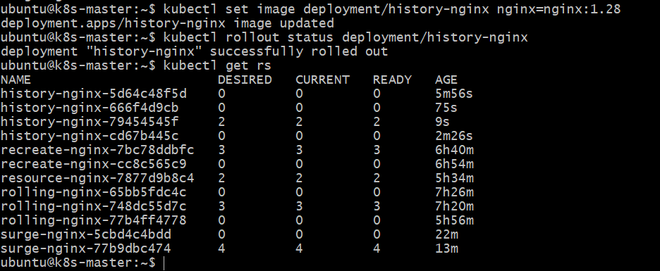
What we are testing
We started with: Revision 1 → nginx:1.25
Then: Revision 2 → nginx:1.26
Revision 3 → nginx:1.27
Revision 4 → nginx:1.28
Because: revisionHistoryLimit: 3
Kubernetes should retain up to 3 old ReplicaSets in addition to the currently active one. The exact ReplicaSet list may also include ReplicaSets from your other Deployments, so look specifically for those beginning with: history-nginx-
Task 7 — Pause and Resume a Deployment
Objective
Pause a Deployment during an update, make a change while it is paused, and then resume the rollout.
We'll continue using: history-nginx
Step 1 — Check current image
Run: kubectl get deployment history-nginx -o wide
You should currently have: nginx:1.28
Step 2 — Pause the Deployment
Run: kubectl rollout pause deployment/history-nginx
You should get: deployment.apps/history-nginx paused
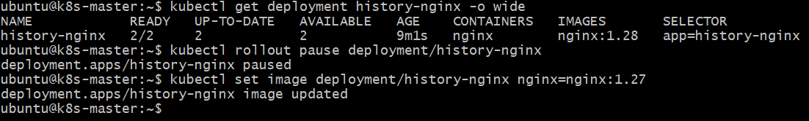
Step 3 — Change the image while paused
Run: kubectl set image deployment/history-nginx nginx=nginx:1.27
You should see: deployment.apps/history-nginx image updated
Now let's verify that the rollout is paused before resuming.
Step 4 — Check Deployment
Run: kubectl get deployment history-nginx -o wide
Then: kubectl rollout status deployment/history-nginx
For the status command, because the Deployment is paused, it may indicate that the rollout is paused rather than completing.
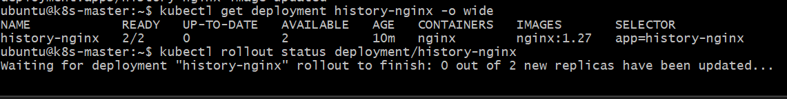
Step 5 — Resume the Deployment
After checking, run: kubectl rollout resume deployment/history-nginx
You should see: deployment.apps/history-nginx resumed
Then: kubectl rollout status deployment/history-nginx
Finally verify: kubectl get deployment history-nginx -o wide
We expect the final image to be: nginx:1.27
and: READY UP-TO-DATE AVAILABLE
2/2 2 2
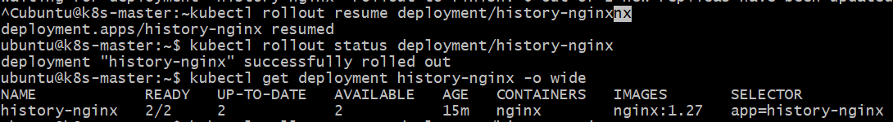
Task 8 — Pod with CPU and Memory Requests
Objective
Create a Pod with CPU and memory requests and observe which worker node the Kubernetes scheduler selects.
Step 1 — Create the YAML
On k8s-master: nano scheduler-pod.yml
Paste: apiVersion: v1
kind: Pod
metadata:
name: scheduler-demo
spec:
containers:
- name: nginx
image: nginx:1.27
resources:
requests:
cpu: "200m"
memory: "256Mi"
limits:
cpu: "500m"
memory: "512Mi"
ports:
- containerPort: 80
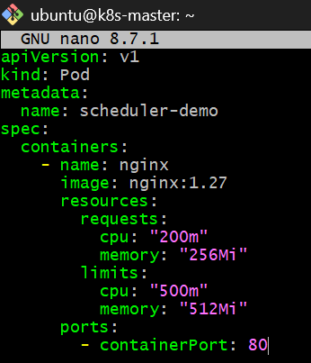
Save: Ctrl + O → Enter → Ctrl + X
Step 2 — Create the Pod
Run: kubectl apply -f scheduler-pod.yml
Then: kubectl get pod scheduler-demo -o wide
The important column is: NODE
It should show either: k8s-worker1
or: k8s-worker2
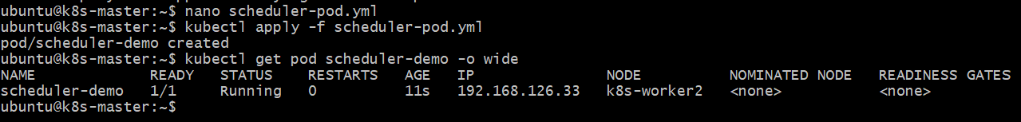
Step 2 — See the scheduler event
Run: kubectl describe pod scheduler-demo
Near the bottom, look for:
Events: You should see an event similar to:
Scheduled
Successfully assigned default/scheduler-demo to k8s-worker2
Also look for:
Requests:
cpu: 200m
memory: 256Mi
Limits:
cpu: 500m
memory: 512Mi
