Jenkins-Challenge
Yes. Since you already have the Hiring App repository and Jenkins/Maven/SonarQube/Nexus/Tomcat setup from the previous lab, we can implement these four Jenkins pipeline jobs against the same application.

CI/CD flow we will implement
GitHub
│
▼
Checkout Source Code
│
▼
SonarQube Analysis
│
▼
Maven Compile / Test
│
▼
Maven Package
│
▼
Nexus Repository
│
▼
Deploy WAR to Tomcat
│
▼
Application
We will create:
Job | Pipeline type | Main purpose
1 | Declarative Pipeline | Standard pipeline {} syntax
2 | Scripted Pipeline | Groovy node {} syntax
3 | Multi-Stage Pipeline | Clearly separated CI/CD stages
4 | Parallel Stage Pipeline | Run independent activities simultaneously
Important
Don't paste the four pipelines all into one Jenkins job. Create four separate Pipeline jobs, so you can demonstrate each pipeline type during your interview/practical.
Task 1 — Declarative Pipeline
Jenkins job
Create: New Item
↓
Hiring-App-Declarative-Pipeline
↓
Pipeline
Choose: Pipeline script
For the first implementation, use this structure:
pipeline {
agent any
tools {
maven 'Maven'
}
environment {
APP_NAME = 'hiring'
}
stages {
stage('Checkout') {
steps {
git branch: 'main',
url: 'https://github.com/narayana-28/hiring-app.git'
}
}

stage('Compile') {
steps {
sh 'mvn clean compile'
}
}
stage('Test') {
steps {
sh 'mvn test'
}
}
stage('Package') {
steps {
sh 'mvn package -DskipTests'
}
}
stage('SonarQube Analysis') {
steps {
withCredentials([
string(
credentialsId: 'sonarqube-token',
variable: 'SONAR_TOKEN'
)
]) {
sh '''
mvn sonar:sonar \
-Dsonar.token=$SONAR_TOKEN
'''
}
}
}
stage('Archive Artifact') {
steps {
archiveArtifacts artifacts: 'target/*.war',
fingerprint: true
}
}
stage('Deploy to Tomcat') {
steps {
sh '''
scp -i /var/lib/jenkins/.ssh/tomcat_deploy \
target/*.war \
jenkins-deploy@10.0.2.95:/opt/tomcat/webapps/
'''
}
}
}
post {
success {
echo 'Hiring App CI/CD completed successfully'
}

failure {
echo 'Hiring App CI/CD failed'
}
}
}
Before running
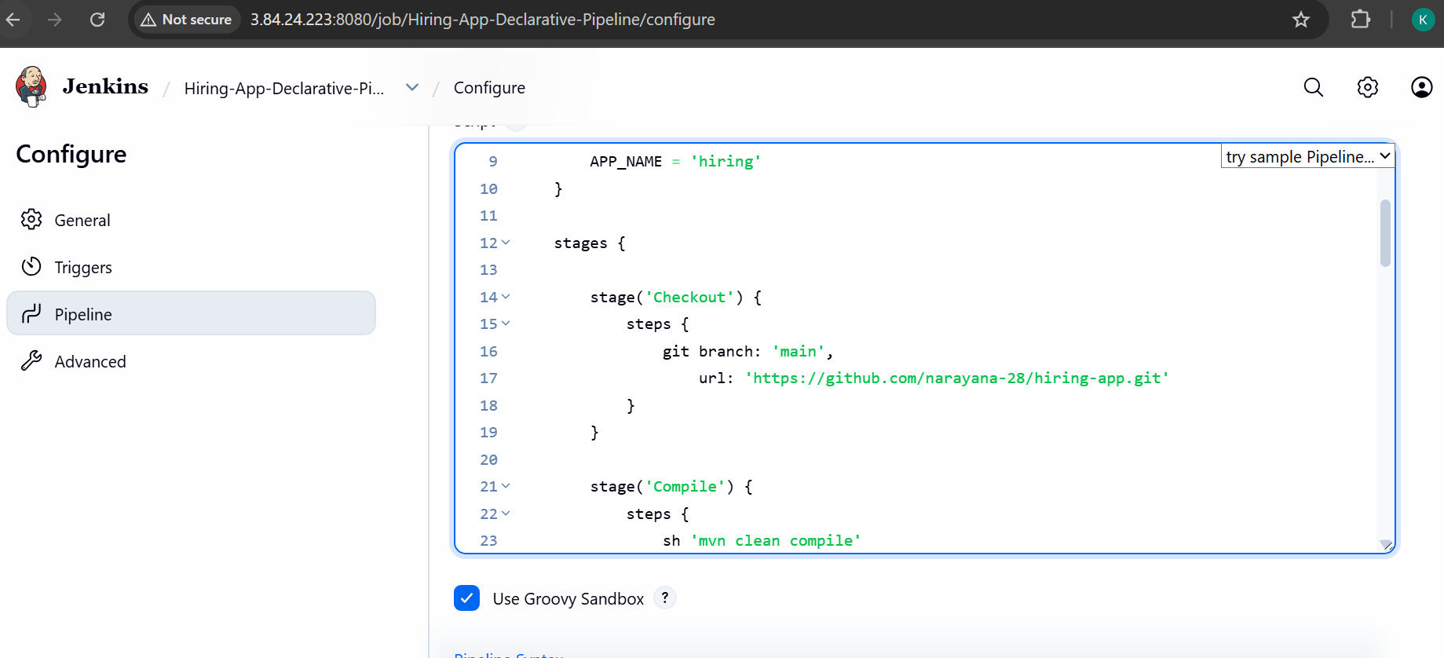
Check that your Jenkins Maven tool name is actually:
Maven
If you configured it as something like:
Maven-3.8.4
change:
maven 'Maven'
to:
maven 'Maven-3.8.4'
Also, because your previous Tomcat lab used the deployment key:
/var/lib/jenkins/.ssh/tomcat_deploy
and:
jenkins-deploy@10.0.2.95
the deployment stage uses those values.
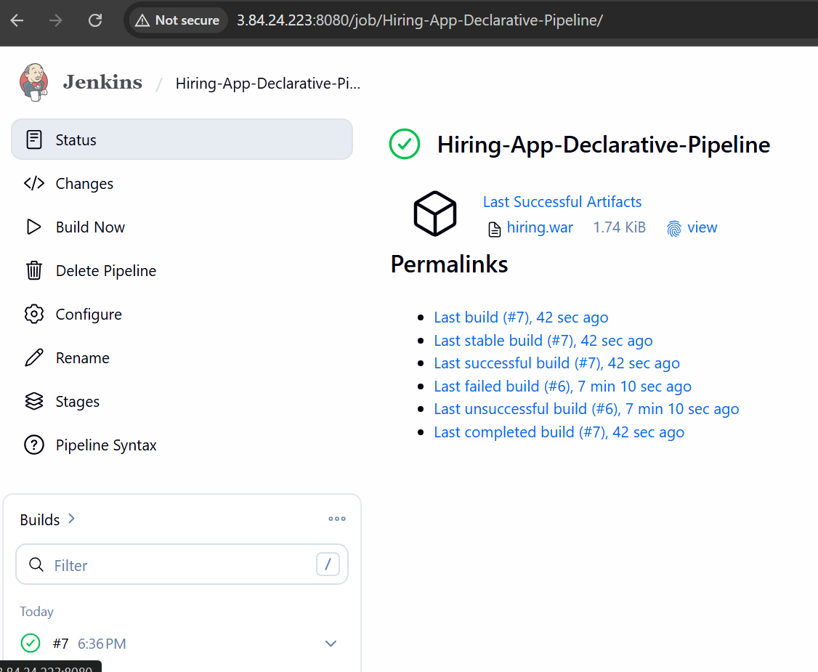
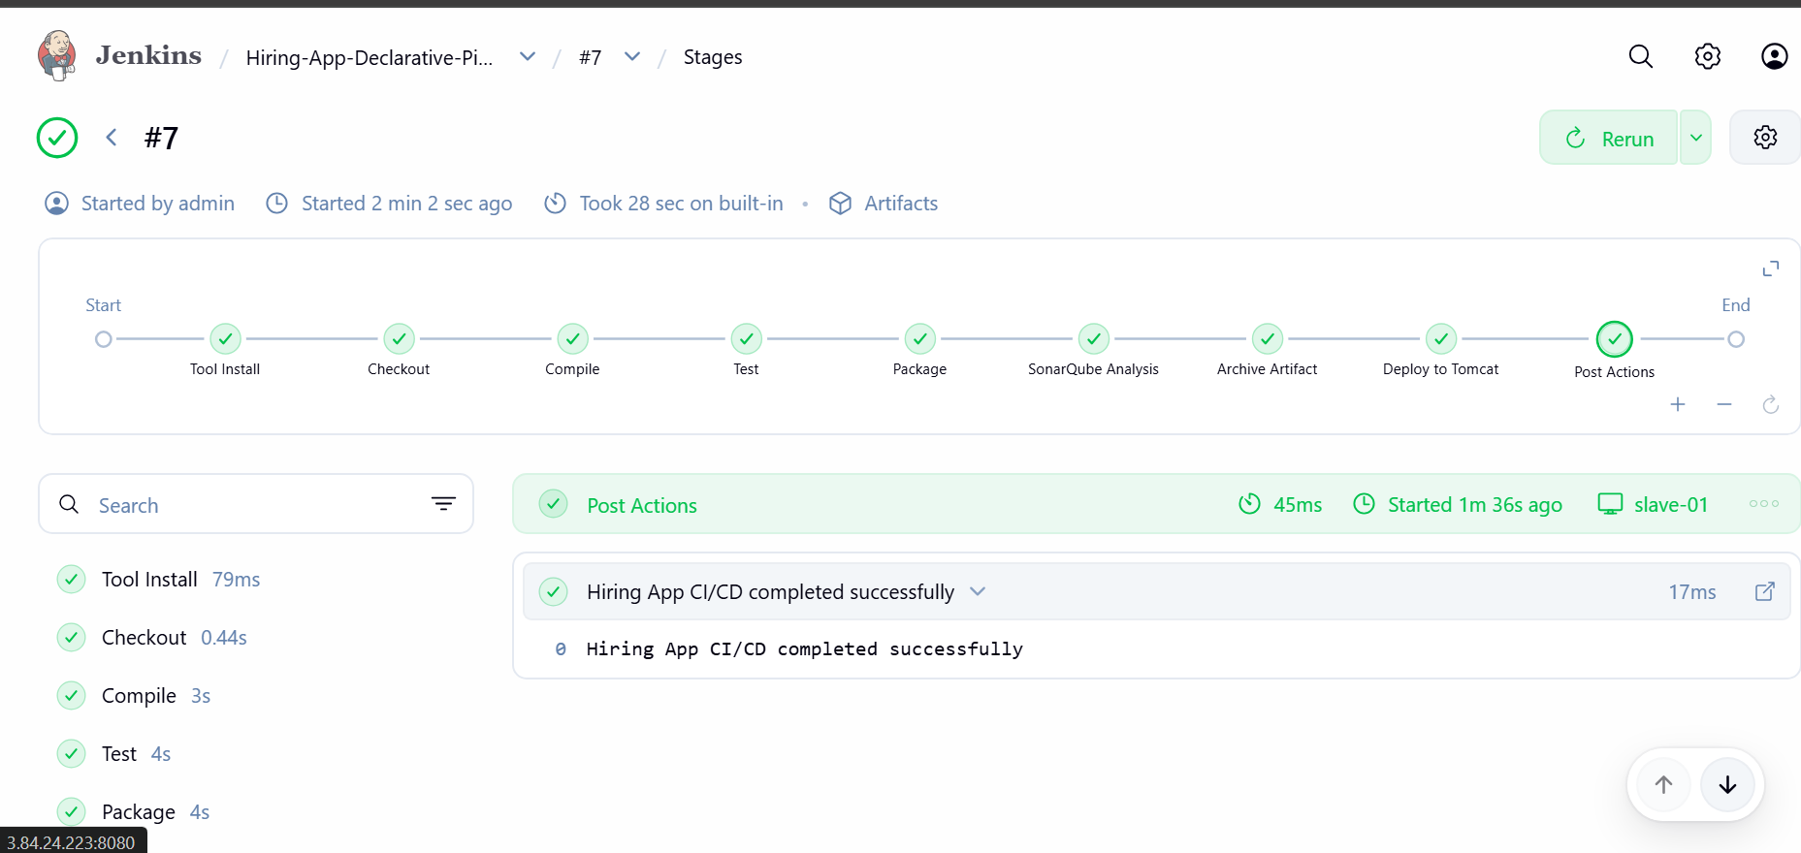

Task 2 — Scripted Pipeline
Create another job:
New Item
↓
Hiring-App-Scripted-Pipeline
↓
Pipeline
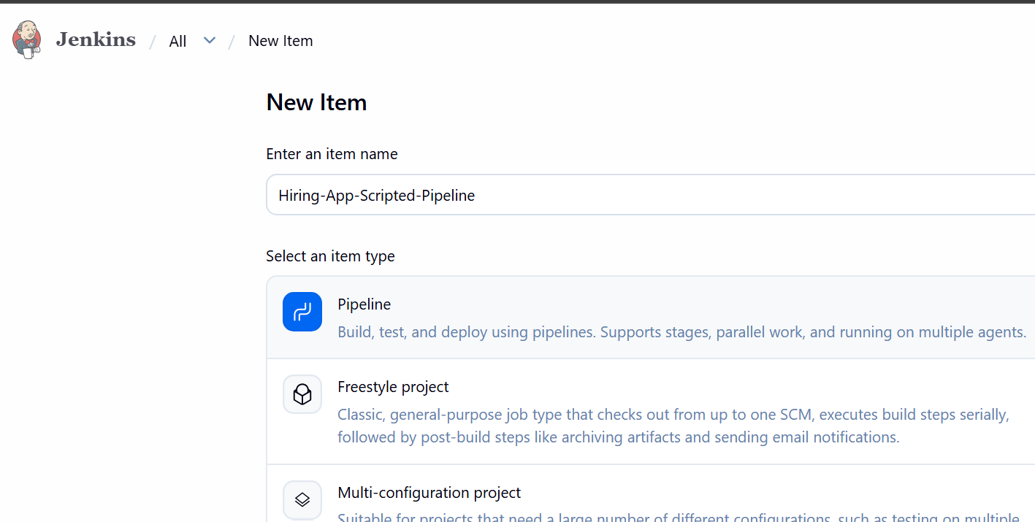
Use:
node('slave-01') {

stage('Checkout') {
echo 'Checking out Hiring App source code'

git branch: 'main',
url: 'https://github.com/narayana-28/hiring-app.git'
}

stage('Compile') {
echo 'Compiling Hiring App'

def mvnHome = tool 'Maven'

sh "${mvnHome}/bin/mvn clean compile"
}

stage('Test') {
echo 'Running unit tests'

def mvnHome = tool 'Maven'

sh "${mvnHome}/bin/mvn test"
}

stage('Package') {
echo 'Creating WAR artifact'

def mvnHome = tool 'Maven'

sh "${mvnHome}/bin/mvn package -DskipTests"
}

stage('SonarQube Analysis') {
echo 'Running SonarQube analysis'

def mvnHome = tool 'Maven'

withCredentials([
string(
credentialsId: 'sonarqube-token',
variable: 'SONAR_TOKEN'
)
]) {
sh """
${mvnHome}/bin/mvn sonar:sonar \
-Dsonar.host.url=http://3.238.243.226:9000 \
-Dsonar.token=\$SONAR_TOKEN
"""
}
}

stage('Archive Artifact') {
echo 'Archiving WAR artifact'

archiveArtifacts(
artifacts: 'target/*.war',
fingerprint: true
)
}

stage('Deploy to Tomcat') {
echo 'Deploying Hiring App to Tomcat'

sshagent(['tomcat-deploy-ssh']) {
sh '''
scp \
-o StrictHostKeyChecking=no \
target/*.war \
jenkins-deploy@10.0.2.95:/opt/tomcat/webapps/
'''
}
}

echo 'Hiring App Scripted Pipeline completed successfully'
}
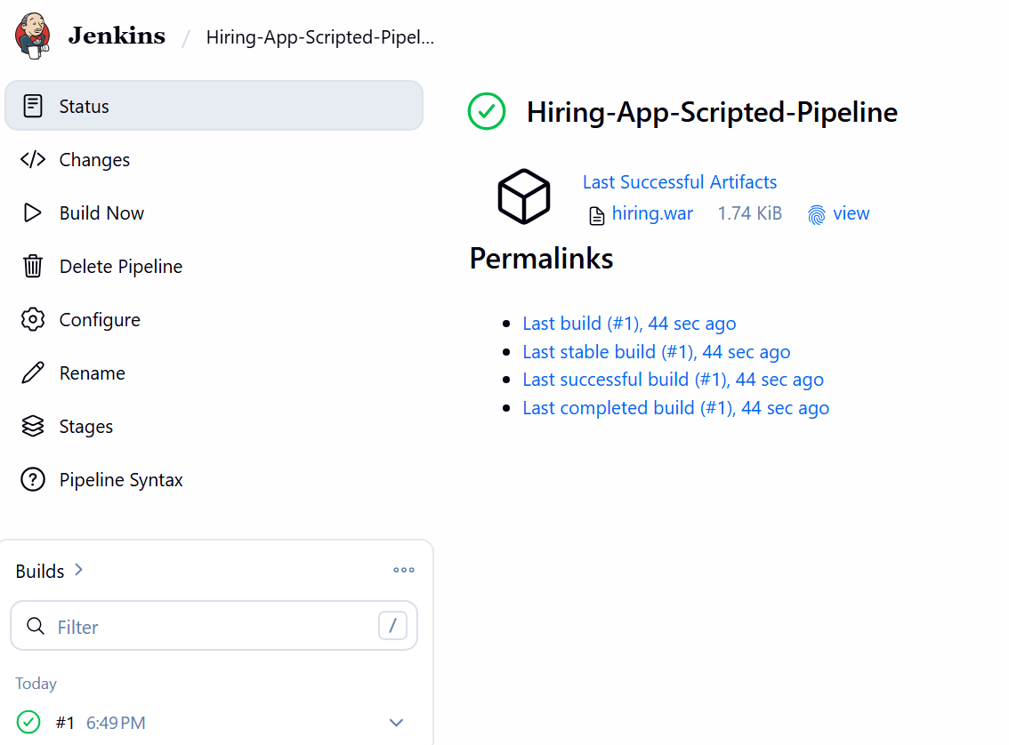
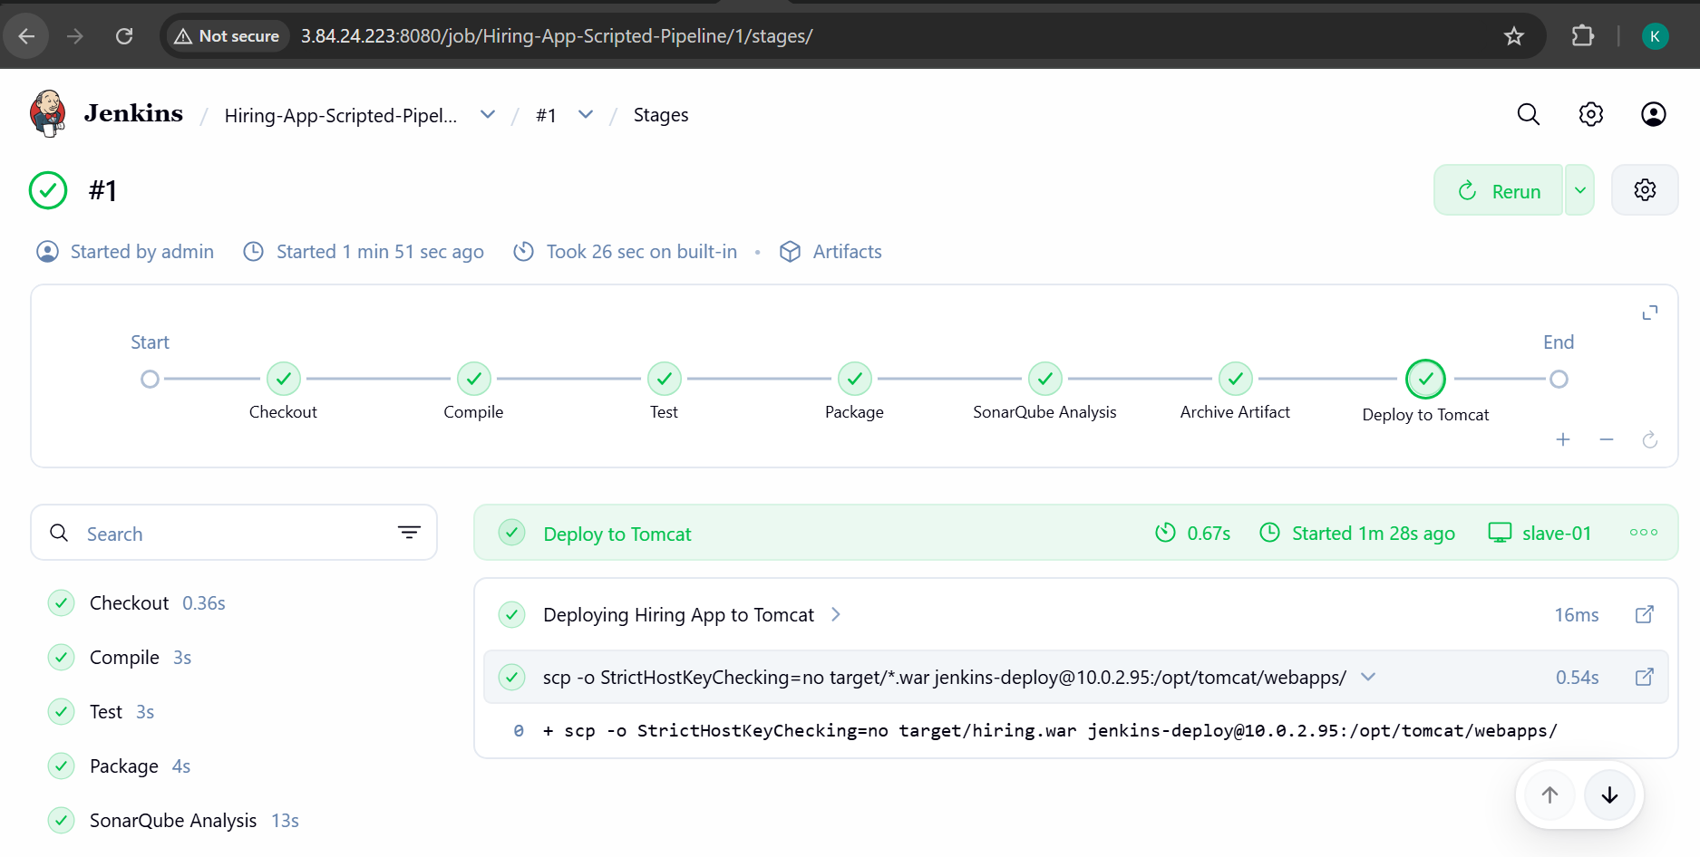
Main difference
Declarative:
pipeline {
agent any

tools {
maven 'Maven'
}

stages {
...
}

post {
...
}
}
The Scripted Pipeline starts with:
node('slave-01') {
and then uses:
stage('Checkout') {
...
}
This is an important Jenkins interview question.

Task 3 — Multi-Stage Pipeline
For the third job:
New Item
↓
Hiring-App-Multi-Stage-Pipeline
↓
Pipeline
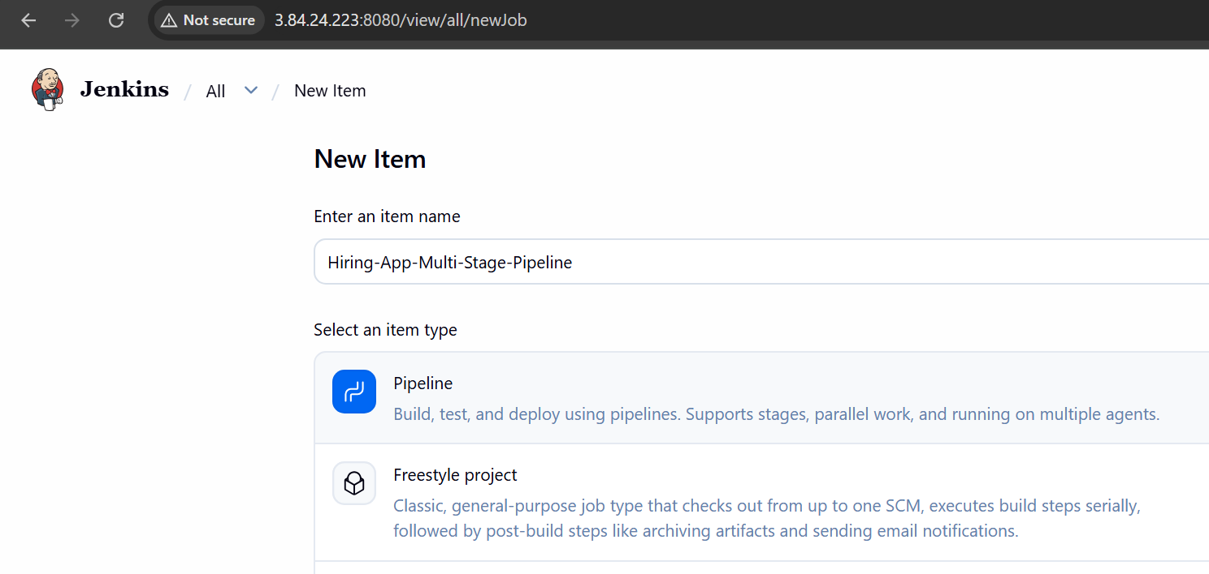
pipeline {
agent {
label 'slave-01'
}

tools {
maven 'Maven'
}

stages {

stage('CI') {
stages {

stage('Checkout') {
steps {
echo '=== Checking out source code ==='

git branch: 'main',
url: 'https://github.com/narayana-28/hiring-app.git'
}
}

stage('Compile') {
steps {
echo '=== Compiling application ==='

sh 'mvn clean compile'
}
}

stage('Test') {
steps {
echo '=== Running unit tests ==='

sh 'mvn test'
}
}

stage('Code Quality') {
steps {
echo '=== Running SonarQube analysis ==='

withCredentials([
string(
credentialsId: 'sonarqube-token',
variable: 'SONAR_TOKEN'
)
]) {
sh '''
mvn sonar:sonar \
-Dsonar.host.url=http://3.238.243.226:9000 \
-Dsonar.token=$SONAR_TOKEN
'''
}
}
}
}
}

stage('Build Artifact') {
stages {

stage('Package') {
steps {
echo '=== Creating WAR file ==='

sh 'mvn package -DskipTests'
}
}

stage('Archive') {
steps {
echo '=== Archiving WAR artifact ==='

archiveArtifacts(
artifacts: 'target/*.war',
fingerprint: true
)
}
}
}
}

stage('CD') {
stages {

stage('Deploy to Tomcat') {
steps {
echo '=== Deploying application to Tomcat ==='

sshagent(['tomcat-deploy-ssh']) {
sh '''
scp \
-o StrictHostKeyChecking=no \
target/*.war \
jenkins-deploy@10.0.2.95:/opt/tomcat/webapps/
'''
}
}
}
}
}
}

post {
success {
echo '======================================'
echo 'Hiring App Multi-Stage Pipeline SUCCESS'
echo '======================================'
}

failure {
echo '======================================'
echo 'Hiring App Multi-Stage Pipeline FAILED'
echo '======================================'
}
}
}
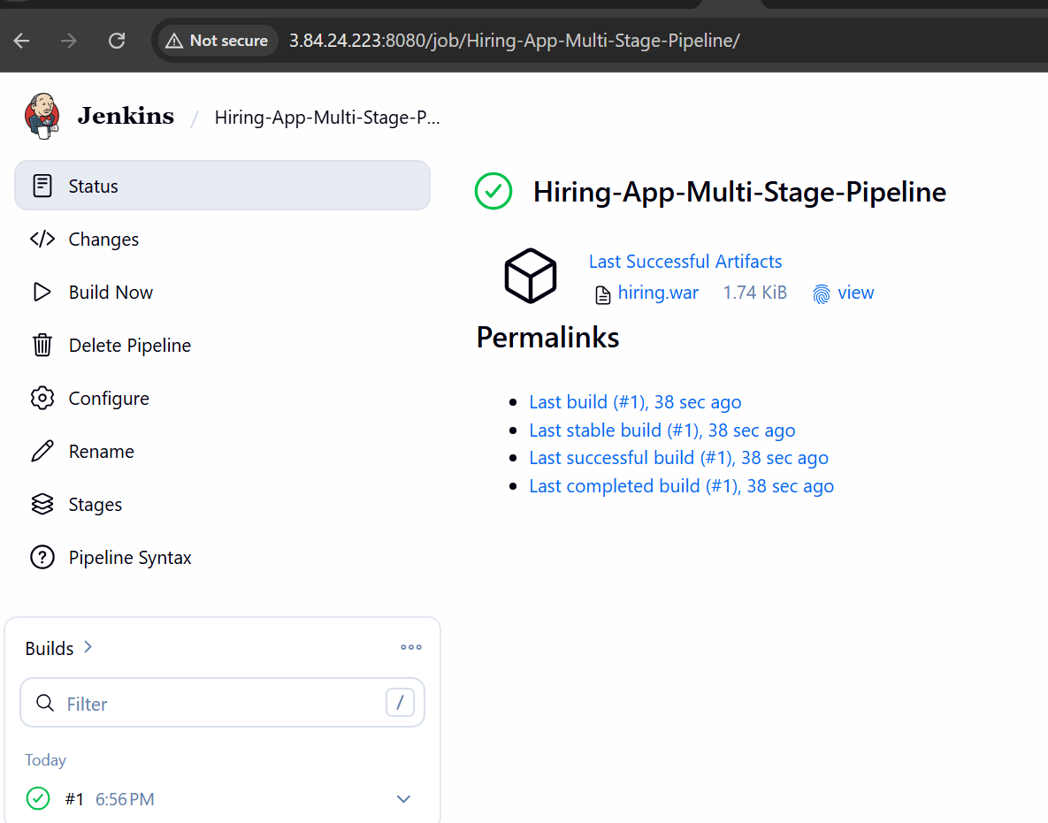
2. What makes this a Multi-Stage Pipeline?
This is the important part for your interview.
We're using nested stages.
For example:
stage('CI') {
stages {
stage('Checkout') {
...
}

stage('Compile') {
...
}

stage('Test') {
...
}

stage('Code Quality') {
...
}
}
}
So Jenkins will show:
CI
├── Checkout
├── Compile
├── Test
└── Code Quality

Build Artifact
├── Package
└── Archive

CD
└── Deploy to Tomcat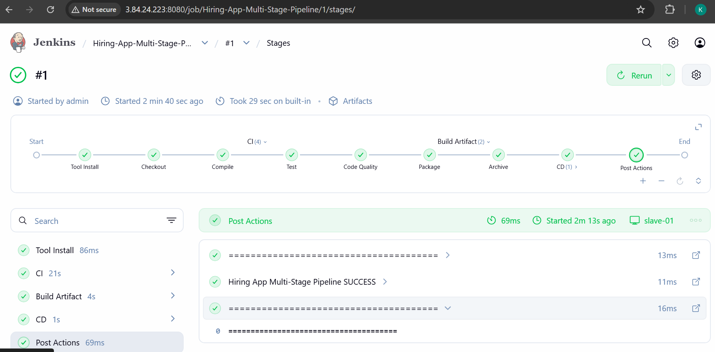

3. Overall CI/CD structure
Your pipeline now represents:
Hiring App
│
▼
┌─────────────┐
│ CI │
└─────────────┘
│
┌─────────────┼─────────────┐
▼ ▼ ▼
Checkout Compile Test
│
▼
SonarQube
│
▼
┌─────────────┐
│Build Artifact│
└─────────────┘
│
┌───────┴───────┐
▼ ▼
Package Archive
│
▼
┌─────────┐
│ CD │
└─────────┘
│
▼
Tomcat
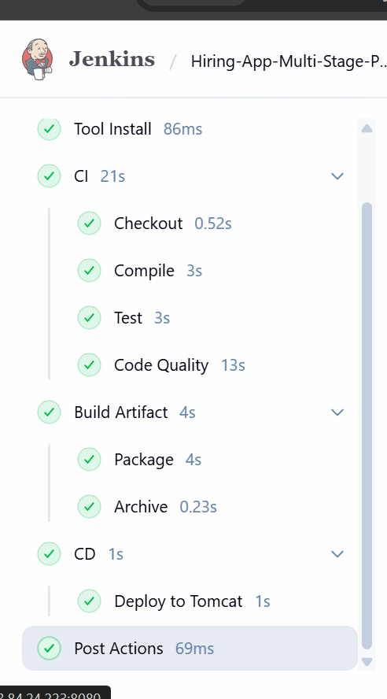

Result
Your Jenkins stage view should look approximately like:
Checkout
↓
Build
↓
Test
↓
SonarQube
↓
Package
↓
Nexus
↓
Deploy
↓
Verify
This is the pipeline I'd recommend using for your main CI/CD demonstration.

Pipeline #4 — Parallel Stage Pipeline
The objective is to demonstrate that independent CI activities can execute at the same time, reducing pipeline execution time.
We'll use this flow:
Checkout
│
▼
┌─────────────────┐
│ Parallel Stage │
└─────────────────┘
/ | \
/ | \
▼ ▼ ▼
Compile Test SonarQube
\ | /
\ | /
└──────┼──────┘
▼
Package
│
▼
Archive
│
▼
Deploy Tomcat
1. Create the Jenkins job
Go to: Jenkins Dashboard → New Item
Name: Hiring-App-Parallel-Pipeline
Select: Pipeline
Click OK.

2. Pipeline configuration
Scroll to: Pipeline → Definition
Select: Pipeline script
Paste this:
pipeline {
]) {
sh '''
mvn sonar:sonar \
-Dsonar.host.url=http://3.238.243.226:9000 \
-Dsonar.token=$SONAR_TOKEN
'''
}

echo '=== SonarQube Analysis completed ==='
}
}
}
}

stage('Package') {
steps {
echo '=== Packaging application ==='

sh 'mvn package -DskipTests'
}
}

stage('Archive Artifact') {
steps {
echo '=== Archiving WAR artifact ==='

archiveArtifacts(
artifacts: 'target/*.war',
fingerprint: true
)
}
}

stage('Deploy to Tomcat') {
steps {
echo '=== Deploying to Tomcat ==='

sshagent(['tomcat-deploy-ssh']) {
sh '''
scp \
-o StrictHostKeyChecking=no \
target/*.war \
jenkins-deploy@10.0.2.95:/opt/tomcat/webapps/
'''
}
}
}
}

post {
success {
echo '======================================'
echo 'Hiring App Parallel Pipeline SUCCESS'
echo '======================================'
}

failure {
echo '======================================'
echo 'Hiring App Parallel Pipeline FAILED'
echo '======================================'
}
}
}
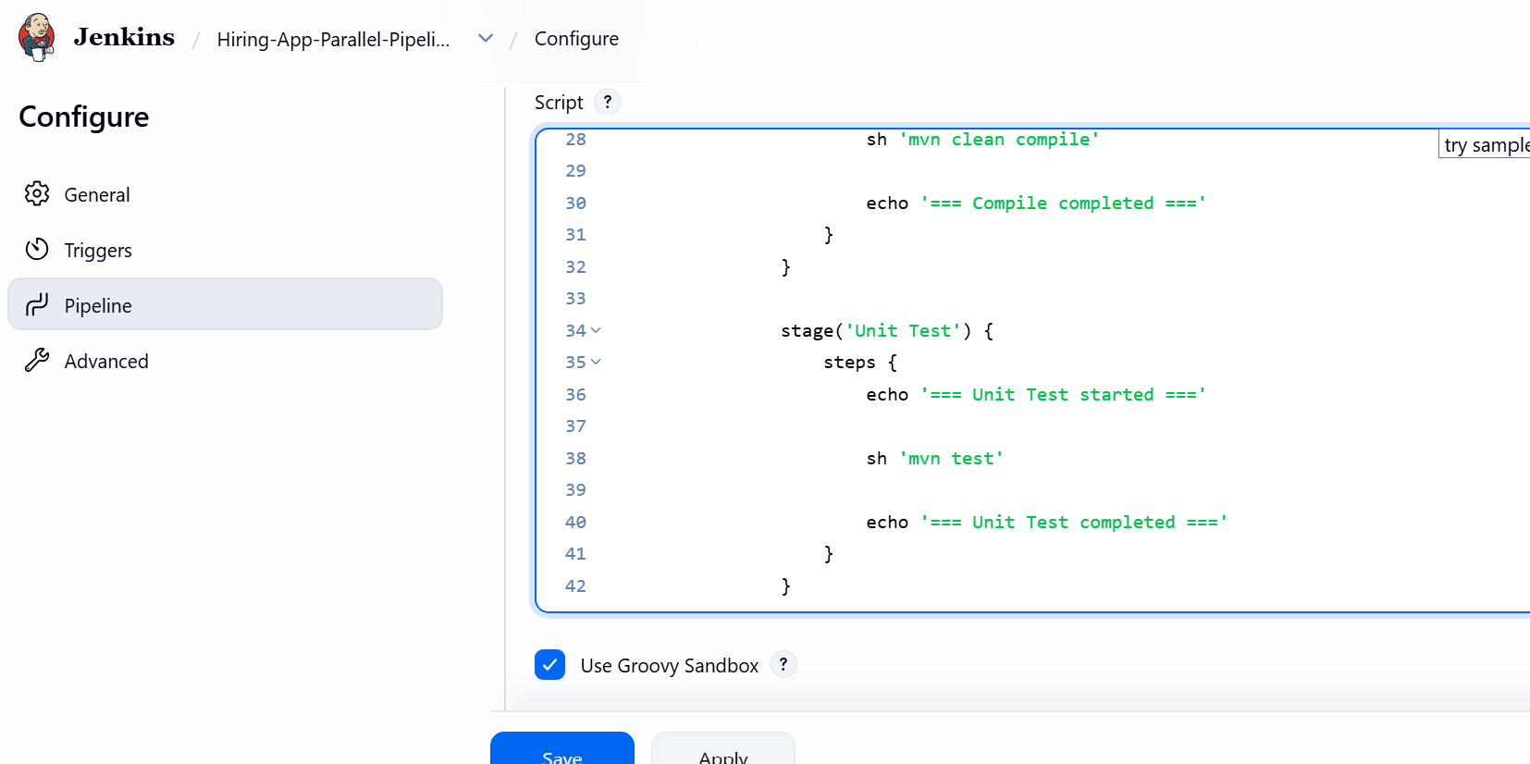

3. The important part — parallel
This is the section you need to understand:
stage('Parallel CI') {
parallel {

stage('Compile') {
...
}

stage('Unit Test') {
...
}

stage('SonarQube Analysis') {
...
}
}
}
Normally:
Compile
↓
Test
↓
SonarQube
would execute sequentially.
With parallel:
┌── Compile ─────────┐
│ │
Checkout ────┼── Unit Test ───────┼── Package
│ │
└── SonarQube ───────┘
Jenkins can execute the three branches concurrently.

4. Important note about this lab
In a real production pipeline, Compile and Test can have a dependency because tests normally need compiled classes.
We're using them in parallel here specifically to demonstrate Jenkins parallel stages, as required by your lab.
For a production-quality pipeline, we'd usually do something like:
Checkout
↓
Compile
↓
┌── Unit Test
├── Integration Test
└── Security Scan
↓
Package
That gives you parallelism without creating an artificial compile/test dependency.

5. Save and Build
Click:
Save → Build Now
Then open: Console Output
You should see something similar to:[Pipeline] { (Checkout)
Then:[Pipeline] { (Parallel CI)
And inside:[Pipeline] { (Compile)
[Pipeline] { (Unit Test)
[Pipeline] { (SonarQube Analysis)
The execution order of their log messages may be interleaved because they are running concurrently.
After all three finish:
Package
↓
Archive Artifact
↓
Deploy to Tomcat
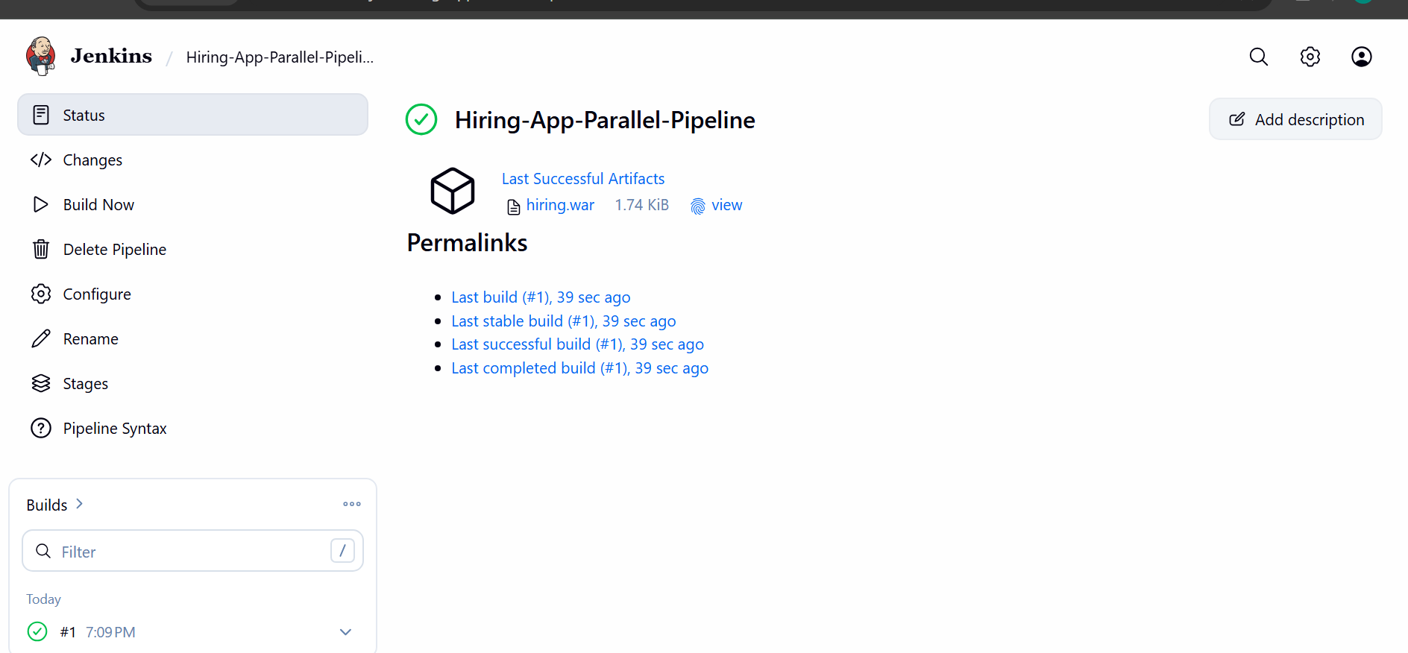

6. Expected final result
You should get: Hiring App Parallel Pipeline SUCCESS
Finished: SUCCESS
