AWS-EC2 INSTANCES
1. Launch one EC2 using Amazon Linux 2 image and add a script in user data to install Apache.
1.Go to EC2 → Launch Instance.
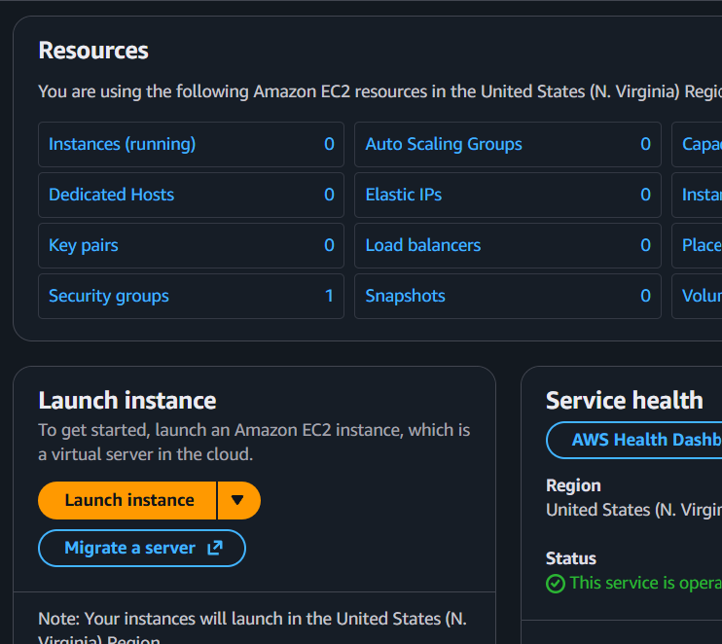
2. Enter the instance name (e.g., Apache-server).
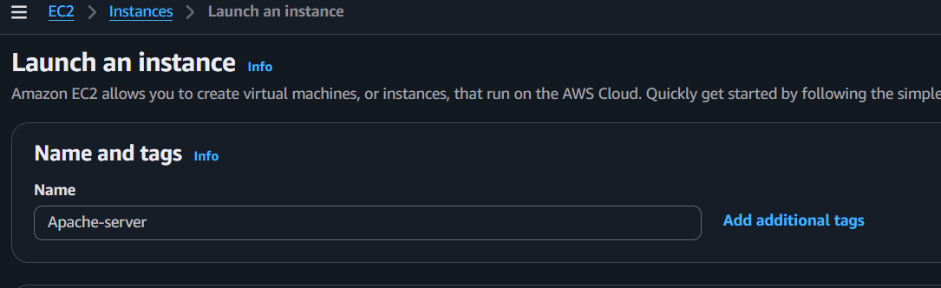
3. Under Application and OS Images (Amazon Machine Image):
Choose Amazon Linux.
Select Amazon Linux 2023 kernal-6.18 AMI.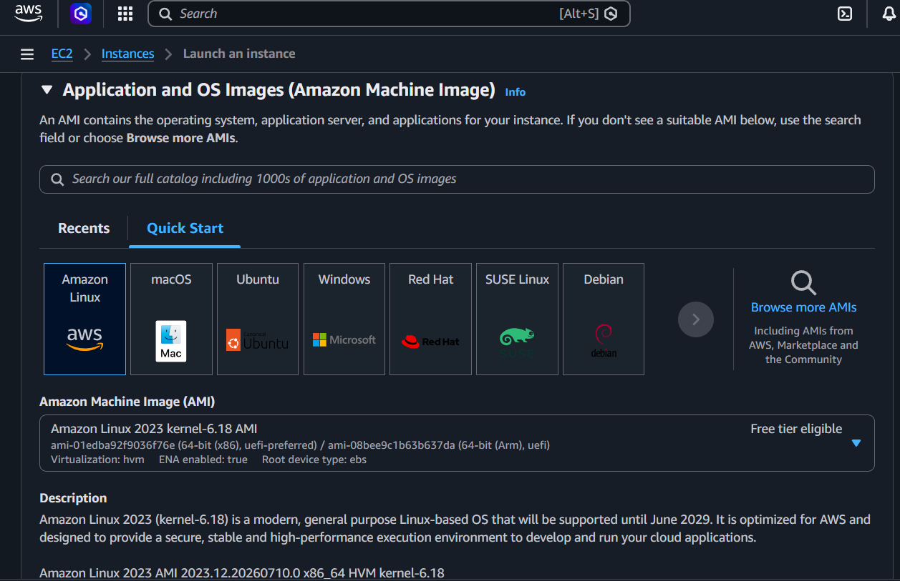
4. Choose t3.micro.
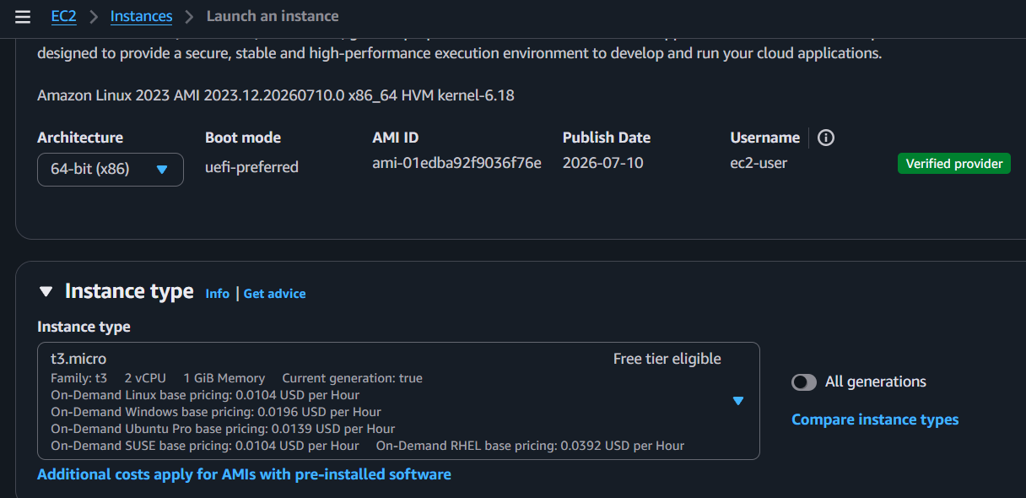
5. Select or create a key pair.
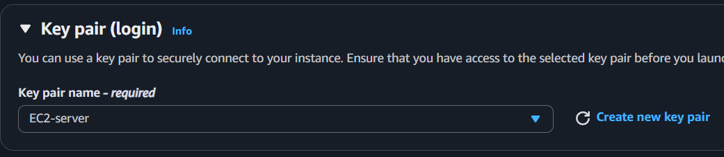
6. Allow SSH (22) and HTTP (80) in the security group.
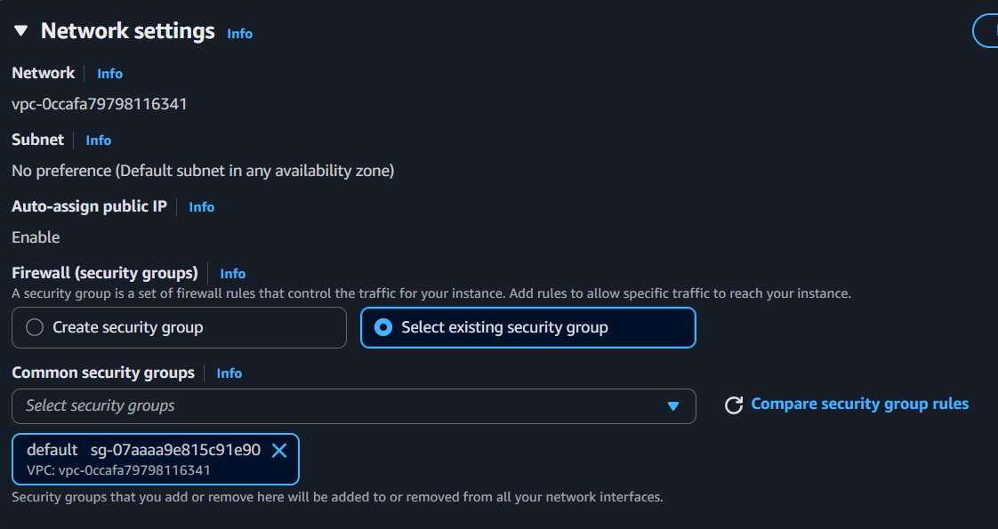
7. Expand Advanced Details.
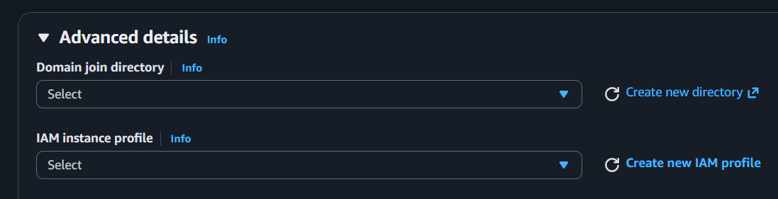
8. Paste the following into User data:

#!/bin/bash
yum update -y
yum install -y httpd
systemctl start httpd
systemctl enable httpd
echo "<h1>Apache Installed Successfully</h1>" > /var/www/html/index.html
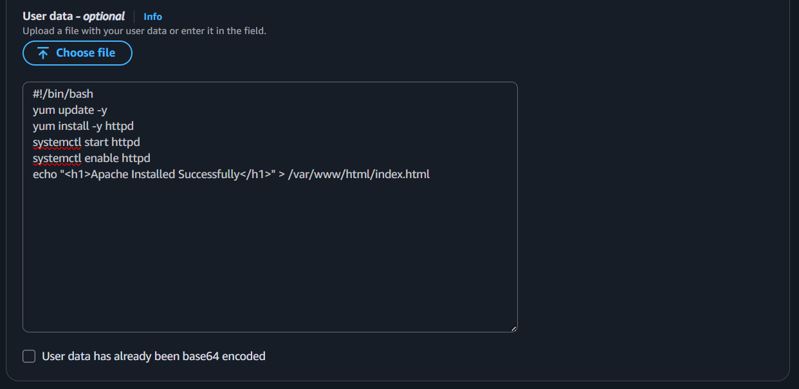
9. Click Launch Instance.
10. After the instance is running, open:
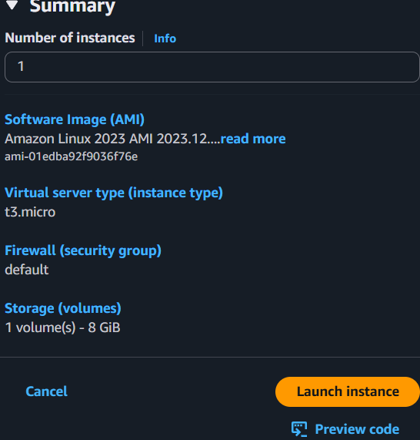
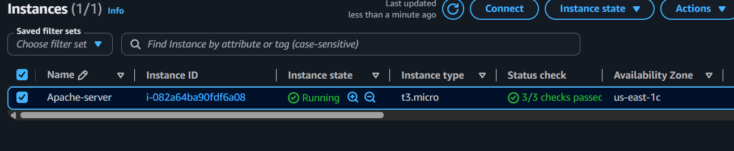
Verify : http://16.16.79.119/
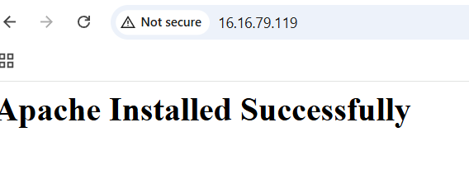
2.Launch one EC2 using Ubuntu image and add a script in user data to install Nginx.
Step-by-step
1. Go to EC2 → Launch Instance.
2. Enter the instance name (e.g., ubuntu-nginx).
3. Under Application and OS Images (Amazon Machine Image):
Choose Ubuntu.
Select ubuntu.
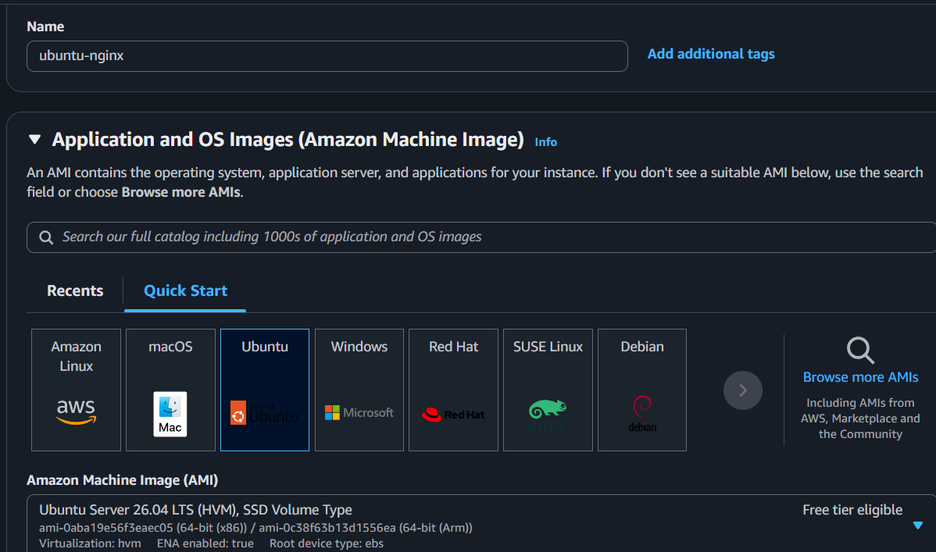
4. Choose t3.micro.
5. Select or create a key pair.
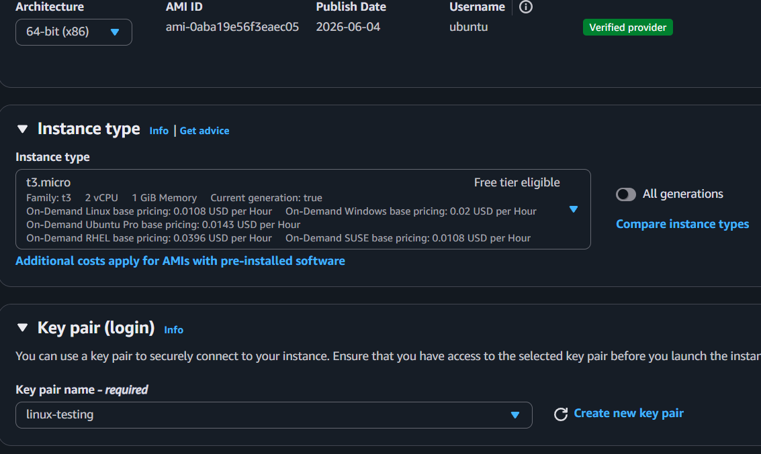
6. Select existing security group.
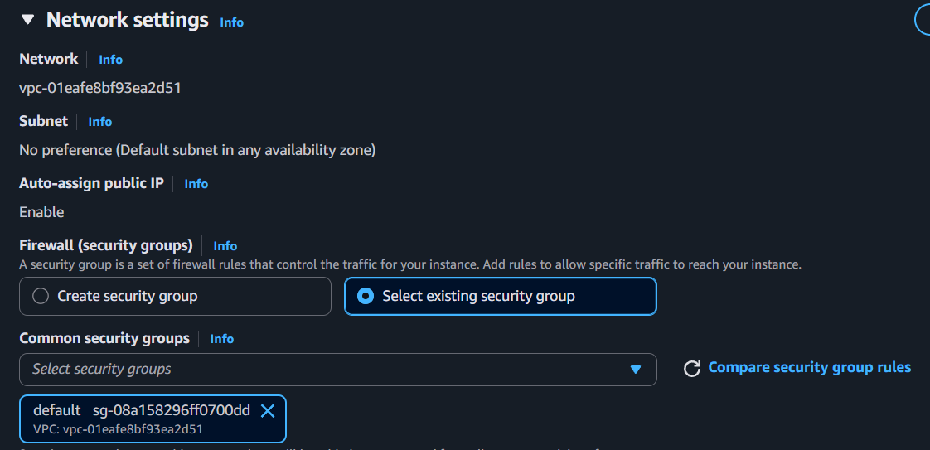
7. Expand Advanced Details.
8. Paste the following into User data:

#!/bin/bash
apt update -y
apt install nginx -y
systemctl enable nginx
systemctl start nginx

echo "<h1>Nginx Installed using User Data</h1>" > /var/www/html/index.nginx-debian.html
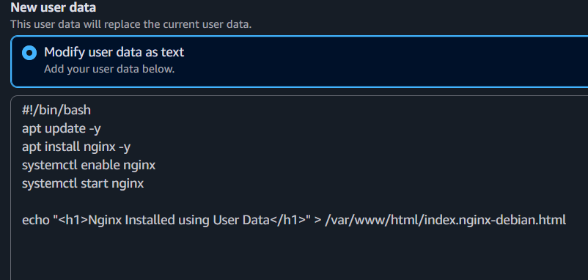
9. Click Launch Instance.
10. After the instance is running, open:
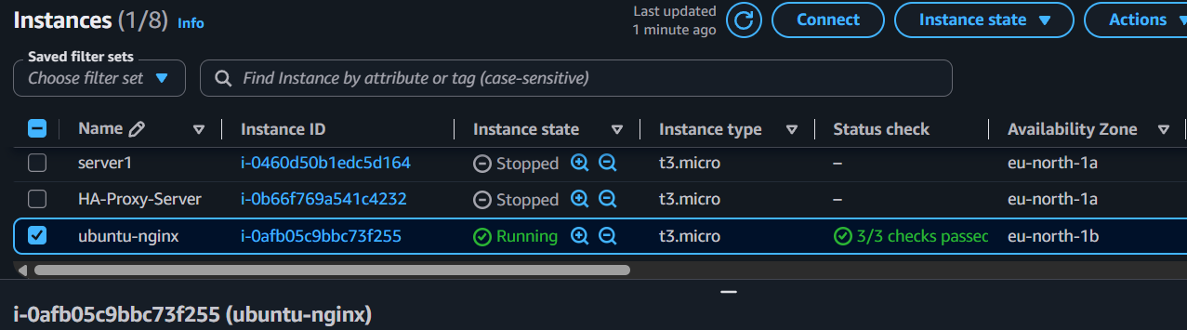
Verify: http://13.53.169.77/

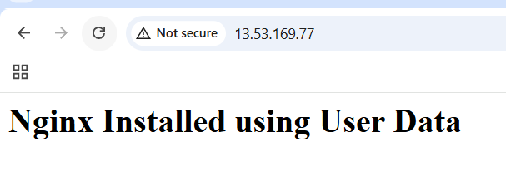

3.Launch one Windows server and install Tomcat on Windows.
1. Launch Windows EC2
- EC2 → Launch Instance
- Name:Windows-Tomcat
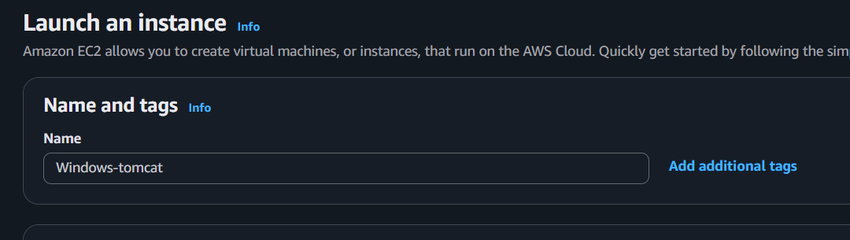
- AMI: Windows Server 2022 Base (or 2025)
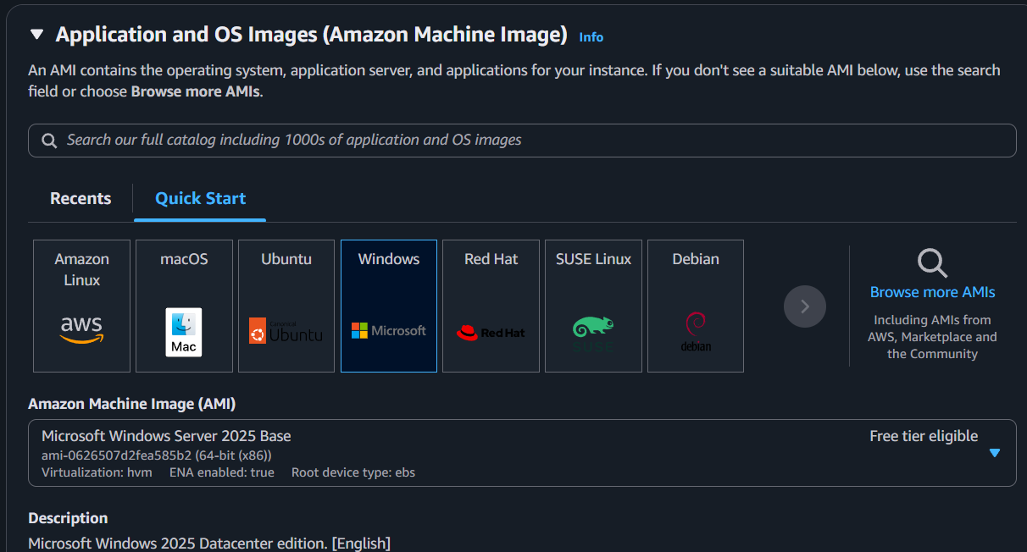
- Instance Type:t3.medium
- Key Pair: Select/Create one
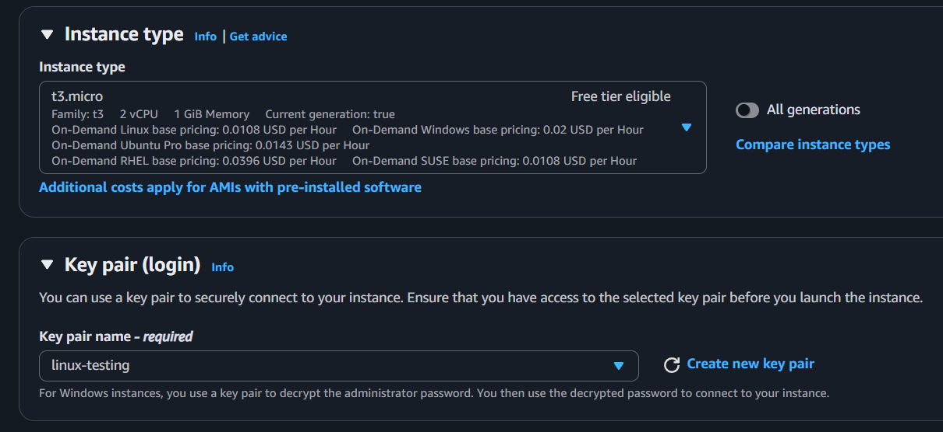
- Security Group:
Select existing security group and edit inbound rules in security group all the below ones
  - RDP (3389) → My IP
  - Custom TCP (8080) → Anywhere (0.0.0.0/0)
- Click Launch Instance
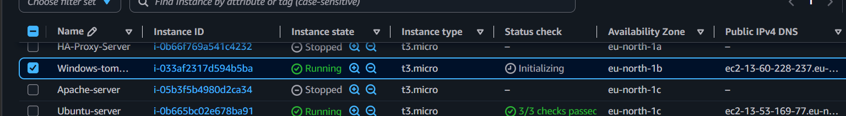
2. Connect to Windows
- EC2 → Select Instance → Connect
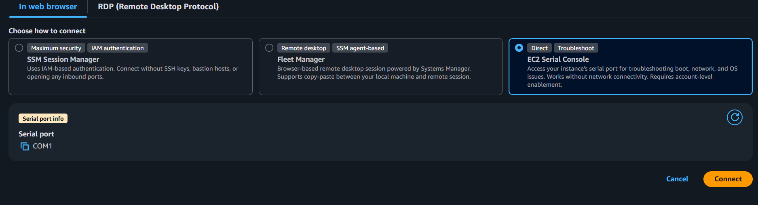
- RDP Client → Get Password
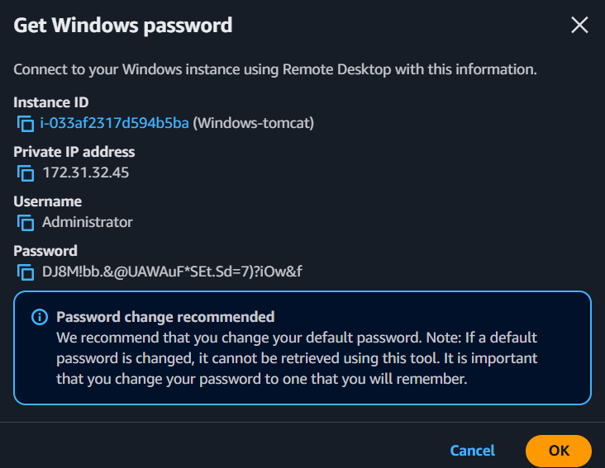
- Upload .pem → Decrypt Password
- Connect using RDP/MobaXterm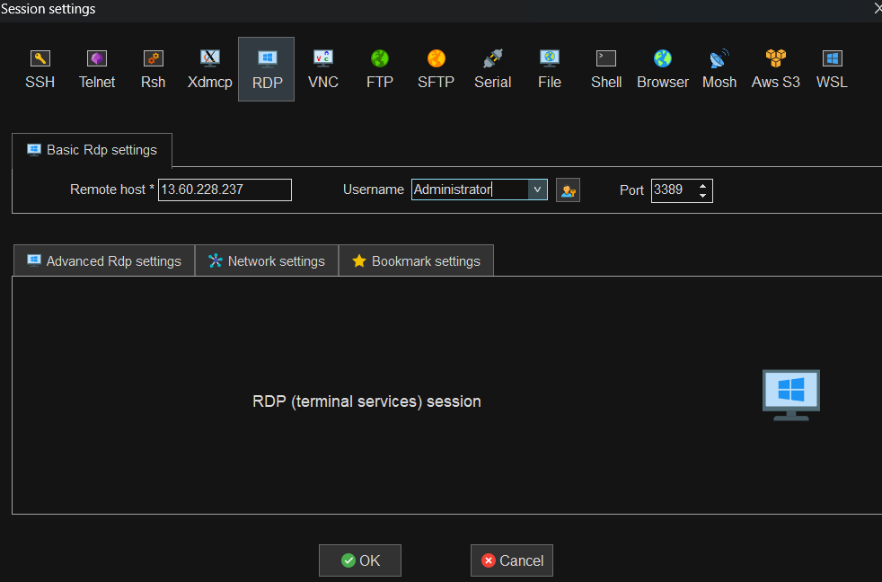
- Remote Host : public ip of windows instance
- Username: Administrator
- Password: Decrypted password
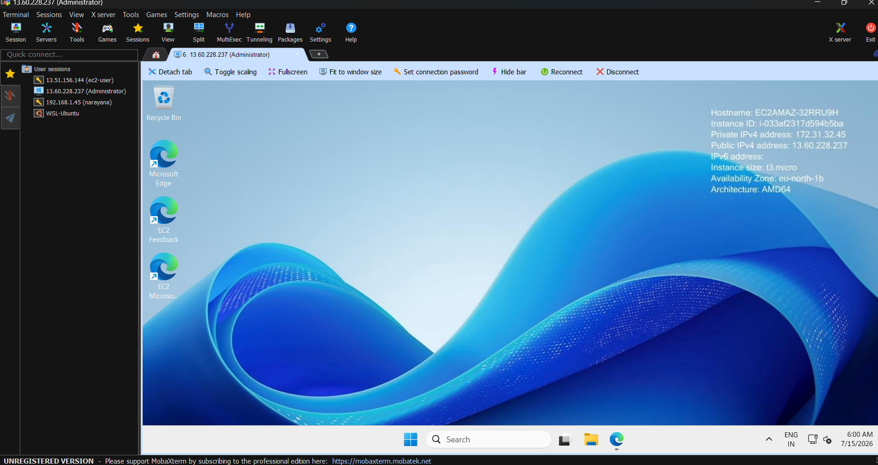
3. Install Java
Download JDK 21:
Install it and verify:
4. Download Tomcat
Download Tomcat 10:
Apache Tomcat 10
Download Core → 64-bit Windows zip.
5. Extract Tomcat
Right-click the ZIP → Extract All → Extract to:
C:\Tomcat
- java -version

6. Start Tomcat
Open Command Prompt:

- cd "C:\Tomcat\apache-tomcat-10.1.57\bin"
- startup.bat
7. Verify
On the Windows server:
- http://localhost:8080

4.Take a snapshot of the instance created in Task 1.
- Log in to the AWS Management Console.
- Navigate to EC2.
- Select the EC2 instance created in Task 1.
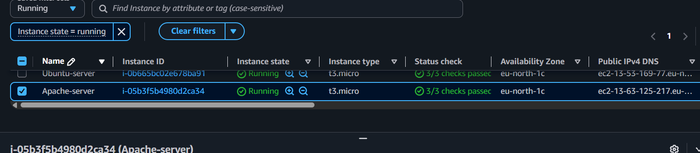
- Go to the Storage tab.
- Select the attached EBS Volume.
- Click on the Volume ID to open the EBS volume details.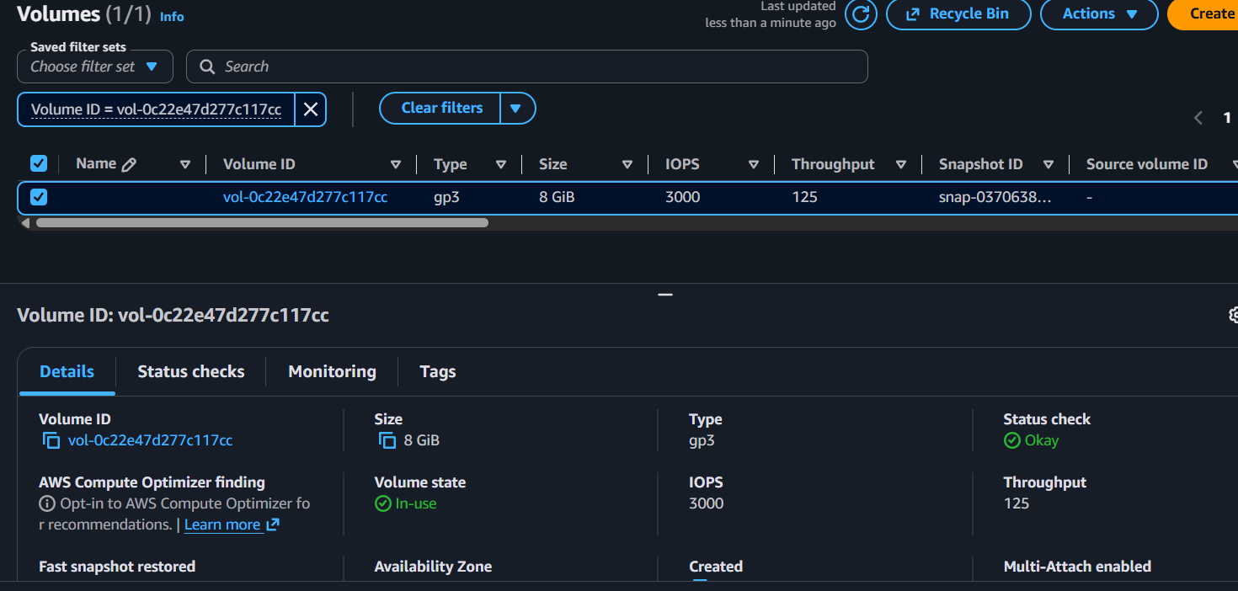
- Select the EBS volume.
- Click Actions → Create Snapshot.
- Enter a Snapshot Name and Description (optional).
- Click Create Snapshot.
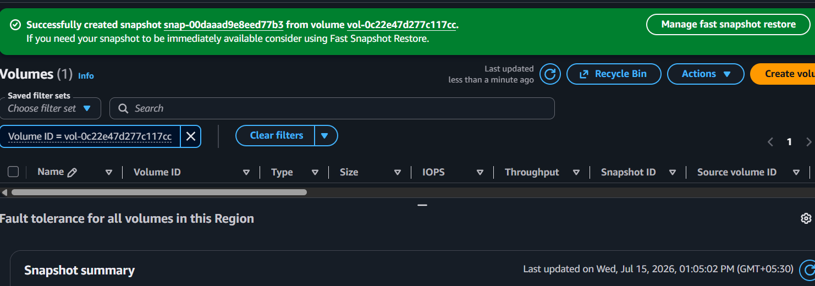
- Navigate to Elastic Block Store → Snapshots.
- Verify that the snapshot status changes to Completed, confirming that the snapshot was created successfully
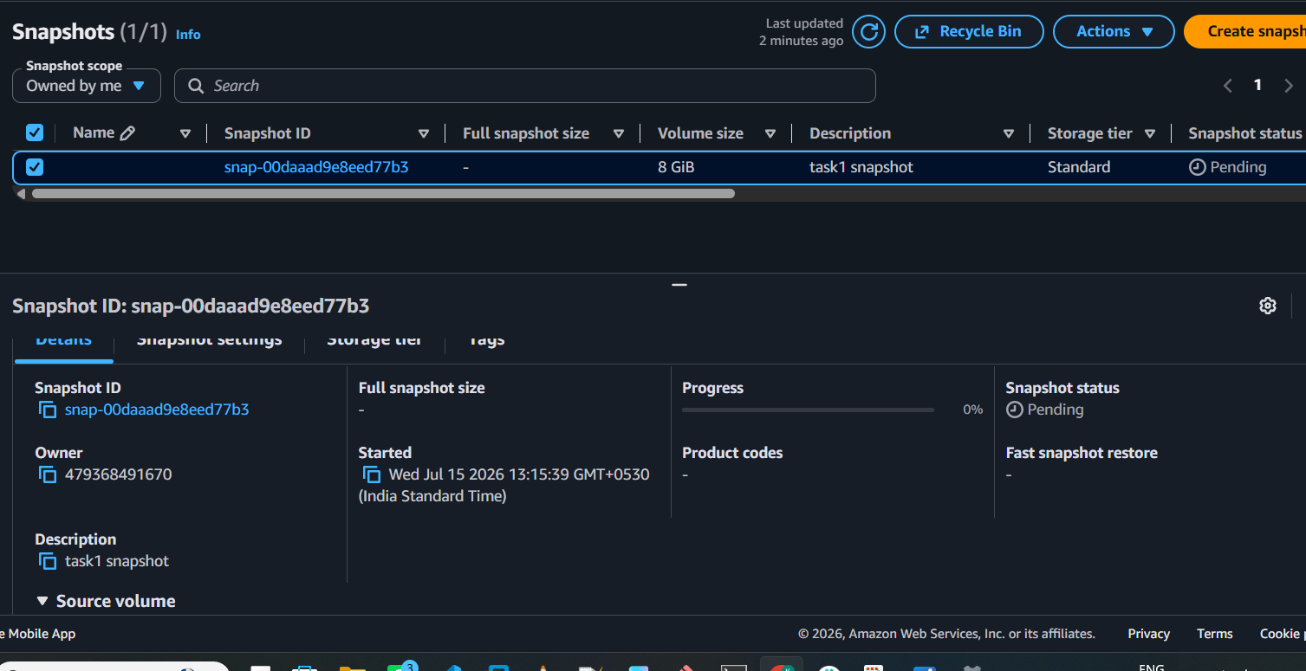

5.Assign passwordless authentication for the EC2 created in Task 2.

6.Launch any EC2 using the spot purchasing option.
7.Enable termination policy on the EC2 created in Task 2.
8.Launch one EC2 using AWS CLI.

