Challenge1.docx

1)Launch one aws ec2 and install jenkins.
A.Go to Aws console, Open EC2 and Launch Instance and
B.Give a Server Name ex: Jenkins-Server
C. Select Ubuntu OS Image
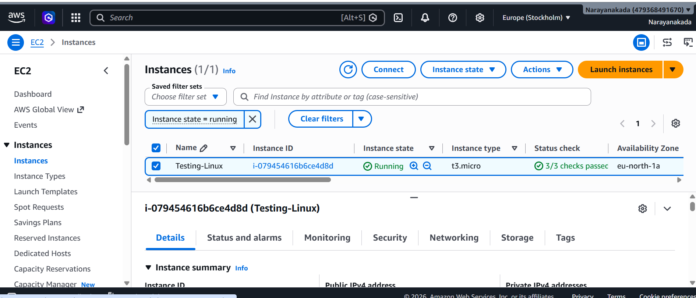
4 Select Number of Instance
5 Create new security group for server security
6 Open security group and
Allow ssh
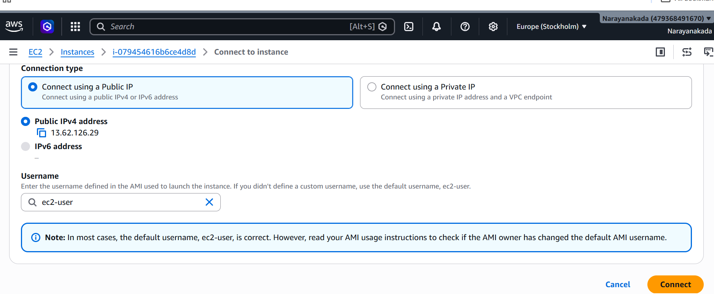
7 Update package by using
cat /etc/os-release
sudo dnf update -y
sudo dnf install jenkins -y
sudo dnf install java-21-amazon-corretto -y
sudo alternatives --config java and enter 2 for java-21
sudo dnf install jenkins -y
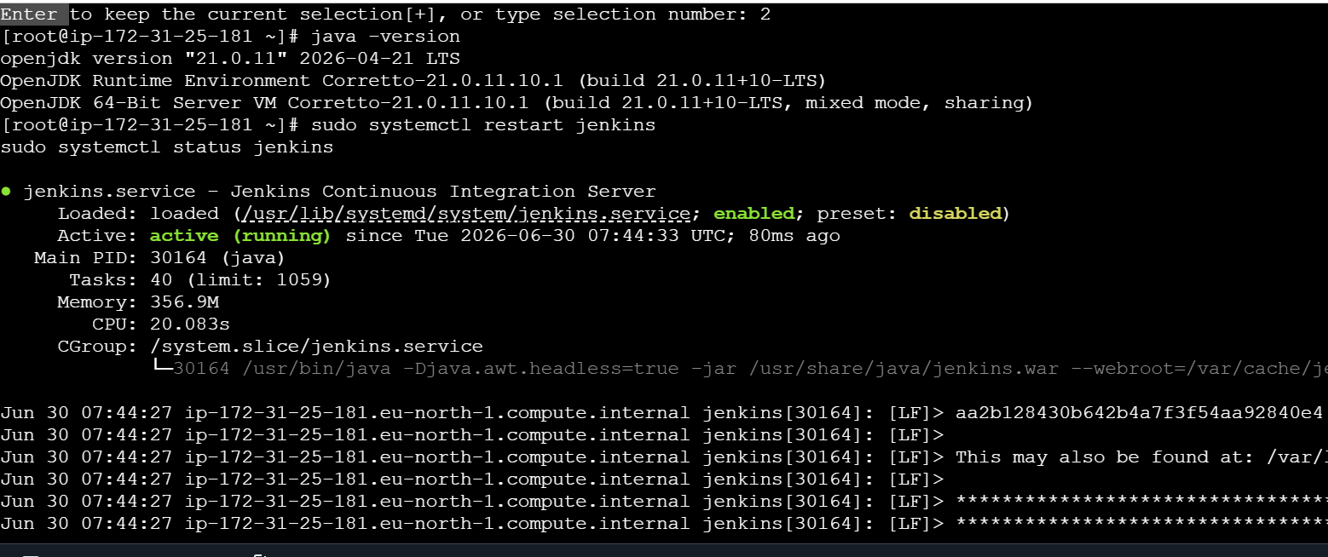
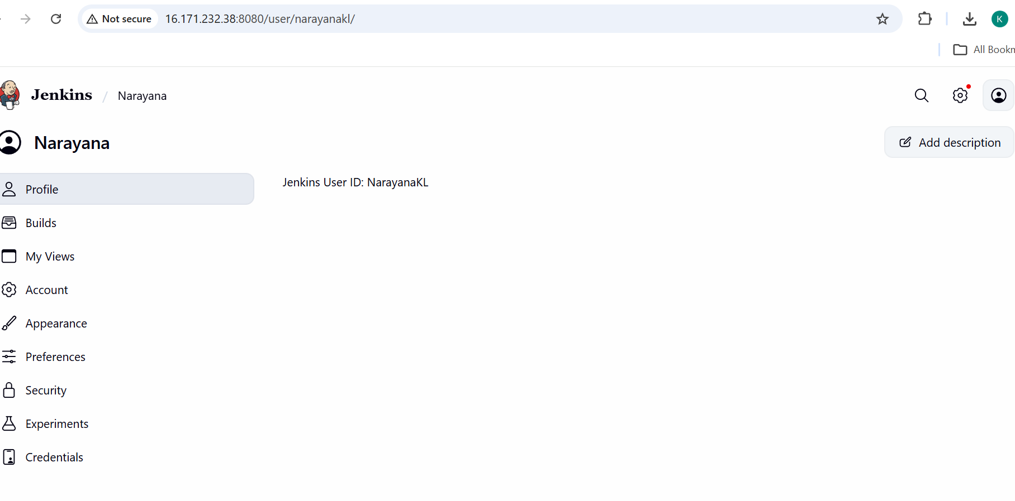

2) Setup Apache Tomcat on Ubuntu Virtual Machine
sudo apt update
sudo apt install tomcat10 -y
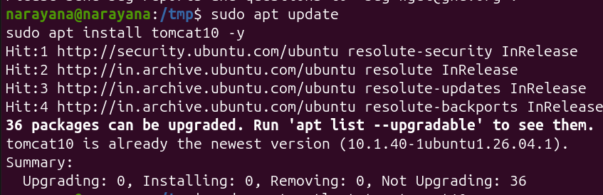
Sudo systemctl start tomcat10
Sudo systemctl status tomcat10
Sudo systemctl stop tomcat10
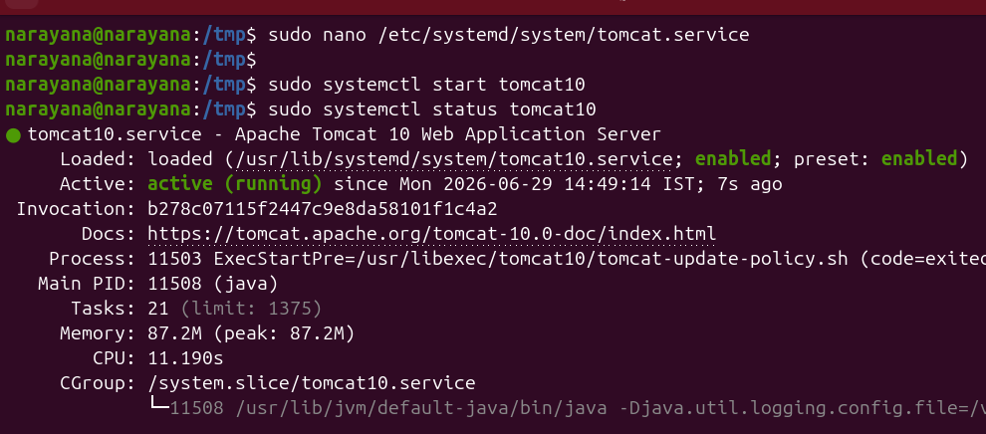
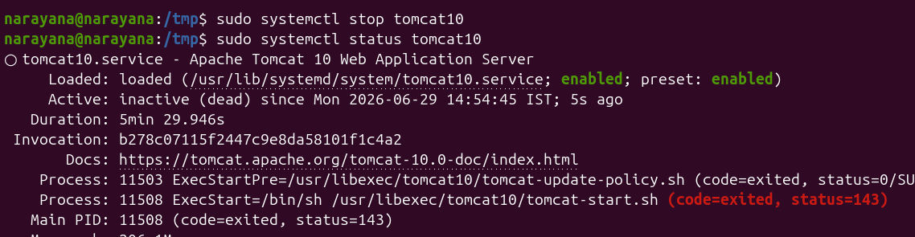
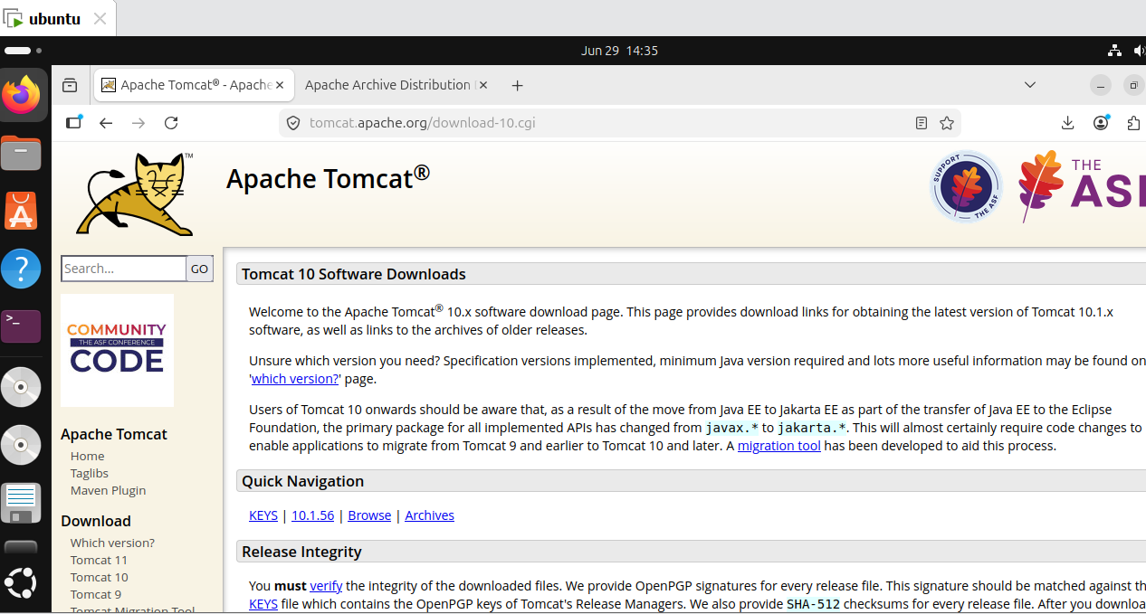
3) Setup Docker Desktop on your local windows.
- Run this command in powershell of windows
wsl –install and after exit fr0m ubuntu

To verify docker use command - docker --version
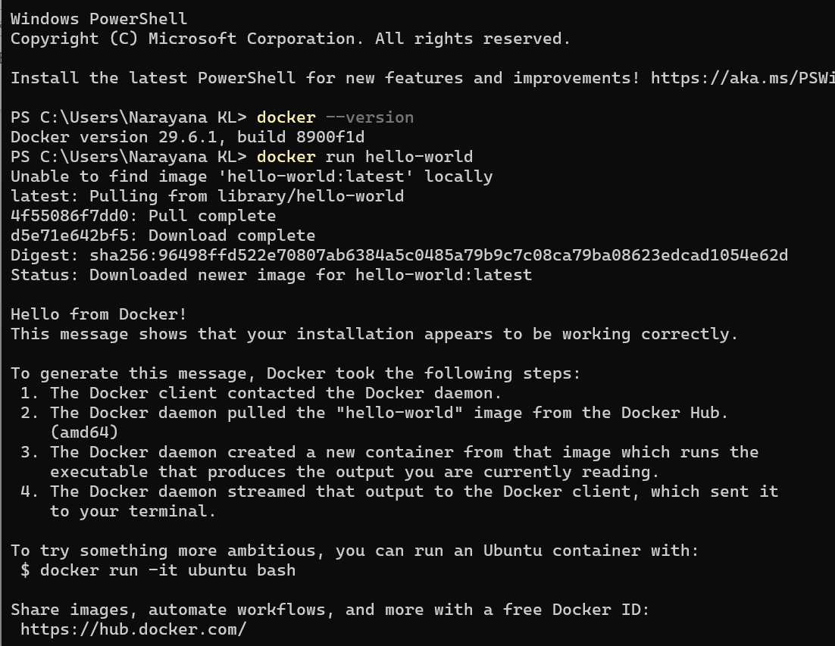
- Download Docker Desktop From
https://www.docker.com/products/docker-desktop/
