08_Bash_scripting

Conditions/ifelse statements:
If then statement
If this happens =do this
otherwise =do that
Ex:
#!/bin/bash
count=100
if [ $count -eq 100 ]
then
echo count is 100
else
echo count is not 100
fi
commands : vi if-script.bash
chmod 777 if-script.bash
./if-script.bash

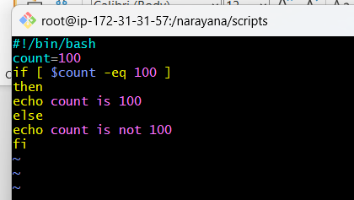
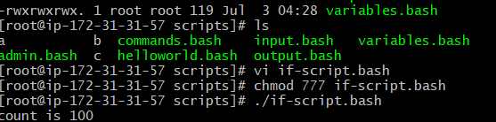

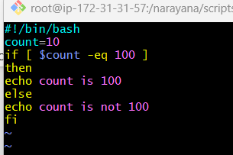
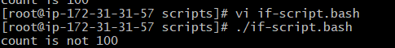
Tasks to Execute
Execute all scripts from thedevops-cloud-documents-channel.

A. Basic Shell Scripts:
1.Output to screen
#!/bin/bash
# Simple output script
echo
echo "Hello World"
echo
commands: vi output.bash
chmod 777 output.bash
cat output.bash
./output.bash

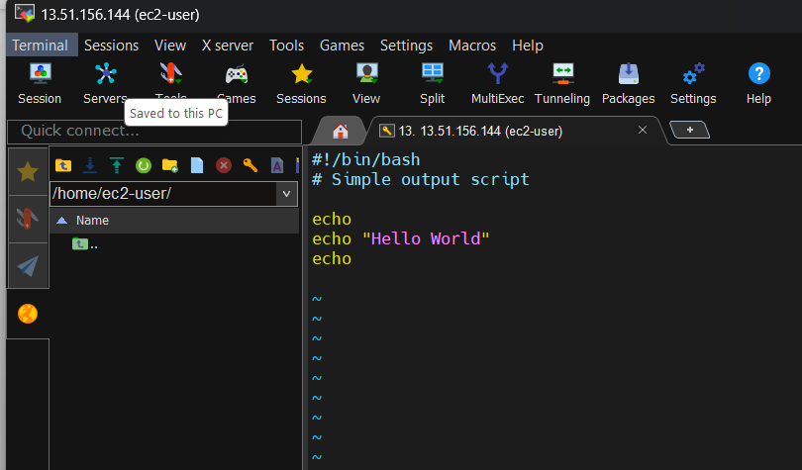
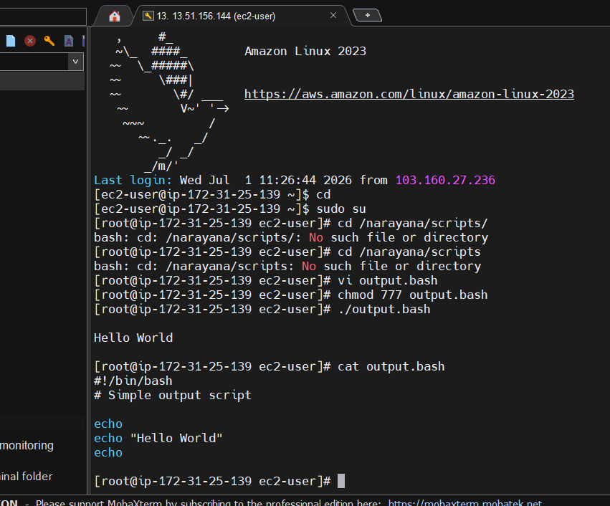
2.Defining Tasks

#!/bin/bash
# Define small tasks

whoami
echo
pwd
echo
hostname
echo
ls -ltr
echo

commands: vi define.bash
chmod 777 define.bash
cat define.bash
./define.bash

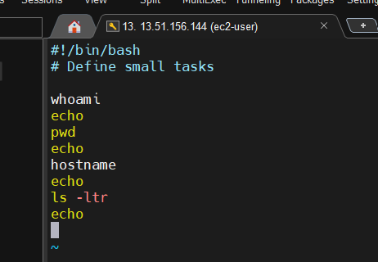

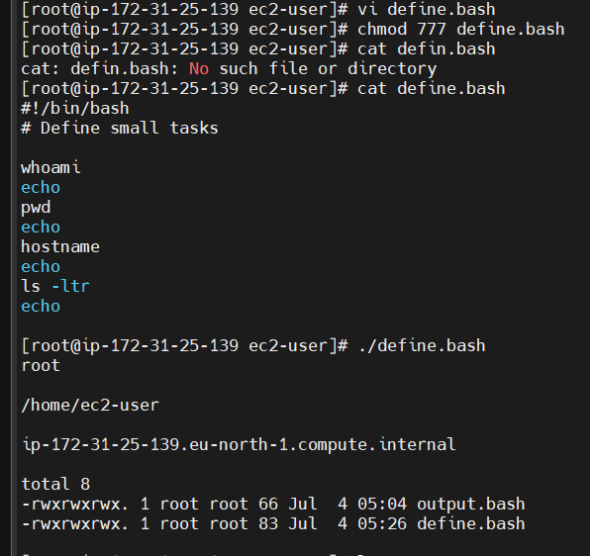

3.Defining variables

#!/bin/bash
# Example of defining variables

a=Narayana
b=Lakshmi
c=’kada.’

echo "My first name is $b"
echo "My surname is $c"
echo ‘My surname is $a’

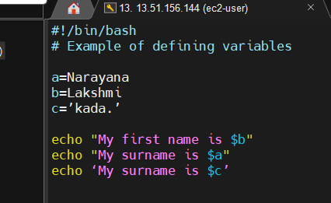

Commands – vi variables.bash
Chmod 777 variables.bash
./variables.bash
Cat variables.bash
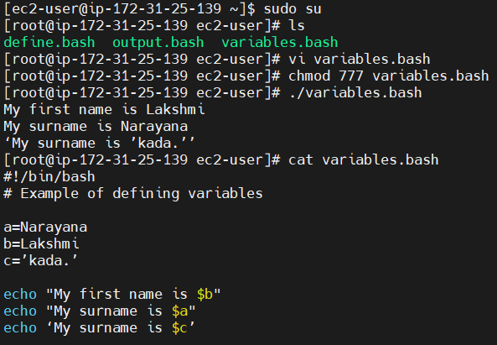

4.Read Input
#!/bin/bash
# Read user input

echo "What is your first name?"
read a
echo

echo "What is your last name?"
read b
echo

echo Hello $a $b
commands : vi read.bash
chmod 777 read.bash
./read.bash
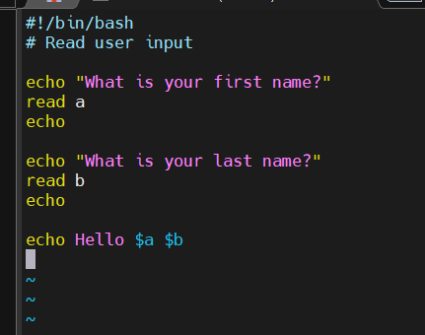
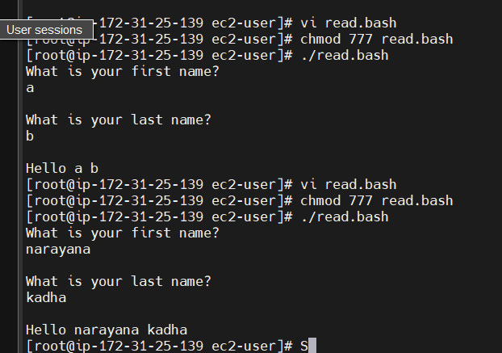

5.Scripts to run commands within

#!/bin/bash
# Script to run commands within

clear
echo "Hello `whoami`"
echo
echo "Today is `date`"
echo
echo "Number of user login: `who | wc -l `"
echo

Commands: vi commands.bash
Chmod 777 commands.bash
./commands.bash
Cat commands.bash

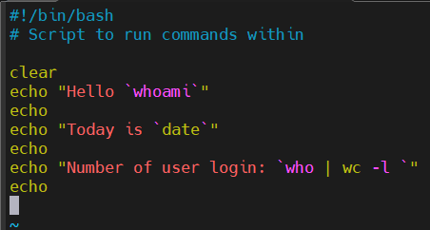
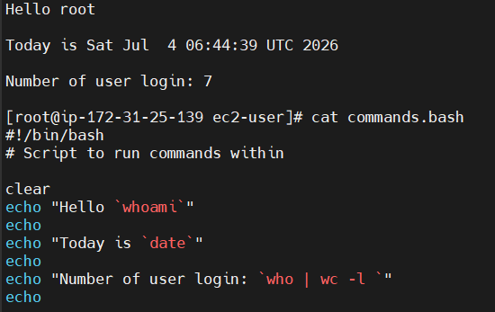

6.Read input and perform a task

#!/bin/bash
# This script will rename a file

echo Enter the file name to be renamed
read oldfilename

echo Enter the new file name
read newfilename

mv $oldfilename $newfilename
echo The file has been renamed as $newfilename

commands :
vim read.scripts
chmod 777 read.scripts
./read.scripts
ls – to check the list of files that are renamed

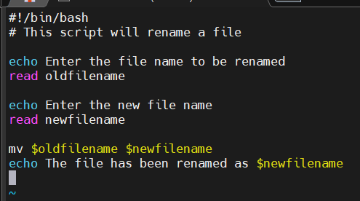
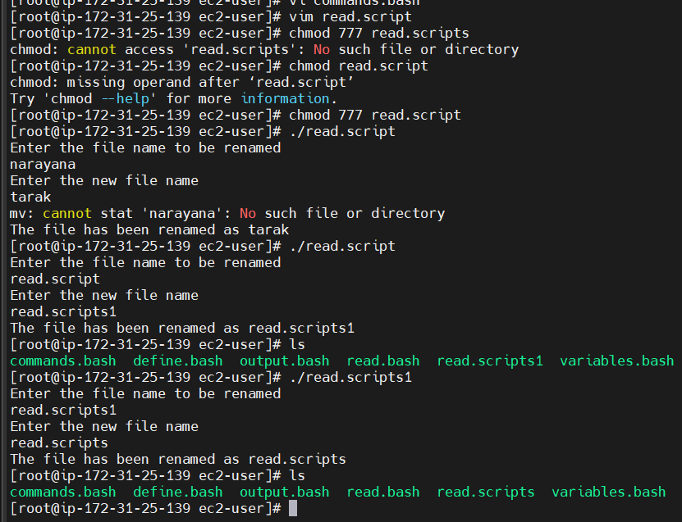

B. Case Scripts:
1.
#!/bin/bash

echo
echo Please chose one of the options below
echo
echo 'a = Display Date and Time'
echo 'b = List file and directories'
echo 'c = List users logged in'
echo 'd = Check System uptime'
echo

read choices

case $choices in

a) date;;
b) ls;;
c) who;;
d) uptime;;
*) echo Invalid choice - Bye.

esac
Commands : vi case.scripts
Chmod 777 case.scripts
./case.scripts

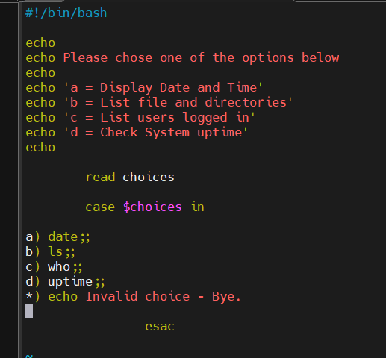

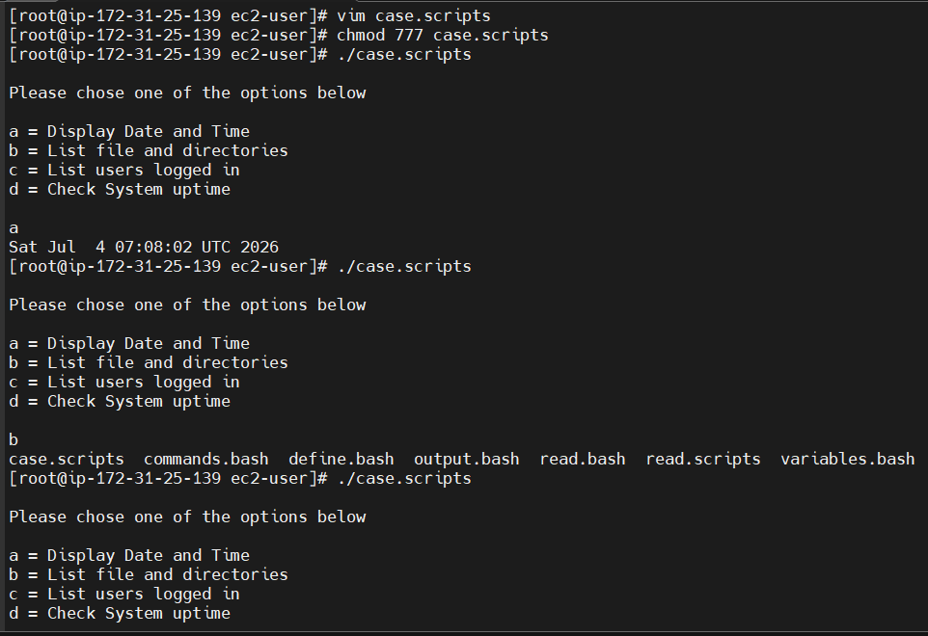

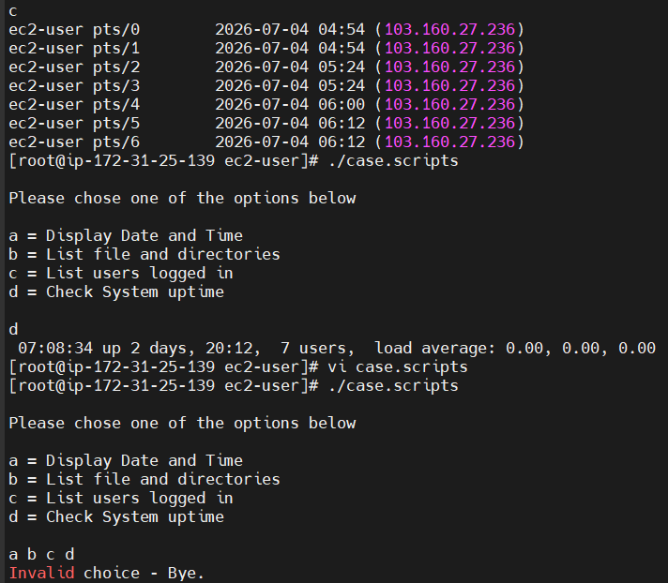

2.This script will look at your current day and tell you the state of the backup

#!/bin/bash

NOW=$(date +"%a")
case $NOW in
Mon)
echo "Full backup";;
Tue|Wed|Thu|Fri)
echo "Partial backup";;
Sat|Sun)
echo "No backup";;
*) ;;
esac
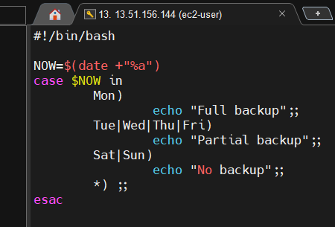

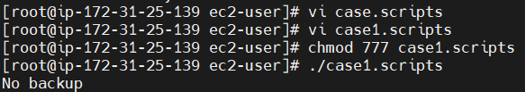

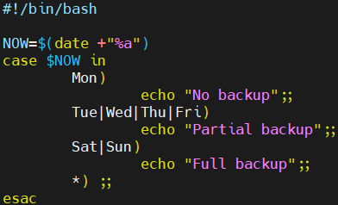

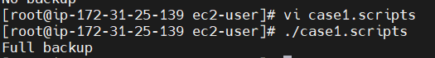

C. do-while Script
1.Script to run for a number of times

#!/bin/bash

c=1
while [ $c -le 5 ]
do
echo "Welcone $c times"
(( c++ ))
done

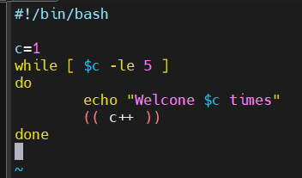

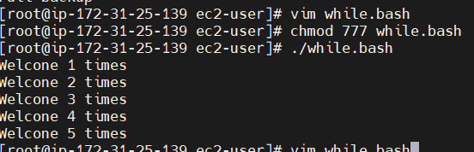

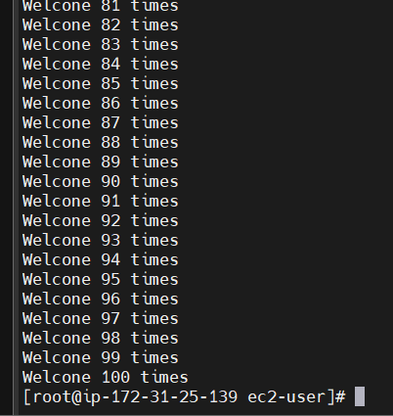
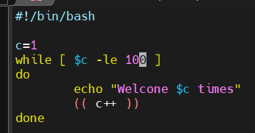

2.Script to run for a number of seconds

#!/bin/bash

count=0
num=10
while [ $count -lt 10 ]
do
echo
echo $num seconds left to stop this process $1
echo
sleep 1

num=`expr $num - 1`
count=`expr $count + 1`
done
echo
echo $1 process is stopped!!!
echo

Commands: vi while1.bash
Chmod 777 while1.bash
./while1.bash

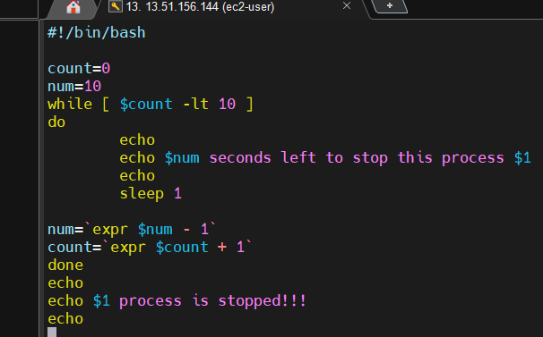

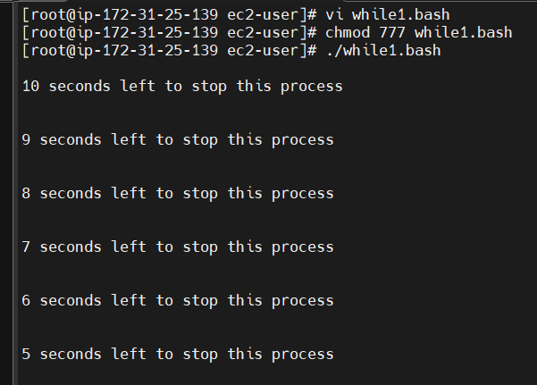
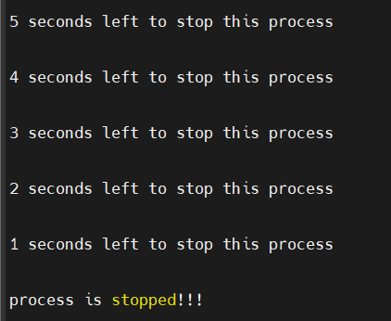

D. for loop Scripts:

1.Simple for loop output

#!/bin/bash

for i in 1 2 3 4 5
do
echo "Welcome $i times"
done

Commands : vi loop.bash
Chmod 777 loop.bash
./loop.bash

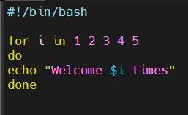
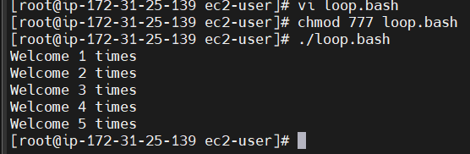

2.Simple for loop output
#!/bin/bash

for i in eat sleep wakeup run play
do
echo See Imran $i
done

Commands : vi loop.bash
Chmod 777 loop.bash
./loop.bash

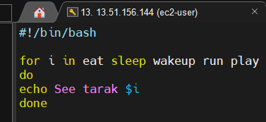
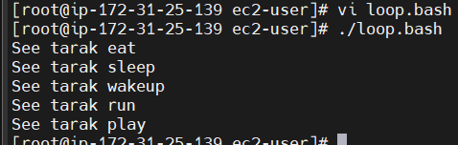

3.for loop to create 5 files named 1-5

#!/bin/bash

for i in {1..5}
do
touch $i
done

Commands : vi loop.bash
./loop.bash

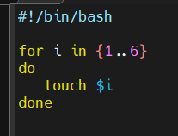

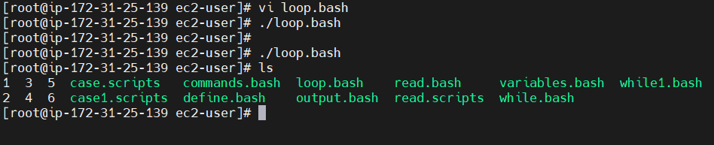

4.for loop to delete 5 files named 1-5

#!/bin/bash

for i in {1..5}
do
rm $i
done
Commands : vi loop.bash
./loop.bash

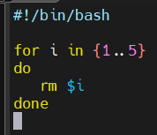

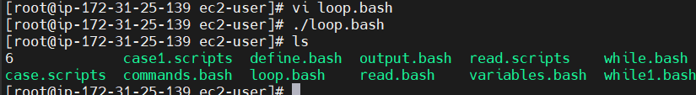

5.Specify days in for loop

#!/bin/bash

i=1
for day in Mon Tue Wed Thu Fri
do
echo "Weekday $((i++)) : $day"
done

Commands : vi loop.bash
./loop.bash

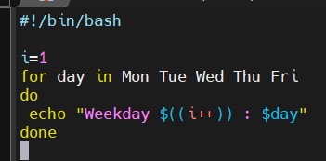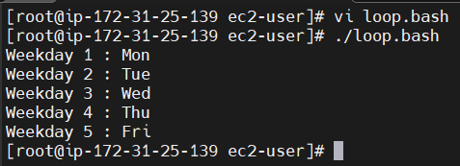

6.List all users one by one from /etc/passwd file

#!/bin/bash

i=1
for username in `awk -F: '{print $1}' /etc/passwd`
do
echo "Username $((i++)) : $username"
done
Commands : vi loop.bash
./loop.bash
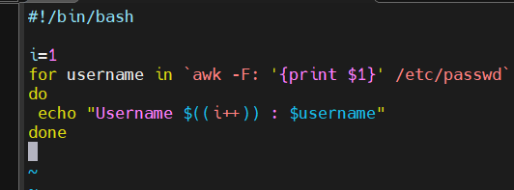
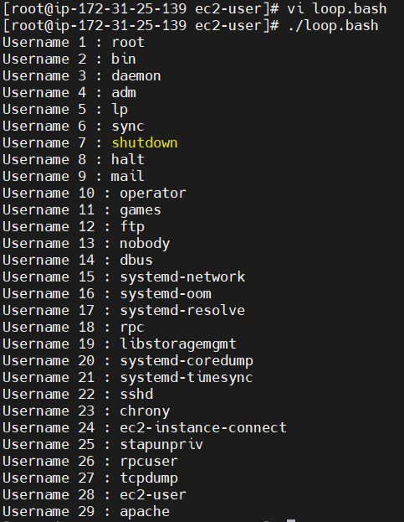

E. If-then Scripts:

1.Check the variable

#!/bin/bash

count=100
if [ $count -eq 100 ]
then
echo Count is 100
else
echo Count is not 100
fi
Commands: vi variables.bash
./variables.bash
Cat variables.bash
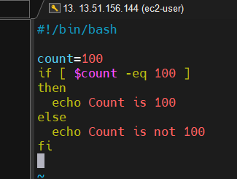

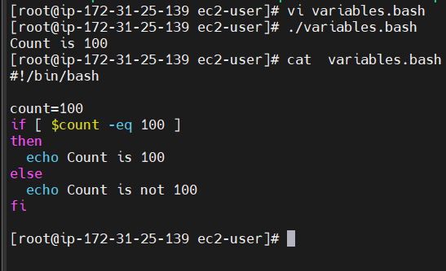

2.Check if a file error.txt exist
#!/bin/bash

clear
if [ -e /home/narayana/error.txt ]

then
echo "File exist"
else
echo "File does not exist"
fi

Commands: vi file.bash
Chmod 777 file.bash
./file.bash

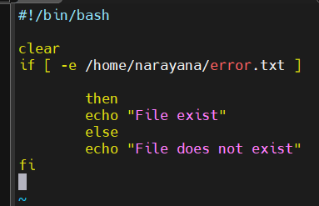

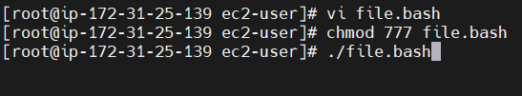
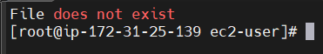

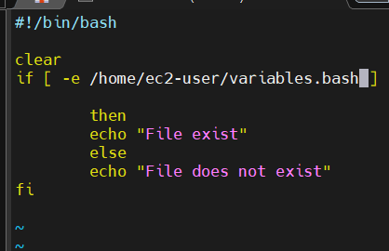

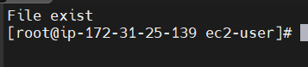

3.Check if a variable value is met
#!/bin/bash

a=`date | awk '{print $1}'`

if [ "$a" == Mon ]

then
echo Today is $a
else
echo Today is not Monday
fi

Commands: vi file.bash
Chmod 777 file.bash
./file.bash

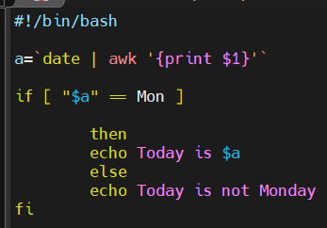

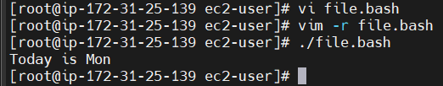

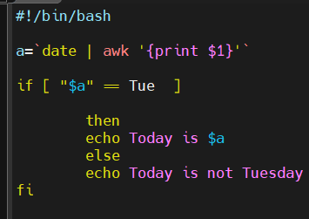

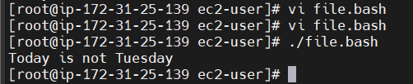

4.Check the response and then output
#!/bin/bash

clear
echo
echo "What is your name?"
echo
read a
echo

echo Hello $a sir
echo

echo "Do you like playing cricket? (y/n)"
read Like
echo

if [ "$Like" == y ]
then
echo You are sportsman

elif [ "$Like" == n ]
then
echo You should play weekly once, it’s a good for your health
echo
fi

Commands: vi file.bash
Chmod 777 file.bash
./file.bash

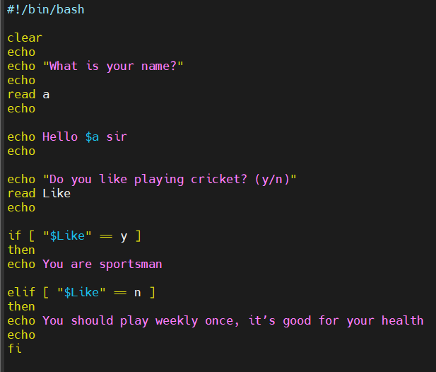

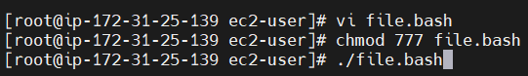

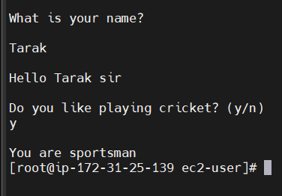

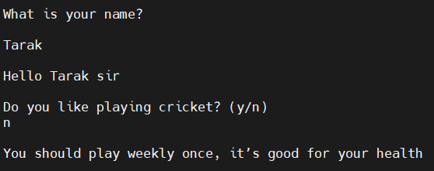

Comparisons:
-eq equal to for numbers
== equal to for letters
-ne not equal to
!== not equal to for letters
-lt less than
-le less than or equal to
-gt greater than
-ge greater than or equal to

File Operations:
-s file exists and is not empty
-f file exists and is not a directory
-d directory exists
-x file is executable
-w file is writable
-r file is readable

Bash Script Tasks

1.Create a bash script to check if a directory is available or not.

#!/bin/bash

DIR="/home/ec2-user/testdir"

if [ -d "$DIR" ]; then
echo "Directory exists."
else
echo "Directory does not exist."
fi

Commands : vi test.bash
Chmod 777 test.bash
./test.bash

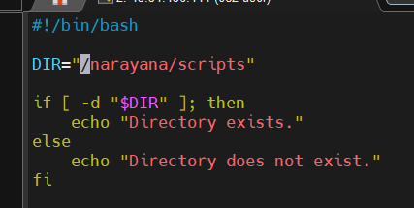

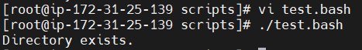

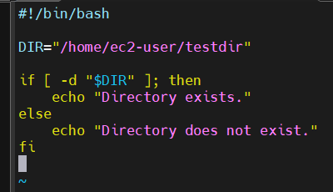

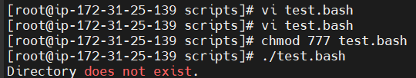

2.Create a bash script to create multiple files.
#!/bin/bash

for i in {4..10}
do
touch file$i.txt
done

echo "7 files created successfully."

Commands : vi test.bash
Chmod 777 test.bash
./test.bash

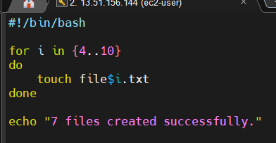

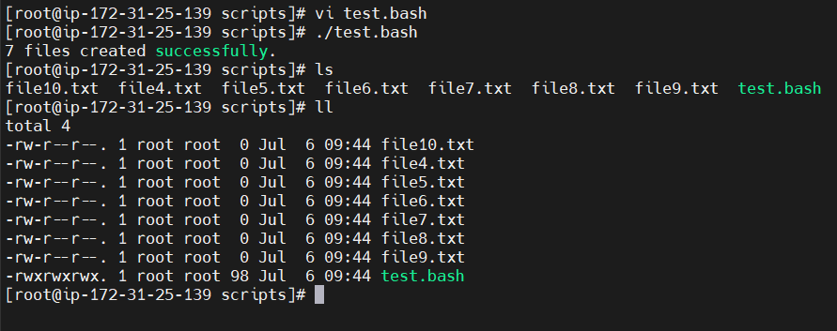

b. Create a bash script to remove multiple files
Now let us try to remove files using rm

#!/bin/bash

for i in {4..10}
do
rm file$i.txt
done

echo "7 files removed successfully."

Commands : vi test.bash
Chmod 777 test.bash
./test.bash

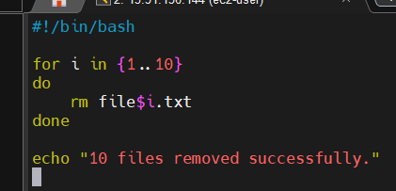

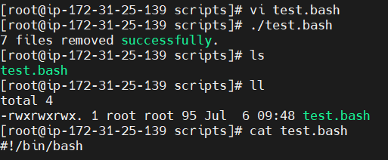

3.Create a bash script to take a backup of a directory.

#!/bin/bash

echo "Enter the directory name"
read dir
cp -r "$dir" "${dir}_backup"

echo "Backup completed successfully."

Commands : vi test.bash
Chmod 777 test.bash
./test.bash

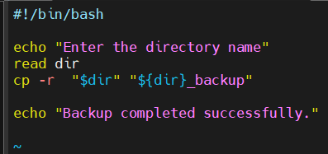

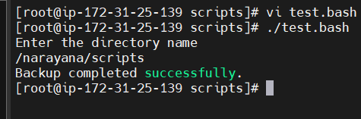

4.Create a bash script to install Nginx on an EC2 server.

#!/bin/bash

sudo dnf update -y
sudo dnf install nginx -y

sudo systemctl enable nginx
sudo systemctl start nginx
sudo systemctl status nginx

echo "Nginx installed successfully."

Command : vi nginx.bash
chmod 755 nginx.bash
./nginx.bash

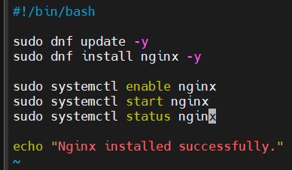

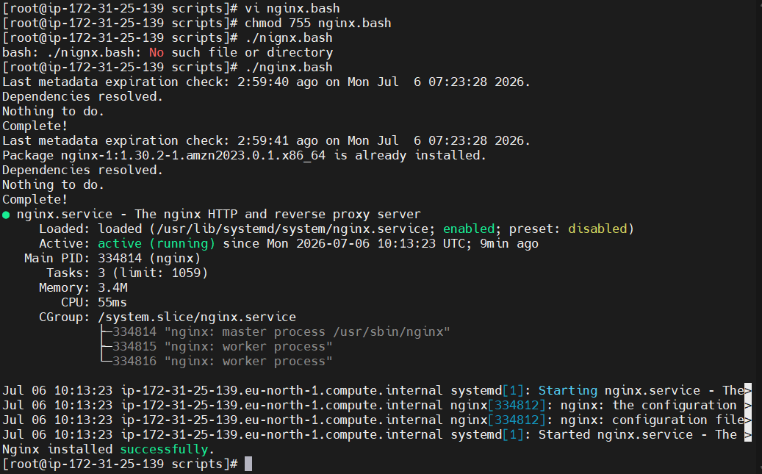

5.Create a bash script to install Apache Tomcat on an EC2 server.
#!/bin/bash

sudo dnf install java-17-amazon-corretto -y

cd /opt

sudo wget https://archive.apache.org/dist/tomcat/tomcat-9/v9.0.108/bin/apache-tomcat-9.0.108.tar.gz

sudo tar -xvzf apache-tomcat-9.0.108.tar.gz

sudo mv apache-tomcat-9.0.108 tomcat

sudo chmod +x /opt/tomcat/bin/*.sh

sudo /opt/tomcat/bin/startup.sh

echo "Tomcat installed successfully."

Command : vi tomcat.bash
Chmod 755 tomcat.bash
./tomcat.bash

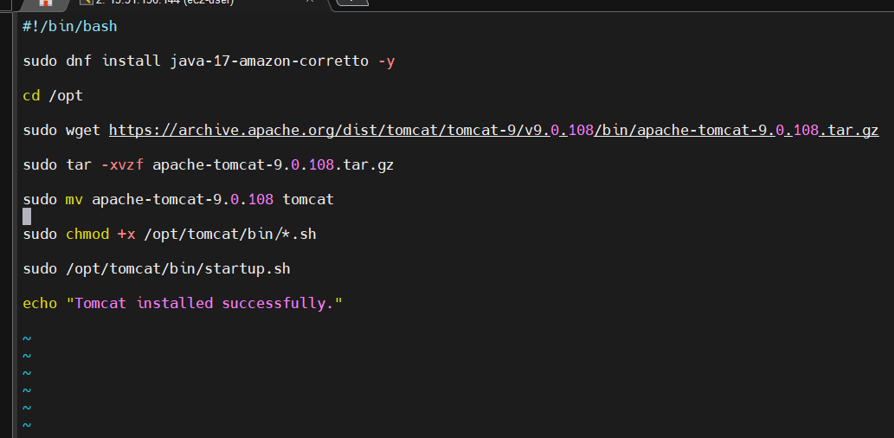
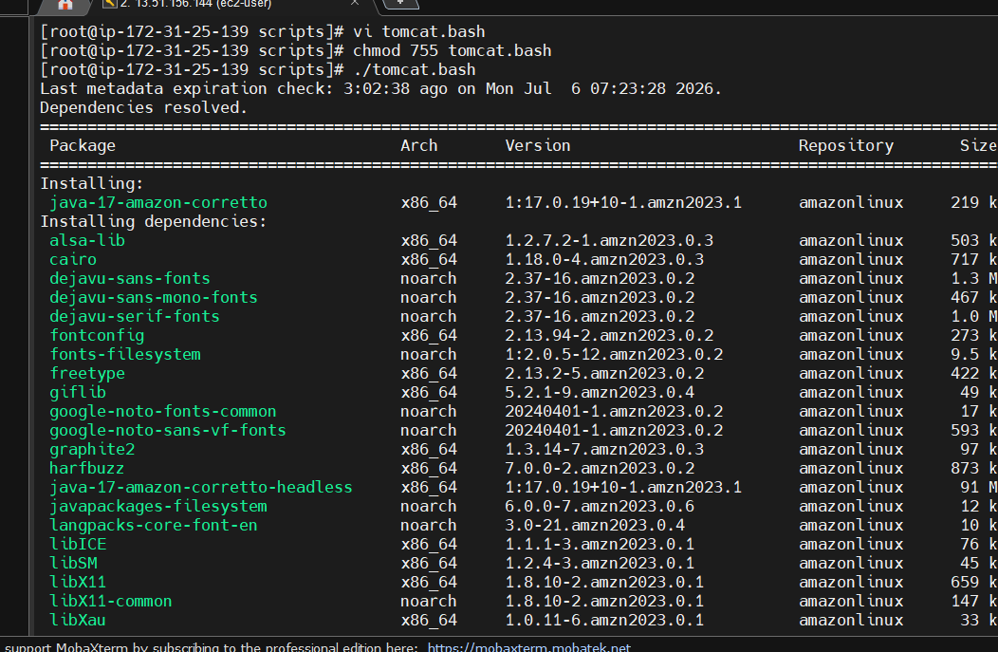

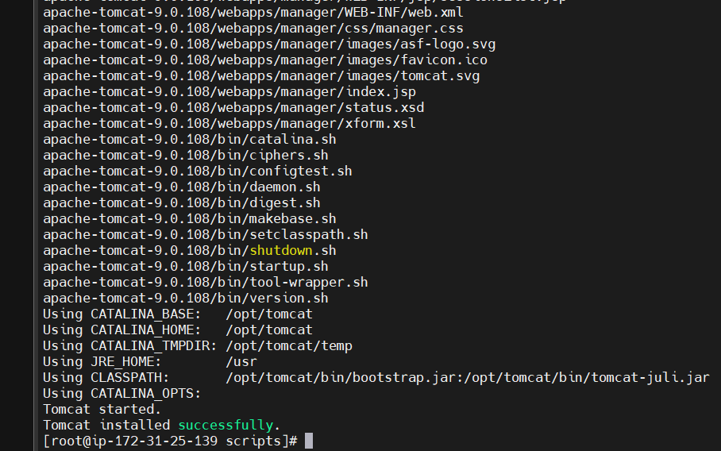
6.Create a bash script to check if the Nginx service is running, if not running then script should start the service.

#!/bin/bash

STATUS=$(systemctl is-active nginx)

if [ "$STATUS" = "active" ]; then
echo "Nginx is already running."
else
echo "Nginx is not running."
sudo systemctl start nginx
echo "Nginx started successfully."
fi

Command: vi nginx-service.bash
chmod 755 nginx-service.bash
./nginx-service.bash
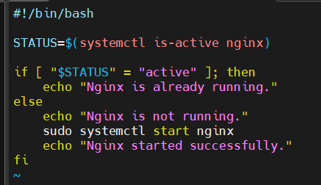

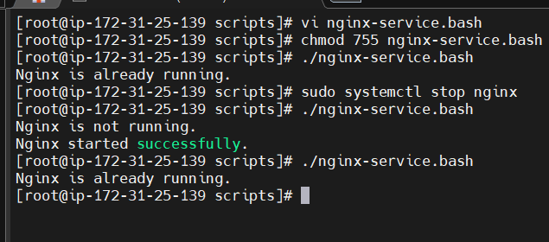

7.Create a bash script for a calculator.

#!/bin/bash

echo "Enter first number:"
read num1

echo "Enter second number:"
read num2

echo "Choose operation (+ - * /)"
read op

case $op in
+)
echo "Result = $((num1+num2))"
;;
-)
echo "Result = $((num1-num2))"
;;
\*)
echo "Result = $((num1*num2))"
;;
/)
echo "Result = $((num1/num2))"
;;
*)
echo "Invalid Operator"
;;
esac

Commands: vi calculator.bash
chmod 755 calculator.bash
./calculator.bash

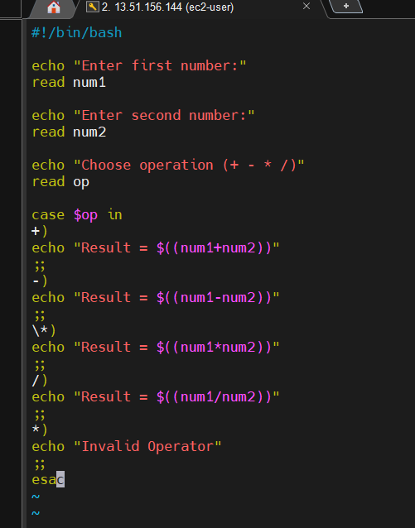

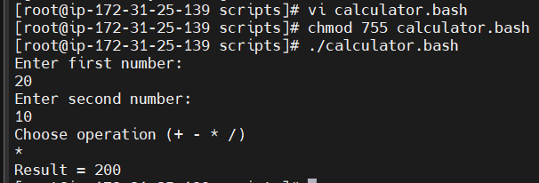

8.Create a bash script to check if a directory exists, if not then create a directory.
#!/bin/bash

DIR="/home/ec2-user/project"

if [ -d "$DIR" ]; then
echo "Directory already exists."
else
mkdir -p "$DIR"
echo "Directory created."
fi

Commands : vi test.bash
Chmod 777 test.bash
./test.bash

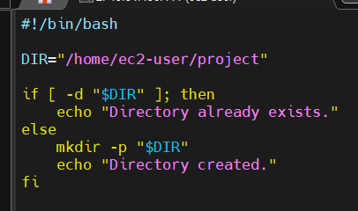

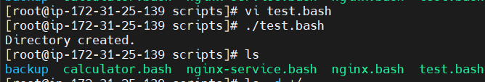
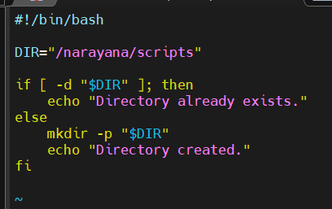

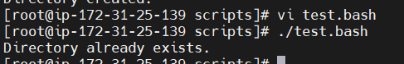

9.Create a bash script to delete the last 3 lines of a file.

#!/bin/bash

echo "enter file name:"
read file

head -n -3 "$file" > temp.txt

mv temp.txt "$file"

echo "Last 3 lines deleted."

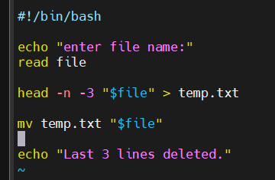

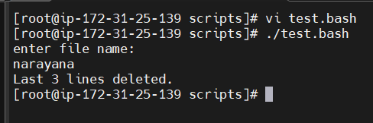

10.Bash script to monitor cpu and if it is more than 80% then send email notification.

#!/bin/bash

CPU=$(top -bn1 | grep "Cpu(s)" | awk '{print int($2+$4)}')

TO="admin@example.com"

if [ "$CPU" -gt 80 ]; then
echo "CPU Usage is $CPU%" | mail -s "High CPU Alert" $TO
else
echo "cpu usage is normal: $cpu%"
fi
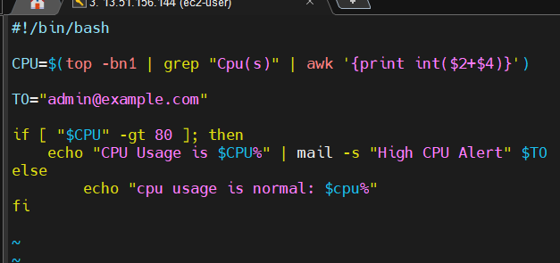

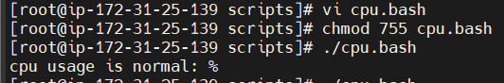

11.Bash script to monitor disk space and if it is more than 80% then send email notification.

#!/bin/bash

THRESHOLD=80
TO="admin@example.com"

DISK_USAGE=$(df -h / | awk 'NR==2 {print $5}' | cut -d'%' -f1)

echo "Current Disk Usage: $DISK_USAGE%"

if [ "$DISK_USAGE" -gt "$THRESHOLD" ]
then
SUBJECT="Disk Space Alert"

MESSAGE="Warning!

Disk usage on $(hostname) is ${DISK_USAGE}%.
Please clean up unnecessary files."

echo "$MESSAGE" | mail -s "$SUBJECT" "$TO"

echo "Email notification sent."
else
echo "Disk usage is normal."
fi
Commands : vi disk.bash
Chomd 755 disk.bash
./disk.bash

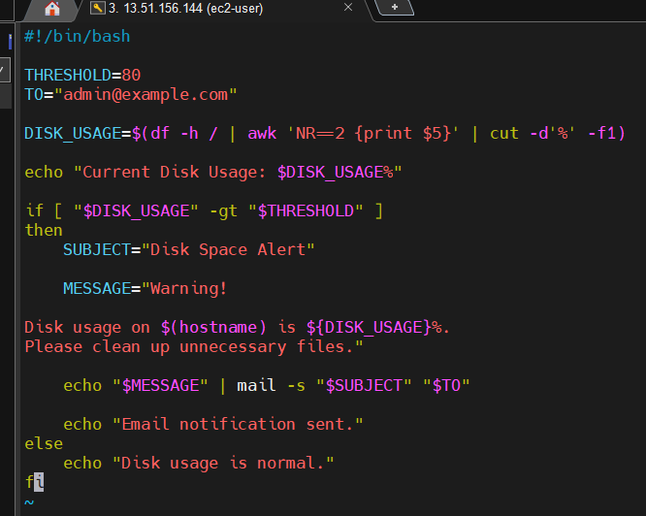

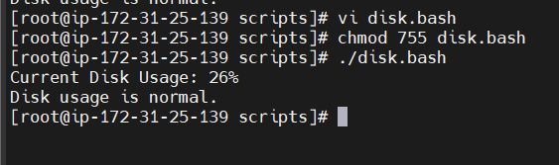

12.Bash script to monitor memory and if it is more than 80% then send email notification.
#!/bin/bash

THRESHOLD=80
TO="admin@example.com"

MEMORY=$(free | awk '/Mem/ {printf("%.0f"), $3/$2*100}')

echo "Current Memory Usage: ${MEMORY}%"

if [ "$MEMORY" -gt "$THRESHOLD" ]
then
SUBJECT="Memory Usage Alert"

MESSAGE="Warning!

Memory usage on $(hostname) is ${MEMORY}%.
Please investigate the running processes."

echo "$MESSAGE" | mail -s "$SUBJECT" "$TO"

echo "Email notification sent."
else
echo "Memory usage is normal."
fi

